"PHP: Hypertext Preprocessor"

* PHP is a server side scripting language that is embedded in HTML.
* It is used to manage dynamic content, databases.
* It is integrated with a number of popular databases like MySQL.
* You add, delete, modify elements within your database through PHP

**PHP is embedded in HTML**

**<html><head>**

**<title>DEMO</title>**

**<body><?php echo “hello” ?>**

**</body>**

**</html>**

**With PHP, you can connect to and manipulate databases.MySQL is the most popular database system used with PHP.**

**INSTALLATION XAMPP**

<https://www.youtube.com/watch?v=2xPGfwj6SgE>

let’s begin--

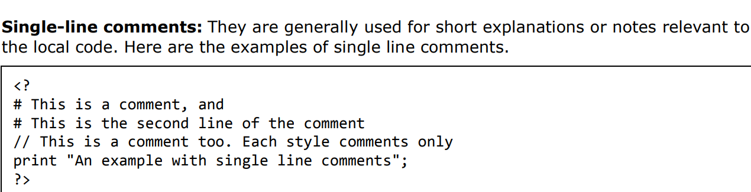

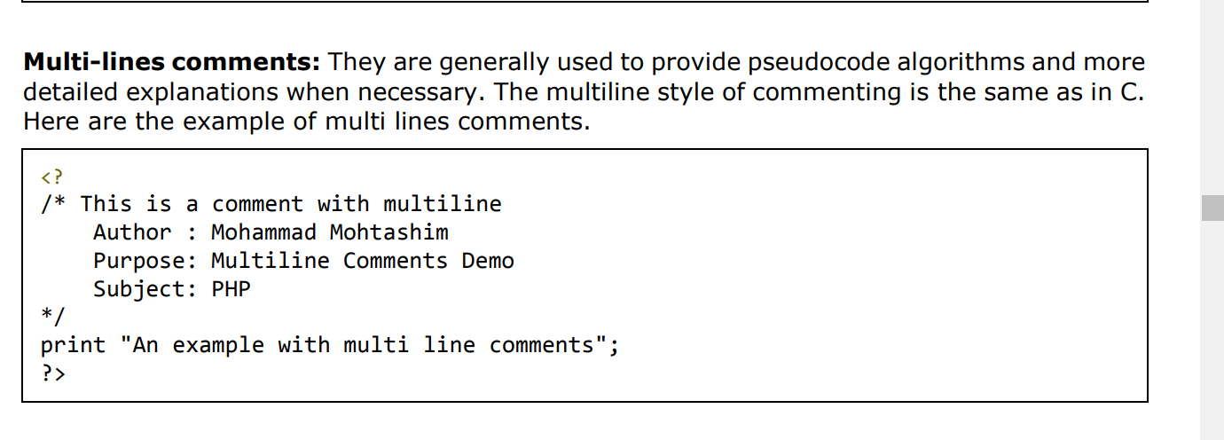

**PHP is whitespace insensitive**

**PHP is case sensitive**

**All variables in PHP are denoted with a leading dollar** **sign ($)**

Variable Naming Rules for naming a variable is:

• Variable names must begin with a letter or underscore character.

• A variable name can consist of numbers, letters, underscores but you cannot use characters like + , - , % , ( , ) . & , etc There is no size limit for variables

- a variable does not know in advance whether it will be used to store a number or a string of characters.

**Escape sequences**

\n is replaced by the newline character PHP 31

• \r is replaced by the carriage-return character

• \t is replaced by the tab character

• \$ is replaced by the dollar sign itself ($)

• \" is replaced by a single double-quote (")

• \\ is replaced by a single backslash (\)

**PHP Function Parameters**

a function is a small unit of program which can take some input in the form of parameters and does some processing and may return a value.

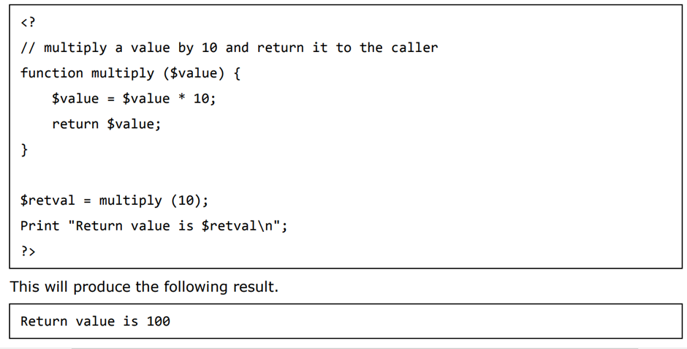

## PHP Variable Handling Functions

The PHP variable handling functions are part of the PHP core. No installation is required to use these functions.

|  |  |
| --- | --- |
| **Function** | **Description** |
| [boolval()](https://www.w3schools.com/php/func_var_boolval.asp) | Returns the boolean value of a variable |
|  |  |
| [empty()](https://www.w3schools.com/php/func_var_empty.asp) | Checks whether a variable is empty |
| [gettype()](https://www.w3schools.com/php/func_var_gettype.asp) | Returns the type of a variable |
| [is_array()](https://www.w3schools.com/php/func_var_is_array.asp) | Checks whether a variable is an array |
| [is_bool()](https://www.w3schools.com/php/func_var_is_bool.asp) | Checks whether a variable is a boolean |
| [is_countable()](https://www.w3schools.com/php/func_var_is_countable.asp) | Checks whether the contents of a variable is a countable value |
| [is_float()](https://www.w3schools.com/php/func_var_is_float.asp) | Checks whether a variable is of type float |
| [is_int()](https://www.w3schools.com/php/func_var_is_int.asp) | Checks whether a variable is of type integer |
| [is_null()](https://www.w3schools.com/php/func_var_is_null.asp) | Checks whether a variable is NULL |
| [is_object()](https://www.w3schools.com/php/func_var_is_object.asp) | Checks whether a variable is an object |
| [is_string()](https://www.w3schools.com/php/func_var_is_string.asp) | Checks whether a variable is of type string |
| [isset()](https://www.w3schools.com/php/func_var_isset.asp) | Checks whether a variable is set (declared and not NULL) |
| [var_dump()](https://www.w3schools.com/php/func_var_var_dump.asp) | Dumps information about one or more variables |

And many more.

HTML FORM

An HTML form is used to collect user input. The user input is most often sent to a server for processing.

## The <input> Element

The HTML <input> element is the most used form element

|  |  |
| --- | --- |
| <input type="text"> | Displays a single-line text input field |
| <input type="radio"> | Displays a radio button (for selecting one of many choices) |
| <input type="checkbox"> | Displays a checkbox (for selecting zero or more of many choices) |
| <input type="submit"> | Displays a submit button (for submitting the form) |
| <input type="button"> | Displays a clickable button |

# **HTML Form Attributes**

## The Action Attribute

The action attribute defines the action to be performed when the form is submitted.

Usually, the form data is sent to a file on the server when the user clicks on the submit button.

In the example below, the form data is sent to a file called "action_page.php"

## <form action="/action_page.php">    </form>

## The Method Attribute

The method attribute specifies the HTTP method to be used when submitting the form data.

The form-data can be sent as URL variables (with method="get") or as HTTP post transaction (with method="post").

<form action="/action_page.php" method="get">

## PHP Global Variables - Superglobals

## PHP $_GET

PHP $_GET is a PHP super global variable which is used to collect form data after submitting an HTML form with method="get".

## PHP $_POST

PHP $_POST is a PHP super global variable which is used to collect form data after submitting an HTML form with method="post".

<https://www.w3schools.com/php/default.asp>

<https://www.w3schools.com/html/html_forms.asp>

<https://www.w3schools.com/php/php_ref_variable_handling.asp> (looking at these once)

**SQL**

SQL is a standard language for accessing and manipulating databases.

* SQL can execute queries against a database
* SQL can retrieve data from a database
* SQL can insert records in a database
* SQL can update records in a database
* SQL can delete records from a database
* SQL can create new databases
* Database Queries
* **A query is a question** or a **request**.
* We can query a database for specific information and have a recordset returned.
* Look at the following query (using standard SQL):
* SELECT LastName FROM Employees
* The query above selects all the data in the "LastName" column from the "Employees" table.

Using SQL in Your Web Site

**To build a web site that shows data from a database, you will need:**

* **An RDBMS database program (i.e. MySQL)**
* **To use a server-side scripting language, like PHP**
* **To use SQL to get the data you want**
* **To use HTML / CSS to style the page**

Most of the actions you need to perform on a database are done with SQL statements.

**The following SQL statement selects all the records in the "Customers" table**:

### **Example**

SELECT * FROM Customers;

Keep in Mind That...

* SQL keywords are NOT case sensitive: select is the same as SELECT

Some of The Most Important SQL Commands

* SELECT - extracts data from a database
* UPDATE - updates data in a database
* DELETE - deletes data from a database
* INSERT INTO - inserts new data into a database
* CREATE DATABASE - creates a new database
* ALTER DATABASE - modifies a database
* CREATE TABLE - creates a new table
* ALTER TABLE - modifies a table
* DROP TABLE - deletes a table
* CREATE INDEX - creates an index (search key)
* DROP INDEX - deletes an index

## SELECT Column Example

The following SQL statement selects the "CustomerName" and "City" columns from the "Customers" table:

### **Example**

SELECT CustomerName, City FROM Customers;

## The SQL WHERE Clause

The WHERE clause is used to filter records.

It is used to extract only those records that fulfill a specified condition.

### **WHERE Syntax**

SELECT column1, column2, ...  
FROM table_name  
WHERE condition;

## WHERE Clause Example

The following SQL statement selects all the customers from the country "Mexico", in the "Customers" table:

### **Example**

SELECT * FROM Customers  
WHERE Country='Mexico';

## The SQL INSERT INTO Statement

The INSERT INTO statement is used to insert new records in a table

INSERT INTO table_name (column1, column2, column3, ...)  
VALUES (value1, value2, value3, ...);

### **Example**

INSERT INTO Customers (CustomerName, ContactName, Address, City, PostalCode, Country)  
VALUES ('Cardinal', 'Tom B. Erichsen', 'Skagen 21', 'Stavanger', '4006', 'Norway');

## The SQL DELETE Statement

The DELETE statement is used to delete existing records in a table.

### **DELETE Syntax**

DELETE FROM table_name WHERE condition;

## The SQL CREATE DATABASE Statement

The CREATE DATABASE statement is used to create a new SQL database.

### **Syntax**

CREATE DATABASE databasename;

## The SQL CREATE TABLE Statement

The CREATE TABLE statement is used to create a new table in a database.

### **Syntax**

CREATE TABLE table_name (  
    column1 datatype,  
    column2 datatype,  
    column3 datatype,  
   ....  
);

SQL ALTER TABLE Statement

The ALTER TABLE statement is used to add, delete, or modify columns in an existing table.

The ALTER TABLE statement is also used to add and drop various constraints on an existing table.

ALTER TABLE - ADD Column

To add a column in a table, use the following syntax:

ALTER TABLE *table_name*  
ADD *column_name datatype*;

<https://www.w3schools.com/sql/default.asp> (Go thru it once)

# **PHP MySQLi Functions**

The MySQLi functions allows you to access MySQL database servers.

|  |  |
| --- | --- |
| [connect()](https://www.w3schools.com/php/func_mysqli_connect.asp) | Opens a new connection to the MySQL server |
| [connect_errno()](https://www.w3schools.com/php/func_mysqli_connect_errno.asp) | Returns the error code from the last connection error |
| [connect_error()](https://www.w3schools.com/php/func_mysqli_connect_error.asp) | Returns the error description from the last connection error |
| [query()](https://www.w3schools.com/php/func_mysqli_query.asp) | Performs a query against a database |

And many more

<https://www.w3schools.com/php/php_ref_mysqli.asp>

# **PhpMyAdmin is a web application wich let you manage (with a visual interface) MySQL Databases**

# **PHP Connect to MySQL**

# **Open a Connection to MySQL**

## Before we can access data in the MySQL database, we need to be able to connect to the server:<?php $servername = "localhost"; $username = "username"; $password = "password"; // Create connection $conn = mysqli_connect($servername, $username, $password); // Check connection if ($conn->connect_error) {   die("Connection failed: " . $conn->connect_error); } echo "Connected successfully"; ?>