New QB

Components:
- Criteria – Wrapper component for all views: search, create, save, schedule
- QueryBuilder – recursive component the creates the query object
- QueryBuilderPage – wrapper for queryBuilder component, includes actions like: save, delete schedule,…
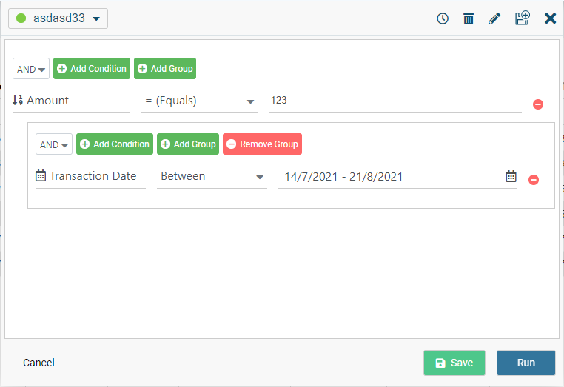

- ScheduleCriteria

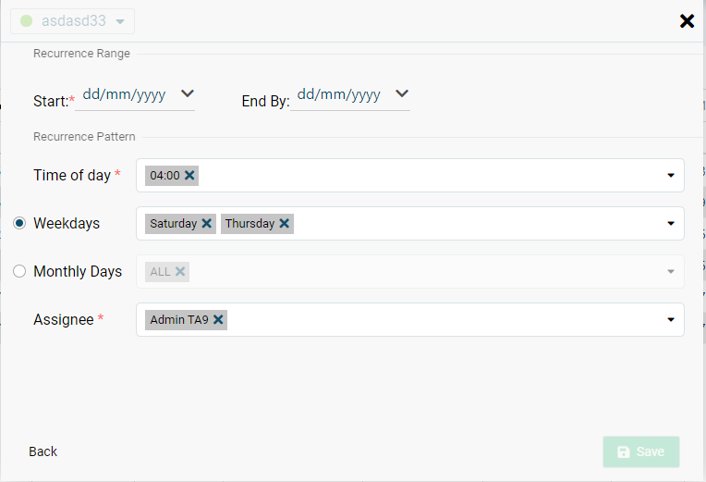
- SearchCriteriaList
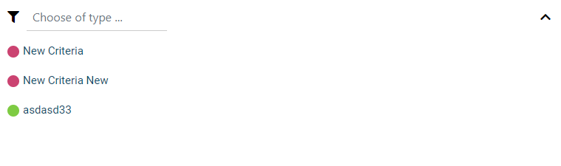
- QueryBuilderSaveCriteria

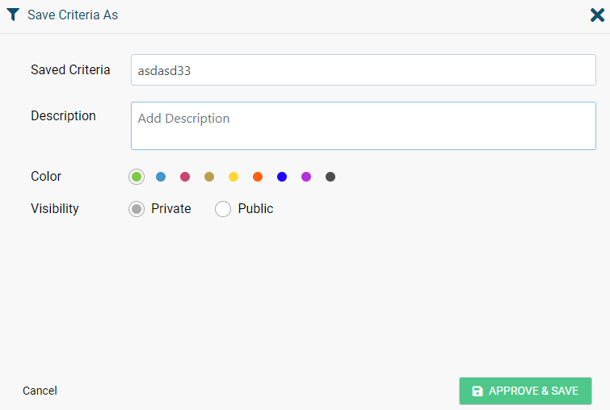

Routing:
The new QB has “internal routing” – no use of angular routing. Criteria.html has all components but only one is rendering (according to the current state).
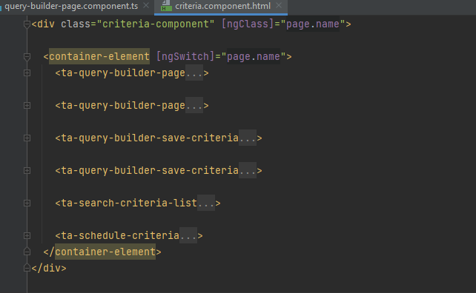

Iframe Communication:
- The communication is done with postMessages
- The listeners are in: criteria.component (new client) and in auto-complete.component (old client)
- Messages:
- Ready – when the qb is rendered
- Close – close the qb
- runQuery – call the runQuery function that is in old client (worksheet.componet)
- updateSelectedIdentifiers – sync between the identifiers dropdown list that is in the qb and in the autocomplete
- openMap – open the old map
- updateSearchText – sync between the text input that is in the qb and in the autocomplete
- isQueryBuilderRuleIsEmpty – sync the filters object in the worksheet.componet (old client)
- onDestroy – when the qb is being destroyed
- buildServerQBFilter – build qb filter and save it in the server (for schedule criteria).
- initialData – required data for the qb from the old client like dataModel, headers, searchText, etc.

Validation

QB has “pure” validation – not angular validation.
There is a subject in criteriaService that called validateQB$ for triggering validation – it calls validateQB function. validateQB is a recursive function the runs on the qbRule and checks that all rules are valid. You can run the validation function with “withErrorMessages” flag – if true it will add and display the error validation messages

Main Flow
The most important data in the QB is queryBuilderFields. After we receive the queryBuilderFields we calling the buildFieldsAndLookups function for building required data for qb – categories, operators and the value section.
To build QB quick filters we need to have 4 dependencies: quickFilters, queryBuilderFields, lookups, headers. The indication that we have all those dependencies is buildQuickFilters$ subject.

Important Notes:

- QB working with one form and the runQuery (in the old client)
Working with another form so all the convert utils are in the criteria.service
- Lookup values are not stored in the db so when we load criteria, we need to connect the correct lookups to the relevant fields
- Location field – to choose location we need to open the map component from the old client. This is done through ruleMapValue$ that is placed in queryBuilder.service
- To indicate if the QB rule is “dirty” we store the original (initial or saved criteria) rule int the criteria.service and then compare it to the current rule and if there is a different, we display the cancel or clearAll button

- The initial data for the qb can arrived in 2 forms:
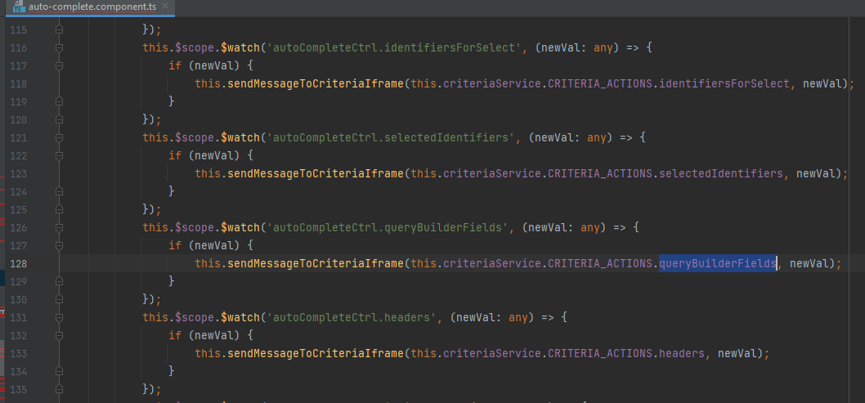
- The QB is rendered before the data is ready so after the data is ready it will send it in separate messages like queryBuilderFields, selectedIdentifiers, headers, etc. lo

- The data is ready and the QB hasn’t rendered yet, so after it will be rendered it will send a message - qbReay and then the old client will send all required data through the message – intialData

