**Heading judgement for indoor position based on the gait pattern**

Lulu Yuan1, Weiwei Tang1, Tian Tan1, Lingxiang Zheng1, Biyu Tang1, Haibin Shi1, Hai Lu1[1]*, Ao Peng1, Huiru Zheng2

1School of Information Science and Engineering, Xiamen University, Xiamen, China

[{lxzheng,luhai}@xmu.edu.cn](mailto:%7blxzheng@xmu.edu.cn)

2School of Computing and Mathematics, University of Ulster, Jordanstown Campus, Shore Road, Newtown Abbey

h.zheng@ulster,ac,uk

***Abstract.****--*In the inertial sensing unit based indoor positioning systems, the gyroscope drift is the primary source of heading error. To reduce this error, we proposed that the heading drift and the real heading change can be distinguished by the similarity of the gait pattern in the same movement model. It use the curve fitting method to find out the gait pattern in walking straightly. The Frechet distance is used to discriminate the gait of walking in turn and walking straightly. Experiments show that this method can recognize the walking in turn successfully with no mistake and the rate of mismatch walking in straight to walking in turn is less than 17.39%. Although there are some mistakes of match the walking in straight to walking in turn model, it will have few impact because heading drift is little in a short time. The result of test two shows that it get the best result compared with the other two methods when doing heading correction. It indicates that the proposal can promote the performance of heading correction and reduce the effect of sensor drift.

**Keywords:** heading estimation, frechet distance, curve fitting

1. Introduction

In general, MEMS gyroscope is used for attitude calculation. Due to the gyroscope drift, it is hard to maintain the correct heading in a long period of time when using an IMU based indoor positioning system. In order to achieve precise indoor positioning, scholars have proposed a variety of heading correction algorithms. The Heuristic Drift Reduction (HDR) method, proposed by the University of Michigan Johann Borenstein, corrects gyroscope drift by specifying a number of main directions [1]-[3]. However, the HDR is based on the ideal straight line walking. If the possibility of straight line walking is low, the HDR has no effect; if this possibility is high, the HDR will correct the output of the gyroscope. In 2010, Johann Borenstein proposed the Heuristic Drift Elimination method(HDE)[4]. Instead of modifying the gyro measurement, the angular velocity between the two steps is modified. The HDE method reduces the drift, in some cases, can even eliminate the error to almost zero. However, the HDE algorithm is also based on straight line walking, which will cause an inaccuracy in tracking. Jimenez, A.R. proposed a further improvement of the HDE algorithm, improved heuristic drift elimination (iHDE), which introduced the motion pattern analysis to improve the HDE correction algorithm[5]. However, there are still some problems such as linear jitter yet to be solved.

The previous work of HDR or HDE and their variant can reduce the error. However, it is based on the hypothesis that people walk according the dominant direction of the building and it is not suitable for tracking walkings in open space or in the environment without dominant direction. In this paper, we aim to eliminate this hypothesis for HDE. We proposed a gait pattern recognition algorithm to identify whether a person is walking straightly or not. The hypothesis is that gait pattern will be similar and repetitive when people is walking straightly and the gait pattern will be changed when people is making turns. It can be used to classify the straight walking and turning. We use the curve of the accelerometer data in a gait cycle to present the gait pattern. The pattern can be obtained by a curve fitting algorithm. The Frechet distance is used to evaluate the similarity of gait pattern and classify the straight walkings and turnings.

The section 2 of this paper will introduce the algorithm and method used to discriminate the walking model. Section 3 presents the experiments and results. The paper is concluded by summary and future work in Section 4.

1. Method

As shown in Fig. 1, we first select the appropriate features from the accelerometer sensor data, then remove the noise using a low-pass filter. The data is then normalized to facilitate the later curve fitting and similarity matching. The degree of fitting are evaluated after curve fitting. Finally, the state of the walk is classify to a straight line or a curve by pattern discrimination.

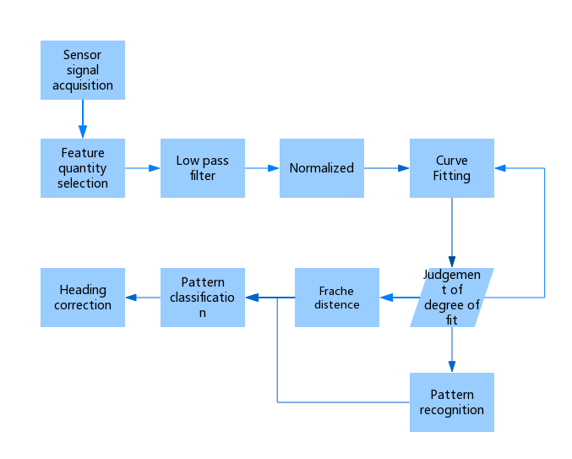

**Fig. 1.** Walking pattern classification

(1) Selection of feature: For the preprocessing phase of the data, the appropriate feature is extracted from inertia data, and get trained data by the normalization process. (2) Low-pass filter: due to the noise of the sensor, signal fluctuations are large. It can reduce the high-frequency components, that is, the noise, using a low-pass filter. (3) Normalization of the data: in this paper, the normalization includes two aspects, one is the normalization of the amplitude. The other one is the normalization of the time period of the gait cycle. Based on the above considerations, the Fourier linear normalization is chosen as the normalization method under the premise that the data do not conform to the approximate normal distribution [6].

 (1)

Calculates the parameters of (1), Making the error minimum.

After curve fitting, we use R - squared method [7] to judge the fitting degree. In [statistics](https://en.wikipedia.org/wiki/Statistics), the coefficient of determination, denoted R2 or r2 and pronounced "R squared", is a number that indicates the proportion of the variance in the dependent variable that is predictable from the independent variable(s).

Before the introduction of coefficient of determination(R-squared), it is necessary to introduce two parameters Sum of squares of the regression (SSR) and Total sum of squares (SST). SSR computation formula is as follows:

 (2)

SST computation formula is as follows:

 (3)

The determination of the coefficient is defined as the ratio of SSR to SST, there are:

$R-squared=\frac{SSR}{SST}$ (4)

Due to SST = SSE + SSR, the formula (4) can be rewritten as:

$R-squared=1-\frac{SSE}{SST}$ (5)

According to equation (5), the value of the determined coefficient is in the range of [0,1]. The coefficient is closer to 1, the fitting curve is more reliable, and the model is more accurate.

For the comparison of the objective functions Gauss8, Fourier6 and Fourier8, Fourier6 achieved the best objective function, which can reduce the system load due to the complexity of the fitting curve. Therefore, we choose Fourier6 for curve fitting.

Finally, the curve is matched by the Frechet distance. After obtaining the standard straight curve, the further work is to select the appropriate curve similarity matching algorithm to classify the action according to the matching result. The simplest algorithm for curve similarity is the least squares method. The method obtains the parameters of the curve similarity by calculating the square of the error of the corresponding points.

If we define two functions:

 (6)

The Frechet distance between them is:

 (7)

After calculating the corresponding Frechet distance, the pattern can be identified by the following formula:

 (8)

Among them, is the Frechet distance of step i and  is the set Frechet distance threshold.

1. Experiment

Two groups of experiments were carried out on the classification of the movement. The Group1 was tested at the Software Park. The walking distance was about 240m and the time was 207s. The total number of steps was 184, the actual turn was 8 times and the straight line was 176 times. Group 2 received about 10 minutes of rectangle walking test, including 3-step straight and 1-step turn rectangular test, for a total of 264 steps, of which 66 steps turn, 198 steps straight.

3.1 Frechet distance in different modes of motion

The data collection contains normal speed straight walking and 90 degrees turn.

The testers tested several groups of straight lines and turned for about 60 steps per group. The Frechet distance in the different motion modes is shown in Table 1, and the sliding window algorithm is added by default.

**Table 1.** Frechet distance

|  |  |  |  |  |  |
| --- | --- | --- | --- | --- | --- |
| Motion mode | Mean | Maximum value | | Minimum value | Standard deviation |
| Non-sliding window | 1.2213 | 2.7242 | 0.5272 | | 1.3188 |
| straight line1 | 0.7761 | 1.7048 | 0.3764 | | 0.8371 |
| straight line2 | 0.6498 | 1.3991 | 0.3279 | | 0.6962 |
| 90 degrees turn | 4.1478 | 5.3065 | 2.4425 | | 4.2045 |

Compared with the non-sliding window straight line 1 and the sliding window straight line 1, it can be found that the Frechet distance error due to the phase difference of the step landing can be effectively reduced after opening the sliding window.

Compared with straight line 1 and straight line 2, it can be found that that the standard curve is consistent in the normal walking process, and the distribution of inertial data is basically the same, the mean of the two line is closer.

In addition, it can be found in the turning experiments that the Frechet distance of direction-changed turn behavior is larger, which can meet the requirements of distinction between straight and turning.

According to the above analysis, it can be found that under different motion modes, the data of the sensor will be distributed in different periods, and then we can use the similarity matching by curve fitting to achieve the purpose of moving pattern classification.

3.2 Gait pattern based Heading Correction

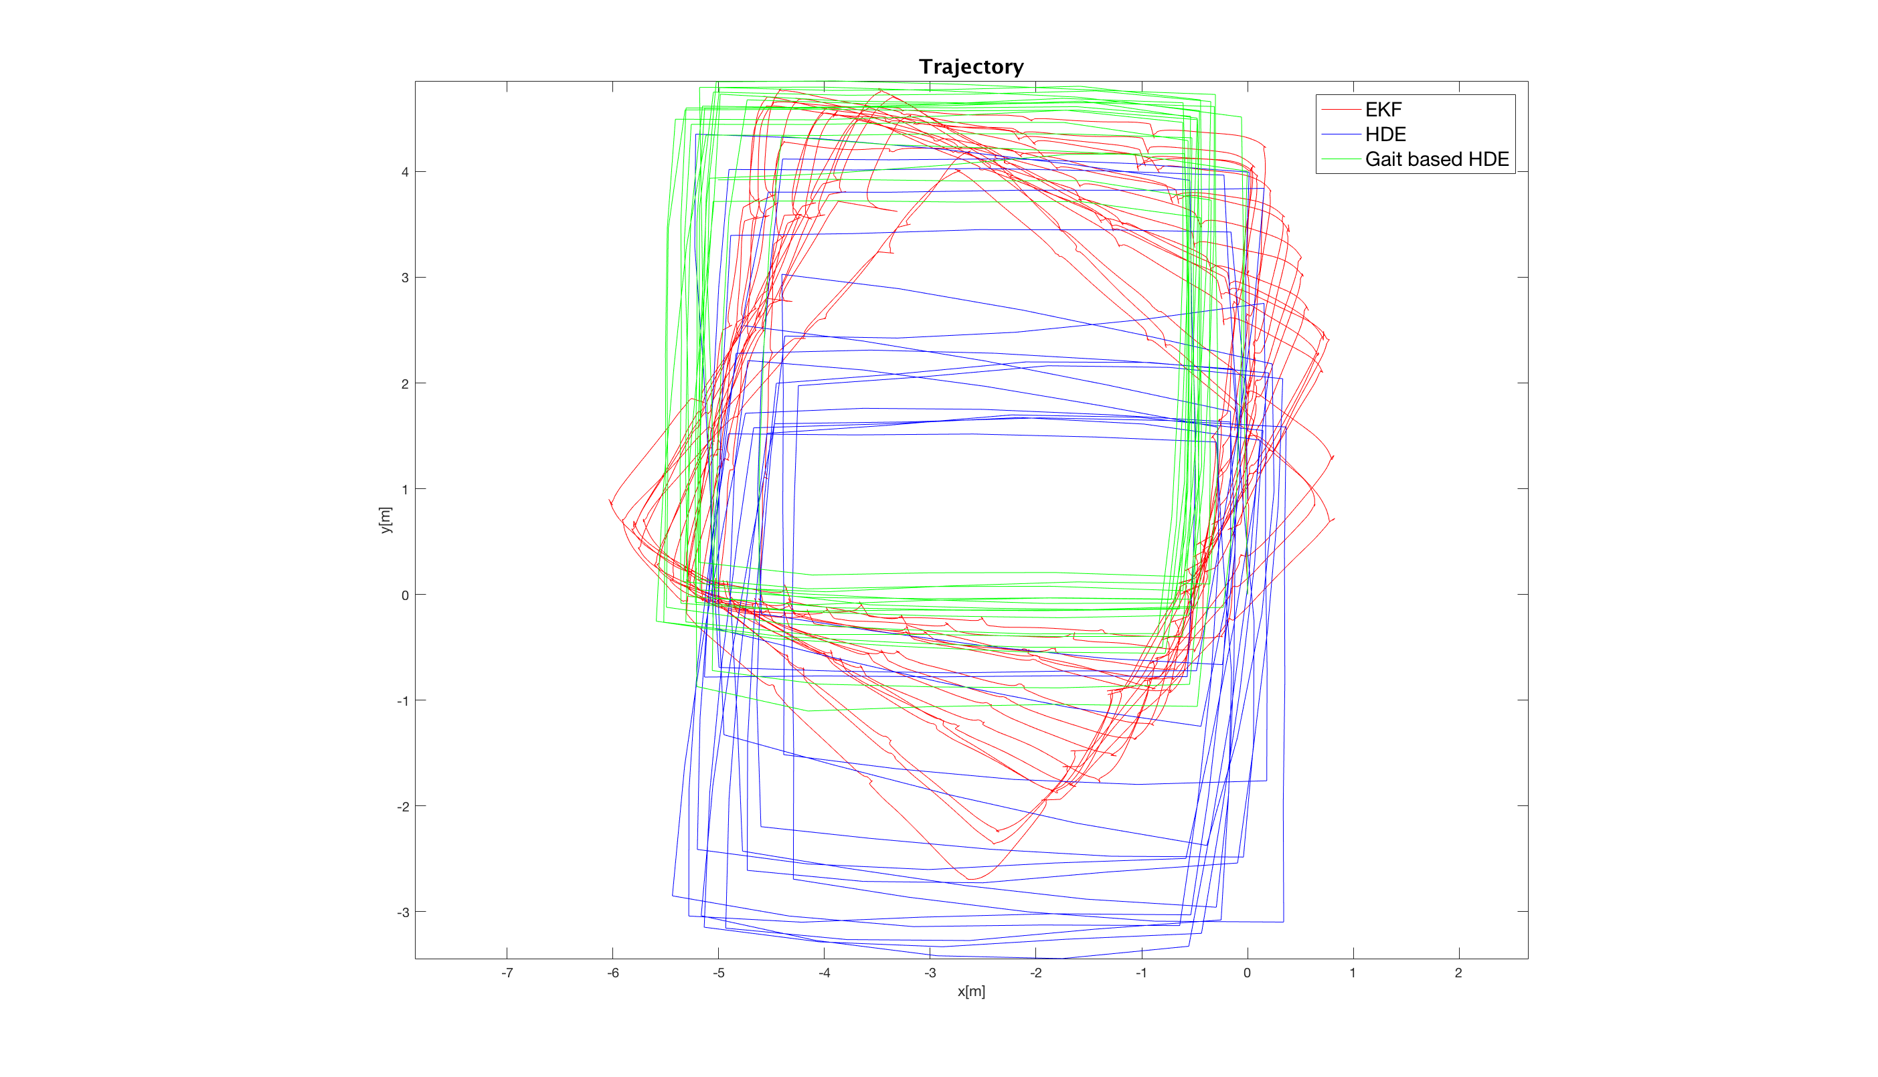

**Fig. 2.** Trajectory

In these test, we apply the gait pattern recognition algorithm to the HDE and evaluate the performance when using it to do the heading correction. In the Fig.2. The red line rep-resents the results of the EKF[8]-[10]; the blue line represents the result of the original HDE[4]; and the green line represents the gait pattern based heading correction with HDE (gait based HDE) we proposed. In this algorithm, we use the gait curve of the previous step as the standard curve, that is, the standard curve is dynamically changing. This is mainly because a person`s gait will change slightly in the course of walking. If a person walks two steps in a straight line, the changes will be slight, but if turning happened, the changes will be big. From Fig. 2. It can be found that the Gait Based HDE got the best result in the experiment.

1. Conclusion

Experiments show that the proposed heading error elimination algorithm based on extended Kalman filter has good applicability in the field of inertial navigation system, and can effectively eliminate the problem of heading drift caused by gyro error. It can satisfy long time accuracy requirements for strap down inertial navigation systems.

With the development of computer science and information technology, the demand for the indoor positioning is getting bigger and bigger, and the requirements for accuracy are getting higher and higher. However, the existing technology cannot measure accurately because of the limitation of gyroscope’s acceleration, which cannot accurately measure and judge the actions when people walking with the acceleration, turn or other acts. In this paper, data analysis is carried out by means of normalization and curve fitting, and then the Frechet distance and pattern recognition method are used to detect the similarity between the training set and the test set, and we get the recognition rate of 91.97%.The above results show in this paper the information of the feet-tied sensor, acceleration and gyroscope can effectively reflect the behavioral characteristics of the user, so as to judge the behavior of the user and improve the accuracy of the indoor positioning based on the inertial sensing unit to a certain extent.

1. References
2. [Borenstein, J, Ojeda, L., and Kwanmuang, S, 2009, "Heuristic Reduction of Gyro Drift in a Personal Dead-reckoning System." Journal of Navigation, Vol 62, No 1, January 2009, pp. 41-58.](http://www-personal.umich.edu/~johannb/Papers/paper144.pdf)
3. Borenstein J, Ojeda L. Heuristic reduction of gyro drift in gyro-based vehicle tracking[C]//SPIE Defense, Security, and Sensing. International Society for Optics and Photonics, 2009: 730507-730507-11.
4. Borenstein, Johann, and Lauro Ojeda. "Heuristic reduction of gyro drift in gyro-based vehicle tracking." *SPIE Defense, Security, and Sensing*. International Society for Optics and Photonics, 2009.
5. [Borenstein, J, Ojeda, L., 2010, "Heuristic Drift Elimination for Personnel Tracking Systems." Journal of Navigation, Vol. 63, No. 4, Oct. 2010, pp. 591-606.](http://www-personal.umich.edu/~johannb/Papers/paper148.pdf)
6. Jiménez A R, Seco F, Zampella F, et al. Improved Heuristic Drift Elimination (iHDE) for pedestrian navigation in complex buildings[C]//Indoor Positioning and Indoor Navigation (IPIN), 2011 International Conference on. IEEE, 2011: 1-8.(iHDE)
7. Hu F, Zhu Z, Zhang J. Mobile panoramic vision for assisting the blind via indexing and localization[C]//European Conference on Computer Vision. Springer International Publishing, 2014: 600-614.
8. Fages A, Ferrari P, Monni S, et al. Investigating sources of variability in metabolomic data in the EPIC study: the Principal Component Partial R-square (PC-PR2) method[J]. Metabolomics, 2014, 10(6): 0.
9. Zheng, Lingxiang, Wencheng Zhou, Weiwei Tang, Xianchao Zheng, Ao Peng, and Huiru Zheng. "A 3D indoor positioning system based on low-cost MEMS sensors." Simulation Modelling Practice and Theory 65 (2016): 45-56.
10. Zheng, Lingxiang, Wencheng Zhou, Weiwei Tang, Xianchao Zheng, Hui Yang, Shuxiang Pu, Chenxiang Li, Biyu Tang, and Yinong Chen. "A foot-mounted sensor based 3D indoor positioning approach." In Autonomous Decentralized Systems (ISADS), 2015 IEEE Twelfth International Symposium on, pp. 145-150. IEEE, 2015.
11. Zheng, Xianchao, Hui Yang, Weiwei Tang, Shuxiang Pu, Lingxiang Zheng, Huiru Zheng, Bruce Liao, and Jolly Wang. "Indoor pedestrian navigation with shoe-mounted inertial sensors." In Multimedia and Ubiquitous Engineering, pp. 67-73. Springer Berlin Heidelberg, 2014.

1. * Corresponding author

   Email address: [luhai@xmu.edu.cn(Hai](mailto:luhai@xmu.edu.cn(Hai) Lu)