Plagiarism Checker

Electronic Project Proposal Management System

* **Project**

Electronic Project Proposal System is an entry point for electronic administration of ICMR funded projects promoting basic research in Science and Engineering. It provides financial assistance to persons engaged in such research, academic institutions, research and development laboratories, industrial concerns and other agencies for such research and for matters connected therewith or incidental thereto are the primary and distinctive mandate of the Board. Icmr Receives Project Proposals for Funds.

Module handled here is plagiarism detection for new submitted proposals.

The term plagiarism is defined as stealing of text, idea, concept, documents, etc. from others’ resources. Stealing of documents or content has been a problem for institutions and organizations for time memorable. The advent of internet has made access of content very easy thus increasing the problem of plagiarism manifolds.

Plagiarism poses an increasing challenge to society, which an affects academia and the publication industries in particular. In an attempt to maintain academic integrity and protect intellectual property, educational institutions and publishing houses have resorted to the use of plagiarism detection services. However, these commercial tools are very limited and it is complicated to deal with cases in which the ownership of the original source text is disputable.

* **Product Functions**

This web based system performs plagiarism detection by comparing the file which is uploaded by the user through our web based application with the previous different proposals kept in hundreds of files.

This process of plagiarism detection may take sevral minutes to compare the user’s uploaded file with the files stored in our application data store.

Project has two **functionalities** for plagiarism detection which are defined as **Semantic and Syntactic.** These are two totally differnet kinds of approach where in one approach we followed detection by going through

the SYNTAX and in another one we have gone through meaning with respect to adjacent sentences using identifiers and word net dictionary.

In the syntactic part, file uploaded is compared with other proposals on the basis of syntax (word match). The maximum words matched in proposal uploaded and that are stored in database gives plagiarism percentage as output.

In the semantic part, file uploaded is compared with other proposals on the basis of meaning of the words. Each word meaning with respect to the sentence are extracted from the Word Net dictionary. The maximum words (w.r.t meaning) matched in proposal uploaded and that are stored in database gives plagiarism percentage as output.

* **Use-case Diagrams**

**Program Officer**

**Fig: Use-Case Diagram for plagiarism detection**

Program Officer is one of the users of ICMR who manage the flow proposals from one authority to other. In this module, Program officer can upload a research proposal to check the plagiarism percentage with respect to the existing proposals. After uploading the proposal, user can view the results on the screen as output.

* **Class Diagrams**

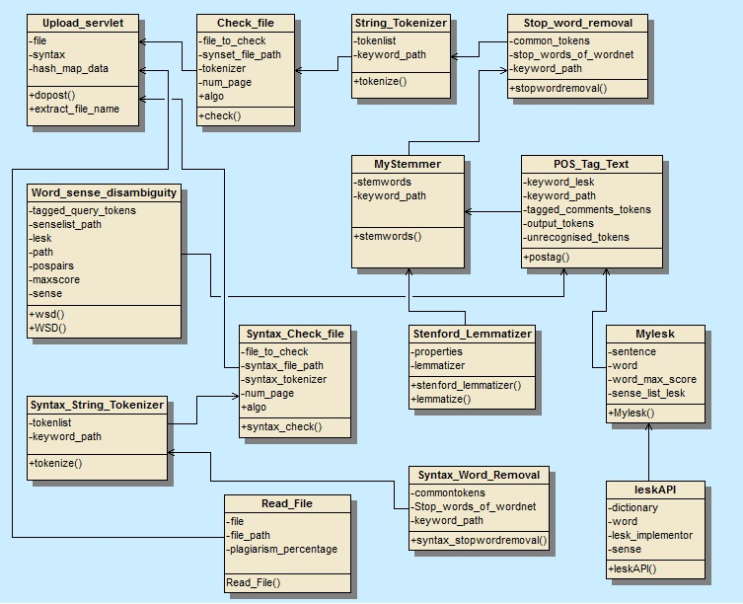

* **Activity Diagrams**

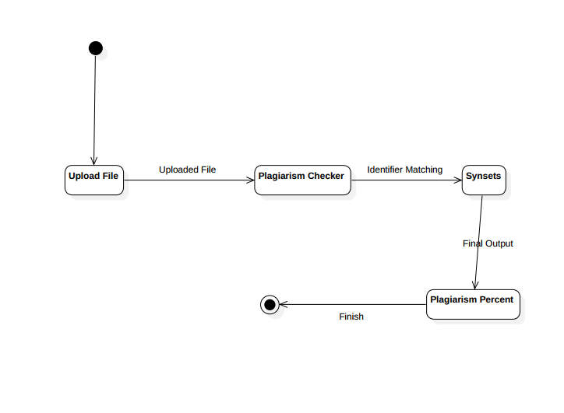

**Fig: Activity Diagram**

* **Sequence Diagrams**