**PROJECT MATCHER**

Software Design Specification



**Product Scope**

The ‘Project Matcher’ intends to find a perfect project match for a student along with his project team and the mentor.

The student will be able to-

* Take online tests which will judge his intelligence and knowledge within a period of 15 days only.
* The student would also get an option to study before giving the test.
* Give preferences as to what kind of project he would want to undertake.
* Maintain a profile, with a profile picture and cotact details.
* See his/her test scores and the result after a period of 15 days only.
* The result would contain the name of the mentor, the project title and also the name of his/her teammates.

The mentor will be able to-

* Provide his/her skillset.
* Maintain a profile, with a profile picture and cotact details.
* Be able to view the final resul after a period of 15 days only.
* The result would contain the names of the students which wil be working under him, followed by the title of the project allocated to them by the service.

**SYSTEM FEATURES**

* 1. **Student** 
     + **Login**

In this module, the student enters a password and the software checks its validity. If the password is valid then he/she is allowed to enter, otherwise “Invalid User/Password” message is displayed.

* + - **Register**

In this module, any new student user can submit his personal details regarding his/her email id, password, contact no, date of birth etc.

* + - **Retrieve Password**

In this module, if the user forgets his password he can click on the icon, then a list of questions is asked and via following the steps he gets a new password.

* + - **Profile**

A profile is the tab which contains various features such as changing the profile picture, password, and contact details, and also give prefrences.

* + - **Study**

The student can easily study about the relavant subjects which he needs to give a test on.

* + - **Take Test**

The module allows a student to take test of subjects such as programming languages (C, C++, JAVA), database, etcetera.

* + - * **Show Result**

After a period of 15 days, the student can easily view the result. The result shows what project is he/she allotted, the team members, and the project mentor.

1. **Mentor** 
   * **Login**

In this module, the mentor enters a password and the software checks its validity. If the password is valid then he/she is allowed to enter, otherwise “Invalid User/Password” message is displayed.

* + **Register**

In this module, any new mentor user can submit his personal details regarding his/her email id, password, contact no, date of birth etc.

* + **Retrieve Password**

In this module, if the user forgets his password he can click on the icon, then a list of questions is asked and via following the steps he gets a new password.

* + **Profile**

A profile is the tab which contains various features such as changing the profile picture, password, and contact details, and also give the skill set.

* + **Show Result**

After the period of 15 days, when all the students have given the tests, the mentor gets a result which includes the list of 4 students who will be working under him/her. The result also shows the name of the project allocated.

**DATA DESIGN**

**USER**

|  |  |  |  |
| --- | --- | --- | --- |
| S.no | COLUMN | TYPE | COMMENT |
| 1 | Username | Varchar | Primary key |
| 2 | FullName | Varchar |  |
| 3 | Password | Varchar |  |
| 4 | Gender | Varchar |  |
| 5 | Emailid | Varchar |  |
| 6 | Contact | Varchar |  |
| 7 | Profilepic | Varchar |  |
| 8 | Mentor | Varchar |  |

**Profile**

|  |  |  |  |
| --- | --- | --- | --- |
| **Sno** | COLUMN | **TYPE** | **COMMENT** |
| 1 | Username | Varchar |  |
| 2 | Teamname | Varchar |  |
| 3 | Projecttitle | Varchar |  |
| 4 | Technology | Varchar |  |
| 5 | Submissiondate | Date/time |  |

**Question**

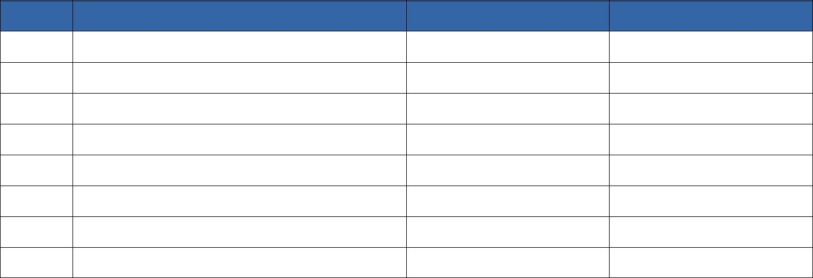

|  |  |  |  |
| --- | --- | --- | --- |
| S.no | COLUMN | TYPE | COMMENTS |
| 1 | Question | Varchar |  |
| 2 | QuestionID | int | Primary key |
| 3 | Answer | Varchar |  |
| 4 | Opt1 | Varchar |  |
| 5 | Opt2 | Varchar |  |
| 6 | Opt3 | Varchar |  |
| 7 | Opt4 | Varchar |  |

**Result**

|  |  |  |  |
| --- | --- | --- | --- |
| S.no | COLUMN | TYPE | COMMENTS |
| 1 | Username | Varchar | Foreign key |
| 2 | UnattemptedQ | int |  |
| 3 | CorrectQ | int |  |
| 4 | IncorrectQ | int |  |
| 5 | Score | int |  |
| 6 | Language | Varchar |  |
|  |  |  |  |
|  |  |  |  |



**USER INTERFACE DESIGN**

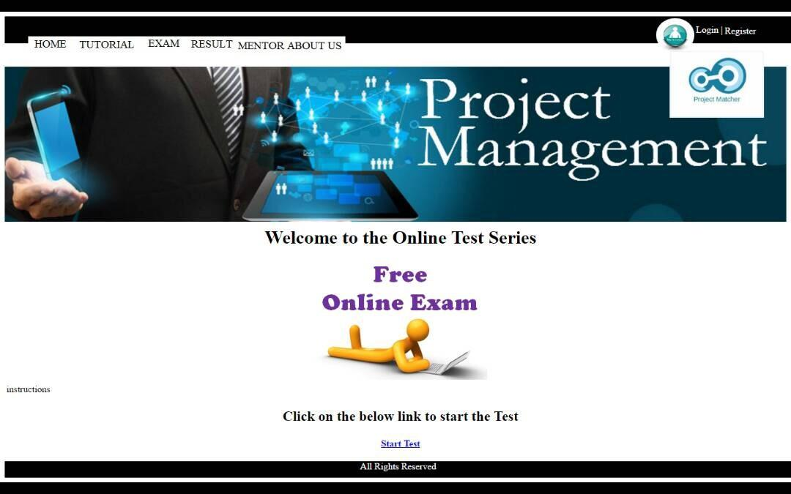

***Startpage***

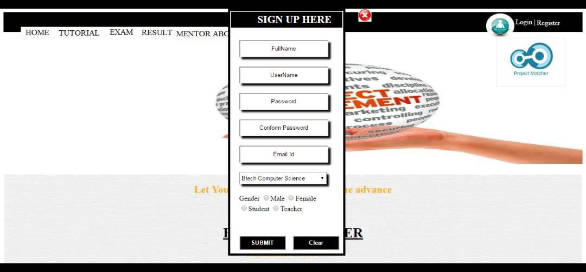

***Sign up Page***

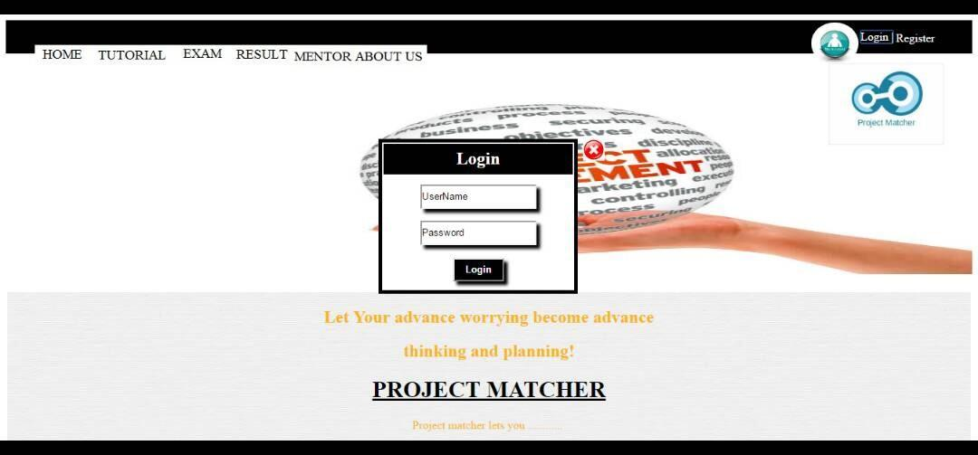

***Login Page***

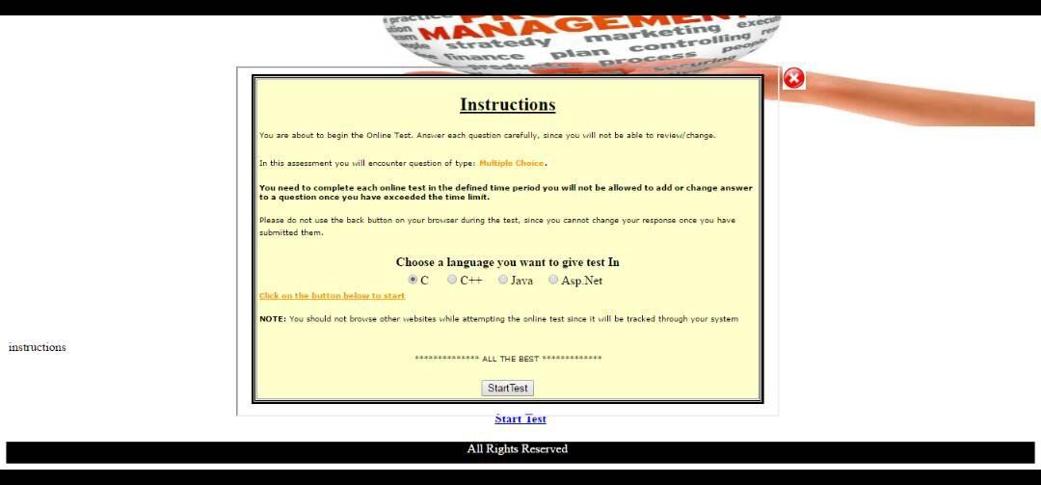

***Before Taking Test***

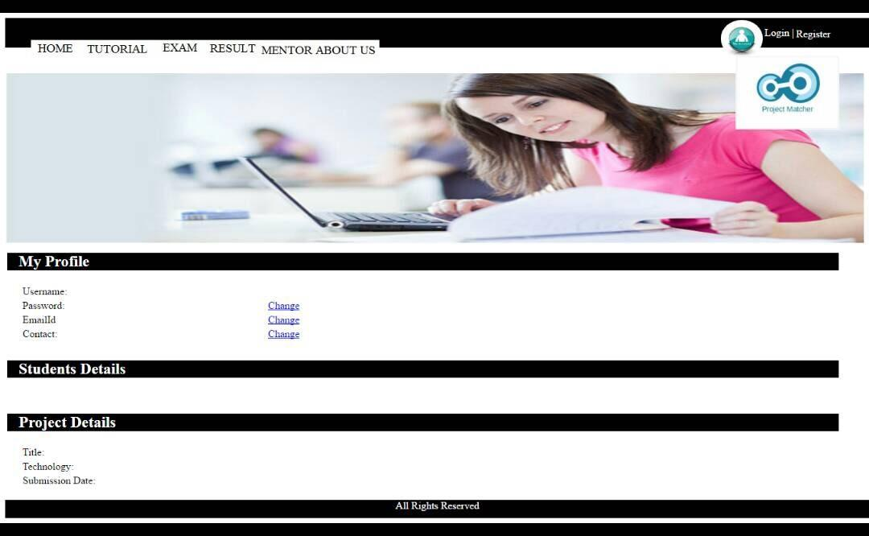

***Homepage***

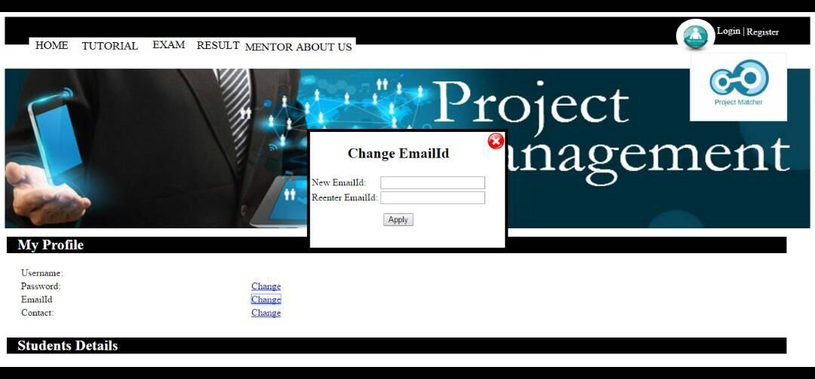

***Change Email-id***

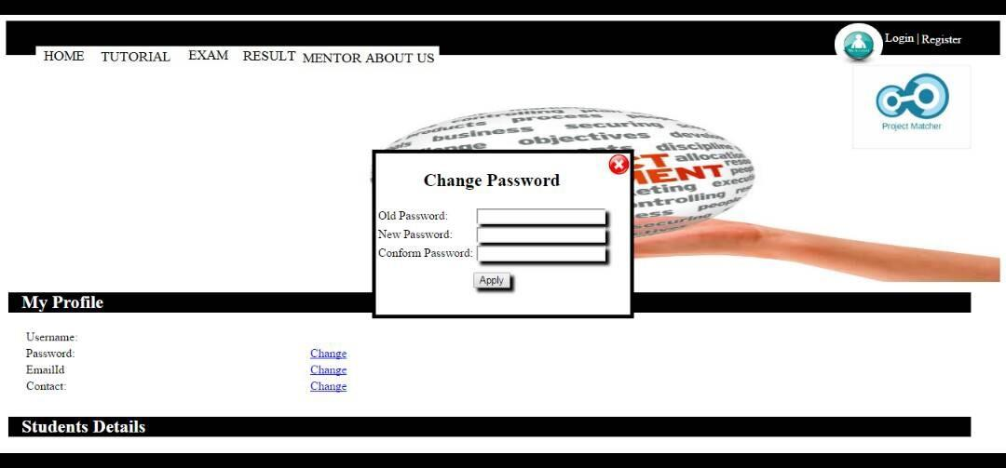

***Change Password***