EXPERIMENT -7

**Aim:** Given a case study with data set(Remove the class label if any). You are expected to perform Clustering using Python/R/Java.

Quote your observations after the Clustering.

**Observations:**

**Using Python/R/Java:**

from sklearn.cluster import KMeans

import pandas as pd

from sklearn.model_selection import train_test_split

from sklearn.metrics import classification_report,confusion_matrix

from sklearn.preprocessing import StandardScaler

import matplotlib.pyplot as plt

from sklearn.decomposition import PCA

file = '/home/lavina/Desktop/pima-indians-diabetes-database/diabetes.csv'

dataFrame = pd.read_csv(file, names=['Pregnancies', 'Glucose', 'BloodPressure', 'SkinThickness', 'Insulin', 'BMI', 'DiabetesPedigreeFunction', 'Age', 'Outcome'])

X = dataFrame.loc[:, ['Pregnancies', 'Glucose', 'BloodPressure', 'SkinThickness', 'Insulin', 'BMI', 'DiabetesPedigreeFunction', 'Age']]

y = dataFrame.loc[:, ['Outcome']]

X_train, X_test, y_train, y_test = train_test_split(X, y, test_size=0.30)

kmeans = KMeans(n_clusters=2, random_state=0, max_iter=200).fit(X_train)

print(kmeans.labels_)

predictions = kmeans.predict(X_test)

print(kmeans.cluster_centers_)

print(confusion_matrix(y_test, predictions))

print(classification_report(y_test, predictions))

x = StandardScaler().fit_transform(X)

pca1 = PCA(n_components=2)

principalComponents = pca1.fit_transform(X)

principalDf = pd.DataFrame(data=principalComponents, columns=['pc1', 'pc2'])

X_train1, X_test1, y_train1, y_test1 = train_test_split(principalDf, y, test_size=0.30)

kmeans = KMeans(n_clusters=2, random_state=0, max_iter=200).fit(X_train1)

print(kmeans.labels_)

predictions = kmeans.predict(X_test1)

print(kmeans.cluster_centers_)

print(confusion_matrix(y_test, predictions))

print(classification_report(y_test, predictions))

plt.scatter(principalDf.loc[:, 'pc1'], principalDf.loc[:, 'pc2'],s=50, cmap='viridis')

centers = kmeans.cluster_centers_

print(centers)

plt.scatter([centers[0][0], centers[1][0]], [centers[0][1], centers[1][1]], c='black', s=200, alpha=0.5)

plt.show()

**Output:**

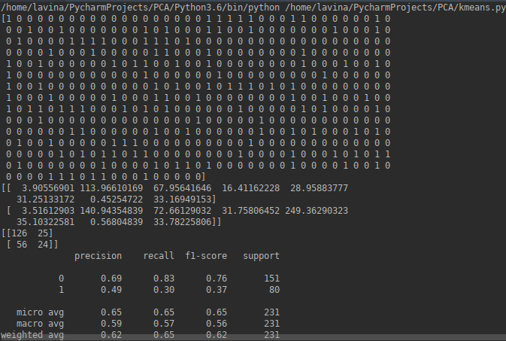

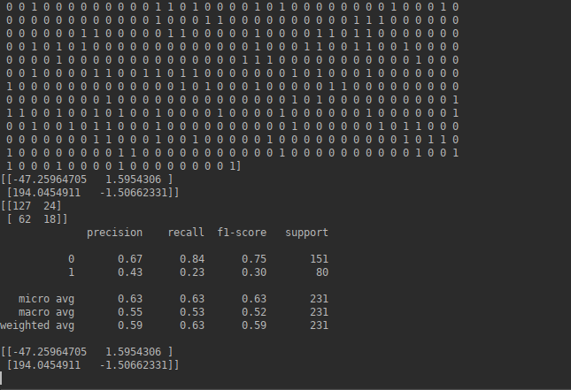

**Conclusion:**Hence we have successfully demonstrated unsupervised learning with k means clustering.