Lavina Golani

Batch A

16

**Experiment:3,4**

Aim: To implement multilayer perceptron

Code:

import pandas as pd

from sklearn.model_selection import train_test_split

from sklearn.preprocessing import StandardScaler

from sklearn.neural_network import MLPClassifier

from sklearn.metrics import classification_report,confusion_matrix

file = '/home/lavina/Desktop/pima-indians-diabetes-database/diabetes.csv'

# load data set into frame

dataFrame = pd.read_csv(file, names=['Pregnancies', 'Glucose', 'BloodPressure', 'SkinThickness', 'Insulin', 'BMI', 'DiabetesPedigreeFunction', 'Age', 'Outcome'])

print(dataFrame.describe())

# splitting into training and test

X = dataFrame.loc[:, ['Pregnancies', 'Glucose', 'BloodPressure', 'SkinThickness', 'Insulin', 'BMI', 'DiabetesPedigreeFunction', 'Age']]

y = dataFrame.loc[:, ['Outcome']]

X_train, X_test, y_train, y_test = train_test_split(X, y, test_size=0.30)

# scaling data

scaler = StandardScaler()

scaler.fit(X_train)

StandardScaler(copy=True, with_mean=True, with_std=True)

X_train = scaler.transform(X_train)

X_test = scaler.transform(X_test)

# creating the model

mlp = MLPClassifier(alpha=0.0001, hidden_layer_sizes=(20, 20, 20), solver='lbfgs', learning_rate='constant', learning_rate_init= 0.0001, max_iter= 100)

mlp.fit(X_train, y_train)

# predicting from the model

predictions = mlp.predict(X_test)

#accuracy

score = mlp.score(X_test, y_test)

print(score)

#analysing output

print(confusion_matrix(y_test, predictions))

print(classification_report(y_test, predictions))

Output with different models:

mlp= MLPClassifier(alpha=0.0001, hidden_layer_sizes=(20, 20, 20), learning_rate='constant', learning_rate_init= 0.0001, max_iter= 100, early_stopping=True)

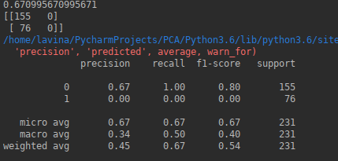

mlp = MLPClassifier(alpha=0.0001,hidden_layer_sizes=(20, 20), learning_rate='constant', learning_rate_init=0.001, verbose=True, max_iter= 200)

Score , COnfusion Matrix , Summary

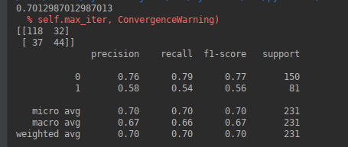

mlp = MLPClassifier(alpha=0.0001, hidden_layer_sizes=(20, 20, 20, 20), learning_rate='constant', learning_rate_init= 0.0001, verbose=True, max_iter= 1000)

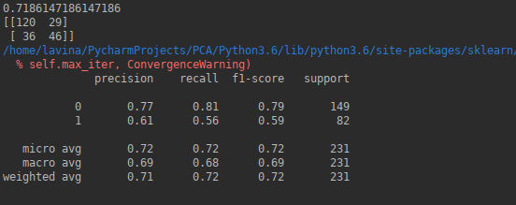

mlp = MLPClassifier(alpha=0.0001, hidden_layer_sizes=(20, 20, 20), solver='lbfgs', learning_rate='constant', learning_rate_init= 0.0001, max_iter= 100)

Conclusion: Hence we have successfully implemented multi layer perceptron.