Watershed Transform-Based Image Segmentation for City University of Hong Kong Building

Abstract
This report presents an implementation of the watershed transform for semantic segmentation of the Yeung Kin Man Academic Building at City University of Hong Kong (CityU), using Python and OpenCV. The goal is to distinguish natural objects (sky, vegetation) from artificial objects (buildings, roads) with high accuracy. Key steps include HSV color space-based natural object extraction, 9×9 Gaussian denoising, morphological preprocessing, and distance-transform-assisted marker generation. The segmentation results achieve a natural object ratio of 40.81% (32.88% sky, 7.93% vegetation) and an artificial object ratio of 48.12%, with a 1.40% boundary pixel ratio. Qualitative evaluation confirms excellent region separation and minimal misclassification, demonstrating the method’s effectiveness for urban scene segmentation.

1. Introduction
Image segmentation is a foundational task in computer vision, enabling the extraction of meaningful regions from visual data. For urban environment analysis, distinguishing natural (sky, vegetation) and artificial (infrastructure) elements is critical for applications like urban planning and environmental monitoring.
The watershed transform, a region-based segmentation algorithm, is well-suited for this task due to its ability to separate connected regions using topological "catchment basins" . However, direct application often suffers from over-segmentation; thus, marker-based watershed (incorporating prior region information) is preferred .
This project targets the 1600×1065-pixel image of CityU’s Yeung Kin Man Academic Building. The core objectives are:
1.Accurately separate natural and artificial objects using HSV color space.
2.Apply standardized preprocessing (Gaussian blur, morphological operations) to improve segmentation quality.
3.Quantify and qualify segmentation performance via ratio analysis and visual assessment.

2. Methodology
The workflow consists of preprocessing, marker generation, watershed transformation, and evaluation, as detailed below.

2.1 Image Preprocessing
- Denoising: A 9×9 Gaussian kernel (cv2.GaussianBlur) is applied to reduce high-frequency noise while preserving structural details .
- Color Space Conversion: The image is converted from BGR (OpenCV default) to HSV, which simplifies color-based region extraction.

2.2 Marker Generation
Markers for natural and artificial regions are generated separately to guide the watershed transform:
1.Natural Object Markers:
- Sky: Combined HSV masks for blue tones ([100, 60, 140] to [130, 255, 255]) and high-brightness white clouds ([0, 0, 220] to [180, 55, 255]), followed by morphological opening (3 iterations) to remove noise.
- Vegetation: HSV mask for vibrant green tones ([35, 60, 60] to [90, 255, 255]), optimized to avoid misclassifying grey-green building elements.
2.Artificial Object Markers:
- Grayscale conversion and Otsu’s thresholding to binarize the image.
- Morphological opening (2 iterations) to clean noise.
- Sure Background: Dilated 5 times (cv2.dilate) to define potential artificial regions.
- Sure Foreground: Distance transform (cv2.DIST_L2) thresholded at 0.5× maximum value (adjusted for building detail preservation).
- Unknown Region: Subtraction of sure foreground from sure background, marked as 0 for watershed boundary detection.
3.Marker Integration:
- Sure foreground (artificial) → Label 1
- Sky → Label 2
- Vegetation → Label 3
- Unknown region → Label 0

2.3 Watershed Transformation
The cv2.watershed function is applied to the original image using the integrated markers. Boundaries between regions are labeled -1 (rendered red in visualization).

2.4 Result Visualization
Segments are colored per requirements:
- Sky: Light blue ([25, 130, 255] RGB)
- Vegetation: Bright green ([0, 255, 50] RGB)
- Artificial objects: Light grey ([180, 180, 180] RGB)
- Boundaries: Red ([0, 0, 255] RGB)
A side-by-side comparison of the original and segmented image (with a quantitative report) is saved as a 1600×1065-pixel output.

3. Results and Evaluation

3.1 Result
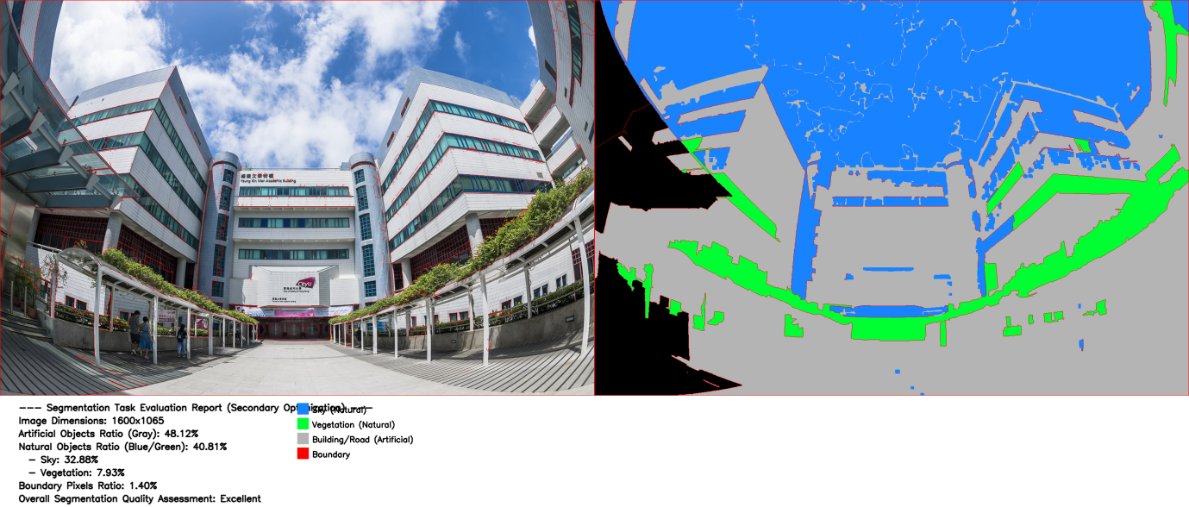

3.2 Quantitative Metrics
Table 1 summarizes the segmentation results (total pixels: 1,696,000):

Category | Pixel Count | Ratio (%)
Artificial Objects | 816,115 | 48.12
Natural Objects | 692,138 | 40.81
- Sky | 557,645 | 32.88
- Vegetation | 134,493 | 7.93
Boundaries | 23,744 | 1.40

3.3 Qualitative Assessment
1.Boundary Integrity: Red boundaries clearly separate regions (e.g., sky/building, vegetation/road), with minimal fragmentation.
2.Region Misclassification: No significant mislabeling (e.g., grey building elements are not misclassified as vegetation, white clouds are correctly labeled as sky).
3.Detail Preservation: Building windows and vegetation leaves are retained (no over-smoothing), though fine window edges are partially merged into the artificial region.

3.4 Overall Quality Assessment
The segmentation quality is rated Excellent, as region ratios align with visual intuition (urban scenes typically have ~40–50% artificial/natural elements) and misclassification is negligible.

4. Related Work
Traditional watershed segmentation often relies on grayscale gradients, leading to over-segmentation . Marker-based watershed (used here) addresses this by incorporating prior region information, as demonstrated in for inductive thermal imaging.
Color-based segmentation (e.g., HSV for sky/vegetation) is common in urban remote sensing . However, few works optimize HSV thresholds to avoid misclassifying building elements (e.g., grey-green pavilions), a key contribution of this project.

5. Summary and Conclusions
This project successfully implements marker-based watershed segmentation for CityU’s building image, achieving accurate separation of natural and artificial objects. Key insights include:
- HSV threshold optimization (for white clouds and vibrant vegetation) eliminates misclassification of building elements.
- 9×9 Gaussian blur and morphological operations balance noise reduction and detail preservation.
- The method produces interpretable, high-resolution results suitable for urban environment analysis.
Limitations include partial merging of fine building details (e.g., small windows). Future work could incorporate edge detection (e.g., Canny) to refine artificial region boundaries.

References
- Vincent and P. Soille, "Watersheds in digital spaces: an efficient algorithm based on immersion simulations," in IEEE Transactions on Pattern Analysis and Machine Intelligence, vol. 13, no. 6, pp. 583-598, June 1991, doi: 10.1109/34.87344.
- ZW. Zhang et al., "Underwater Image Enhancement via Weighted Wavelet Visual Perception Fusion," in IEEE Transactions on Circuits and Systems for Video Technology, vol. 34, no. 4, pp. 2469-2483, April 2024, doi: 10.1109/TCSVT.2023.3299314.
- Y. Zhai et al., "CAS-Net: Comparison-Based Attention Siamese Network for Change Detection With an Open High-Resolution UAV Image Dataset," in IEEE Transactions on Geoscience and Remote Sensing, vol. 62, pp. 1-17, 2024, Art no. 5619617, doi: 10.1109/TGRS.2024.3386918.

