The following figure shows a pair of cameras, each with focal length unity whose principal axes meet at a point. The y-axes of both cameras are parallel and point out of the page.

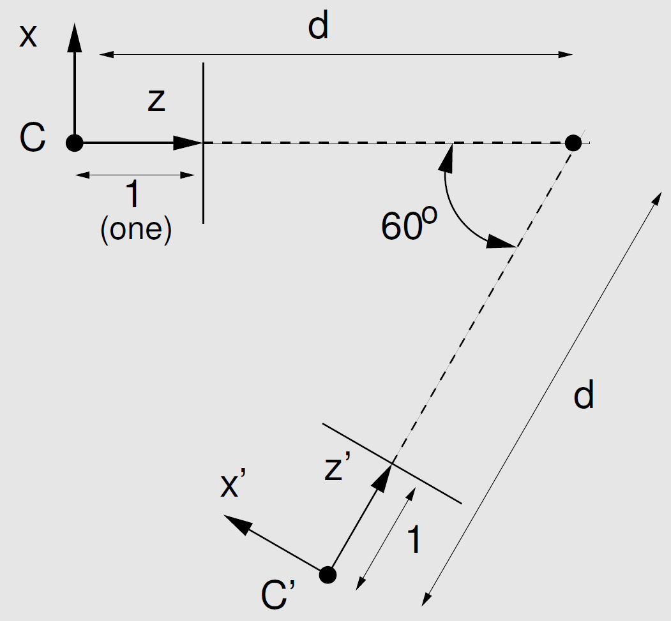

Assuming camera C has projection matrix P = [I | 0], then
- work out the projection matrix P' for C' (hint: P' = [R | t]),
- work out the fundamental matrix F (hint: K = K' = I; using the form derived in lecture 9).
- use the relationship I' = Fx to compute the epipolar line in the right image correspondingto the homogeneous point x = [1, 1, 1]^{T} in the left image.

