- Consider a grey-level image f (x, y) with histogram sketched below.
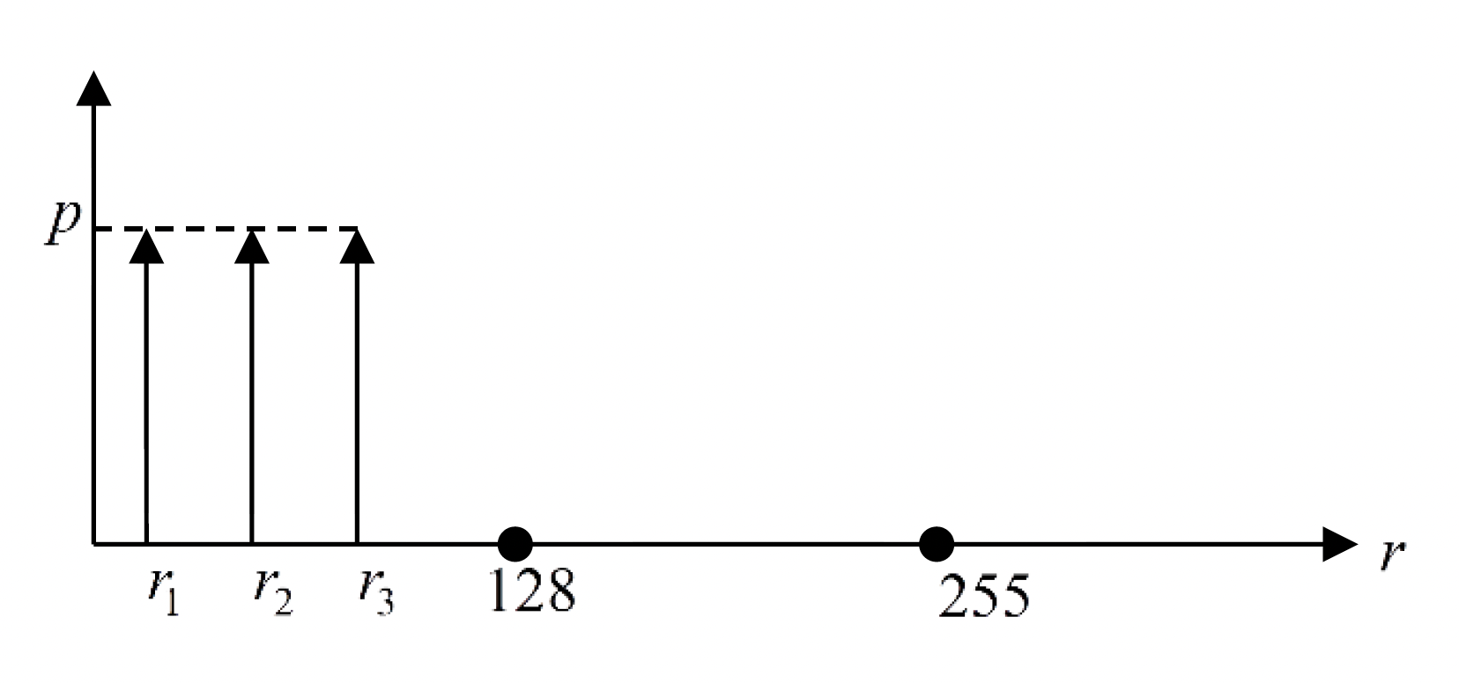
Figure. 1
- What can we say about f (x, y)?
- Propose an intensity transformation function which will improve the contrast of the image
when it is used to modify the intensity of the image.

- Sketch the histogram of the transformed intensity.

- An old movie is to be restored. Frames of the movie contain black spots which we wish to remove by median filtering. Figure 2 shows a representative example of a small region of a frame of the movie.

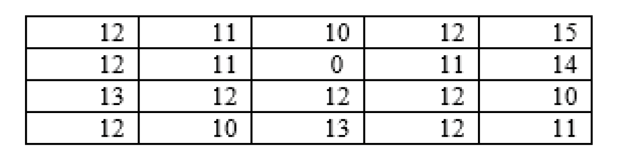
Figure. 2

There are two ways to apply media filtering: a) a 3x3 window; b) first applies a median filter with a window of 3 columns and 1 row, and then applies to the result of this median filtering with a 1 column by 3 row window.

- If the image contains rectangular objects with sharp corners, which of the two methods
given in a) and b) above is best? Explain your answer.

- If the black spots in the pixel frames are 2 x 2 pixels in size, which of the methods is best? Explain your answer.

- Even in regions without black spots median filtering will change the exact values of many
pixels. Propose a method based on a 3x3 window in which pixels are left unchanged unless there is black spot.

- State which one of the following filters is nonlinear: Weighted Averaging Filter, Sobel Filter, Median Filter. Justify your answer with an example.

