- What is the difference between the derivative of a Gaussian filter and the difference of Gaussians filter?

- Why is it considered important to convolve the image with a Gaussian before computing the Laplacian?

- Consider the following image:
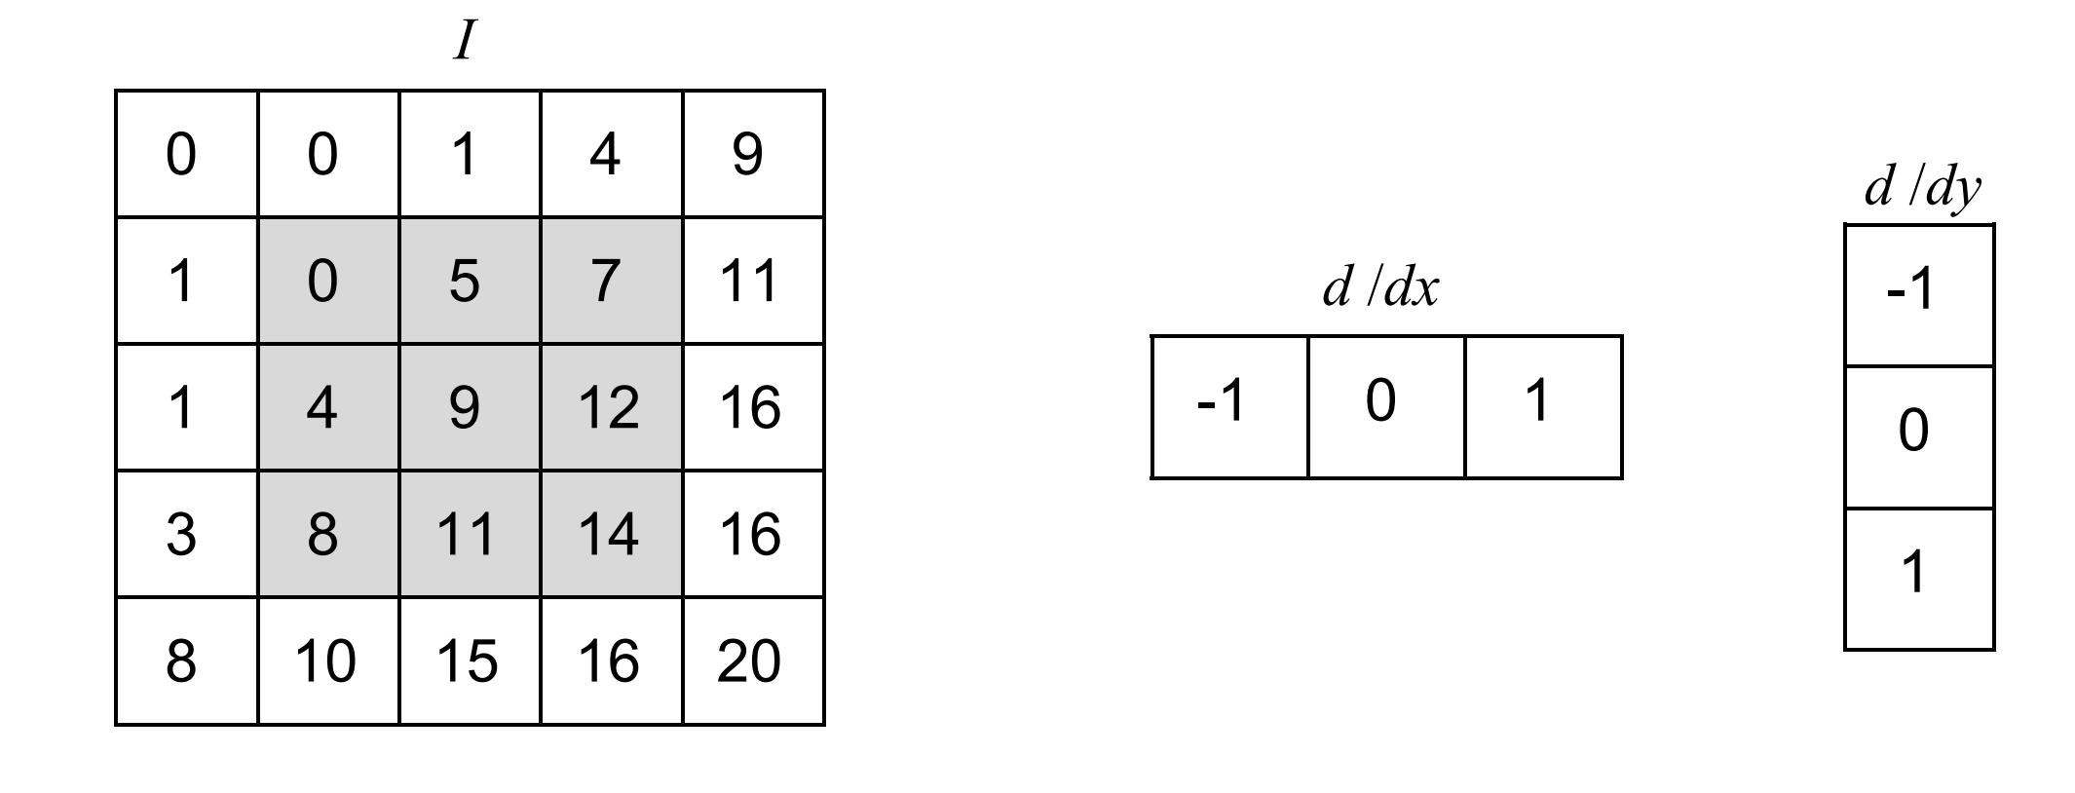
We will compute the Harris matrix for the 3 by 3 highlighted window. In the following formula $I_{x}=\frac{dI}{dx}, I_{y}=\frac{dI}{dy}$and W is the window highlighted in the image.
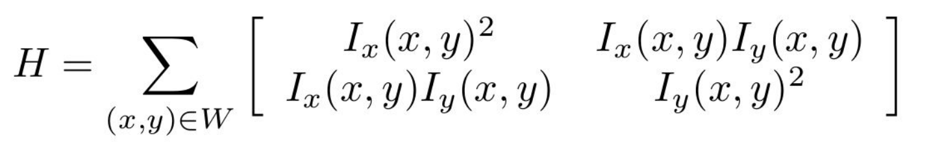

- Compute the derivatives using the differentiation kernels shown above.
- Compute the Harris Matrix based on the derivatives.

- Compute the Corner Response Measure $R=\det\left(H\right)– k∙trace{\left(H\right)}^{2}$ for $k=0.04$. What do we have here?

