The camera shown in the following figure has its x, y and z axes aligned with the world's y, z and x axes respectively. The world frame's origin is at (0, -h, 4h) in the camera's frame.
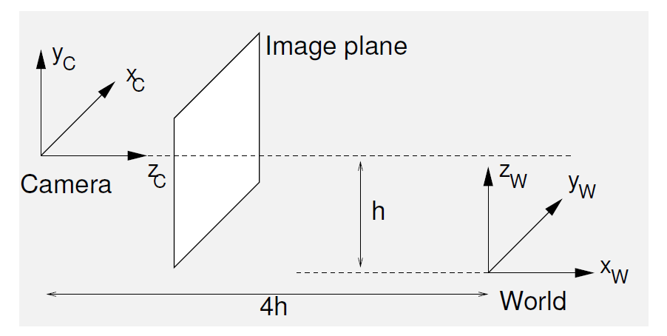
- By deriving a succession of Euclidean transformations, find the camera's extrinsic camera calibration matrix [R T], such that
$$X_{c}=\left[\begin{matrix}R & T \\ 0^{T} & 1\end{matrix}\right]X_{W}$$
- The “ideal” image plane is placed at $Z_{c}=1$. (Ideal means that the intrinsic camera matrix $K$ is just a 3 x 3 identity matrix.) Derive the image coordinates of the vanishing point of the family of lines parallel to the following line, expressed parametrically as:
$$(X_{W},Y_{W},Z_{W})=(2+4t, 3+2t,4+3t)$$
- The following is the general formulation of intrinsic calibration matrix (projection matrix):
$$\left[\begin{matrix}f & sf & u_{0} \\ 0 & γf & v_{0} \\ 0 & 0 & 1\end{matrix}\right],$$
where $f$ indicates focal length, $γ$ is aspect ratio, and ($u_{0}$, $v_{0}$) is principal point.
Let the actual camera has $f=800$ pixels, $γ=0.9$, $s=0$, and ($u_{0}$, $v_{0}$) = (350, 250) pixels. Derive the coordinates in the actual image plane of the vanishing point of part (b).

