Part 4 Report: DeepSeek Main Experiments
CS6493 Natural Language Processing - Topic 1
DeepSeek-R1-Distill-Qwen-1.5B on MATH-500 and GSM8K
Scope note: This report only covers the work package assigned to Member 4, namely the DeepSeek main experiments on MATH-500 and GSM8K. It does not include the Qwen experiments, AIME experiments, or the group-level final synthesis handled by other members.

1. Introduction
Topic 1 asks the group to study the mathematical reasoning ability of large language models under multiple prompting strategies. According to the project specification, the full topic should evaluate at least three prompting methods, test both Qwen2.5-Math-1.5B and DeepSeek-R1-Qwen-1.5B, use the MATH-500, GSM8K test set, and AIME 2024 datasets, and report at least accuracy and response length. Within that larger plan, my assigned work was the DeepSeek main experiment on MATH-500 and GSM8K. The goal of this sub-report is therefore narrower: to document the DeepSeek side of the main benchmark, describe the experimental pipeline, and present the final results for the three prompt methods CoT, Least-to-Most, and Self-Consistency.

2. Related Work
The prompting strategies used in this report follow the methods explicitly recommended in the project brief. Chain-of-Thought prompting encourages the model to produce intermediate reasoning steps before giving a final answer. Least-to-Most prompting decomposes the original problem into smaller sub-problems and solves them sequentially. Self-Consistency repeats reasoning multiple times and selects the most consistent final answer, which is known to improve reasoning accuracy at the cost of much higher token usage. These methods were selected because they are directly aligned with the teacher’s requirements and because they provide a clean trade-off between simple prompting, structured decomposition, and consensus-based reasoning.
- Wei et al. (2022): Chain-of-Thought prompting for reasoning tasks.
- Zhou et al. (2023): Least-to-Most prompting for complex reasoning.
- Wang et al. (2022): Self-Consistency for improving reasoning reliability.

3. Methodology
The implemented pipeline is built around the DeepSeek-R1-Distill-Qwen-1.5B model and the two datasets that belong to the main experiment package: MATH-500 and GSM8K. Each item is loaded from the unified JSONL datasets prepared by the group preprocessing pipeline. For every question, the experiment script records the dataset name, question identifier, prompt method, raw model output, extracted final answer, correctness flag, response length, and generation time. This matches the structured-record requirement stated in the team plan and supports later re-evaluation without rerunning the model.
- Model: DeepSeek-R1-Distill-Qwen-1.5B
- Datasets in this sub-report: MATH-500 (500 questions) and GSM8K (800 final evaluated questions)
- Prompt methods: CoT, Least-to-Most, Self-Consistency with k = 5
- Core required metrics: accuracy and response length; runtime is additionally reported as a practical cost signal
Automatic evaluation first extracts a candidate final answer from the raw output. The extractor prioritizes explicit answer markers such as boxed answers or answer phrases, then applies conservative cleanup and dataset-specific matching. For GSM8K, numeric correctness is the main criterion. For MATH-500, the matcher tries normalized text matching, numeric matching, and symbolic-equivalence checks where possible. This design allows the report to reflect both model reasoning quality and answer-format stability.

4. Experiments
The final experiment run covers all 500 MATH-500 questions and 800 GSM8K questions contained in the final result files. Each question was tested under CoT, Least-to-Most, and Self-Consistency. Because Self-Consistency requires repeated decoding and voting, it is expected to be much more expensive than the other two methods. The table below summarizes the final accuracy values that were used in the presentation and are treated as the final result of this work package.
Dataset | CoT | LtM | SC | Best Method | Observation
GSM8K | 48.75% | 49.13% | 55.87% | SC | Best overall accuracy.
MATH-500 | 19.80% | 23.00% | 25.60% | SC | Harder symbolic benchmark.

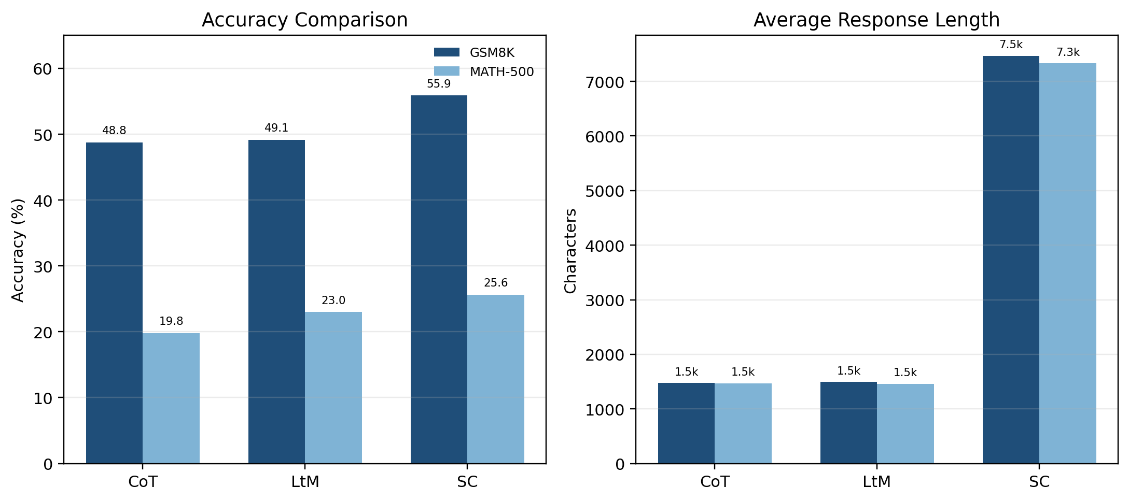
Figure 1. Accuracy and average response length by prompt method and dataset.
The final results show a clear ranking pattern. On GSM8K, Self-Consistency achieves the best accuracy at 55.87%, followed by Least-to-Most at 49.13% and CoT at 48.75%. On MATH-500, Self-Consistency again performs best at 25.60%, followed by Least-to-Most at 23.00% and CoT at 19.80%. This means the same method wins on both datasets, but the size of the improvement is not the same. GSM8K remains substantially easier than MATH-500 for this 1.5B model, which suggests that symbolic reasoning and answer formatting remain challenging on the harder benchmark.

5. Cost Analysis
The project brief requires response length as a core metric, and the final logs also allow us to analyze generation time. The two cost indicators point to the same conclusion: the most accurate method is also the most expensive one. Self-Consistency increases average response length from about 1.47k-1.49k characters to roughly 7.33k-7.47k characters, which is about five times longer than CoT and Least-to-Most. The runtime increase is similarly large. On GSM8K, average generation time rises from around 18 seconds to 90.44 seconds. On MATH-500, it rises from about 20 seconds to 102.10 seconds.
Dataset | Metric | CoT | LtM | SC
GSM8K | Avg response length | 1472.40 | 1491.45 | 7468.57
 | Avg generation time (s) | 17.91 | 18.10 | 90.44
MATH-500 | Avg response length | 1468.95 | 1458.19 | 7329.16
 | Avg generation time (s) | 20.26 | 19.84 | 102.10

Therefore, the choice of prompt method should depend on the goal of the application. If the main objective is the highest possible accuracy, Self-Consistency is the strongest setting in this report. If inference cost matters more, CoT or Least-to-Most may be more practical, because their accuracy gap is much smaller than their cost gap.

6. Discussion
A central finding of this work is that not all errors come from completely incorrect reasoning. Many MATH-500 failures occur because the model does not end with a clean and stable final answer, even when the middle of the reasoning chain looks partially relevant. This is important because the automatic evaluator can only compare the extracted final answer with the gold answer. If the model ends with a truncated phrase, an unfinished formula, or a narrative sentence rather than a final answer, the item is counted as incorrect.
Question ID | Method | Extracted final answer | Ground truth | Why it fails
math500_0002 | SC | that correct | p - q | The model ends with an incomplete phrase rather than a symbolic result.
math500_0005 | SC | Angela at (6.8, 1.4) | \text{Evelyn | The output keeps narrative context instead of returning the required final conclusion.
math500_0008 | COT | From | 90^\circ | The answer is truncated and the extractor only sees a fragment.

These examples show three different failure modes. First, the model may end with an incomplete symbolic phrase rather than a valid mathematical answer. Second, it may stay in narrative reasoning mode and never switch to a final answer statement. Third, the answer may be cut off or malformed, so the extracted result becomes only a fragment. These issues affect MATH-500 more strongly than GSM8K because MATH-500 contains more symbolic answers and is less forgiving when the final format is unstable.

7. Conclusion
This report documents the DeepSeek main experiment required by my assigned part of Topic 1. Within this scope, DeepSeek-R1-Distill-Qwen-1.5B was evaluated on MATH-500 and GSM8K under three prompt methods. The final conclusion is straightforward: Self-Consistency is the strongest method in terms of accuracy on both datasets, but it is also much more expensive in response length and generation time. GSM8K is clearly easier than MATH-500 for this model. The main weakness on the harder benchmark is not only reasoning depth, but also unstable answer endings that reduce evaluation reliability. A natural next step for this line of work would be to enforce a stricter final-answer format or use a more robust answer-constrained decoding strategy.

References
Wei, J., Wang, X., et al. (2022). Chain-of-thought prompting elicits reasoning in large language models.
Wang, X., Wei, J., Schuurmans, D., et al. (2022). Self-consistency improves chain of thought reasoning in language models.
Zhou, D., et al. (2023). Least-to-Most Prompting Enables Complex Reasoning in Large Language Models.
Cobbe, K., et al. (2021). Training verifiers to solve math word problems.
City University of Hong Kong, CS6493 Project Specification, Topic 1 - Mathematical Reasoning Ability of Large Language Models.

Appendix A. Presentation Slides
The course instructions state that the presentation slides should be included at the end of the report. The following pages attach the three slides used for this DeepSeek sub-report.

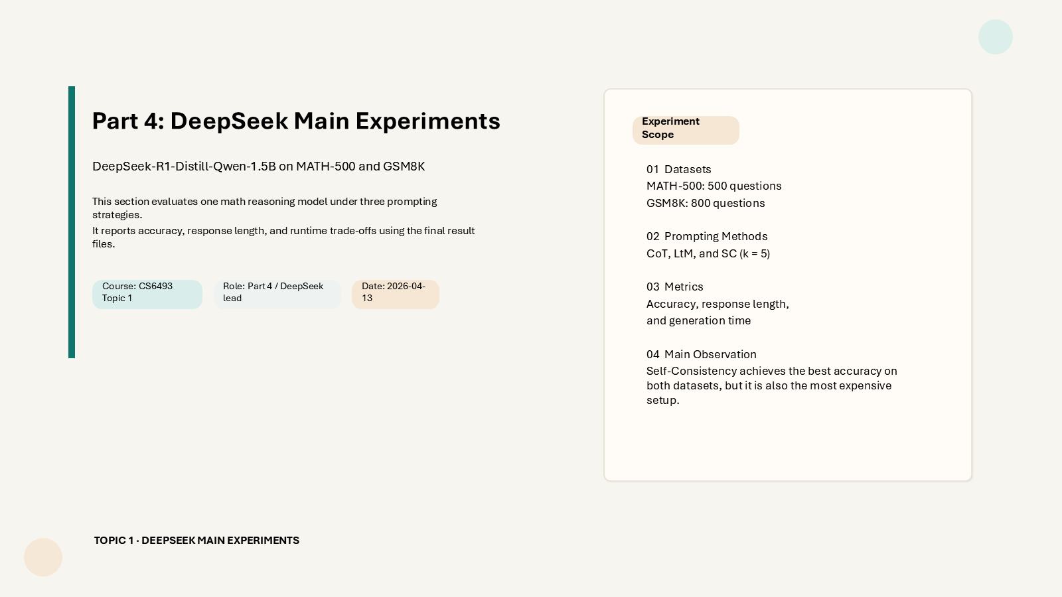
Appendix Slide 1

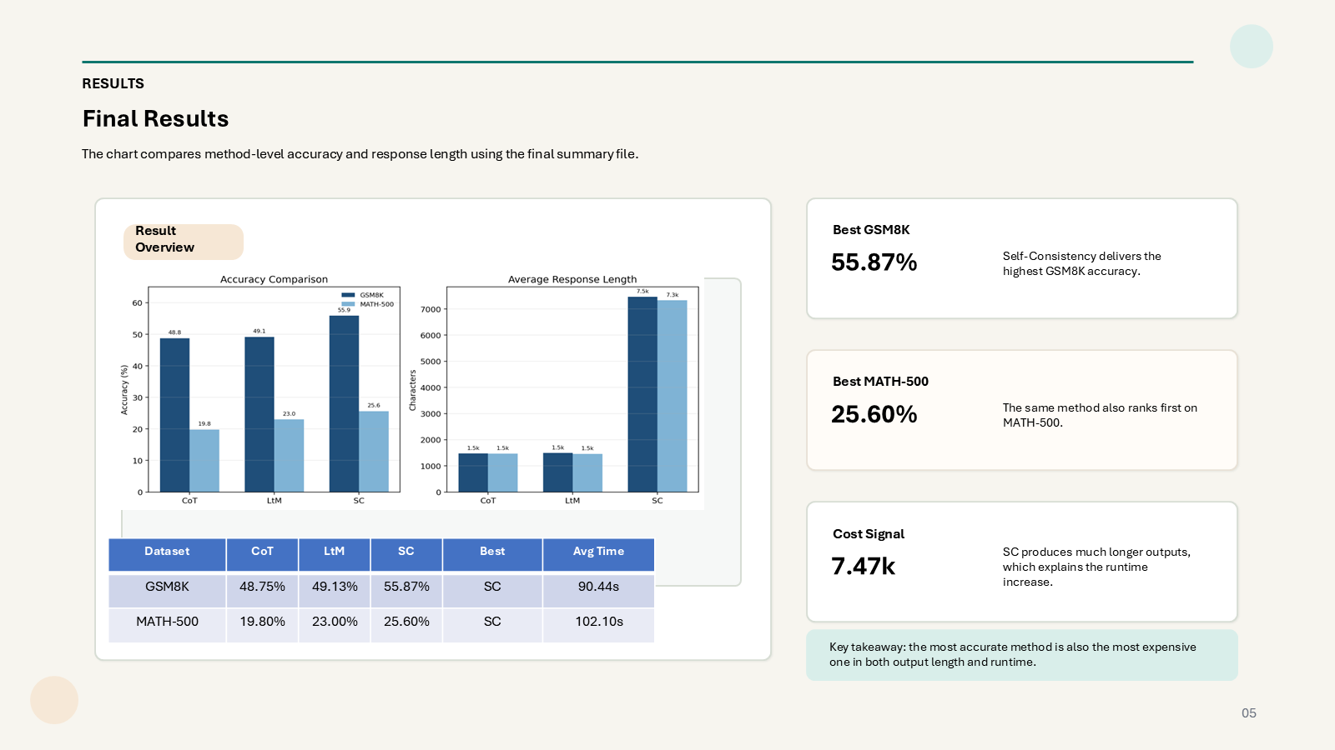
Appendix Slide 2

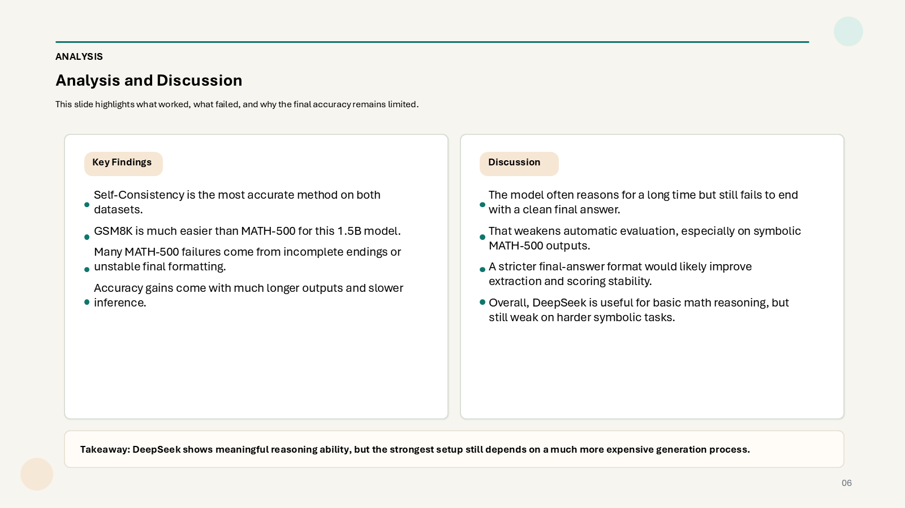
Appendix Slide 3

