Business Plan

Nongfu Spring "AR Traceability + Green Points"

E-Commerce App

Lakers

Team Members:

1 LI Xianlin 60003835

2 XIE Yi 59658209

3 LI Cheng 59987804

4 HUANG Dehao 60021619

5 ZHANG Kaige 60065468

6 WANG Boheng 59624730

7 ZENG Qiang. 59730887

catalogue
1. Executive Summary 2
1.1 Company Background 2
1.2 Market Analysis 3
1.3 Sales and Promotion and Market Risk 3
1.4 Products & Services Discussions 4
1.5 Revenue Model and Business Risks 4
2. Company Background 4
2.1 Basic Information 4
2.2 Development Milestones 5
2.3 Brand Core 5
2.4 Sustainable Development Commitment 5
3. Market Analysis 5
3.1 External Competitive Environment 6
3.2 Internal Strategic Focus 6
4. Sales and Promotion and Market Risk 6
4.1 Advertising Campaign 7
4.2 Green Points Reward 7
4.3 Market Risk 7
5. Products & Services Discussions 7
5.1 Product and Services Overview 7
5.1.1 Product Concept 8
5.1.2 Core Features and Services 8
5.1.3 Key Highlights 8
5.2 Business Model 8
5.2.1 Value Proposition 9
5.2.2 Revenue Streams 9
5.2.3 Cost Structure 10
5.3 Development Plan 10
5.4 Risks and Countermeasures 11
5.4.1 Major Technical Risks 11
5.4.2 Development Risks 11
6. Revenue Model and Business Risks 11
6.1 Revenue Model 11
Year 3 Incremental Revenue Mix 12
6.2 Financial Justification 12
6.2.1 Cost Classification 13
6.2.2 ROI Analysis 14
6.2.3 Multi-Dimensional Value Justification 14
6.2.4 3-Year Financial Projection 15
6.3Business Risks – Financial 15

1. Executive Summary

1.1 Company Background
Nongfu Spring was founded in 1996 by Zhong Shanshan and publicly listed in 2020 with an 85% opening price surge. It dominates China’s premium bottled water segment, operating 12 protected water sources from Qiandao Lake to Changbai Mountain. In 2024, the company achieved $5.9B USD in revenue with an industry-leading 28.3% net profit margin. Its first-half 2025 revenue reached 256.22 billion yuan, a year-on-year increase of 15.6%.
Adhering to the brand ethos of "purity and nature," Nongfu Spring offers additive-free natural water and implements stringent quality controls exceeding international standards. It also actively engages in watershed conservation to fulfill its sustainability commitment. The proposed $1.05M app investment accounts for just 0.018% of its annual revenue, presenting a minimal-risk, high-impact initiative to establish direct-to-consumer relationships and deepen brand equity in an increasingly commoditized market.

1.2 Market Analysis
Porter’s Five Forces analysis reveals intense rivalry among beverage giants like Coca-Cola and PepsiCo, high substitution threats, powerful buyers with low switching costs, moderate barriers for new entrants (due to brand loyalty and supply chain complexity), and low-to-moderate supplier pressure. Nongfu Spring holds a 48.4% share of China’s premium bottled water market (45+ billion liters) but faces threats from private-label imitation and converging sustainability positioning.
SWOT analysis highlights core strengths: AR transparency innovation, Green Points loyalty program, strong ESG alignment, and D2C channel control. Weaknesses include high development costs and reliance on user engagement. Opportunities span data-driven personalization, cross-portfolio expansion, and B2B ESG collaboration. Threats include technological failures, greenwashing skepticism, and economic downturns reducing premium spending. Regulatory support for verifiable sustainability positions the transparent digital platform as a key differentiator.

1.3 Sales and Promotion and Market Risk
The omnichannel strategy features QR-equipped bottle return stations that award "Green Points," driving repeat purchases through a tiered membership system (bronze to platinum) with escalating discounts. Promotional narratives such as "Every bottle has a story" (AR traceability) and "Don't throw it away" (recycling rewards) are amplified via social sharing challenges, collaboration events, and referral codes with dual-user rewards. In-app dashboards visualize users’ environmental impact.
Critical market risks include AR novelty fatigue, insufficient recycling incentives, competitive replication of sustainability rewards, regulatory compliance issues (environmental labeling, waste facility permitting), supply chain disruptions (scannable packaging delays, PET material cost inflation), and dependence on municipal cooperation for return station placement. These factors could compress marketing ROI and brand recall.

1.4 Products & Services Discussions
The platform integrates three core services to form a "trust + participation + incentive" value loop:
- AR Traceability: Scanning bottles triggers immersive animations showcasing the journey from water source to delivery, turning abstract quality into tangible experiences.
- Green Points Reward: Recycling empty bottles via QR scans earns points redeemable for product coupons, exclusive merchandise, or charity donations to water projects.
- Healthy Lifestyle Challenges: Gamified hydration and fitness goals foster community engagement and brand-aligned habits.
The app follows a six-month agile development plan: Phase 1 (Months 1-2: requirements/UI design), Phase 2 (Months 3-6: AR module, points/e-commerce engine development), Phase 3 (Months 5-6: integration/testing/launch). Risks of app abandonment and complexity are mitigated through content refreshes, dynamic rewards, and phased feature rollouts.

1.5 Revenue Model and Business Risks
The four-stream revenue model targets the following Year 3 composition:
- 55%: Direct packaged water sales via in-app purchases (capturing retailer margins)
- 20%: Transaction fees from third-party eco-products (e.g., custom bottles)
- 15%: Premium membership subscriptions (exclusive AR content, double points)
- 10%: Targeted advertising from wellness partners
First-year investment totals 1.05M, including 450K in development costs (62% software, 21% marketing, 13% cloud) and $600K in annual operations (50% logistics, 33% team, 8% rewards, 8% infrastructure). Break-even is projected at 14 months.
Key business risks include cost overruns, low app adoption/revenue, margin erosion (excessive rewards or high delivery costs), and data/ESG credibility issues (privacy breaches, inaccurate recycling metrics). Mitigation measures include conservative financial modeling, blockchain-verified ESG reporting, tiered rewards, and robust cybersecurity.

2. Company Background

2.1 Basic Information
Nongfu Spring Co., Ltd. was founded in 1996 by Zhong Shanshan in Jiande, Zhejiang, initially named Zhejiang Qiandao Lake Yangshengtang Drinking Water Co., Ltd. Its core business focuses on high-quality drinking water and healthy beverages, with development rooted in premium natural water resources and extending across the entire healthy beverage industry chain.

2.2 Development Milestones
- 1996: Established and built its first production base by Qiandao Lake (a national first-class water resource protection area), laying the foundation for high-quality product supply.
- 2020: Listed on the Hong Kong Stock Exchange with an opening price surge of over 85%, reflecting strong market recognition and investor confidence.
- As of 2024: Built 12 major water sources across China (including Qiandao Lake, Changbai Mountain, and Danjiangkou), forming a widespread and stable supply network.
- 2025 H1: Achieved 256.22 billion yuan in total revenue, a year-on-year increase of 15.6%, maintaining continuous growth and strong business resilience.

2.3 Brand Core
- Brand Spirit: Adheres to "purity and nature," with the core mission of providing consumers with high-quality drinking water and healthy beverages.
- Value Concept: Emphasizes natural ingredients to ensure product purity and safety, advocating a healthy lifestyle. For example, it uses natural water sources and does not add artificial minerals to bottled water.
- Quality Orientation: Implements strict quality control (meeting or exceeding international standards) and has established a full-link quality assurance system covering raw material procurement, production, and sales.

2.4 Sustainable Development Commitment
The company prioritizes environmental protection and sustainable development, actively participating in water source protection and ecological construction. It focuses on safeguarding the ecological environment around major water sources to ensure long-term access to high-quality water resources. This commitment is reflected in practical actions (e.g., water source protection) and integrated into product R&D, production, and operations, becoming a key part of its core competitiveness.

3. Market Analysis
This section evaluates the feasibility of Nongfu Spring’s digital transformation, focusing on integrating AR with ESG-driven loyalty programs. Leveraging its 48.4% share of the high-end water market, the initiative aims to address market saturation and align with evolving consumer demands for health and transparency.

3.1 External Competitive Environment
The market faces fierce competition from global beverage companies and significant substitution threats from functional beverages. Buyers’ bargaining power is strengthened by low switching costs, pushing enterprises to move beyond price-based competition. The AR-gamified ecosystem is a key driver of customer loyalty. While e-commerce reduces market entry barriers, the high technological investment in AR infrastructure creates new barriers, shifting competition from product availability to digital interactions.

3.2 Internal Strategic Focus
The program adopts a D2C approach to bypass traditional intermediaries, using "Green Points" to promote circular economy participation. However, this strategic shift requires overcoming high development costs and potential user adoption barriers. Successful implementation offers opportunities for data monetization and B2B ESG partnerships, but these must be balanced against technological instability and greenwashing reputational risks.
Nongfu Spring aims to bridge the gap between its distributor-dependent model (90% of sales) and D2C channels. Targeting consumers shifting from sugary drinks to convenient hydration, it covers budget, mainstream, and high-end lifestyle segments. This strategy leverages urbanization and premiumization trends, positioning product purity and eco-friendly packaging as market choices rather than basic requirements.

3.3 Strategic Significance of AR Integration
Incorporating AR technology is a critical evolutionary step to mitigate consumer bargaining power and market saturation. By meeting demands for "verified purity" and sustainability, Nongfu Spring transforms from a commodity provider to a lifestyle brand, ensuring long-term competitiveness in a dynamic economic environment.

4. Sales and Promotion and Market Risk
To maximize promotional effectiveness, a full-cycle plan integrating online and offline elements is designed. The plan first focuses on generating buzz and wide reach, then explores diverse collaborations, and continuously tracks progress to boost user engagement.

4.1 Advertising Campaign
At launch, promotional content must convey key information through clear slogans, such as:
- "Every bottle has a story. Scan it to discover the purity behind your water."
- "Don’t throw it away — bring it back, earn rewards, and make a difference."
Campaigns will promote AR traceability (transparent sourcing) and recycling rewards, encouraging users to scan bottles, share AR experiences, and actively return empty bottles. Events integrating these two core elements will be launched to drive initial engagement.

4.2 Green Points Reward
The Green Points system combines offline channels (retail stores, vending machines) with online app activities:
- Bottle return stations equipped with QR scanners award points to encourage repeat purchases.
- The app features a "Recycle-to-Earn" dashboard and tiered membership system with escalating discounts to sustain engagement.
After initial launch, collaborative activities will be introduced:
- Limited-time partner events offering extra points.
- An invitation mechanism where both the inviter and invitee (registering via referral code) earn points.

4.3 Market Risk
- Engagement Risks: AR novelty may fade, reducing repeat usage; rewards may be insufficient to change recycling behavior.
- Competitive Risks: Competitors may replicate sustainability concepts, diminishing the campaign’s uniqueness.
- Regulatory Risks: Varying environmental labeling regulations, waste collection approvals, and sudden changes to vending machine policies could disrupt deployment and increase costs.
- Supply Chain Risks: Disruptions may hinder the production of scannable packaging, impacting the "story-per-bottle" experience.

5. Products & Services Discussions

5.1 Product and Services Overview

5.1.1 Product Concept
An AR-enabled e-commerce app integrating product traceability transparency and eco-behavior incentives, creating a "Purchase - Trace - Recycle - Socialize" closed-loop ecosystem. Users can purchase beverages directly, verify product origins via AR, and earn points through environmental actions.

5.1.2 Core Features and Services
- AR Traceability System: Scanning the QR code inside bottle caps triggers AR animations showcasing the water source ecosystem, production process, quality inspection, and logistics, enhancing brand trust.
- Green Points System: Recycling empty bottles via QR scans earns "Green Energy" points redeemable for new product trial packs, partner brand health food vouchers, or charity project donations.
- Health Community Challenges: Themed challenges (e.g., "Daily Hydration Goal," "Low-Carbon Check-ins") encourage social media sharing of achievements, generating UGC and boosting app retention.

5.1.3 Key Highlights
- Targets modern consumers: Meets young people’s demands for brand transparency, sustainability, and entertaining experiences.
- Technology-enabled trust: AR transforms abstract "quality" into tangible experiences, addressing information asymmetry.
- ESG integration: The Green Points system combines commerce, incentives, and public welfare, creating a win-win for the brand and society.

5.2 Business Model

Category | Details
Key Partners | Nongfu Spring (manufacturer), charity foundations, health food brands, sports brands
Key Activities | App development and maintenance, platform operation (e-commerce, points, community), content production (AR animations, campaigns)
Value Propositions | Transparency & trust (AR traceability), eco-rewards (points redemption), health & fun (community challenges), convenient shopping (one-stop platform)
Customer Relationships | Community building (challenges), membership system (tiered privileges), personalized service (preference-based recommendations), continuous engagement (recycling/challenges)
Customer Segments | Families with children (prioritize health/quality), environmental advocates (align with sustainability), loyal brand users (existing consumers)
Key Resources | Physical resources (supply chain, recycling network), brand assets (reputation)
Channels | Owned channels (app, product QR codes), digital channels (official website, social media), offline channels (retail promotions, environmental events)
Cost Structure | Fixed costs (team salaries, server fees), variable costs (AR content, points redemption, marketing), R&D costs (technology development, system maintenance)
Revenue Streams | Direct sales (in-app product transactions), partnership promotions (co-branded advertising), membership subscriptions (paid privileges)

5.2.1 Value Proposition
- To Consumers: Offers "Trustworthy Traceability + Environmental Participation + Social Motivation," turning purchases into expressions of a sustainable lifestyle.
- To the Brand: Establishes a user data platform to track consumer behavior and environmental engagement, providing insights for product development and ESG optimization.

5.2.2 Revenue Streams
- Direct Sales: Revenue from in-app beverage and branded merchandise sales.
- Partnerships & Promotions: Advertising revenue from health food and sports brand collaborations.
- Membership Subscriptions: Paid members gain access to exclusive AR content, double points, and customized health plans.

5.2.3 Cost Structure
- Fixed Costs: Team salaries, server fees.
- Variable Costs: AR content production, points redemption, marketing campaigns.
- R&D Costs: Technology development and system maintenance.

5.3 Development Plan

Phase 1: Requirements & UI Design (Months 1-2)
- Conduct market and user needs research, select appropriate technologies.
- Finalize product design and create a clickable prototype.
- Establish project management and development environments.

Phase 2: Core Module Development (Months 3-6)
This phase includes parallel tasks:
- AR Module Development (Months 3-4): Implement bottle pattern recognition/tracking algorithms, develop AR animations/3D scenes, complete internal testing.
- Points & E-commerce Features (Months 3-6):
  - Months 3-4: Design user account/points logic, develop product catalog/shopping cart/order management, integrate payment gateways.
  - Months 5-6: Complete points mall development, integrate AR/recycling system interfaces, develop membership system and charity redemption features.

Phase 3: System Integration, Testing & Launch (Months 5-6)
- System Integration: Seamlessly integrate AR, points, and e-commerce modules.
- Comprehensive Testing: Conduct functional, performance, security, and cross-platform compatibility testing.
- Launch Preparation: Submit to app stores, configure servers, set up monitoring systems.
- Gradual Rollout: Launch to a small user group, collect feedback, then expand to full user base.
- 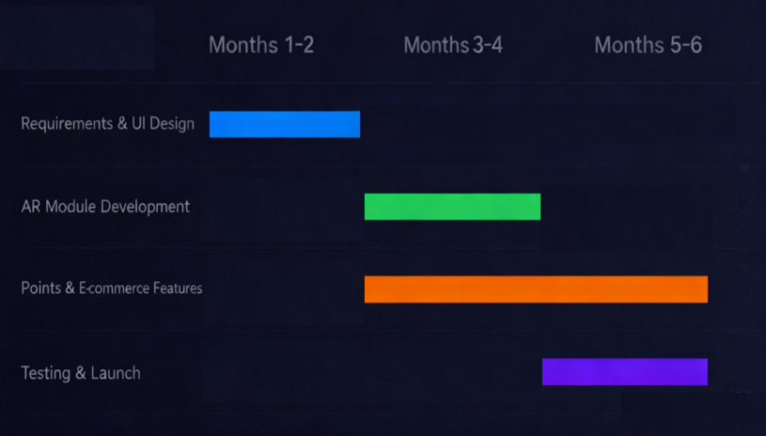

5.4 Risks and Countermeasures

5.4.1 Major Technical Risks
- Risk: AR recognition failure under complex lighting.
  - Countermeasure: Preload multi-angle model libraries for offline recognition; integrate AI image enhancement algorithms.
- Risk: QR code replication or fraudulent recycling.
  - Countermeasure: Use dynamically encrypted QR codes with geographic verification; deploy dedicated scanners at recycling points.
- Risk: Server overload during peak traffic.
  - Countermeasure: Adopt microservices architecture; configure auto-scaling for critical modules.

5.4.2 Development Risks
- Risk: AR underperformance on low-end devices.
  - Countermeasure: Launch a "Lightweight Mode" disabling non-essential animations to ensure core functionality.

6. Revenue Model and Business Risks

6.1 Revenue Model
Revenue Model | Description
Direct Packaged Water Sales via In-app Purchases | Enables D2C engagement and personalization, driving high conversion and repeat purchases. Limited-edition packages further boost purchasing power.
Transaction Fees from Third-Party Collaboration Goods | Facilitates sales of partner products (e.g., custom bottles, straws) and collects commissions on successful transactions.
Membership Premium | Users pay a subscription fee for exclusive benefits: members-only AR content, double Green Points, exclusive health tips/plans.
In-app Advertising | Sells banner and pop-up ads to sports, outdoor, and wellness brands, generating supplementary revenue.

Year 3 Incremental Revenue Mix
- 55%: Direct packaged water sales (driven by AR features, coupons, and in-app ordering)
- 20%: Transaction fees from third-party products (co-branded bottles, accessories)
- 15%: Membership premium fees (exclusive content, extra points, health features)
- 10%: In-app advertising revenue (targeted ads for relevant brands)
This structure combines direct sales, collaborations, and subscriptions to solidify Nongfu Spring’s position in the digital beverage market.
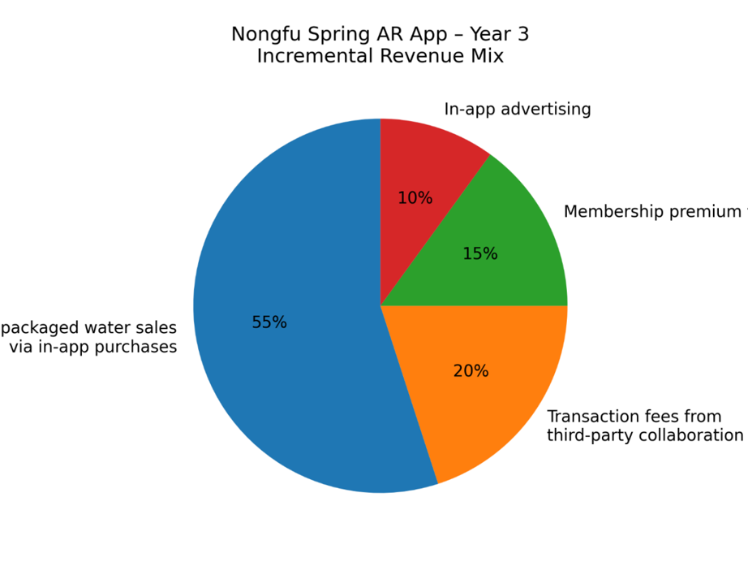

6.2 Financial Justification

6.2.1 Cost Classification
The total cost of the APP project is divided into Application Construction Cost (CAPEX) (one-time initial investment) and Operation and Maintenance Cost (OPEX) (recurring annual expenses), with detailed composition as follows:

6.2.1.1 Application Construction Cost (First-Year CAPEX: $450,000)
This cost covers the one-time investment required to convert the project from concept to launch, mainly including:
- Software Development Cost ($280,000): The core cost of the project, including the development of the AR module (computer vision logic for bottle label recognition, 3D animation overlay), Green Points system (blockchain/database tracking logic for recycling and redemption), e-commerce integration (shopping cart, user profile, payment gateway), and community forum functions (social sharing, interaction logic).
- Cloud Server & Equipment Cost ($60,000): Hardware and cloud infrastructure required for development and testing, such as high-performance graphical workstations for AR 3D modeling, a variety of iOS/Android mobile devices for compatibility testing, high-bandwidth cloud server instances, and Content Delivery Network (CDN) setup.
- Payment Channel & API Integration Cost ($15,000): Fees for connecting third-party payment gateways (e.g., Alipay, WeChat Pay) and integrating external APIs (e.g., charity project data, partner brand voucher systems).
- Initial Marketing & Content Creation Cost ($95,000): Costs for initial promotional content production (e.g., AR animation of water sources, promotional videos), market launch campaigns, and compilation of product databases (high-resolution images, nutritional information for the e-commerce section).
- Other Auxiliary Costs: Includes workplace setup for the digital team, technical consulting fees (carbon footprint tracking algorithms), domain registration, app store developer fees, and recruitment/training costs for the new digital division (incorporated into the above categories).

6.2.1.2 Operation and Maintenance Cost (Annual OPEX: $600,000)
This cost refers to the recurring expenses to ensure the long-term stable operation, security, and profitability of the APP ecosystem:
- Logistics & Distribution Subsidies ($300,000): Costs for establishing a "last-mile" delivery network for physical goods (bottled water), including cooperation fees with third-party logistics providers (e.g., JD Logistics, Cainiao) and subsidies for high-weight cargo transportation.
- Operation Team Salaries ($200,000): Annual salaries for the dedicated team responsible for APP operation, including community management (challenges, user interaction), content updates (seasonal AR animations), and customer service.
- Green Points Rewards Cost ($50,000): The cost of goods/services used for point redemption, such as Nongfu Spring trial packs, partner brand vouchers, and donations to charity projects.
- Server Maintenance & Security Cost ($50,000): Annual cloud server rental fees, bandwidth expansion costs (scaling with user growth), security audits, SSL certification fees, and data backup expenses.
- Legal & Compliance Cost: Fees for ensuring compliance with data protection laws (e.g., China’s PIPL), drafting user agreements for the community platform, and protecting intellectual property rights of AR content (incorporated into the above categories).

6.2.2 ROI Analysis
The project has significant profit potential and strategic value, with the following key return drivers:
- Direct Sales Margin Improvement: By shifting sales from traditional retail intermediaries to the proprietary APP, Nongfu Spring captures the retail margin (typically 15%-20% of product price). Even if the APP captures only 0.5% of the company’s annual revenue (≈30 billion RMB), the incremental direct channel revenue will far exceed the annual operation cost.
- Customer Loyalty Enhancement: The Green Points system increases customer "switching costs." According to industry benchmarks, a 5% increase in customer retention can boost profits by 25%-95%, reducing the cost of acquiring new customers (CAC) and extending customer lifetime value (LTV).
- Marketing Efficiency Optimization: The AR "scan-to-explore" feature serves as a viral marketing tool, reducing reliance on traditional TV/print advertising. User-generated content (UGC) from health challenges further amplifies brand exposure at low cost.
- Inventory Management Upgrade: Real-time sales data from the APP enables accurate demand forecasting, reducing inventory backlogs and warehouse storage costs (typically 3%-5% of product costs).

6.2.3 Multi-Dimensional Value Justification
Beyond financial returns, the project also creates non-monetary strategic value for Nongfu Spring:
- Low Financial Risk: The total first-year investment ($1.05M) accounts for only 0.018% of the company’s 2024 revenue, minimizing financial exposure while exploring digital transformation.
- Solid Profitability Outlook: With conservative projections (e.g., 10% of existing customers adopting the APP), the project is expected to break even in 14 months, followed by high-margin digital revenue (e.g., membership fees, advertising).
- Health & Social Impact: The APP promotes healthy hydration habits through hydration challenges and supports clean-water charity projects via Green Points donations, enhancing the brand’s social image.
- Environmental (ESG) Value: The bottle recycling reward system increases the return rate of plastic bottles (targeting a 20% increase), reducing plastic waste and carbon emissions. It also provides measurable ESG data for annual reporting, strengthening the company’s sustainability credentials.

6.2.4 3-Year Financial Projection
The financial projection for the APP shows a steady growth trend in revenue, with costs gradually stabilizing as the user base scales. The key indicators are as follows (unit: $100,000):

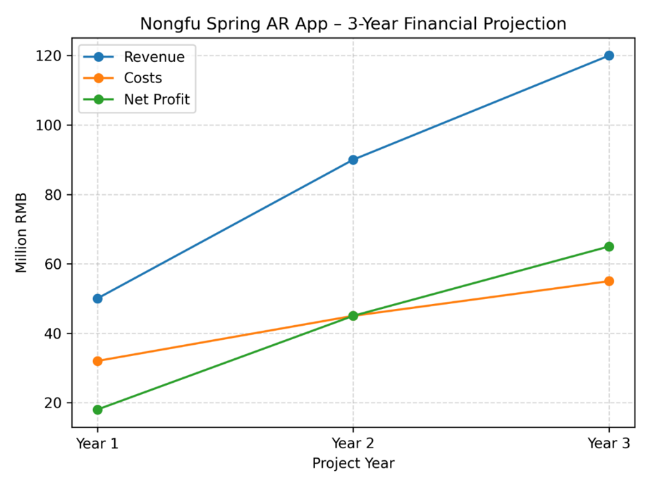

6.3Business Risks – Financial
- Cost Overrun Risk
The app's development, cloud infrastructure, logistics, and reward system costs may exceed the budget, which could lead to delayed payback. Any unexpected overspend in these areas could impact the expected return on investment and delay the financial breakeven point.
- Adoption & Revenue Risk
If app downloads, active user engagement, or order volume fall below expectations, the incremental revenue may not be sufficient to cover fixed operational costs. This could negatively affect the overall financial sustainability of the project.
- Margin Erosion Risk
The Green Points reward system, if too generous, and high delivery/return logistics costs can erode the contribution margin. A more costly reward program or inefficient logistics could reduce profitability, leading to financial strain.
- Data & ESG Credibility Risk
Privacy breaches or inaccurate data regarding recycling or donation activities could result in regulatory penalties and reputational loss, impacting both the financial performance and the company’s ability to maintain a strong ESG (Environmental, Social, Governance) profile.
Conclusion:
Based on the success of similar loyalty apps (e.g., Starbucks Rewards) and the high volume of Nongfu Spring's existing customer base, we predict that if the app converts even a fraction of daily drinkers into digital subscribers, the project will break even within 14 months. The added value of brand image enhancement via sustainability (Green Points) and technology (AR) makes this a financially sound investment.

