1. Preliminary Analysis

1.1 Introduction
This report summarizes a study conducted using the Kaggle "ScreenTime vs MentalWellness Survey 2025" dataset. The research aims to investigate the relationship between screen time—particularly work-related screen use—and the mental wellness of employees. In today’s competitive job market, prolonged working hours and increased screen time have become commonplace, raising concerns about their impact on employee mental health and overall corporate sustainability.

1.2 Methodology
The dataset consisted of 400 observations and 14 variables. Key variables included:
- work_screen_hours
- mental_wellness_index_0_100

1.2.1 Data Preprocessing
- Categorical variables such as gender and work_mode were encoded using Label Encoding and One-Hot Encoding, respectively.

1.2.2 Feature Selection
- Multiple methods were employed to evaluate feature importance, including:
  - Correlation analysis
  - F-regression
  - Mutual information

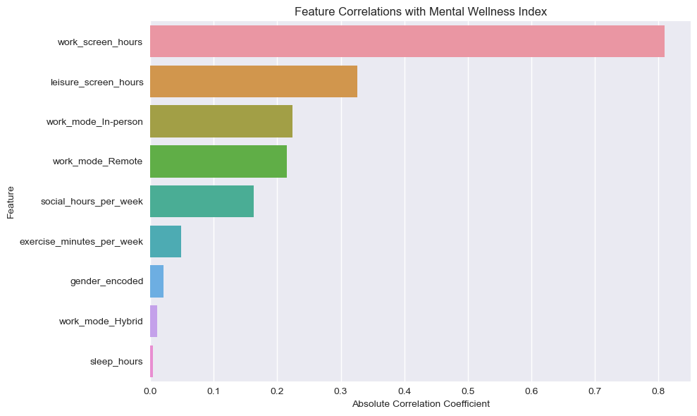

1.3 Key Findings
- Work screen time demonstrated a strong negative correlation with the mental wellness index, with a correlation coefficient of -0.811.
- As work screen hours increase, the mental wellness index shows a clear declining trend.
- Across all feature importance rankings, work screen time emerged as the most influential factor, significantly outweighing other variables.

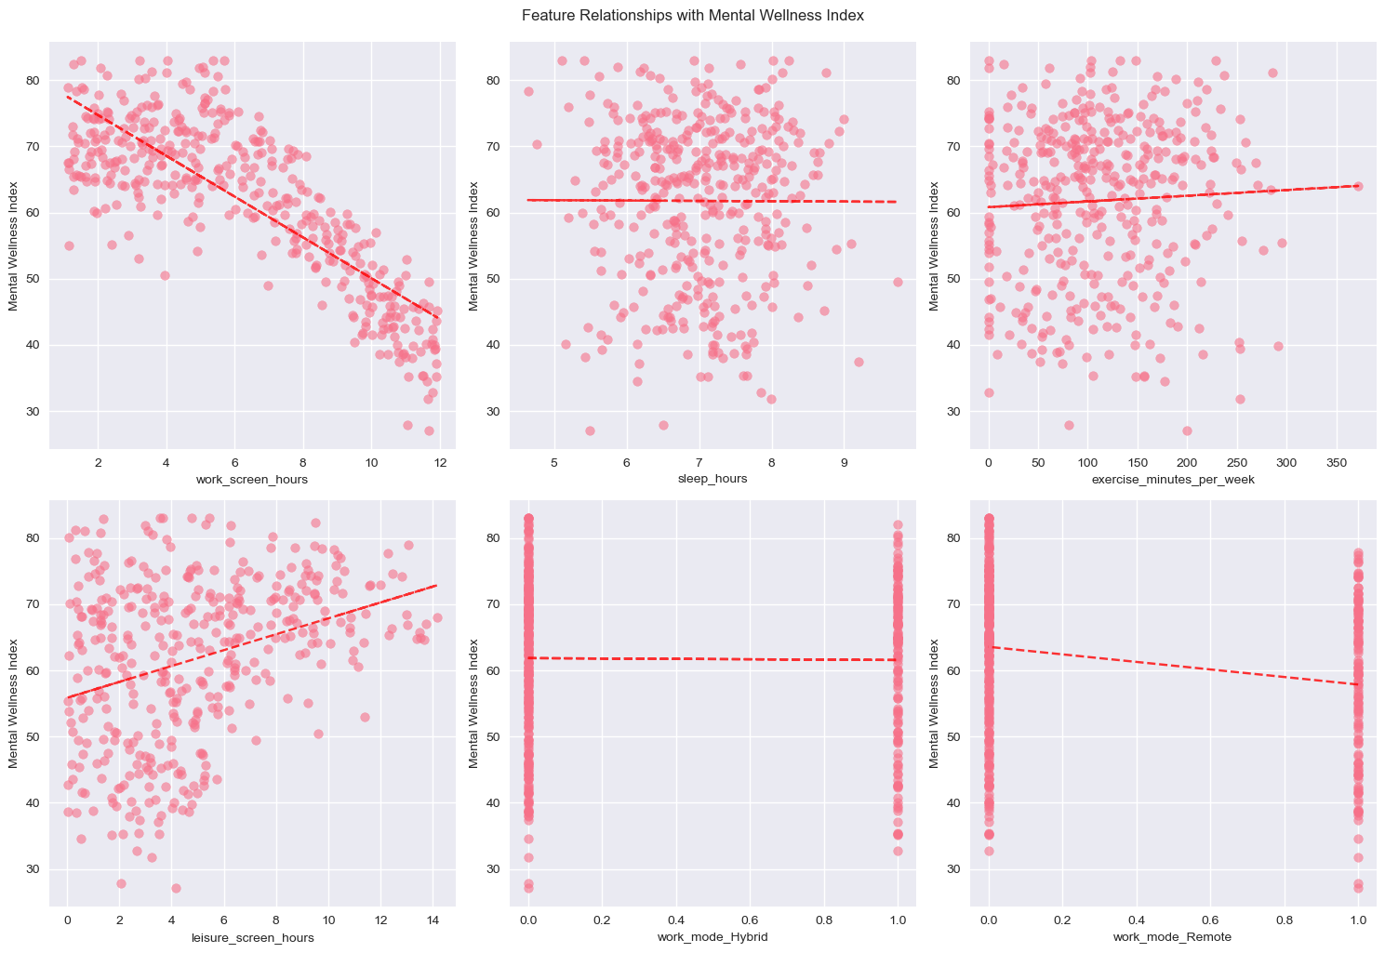1.4 Conclusion
The study confirms that prolonged work-related screen time is strongly associated with decreased mental wellness among employees. These findings highlight the need for organizations to implement screen time management policies and promote mental health support systems to ensure sustainable workforce well-being.

2. Linear Regression Analysis in Detail

2.1 Core Conclusion
Work-related screen time exerts a strong negative impact on mental wellness, total screen time has a moderate negative impact, while leisure screen time shows a mild positive impact—all with statistical significance.

2.2 Research Objectives
Quantify the linear relationships between three screen time variables (total screen time, work screen time, leisure screen time) and the mental wellness index respectively; verify the hypothesis that "longer screen time leads to lower mental health scores"; and compare the differential impacts of different types of screen use on mental health to provide data support for intervention strategies.

2.3 Research Methodology
- Data Selection: Extract 4 core variables—3 independent variables (daily total/work/leisure screen time, in hours) and 1 dependent variable (mental wellness index, scored 0-100)—with a sample size of 400.
- Data Preprocessing: No missing values were found for all core variables; 2 outliers in leisure screen time were detected via the IQR method and handled using the truncation approach.
- Model Construction: Separate linear regression models were built for each independent variable with the dependent variable, and parameters were fitted using the least squares method.
- Analysis & Visualization: Key indicators (regression coefficient, R², significance) were analyzed, and results were visualized through scatter plots with regression lines and residual distribution charts.

2.4 Core Results

2.4.1 Model Indicator Comparison

Indicator | Total Screen Time Model | Work Screen Time Model | Leisure Screen Time Model
Regression Coefficient | -1.5870 | -3.0805 | 1.2020
R-squared (R²) | 0.198 | 0.657 | 0.106
Correlation Coefficient | -0.4448 | -0.8106 | 0.3263
Statistical Significance | p<0.001 | p<0.001 | p<0.001
- 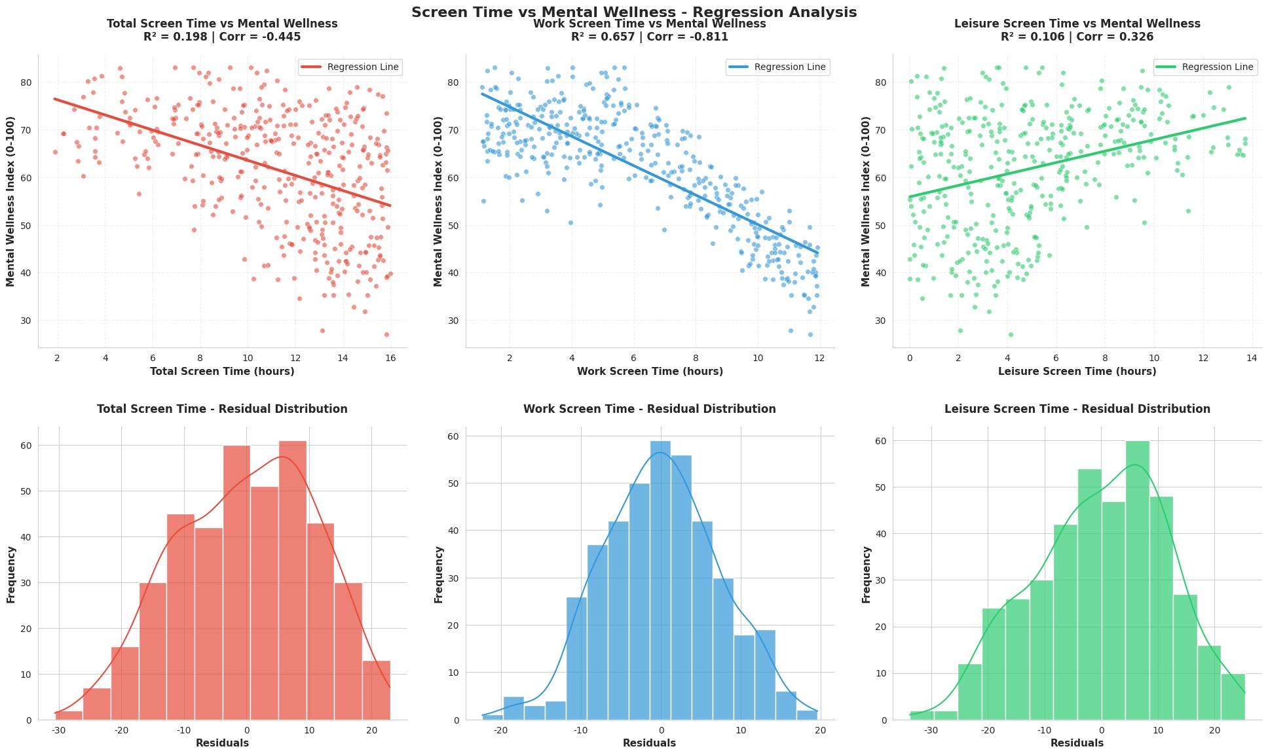Top row: Scatter plots with regression lines for each model, showing the direction and strength of relationships. The work screen time model (middle) has the tightest data clustering around the regression line.
- Bottom row: Residual distributions for each model, all roughly bell-shaped, verifying the normality assumption.

2.4.2 Key Interpretations
- Total Screen Time vs. Mental Wellness: Each 1-hour increase in total screen time leads to an average 1.59-point decrease in the mental wellness index, explaining 19.8% of mental wellness variation (weak-to-moderate explanatory power).
- Work Screen Time vs. Mental Wellness: Each 1-hour increase in work screen time results in an average 3.08-point decrease in the mental wellness index, accounting for 65.7% of mental wellness variation (strong explanatory power, the most impactful factor).
- Leisure Screen Time vs. Mental Wellness: Each 1-hour increase in leisure screen time brings an average 1.20-point increase in the mental wellness index, explaining only 10.6% of mental wellness variation (weak explanatory power, contradicting the initial hypothesis).

2.5 Targeted Recommendations
- For High Work Screen Time Groups (＞4 hours/day): Implement a "work-screen interval system" (10-minute breaks per hour), set clear "screen-off times" for work devices, and provide monthly mental health assessments.
- For General Groups (Total Screen Time: 5-10 hours/day): Prioritize reducing work screen time, maintain moderate leisure screen time (3-5 hours/day), and adopt the "20-20-20 rule".
- For Low Screen Time Groups (＜5 hours/day): Summarize their balanced screen use patterns into a "Healthy Screen Use Guide" and offer incentives (e.g., gym memberships).
- For Policy Makers/Organizations: Develop differentiated interventions for high work screen time groups and correct the misconception that "all screen use is harmful".

3. Further Analysis

3.1 Data Overview
First, load the data file and store it, print the shape, column names, data types, etc., check for missing values, and display the first 5 rows of the dataset to quickly understand the structure and content of the data.

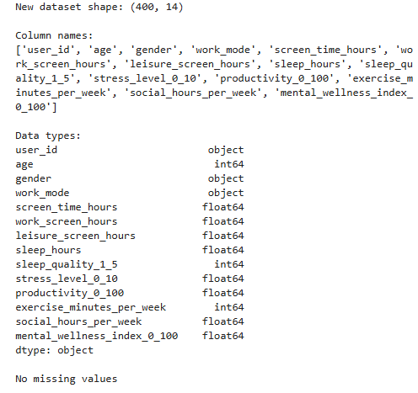

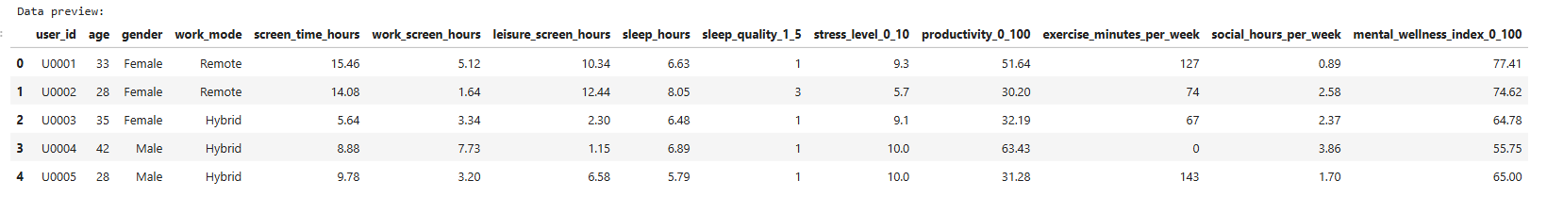

3.2 Descriptive Statistics of Key Variables
Next, obtain basic statistical information of key columns, including count, mean, standard deviation, minimum value, 25th percentile, median, 75th percentile, and maximum value. Visualize the distribution of key variables simultaneously. A comprehensive exploratory analysis of the screen time and mental health dataset was conducted using statistical summaries and visual charts. Through histograms, the distribution patterns of various variables (such as whether they are normally distributed, whether there is skewness, etc.) can be intuitively understood. The mean line can show the central position of the data, and the data range analysis can help understand the value range of the variables.
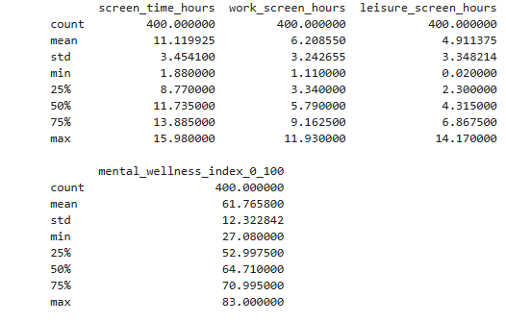
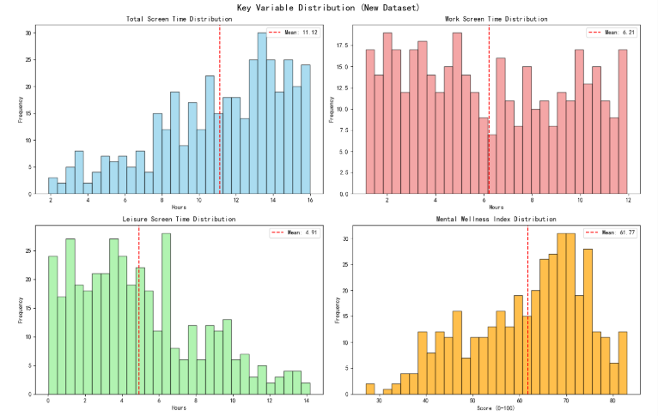

3.3 Work Screen Time vs Productivity Regression Analysis
Based on the analysis results presented earlier, we can conclude that company employees' mental wellness is largely influenced by work screen hours. Although employees' mental wellness is particularly important to the company, honestly speaking, companies also care more about business performance. Considering this aspect, we specifically analyzed the relationship between work screen hours and productivity.
First, we visualized the work screen hours and productivity data, hoping to intuitively display the relationship between work screen hours and productivity by using scatter plots, histograms, and box plots. Then we conducted correlation analysis, obtaining a correlation r = 0.5176, indicating a moderate positive correlation between the variables.
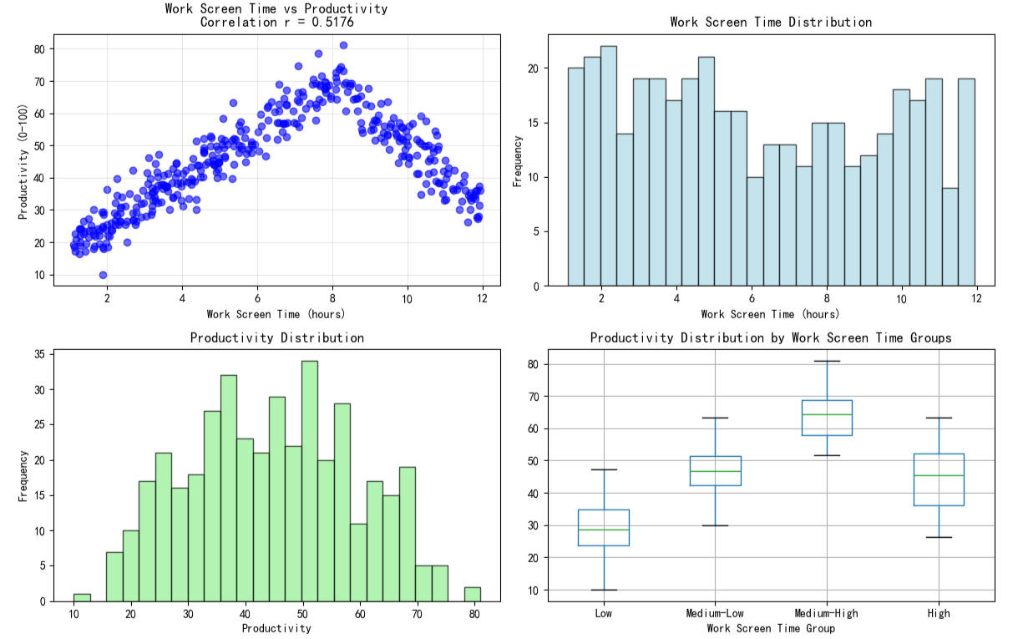
Through analysis, we found that the relationship between work screen time and productivity approximately follows a quadratic relationship. There may be an optimal work screen hour point, beyond which productivity decreases.
Next, we constructed regression models to further analyze the relationship between work screen hours and productivity. We built both linear regression and polynomial regression models. By calculating the evaluation metrics of the regression model: MSE, RMSE, MAE, R², we determined that polynomial regression was the optimal model. We output the polynomial regression equation and calculated the extreme value:
Productivity = -7.2 + 17.8 × Work Screen Time + -1.2 × Work Screen Time²
Extreme point: Work screen time = 7.43 hours
Maximum productivity = 58.85

3.3.1 Model Performance Comparison

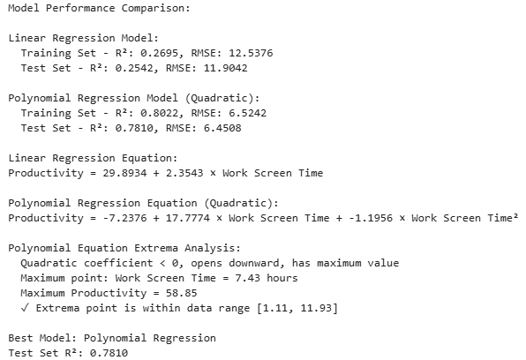
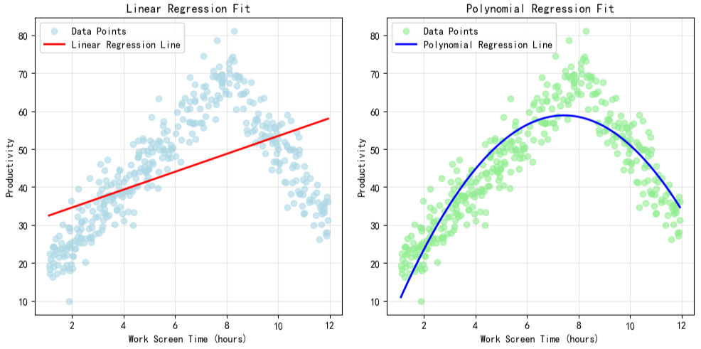

From the previous analysis, we can draw the following conclusions respectively: regarding work screen hours and employee mental wellness, as work screen hours increase, employee mental wellness continuously decreases. Meanwhile, regarding work screen hours and productivity, as work screen hours increase, productivity keeps rising, but when it exceeds a certain threshold, productivity gradually declines. Based on these conclusions, we simultaneously present the impact of work screen hours on mental wellness and productivity.
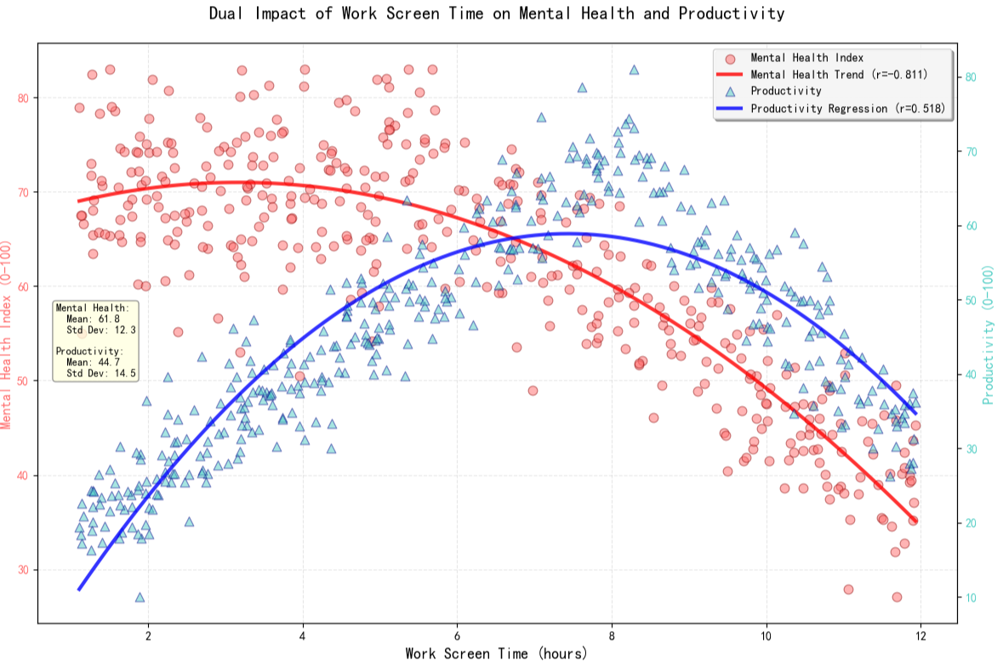

3.4 Conclusion
From this, we can conclude that if companies want to sacrifice some employee mental wellness to improve productivity, they can control employees' work screen hours at 7.43 hours. Meanwhile, based on the previous analysis, if companies want to improve employees' mental wellness levels, they should reduce employees' work screen hours beyond this baseline.

4. Multi-dimensional Verification via K-Means Clustering

4.1 Introduction
The previous regression analyses established two critical baselines: first, that extended work screen hours negatively impact mental wellness; and second, that productivity follows a non-linear trajectory, peaking within a specific window before declining.
However, regression lines represent average trends. We must ask: Do these mathematical patterns hold true for distinct groups of actual employees?
To verify this, this section shifts from predictive modeling (Regression) to descriptive segmentation (Clustering). We utilize K-Means Clustering to partition the workforce based on behavioral patterns. Our objectives are to confirm the existence of the "Burnout" cohort predicted by the regression models and to identify the ideal employee profile that balances the trade-off between output and health.

4.2 Methodology and Clustering Overview
Methodology: We applied the K-Means algorithm (K=3) using the verified high-impact features: Work Screen Hours, Mental Wellness Index, and Productivity Score.
Table 4.1 Clustering result
Cluster Name | Work Screen Hours (Mean) | Mental Wellness Index (Mean) | Productivity (Mean) | Key Characteristic Summary
Balanced/Healthy | 6.96 (Medium) | 60.88 (Medium) | 51.08 (Medium) | Optimal Balance. Lowest stress (5.47), highest sleep (7.89h), and highest exercise. Achieves medium productivity and good health.
Burnout/High Stress | 9.41 (Highest) | 50.46 (Lowest) | 52.27 (Medium) | Worst Health Outcome. Highest screen time and extreme stress (9.15), leading to the lowest mental wellness despite high input hours.
Disengaged/Relaxed | 3.42 (Lowest) | 70.71 (Highest) | 35.67 (Lowest) | Healthy but Inefficient. Lowest screen time and highest mental wellness, but drastically low productivity.

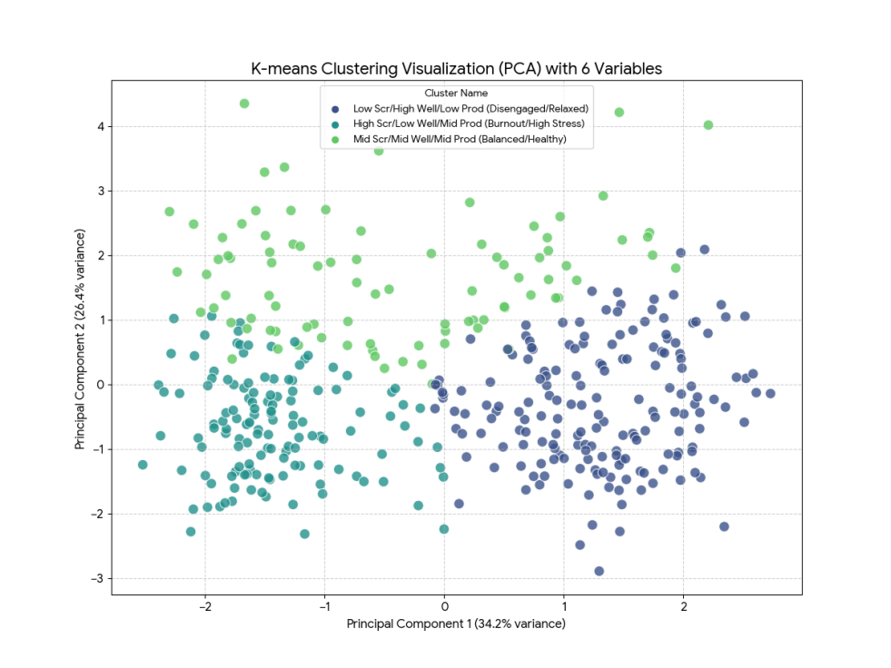
Figure 4.1 Clustering visualization

4.3 Detailed Profile Verification & The "Productivity Paradox"
The analysis of cluster centroids reveals three distinct work patterns that directly corroborate the "Productivity Paradox" hypothesis.

4.3.1 Mean Value Analysis: The Input-Output Mismatch
First, we examine the normalized feature means of each cluster, revealing three distinct behavioral patterns.
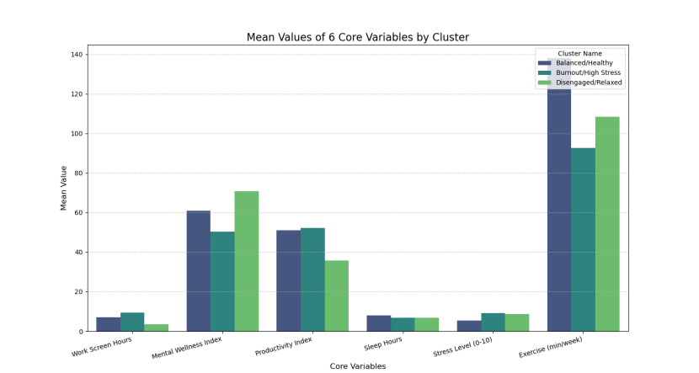
Figure 4.2 Mean Values of 6 Core Variables by Cluster

4.3.1.1 Extreme Differences
The graph clearly highlights the two most polar opposite variables:
- Stress Level: Burnout/High Stress has a mean stress level (≈9.15) that is significantly higher than both Disengaged/Relaxed (≈8.76) and Balanced/Healthy (≈5.47). Stress is the most differentiating factor for the Burnout group.
- Exercise Minutes: The Balanced/Healthy group leads significantly in exercise (≈138 min/week), confirming their proactive approach to wellness.

4.3.1.2 Health-Productivity Trade-Off
- The Disengaged/Relaxed group, despite having the best Mental Wellness score, is easily identifiable by the lowest bar in Productivity Index (≈35.67).
- The Burnout/High Stress group's highest bar in Work Screen Hours (≈9.41) is directly mirrored by the lowest bar in Mental Wellness Index (≈50.46).

4.3.1.3 Optimal Balance
The Balanced/Healthy group achieves its medium-high scores in Mental Wellness and Productivity by maintaining high values in all three non-work-related health factors: high Sleep Hours, high Exercise, and very low Stress.

4.3.2 Distribution Analysis: Statistical "Zero Gain"
To rule out outliers affecting the means, we further verified whether "more work" truly yields "more gain" using Box Plots.

4.3.2.1 Work Screen Hours
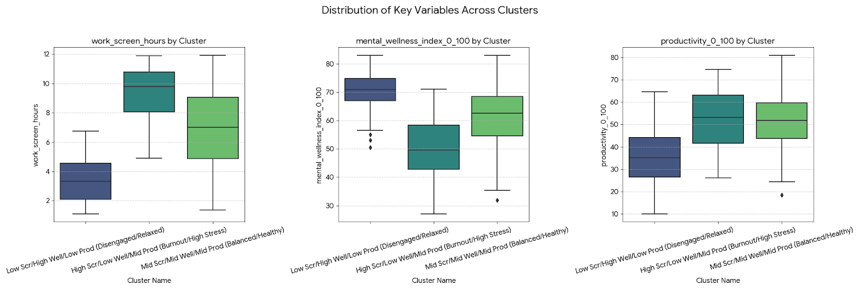
Figure 4.3 work screen hours boxplot
- The distribution for Burnout/High Stress is clearly concentrated at the highest end, confirming its high screen time characteristic. This difference is statistically significant across all groups.

4.3.2.2 Mental Wellness Index

Figure 4.4 mental wellness index boxplot
- Mental Wellness shows a strong inverse correlation with screen time. The lowest screen time group (Disengaged/Relaxed) exhibits the highest mental wellness, while the highest screen time group (Burnout/High Stress) shows the lowest.

4.3.2.3 Productivity

Figure 4.5 Productivity boxplot
- Disengaged/Relaxed has the lowest productivity. Importantly, Burnout/High Stress does not achieve the highest productivity despite the extreme effort; its output is comparable to the Balanced/Healthy group.

4.4 Conclusion & Strategic Implications

4.4.1 Core Finding: Verifying "Diminishing Returns"
Combining the analyses of mean values and distribution ranges, the K-Means clustering model successfully completes the multi-dimensional verification of the "Productivity Paradox," revealing key mechanisms:

4.4.1.1 The "Time Trap"
The data confirms that excessive work screen time (above 9 hours, as seen in Cluster 0) represents a point of diminishing returns. Attempting to boost output simply by extending hours is futile; it significantly increases stress and sleep deprivation without delivering a statistically significant increase in productivity.

4.4.1.2 The "Balance Dividend"
Clustering result proves that a strategy of "approx. 7 hours of work + adequate sleep + regular exercise" is the optimal approach. This is not just a health suggestion but an efficiency protocol—it maintains high productivity while maximizing employee physical and mental well-being.

4.4.2 Cluster-Based Data-Driven Strategies
Based on these findings, we propose the following targeted strategies:

4.4.2.1 Maximize Productivity
Abandon "Duration Worship." Since the highest screen time group does not yield the highest productivity, organizations should target a work screen time of around 7 hours, focusing on workflow efficiency rather than hours logged.

4.4.2.2 Improve Mental Health
Low stress (mean 5.47) is key to sustainability. We recommend enforcing mandatory breaks and actively promoting sleep hygiene and regular exercise.

4.4.2.3 Targeted Group Activation
For the "Disengaged/Relaxed", the issue is output, not health. Rather than simply pressuring for more hours, provide structured goals and clear workflows to channel their high wellness into a higher productivity baseline.
However, is controlling screen time (the "Quantity") the only solution? K-Means only addresses the "Quantity" of work, not the "Quality" of the environment. This leads us to a critical new dimension: The moderating role of Work Modes and Social Interaction.
In the following section, we will delve into these environmental factors using ANOVA and correlation analysis.

5.Exploring Differences in Work Patterns

Based on the above research, we have identified the impact of screen time on productivity and efficiency. To further explore whether there are better ways to enhance mental well-being while maintaining necessary screen usage for work.

5.1.Analysis of Variance Based on Different Working Modes Analysis of Variance

ANOVA is a statistical method used to test whether a categorical independent variable has a significant effect on the mean value of a continuous dependent variable.
Hypothesis Testing:
H₀: There were no significant differences in the average mental health indices among the three groups.
Results of Mental Health:
F=13.762
P=0.000<0.001
The results of the analysis of variance indicate that the mean mental health indices across the three work patterns exhibit extremely significant statistical differences. Work patterns exert an influence on individuals' mental health status.
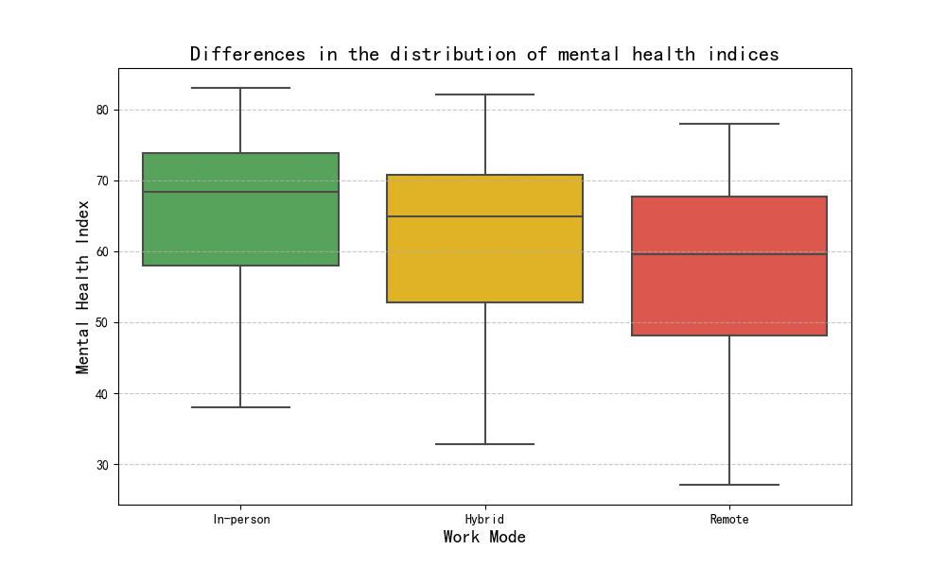
Tukey's HSD:
ANOVA can only tell us that a significant difference exists, but it cannot specify which two groups differ (for example, whether “remote vs. in-person” or “remote vs. hybrid” shows a difference).
Tukey's Honestly Significant Difference is a post-hoc test specifically designed for use after ANOVA. It simultaneously compares all possible pairings of groups and adjusts the p-values to control the overall Type I error rate within a predetermined $\text{α}$ level.

Group1 | Group2 | meandiff | p-value | reject
Hybrid | In-person | +4.04 | 0.015 | True
Hybrid | Remote | -3.70 | 0.033 | True
Remote | In-person | -7.74 | 0.000 | True
Mental Health Index:
In-person> Hybrid > Remote
In terms of mental health index, pairwise comparisons reveal significant differences across work arrangements. Individuals in in-person settings exhibit the strongest mental health outcomes, while those in remote settings demonstrate the weakest mental health outcomes.
It indicates that even when screen time at work is kept within optimal limits, companies can further enhance employee well-being by optimizing work patterns.

5.2 Descriptive Statistics Based on Different Working Modes
Screen Time:
The hybrid mode had the longest average screen time, encompassing both leisure and work activities. In contrast, the remote work mode had the least leisure screen time.

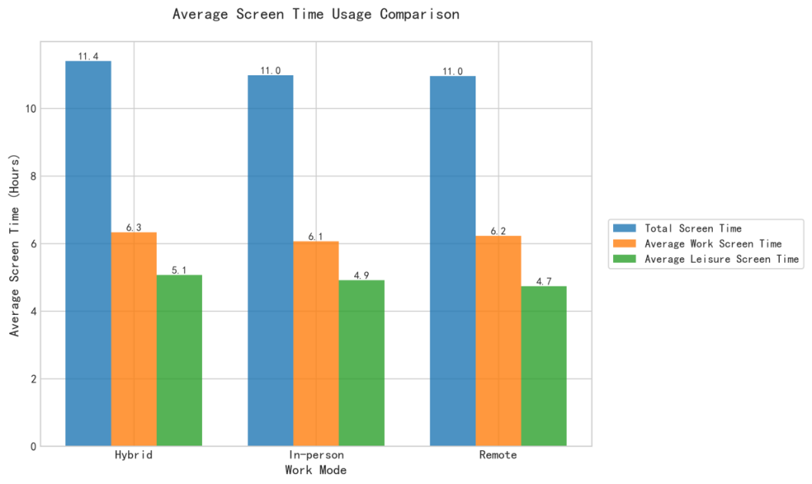
Exercise Time and Social Time:
Work Mode | Average Week Exercise Time (hours) | Average Week Social Time(hours)
Hybrid | 1.81 | 2.98
In-person | 1.92 | 4.16
Remote | 1.75 | 1.75

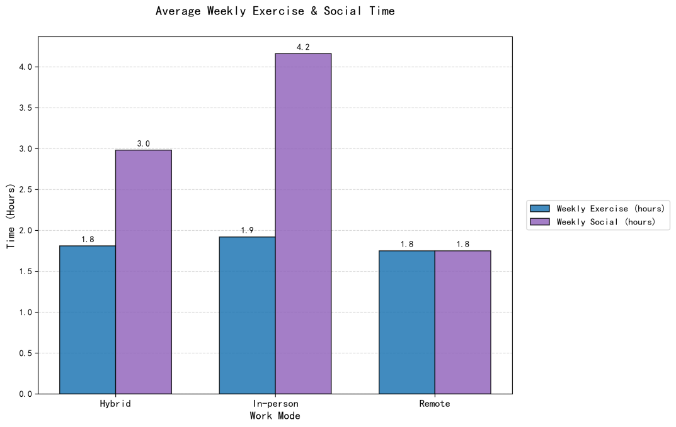

The average weekly exercise time across the three work modes shows little variation, but significant differences emerge in social interaction time. The face-to-face mode boasts substantially higher average social interaction time than the other two modes, while the remote mode has the least social interaction time (1.75 hours), indicating its primary reliance on online communication.
Through analysis, we found that remote mode had the lowest levels of social time and leisure screen time.

5.3 Investigating Social Time and Leisure Screen Usage Across Different Work Modes
To further validate and quantify these findings, scatter plots and trend lines depicting screen usage time and weekly social time versus mental health indices were plotted according to different grouping patterns as follows:
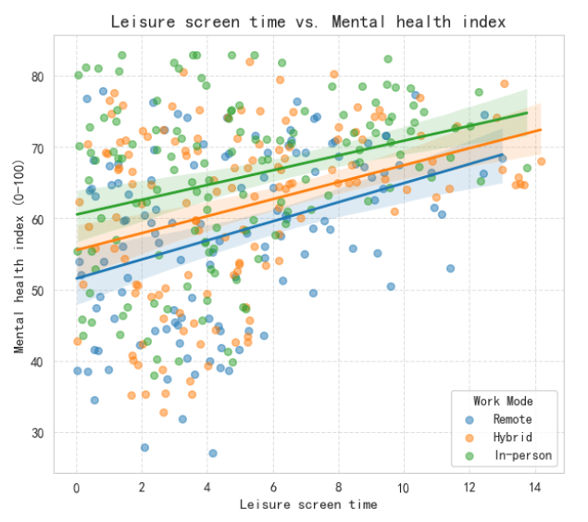
The health benefits from leisure time are highest in remote mode, but its baseline is lowest. This reflects the extremely high mental health risks employees face in remote mode when lacking leisure and relaxation.
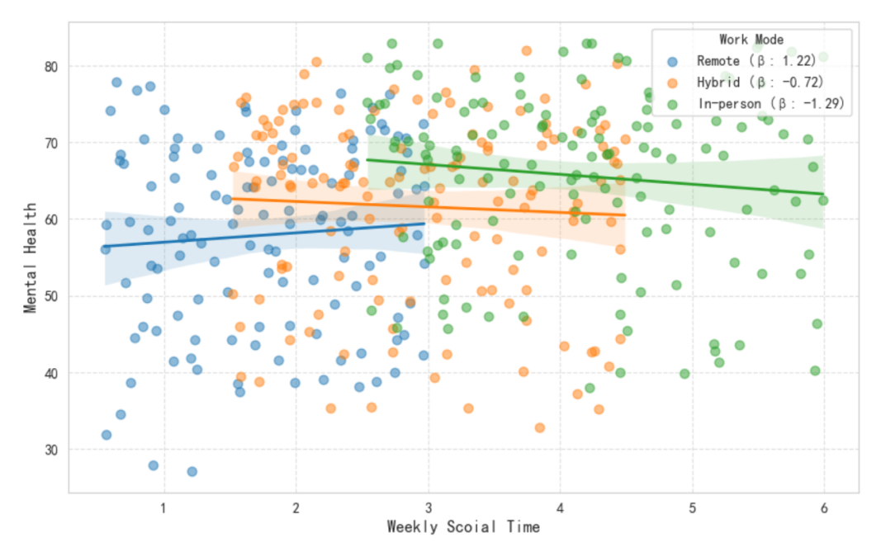
Plotting scatter diagrams and regression lines based on mental health and social time across different work modes, we find that the β coefficient is highest for the remote mode. This indicates that social activities serve as restorative resources for remote employees, with each instance of social interaction yielding health benefits. In contrast, employees in hybrid and in-person modes exhibit negative slopes, suggesting that the work-related social activities maybe pressure for workers.

5.4 Conclusions and Recommendations
Based on the above research, we found that work modes significantly impact mental health. Even when screen time at work is controlled within optimal ranges, the work mode itself still exerts an influence on health. The low mental health levels associated with the remote mode stem from its inherent nature, which leads to low social interaction and low leisure time, placing its baseline health level at the lowest point.
For remote workers:
Boosting Social Engagement: Establish a “Remote Team-Building Allowance” to encourage and organize non-work-related offline gatherings, compensating for the social gaps inherent in remote work.
Guaranteeing Leisure Time:Companies can require employees to mute or log off work software after hours. This safeguards employees' rest periods, ensuring they enjoy high-quality leisure screen time.
For in-person/hybrid workers:
Reduce ineffective socializing: Minimize unnecessary formal work dinners or meetings to prevent socializing from becoming a new source of work stress.
Encourage genuine rest: Encourage employees to redirect social time toward family, friends, and personal hobbies, ensuring social activities truly recharge energy rather than becoming another form of work extension.

