**Freeway Coordinates**

**Information**

***Important Websites***

Website to find coordinates:<http://www.gps-coordinates.net/>

For each offramp you need to get the data from, verify it with the information from the following so you know which exit number and which side of the freeway it exits on:

<http://en.wikipedia.org/wiki/U.S._Route_101_in_California#Major_intersections>

<http://en.wikipedia.org/wiki/Interstate_10_(California)#Exit_list>

***Format***

Exit Number

Off-Ramp Name

North: Latitude, Longitude

South: Latitude, Longitude

***Example: If exit exists as both Northbound and Southbound exit***

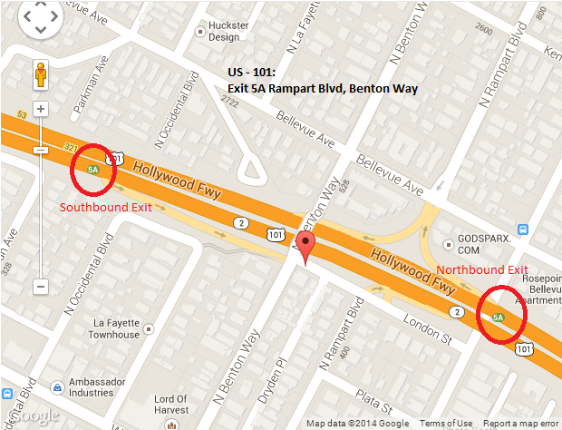

Exit 5A

Rampart Boulevard, Benton Way

North: 34.074402, -118.272001

South: 34.075746, -118.27662

***If exit exists only as a Northbound or Southbound exit***

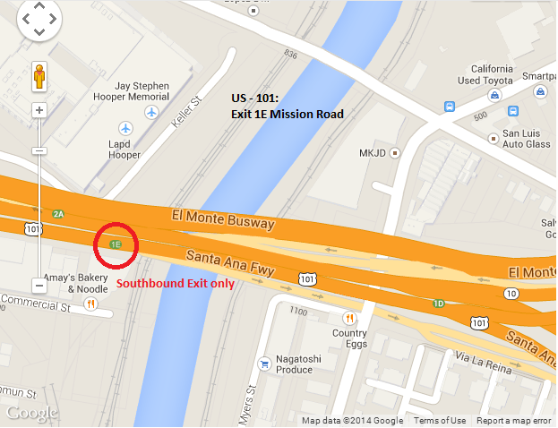

Exit 1E

Mission Road

South: 34.053059, -118.229295

**Coordinates**

**I-10**

1) SR 1 north (Pacific Coast Highway) – Oxnard, 34.011362, -118.494424

2) 4th Street, 5th Street, 34.012732, -118.489253,

3) SR 1 south (Lincoln Boulevard) to SR 2 east, 34.014742, -118.486034  
4) 20th Street: 34.023172, -118.473739  
5) Cloverfield Boulevard: 34.024452, -118.469361  
6) Centinela Avenue: 34.027671, -118.452839  
7) Bundy Drive: 34.028222,-118.449277

8) I-405 (San Diego Freeway) – Sacramento, LAX Airport, Long Beach: 34.031263, -118.433699  
9) National Boulevard, Overland Avenue: 34.031832, -118.417090

10) National Boulevard: 34.029592, -118.403143  
11) Robertson Boulevard – Culver City: 34.030997, -118.390590  
12) La Cienega Boulevard, Venice Boulevard (SR 187 west): 34.036794, -118.377544  
13) Fairfax Avenue, Washington Boulevard: 34.035122, -118.369519  
14) La Brea Avenue: 34.034369, -118.349945  
15) Crenshaw Boulevard: 34.034891, -118.333770  
16) Arlington Avenue: 34.036651, -118.317720

17) Western Avenue, Normandie Avenue: 34.037060, -118.304073   
18) Hoover Street, Vermont Avenue: 34.036886, -118.287085  
19) Hoover Street ??  
 20) I-110 south (Harbor Freeway) / SR 110 north (Harbor Freeway) / Pico Boulevard – San Pedro, Pasadena, Downtown Los Angeles: 34.038120, -118.274054  
21) Grand Avenue: 34.034585, -118.267097  
22) Los Angeles Street – Convention Center: ?????  
23) Maple Avenue: 34.031250, -118.259855  
24) San Pedro Street: 34.029588, -118.256089  
25) Central Avenue: 34.025880, -118.249233  
26) Alameda Street: 34.024777, -118.239202

27) Mateo Street, Santa Fe Avenue: 34.027978, -118.230962  
28) I-5 south (Santa Ana Freeway) / SR 60 east (Pomona Freeway) – Santa Ana, Pomona: 34.029155, -118.219345  
29) Boyle Avenue: 34.034454, -118.220118 (North from 27 )  
30) Fourth Street: 34.042598, -118.217156 (North from 29)  
31) Cesar Chavez Avenue: 34.049532, -118.213809 (North from 30)  
32) I-5 north (Golden State Freeway) – Sacramento: 34.055043, -118.213809 (North from 31)  
33) US 101 north (Santa Ana Freeway via San Bernardino Freeway) – Los Angeles, Hollywood: 34.055115, -118.217886 (North from 32)  
34) State Street: 34.055541, -118.211320   
35) Soto Street: 34.054972, -118.202351  
36) City Terrace Drive: 34.056501, -118.182610  
37) Eastern Avenue: 34.060732, -118.173640

**US-101**

Exit __

I-5 south (Santa Ana Freeway) – Santa Ana

North: 34.02560560439752, -118.20610597729683

South: 34.026248043628705, -118.20835366845131

Exit __

Euclid Avenue

South: 34.028593238984264, -118.21348875761032

Exit 1

SR 60 east (Pomona Freeway) / Soto Street – Pomona

South: 34.033757997533286, -118.22110287845135

Exit 1A

Seventh Street

South: 34.03562232367254, -118.22175230830908

Exit 1B

Fourth Street

North: 34.04109614854208, -118.22126045823097  
South: 34.04448550872009, -118.22116926312447

Exit 1C

First Street

North: 34.045672308394295, -118.22103783488274

South: 34.049148157943556, -118.22227969765663

Exit 1D

Cesar Chavez Avenue

North: 34.04985708930202, -118.22247013449669

Exit 1D

I-10 east (San Bernardino Freeway) – San Bernardino

South: 34.05247719482622, -118.22564654052258

Exit 1E

Mission Road

South: 34.053081652120184, -118.22936743497849

Exit 2A

Vignes Street

North: 34.05343276871648, -118.23052279651165

Exit 2B

Alameda Street – Union Station

North: 34.053932774017646, -118.23495045304298

South: 34.05371721653833, -118.2367180287838

Exit 2B

Los Angeles Street

South: 34.05599054256801, -118.24097201228142

Exit 2C

Spring Street

North: 34.05643275628624, -118.24142530560493

Exit 2C

Broadway

South: 34.0580904816502, -118.24431136250496

Exit 3A

Grand Avenue, Temple Street

North: 34.05851490746194, -118.2445715367794

South: 34.061065861804984, -118.24761047959328

Exit 3B

SR 110 north (Pasadena Freeway) / I-110 south (Harbor Freeway) –Pasadena, San Pedro

North: 34.05851490746194, -118.2445715367794

South: 34.06426777857052, -118.25060918927193

Exit 4A

Glendale Boulevard, Echo Park Avenue, Union Avenue, Belmont Avenue

North: 34.06876270115537, -118.2582400739193

South: 34.07053127561425, -118.26379761099815

Exit 4B

SR 2 east (Alvarado Street)

North: 34.071157822030806, -118.26465860009193

South: 34.0727663809727, -118.26898768544197

Exit 5A

Rampart Boulevard, Benton Way

North: 34.07441267831724, -118.27201589941978

South: 34.075752354163406, -118.27661320567131

Exit 5B

Silver Lake Boulevard

North: 34.076487722776285, -118.27854439616203

South: 34.0779384463634, -118.28548595309258

Exit 6A

Vermont Avenue

North: 34.07909145397221, -118.28943148255348

South: 34.0806643176524, -118.29425945878029

Exit 6B

Melrose Avenue, Normandie Avenue

North: 34.08207276118474, -118.29549863934517

South: 34.08660450255726, -118.30326899886131

Exit 7

SR 2 west (Santa Monica Boulevard) / Western Avenue

North: 34.08844600854346, -118.30486759543419

South: 34.09460998622675, -118.31084623932838

Exit 8A

Sunset Boulevard

North: 34.097532998562855, -118.31398978829384

South: 34.10158418004354, -118.31670418381691

Exit 8B

Hollywood Boulevard

North: 34.09870350787059, -118.31474617123604

South: 34.10372296572505, -118.31932201981544

Exit 8C

Gower Street

North: 34.10408719798242, -118.31975117325783

South: 34.10498777771701, -118.32598362118006

Exit 9A

Vine Street

South: 34.107460713704, -118.33017691969872

Exit 9B

Cahuenga Boulevard – Hollywood Bowl

North: 34.10670673683935, -118.32850657403469

South: 34.10934618166433, -118.3333070576191

Exit 9C

Highland Avenue (SR 170 south) – Hollywood Bowl

North: 34.109459441652625, -118.33310320973396

South: 34.120242874537226, -118.33892896771431

Exit 11A

Barham Boulevard – Burbank

North: 34.12212916780053, -118.34028147161007

South: 34.13054980484384, -118.34900334477425

Exit 11B

Universal Studios Boulevard

North: 34.129486308564914, -118.34755226969719

Exit 12A

Lankershim Boulevard – Universal City

North: 34.13631776241916, -118.36066290736198

South: 34.13707924549337, -118.36221858859062

Exit 12B

Ventura Boulevard

North: 34.13818260675327, -118.36326733231544

Exit 12C

Vineland Avenue

North: 34.145261980375246, -118.36828842759132

South: 34.14852730526487, -118.37275430560112

Exit 13B

SR 134 east (Ventura Freeway) – Pasadena

South: 34.15440279630737, -118.38371112942696

Exit 13

SR 170 north (Hollywood Freeway) – Sacramento

North: 34.1491865703665, -118.37318882346153

Exit 13A

Tujunga Avenue

South: 34.153917, -118.379053

Exit 14

Laurel Canyon Boulevard – Studio City

North: 34.154583, -118.393055

South: 34.155222, -118.400694

Exit 15

Coldwater Canyon Avenue

North: 34.156847, -118.41109

South: 34.156625, -118.416744

Exit 16

Woodman Avenue

North: 34.155772, -118.428202

South: 34.155515, -118.434307

Exit 17

Van Nuys Boulevard

North: 34.155976, -118.446077

South: 34.157592, -118.453168

Exit 18

Sepulveda Boulevard

North: 34.159634, -118.462062

Exit 19A

I-405 (San Diego Freeway) – Santa Monica, Sacramento

North: 34.159554, -118.463715

South: 34.162662, -118.472083

Exit 19B

Haskell Avenue

North: 34.16465, -118.473199

South: 34.16489, -118.474701

Exit 20

Hayvenhurst Avenue

North: 34.165351, -118.489625

Exit 21

Balboa Boulevard – Encino

North: 34.168396, -118.497403

South: 34.170988, -118.504077

Exit 22

White Oak Avenue

North: 34.171299, -118.515449

South: 34.171024, -118.521329

Exit 23

Reseda Boulevard

North: 34.172409, -118.532701

South: 34.173163, -118.539299

Exit 24

Tampa Avenue

North: 34.17366, -118.55094

South: 34.173456, -118.556369

Exit 25

Winnetka Avenue – Woodland Hills

North: 34.173021, -118.568053

South: 34.170926, -118.573857

Exit 26A

De Soto Avenue, Serrania Avenue

North: 34.168165, -118.584124

South: 34.168449, -118.591881

Exit 26B

Canoga Avenue

North: 34.169231, -118.595089

Exit 27

SR 27 (Topanga Canyon Boulevard) / Ventura Boulevard

North: 34.170411, -118.602814

South: 34.16774155113126, -118.61423090100288

Exit 27C

Shoup Avenue

North: 34.170216, -118.610753

Exit 28

Fallbrook Avenue

South: 34.163478, -118.625956

Exit 28

Woodlake Avenue

North: 34.162626, -118.629089

Exit 29

Mulholland Drive, Valley Circle Boulevard

North: 34.160788, -118.634207

South: 34.157956, -118.64