

EduCenter Management System

Supervisor: | TRƯƠNG TRUNG
Semester: | II
Batch No: | T3.2511.M0
Group No: | 3
Order: | Full name | Roll No.
1. | THÁI PHÁT | Student1693582
2. | LA VĨ QUYỀN | Student1693584

Month: October Year: 2026


This is to certify that

Mr. | THÁI PHÁT
Mr. | LA VĨ QUYỀN

Have successfully Designed & Developed
EDUCENTER MANAGEMENT SYSTEM

Submitted by:
Mr. TRUONG TRUNG

Date Of Issue:

Authorized Signature:
Content

Content
Acknowledge
Synopsis
Review 1 Page 01
Review 2 Page 10
Review 3 Page 30
Testing Document Page 38
Final Checklist Page 41
Task Sheet Page 43

Acknowledge
As we understand, the eProject is a step-by-step, guided learning experience that closely mirrors classroom and lab-based training, translating it into actual implementation. In Semester II the eProject allows us to:
• Apply Python, FastAPI and SQL knowledge to a complete, realistic back-end system.
• Design a relational database in PostgreSQL and manage its evolution with migrations (Alembic).
• Package and deploy a multi-container application with Docker and Docker Compose.
• Integrate an applied AI service (Google Gemini) safely, with a rule-based fallback.
• Practise automated testing, role-based security and team work through Git and pull requests.
• Turn individual lab exercises into one unified, working application.

We would like to send a great thank you to our instructor, Mr. Truong Trung, for his guidance and feedback during this project, and to our classmates for their support.
Despite the mistakes we may have made, we hope to keep widening our knowledge of back-end development, DevOps and applied AI.
We also thank Aptech for the project requirements, which helped us gain realistic experience. We will continue learning to be even more successful in the future.
Yours Sincerely, Team Group 03.

Synopsis
The primary objective of this program is to provide hands-on experience in working on real-life projects. These applications serve as building blocks that help us develop larger and more robust systems.
Rather than focusing on one specific tool, the program presents a real-world scenario that requires us to combine the subjects of Semester II: Python programming, database design, containerisation with Docker and applied AI.
The application developed in this project, EduCenter Management System, is a centralised platform for a language and training centre. It replaces a legacy back end built on Firebase Realtime Database and Cloud Functions with a REST API written in FastAPI, a PostgreSQL database and a Docker deployment. The system manages users and permissions for four roles (Admin, Teacher, Student, Parent), classes and enrolments, attendance, scores and class reports, tuition, and an AI Coach that gives feedback on students' writing and speaking texts.
A clear understanding of the subject matter is essential for successful implementation. We have gone through the requirements and designed the system step by step, as described in the reviews of this documentation.

Review 01

Problem Definition
Training centres handle a large amount of daily operational data: classes and timetables, student attendance, test scores, tuition payments and communication with parents. When this data is kept in spreadsheets, chat groups or a loosely structured cloud database, it becomes hard to keep consistent, hard to report on, and hard to protect.
Our reference system stored everything in Firebase Realtime Database, with access rules written in a JSON file and business logic spread across Cloud Functions. This approach created several problems:
✓ Data is stored as nested JSON nodes, so joins and statistics (attendance rate, average score, overdue tuition) must be computed by hand in the client or in many functions.
✓ Permissions live in a rules file that is difficult to test and easy to break.
✓ There is no schema or migration history, so data quality depends on each developer.
✓ The system is tied to one vendor and cannot be run offline or on a school server.
Solution: EduCenter Management System rebuilds the back end as a REST API with FastAPI, stores data in a relational PostgreSQL database with Alembic migrations, checks every permission on the server, and runs the whole stack (database, API, web interface) with one Docker Compose command.
1.1 Core Objectives
✓ Centralised data: store users, classes, enrolments, attendance, scores, tuition and AI Coach history in one relational database.
✓ Secure access: JWT login, bcrypt password hashing, temporary lock after 5 failed logins, and role-based data scope checked on every request.
✓ Academic operations: teachers take attendance for a whole class in one step and record scores; students and parents follow progress.
✓ Reporting: class summaries (attendance rate, average score) computed with pandas and exported to Excel.
✓ Tuition control: create tuition items, record payments and mark overdue items automatically.
✓ Applied AI: an AI Coach gives feedback on writing and speaking texts with Google Gemini, with a rule-based fallback and a daily usage limit.
✓ Easy deployment: the full system runs with docker compose up --build.
1.2 User Roles & Key Functionalities
1. Administrator
✓ Manage user accounts for all roles, activate or deactivate accounts.
✓ Link parents with their children.
✓ Create classes, assign teachers, enrol or remove students.
✓ Create tuition items, record payments, mark overdue items, view tuition summary.
✓ View dashboards and use the AI Coach.
2. Teacher
✓ View only the classes he or she is in charge of.
✓ Take attendance for the whole class with four statuses: present, late, absent, excused.
✓ Record, edit and delete scores.
✓ View the class report and export it to Excel.
✓ Use the AI Coach to prepare feedback.
3. Student
✓ View own attendance history and attendance rate.
✓ View own scores and average per class.
✓ View own tuition status.
✓ Submit writing or speaking texts to the AI Coach (20 requests per day).
4. Parent
✓ Choose one of his or her children.
✓ View the child's attendance, scores and tuition. Access to any other student is blocked with HTTP 403.
Project Impact: moving from a loosely structured cloud database to a relational, tested and containerised system makes the centre's data consistent, its permissions verifiable and its deployment repeatable on any machine.

Customer Requirements Specifications
I. CRS/Requirements Specifications
Teacher / Student / Parent Undertaken:
1. List of inputs to the system
▪ Login credentials (username, password).
▪ Attendance sheet of a class for a date (student, status, note).
▪ Score entries (class, student, kind, value, maximum value, note).
▪ Writing or speaking text for the AI Coach (kind, text).
▪ Selected child (for parents).
2. Overview of processes involved in the system
▪ Validate credentials and return a JWT token.
▪ Save attendance as an upsert (one record per student per day).
▪ Validate and save scores (value between 0 and the maximum).
▪ Generate AI feedback (Gemini or rule-based) and save the session.
▪ Filter every query by the user's data scope.
3. List of outputs expected from the system
▪ Login result or lock notification.
▪ Class roster, attendance list and attendance rate.
▪ Score list and average score per class.
▪ Class report on screen and as an .xlsx file.
▪ Tuition status of the student or the selected child.
▪ AI feedback and history.
Administrator Undertaken:
1. List of inputs to the system
▪ User data (username, full name, role, password).
▪ Parent to child links.
▪ Class data (code, name, schedule, teacher) and enrolments.
▪ Tuition items (student, class, amount, due date, note) and payments.
2. Overview of processes involved in the system
▪ Add, edit, activate or deactivate users.
▪ Create and update classes, enrol and remove students.
▪ Record payments, mark overdue items, summarise tuition.
3. List of outputs expected from the system
▪ User list and class list.
▪ Tuition summary by status and tuition export (.xlsx).
▪ Overall dashboard of the system.
Hardware and software required for implementing the project
No | Item | Requirement
1 | Operating system | Windows 10/11 (64-bit), macOS or Linux
2 | Hardware | CPU with 2 cores or better, 8 GB RAM (about 2 GB free for the containers), 5 GB disk
3 | Runtime | Docker Desktop (Docker Engine + Docker Compose v2), Git
4 | Back end | Python 3.12, FastAPI 0.115, SQLAlchemy 2.0, Pydantic 2, Alembic 1.14, PyJWT, bcrypt, pandas, openpyxl, httpx
5 | Database | PostgreSQL 16 (container); SQLite for automated tests
6 | Front end | React 19, Vite 7, Tailwind CSS 3, React Router 7, served by nginx
7 | AI service | Google Gemini API (gemini-2.5-flash), optional; rule-based fallback without a key
8 | Tools | VS Code, Postman / Swagger UI, pytest, GitHub
9 | Other | A working internet connection (first build and Gemini calls only)

II. CRS/Customer Acceptance Criteria
S.N | Customer's Acceptance Criteria
1 | Given any user  when he or she logs in with a correct username and password then the system returns a token and opens the dashboard of his or her role.
2 | Given any user  when the password is wrong 5 times in a row then the account is locked for 15 minutes and login returns HTTP 423.
3 | Given a request without a valid token  when it calls a protected endpoint then the system returns HTTP 401.
4 | Given the Admin role  when managing users then the admin can create, edit, activate, deactivate users and link a parent to a child.
5 | Given the Admin role  when managing classes then the admin can create a class, assign a teacher, enrol and remove students.
6 | Given the Teacher role  when saving attendance twice for the same class and date then the records are updated, not duplicated.
7 | Given the Teacher role  when opening a class he or she does not teach then the system returns HTTP 403.
8 | Given the Teacher role  when entering a score greater than the maximum value then the system rejects it; otherwise the class average is updated.
9 | Given the Teacher role  when exporting the class report then an .xlsx file with attendance rate and average score is downloaded.
10 | Given the Admin role  when running Mark overdue then unpaid items with a past due date change to overdue; paying an item changes it to paid.
11 | Given the Parent role  when viewing data then only his or her own children are visible; any other student returns HTTP 403.
12 | Given the Student role  when submitting a text to the AI Coach then feedback is returned and saved; after 20 requests in a day the system returns HTTP 429.
13 | Given no Gemini API key or a failed Gemini call  when the AI Coach is used then rule-based feedback is returned with provider = rules.

III. Project Plan
1. Project Details
▪ Name of the Client: EduCenter, a language and training centre (EduCenter Management System).
▪ Date of Project Plan: October 2026.
▪ Project Vision / Objectives: Rebuild the centre management back end with FastAPI, PostgreSQL and Docker so that data is relational, permissions are enforced on the server and the system can be deployed with one command.
▪ Scope: Five modules: (1) login and role-based authorisation, (2) classes and enrolments, (3) attendance, scores and reports, (4) tuition, (5) AI Coach. Chat, notifications and gamification of the reference system are out of scope.
▪ Our understanding of the client organisation: The centre runs many classes taught by different teachers. Teachers record attendance and scores after each session, the office manages tuition, and parents want to follow their children's progress. All data used in this project is fictitious.
▪ Project Organisation with Responsibilities and Authorities: Project Team Leader and Developer: La Vĩ Quyền (repository owner; back end, front end, Docker, CI). Analyst, Database Designer and Developer: Thái Phát (requirements, database design, design documentation, remaining screens and tests of modules 1 to 3). Work is split evenly; both members review each other's pull requests and test each other's modules. Details are given in the Task Sheet.
2. Project Initiation / Requirement Documents
▪ Documents: Problem Definition, Customer Requirements Specifications, Project Plan.
3. Deliverables
▪ Items: Design documentation, source code (back end, front end, migrations, tests), Docker Compose configuration, installation guide, user guide, presentation and demo video.
4. Project Dependencies
▪ Items: Docker Desktop on the demo machine; Python 3.12 and Node 20 images; optional Google Gemini API key.
5. Major Project Milestones
▪ Project start, requirement analysis: 09/10/2026
▪ Working prototype of 5 modules (back end, front end, Docker): 14/10/2026
▪ Review 1 and Review 2 (1st Status Report): 23/10/2026
▪ Review 3 (screens, testing): 13/11/2026
▪ Submit design documents to the lecturer: 20/11/2026, 08:00 to 17:30
▪ Submit the completed project: 02/12/2026, 08:00 to 17:30
▪ Project defence: 05/12/2026, 13:30
6. Quality Plan
▪ Review activities: Weekly review meeting with the lecturer; every change merged through a pull request reviewed by the other member.
▪ Testing activities: Automated API tests with pytest (15 tests, all passing); manual test cases in the Testing Document; cross testing between members; a clean run from git clone on another machine before submission.
▪ Backup and recovery strategies: Source code on GitHub with feature branches; database stored in a named Docker volume; schema recreated from Alembic migrations and sample data from the seed script (docker compose down -v, then up).

Review 02

Data Flow Diagram
I. Data Flow Diagram Level 0 (Context Diagram)
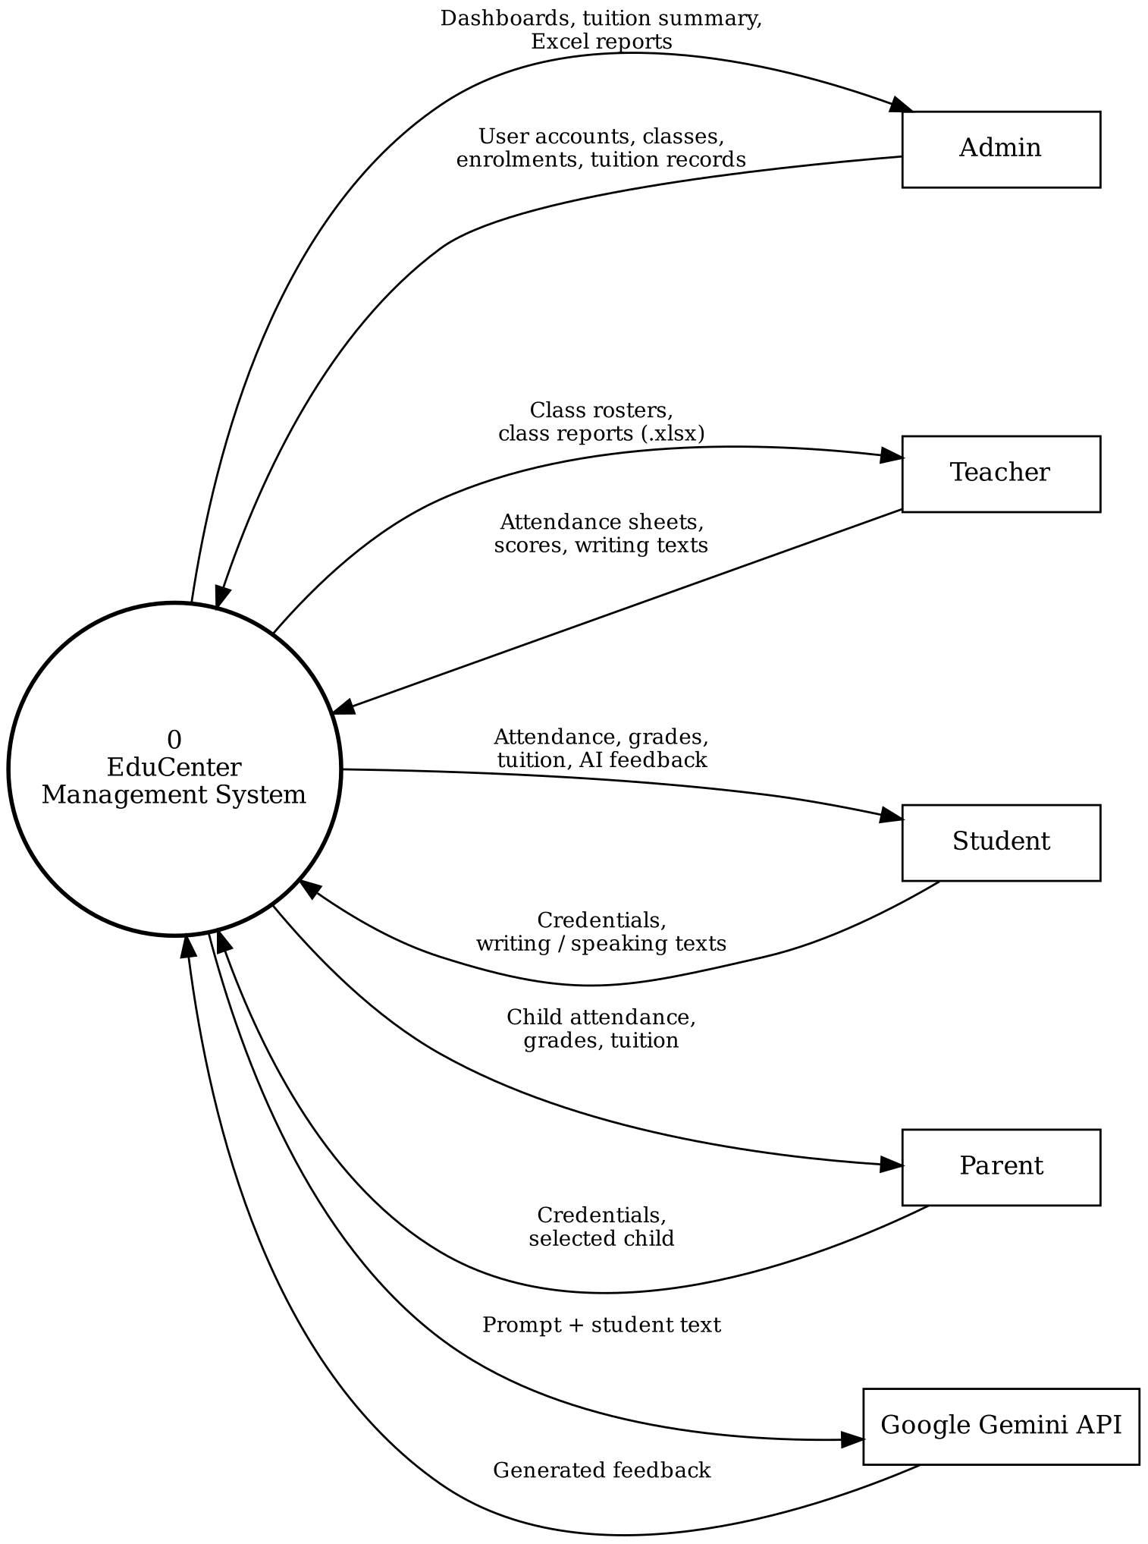

II. Data Flow Diagram Level 1
Level 1 is split into three parts so that every process and data store stays readable.
a) Authentication, authorisation and user management
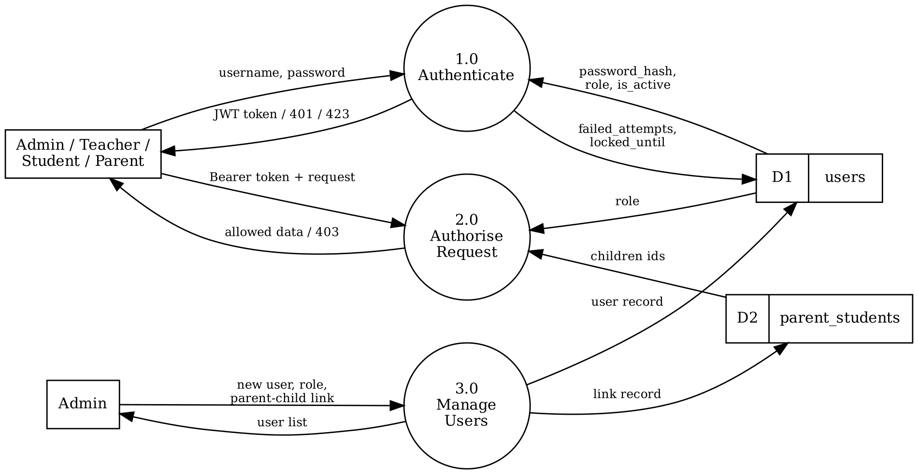
b) Academic operations: classes, attendance, scores and reports
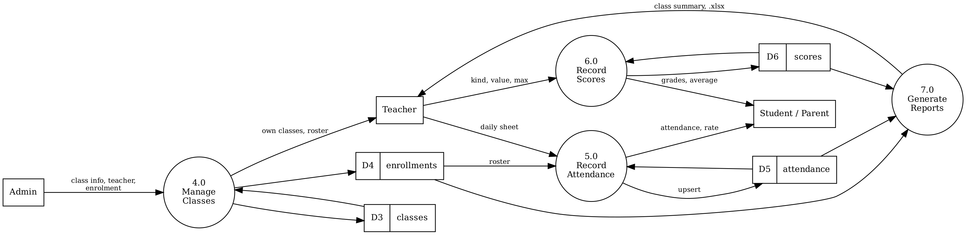

c) Tuition and AI Coach
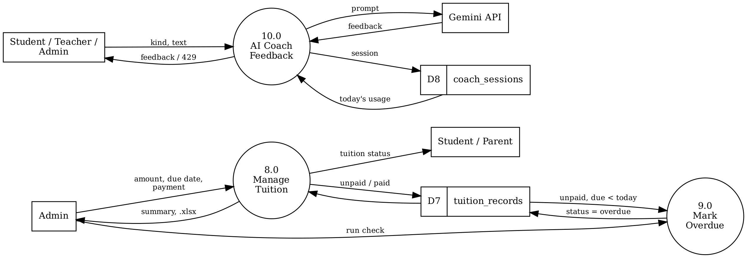
Data stores
Store | Table | Content
D1 | users | Accounts of all roles, password hash, login lock data
D2 | parent_students | Parent to child links
D3 | classes | Class code, name, schedule, teacher
D4 | enrollments | Students enrolled in each class
D5 | attendance | One record per student, class and date
D6 | scores | Score entries with kind and maximum value
D7 | tuition_records | Tuition items and payment status
D8 | coach_sessions | AI Coach input, feedback and provider

A. Entity Relationship Diagram
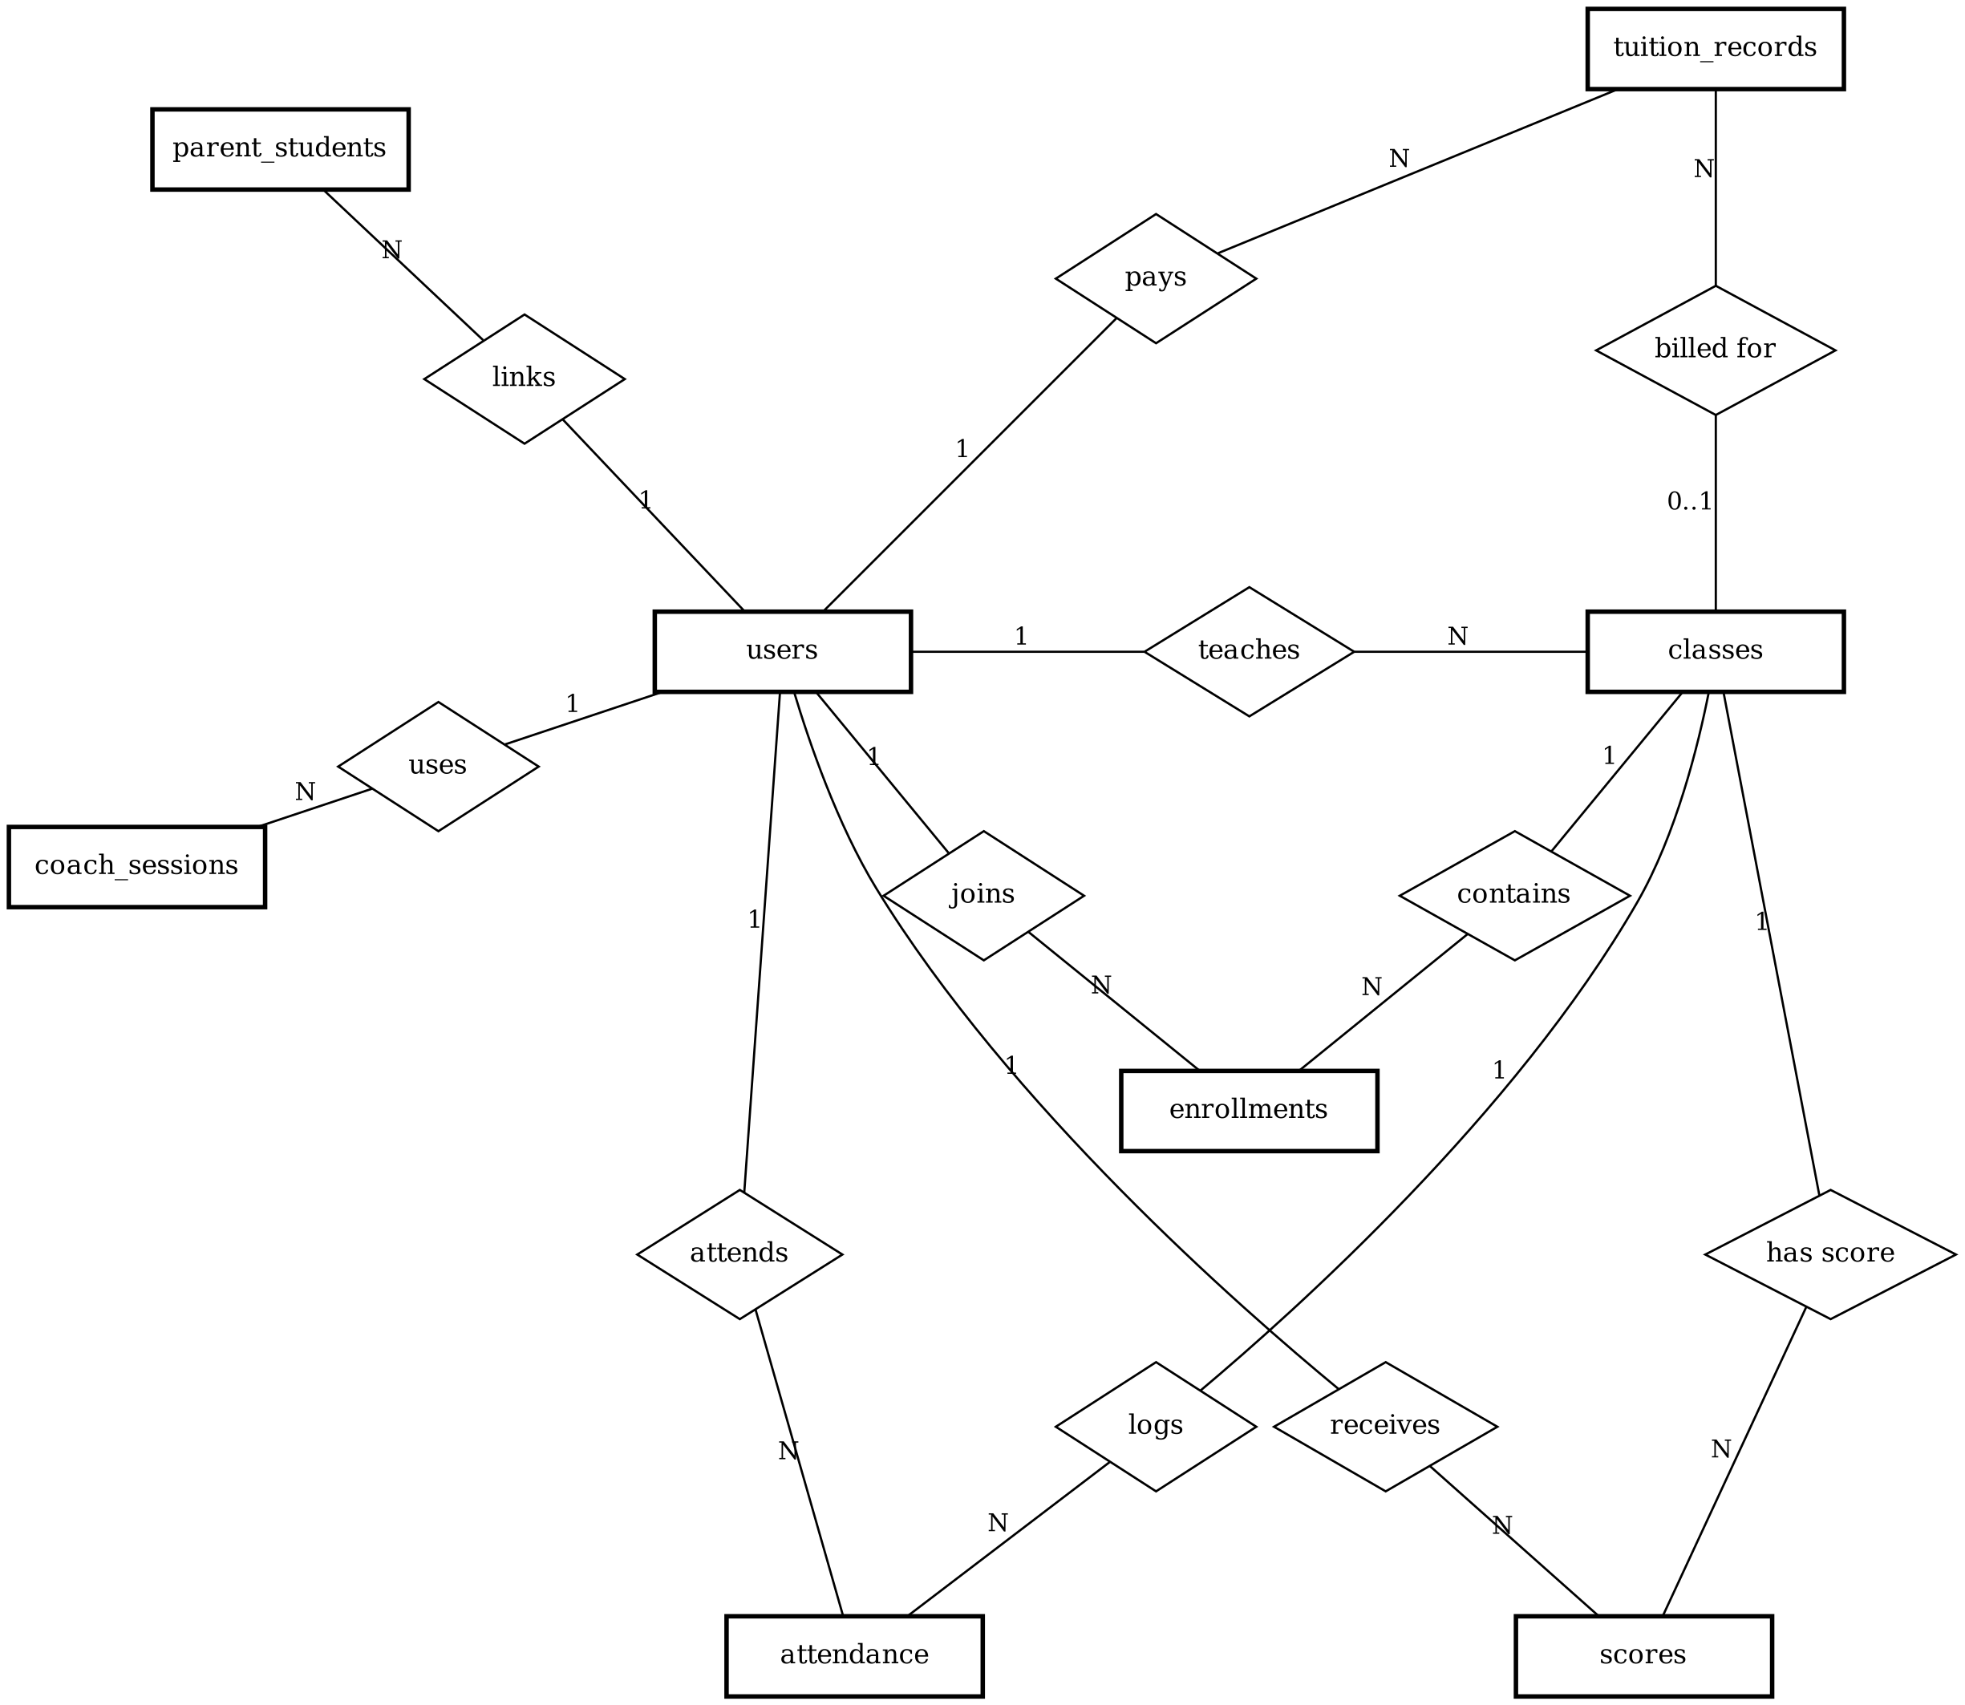
Cardinality: one user (teacher) teaches many classes; one class contains many enrolments, attendance records and scores; one student has many enrolments, attendance records, scores and tuition items; a parent is linked to many children through parent_students; one user has many AI Coach sessions.

B. Entity Attributes
1. User Entity (users)
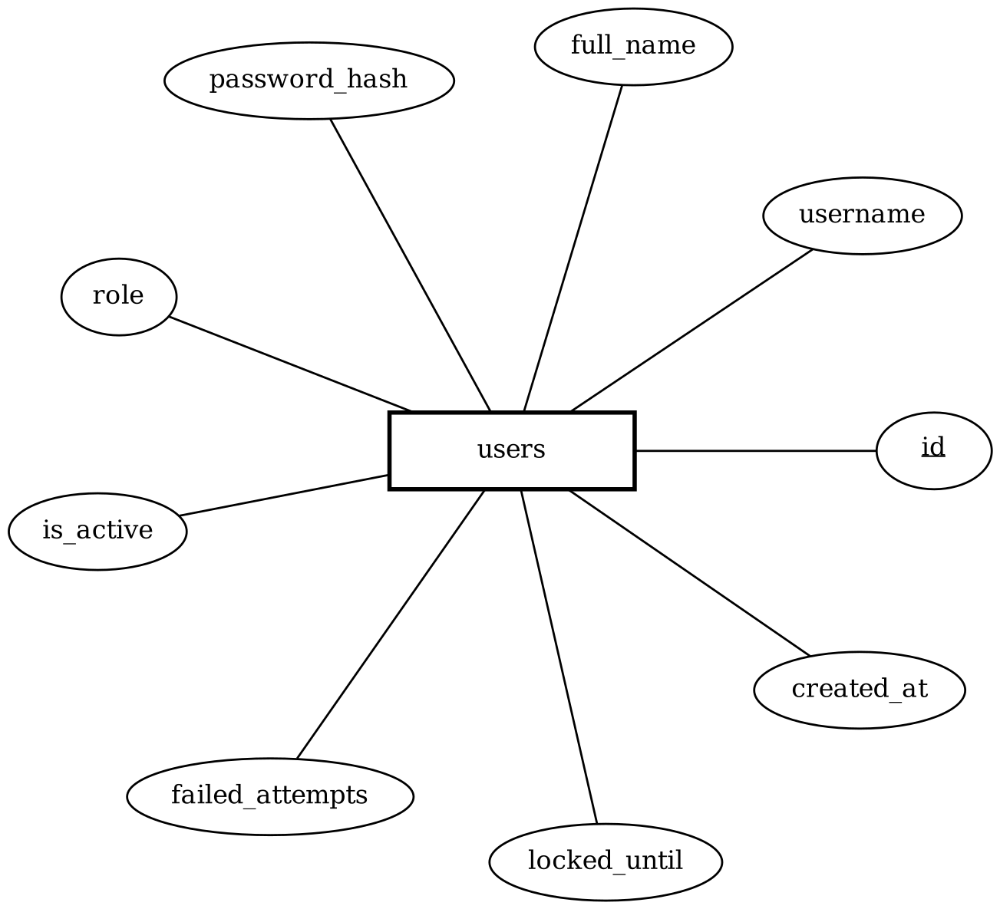
2. Class Entity (classes)
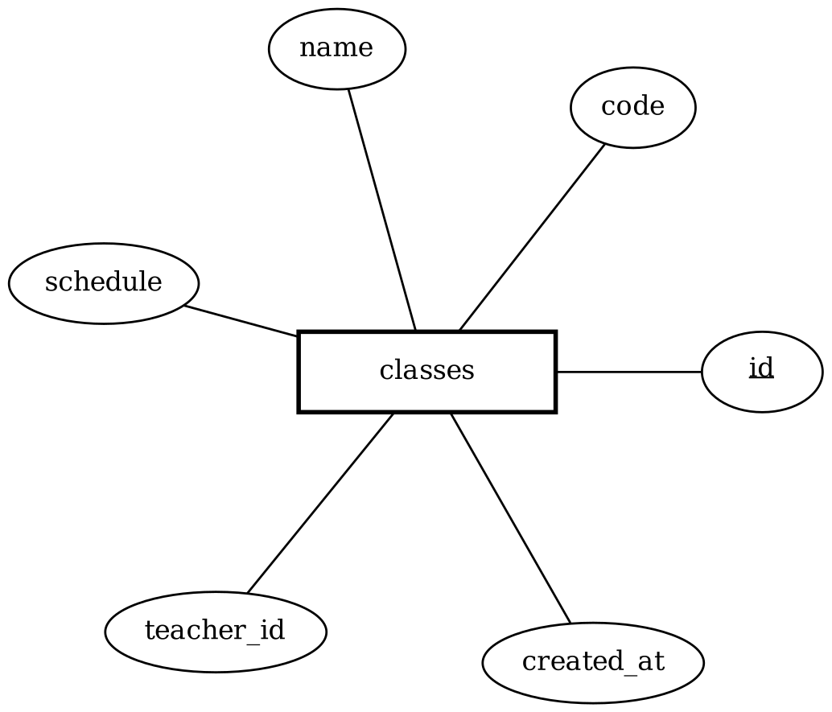
3. Enrolment Entity (enrollments)
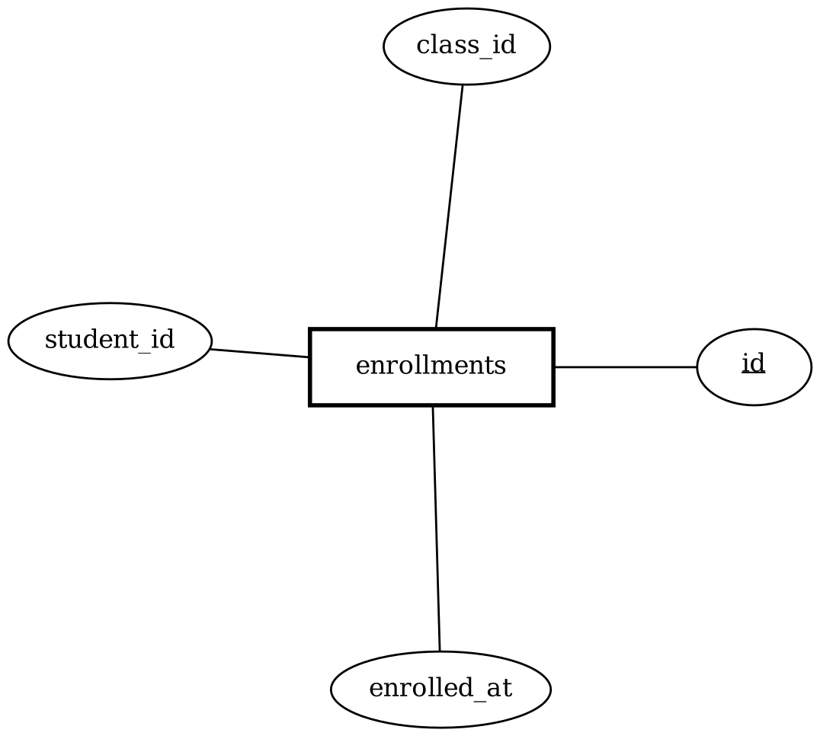
4. Parent - Student Link Entity (parent_students)
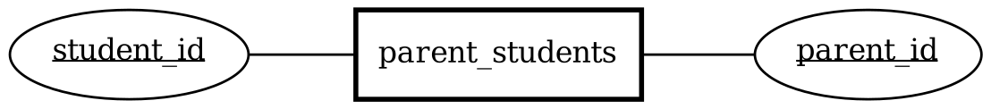
5. Attendance Entity (attendance)
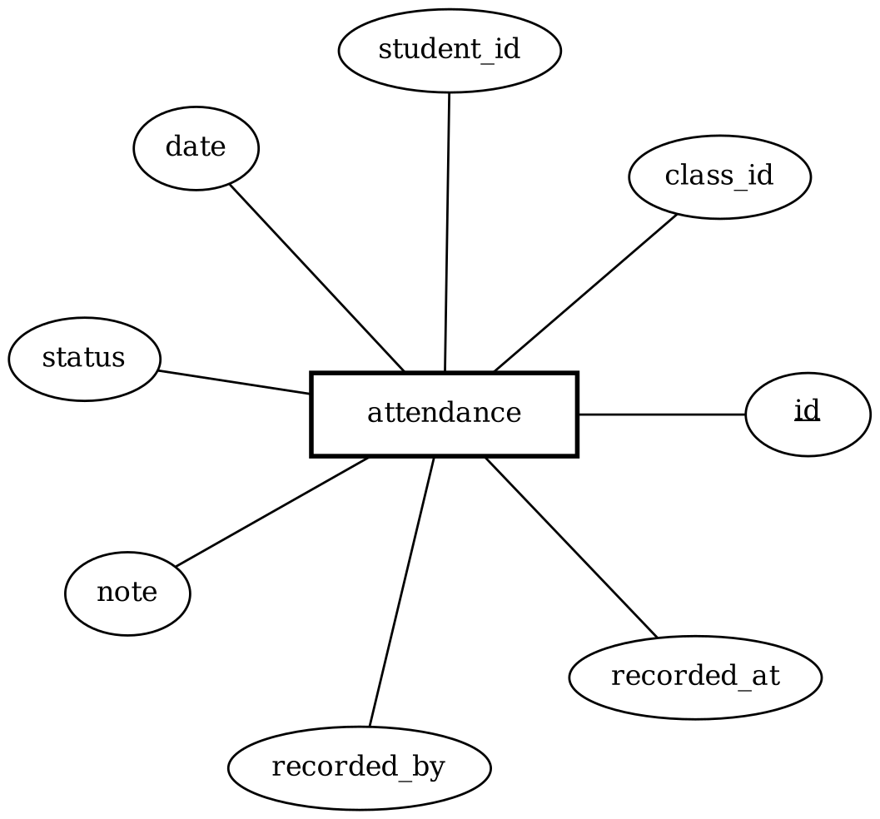
6. Score Entity (scores)
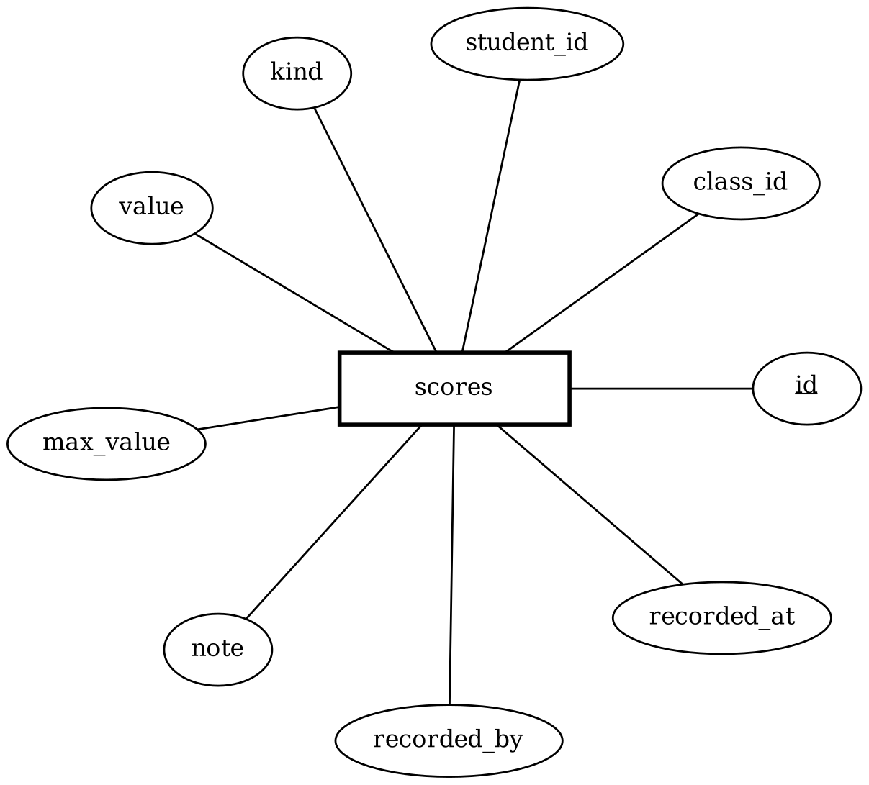
7. Tuition Entity (tuition_records)
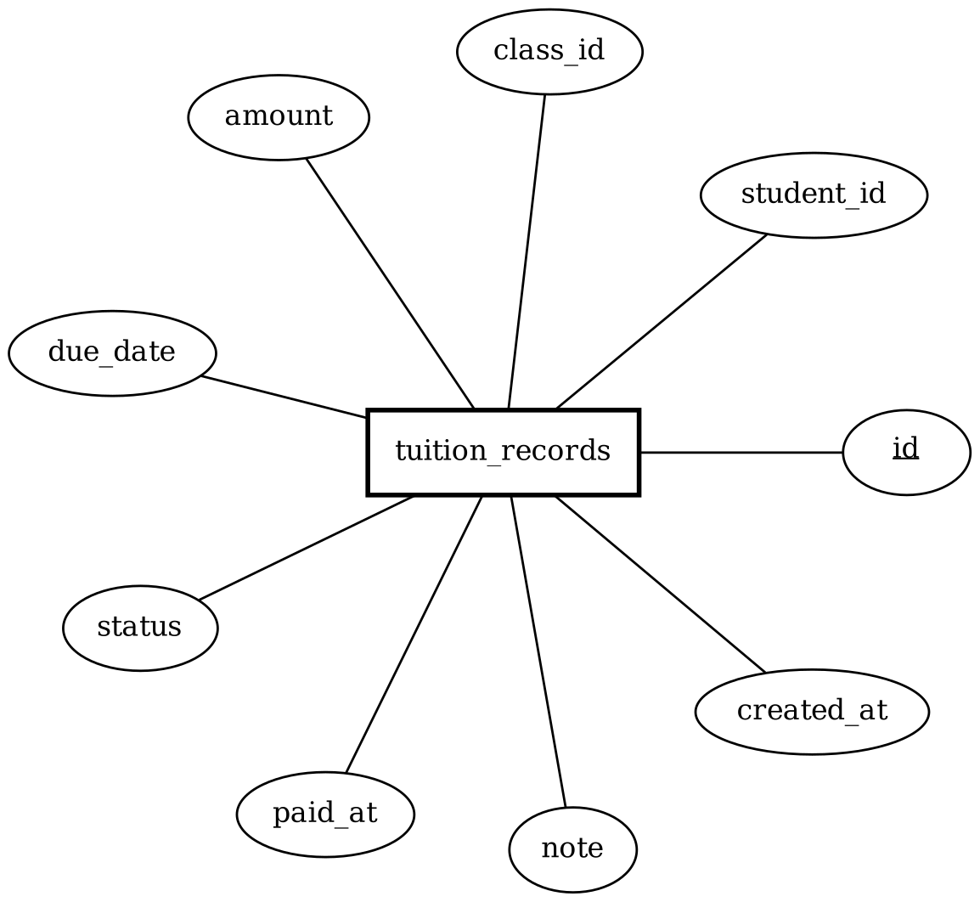
8. AI Coach Session Entity (coach_sessions)
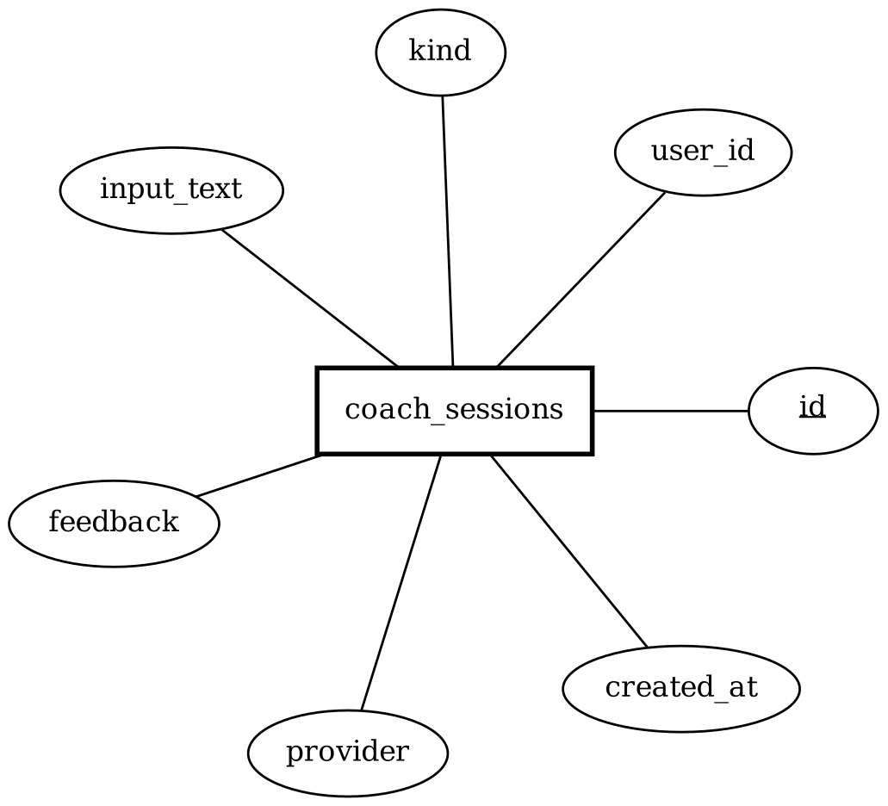

A. Table Design
Table Name: users
Serial | Fields | Data type | Keys | Constraints | Description
1 | id | integer | PK | Auto increment, Not Null | User identifier
2 | username | varchar(64) |  | Unique, Index, Not Null | Login name (letters, digits, _ . -)
3 | full_name | varchar(120) |  | Not Null | User's full name
4 | password_hash | varchar(255) |  | Not Null | bcrypt hash of the password
5 | role | varchar(16) |  | Not Null, in (admin, teacher, student, parent) | User role
6 | is_active | boolean |  | Not Null, Default true | Account is active
7 | failed_attempts | integer |  | Not Null, Default 0 | Consecutive failed logins
8 | locked_until | timestamptz |  | Nullable | End of temporary lock
9 | created_at | timestamptz |  | Not Null, Default now (UTC) | Record creation time

Table Name: parent_students
Serial | Fields | Data type | Keys | Constraints | Description
1 | parent_id | integer | PK, FK | References users.id, On delete cascade | Parent account
2 | student_id | integer | PK, FK | References users.id, On delete cascade | Child (student) account

Table Name: classes
Serial | Fields | Data type | Keys | Constraints | Description
1 | id | integer | PK | Auto increment, Not Null | Class identifier
2 | code | varchar(32) |  | Unique, Index, Not Null | Class code, e.g. IELTS-A1
3 | name | varchar(120) |  | Not Null | Class name
4 | schedule | varchar(200) |  | Nullable | Timetable description
5 | teacher_id | integer | FK | References users.id, On delete set null, Index | Teacher in charge
6 | created_at | timestamptz |  | Not Null, Default now (UTC) | Record creation time

Table Name: enrollments
Serial | Fields | Data type | Keys | Constraints | Description
1 | id | integer | PK | Auto increment, Not Null | Enrolment identifier
2 | class_id | integer | FK | References classes.id, On delete cascade, Index | Class
3 | student_id | integer | FK | References users.id, On delete cascade, Index | Student
4 | enrolled_at | timestamptz |  | Not Null, Default now (UTC) | Enrolment time
5 | (class_id, student_id) |  | UQ | Unique uq_enrollment | A student is enrolled once per class

Table Name: attendance
Serial | Fields | Data type | Keys | Constraints | Description
1 | id | integer | PK | Auto increment, Not Null | Attendance identifier
2 | class_id | integer | FK | References classes.id, On delete cascade, Index | Class
3 | student_id | integer | FK | References users.id, On delete cascade, Index | Student
4 | date | date |  | Not Null, Index | Session date
5 | status | varchar(16) |  | Not Null, in (present, absent, excused, late) | Attendance status
6 | note | varchar(300) |  | Nullable | Teacher's note
7 | recorded_by | integer | FK | References users.id, On delete set null | User who recorded
8 | recorded_at | timestamptz |  | Not Null, Default now (UTC) | Recording time
9 | (class_id, student_id, date) |  | UQ | Unique uq_attendance_day | One record per student per day

Table Name: scores
Serial | Fields | Data type | Keys | Constraints | Description
1 | id | integer | PK | Auto increment, Not Null | Score identifier
2 | class_id | integer | FK | References classes.id, On delete cascade, Index | Class
3 | student_id | integer | FK | References users.id, On delete cascade, Index | Student
4 | kind | varchar(40) |  | Not Null | Score type: quiz, midterm, final...
5 | value | numeric(5,2) |  | Not Null, >= 0 and <= max_value | Score obtained
6 | max_value | numeric(5,2) |  | Not Null, Default 10, > 0 | Maximum score
7 | note | varchar(300) |  | Nullable | Teacher's note
8 | recorded_by | integer | FK | References users.id, On delete set null | User who recorded
9 | recorded_at | timestamptz |  | Not Null, Default now (UTC) | Recording time

Table Name: tuition_records
Serial | Fields | Data type | Keys | Constraints | Description
1 | id | integer | PK | Auto increment, Not Null | Tuition item identifier
2 | student_id | integer | FK | References users.id, On delete cascade, Index | Student
3 | class_id | integer | FK | References classes.id, On delete set null, Nullable | Related class
4 | amount | numeric(12,2) |  | Not Null, > 0 | Amount to pay (VND)
5 | due_date | date |  | Not Null, Index | Payment deadline
6 | status | varchar(16) |  | Not Null, Default unpaid, in (unpaid, paid, overdue) | Payment status
7 | paid_at | timestamptz |  | Nullable | Payment time
8 | note | varchar(300) |  | Nullable | Note
9 | created_at | timestamptz |  | Not Null, Default now (UTC) | Record creation time

Table Name: coach_sessions
Serial | Fields | Data type | Keys | Constraints | Description
1 | id | integer | PK | Auto increment, Not Null | Session identifier
2 | user_id | integer | FK | References users.id, On delete cascade, Index | User who asked
3 | kind | varchar(16) |  | Not Null, in (writing, speaking) | Type of text
4 | input_text | text |  | Not Null | Text submitted by the user
5 | feedback | text |  | Not Null | Feedback returned
6 | provider | varchar(32) |  | Not Null, in (gemini, rules) | Feedback source
7 | created_at | timestamptz |  | Not Null, Default now (UTC), Index | Creation time (daily limit)

B. Relationship Diagram
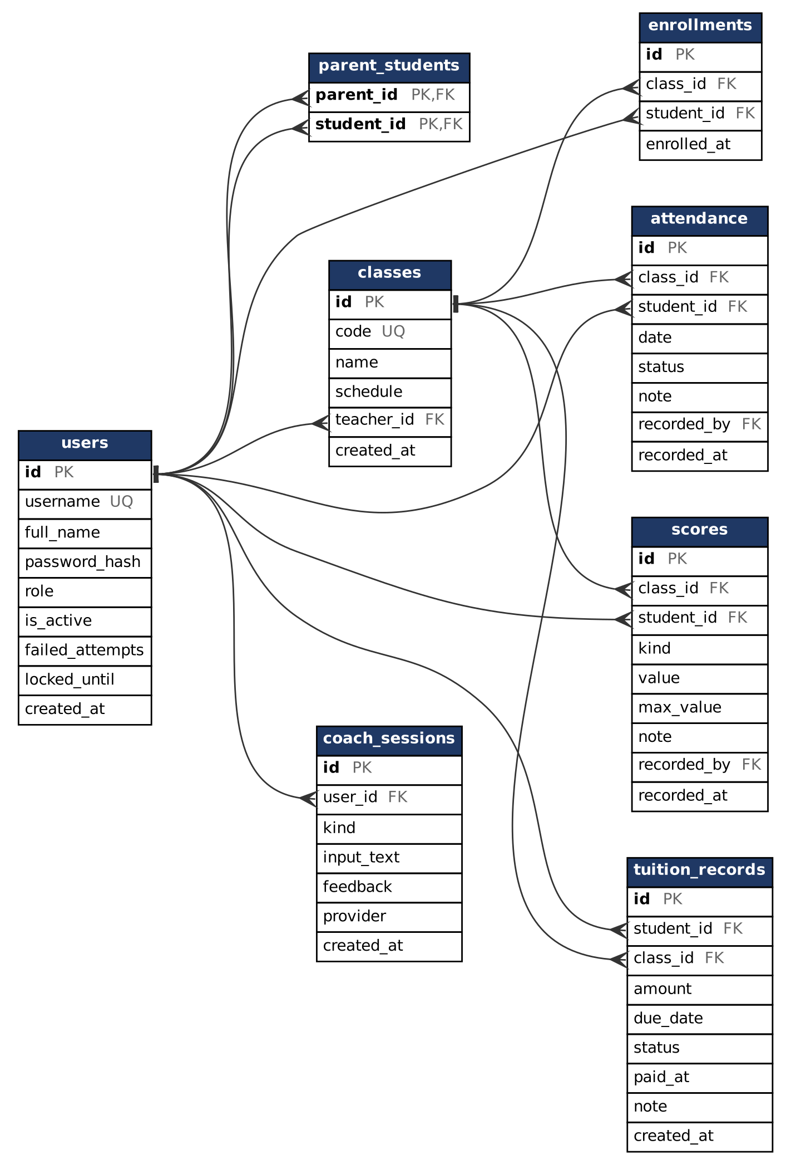

SiteMap
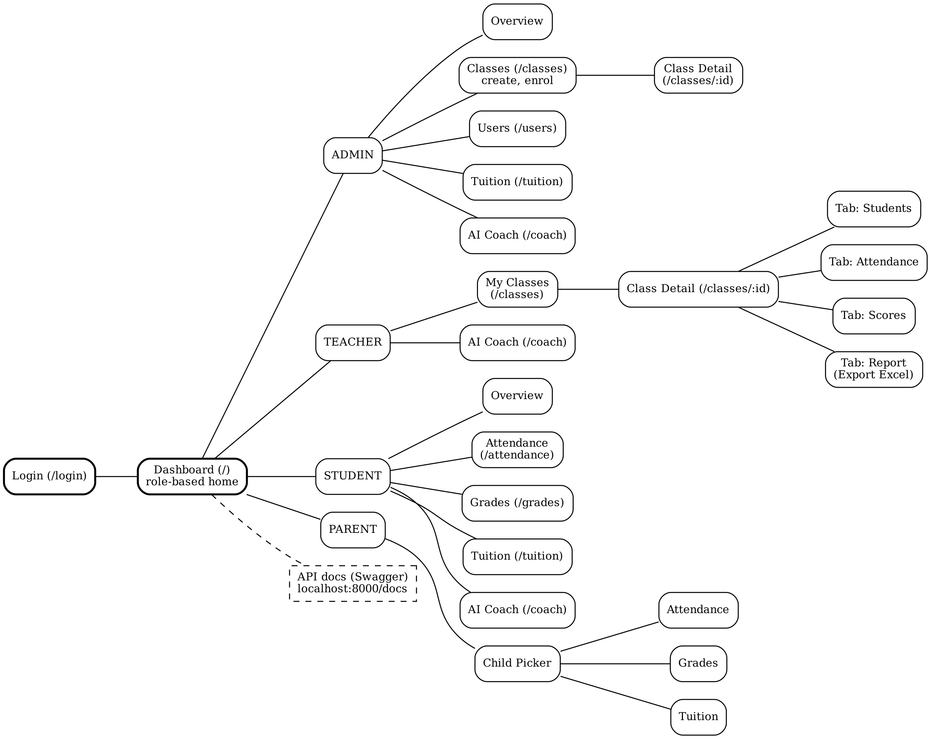
Every route except /login is protected. The web interface checks the role to show the right menu, and the API checks the role and data scope again on each request.

Algorithm
This section describes the algorithms of the three most important processes of the system.
1. Login with temporary account lock
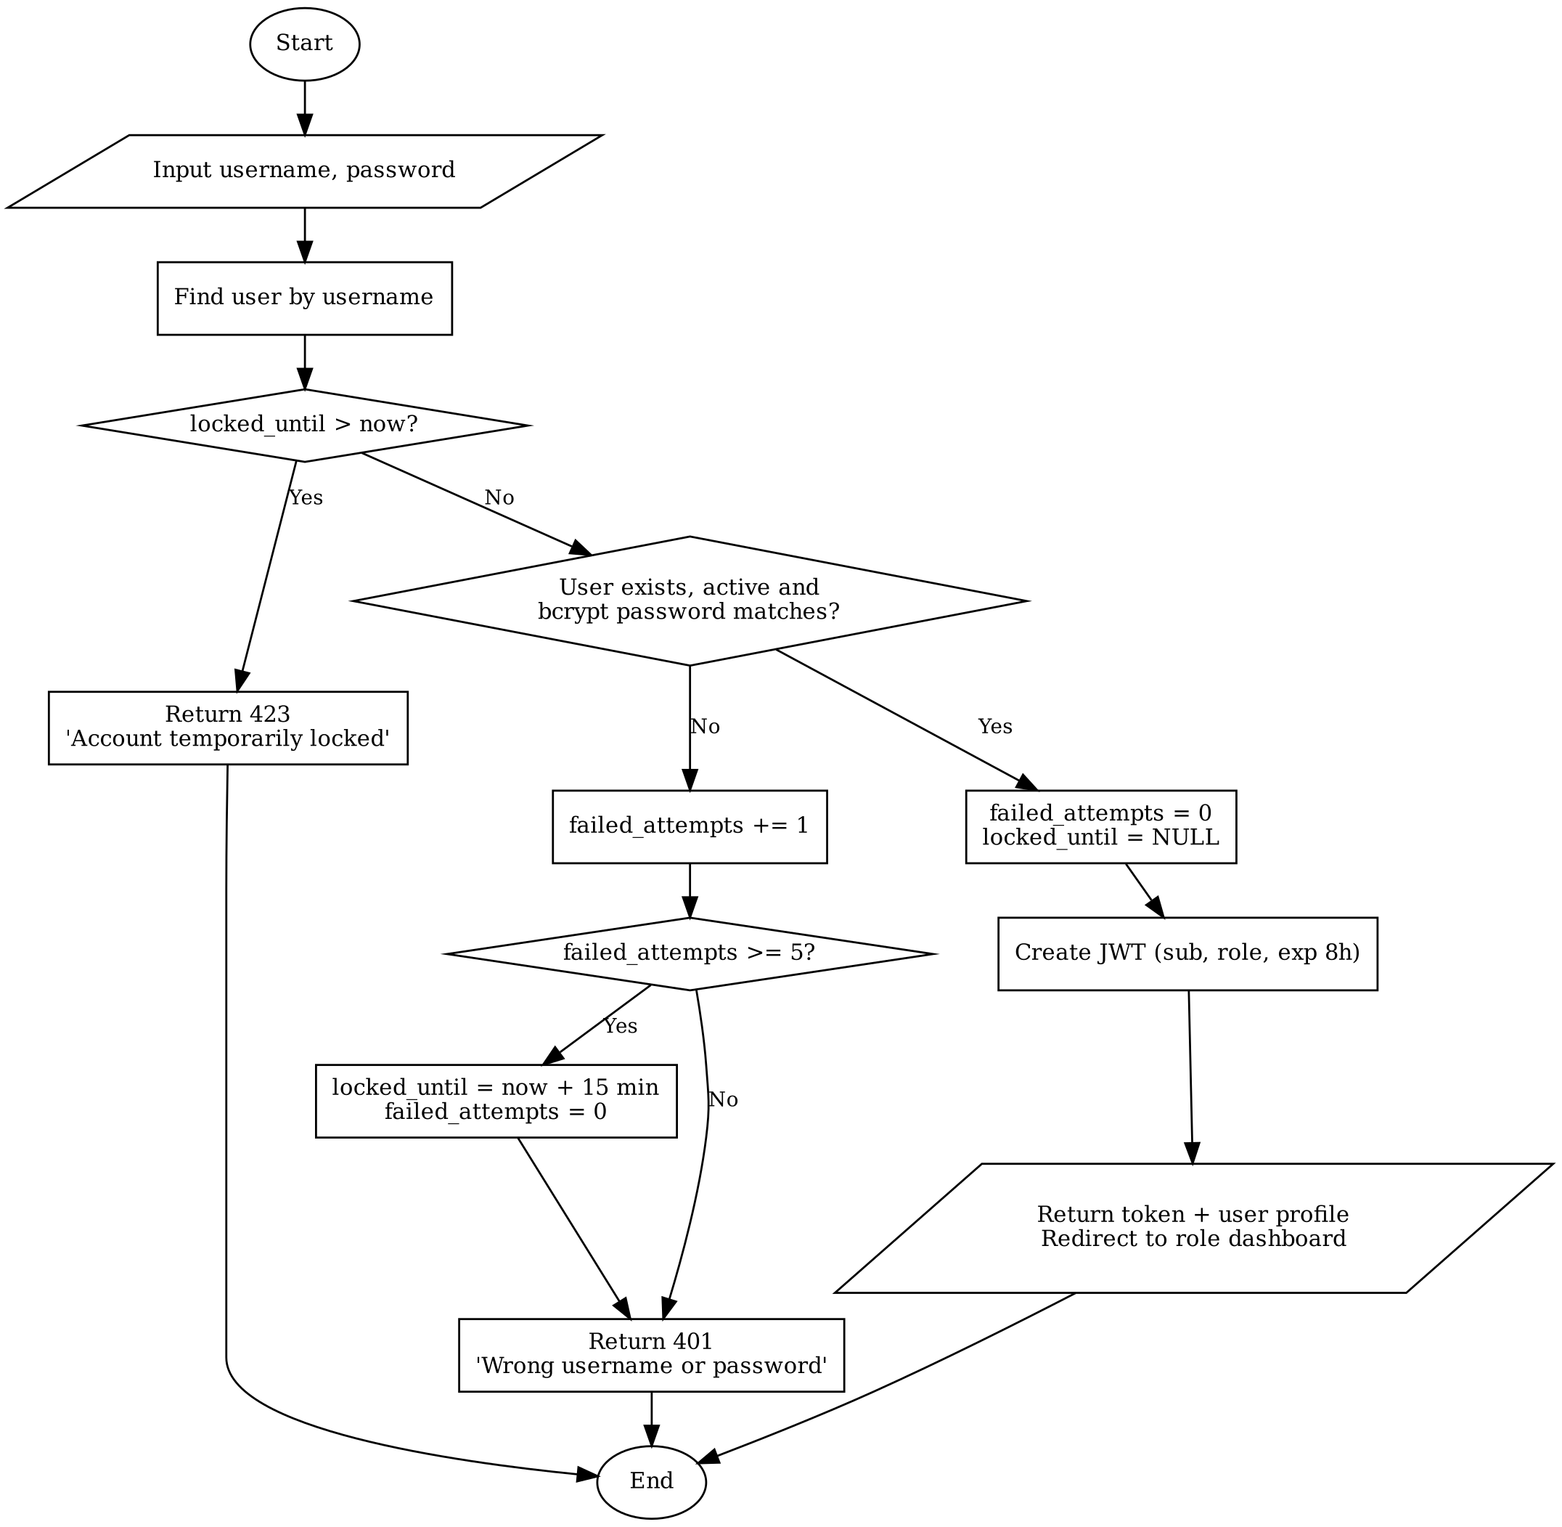

2. Teacher saves class attendance (batch upsert)
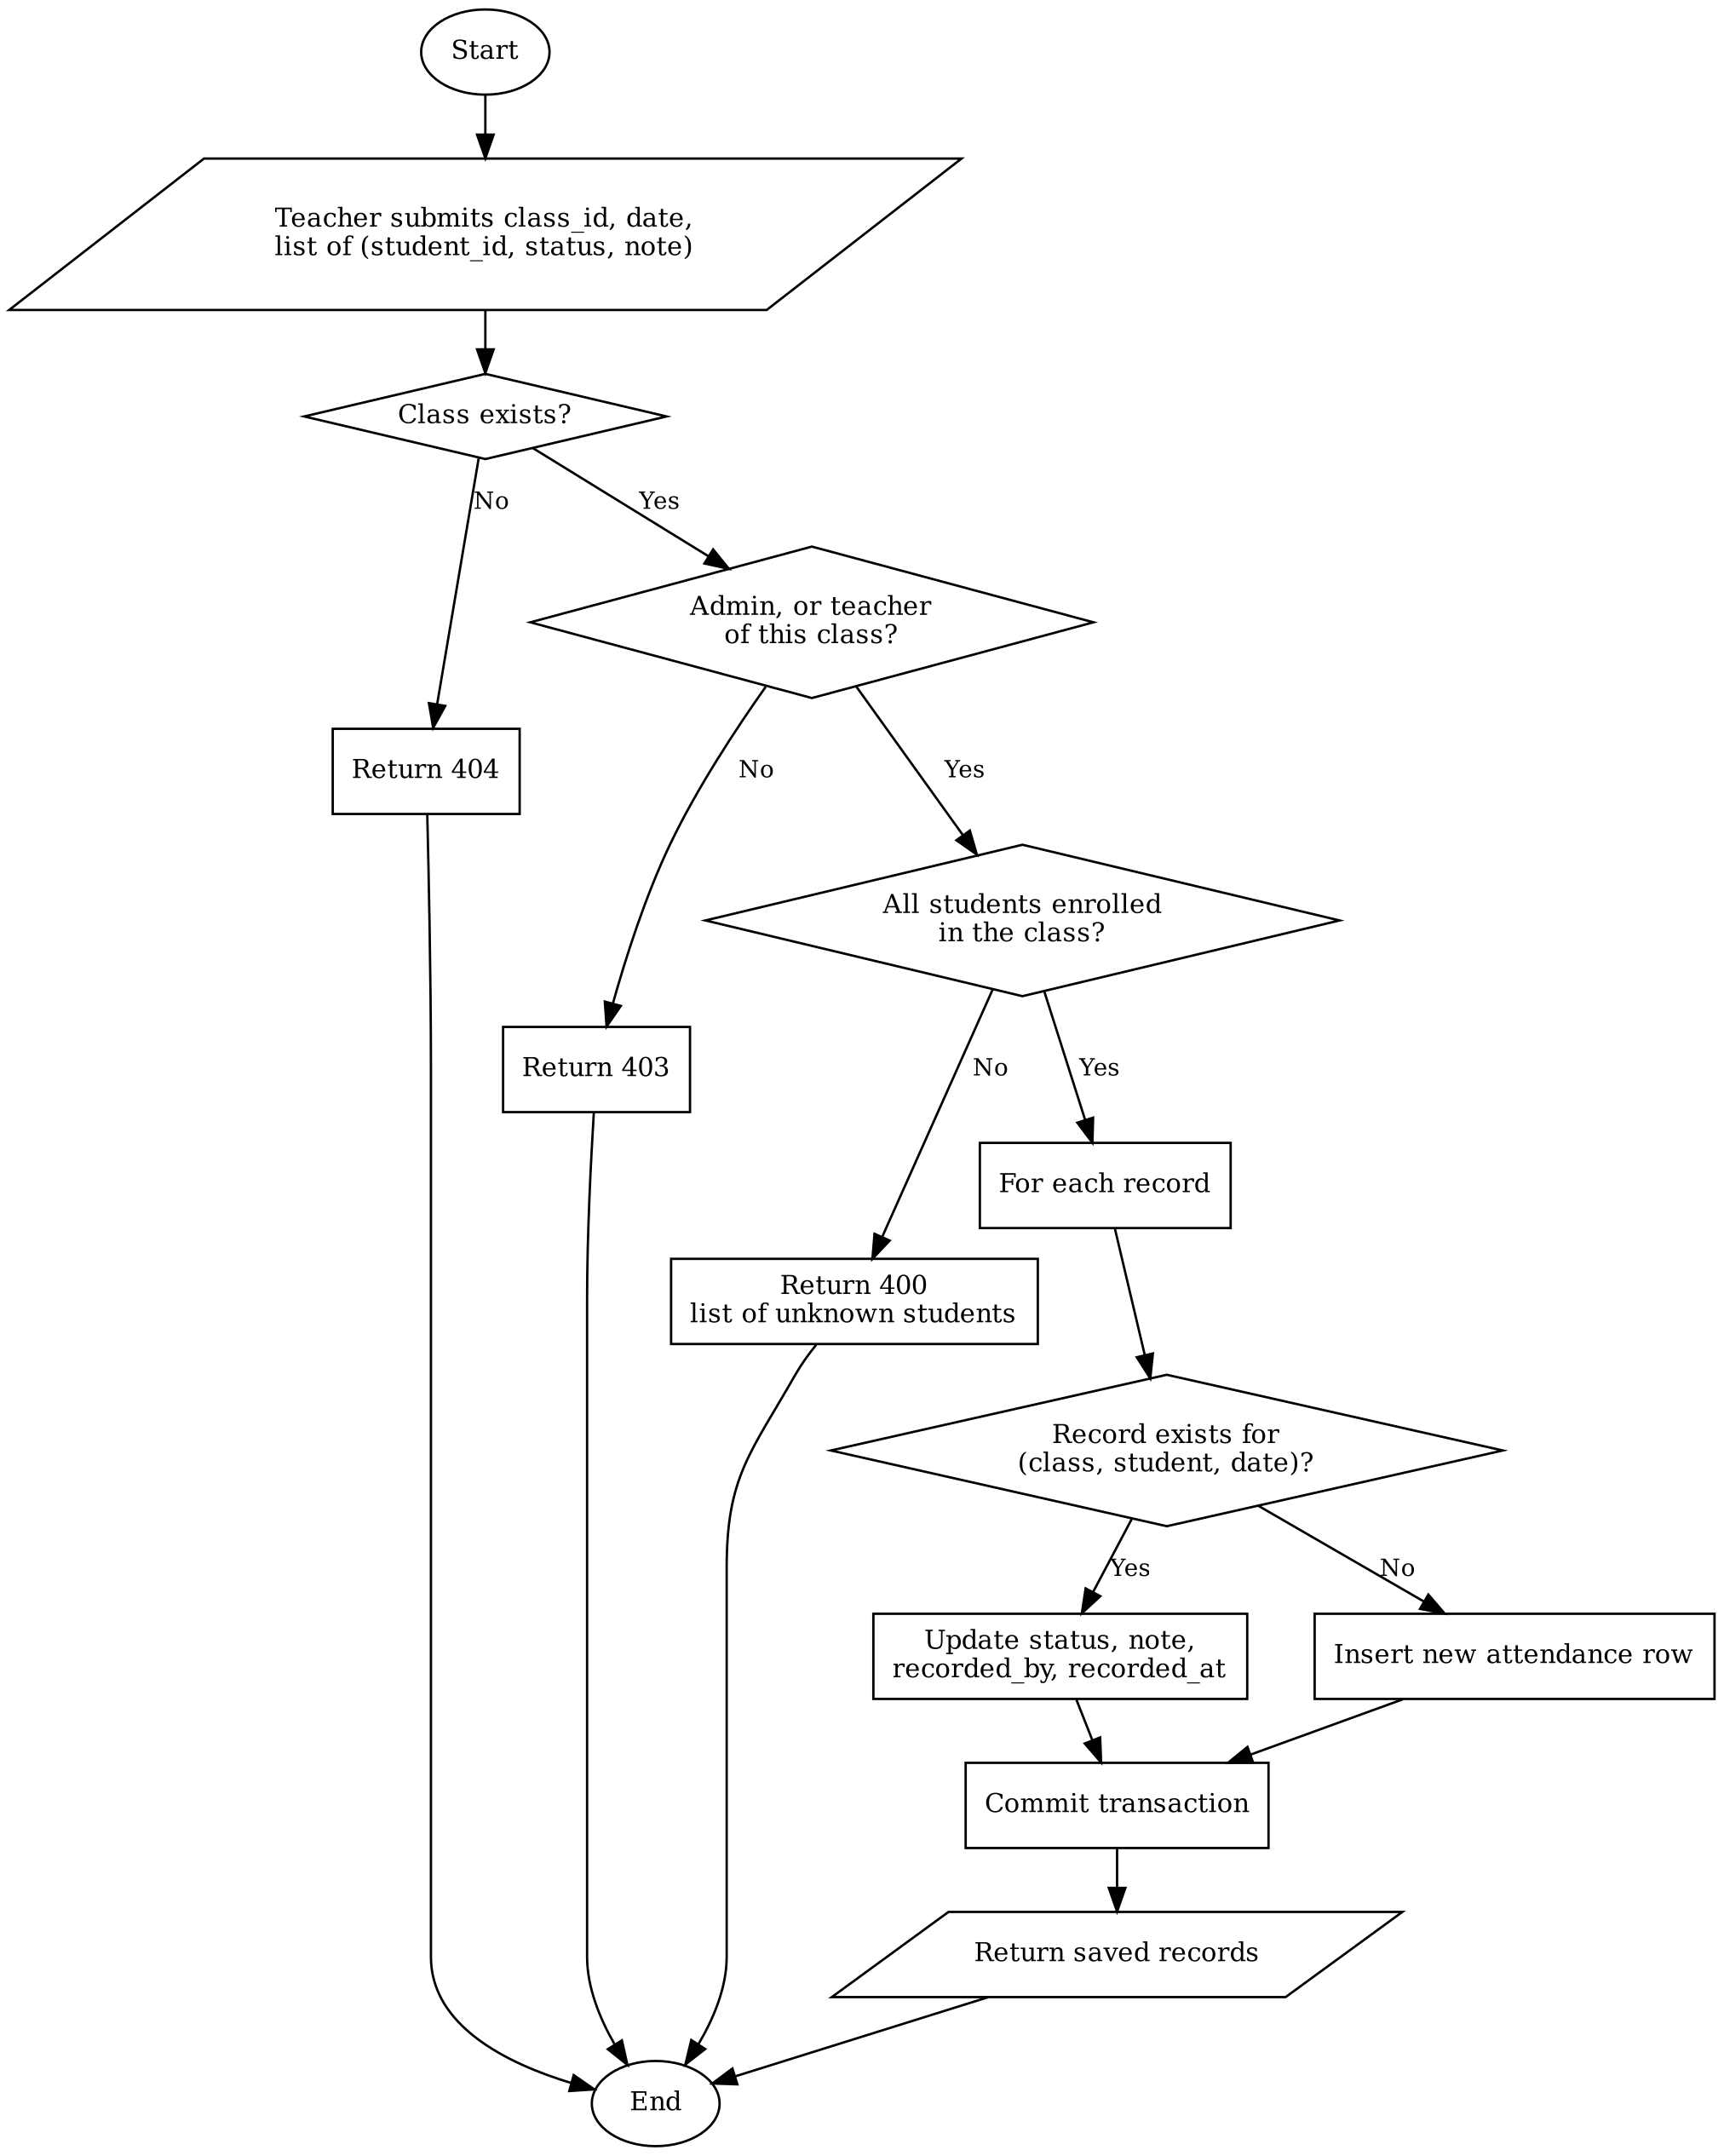

3. AI Coach feedback with daily limit and fallback
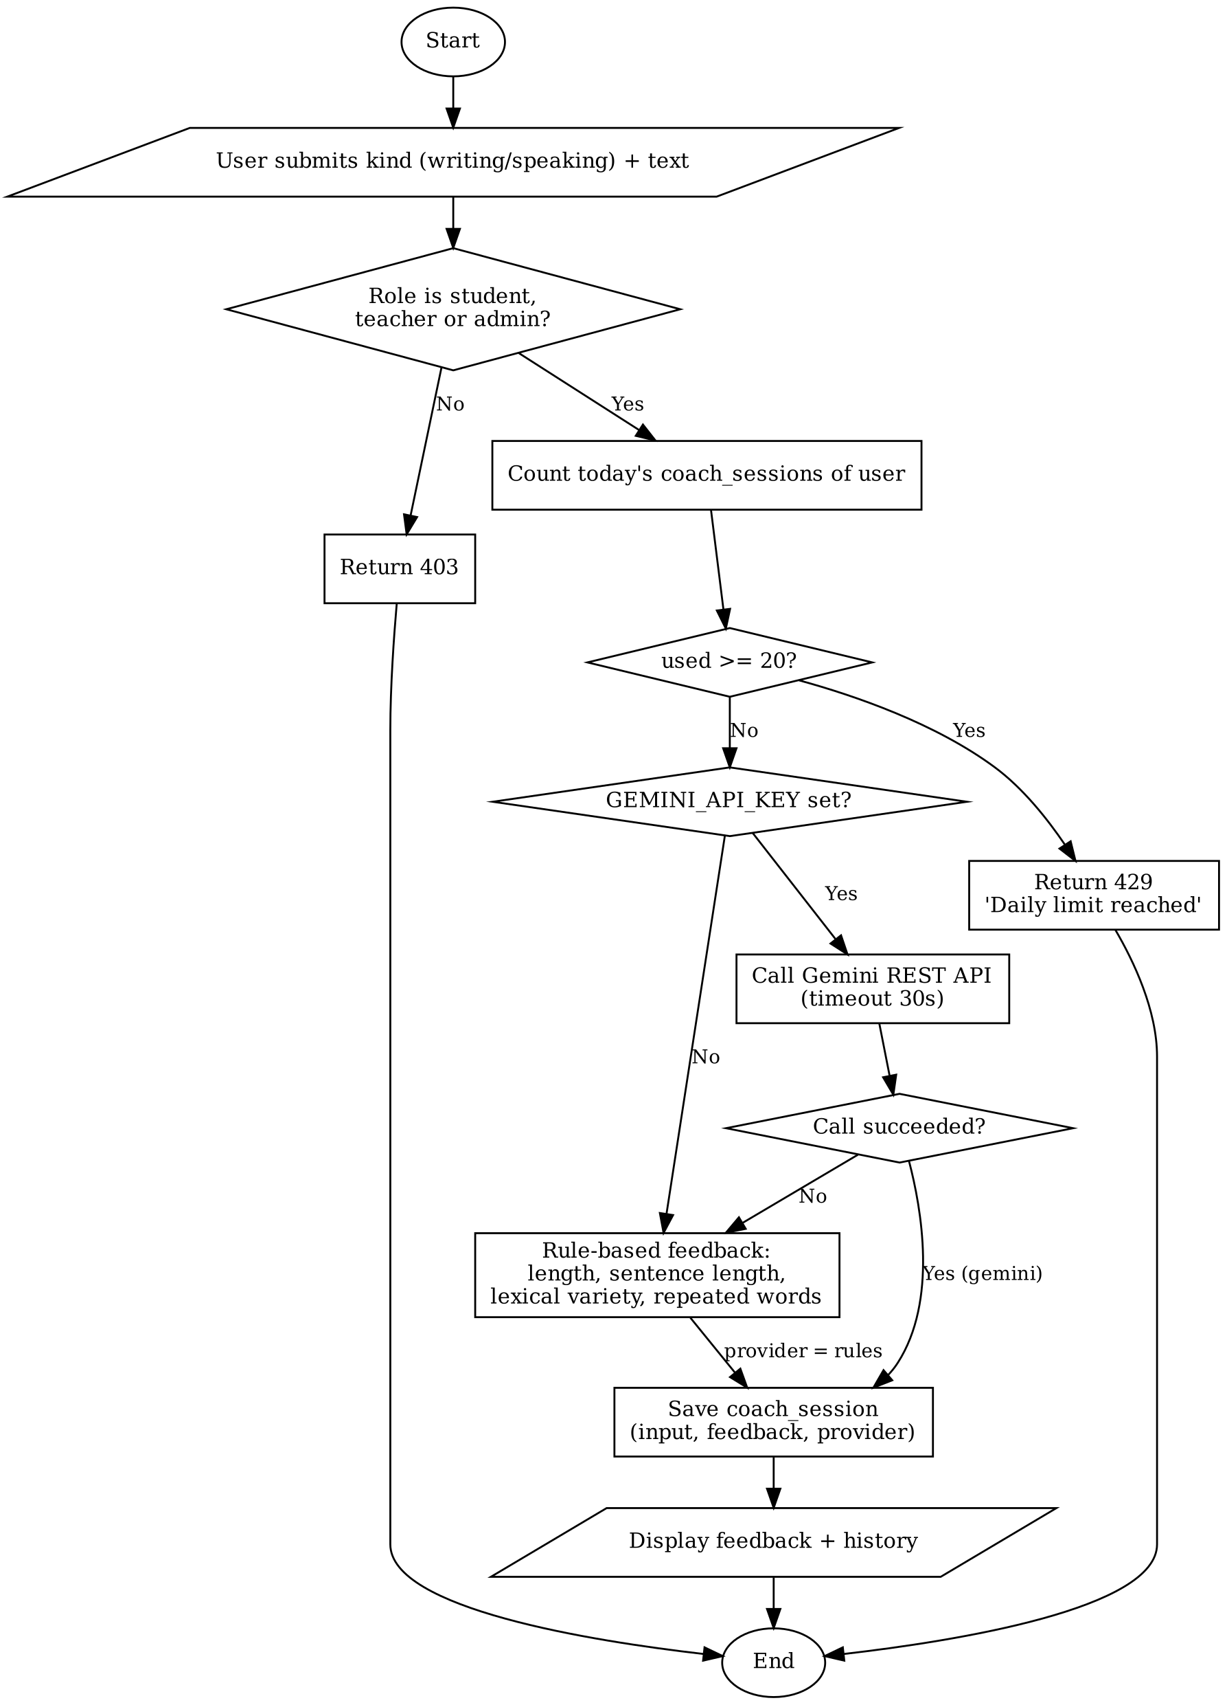

Review 03

Screen shots
This section describes the main screens of the web interface (React, served by nginx at http://localhost:8080) and the API documentation page.
1. Login
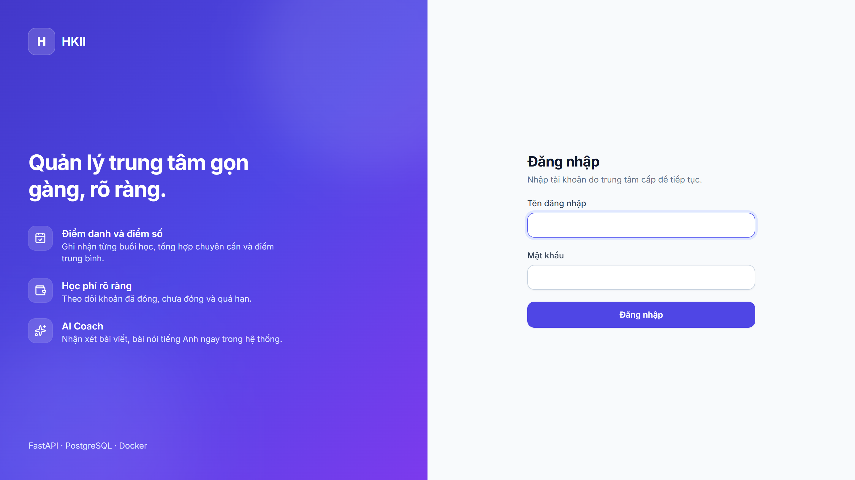
• Description: The entry page of the web interface. Users enter username and password; wrong credentials show one generic message, and repeated failures lock the account for 15 minutes.
• From: Root URL or any protected route when the user is not logged in.
• To: Dashboard of the user's role after a successful login.

2. Admin Dashboard
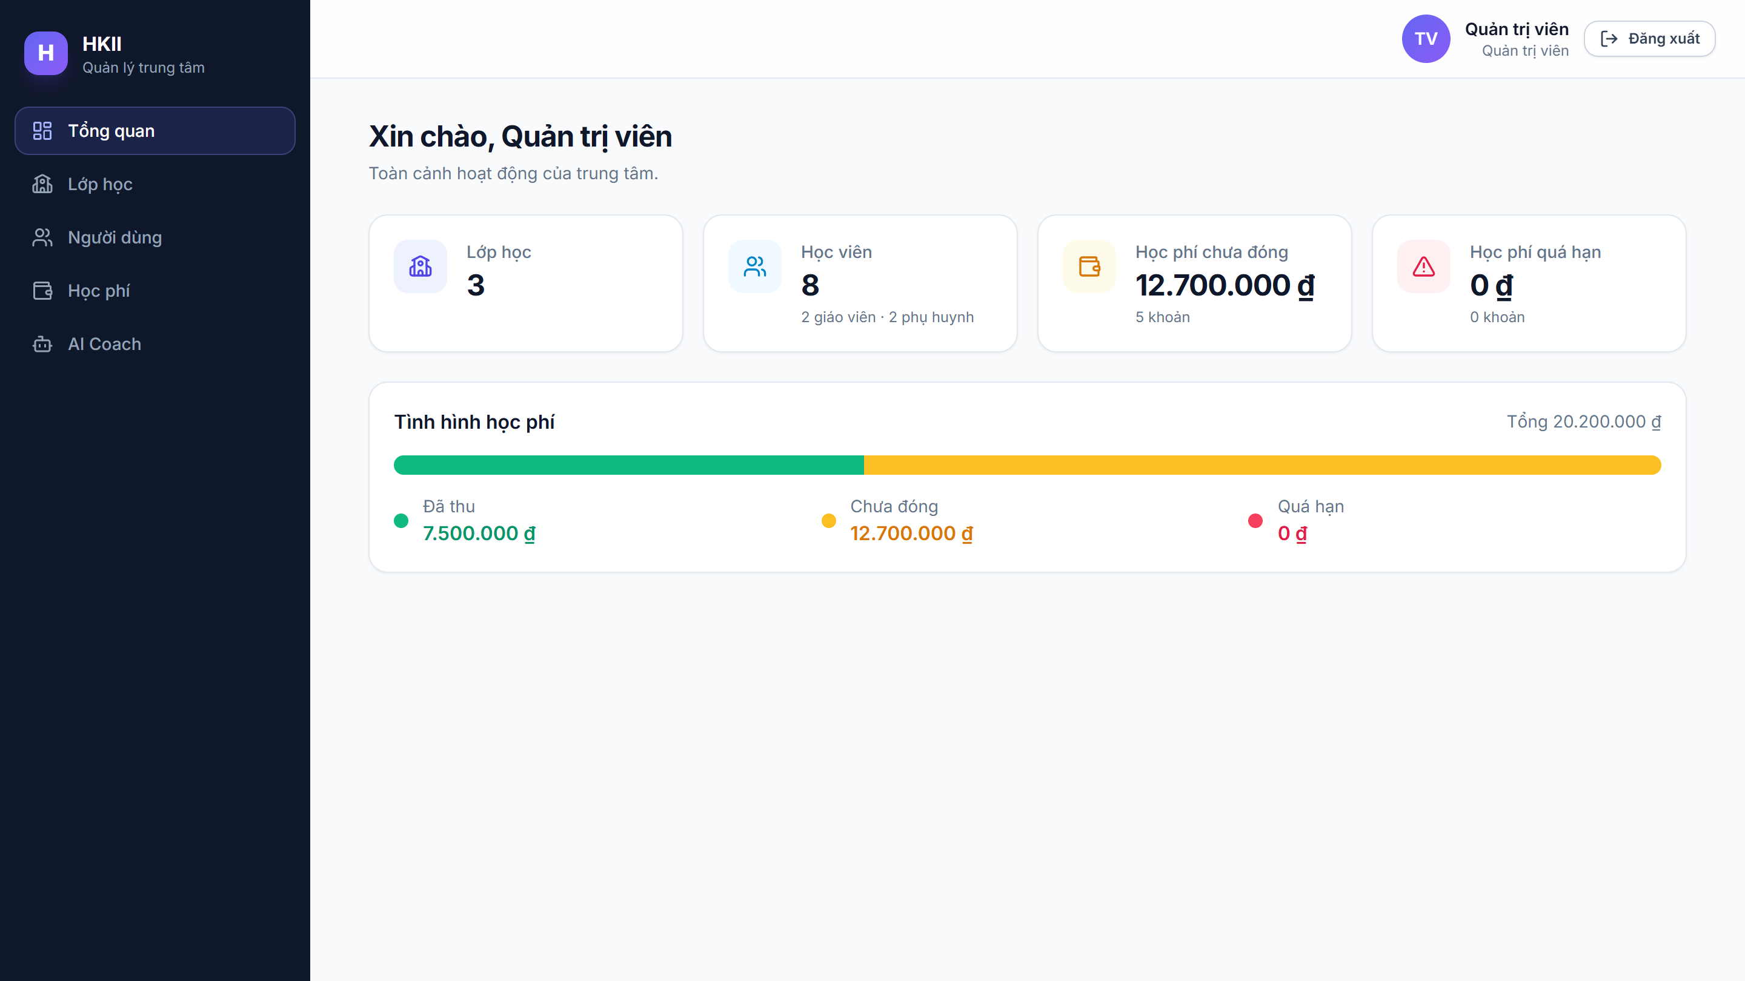
• Description: Overview for the administrator: number of users, classes and tuition figures by status.
• From: Opened automatically after an admin logs in, or from the Overview menu.
• To: Classes, Users, Tuition and AI Coach pages.

3. User Management
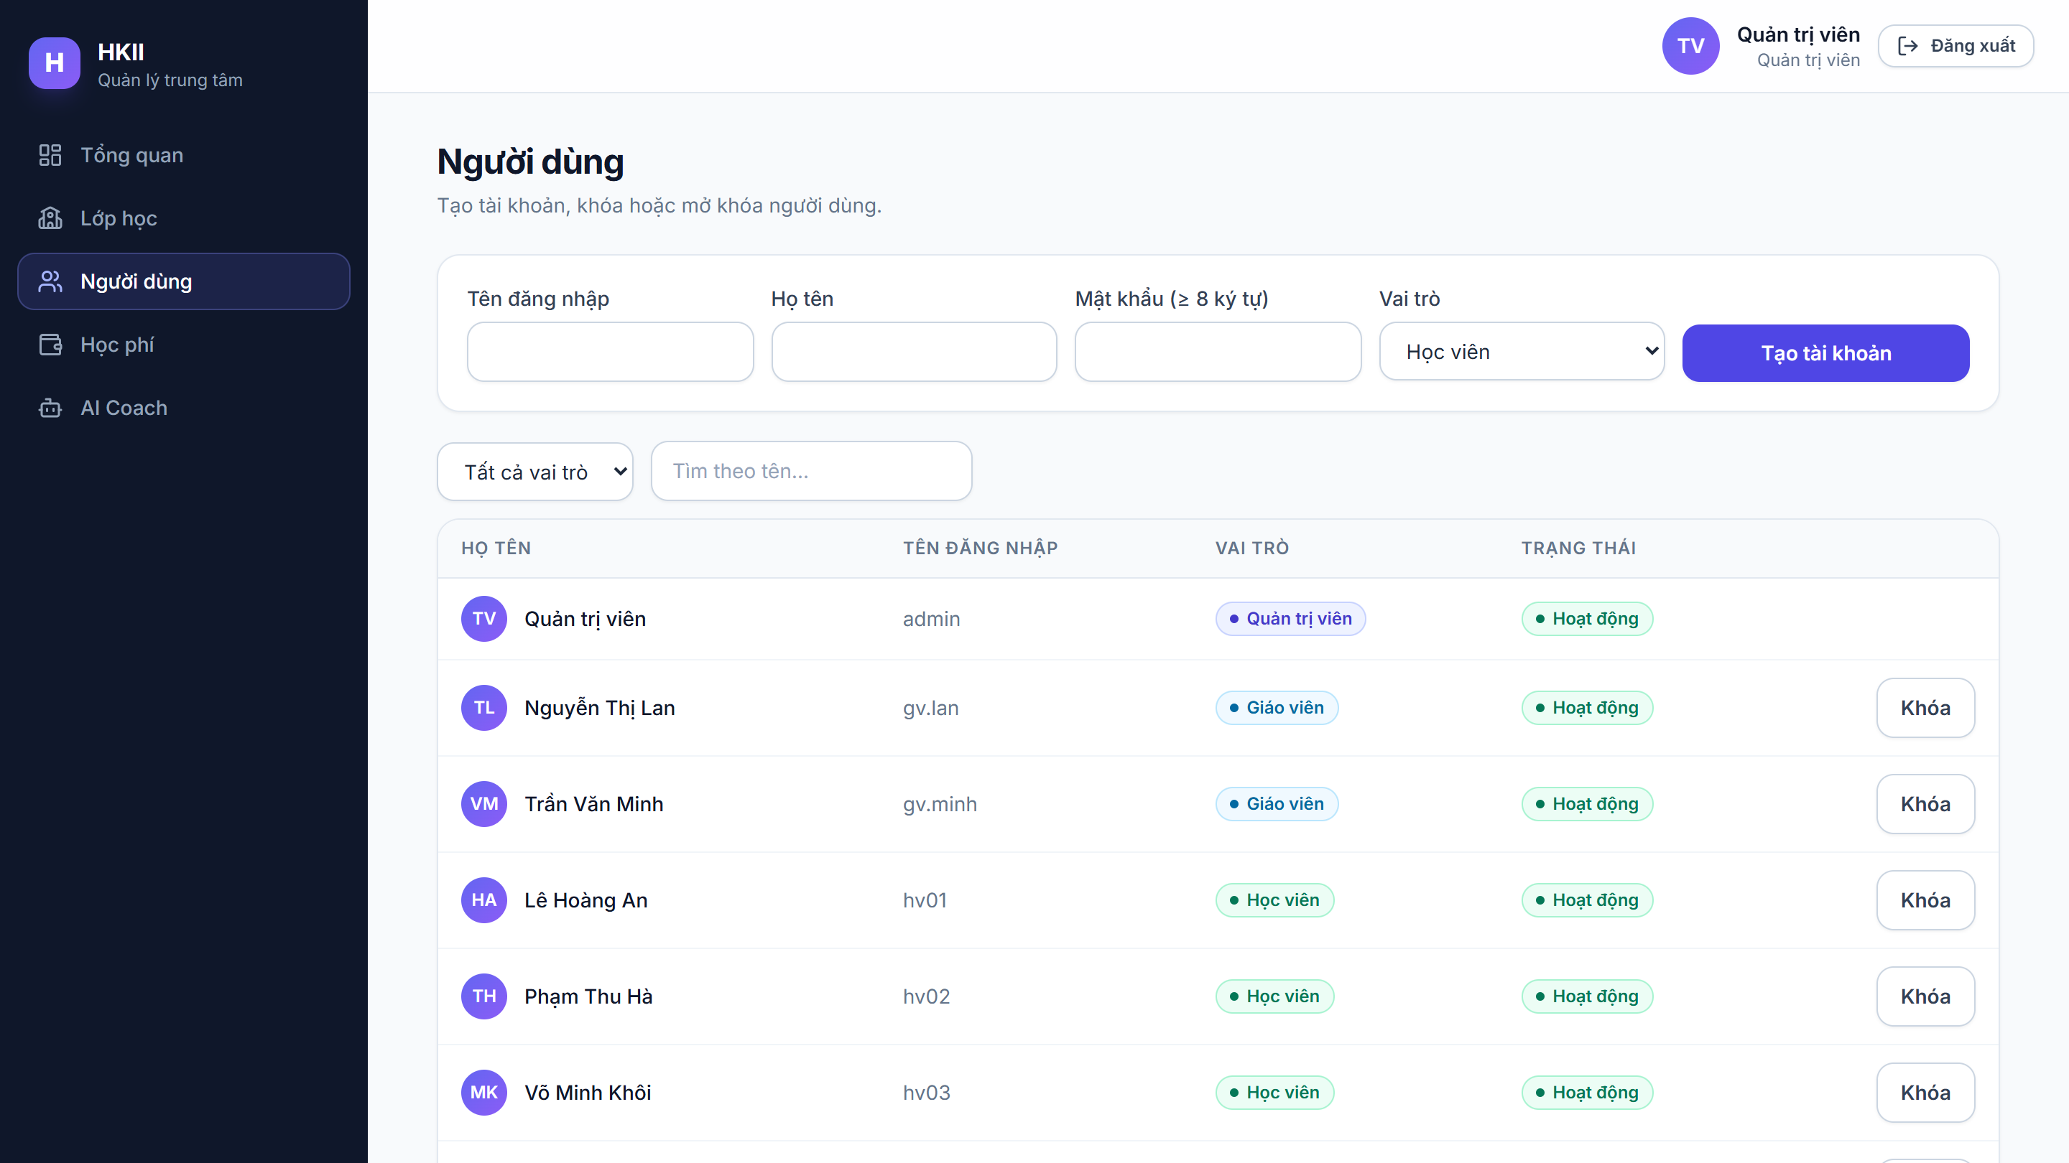
• Description: Admin creates accounts for all roles, edits full name, role and password, and activates or deactivates accounts.
• From: Users menu (admin only).
• To: Stays on the same page and refreshes the list after each change.

4. Class Management
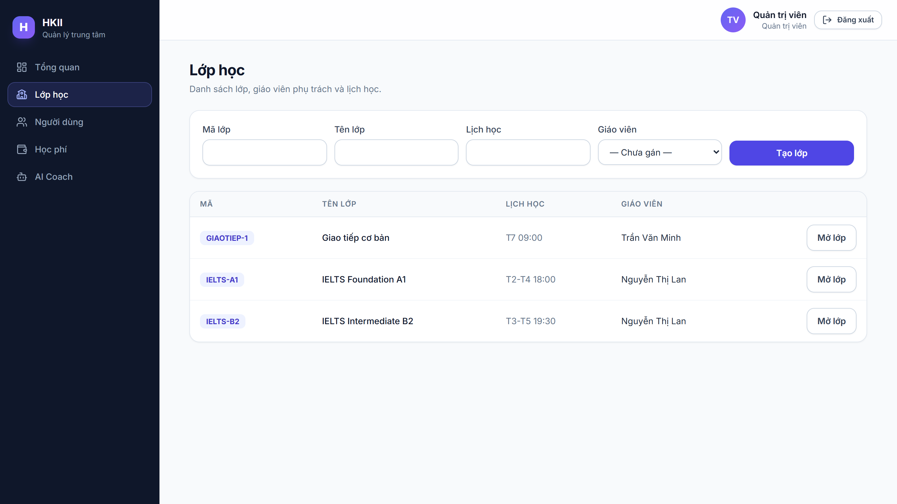
• Description: List of classes with code, name, schedule and teacher. Admin creates a class and enrols students; teachers see only their own classes.
• From: Classes menu (admin and teacher).
• To: Class Detail page of the selected class.

5. Class Detail: Attendance
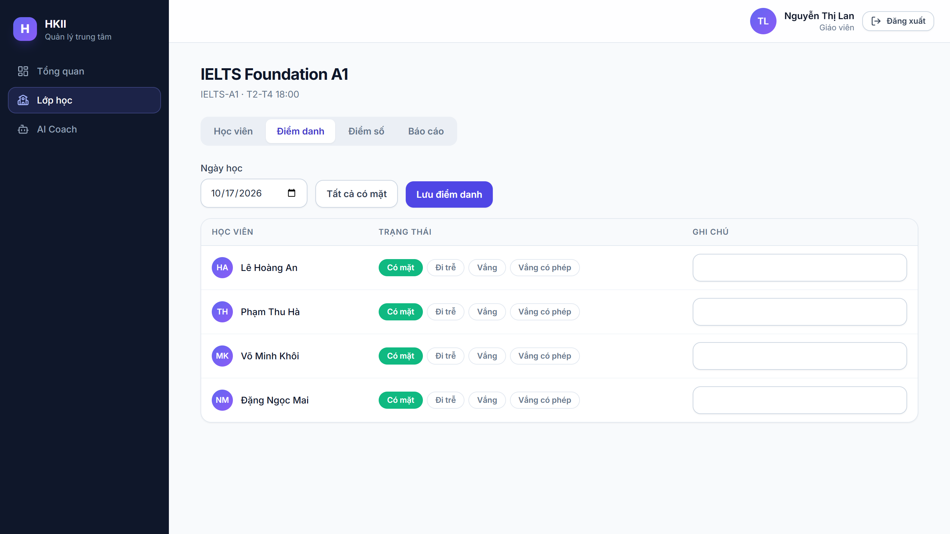
• Description: Teacher picks a date and marks every student as present, late, absent or excused, then saves the whole sheet in one request. Saving again for the same date updates the records.
• From: Class Detail page, Attendance tab.
• To: Students, Scores and Report tabs of the same class.

6. Class Detail: Report
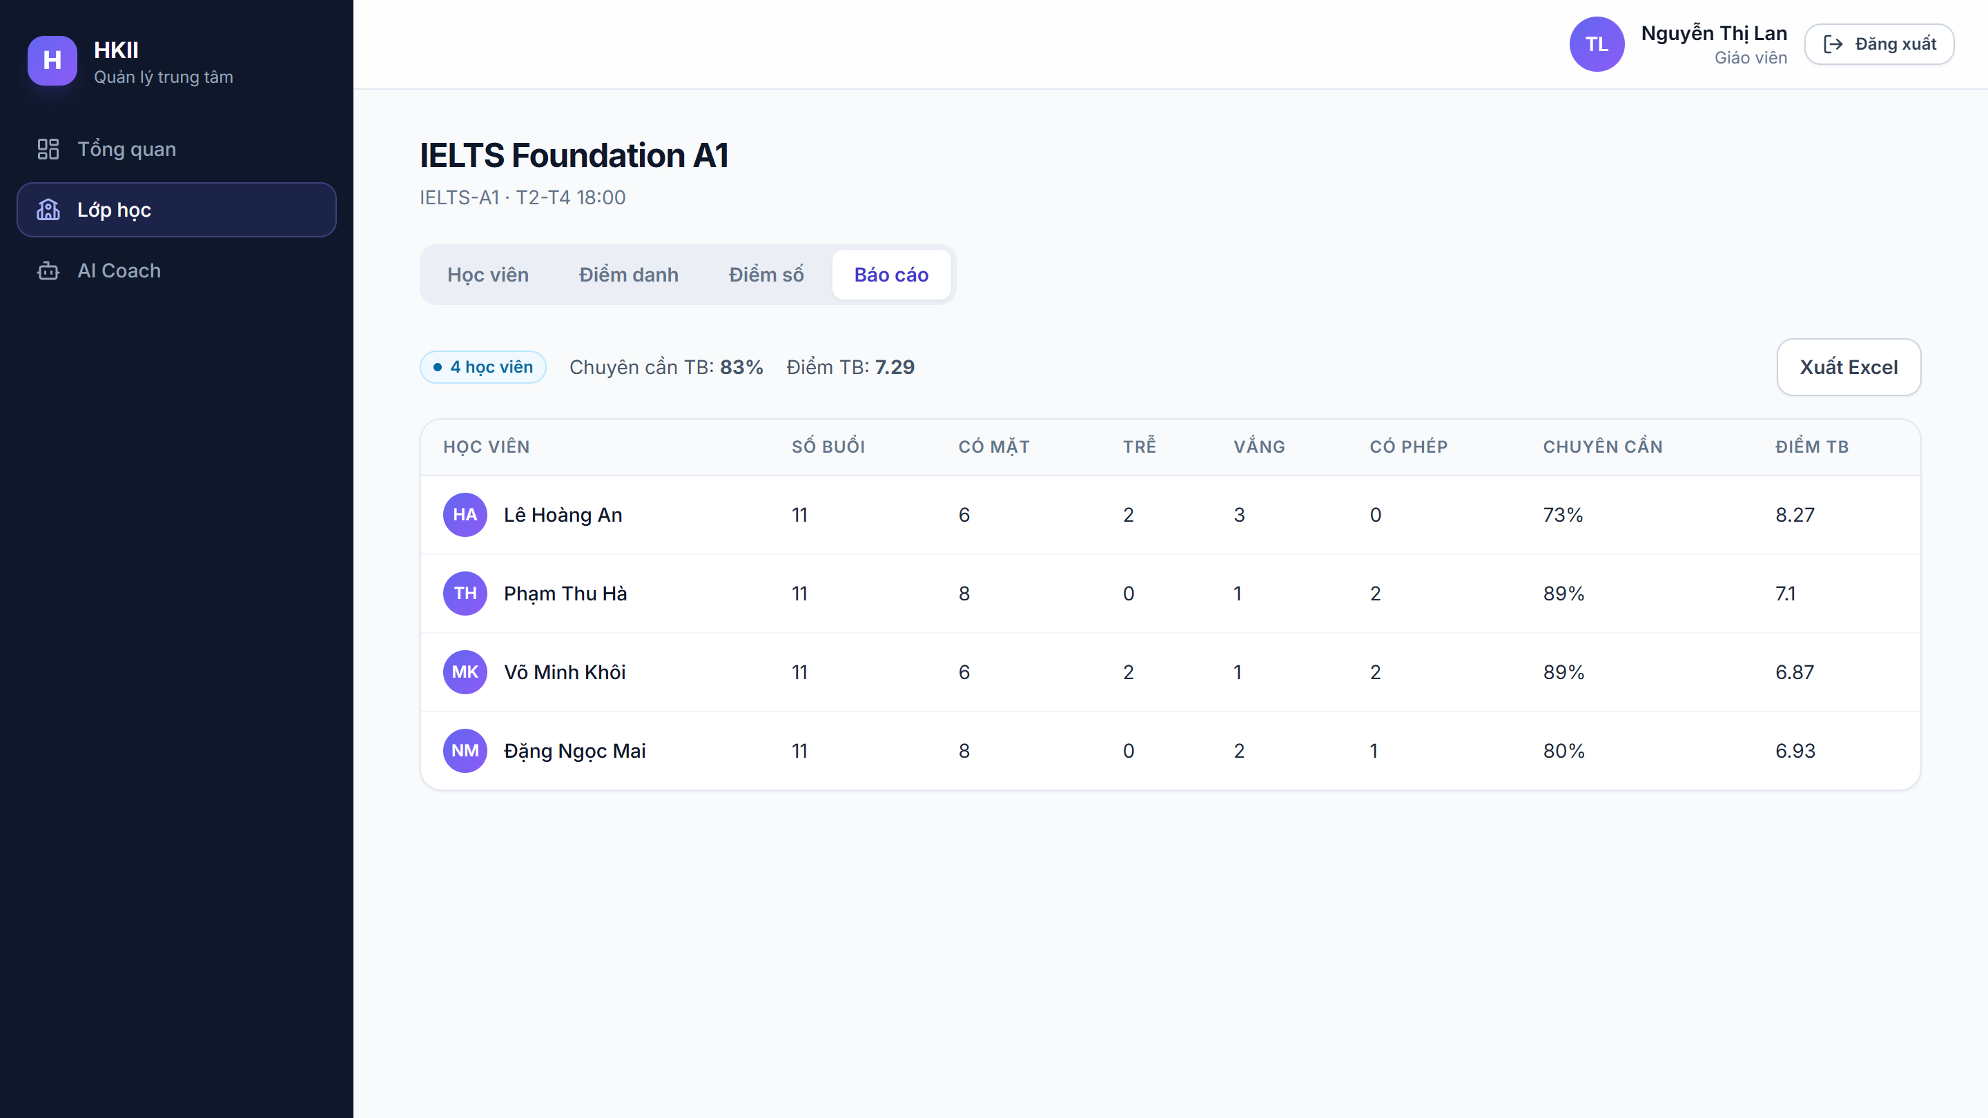
• Description: Class summary computed with pandas: attendance rate and average score of each student. The Export Excel button downloads an .xlsx file.
• From: Class Detail page, Report tab.
• To: Downloads the report file; other tabs of the class.

7. Tuition Management
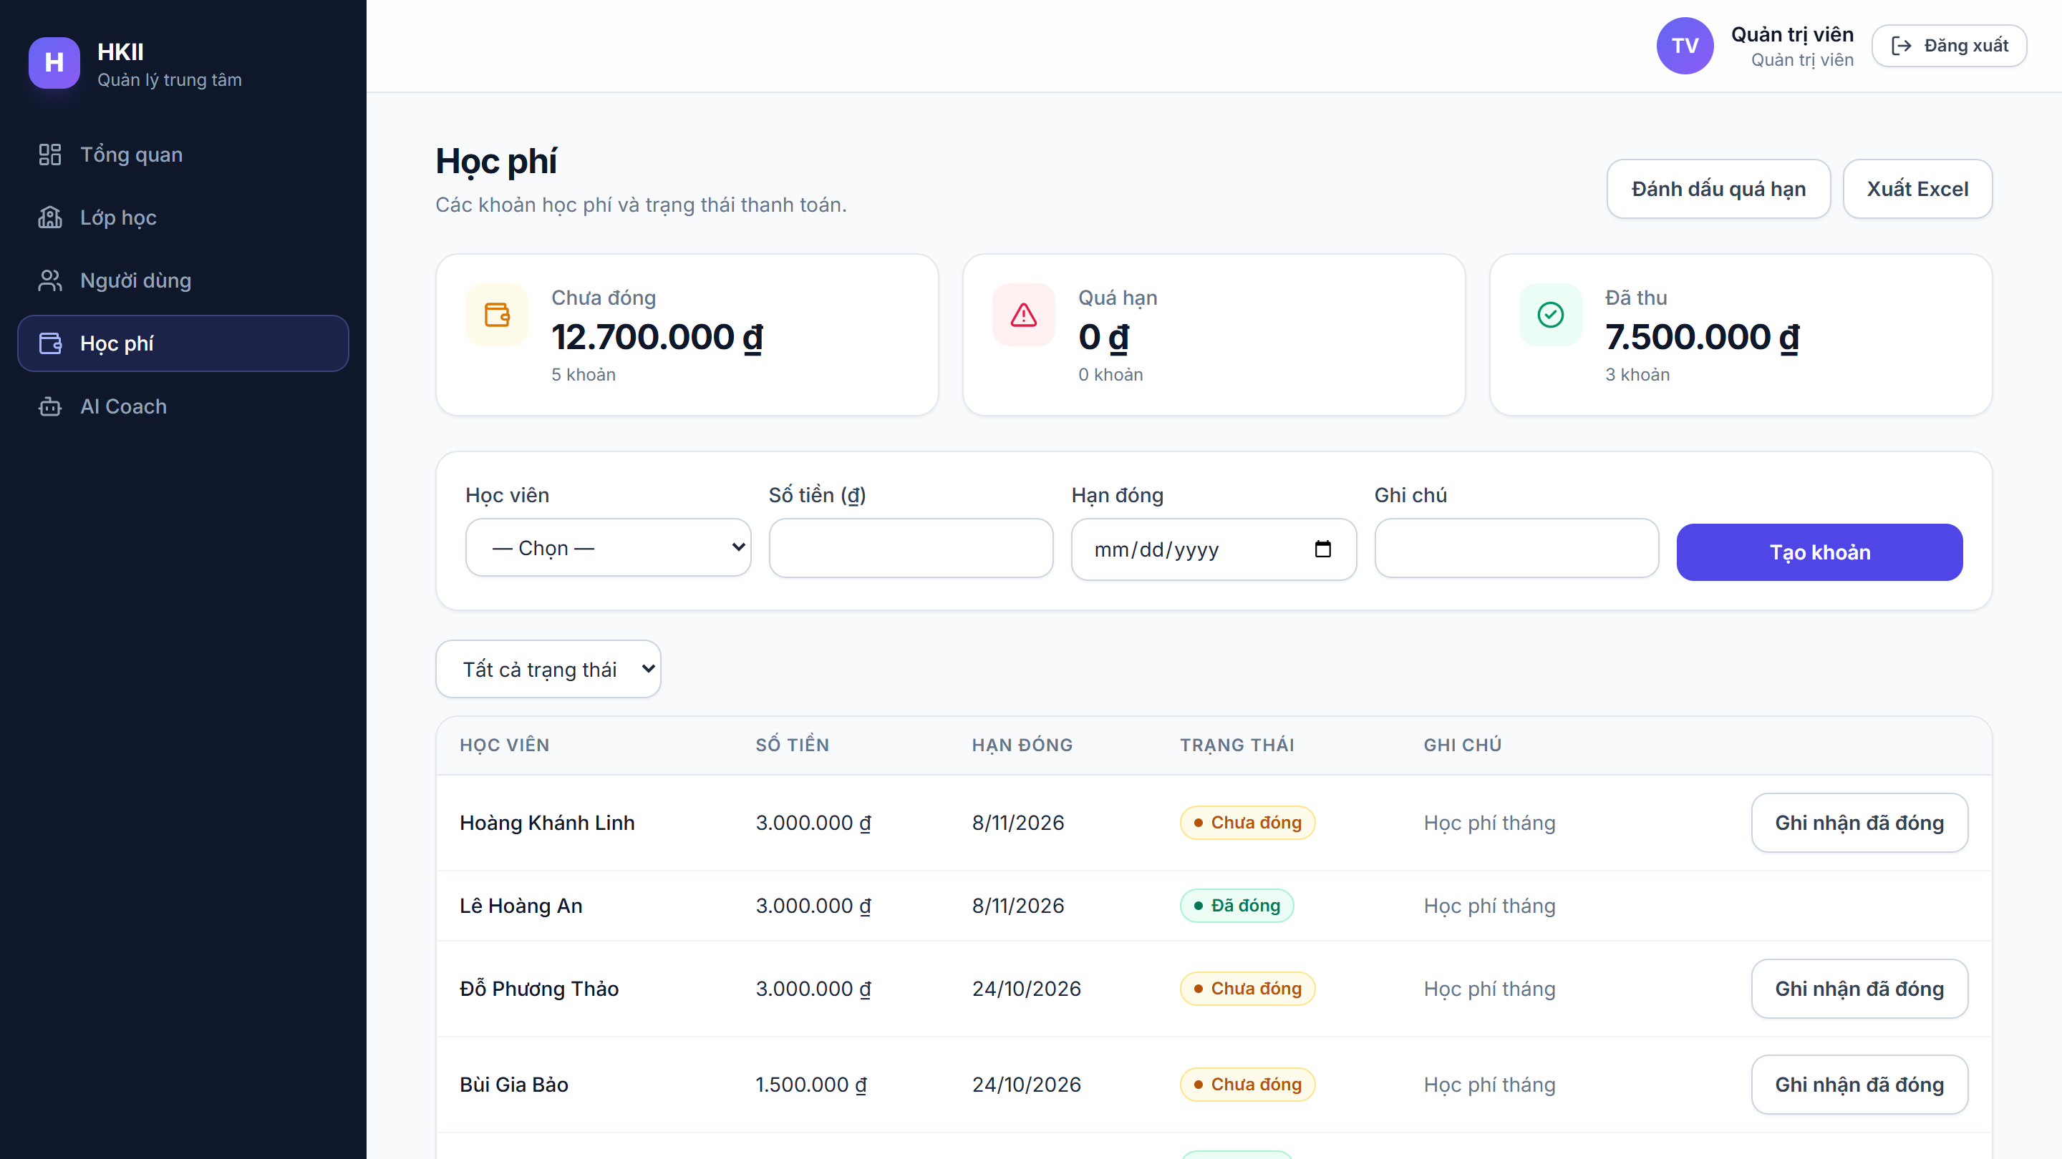
• Description: Admin creates tuition items, records payments and runs Mark overdue. Totals by status are shown at the top. Students and parents see a read-only version.
• From: Tuition menu (admin, student, parent).
• To: Stays on the same page; export of tuition data.

8. Student Dashboard
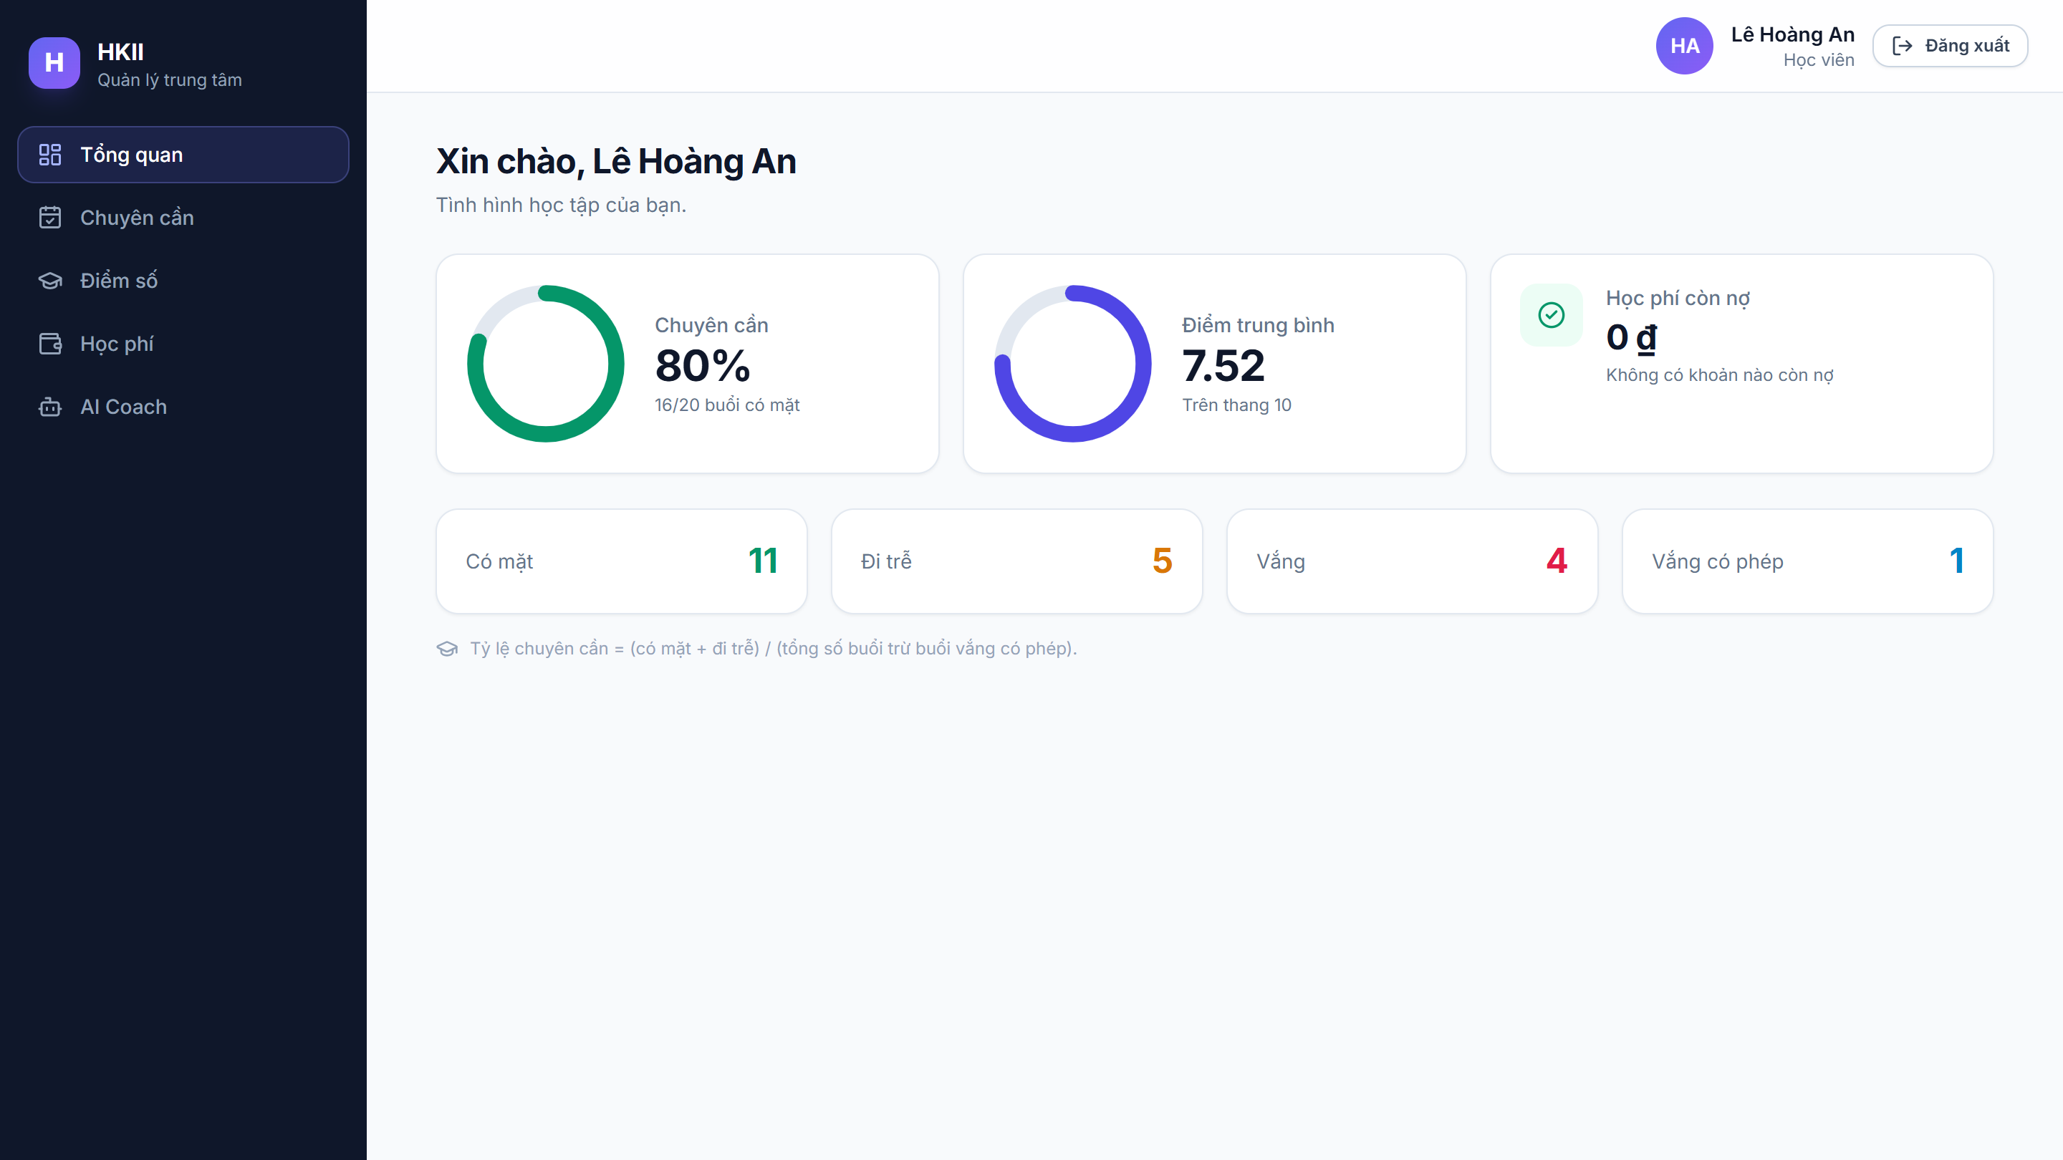
• Description: Personal overview for a student: attendance rate, latest scores and tuition status.
• From: Opened automatically after a student logs in.
• To: Attendance, Grades, Tuition and AI Coach pages.

9. Parent: Child Attendance
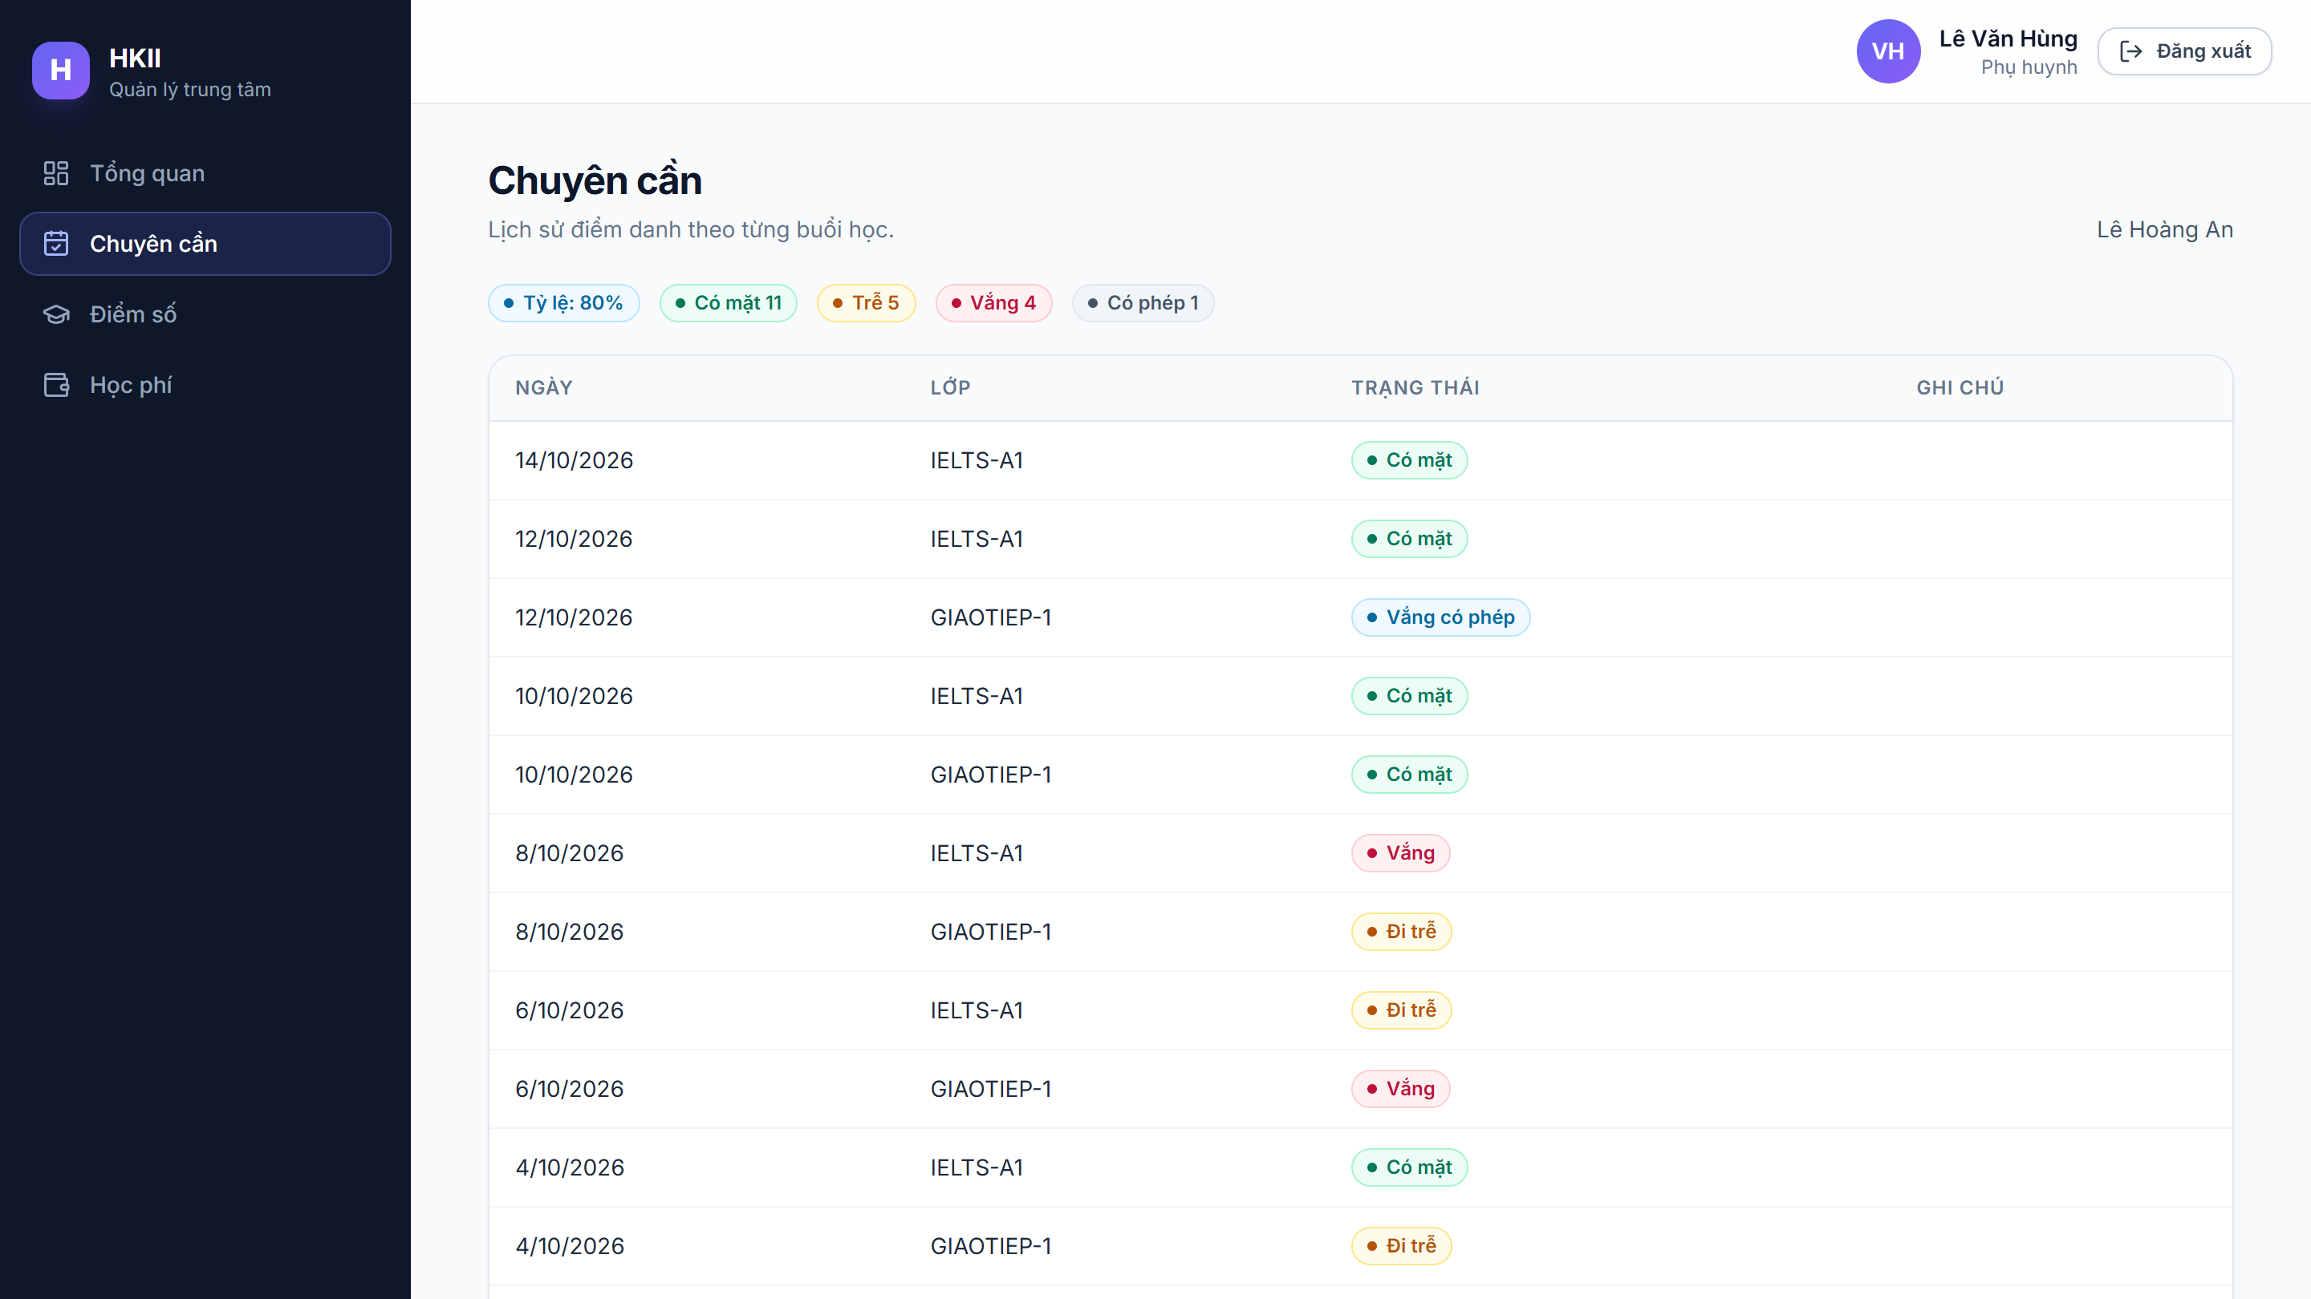
• Description: A parent selects one of his or her children and views the attendance history. Data of other students cannot be opened.
• From: Attendance menu after login as parent; child picker at the top.
• To: Grades and Tuition pages of the selected child.

10. Grades
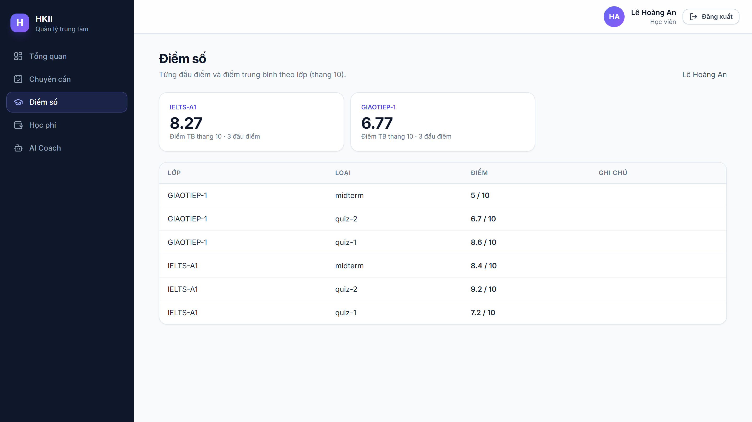
• Description: Scores of the student (or the selected child) grouped by class, with the average score of each class.
• From: Grades menu (student, parent).
• To: Dashboard, Attendance and Tuition pages.

11. AI Coach
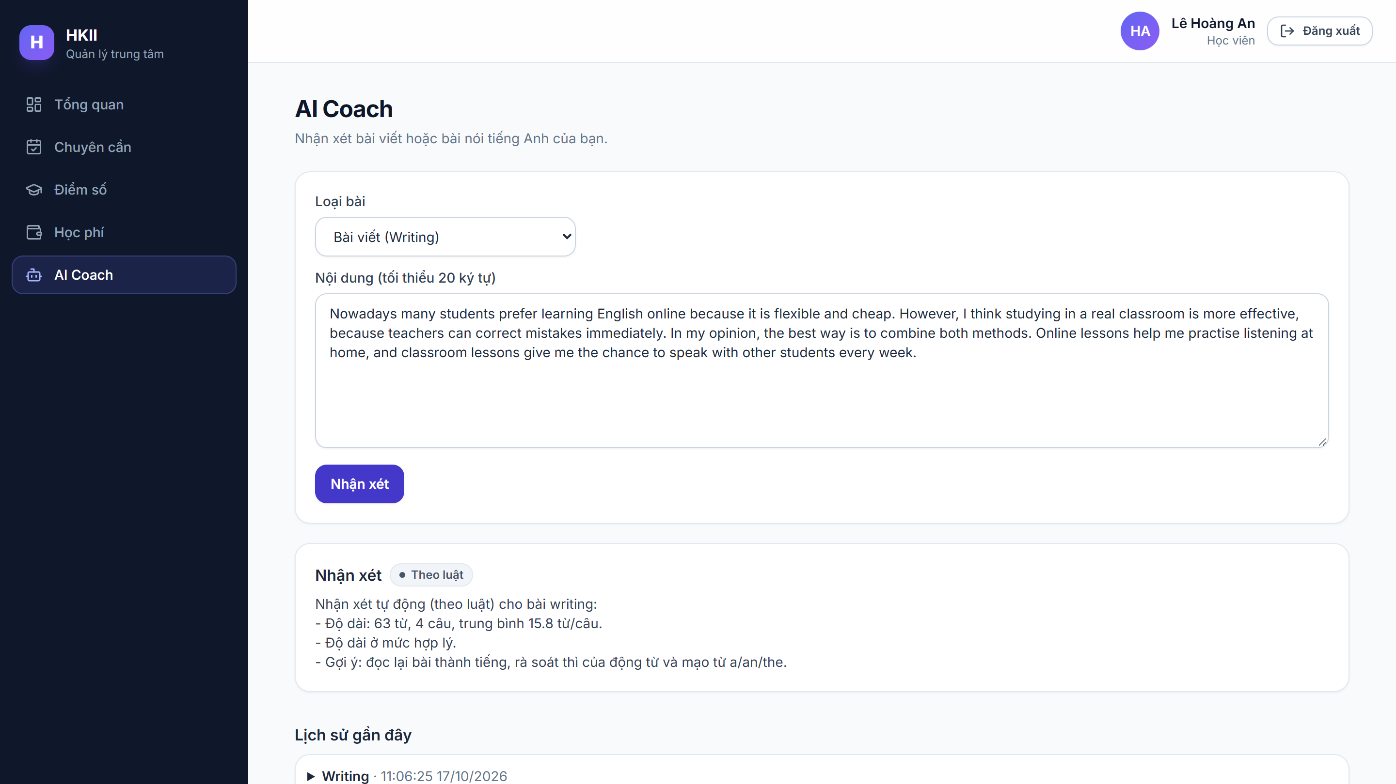
• Description: User chooses writing or speaking, pastes a text and receives feedback (strengths, errors with corrections, suggestions). History of previous sessions is listed below. Limit: 20 requests per day.
• From: AI Coach menu (admin, teacher, student).
• To: Stays on the same page and adds the new feedback to the history.

12. API Documentation (Swagger UI)
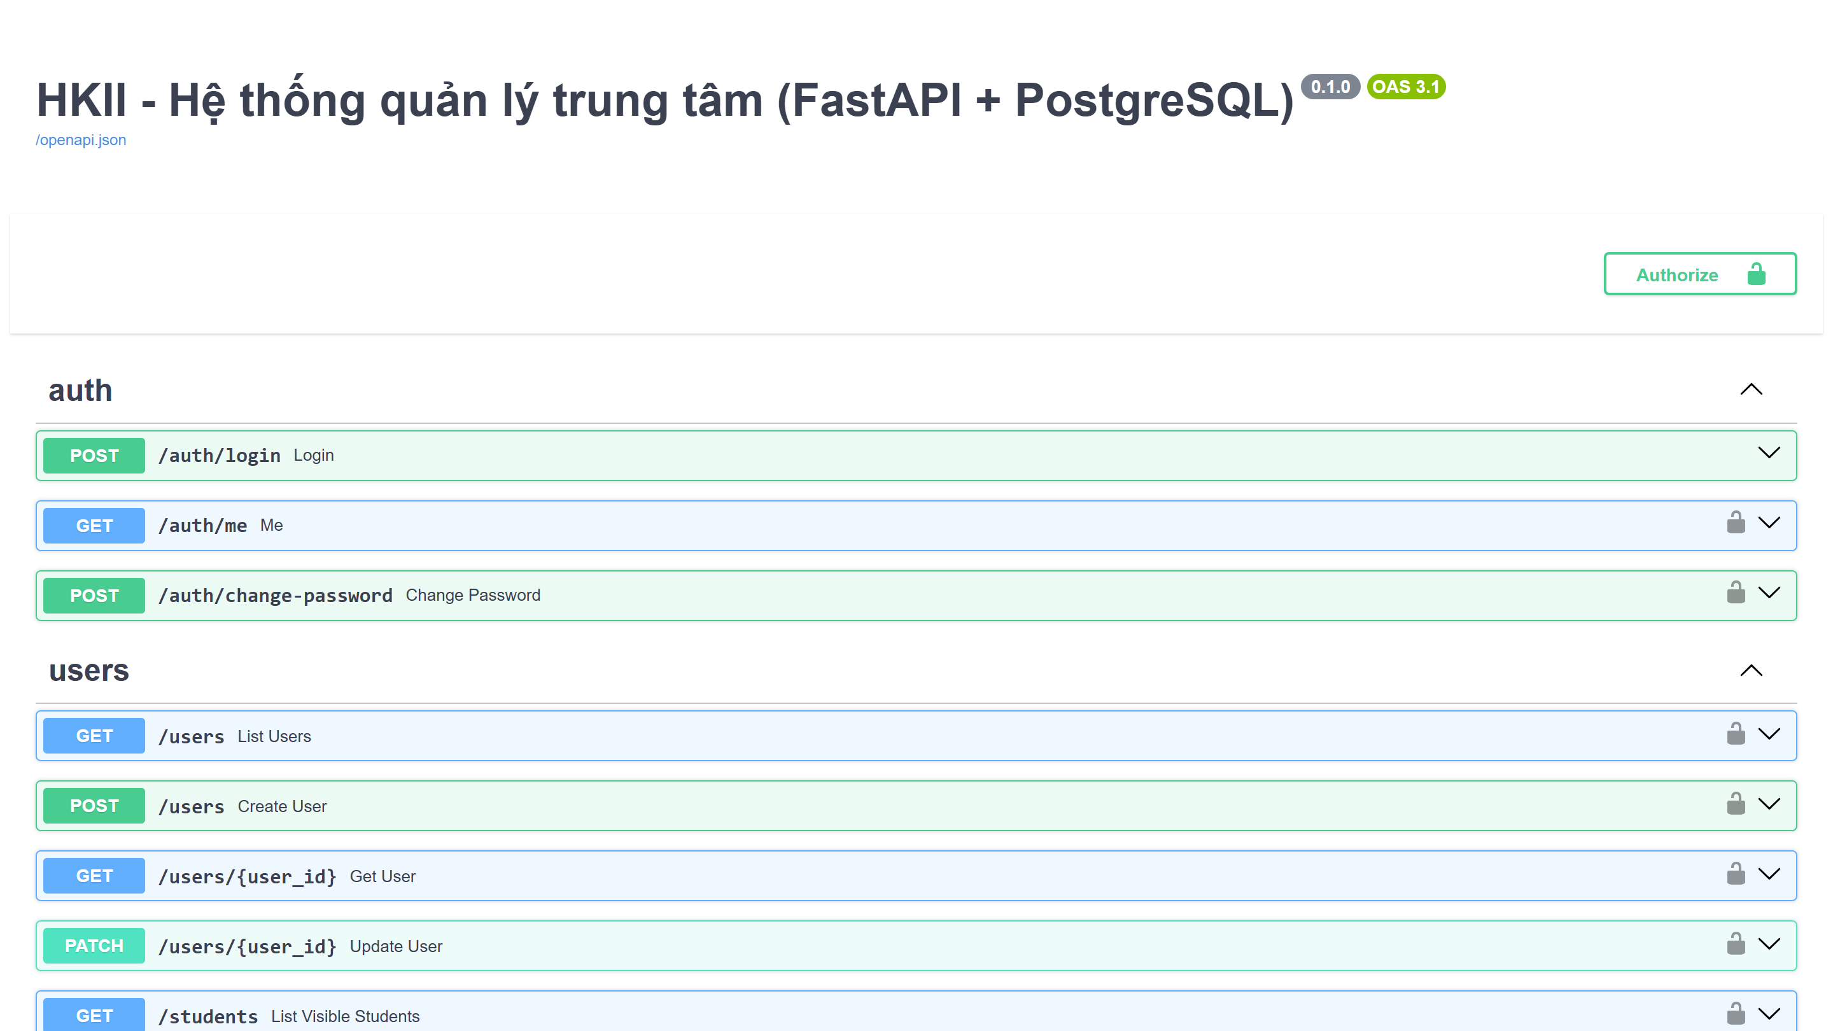
• Description: Interactive documentation generated by FastAPI: 36 operations on 27 paths, grouped by module, with an Authorize button for the JWT token.
• From: http://localhost:8000/docs
• To: Each endpoint can be tried directly from the page.

Common interface properties (applied to all screens)
Properties | Value
Document theme and colour scheme | Light mode. Primary: Indigo (#4f46e5); text: Slate (#1e293b); background: Slate 50 (#f8fafc)
Form / Page background colour | White (#ffffff) cards with rounded corners on a light slate page
Title font | Inter Variable, semibold, 18 to 24 px
Title colour / alignment | Slate 800 (#1e293b), left-aligned
Background colour of controls | White (#ffffff) with slate 300 border (#cbd5e1), rounded 12 px
Foreground colour of controls | Slate 800 text, slate 400 placeholder
Control caption: size / style | 14 px, medium weight, slate 600
Focus state | Indigo 500 border with indigo 100 focus ring
Control caption and controls alignment | Labels above inputs, left-aligned
Command button alignment | Right of the form header or below the form; primary buttons in indigo

Testing document
A. Automated tests (pytest, back end). Command: docker compose run --rm --no-deps api python -m pytest -q. Result on 23/10/2026: 15 passed.
Sr.No | Features Tested | Expected Result | Result
1 | Health check (GET /health) | Returns 200 and status ok | Pass
2 | Login with wrong password | Returns 401 with one generic message (does not reveal whether the account exists) | Pass
3 | Account lock after repeated failures | After 5 wrong passwords the account is locked; login returns 423 | Pass
4 | Call a protected endpoint without token | Returns 401 | Pass
5 | Student creates a class or a user | Returns 403 | Pass
6 | Parent views another student's data | Own child visible; other student returns 403 | Pass
7 | Teacher manages another teacher's class | Returns 403 | Pass
8 | Teacher views tuition | Returns 403 | Pass
9 | Attendance saved twice for the same date | Records updated (upsert), no duplicate row | Pass
10 | Attendance for a student not in the class | Returns 400 with the list of unknown students | Pass
11 | Score validation and summary | Value above max_value rejected (422); average per class correct | Pass
12 | Mark overdue and pay tuition | Past-due unpaid item becomes overdue; pay sets paid and paid_at; paying twice returns 409 | Pass
13 | Class report and Excel export | Summary returns attendance rate and average; export returns a valid .xlsx file | Pass
14 | AI Coach without Gemini key | Feedback generated with provider = rules and saved in history | Pass
15 | Parent uses the AI Coach | Returns 403 | Pass

B. Manual test cases (web interface and deployment).
Sr.No | Features Tested | Expected Result | Result
16 | Login form: valid credentials of each role | Redirects to the dashboard of that role with the right menu | Pass
17 | Login form: empty username or password | Form shows required message; no request sent | Pass
18 | Admin creates a user with a username already used | Error message, no new account | Pass
19 | Admin creates a class and enrols 3 students | Class appears in the list; roster shows 3 students | Pass
20 | Teacher saves the attendance sheet | Success message; attendance rate updated on the Report tab | Pass
21 | Teacher exports the class report | Browser downloads an .xlsx file that opens in Excel | Pass
22 | Admin records a tuition payment | Status changes to paid; totals at the top are updated | Pass
23 | Parent switches between two children | Attendance, grades and tuition change to the selected child | Pass
24 | Student sends a text to the AI Coach | Feedback shown and added to the history | Pass
25 | Swagger UI: Authorize with a token and call /auth/me | Returns the profile of the logged-in user | Pass
26 | Clean run on another machine: docker compose up --build | Tables created by Alembic, sample data loaded, web opens at port 8080 | Planned (before 20/11/2026)
27 | AI Coach daily limit (21st request in a day) | Returns 429 with a clear message | Planned (test being added)

Final checklist
Sr.No | Aspects Tested | Suggestion / Remarks
1 | Are all the users able to view the images and links? | Yes, all icons, images and navigation links render correctly.
2 | Have all the views, modules and controllers been properly integrated and is the site function as a single page application? | Yes, the React single page application calls one FastAPI back end through /api; the five modules share one database and one login.
3 | Are the GUI content devoid of spelling mistakes? | Yes, labels and messages have been proofread.
4 | Is the application user-friendly? | Yes, each role sees only its own menu; tables and forms follow one consistent style.
5 | Is the application launching correctly in all popular browsers? | Yes, tested on Google Chrome, Microsoft Edge and Mozilla Firefox.
6 | Are all the forms validated with proper criteria? | Yes, Pydantic validates every request on the server (length, pattern, ranges) and the forms validate required fields.
7 | Do all text links lead to the appropriate page? | Yes, React Router routes are protected by role; unknown routes return to the dashboard.
8 | Do all image links lead to the appropriate page? | Yes.
9 | Are all the images and links clearly visible on the page? | Yes, light theme with good contrast.
10 | Does the web page work properly in all the tested browsers? | Yes.
11 | Does the web page take too long to be loaded fully? | No, pages load in under 2 seconds on a local Docker deployment.
12 | Is the navigation sequence correct through all the web pages on the site? | Yes, see the Site Map.
13 | Is the JavaScript code working as expected in all click events? | Yes, buttons, tabs, child picker and Excel download work as expected.
14 | Is the database securely protected against unauthorised access? | Yes, passwords hashed with bcrypt, JWT on every request, role and data scope checked in deps.py, temporary lock after 5 failed logins, secrets kept in .env (not committed).
15 | Does the application handle exceptions gracefully? | Yes, clear HTTP errors (400, 401, 403, 404, 409, 423, 429) with messages; the AI Coach falls back to rule-based feedback when Gemini fails.

Task Sheet
No | Member | Contents | Table Name | Planned Start | Actual Start | Days | Status
1 | Thái Phát | Requirement analysis: problem definition, 4 roles, 5 modules, acceptance criteria |  | 09/10/2026 | 09/10/2026 | 3 | Done
2 | Thái Phát | Database design: ERD, 8 tables, keys and constraints | all tables | 11/10/2026 | 11/10/2026 | 3 | Done
3 | La Vĩ Quyền | Back end: FastAPI, models, Alembic migration, JWT, role checks, 36 API operations, 15 tests | all tables | 14/10/2026 | 14/10/2026 | 1 | Done
4 | La Vĩ Quyền | Front end React + nginx; Docker Compose (db, api, web) |  | 14/10/2026 | 14/10/2026 | 1 | Done
5 | La Vĩ Quyền | Run guide, demo script, presentation; new interface design |  | 17/10/2026 | 17/10/2026 | 1 | Done
6 | Both | Task assignment, 15 GitHub Issues for remaining work |  | 19/10/2026 | 19/10/2026 | 1 | Done
7 | Thái Phát | Documentation Review 1 and Review 2, 1st Status Report |  | 20/10/2026 | 20/10/2026 | 4 | Done
8 | Thái Phát | Screens: change password, parent-child link, edit score; tests for enrolment and user management | users, parent_students, scores, enrollments | 26/10/2026 |  | 7 | Planned
9 | La Vĩ Quyền | AI Coach daily-limit test; GitHub Actions CI (pytest + npm build); tests on PostgreSQL; security review of .env | coach_sessions | 26/10/2026 |  | 7 | Planned
10 | Thái Phát | Review 3: screenshots, testing document, final checklist |  | 02/11/2026 |  | 10 | Planned
11 | La Vĩ Quyền | Installation guide, user guide, clean-machine run |  | 09/11/2026 |  | 7 | Planned
12 | Both | Cross testing (each member tests the other's modules), fix bugs |  | 16/11/2026 |  | 4 | Planned
13 | Both | Submit design documents (20/11), final project (02/12), slides, demo video, defence rehearsal (05/12) |  | 20/11/2026 |  | 15 | Planned

