Q1. Convert the column name to single word names.

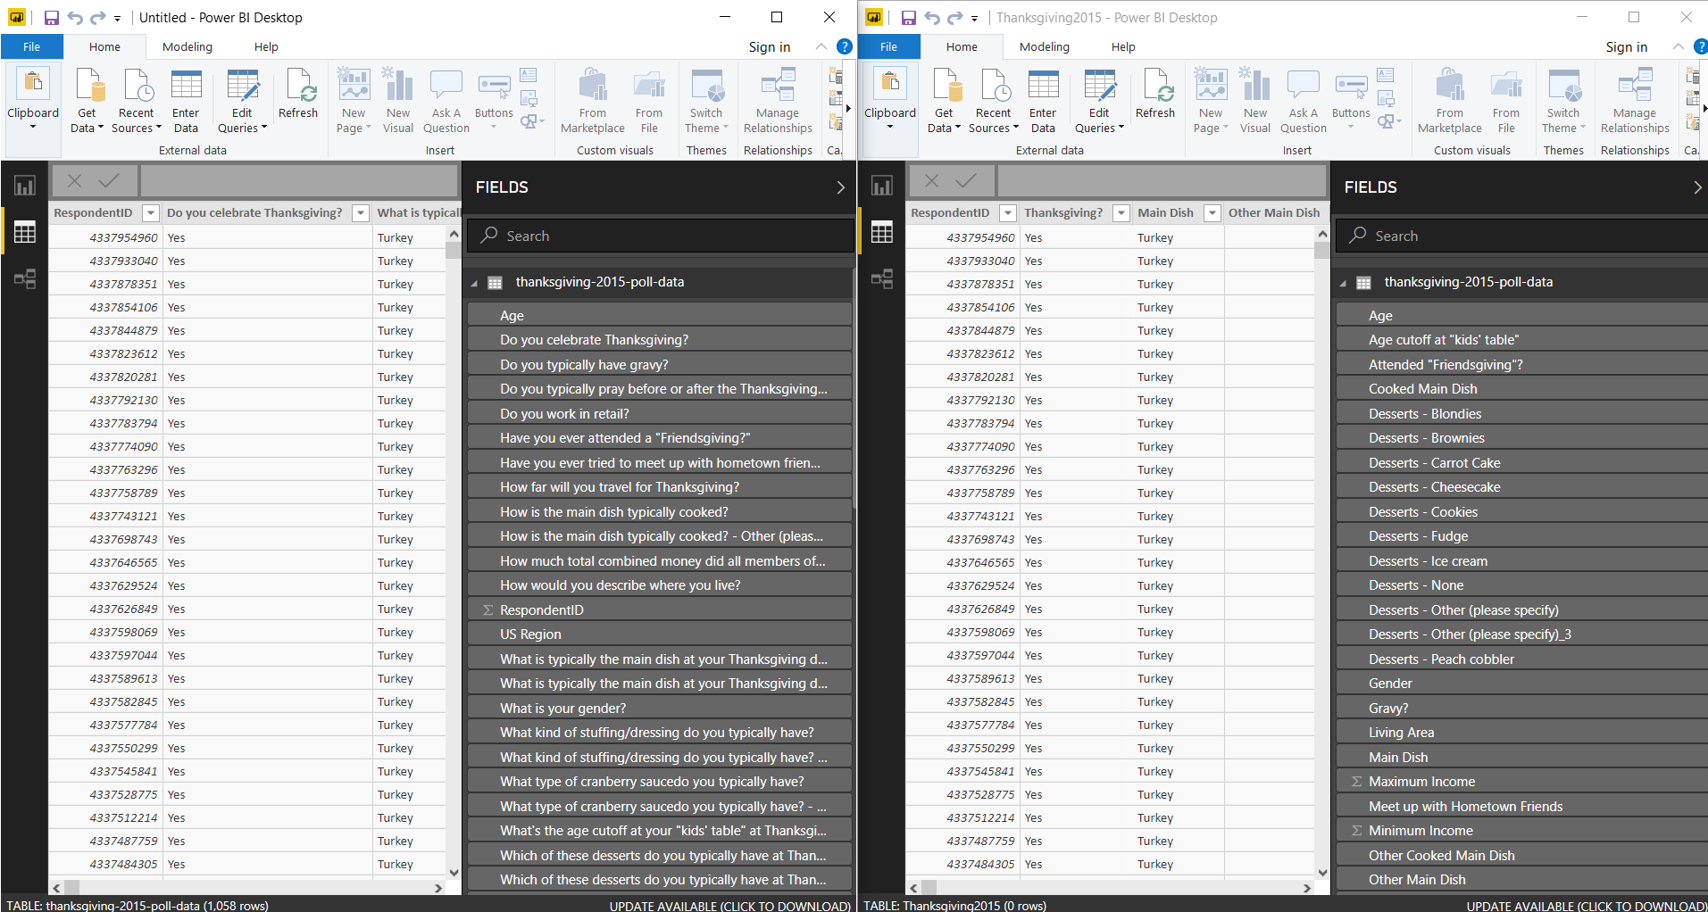

Q2. Discover regional and income-based patterns in what Americans eat for Thanksgiving.

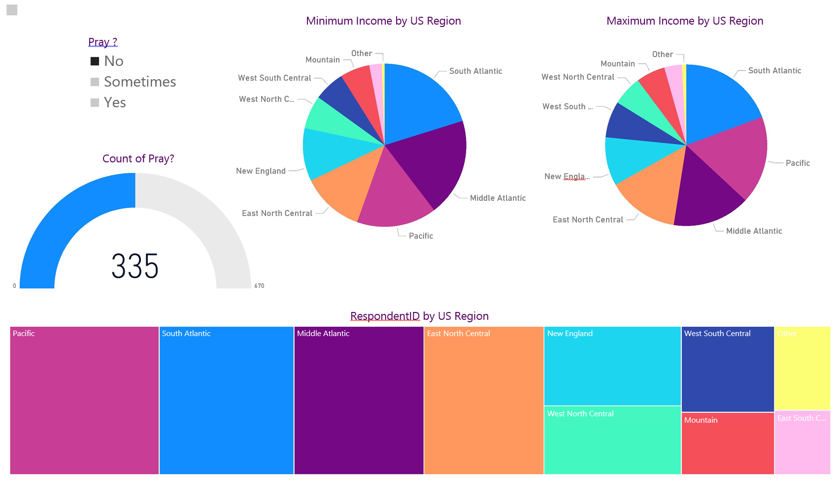

Q3. Compare income between people who tend to eat homemade cranberry sauce for Thanksgiving vs people who eat canned cranberry sauce ?

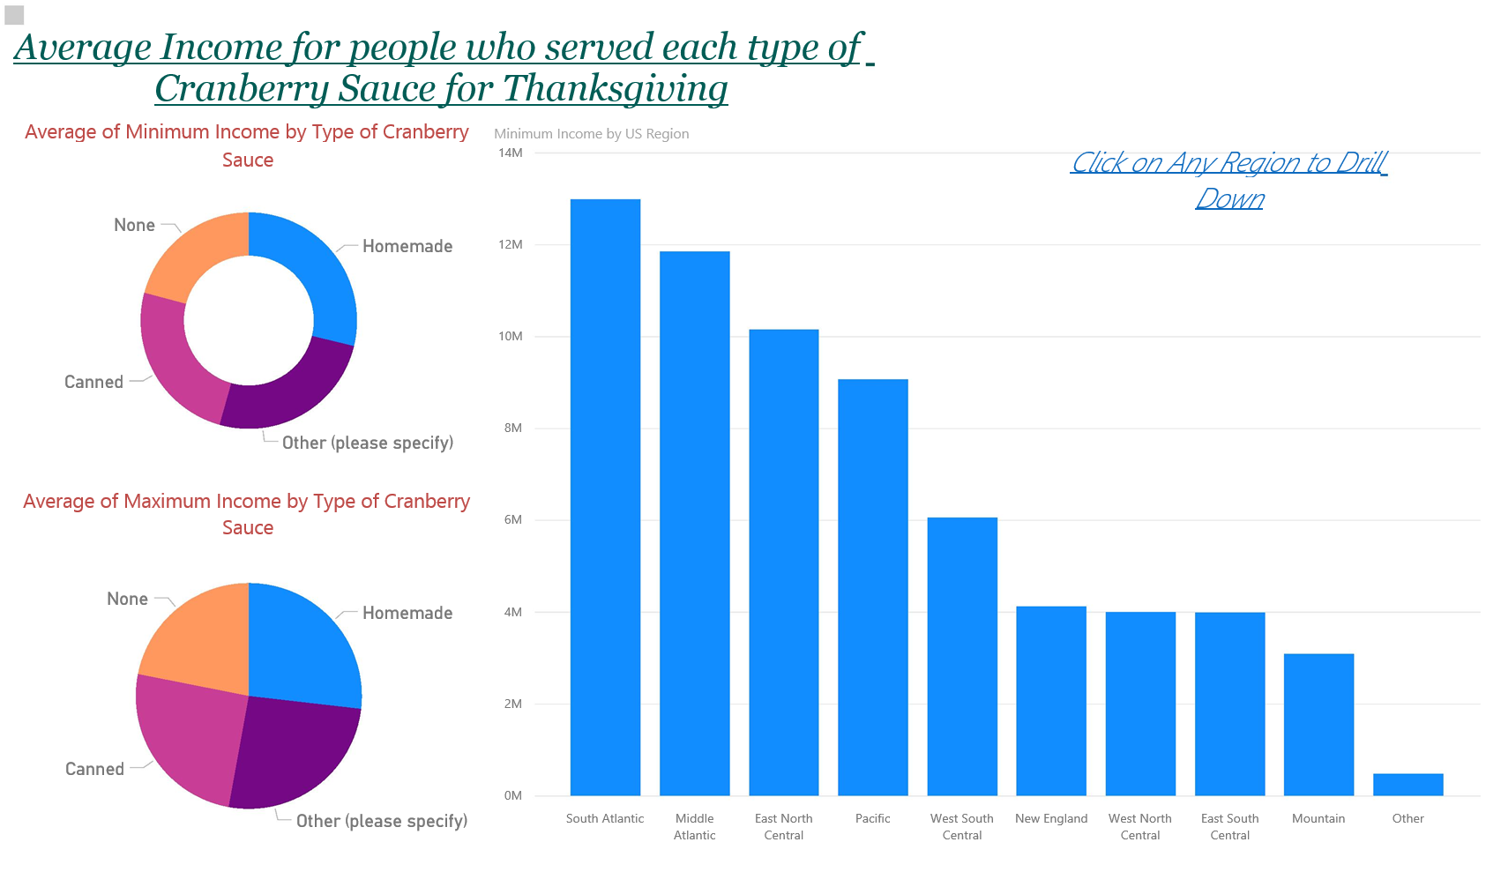

Q4. Find the average income for people who served each type of cranberry sauce for Thanksgiving (Canned, Homemade, None, etc).

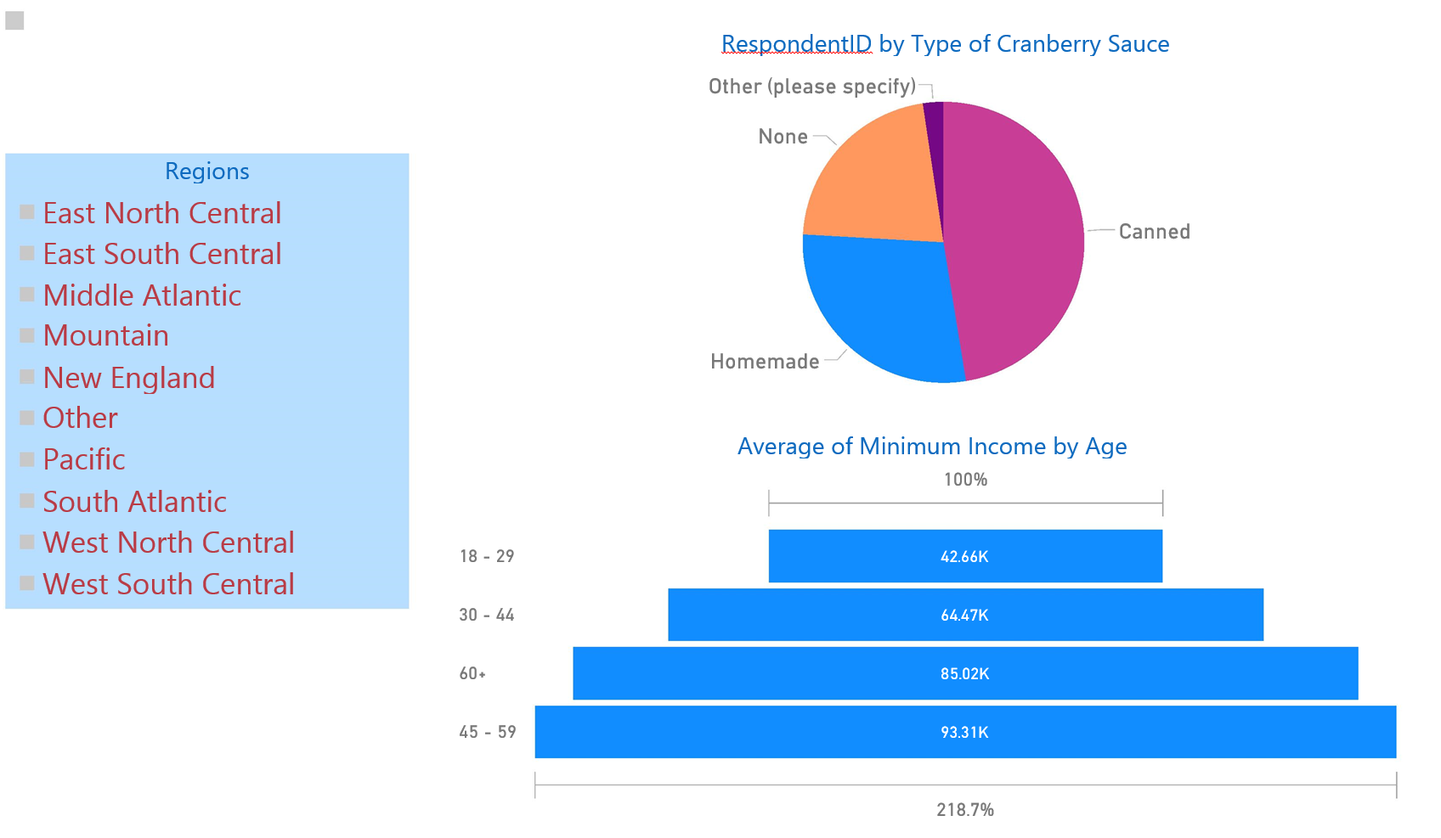

Q5. Find the number of people who live in each area type (Rural, Suburban, etc), who eat different kinds of main dishes for Thanksgiving.

