Digital Literacy Project Report

Report Name: Lavisha Gupta
Registration Number: 25BCE10097
Course: CSE0001 Digital Literacy
Program: B.Tech Computer Science and Engineering

INTRODUCTION

Digital literacy refers to the ability to use digital devices, internet services, and online platforms in a safe and effective manner. In today’s academic environment, students depend on digital tools for learning, communication, and project work. The main aim of this project was to develop practical knowledge of digital platforms such as GitHub, coding websites, Google Forms, and professional communication methods. The project also focused on understanding cyber safety and responsible use of online resources. All the tasks were completed step by step and organized in a GitHub repository. This report explains each task along with the work performed and learning outcomes. This project helped to enhance understanding of how technology can be used productively for academic and professional purposes. Overall , the project strengthened confidence in using digital tools.

Task 1 – Infographic Creation

In this task, a digital infographic was created using Canva the explain the concept of digital literacy. The infographic included topics such as basic digital tools, safe internet usage, and responsible online behaviour. A suitable template was selected in Canva, and the content was added in a simple and clear format. After completing the design, the infographic was downloaded and uploaded to the GitHub repository. This task helped in understanding how to present information visually using digital tools. Also it improved creativity and design skills while organising information in easy to understand and attractive manner.

Task 2 – Digital Portfolio

In this task, profiles were created on different online platforms such as GitHub, LinkedIn, and StackOverflow. These platforms are important for building a professional online presence. Basic details such as education and course information were added to the profiles. Screenshots of all profiles were taken and uploaded to the repository as proof of work. This task helped in understanding how digital platforms can be used for learning and future career development. It also improves awareness about maintaining aa professional identity and personal branding in the digital world.

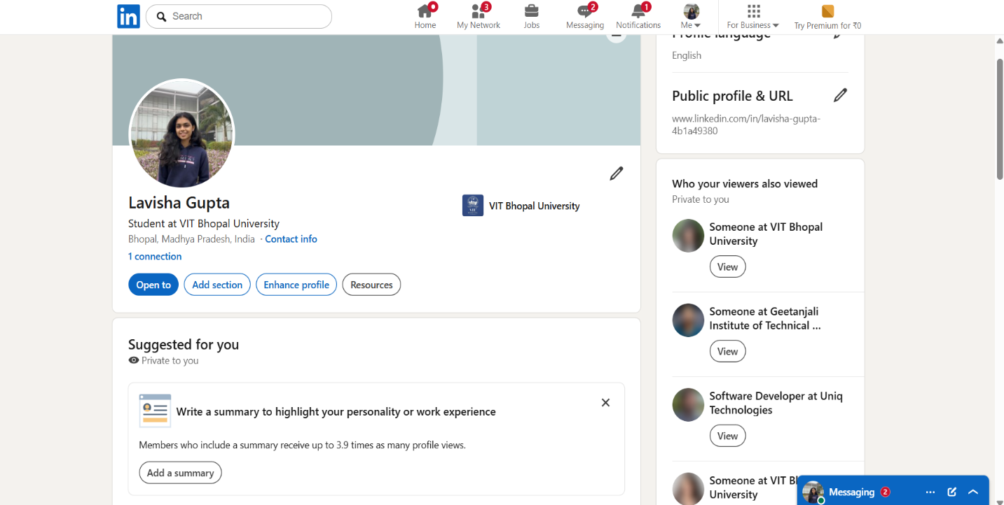

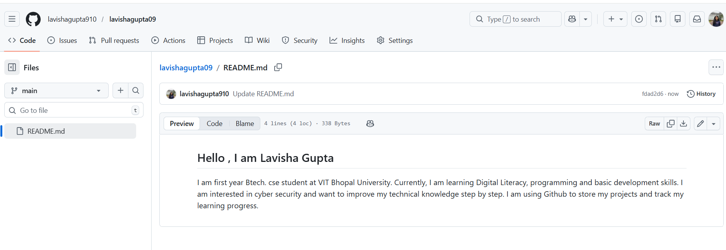

Task 3 – Coding Platform and Google Form

This task involved using a coding platform and creating a Google Form. An account was created on HackerRank, and basic problems were solved to understand how coding platforms work. A Google Form was created with multiple questions related to digital literacy. The form included different types of questions and was connected to a response sheet. Screenshots of both the coding platform and the Google Form were uploaded to the repository. This task helped in learning online collaboration and data collection tools. Also, it improves problem solving skills and understanding of how digital tools can be used to gather information.
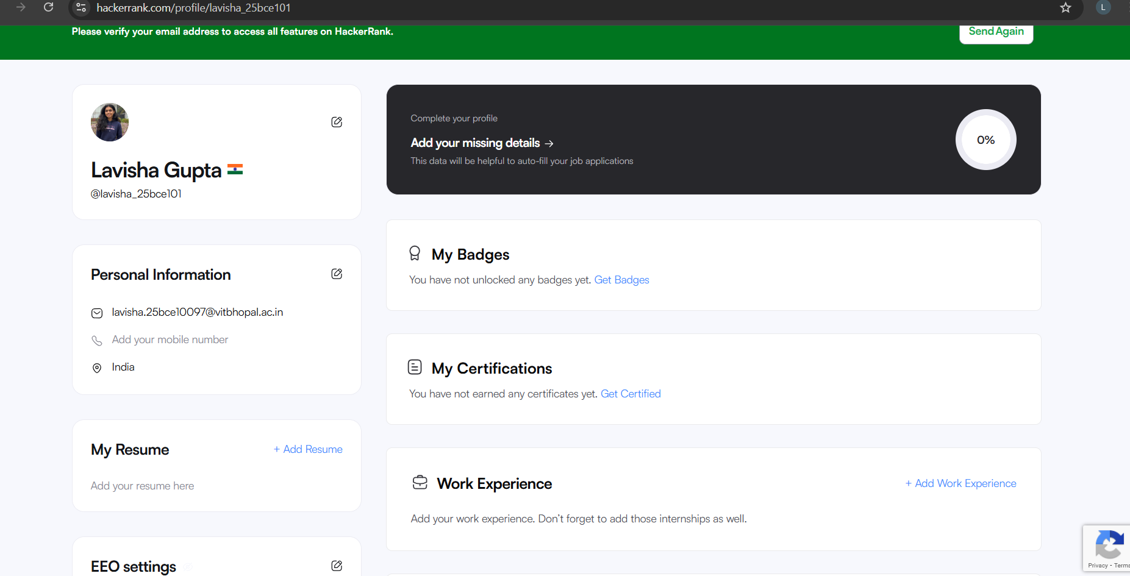

Task 4 – Email and Social Media Etiquette

In this task, two professional emails were written to understand formal communication. One email was written for assignment submission, and the other was related to internship inquiry. A checklist of social media do’s and don’ts was also prepared to understand responsible online behaviour. This task helped in improving communication skills and understanding proper usage of social media platforms.

A short case scenario to understand effect of poor digital communication is once a student sent an assignment email to a faculty without greeting, proper subject line and attachment. Submission is delayed and marks are lost as faculty could not identify the purpose of email. This situation shows that attention is important while writing email. Proper digital communication could have prevented the misunderstanding and ensured smooth interaction.

Task 5 – Cybercrime Case Study

In this task, a case study on cyberbullying was prepared. While researching, the most surprising fact was that how in very short time harmful messages can spread online easily and someone’s personal health. Sometimes, repeated negative messages and comments can seriously cause harm to person. One habit that I would change is being more careful about what I post or comment online. I would not engage in harmful content and will report it. This search help me understand importance of digital responsibility and online practices.

Conclusion

This project helped in developing practical knowledge of digital tools and platforms. It improved skills such as creating content, managing online profiles, writing professional emails, and understanding cyber safety. The use of GitHub for organizing all tasks also helped in learning how to present work in a structured manner. Overall, this project was useful in building essential digital skills required for students.
- Github profile : https://github.com/lavishagupta910
- Linkedin profile : https://www.linkedin.com/in/lavisha-gupta-4b1a49380?utm_source=share_via&utm_content=profile&utm_medium=member_android

- Hackerrank: https://www.hackerrank.com/profile/lavisha_25bce101

- Google form: https://docs.google.com/forms/d/e/1FAIpQLSf9PIE9nT9H5R6rdmxlAOBYZp72N86_LU8AJHrvWKw50v7HTA/viewform?usp=publish-editor

