ASSIGNMENT- 3: Java user input using Scanner Class

- Sum of two numbers:-

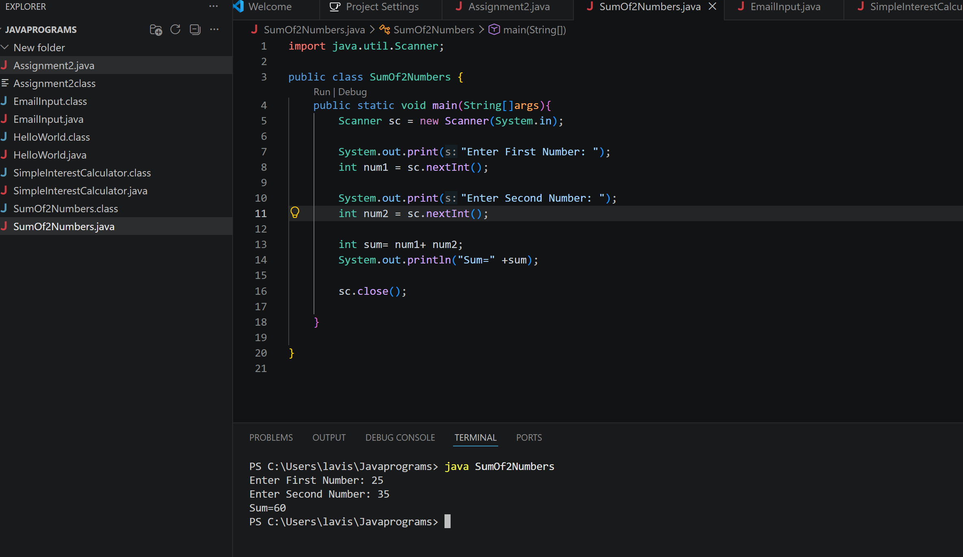

- Email Address Input

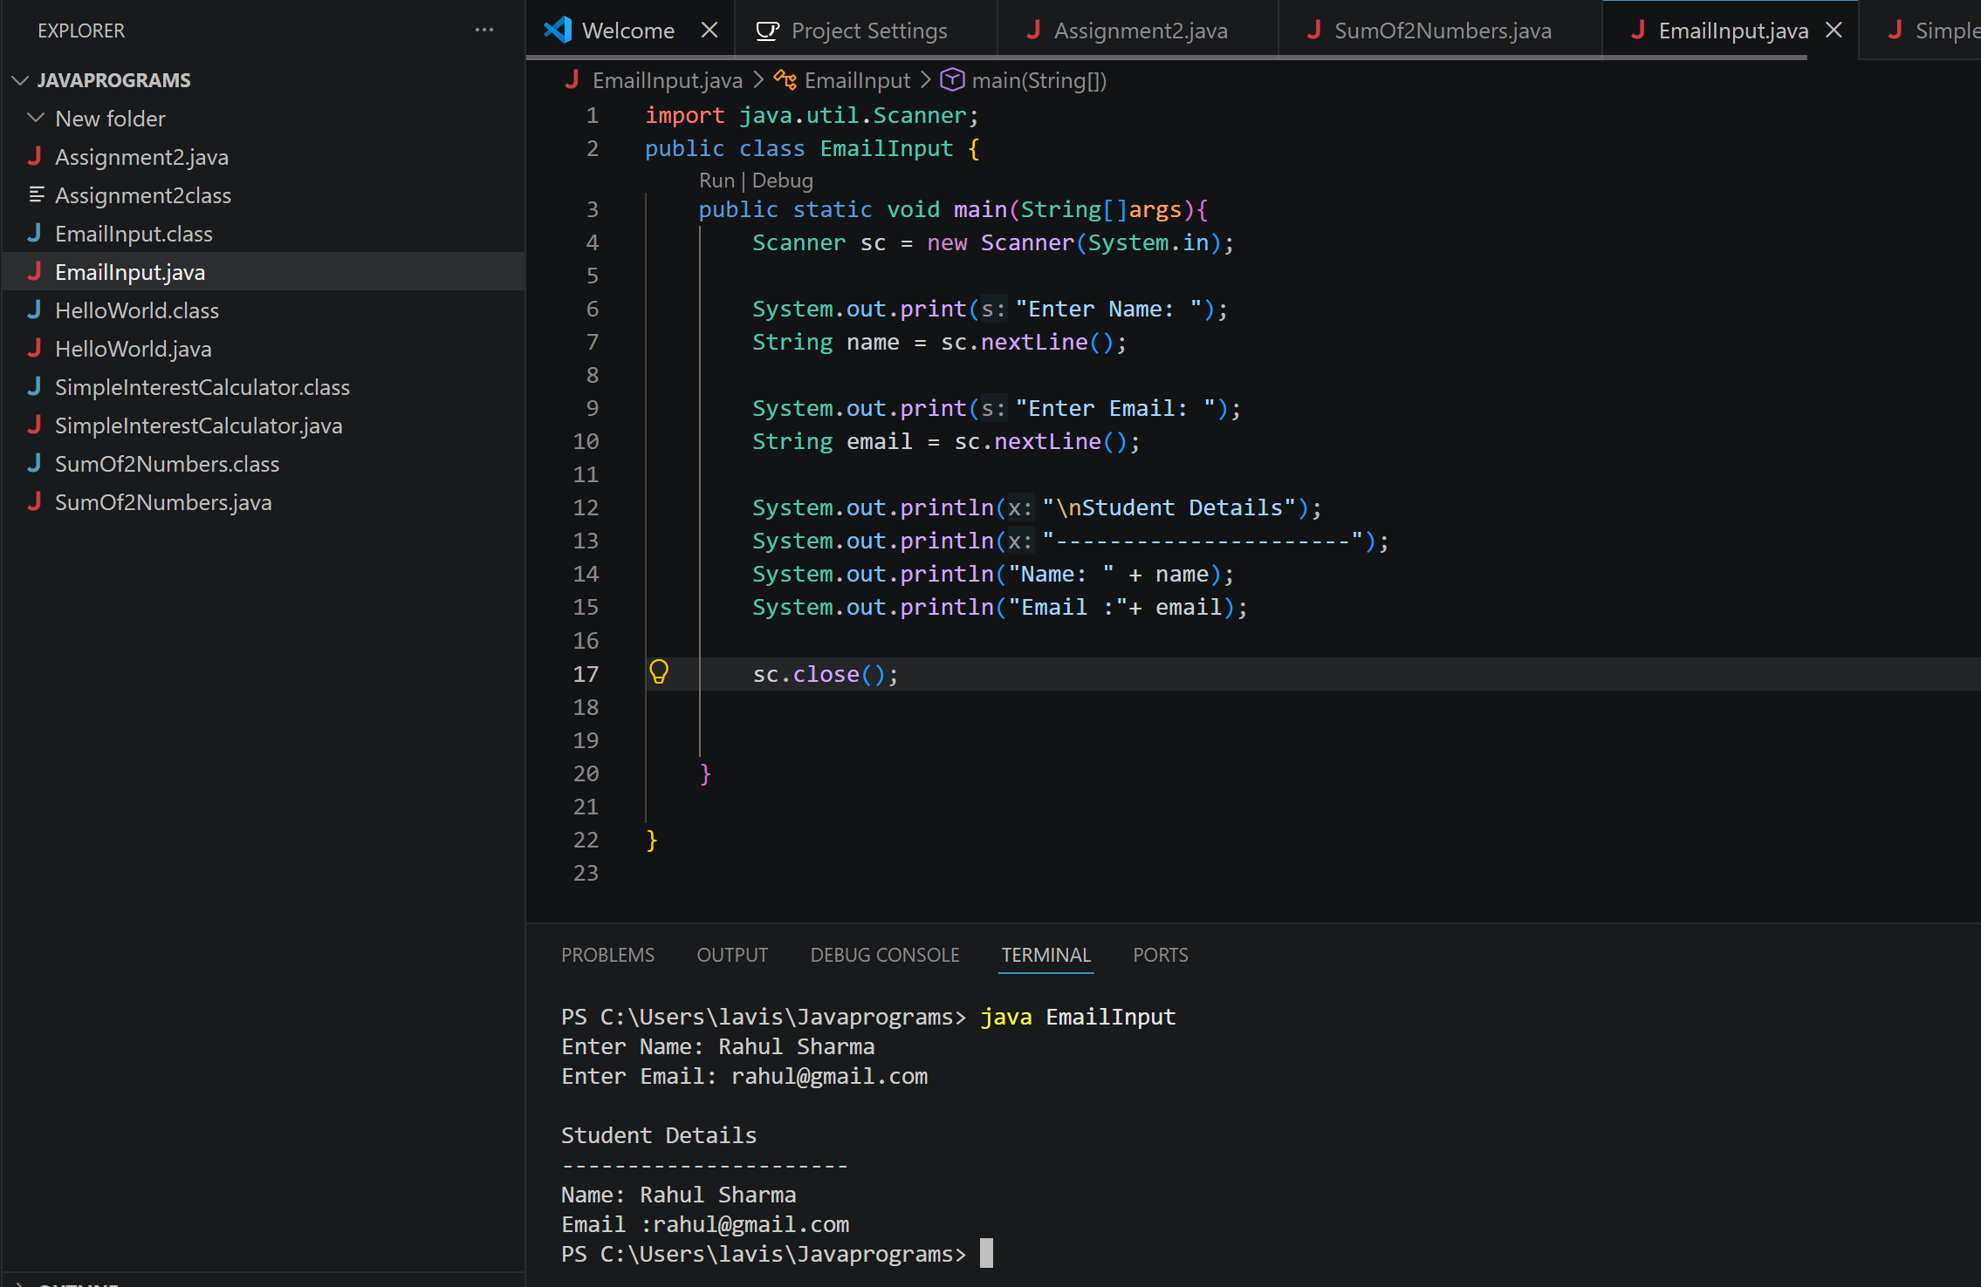

- Simple Interest Calculator

