Navigate to the above w3schools link.

1. Navigate to the SELECT section of the tutorial: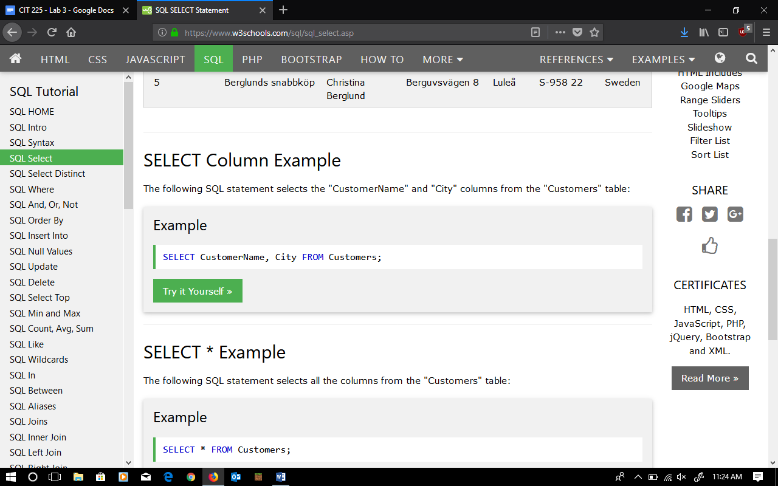Click on the green “try it yourself” button under the SELECT Column Example: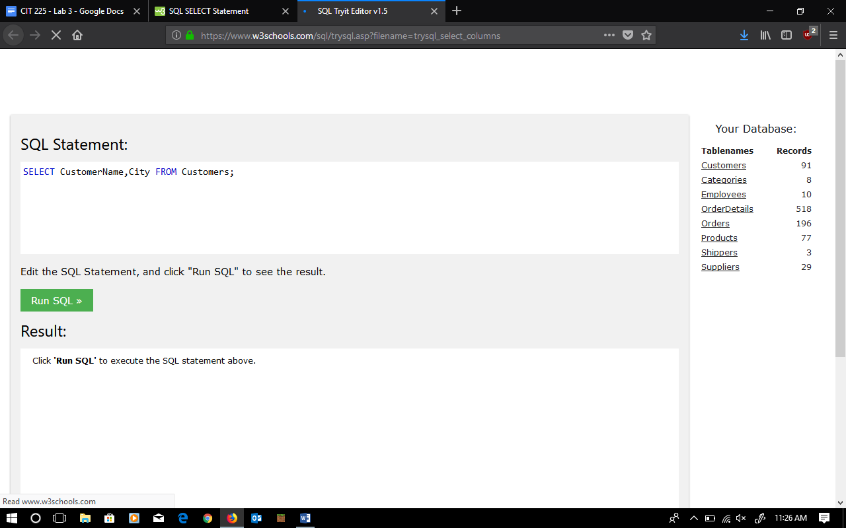
2. Click the green “Run SQL” button to view the results. Modify the SQL Statement above to select all the records from the Customers table.

SELECT * FROM Customers;

1. Modify the SQL to select all the records from the Customers table, sorted by city. Hint: you may need to refer to the “ORDER BY” section of the w3schools tutorial.

SELECT * FROM Customers ORDER BY City;

1. Modify the SQL to select the customer name, city, and country, sorted by country.

SELECT CustomerName, City, Country FROM Customers ORDER BY Country;

1. Modify the SQL to select customer name, city, and country of those customers from Germany. Hint: look at the “WHERE” section of the tutorial.

SELECT CustomerName, City, Country FROM Customers

WHERE Country =’Germany’;

1. Modify the SQL to get the total number of different countries in the Customer table. Hint: look at “SELECT DISTINCT” tutorial examples.

SELECT DISTINCT Country FROM Customers;

1. Modify the SQL to get the total number of different cities in the Customer table.

SELECT DISTINCT City FROM Customers;

1. Modify the SQL to get the name and price of the 5 most expensive products in the product table. Hint: look at the SELECT TOP section of the tutorial.

SELECT TOP 5 Price, ProductName FROM Products;

1. Modify the SQL to get the name and price of the 5 least expensive products in the product table. Hint: look at the SELECT TOP section of the tutorial.

SELECT TOP 5 Price, ProductName FROM Products ORDER BY Price ASC;

1. Modify the SQL to get the count of products, total of prices, and average price of products in the product table. The count should be called “Num_of_Product”, the total of all prices should be called “Sum_of_Prices”, and the average price should be called “Avg_Price”.

SELECT COUNT(*)

FROM products;

Num_of_Product = 77

SELECT SUM(Price)

FROM Products;

Sum_of_Prices = 2222.71

SELECT AVG(Price)

FROM Products;

Avg_Price = 28.866363636363637