COGNIFYZ TECHNOLOGIES
Data Science Internship
FINAL INTERNSHIP REPORT
Restaurant Rating Prediction using Multi-Level Data Analytics and Machine Learning
Submitted by
Lavishka Bhardwaj
B.Tech — Artificial Intelligence & Data Science
Department of Artificial Intelligence & Data Science
July 2026

Certificate
CERTIFICATE OF INTERNSHIP COMPLETION
This is to certify that Lavishka Bhardwaj, a student of B.Tech (Artificial Intelligence & Data Science), has successfully completed the Data Science Internship Program at Cognifyz Technologies, covering data exploration and preprocessing, descriptive and geospatial analysis, service-feature and price-range analysis, feature engineering, predictive modelling, and data visualization, culminating in the project titled "Restaurant Rating Prediction using Multi-Level Data Analytics and Machine Learning."
During the course of this internship, the intern demonstrated strong proficiency in Python-based data analysis, statistical reasoning, and machine learning, and consistently delivered well-documented, insight-driven work across all three internship levels.
We wish them continued success in their future academic and professional endeavors.

_____________________________
Authorized Signatory, Cognifyz Technologies

Acknowledgement
I would like to express my sincere gratitude to Cognifyz Technologies for providing me with the opportunity to undertake this Data Science Internship and to work on a real-world restaurant analytics dataset. This experience significantly strengthened my practical understanding of data cleaning, exploratory analysis, feature engineering, and machine learning.
I am grateful to my faculty mentors and the Department of Artificial Intelligence & Data Science for their continuous guidance, encouragement, and constructive feedback throughout the course of this project.
I would also like to thank my peers and family for their unwavering support and motivation during the course of this internship and the preparation of this report.
Finally, I acknowledge the open-source Python data science community, whose tools — Pandas, NumPy, Matplotlib, Seaborn, Scikit-learn, and Folium — made this project possible.

Abstract
Customer ratings are among the most influential signals in the restaurant industry, shaping discovery, footfall, and revenue on modern food-discovery and delivery platforms. This report presents a complete, three-level data science project undertaken as part of the Cognifyz Technologies Data Science Internship, using a real-world, multi-country restaurant dataset comprising 9,551 records and 21 original attributes spanning 15 countries and 141 cities.
The project progressed through data exploration and preprocessing, descriptive and geospatial analysis, service-feature and price-range analysis, feature engineering, predictive modelling, customer-preference analysis, and final data visualization. Nine new features were engineered from the raw data, expanding the dataset to 33 columns, before three regression models — Linear Regression, Decision Tree, and Random Forest — were trained to predict a restaurant's Aggregate rating.
The Random Forest Regressor achieved the strongest performance, with an R² Score of 0.971, an MAE of 0.169, and an RMSE of 0.255 on held-out test data, outperforming both Linear Regression (R² = 0.966) and the Decision Tree Regressor (R² = 0.939). Feature-importance analysis identified customer engagement (Votes) and rating status as the dominant predictors of rating. The project further surfaced actionable business insights — including the under-penetration of table booking and online delivery services, extreme geographic concentration of listings, and the disproportionate influence of customer engagement on satisfaction — with direct relevance to restaurant owners, delivery platforms, and market-expansion strategy.

Table of Contents
Certificate 1
Acknowledgement 1
Abstract 1
Table of Contents 1
6. Introduction 1
6.1 What is Restaurant Analytics? 1
6.2 Why Restaurant Rating Prediction? 1
6.3 Real-World Applications 1
7. Problem Statement 1
8. Objectives 1
9. Dataset Description 1
9.1 Dataset Overview 1
9.2 Key Statistics 1
9.3 Feature Groups 1
9.4 Target Variable 1
9.5 Data Types 1
10. Technologies Used 1
11. Project Workflow 1
12. Level 1 Analysis 1
12.1 Task 1 — Data Exploration and Preprocessing 1
Objective 1
Code Explanation 1
Results 1
Observation 1
12.2 Task 2 — Descriptive Analysis 1
Objective 1
Code Explanation 1
Results 1
Observation 1
12.3 Task 3 — Geospatial Analysis 1
Objective 1
Code Explanation 1
Results 1
Observation 1
13. Level 2 Analysis 1
13.1 Task 1 — Table Booking & Online Delivery Analysis 1
Objective 1
Code Explanation 1
Results 1
Observation 1
13.2 Task 2 — Price Range Analysis 1
Objective 1
Code Explanation 1
Results 1
Observation 1
13.3 Task 3 — Feature Engineering 1
Objective 1
Code Explanation 1
Results 1
Observation 1
14. Level 3 Analysis 1
14.1 Machine Learning 1
14.2 Customer Preference Analysis 1
Objective 1
Observation 1
14.3 Data Visualization 1
Objective 1
Observation 1
15. Machine Learning Models 1
15.1 Linear Regression 1
15.2 Decision Tree Regressor 1
15.3 Random Forest Regressor 1
16. Model Evaluation 1
16.1 Why Random Forest Performed Best 1
17. Business Insights 1
18. Results 1
18.1 Heatmap 1
18.2 Feature Importance 1
18.3 Actual vs Predicted 1
18.4 Geospatial Map 1
18.5 Customer Preference 1
18.6 Top Cuisines 1
18.7 Model Comparison 1
18.8 Rating Distribution 1
19. Challenges Faced 1
Missing Values 1
Country Mapping 1
Feature Engineering 1
Encoding 1
Model Selection 1
20. Conclusion 1
21. Future Scope 1
22. References 1

6. Introduction

6.1 What is Restaurant Analytics?
Restaurant analytics is the practice of collecting, processing, and interpreting the data generated by restaurants and their customers — including pricing, cuisine offerings, geographic location, service features such as table booking and online delivery, customer votes, and aggregate ratings — in order to uncover patterns that explain business performance and customer satisfaction. It combines exploratory data analysis, geospatial analysis, and machine learning to convert raw operational data into actionable business intelligence that restaurant owners, food-delivery platforms, and investors can act upon.

6.2 Why Restaurant Rating Prediction?
A restaurant's aggregate rating is one of the strongest signals of customer satisfaction, and it directly influences discovery, footfall, and revenue on food-discovery and delivery platforms. Understanding which factors most strongly influence this rating — service features, pricing, cuisine variety, or customer engagement — allows restaurant owners and platforms to make targeted, data-driven improvements. Predicting ratings computationally also enables early identification of underperforming restaurants and supports recommendation and ranking systems.

6.3 Real-World Applications
- Food-discovery and delivery platforms use rating prediction to rank, filter, and recommend restaurants to customers.
- Restaurant owners use feature-importance analysis to prioritize investments, such as enabling online delivery or table booking.
- Market-entry and expansion teams use geospatial and country/city-level analysis to identify high-potential locations.
- Pricing strategists use price-range-versus-rating analysis to avoid mispricing that erodes customer satisfaction.
- Investors and franchise evaluators use aggregate analytics to benchmark restaurant performance objectively across regions.

7. Problem Statement
Restaurant owners and food-delivery platforms have access to large volumes of structured data — location, cuisine, pricing, votes, and service availability — but often lack a systematic, quantitative understanding of how these factors combine to influence customer ratings. In the dataset used for this project, ratings are also highly imbalanced: a large proportion of restaurants are unrated, which complicates both exploratory analysis and predictive modelling.
This project addresses the problem of predicting a restaurant's Aggregate Rating from its observable characteristics, and of surfacing the underlying business drivers of customer satisfaction, using a real-world, multi-country restaurant dataset of 9,551 records collected as part of the Cognifyz Technologies Data Science Internship.

8. Objectives
The internship program was structured across three progressive levels — Level 1 (Foundations), Level 2 (Intermediate Analysis) and Level 3 (Advanced Analytics and Modelling). The specific objectives pursued in this project were:
- To explore, clean, and preprocess the restaurant dataset, handling missing values and inconsistent data types.
- To perform descriptive statistical analysis on numerical and categorical variables.
- To conduct geospatial analysis of restaurant locations and study regional rating patterns.
- To analyze the business impact of table booking and online delivery services on customer ratings.
- To study the relationship between restaurant price range and customer satisfaction.
- To engineer new, machine-learning-ready features from the raw dataset.
- To build, train, and evaluate multiple regression models for predicting the Aggregate Rating.
- To identify the most important features driving restaurant ratings using feature-importance analysis.
- To visualize key patterns and communicate actionable, data-driven business insights to stakeholders.

9. Dataset Description

9.1 Dataset Overview
The dataset used for this project is a global, Zomato-style restaurant dataset comprising restaurant listings collected across 15 countries, with each row representing a single restaurant and its associated attributes — location, cuisine, cost, services offered, and customer feedback. The dataset was progressively cleaned and enriched across the three internship levels: a Cleaned Dataset (with an added Rating Status column), a Cleaned Dataset With Country (with ISO country names mapped from country codes), and finally a Feature Engineered Dataset used for predictive modelling.

9.2 Key Statistics
Attribute | Value
Number of records (rows) | 9,551
Original number of columns | 21
Columns after feature engineering | 33
Number of countries represented | 15
Number of unique cities | 141
Missing values (raw dataset) | 9 (in Cuisines column, ≈0.09%)
Duplicate records | None found
Target variable | Aggregate rating
Table 1: Key dataset statistics.

9.3 Feature Groups
The original 21 columns can be grouped into the following categories:
- Identification: Restaurant ID, Restaurant Name.
- Location: Country Code, City, Address, Locality, Locality Verbose, Longitude, Latitude.
- Menu & Pricing: Cuisines, Average Cost for two, Currency, Price range.
- Service Features: Has Table booking, Has Online delivery, Is delivering now, Switch to order menu.
- Feedback: Aggregate rating, Rating color, Rating text, Votes.

9.4 Target Variable
The target variable for predictive modelling is Aggregate rating — a continuous numeric score between 0.0 and 4.9 representing the overall rating a restaurant has received. Because the target is continuous, the prediction task was framed as a regression problem rather than a classification problem. A restaurant with Aggregate rating equal to 0.0 is treated as 'Not Rated' rather than a genuine low score, and this distinction was captured through a dedicated Rating Status feature.

9.5 Data Types
Numerical variables include Aggregate rating, Votes, Average Cost for two, Price range, and the geographic coordinates (Longitude, Latitude). Categorical variables include City, Cuisines, Currency, Has Table booking, Has Online delivery, Rating text, and Rating color. Selected categorical columns were converted from the generic object type to pandas' category type during preprocessing to make their categorical nature explicit and reduce memory footprint.
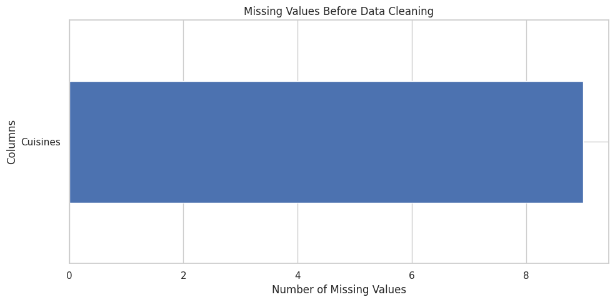
Figure 1: Missing values identified in the raw dataset prior to cleaning — only the Cuisines column was affected.

10. Technologies Used
The project was implemented entirely in Python, using the following core libraries and tools:
Technology | Purpose
Python | Core programming language for data analysis and modelling
Pandas | Data loading, cleaning, transformation, and aggregation
NumPy | Numerical computation and array operations
Matplotlib | Static charting and figure generation
Seaborn | Statistical visualization (heatmaps, violin plots, pairplots)
Scikit-learn | Regression modelling, encoding, train/test split, evaluation metrics
Folium | Interactive geospatial mapping of restaurant locations
Google Colab | Cloud-based notebook execution environment
Jupyter Notebook | Local interactive development and documentation
Table 2: Technologies and tools used in the project.

11. Project Workflow
The project followed a structured, end-to-end data science workflow, moving from raw data to actionable business insight:
Dataset
↓
Data Cleaning
↓
Exploratory Data Analysis
↓
Geospatial Analysis
↓
Feature Engineering
↓
Machine Learning
↓
Evaluation
↓
Business Insights
Each stage of the workflow corresponds to a task within the three-level internship structure: Level 1 covers data exploration, descriptive analysis, and geospatial analysis; Level 2 covers service-feature analysis, price-range analysis, and feature engineering; and Level 3 covers predictive modelling, customer-preference analysis, and final data visualization.

12. Level 1 Analysis
Level 1 established the analytical foundation of the project: exploring the raw dataset, cleaning it, computing descriptive statistics, and performing an initial geospatial study of restaurant locations.

12.1 Task 1 — Data Exploration and Preprocessing

Objective
To explore and preprocess the restaurant dataset: identify the number of rows and columns, understand the dataset structure, check and handle missing values, check for duplicate records, inspect and convert data types, and analyze the distribution and imbalance of the target variable, Aggregate rating.

Code Explanation
The dataset was loaded with pandas and inspected using .shape, .info(), and .isnull().sum(). The single affected column, Cuisines, had its 9 missing values imputed with the placeholder "Unknown" rather than dropped, to preserve every restaurant record:
df = pd.read_csv('Dataset.csv')
print(df.shape) # (9551, 21)
print(df.isnull().sum()) # Cuisines: 9
df['Cuisines'] = df['Cuisines'].fillna('Unknown')
df['Rating Status'] = df['Aggregate rating'].apply(
lambda r: 'Not rated' if r == 0 else 'Rated')

Results
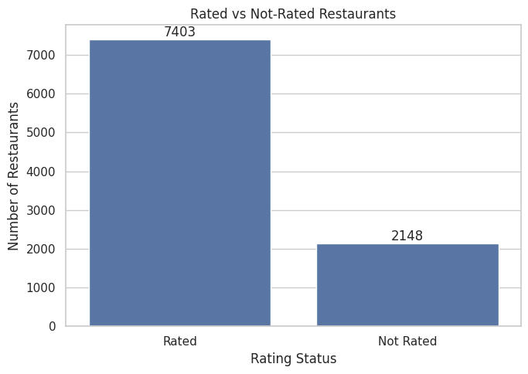
Figure 2: Rated vs. Not-Rated restaurants — 7,403 restaurants carry a genuine rating while 2,148 (22.5%) are unrated.
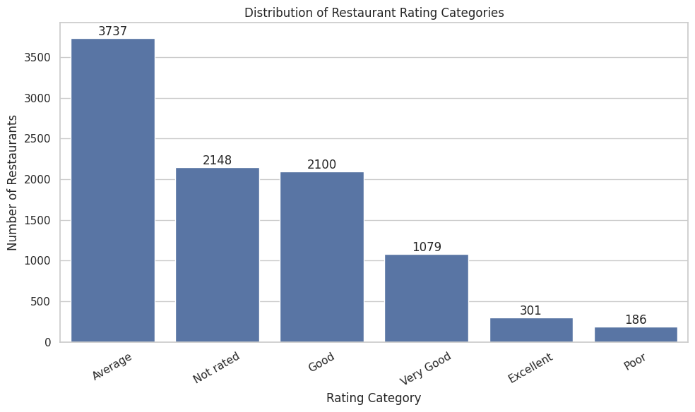
Figure 3: Distribution of restaurants across rating-text categories.
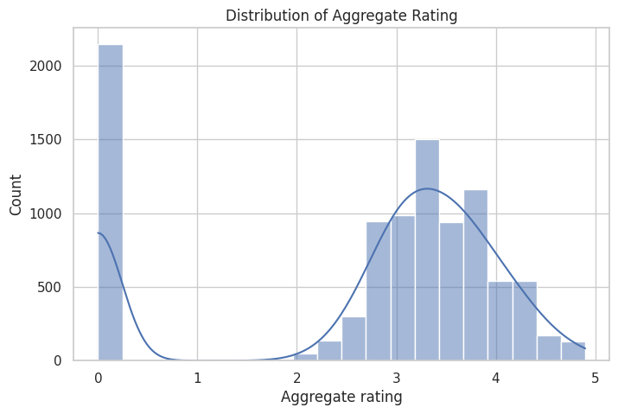
Figure 4: Distribution of the Aggregate rating target variable, showing a spike at 0 (unrated) and a roughly normal spread between 2.5 and 4.5 for rated restaurants.

Observation
The dataset contains 9,551 restaurant records and 21 original columns. Only the Cuisines column had missing values (9 records, ≈0.09%), and no duplicate rows were found. The target variable is imbalanced: 'Average' is the largest rating category (3,737 restaurants, 39.13%), 'Not rated' restaurants form a substantial 22.49% of the data, and 'Poor' is the smallest genuine category (186 restaurants, 1.95%) — the largest category is roughly 20 times the size of the smallest. Because Aggregate rating is continuous, the prediction task was framed as regression, but this imbalance was kept in mind during model evaluation.

12.2 Task 2 — Descriptive Analysis

Objective
To perform descriptive statistical analysis on the restaurant dataset: summarizing numerical variables, exploring categorical variables, identifying the most popular cuisines, identifying the cities with the highest restaurant counts, and drawing business insights.

Code Explanation
df.describe() # mean, std, min, max, quartiles
df['Cuisines'].value_counts().head(10) # most popular cuisines
df['City'].value_counts().head(20) # cities with most restaurants

Results
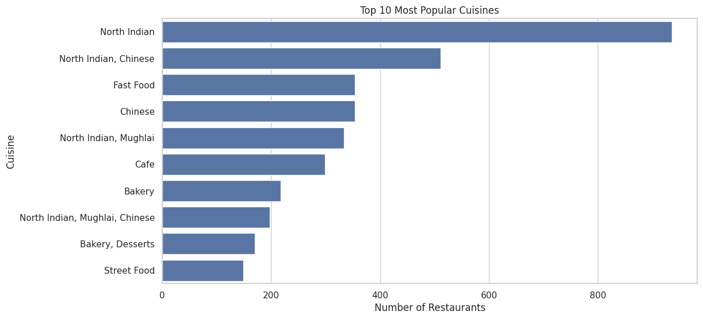
Figure 5: Top 10 most popular cuisines by number of restaurants offering them.
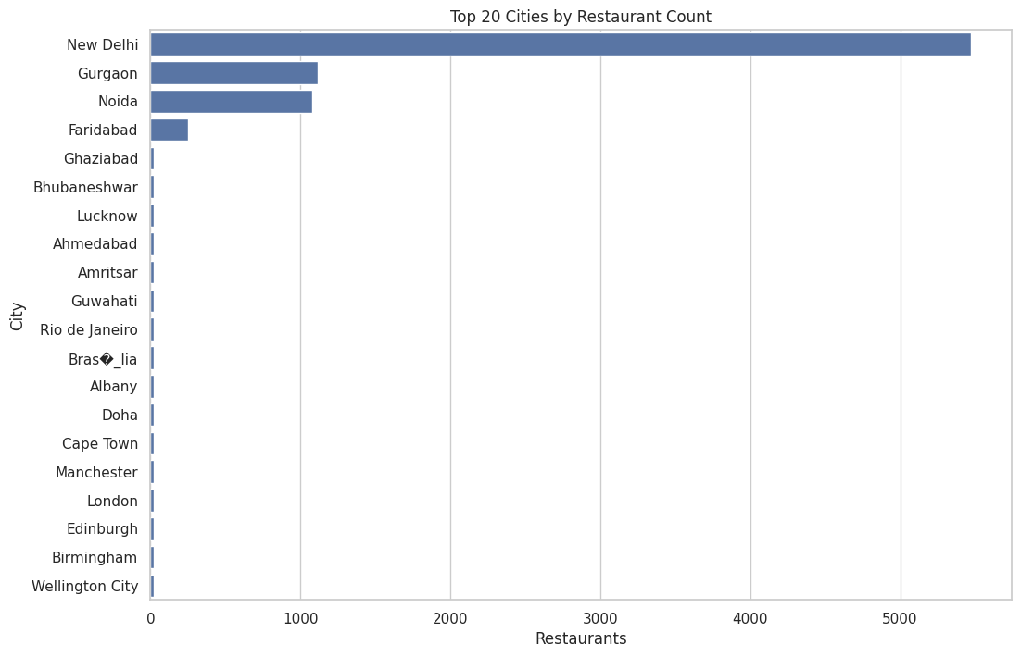
Figure 6: Top 20 cities ranked by number of listed restaurants.
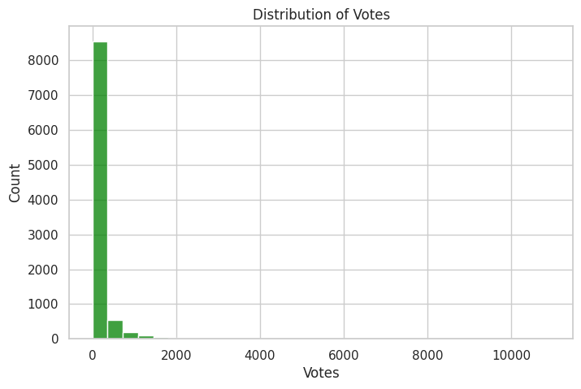
Figure 7: Distribution of customer votes across restaurants, showing strong right-skew.

Observation
North Indian cuisine (alone and in combination with Chinese and Mughlai) dominates the cuisine landscape. Restaurant listings are heavily concentrated in a handful of cities — New Delhi alone accounts for roughly 5,470 restaurants, followed by Gurgaon (~1,120) and Noida (~1,080), together dwarfing every other city in the dataset. Customer votes are highly skewed, with the vast majority of restaurants receiving fewer than 500 votes and a small number of high-profile restaurants receiving several thousand.

12.3 Task 3 — Geospatial Analysis

Objective
To perform geospatial analysis of restaurant locations using latitude and longitude coordinates: visualizing restaurant locations on an interactive map, analyzing distribution across countries and cities, and studying the relationship between location and aggregate rating.

Code Explanation
import folium
m = folium.Map(location=[df['Latitude'].mean(),
df['Longitude'].mean()], zoom_start=2)
for _, row in df.iterrows():
folium.CircleMarker(
location=[row['Latitude'], row['Longitude']],
radius=2, popup=row['Restaurant Name']
).add_to(m)
m.save('Restaurant_Map.html')

Results
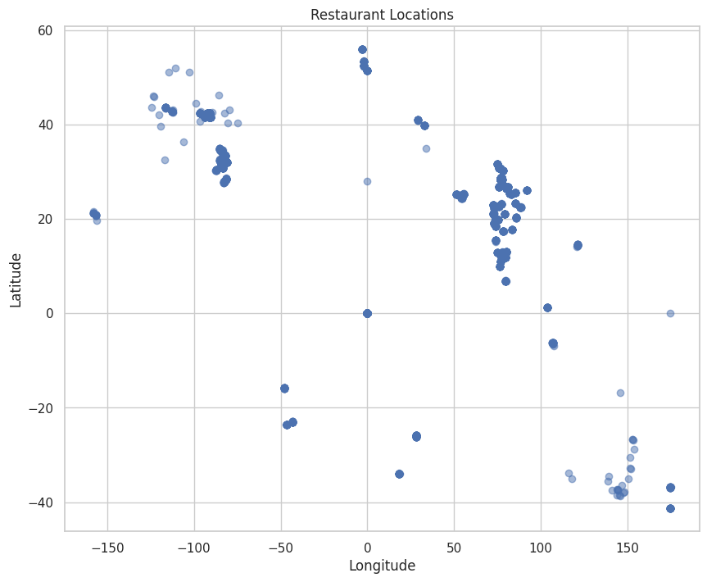
Figure 8: Global scatter of restaurant locations by latitude and longitude.
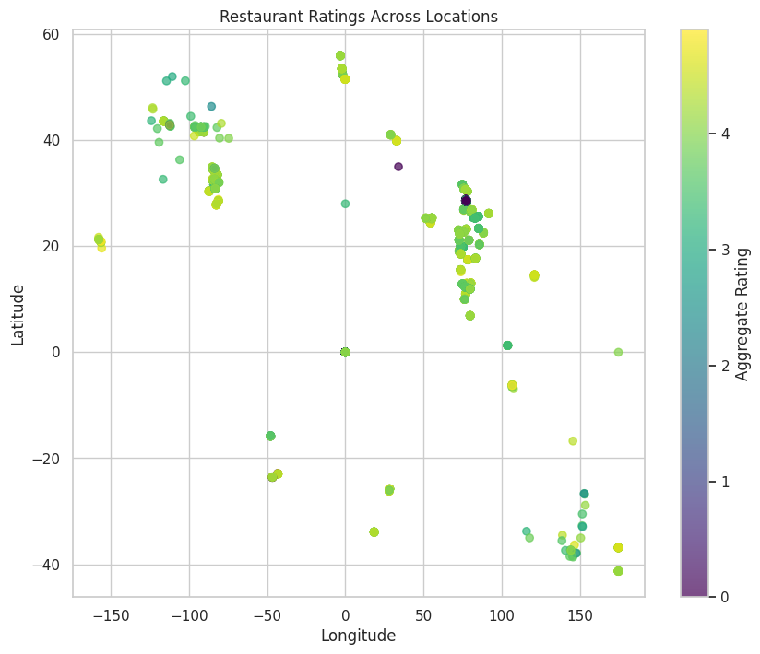
Figure 9: Restaurant locations colored by Aggregate rating, highlighting regional rating patterns.
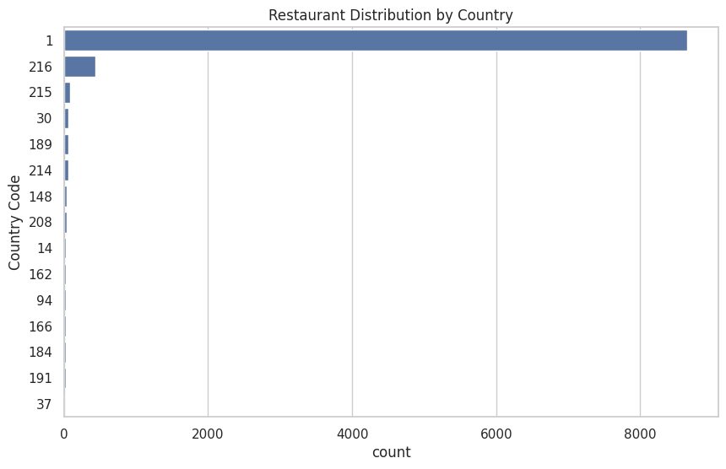
Figure 10: Restaurant distribution by Country Code — the dataset is heavily concentrated in a single country (India).
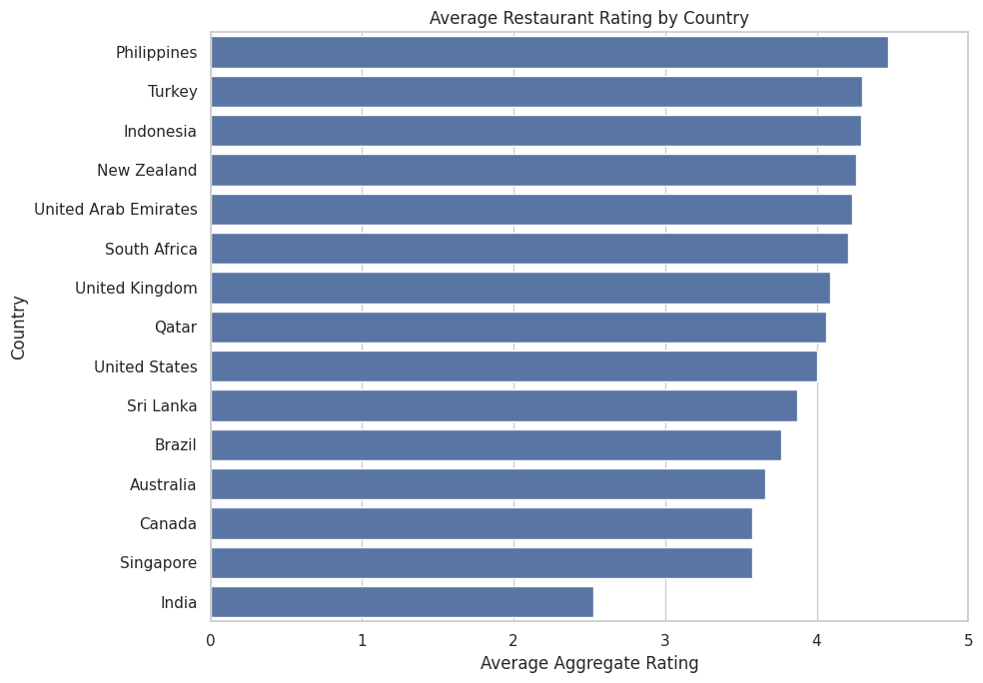
Figure 11: Average Aggregate rating by country, restricted to countries with a meaningful sample size.

Observation
The dataset spans 15 countries, but India contributes the overwhelming majority of records, so the dataset is heavily concentrated in the Indian market. Because the country distribution is uneven, country-level rating comparisons were restricted to countries with at least 20 restaurants to avoid unreliable averages driven by tiny samples. Correlation analysis (Figure 3 in the geospatial notebook) indicated that geographic coordinates alone have a weak relationship with rating, meaning location matters more through city-level market dynamics than through raw latitude/longitude position.

13. Level 2 Analysis
Level 2 moved from descriptive exploration into business-oriented analysis: quantifying the effect of service features (table booking, online delivery) and price positioning on customer ratings, and engineering new features to support predictive modelling.

13.1 Task 1 — Table Booking & Online Delivery Analysis

Objective
To analyze restaurant services related to table booking and online delivery: their overall adoption rates, their relationship with customer ratings, and how online delivery adoption varies across price ranges.

Code Explanation
df.groupby('Has Table booking')['Aggregate rating'].mean()
df.groupby('Has Online delivery')['Aggregate rating'].mean()
pd.crosstab(df['Price range'], df['Has Online delivery'],
normalize='index') * 100

Results
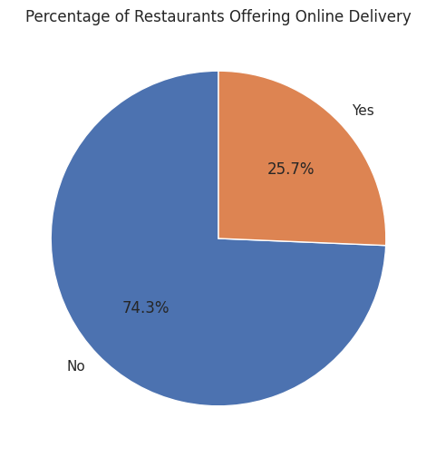
Figure 12: 25.7% of restaurants offer online delivery.
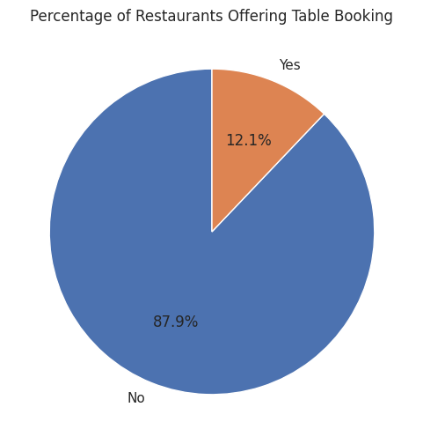
Figure 13: Only 12.1% of restaurants offer table booking.
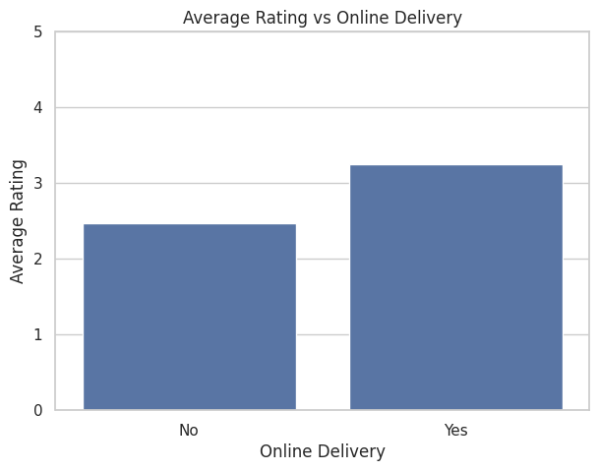
Figure 14: Average rating is higher for restaurants offering online delivery (≈3.25) than those without (≈2.47).
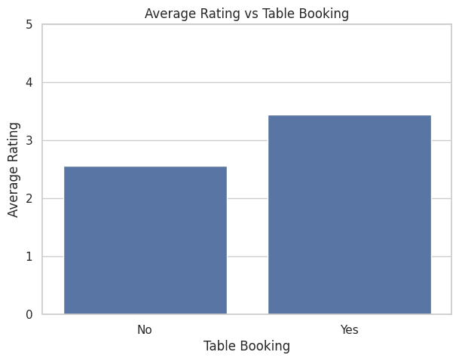
Figure 15: Average rating is higher for restaurants offering table booking (≈3.44) than those without (≈2.55).
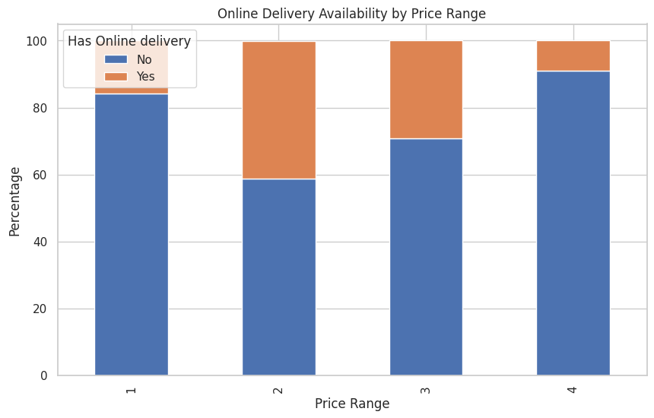
Figure 16: Online delivery availability by price range (1 = cheapest, 4 = most expensive) — adoption peaks in the mid-range.
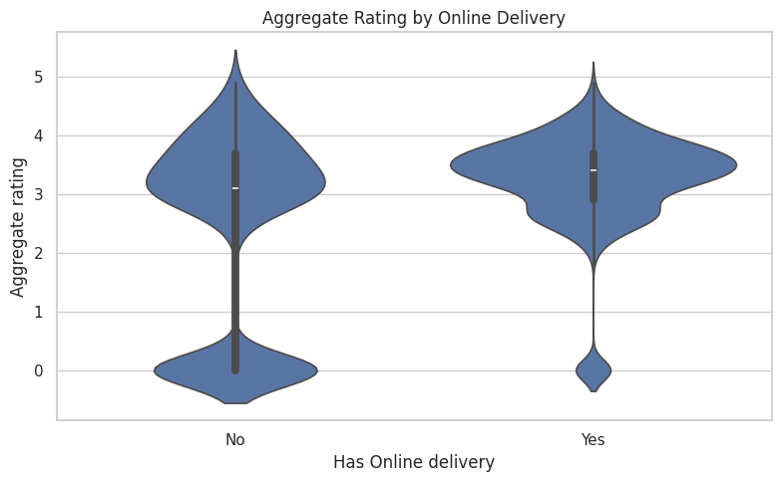
Figure 17: Violin plot of Aggregate rating by online-delivery availability, showing a tighter, higher-centered distribution for delivery-enabled restaurants.

Observation
Only a minority of restaurants provide table booking (12.1%) or online delivery (25.7%), showing these remain differentiating rather than universal features. Restaurants offering either service show meaningfully higher average ratings than those without, and adoption of online delivery is not uniform across price tiers — it is most common among mid-priced (price range 2–3) restaurants and least common in the cheapest and priciest tiers.

13.2 Task 2 — Price Range Analysis

Objective
To analyze the relationship between restaurant price ranges and customer ratings: identifying the most common price range, calculating average ratings per range, analyzing rating colors, and exploring the distribution across price categories.

Code Explanation
df['Price Category'] = pd.cut(
df['Price range'], bins=[0,1,2,3,4],
labels=['Budget','Affordable','Premium','Luxury'])
df.groupby('Price Category')['Aggregate rating'].mean()

Results
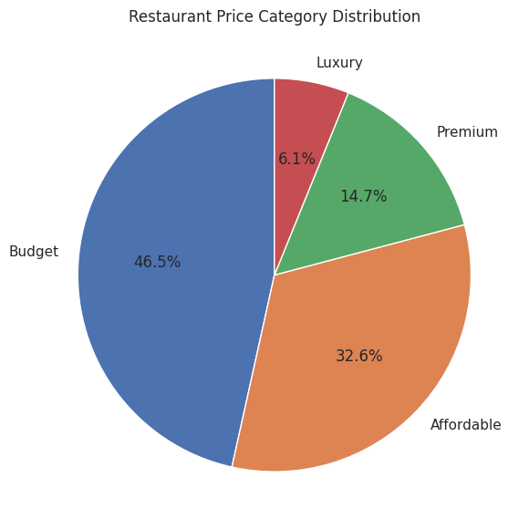
Figure 18: Restaurant price-category distribution — Budget restaurants make up 46.5% of the dataset.
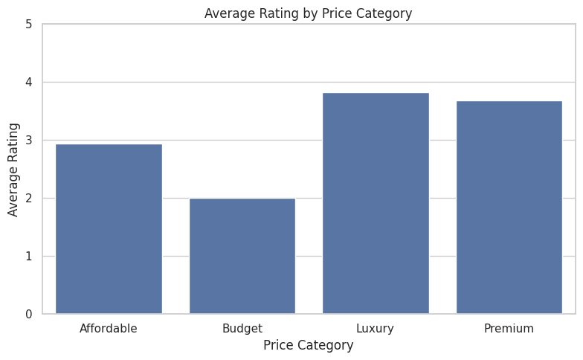
Figure 19: Average rating by price category — Luxury (≈3.82) and Premium (≈3.68) restaurants outperform Affordable (≈2.94) and Budget (≈2.00).
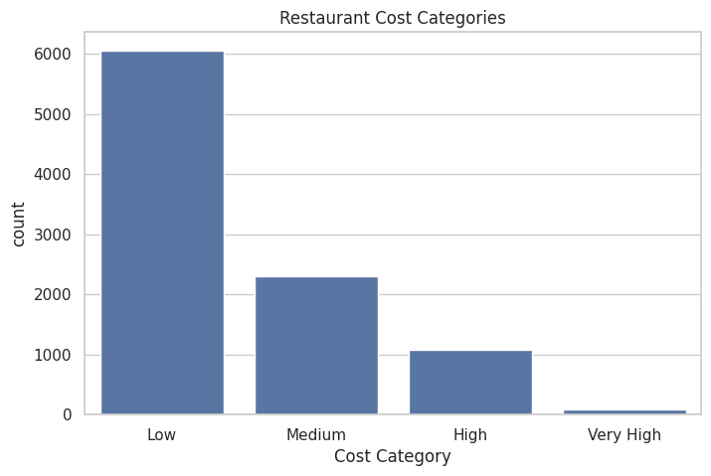
Figure 20: Restaurant count by cost category (Low, Medium, High, Very High), skewed heavily toward Low-cost restaurants.
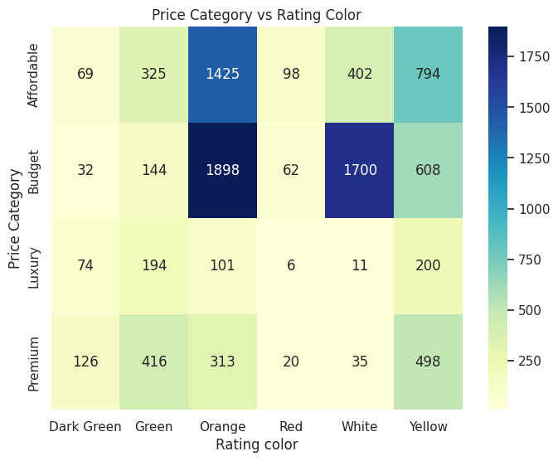
Figure 21: Cross-tabulation heatmap of price category against Zomato rating color.
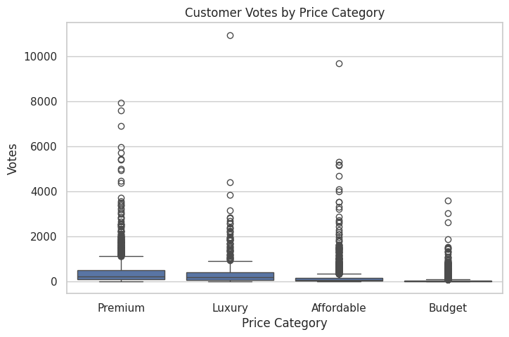
Figure 22: Distribution of customer votes across price categories, showing Premium and Luxury restaurants attract higher-variance engagement.

Observation
Budget restaurants represent the largest share of the dataset (46.5%), reflecting strong demand for affordable dining. However, average ratings rise with price category up to a point — Luxury and Premium restaurants receive noticeably higher average ratings than Budget restaurants — showing that pricing and perceived quality are correlated, although higher price alone does not guarantee a higher rating for every individual restaurant.

13.3 Task 3 — Feature Engineering

Objective
To create new, meaningful features from the existing dataset to improve future machine-learning models: text-based features, encoded categorical variables, numerical derivatives, and binary flags.

Code Explanation
fe['Restaurant Name Length'] = fe['Restaurant Name'].str.len()
fe['Address Length'] = fe['Address'].str.len()
fe['Cuisine Count'] = fe['Cuisines'].str.split(',').apply(len)
fe['Table Booking'] = (fe['Has Table booking']=='Yes').astype(int)
fe['Online Delivery'] = (fe['Has Online delivery']=='Yes').astype(int)
fe['High Rated Restaurant'] = (fe['Aggregate rating']>=4).astype(int)
fe['Cost Per Person'] = fe['Average Cost for two'] / 2
fe['Log Votes'] = np.log1p(fe['Votes'])

Results
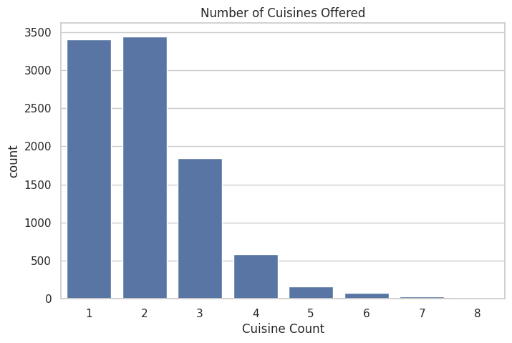
Figure 23: Distribution of the number of cuisines offered per restaurant — most restaurants list 1–2 cuisines.
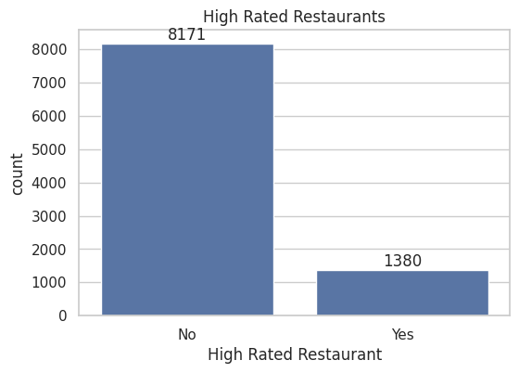
Figure 24: Binary High Rated Restaurant flag: 1,380 restaurants (≥4.0 rating) vs. 8,171 that fall below the threshold.

Observation
Nine new engineered columns were added, expanding the dataset from 22 to 33 columns. Binary encoding converted categorical service flags into machine-learning-friendly numerical values; Cost Per Person offered a more interpretable pricing metric than the raw two-person cost; Cuisine Count captured menu diversity; and a log transform of Votes reduced the heavy right-skew seen in Figure 8, improving downstream model stability.

14. Level 3 Analysis
Level 3 combined machine learning, customer-preference analysis, and a final consolidated round of visualization to translate the engineered dataset into predictions and business-ready insight.

14.1 Machine Learning
Full methodology, model architectures, and evaluation results for the predictive-modelling task are presented in Chapter 15 (Machine Learning Models) and Chapter 16 (Model Evaluation) to avoid duplication.
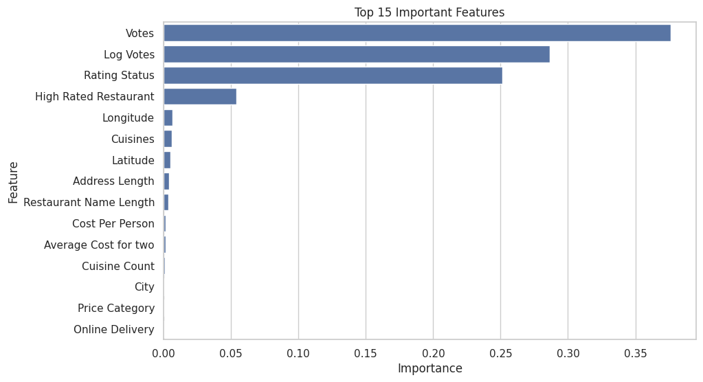
Figure 25: Top 15 features ranked by importance in the Random Forest model — Votes, Log Votes, and Rating Status dominate.

14.2 Customer Preference Analysis

Objective
To understand customer preferences by analyzing ratings, cuisines, votes, pricing, and service features: the most popular and most-voted cuisines, customer preference for delivery/booking services, and city-wise customer satisfaction.
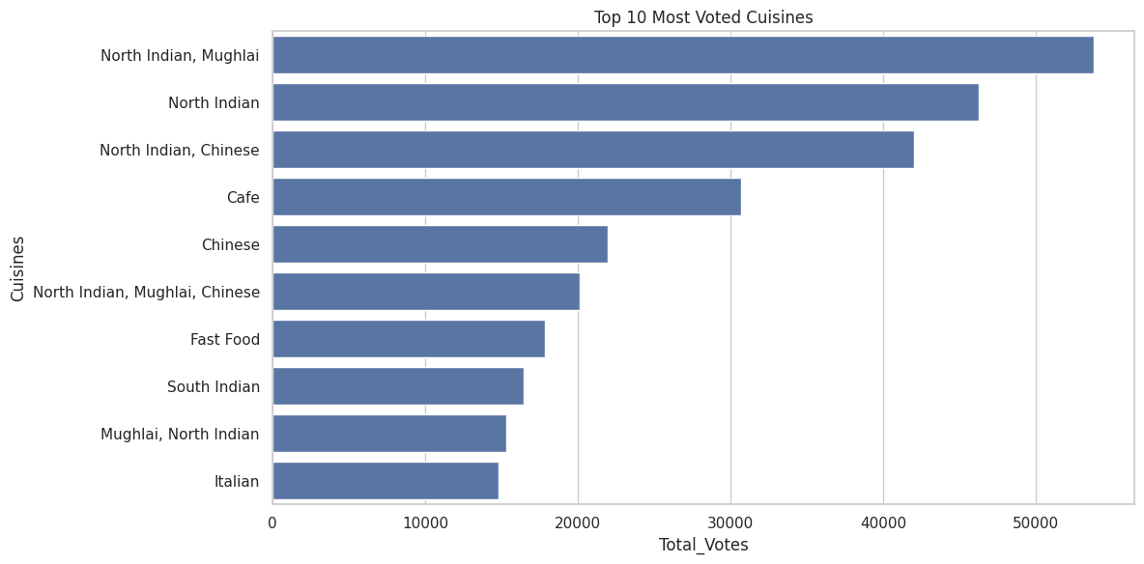
Figure 26: Top 10 cuisines ranked by total customer votes — North Indian / Mughlai combinations lead engagement.
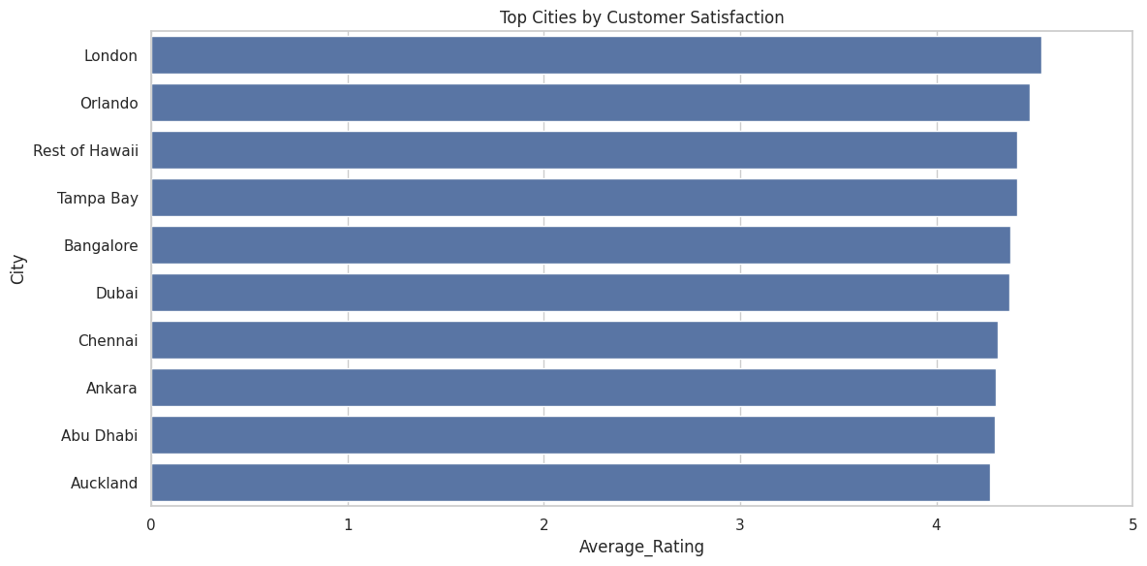
Figure 27: Top cities ranked by average customer satisfaction (average rating).

Observation
A small number of cuisines dominate both popularity and voting volume, indicating concentrated customer demand. Restaurants offering online delivery and table booking consistently receive higher average ratings, reinforcing the Level 2 findings. Customer satisfaction varies meaningfully across cities — London, Orlando, and several Philippine and UAE cities post the highest average ratings among cities with a reasonable restaurant count, useful signal for expansion planning.

14.3 Data Visualization

Objective
To create a consolidated set of visualizations that reveal overall patterns, trends, and variable relationships across the cleaned and engineered dataset.
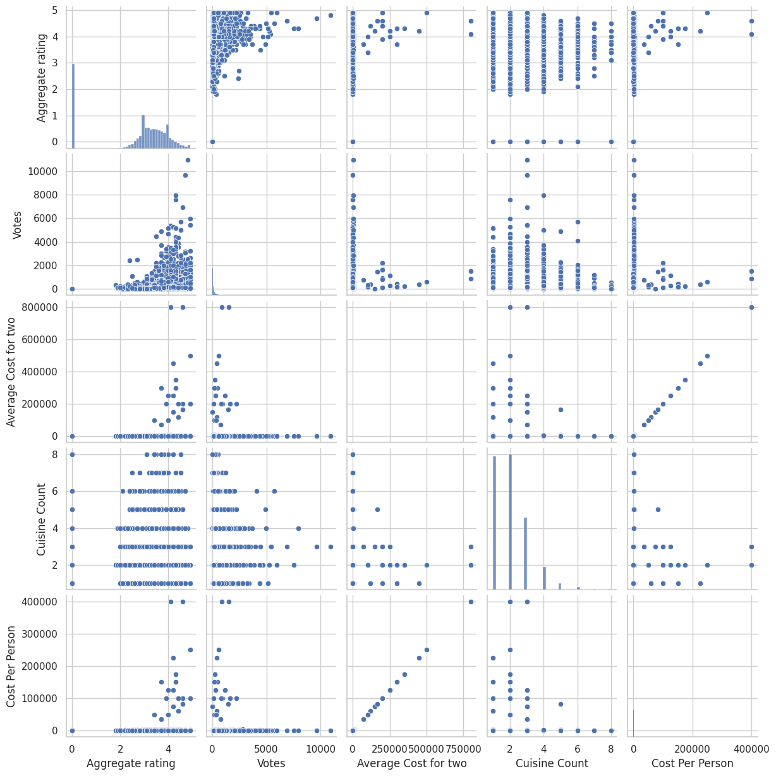
Figure 28: Pairplot of Aggregate rating, Votes, Average Cost for two, and Cuisine Count, showing pairwise relationships and marginal distributions.
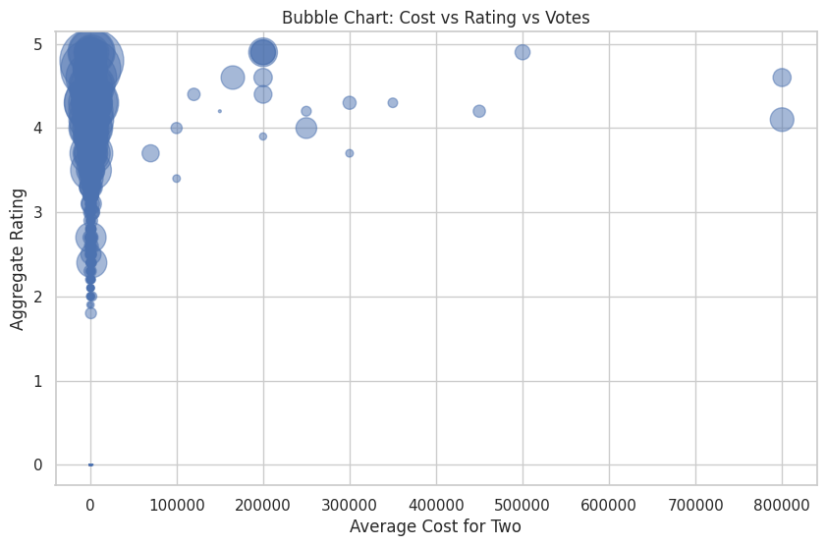
Figure 29: Bubble chart of Average Cost for two vs. Aggregate rating, with bubble size representing Votes.

Observation
Restaurant ratings are concentrated between 3.0 and 4.5 for rated restaurants; customer votes are highly skewed, with a small number of restaurants generating disproportionate engagement; and correlation analysis (see Chapter 15) confirms that customer engagement (Votes) has the strongest positive relationship with Aggregate rating among all engineered features.

15. Machine Learning Models
Three regression algorithms of increasing complexity were trained and compared on the feature-engineered dataset, using an 80/20 train-test split (random_state=42):
X_train, X_test, y_train, y_test = train_test_split(
X, y, test_size=0.20, random_state=42)

15.1 Linear Regression
Linear Regression models the target as a weighted linear combination of input features:
ŷ = β₀ + β₁x₁ + β₂x₂ + … + βₙxₙ + ε
where β₀ is the intercept, β₁…βₙ are learned feature coefficients, and ε is the irreducible error term. Coefficients are estimated by minimizing the sum of squared residuals (Ordinary Least Squares). Linear Regression is fast, highly interpretable, and served as the project's baseline model.
linear = LinearRegression()
linear.fit(X_train, y_train)
linear_prediction = linear.predict(X_test)

15.2 Decision Tree Regressor
A Decision Tree recursively partitions the feature space into regions that minimize the variance of the target within each region, splitting on the feature and threshold that most reduces mean-squared error at each node:
MSE(node) = (1/n) Σ (yᵢ − ȳ)²
Decision Trees can capture non-linear relationships and feature interactions without explicit feature transformation, but a single unconstrained tree is prone to overfitting the training data, which reduces its generalization to unseen restaurants.
tree = DecisionTreeRegressor(random_state=42)
tree.fit(X_train, y_train)
tree_prediction = tree.predict(X_test)

15.3 Random Forest Regressor
Random Forest is an ensemble method that trains many decision trees on bootstrap-resampled subsets of the training data and random subsets of features, then averages their individual predictions:
ŷ = (1/T) Σₜ₌₁ᵀ treeₜ(x)
where T is the number of trees (100 in this project) and treeₜ(x) is the prediction of the t-th tree. Averaging over many decorrelated trees reduces variance relative to a single tree, which is why Random Forest typically generalizes better than an individual Decision Tree while retaining the ability to model non-linear relationships.
forest = RandomForestRegressor(n_estimators=100, random_state=42)
forest.fit(X_train, y_train)
forest_prediction = forest.predict(X_test)

16. Model Evaluation
Three evaluation metrics were used to compare the models on the held-out 20% test set: Mean Absolute Error (MAE), Root Mean Squared Error (RMSE), and the coefficient of determination (R² Score).
mae = mean_absolute_error(y_test, prediction)
rmse = np.sqrt(mean_squared_error(y_test, prediction))
r2 = r2_score(y_test, prediction)
Model | MAE | RMSE | R² Score
Linear Regression | 0.200 | 0.279 | 0.966
Decision Tree | 0.233 | 0.372 | 0.939
Random Forest | 0.169 | 0.255 | 0.971
Table 3: Model comparison on the held-out test set (lower MAE/RMSE and higher R² indicate better performance).
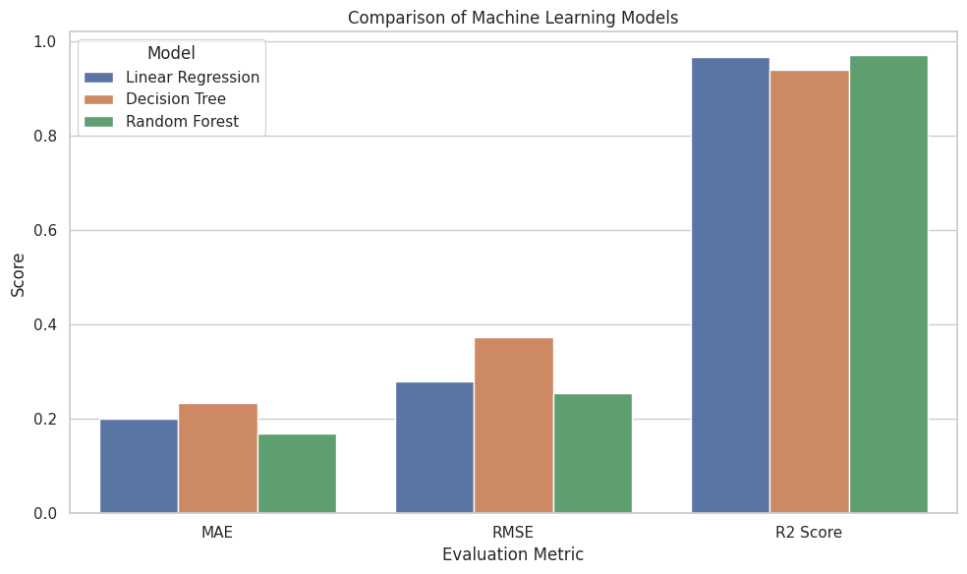
Figure 30: Side-by-side comparison of MAE, RMSE, and R² Score across all three models.
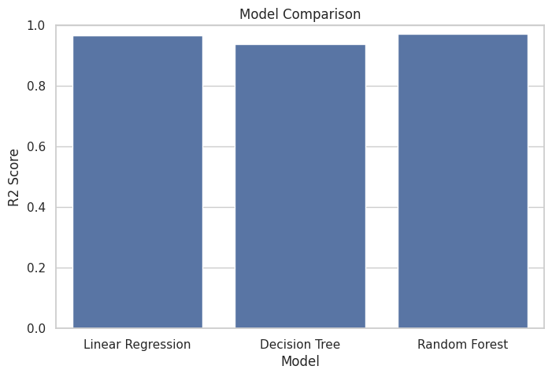
Figure 31: R² Score comparison across models — Random Forest achieves the highest score.
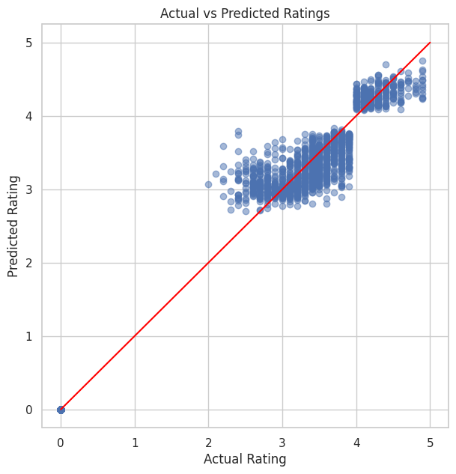
Figure 32: Actual vs. Predicted ratings for the Random Forest model. Points cluster tightly around the ideal y = x diagonal.
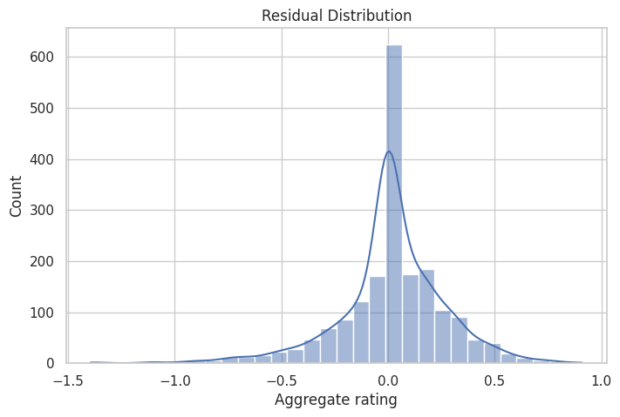
Figure 33: Distribution of residuals (actual − predicted) for the Random Forest model, sharply peaked around zero.

16.1 Why Random Forest Performed Best
The Random Forest Regressor achieved the lowest MAE (0.169), the lowest RMSE (0.255), and the highest R² Score (0.971) of the three models, making it the best-performing model for this task. Several factors explain this result:
- Ensembling reduces variance: averaging predictions across 100 trees smooths out the overfitting that affects a single Decision Tree (whose R² of 0.939 was the lowest of the three), since individual trees' errors partially cancel out.
- Non-linear capacity: unlike Linear Regression, Random Forest can model non-linear relationships and interactions — for example, between Votes, Rating Status, and price-related features — without manual feature engineering of interaction terms.
- Robustness to skewed/engineered features: tree-based splits are invariant to monotonic transformations and are naturally robust to the heavy skew present in Votes, which Linear Regression is more sensitive to despite the Log Votes transformation.
- Feature importance signal: the dominance of Votes, Log Votes, and Rating Status in the feature-importance ranking (Figure 22) aligns with intuition — highly-voted, genuinely-rated restaurants are systematically easier to predict — and Random Forest can exploit this hierarchy more effectively through repeated splitting.
It is worth noting that Linear Regression also performed remarkably well (R² = 0.966), suggesting that much of the relationship between the engineered features and Aggregate rating is close to linear, and that Rating Status in particular acts as a near-deterministic feature (Not-rated restaurants have Aggregate rating exactly 0.0), which inflates R² for all three models.

17. Business Insights
- 22.5% of restaurants in the dataset are unrated, representing a substantial 'ratings gap' that platforms could close through targeted review-solicitation campaigns.
- Restaurant listings are extremely concentrated: New Delhi alone accounts for roughly 57% of all restaurants in the dataset, followed distantly by Gurgaon and Noida — expansion strategies should account for this concentration risk.
- North Indian cuisine (alone and in combination with Chinese/Mughlai) dominates both restaurant count and customer voting volume, indicating strong, durable demand for this cuisine category.
- Only 12.1% of restaurants offer table booking and 25.7% offer online delivery — both remain under-penetrated service features with room for competitive differentiation.
- Restaurants offering table booking average a full rating point higher (≈3.44 vs ≈2.55) than those without — one of the strongest single-feature effects observed in the dataset.
- Restaurants offering online delivery average ≈3.25 vs ≈2.47 for those without, reinforcing those services correlate strongly with customer satisfaction (though causality cannot be confirmed from observational data alone).
- Budget restaurants dominate by count (46.5%) but Luxury and Premium restaurants achieve meaningfully higher average ratings — suggesting a 'quality premium' rather than a simple price-satisfaction trade-off.
- Online-delivery adoption is not linear with price: it peaks in the mid-price tiers rather than the cheapest or most expensive restaurants, reflecting differing operating models across price segments.
- Customer engagement (Votes) is the single strongest predictor of Aggregate rating in the feature-importance analysis, more influential than price, cuisine, or location — visibility and engagement appear to compound with perceived quality.
- Geographic coordinates alone show weak correlation with rating, implying that city-level market dynamics (competition, price positioning, service adoption) matter far more than raw location.
- Countries with small restaurant counts (e.g., under 20 records) show volatile average ratings and should be excluded or flagged when benchmarking country performance.
- The Random Forest model's high accuracy (R² = 0.971) demonstrates that restaurant ratings are substantially predictable from observable, non-subjective characteristics, supporting its use in early-warning or quality-monitoring systems.
- Cost Per Person and Average Cost for two are near-duplicate signals (as shown in the correlation heatmap), so future feature sets could safely drop one to reduce redundancy.
- Restaurants offering multiple cuisines (2–3) are the most common configuration, but very high cuisine counts (6+) are rare and do not show a clear ratings benefit, suggesting menu focus is not penalized by customers.

18. Results
This chapter consolidates the key result visualizations produced across the project for quick reference.

18.1 Heatmap
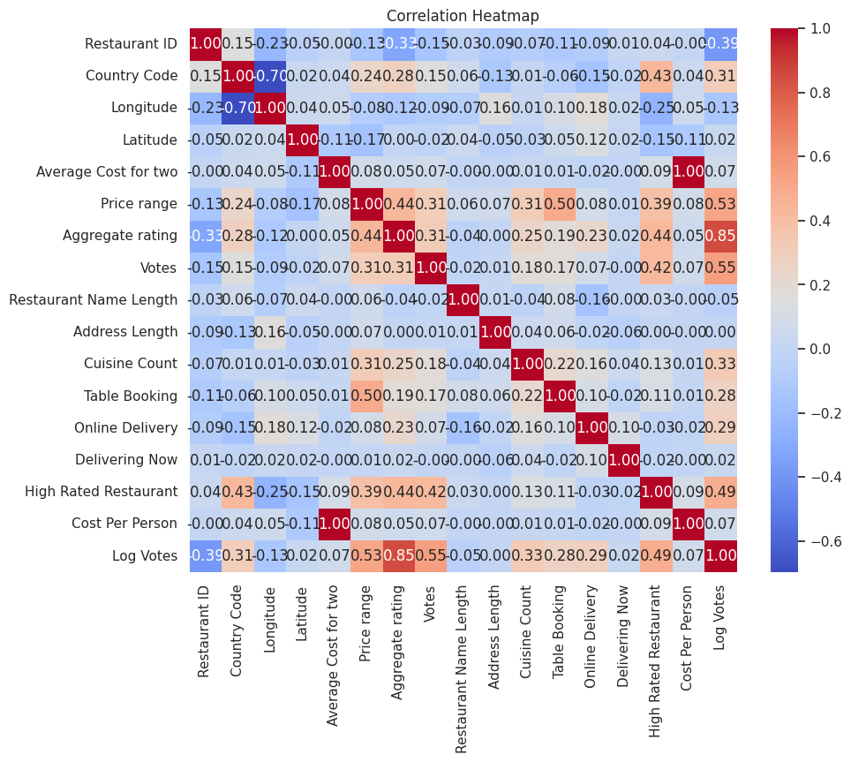
Figure 34: Full correlation heatmap across numerical and engineered features in the dataset.

18.2 Feature Importance

Figure 35: Top 15 features by importance in the Random Forest model.

18.3 Actual vs Predicted

Figure 36: Actual vs. Predicted Aggregate rating for the Random Forest model on the test set.

18.4 Geospatial Map

Figure 37: Global restaurant locations colored by Aggregate rating. An interactive Folium version (Restaurant_Map.html) is included in the project deliverables.

18.5 Customer Preference

Figure 38: Top cities ranked by average customer satisfaction.

18.6 Top Cuisines

Figure 39: Top 10 most popular cuisines by restaurant count.

18.7 Model Comparison

Figure 40: Comparison of MAE, RMSE, and R² Score across Linear Regression, Decision Tree, and Random Forest.

18.8 Rating Distribution

Figure 41: Distribution of Aggregate rating across the full dataset.

19. Challenges Faced

Missing Values
Although only the Cuisines column had missing values, deciding how to treat them required care: dropping the 9 affected rows was viable given their small share (0.09%), but imputing with "Unknown" was preferred to preserve every restaurant record and to keep the dataset size consistent across all downstream tasks.

Country Mapping
The raw dataset only provides a numeric Country Code, not a human-readable country name. Mapping these codes to actual country names (e.g., 1 → India, 216 → United States) required building and validating a lookup table, since an incorrect mapping would silently corrupt every country-level aggregation and chart in later chapters.

Feature Engineering
Deciding which engineered features would add genuine predictive signal — as opposed to redundant or leakage-prone variables — required iteration. For example, Rating Status (derived directly from Aggregate rating) is highly predictive almost by construction, and its inclusion needed to be interpreted carefully rather than treated as a 'free' accuracy gain.

Encoding
The dataset mixes free-text categorical fields (Cuisines, with over 1,800 unique combinations), low-cardinality categoricals (Has Table booking, Has Online delivery), and high-cardinality location fields (City, Address). Selecting an encoding strategy that avoided excessive dimensionality (from naive one-hot encoding of Cuisines or City) while still preserving useful signal required trade-offs, ultimately favoring engineered numeric summaries (e.g., Cuisine Count) over full categorical expansion for several fields.

Model Selection
With all three models achieving R² above 0.93, distinguishing genuine performance differences from noise required looking beyond a single metric — MAE, RMSE, and R² were considered jointly, and residual-distribution analysis (Figure 24) was used to confirm that the Random Forest's advantage was consistent rather than driven by a few outliers.

20. Conclusion
This project delivered a complete, end-to-end data science workflow on a real-world, multi-country restaurant dataset of 9,551 records, structured across the three progressive levels of the Cognifyz Technologies Data Science Internship. The dataset was explored, cleaned (resolving all missing values with negligible data loss), and statistically summarized; restaurant locations were mapped and analyzed geospatially; the business impact of service features such as table booking and online delivery was quantified; nine new features were engineered to prepare the data for modelling; and three regression models were trained and rigorously compared.
The Random Forest Regressor emerged as the best-performing model, achieving an R² Score of 0.971, an MAE of 0.169, and an RMSE of 0.255 on held-out data — meaningfully outperforming both Linear Regression (R² = 0.966) and the Decision Tree Regressor (R² = 0.939). Feature-importance analysis confirmed that customer engagement (Votes and its log-transformed counterpart) and rating status are the dominant drivers of predicted rating, ahead of price, cuisine, and location-based features.
Beyond predictive accuracy, the project surfaced fourteen actionable business insights — from the under-penetration of table booking and online delivery services, to the extreme geographic concentration of listings, to the disproportionate influence of customer engagement on ratings — that can directly inform decisions by restaurant owners, food-delivery platforms, and market-expansion teams.

21. Future Scope
- Incorporate textual review data (customer comments) using NLP techniques such as sentiment analysis to enrich the feature set beyond structured attributes.
- Apply gradient-boosting methods (XGBoost, LightGBM, CatBoost) to benchmark against Random Forest and potentially push R² further.
- Address the country/city imbalance with stratified sampling or hierarchical modelling, so that predictions for under-represented markets are not dominated by the Indian subset.
- Deploy the trained Random Forest model behind a REST API to enable real-time rating prediction for new or updated restaurant listings.
- Extend the geospatial analysis with clustering (e.g., DBSCAN) to identify natural restaurant 'hubs' and underserved geographic gaps for expansion planning.
- Build a live, interactive dashboard (e.g., using Plotly Dash or Streamlit) so non-technical stakeholders can explore the insights without running the notebooks directly.
- Periodically retrain the model as new restaurant and rating data becomes available, to guard against data or concept drift over time.

22. References
- Cognifyz Technologies — Data Science Internship Program Task Guidelines.
- Pandas Development Team. pandas documentation. https://pandas.pydata.org/docs/
- NumPy Developers. NumPy documentation. https://numpy.org/doc/
- Hunter, J. D. Matplotlib: A 2D Graphics Environment. https://matplotlib.org/
- Waskom, M. Seaborn: statistical data visualization. https://seaborn.pydata.org/
- Pedregosa, F. et al. Scikit-learn: Machine Learning in Python. Journal of Machine Learning Research, 2011. https://scikit-learn.org/
- Folium Developers. Folium documentation — Python data visualized on interactive Leaflet maps. https://python-visualization.github.io/folium/
- Breiman, L. Random Forests. Machine Learning, 45(1), 5–32, 2001.
- Zomato Restaurant Dataset (Kaggle-style schema) used as the basis for the internship dataset.

