## # IMPORTING LIBRARIES

import pandas as pd

import matplotlib.pyplot as plt

from sklearn.model_selection import train_test_split

from sklearn.linear_model import LinearRegression

from sklearn.metrics import confusion_matrix,accuracy_score

import math

from sklearn import metrics

from sklearn.model_selection import train_test_split

from sklearn.ensemble import RandomForestRegressor

from sklearn.metrics import confusion_matrix,accuracy_score

# # READING DATASET

df=pd.read_csv('productivity_n_hourly_compensation.csv')

df

## output:

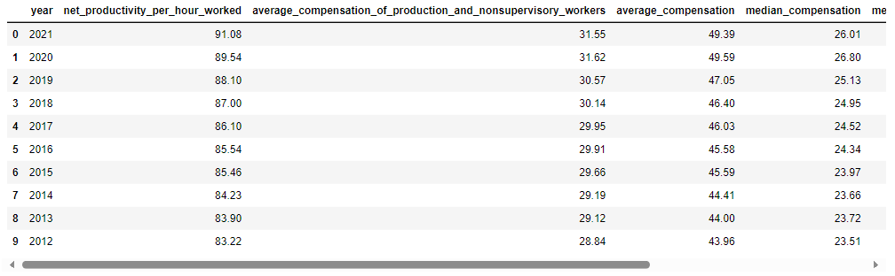

# # TO CHECK THE FIRST FIVE COLUMNS

df.head()

# output:

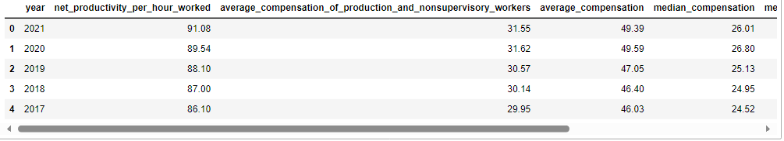

# # CHECKING MISSING VALUES

df.isnull().sum()

# output:

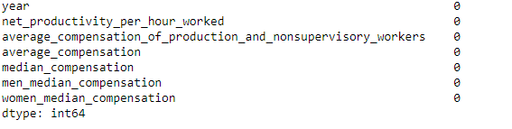

# df.isnull( ).any( )

# output:

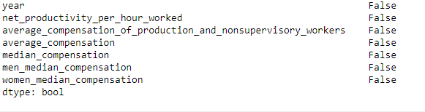

# # CHECKING INFORMATION ABOUT DATASET

df.info()

# output:

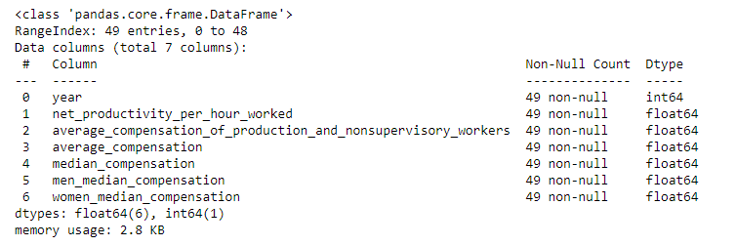

# #TO CHECK STATISTICS OF DATASET

df.describe()

# output:

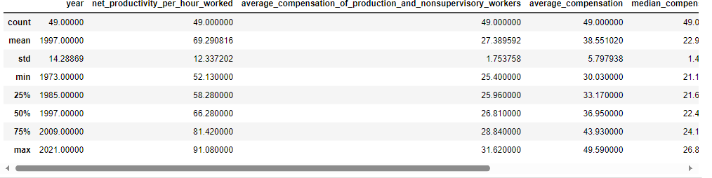

print('lenghth of dataset:',len(df))

print('shape of dataset:',df.shape)

# output:



#

# PLOTING LINE GRAPH FOR AVERAGE COMPENSATION OF PRODUCTIVITY_N_HOURLY_COMPENSATION

import matplotlib.pyplot as plt

df['average_compensation'].plot(figsize=(16,6))

plt.title('Linechart')

plt.xlabel('average_compensation')

plt.ylabel('frequency')

plt.show()

# output:

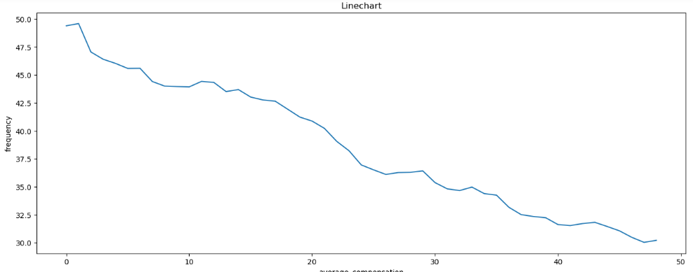

# # TRAINING THE MODEL FOR MultipleLinearRegression

# # splitting the dataset

x=df.drop('net_productivity_per_hour_worked',axis=1)

y=df['net_productivity_per_hour_worked']

x_train,x_test,y_train,y_test=train_test_split(x,y,random_state=0)

print(x_train.shape)

print(x_test.shape)

print(y_train.shape)

print(y_test.shape)

# output:

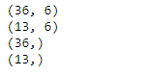

# # MODEL TRAINING

regressor=LinearRegression()

regressor.fit(x_train,y_train)

# output:

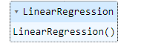

# #TO CHECK CO-EFFICIENT AND INTERCEPT

print(regressor.coef_)

print(regressor.intercept_)

# output:



# # PREDICTION

predicted=regressor.predict(x_test)

predicted

# output:



print(x_test)

# output:

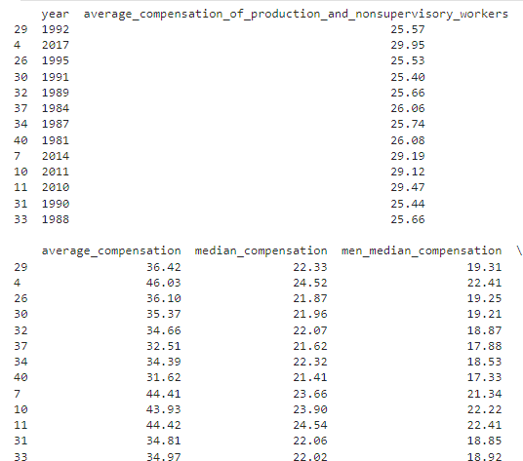

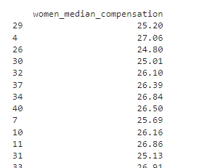

predicted.shape

# output:

(13,)

dframe=pd.DataFrame(y_test,predicted)

dframe

# output:

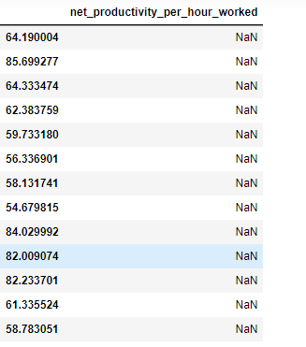

# # TO CHECK ACTUAL PRICE AND PREDICTED PRICE

dfr=pd.DataFrame({'Actual Price':y_test,'Predicted Price':predicted})

dfr

# output:

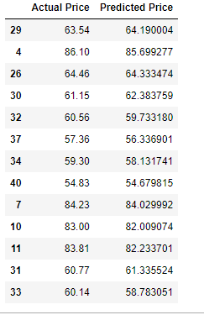

dfr.head(40)

# output:

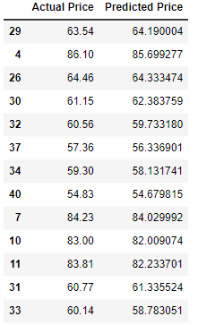

# # EVALUATING THE MODEL

from sklearn.metrics import confusion_matrix,accuracy_score

train_accuracy=regressor.score(x_train,y_train)

print('train_accuracy:',train_accuracy)

test_accuracy=regressor.score(x_test,y_test)

print('test_accuracy:',test_accuracy)

# output:



import math

from sklearn import metrics

print('Mean Absolute Error:',metrics.mean_absolute_error(y_test,predicted))

print('Mean Squared Error:',metrics.mean_squared_error(y_test,predicted))

print('Root Mean Squared Error:',math.sqrt(metrics.mean_squared_error(y_test,predicted)))

# output:

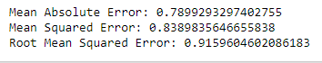

graph=dfr.head(20)

graph

# output:

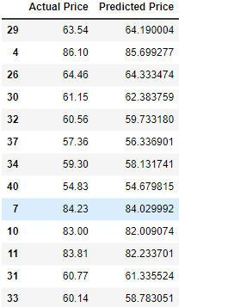

# # TO PLOT THE BAR GRAPH AND TO CHECK THE ACTUAL PRICE AND PREDICTED PRICE

graph.plot(kind='bar')

plt.title('BarGraph')

plt.xlabel('Actual&prediceted price')

plt.ylabel('frequency')

plt.show()

# output:

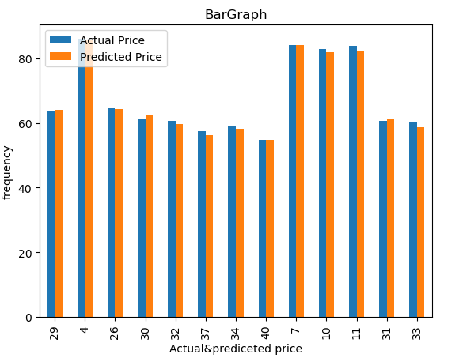

**from** sklearn.model_selection **import** train_test_split

x_train,x_test,y_train,y_test**=**train_test_split(x,y,test_size**=**0.90,random_state**=**100)

print(x_train**.**shape)

print(x_test**.**shape)

print(y_train**.**shape)

print(y_test**.**shape)

# output:

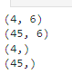

# # TRAINING THE MODEL FOR RandomForestRegressor

# #MODEL TRAINING

**from** sklearn.ensemble **import** RandomForestRegressor

regressorRandomForestRegressor(n_estimators**=**100,random_state**=**0)

regressor**.**fit(x_train,y_train)

# output:



predicted=regressor.predict(x_test)

predicted

# output:

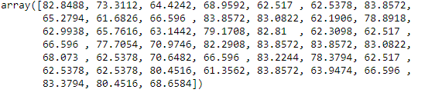

from sklearn.metrics import confusion_matrix,accuracy_score

train_accuracy=regressor.score(x_train,y_train)

print('train_accuracy:',train_accuracy)

R_test_accuracy=regressor.score(x_test,y_test)

print('test_accuracy:',R_test_accuracy)

# output:



# # USING BAR GRAPH COMPARISON BETWEEN LINEAR MODEL AND RANDOM FOREST REGRESSION

import matplotlib.pyplot as plt

linear_regression_accuracy = 0.9949918060732188

random_forest_accuracy =0.8404782538548659

accuracy_scores = [linear_regression_accuracy, random_forest_accuracy]

model_names = ['Linear Regression', 'Random Forest Regression']

plt.bar(model_names, accuracy_scores)

plt.xlabel('Regression Models')

plt.ylabel('Test Accuracy')

plt.title('Comparison of Test Accuracy: Linear Regression vs Random Forest Regression')

plt.show()

# output:

