APPENDIX 1

GRAPH PLOTTER

PROJECT REPORT

*by*

SUSHANT KUMAR SINGH

LAVKUSH YADAV

PRIYA SHARMA

Section: K19NS

Roll Number(s): B48 , B55 , B65



Department of Intelligent Systems

School of Computer Science Engineering

Lovely Professional University, Jalandhar

OCT-2020

APPENDIX 2

Student Declaration

This is to declare that this report has been written by us. No part of the

report is copied from other sources. All information included from other sources

have been duly acknowledged. We aver that if any part of the report is found to

be copied, we are shall take full responsibility for it.

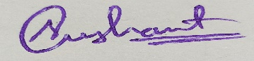

SUSHANT KUMAR SINGH

Roll number: B48

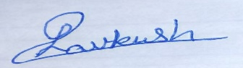

LAVKUSH YADAV

Roll number: B55

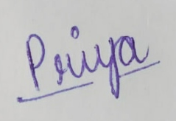

PRIYA SHARMA

Roll number: B65

Place : Jalandhar

Date :28/10/2020

APPENDIX 3

TABLE OF CONTENTS

TITLE PAGE NO.

1. Aim and brief description…….……..………............................................................. 1

1.1 Matplotlib.................................................................................................................... 1

1.2 Trignometric graph...................................................................................................... 1

1.2.1 Sine graph ................................................................................................................... 2

1.2.2 Cosine graph................................................................................................................ 3

1.2.3 Tan graph…................................................................................................................. 3

1.3 Exponential graph ....................................................................................................... 4

1.4 Algebraic graph........................................................................................................... 5

1.5 Logarithmic graph ...................................................................................................... 6

1.6 Pie chart……............................................................................................................... 7

2. Work division.............................................................................................................. 8

3. Platform used............................................................................................................... 8

4. SWOT analysis............................................................................................................ 9

APPENDIX 4

BONAFIDE CERTIFICATE

Certified that this project report “ GRAPH PLOTTER ” is the bonafide work of “ Sushant Kumar Singh , Lavkush Yadav , Priya Sharma ” who carried out the project work under my supervision.

Ashish Srivastava

Assistant Professor

ID:- 25703

Dept:- Computer Science and Engineering

**AIM:** To make a graph plotter using graph plotting libraries of python

**BRIEF DESCRIPTION :**

Python has the ability to create graphs by using the matplotlib library. It has numerous packages and functions which generate a wide variety of graphs and plots. It is also very simple to use. It along with numpy and other python built-in functions achieves the goal. In this article we will see some of the different kinds of graphs it can generate.

* **MATPLOTLIB**

Matplotlib is a plotting library for the Python programming language and its numerical mathematics extension NumPy. It provides an object-oriented API for embedding plots into applications using general-purpose GUI toolkits like Tkinter, wxPython, Qt, or GTK+.

Matplotlib was originally written by John D. Hunter, since then it has an active development community, and is distributed under a BSD-style license. Michael Droettboom was nominated as matplotlib's lead developer shortly before John Hunter's death in August 2012,and further joined by Thomas Caswell.

Matplotlib 2.0.x supports Python versions 2.7 through 3.6 . Python 3 support started with Matplotlib 1.2 . Matplotlib 1.4 is the last version to support Python 2.6 . Matplotlib has pledged to not support Python 2 past 2020 by signing the Python 3 Statement.

**REPRESENTATION OF GRAPH**

**I ) TRIGNOMETRIC GRAPH**

In mathematics, the trigonometric functions (also called circular functions, angle functions or goniometric functions) are real function which relate an angle of a right-angled triangle to ratios of two side lengths. They are widely used in all sciences that are related to geometry, such as navigation, solid mechanics, celestial mechanics, and many others. They are among the simplest periodic functions, and as such are also widely used for studying periodic phenomena, through [Fourier analysis](https://en.m.wikipedia.org/wiki/Fourier_analysis).

The most widely used trigonometric functions are the [sine](https://en.m.wikipedia.org/wiki/Sine), the cosine, and the tangent. Their [reciprocals](https://en.m.wikipedia.org/wiki/Multiplicative_inverse) are respectively the cosecant, the secant, and the cotangent, which are less used in modern mathematics.

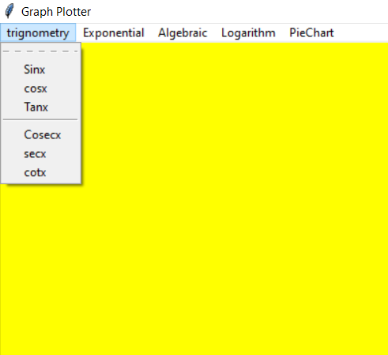

* SINE GRAPH :

A **sine wave** or **sinusoid** is a [mathematical curve](https://en.m.wikipedia.org/wiki/Curve) that describes a smooth periodic [oscillation](https://en.m.wikipedia.org/wiki/Oscillation). A sine wave is a [continuous wave](https://en.m.wikipedia.org/wiki/Continuous_wave). It is named after the function [sine](https://en.m.wikipedia.org/wiki/Sine), of which it is the [graph](https://en.m.wikipedia.org/wiki/Graph_of_a_function). It occurs often in both pure and applied [mathematics](https://en.m.wikipedia.org/wiki/Mathematics), as well as [physics](https://en.m.wikipedia.org/wiki/Physics), [engineering](https://en.m.wikipedia.org/wiki/Engineering), [signal processing](https://en.m.wikipedia.org/wiki/Signal_processing) and many other fields.

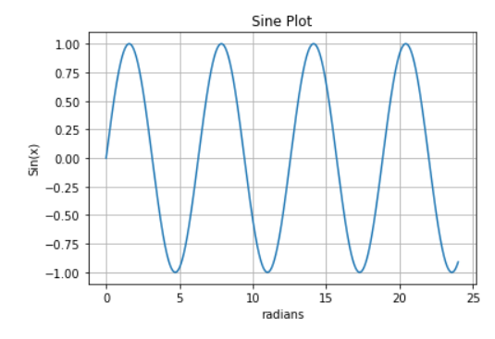

* COSINE GRAPH :

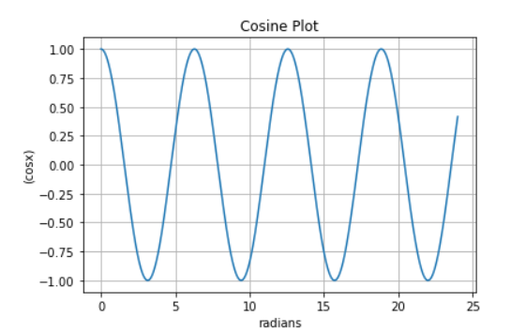

* TANGENT GRAPH :

In [geometry](https://en.m.wikipedia.org/wiki/Geometry), the **tangent line** (or simply **tangent**) to a plane [curve](https://en.m.wikipedia.org/wiki/Curve) at a given [point](https://en.m.wikipedia.org/wiki/Point_(geometry)) is the [straight line](https://en.m.wikipedia.org/wiki/Straight_line) that "just touches" the curve at that point. [Leibniz](https://en.m.wikipedia.org/wiki/Leibniz) defined it as the line through a pair of [infinitely close](https://en.m.wikipedia.org/wiki/Infinitesimal) points on the curve.[[1]](https://en.m.wikipedia.org/wiki/Tangent#cite_note-1) More precisely, a straight line is said to be a tangent of a curve *y* = *f*(*x*) at a point *x* = *c* if the line passes through the point (*c*, *f*(*c*)) on the curve and has slope *f*'(*c*), where *f*' is the [derivative](https://en.m.wikipedia.org/wiki/Derivative) of *f*.

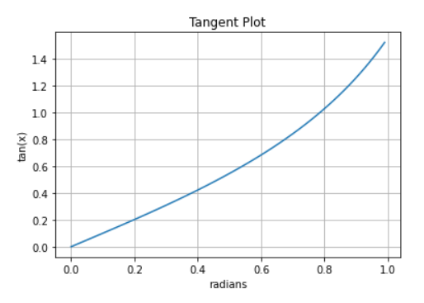

**II) EXPONENTIAL GRAPH**

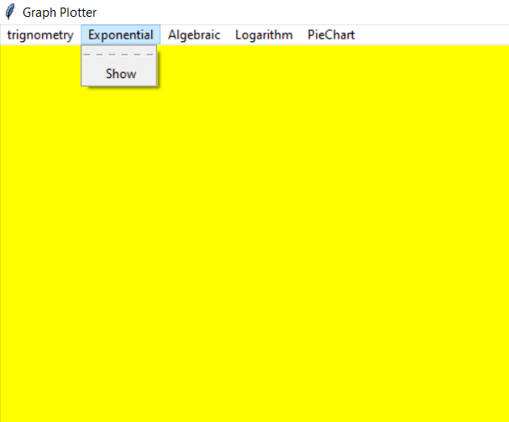

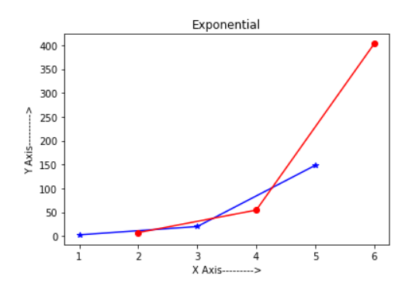

**III) ALGEBRAIC GRAPH**

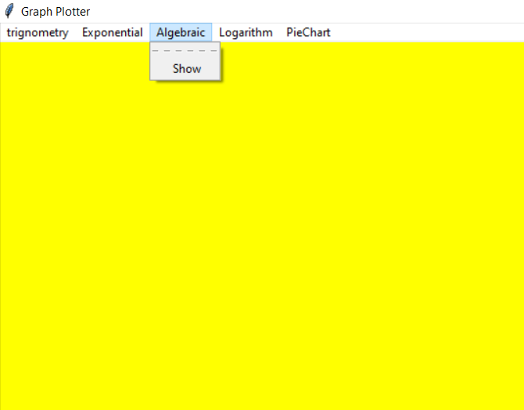

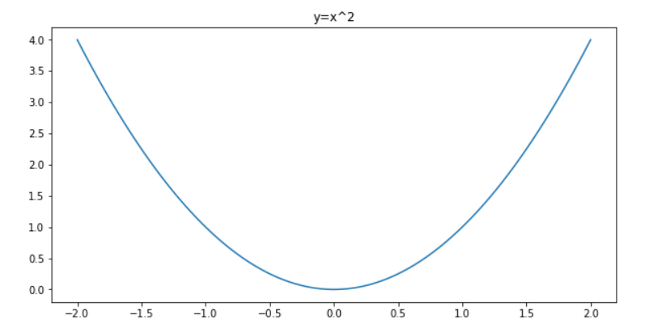

**IV ) LOGARITHMIC GRAPH**

A **logarithmic scale** (or **log scale**) is a way of displaying numerical data over a very wide range of values in a compact way—typically the largest numbers in the data are hundreds or even thousands of times larger than the smallest numbers

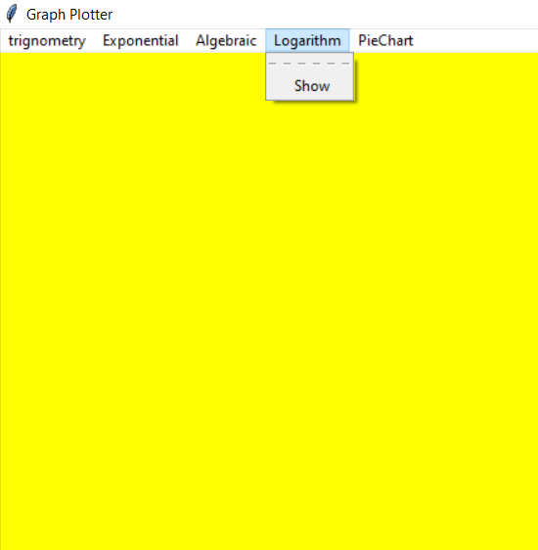

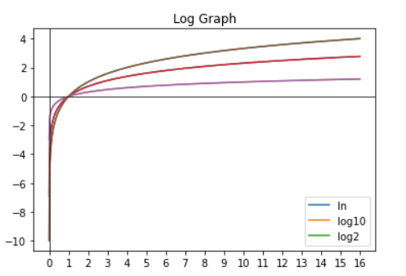

**V) PIE CHART :**

A **pie chart** (or a **circle chart**) is a circular [statistical graphic](https://en.m.wikipedia.org/wiki/Statistical_graphics), which is divided into slices to illustrate numerical proportion. In a pie chart, the [arc length](https://en.m.wikipedia.org/wiki/Arc_length) of each slice (and consequently its [central angle](https://en.m.wikipedia.org/wiki/Central_angle) and [area](https://en.m.wikipedia.org/wiki/Area)), is [proportional](https://en.m.wikipedia.org/wiki/Proportionality_(mathematics)) to the quantity it represents. Pie charts are very widely used in the business world and the mass media.

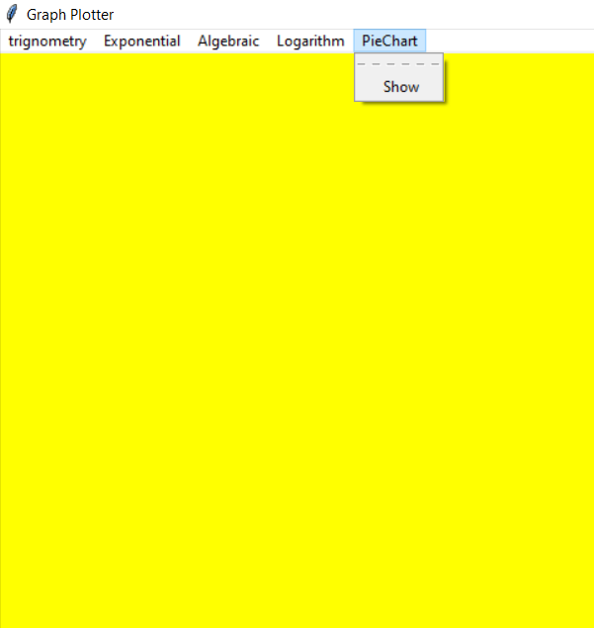

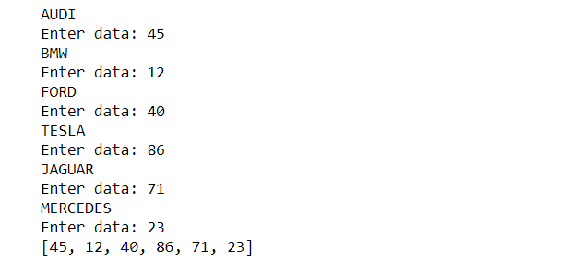

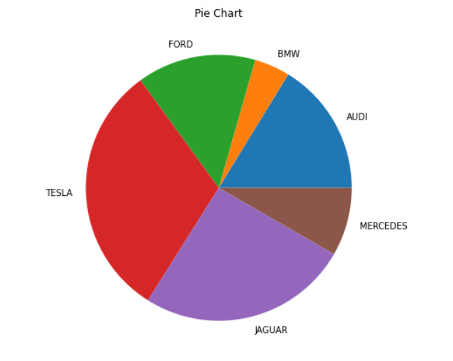

**WORK DIVISION :**

All the work was done equally by all the team members . Each task was divided in such a way that equal participation of all the team member is there .

1. Collection of resources and content material
2. Coding and testing
3. Feedback and implementation
4. Preparation of project report

**PLATFORM USED :**

ANACONDA PYTHON

**SWOT ANALYSIS :**

The primary aim of developing this graph plotter is to provide the user with a facility to plot the various types of graph as per choice within seconds , as per the users input .

• Strength

1. Work well in team setting

2.has a strong sense of creativity

3.support flexibility, assessment

4.leadership

5.colloboration

• Weakness

1.little relevant work experience

2.lack of knowledge in project specific language

3.lack of strategic planning

4.does not easily give up control

5.stress management skills

• Opportunity

1. Support for professional development opportunities

2.develop research

3.integration of system

4.community partners

5.higher studies

• Threats

1.strong competitors

2.heavy academic burden

3.accelerated expectation vs. Reality

4.accreditation requirement

5.lack of good materials.

Why Used To/Future Goals:

• Explore new solution

• Identify barriers that will limit goals/objectives

• Decide on direction that will be most effective

• Reveal possibilities and limitation for changes

• Act as a brainstorming device