Name: Lavkush Kumar
Roll no: 2025msc13

MOTILAL NEHRU NATIONAL INSTITUTE OF TECHNOLOGY
Data Structure Lab -CS 52201 MSc. Mathematics
Assignment – 1- Operations on Arrays

Question 1
// Traverse the array with n elements
#include <stdio.h>
int main()
{
int i, n, a[100];
// Input number of elements
printf("Enter the number of elements in array:");
scanf("%d", &n);
// Declare array of size n
printf("Enter the elements in array:\n");
for (i = 0; i < n; i++)
{
scanf("%d", &a[i]);
}
// Print the elements of the array
printf("The elements in array are:\n");
for (i = 0; i < n; i++)
{
printf(" %d", a[i]);
}

return 0;
}

Output 1
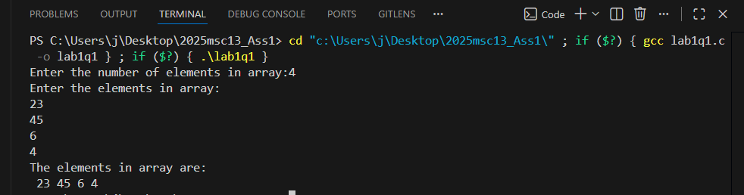

Question 2
// Sort array with n elements using bubble sort.
#include <stdio.h>
int main()
{
int i, j, n, a[100], temp;
// Input number of elements
printf("Enter the number of elements in array:");
scanf("%d", &n);
// Declare array of size n
printf("Enter the elements in array:\n");
for (i = 0; i < n; i++)
{
scanf("%d", &a[i]);
}
// Bubble sort algorithm
for (i = 0; i < n - 1; i++)
{
for (j = 0; j < n - i - 1; j++)
{
if (a[j] > a[j + 1])
{
temp = a[j];
a[j] = a[j + 1];
a[j + 1] = temp;
}
}
}
// Print sorted array
printf("The sorted array is:\n");
for (i = 0; i < n; i++)
{
printf("%d ", a[i]);
}
return 0;
}

Output 2
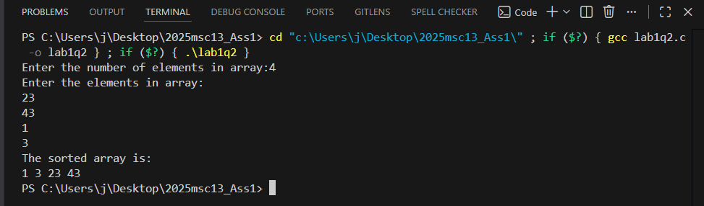

Question 3
// Implement Selection Sort with n elements in array.
#include <stdio.h>
int main()
{
int i, j, n, a[100], min_idx, temp;
// Input number of elements
printf("Enter the number of elements in array:");
scanf("%d", &n);
// Declare array of size n
printf("Enter the elements in array:\n");
for (i = 0; i < n; i++)
{
scanf("%d", &a[i]);
}
// Selection Sort Algorithm
for (i = 0; i < n - 1; i++)
{
min_idx = i;
for (j = i + 1; j < n; j++)
{
if (a[j] < a[min_idx])
{
min_idx = j;
}
}
// Swap the found minimum element with the first element
temp = a[min_idx];
a[min_idx] = a[i];
a[i] = temp;
}
// Print the sorted elements of the array
printf("The sorted elements in array are:\n");
for (i = 0; i < n; i++)
{
printf(" %d", a[i]);
}

return 0;
}

Output 3
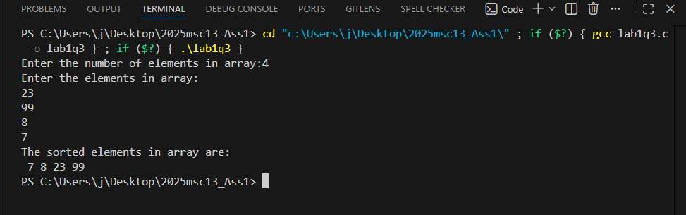

Question 4
// Implement Insertion Sort with n elements in array.
#include <stdio.h>
int main()
{
int i, j, n, a[100], key;
// Input number of elements
printf("Enter the number of elements in array:");
scanf("%d", &n);
// Declare array of size n
printf("Enter the elements in array:\n");
for (i = 0; i < n; i++)
{
scanf("%d", &a[i]);
}
// Insertion Sort Algorithm
for (i = 1; i < n; i++)
{
key = a[i];
j = i - 1;
// Move elements of a[0..i-1], that are greater than key,
// to one position ahead of their current position
while (j >= 0 && a[j] > key)
{
a[j + 1] = a[j];
j = j - 1;
}
a[j + 1] = key;
}
// Print the sorted elements of the array
printf("The sorted elements in array are:\n");
for (i = 0; i < n; i++)
{
printf(" %d", a[i]);
}

return 0;
}

Output 4
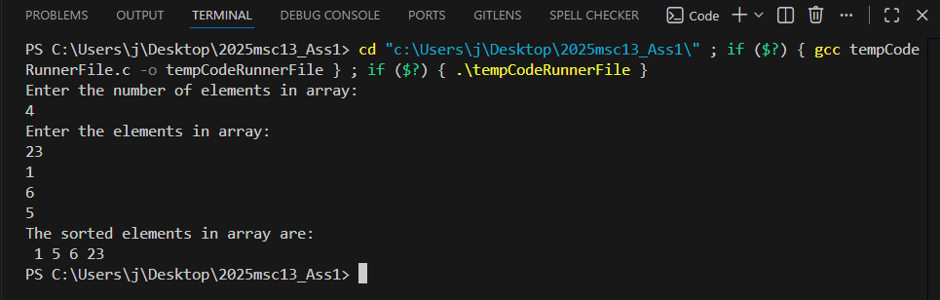

Question 5
// Sort the array elements of size n using Quick sort
#include <stdio.h>
int main()
{
int i, j, n, a[100], temp;
// Input number of elements
printf("Enter the number of elements in array:");
scanf("%d", &n);
// Declare array of size n
printf("Enter the elements in array:\n");
for (i = 0; i < n; i++)
{
scanf("%d", &a[i]);
}
// Quick Sort Algorithm
for (i = 0; i < n - 1; i++)
{
for (j = i + 1; j < n; j++)
{
if (a[i] > a[j])
{
// Swap a[i] and a[j]
temp = a[i];
a[i] = a[j];
a[j] = temp;
}
}
}
// Print the sorted elements of the array
printf("The sorted elements in array are:\n");
for (i = 0; i < n; i++)
{
printf(" %d", a[i]);
}

return 0;
}

Output 5
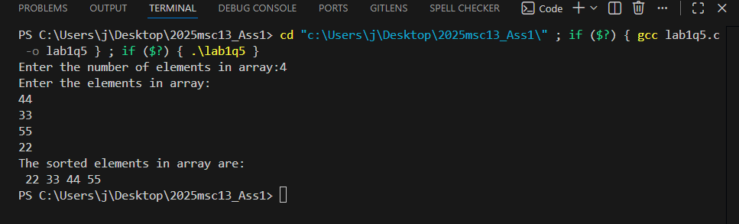

Question 6 – Linear search
// Implement Linear search with nelements in a array using recursion.
#include <stdio.h>
int main()
{
int arr[50], n, i, target, result;
int linearSearch(int arr[], int n, int target)
{
if (n <= 0)
{
return -1; // Base case: not found
}
if (arr[n - 1] == target)
{
return n - 1; // Found at index n-1
}
return linearSearch(arr, n - 1, target); // Recursive call
}
printf("Enter number of elements in array: ");
scanf("%d", &n);
printf("Enter %d elements:\n", n);
for (i = 0; i < n; i++)
{
scanf("%d", &arr[i]);
}
printf("Enter the target element to search: ");
scanf("%d", &target);
result = linearSearch(arr, n, target);
if (result != -1)
{
printf("Element found at index: %d\n", result);
}
else
{
printf("Element not found in the array.\n");
}
return 0;
}

Binary Search

// Implement binary search with nelements in a array using recursion.
#include <stdio.h>
int main()
{
int arr[50], n, i, target, result;
int binarySearch(int arr[], int left, int right, int target)
{
if (left > right)
{
return -1; // Base case: not found
}
int mid = left + (right - left) / 2;
if (arr[mid] == target)
{
return mid; // Found at index mid
}
else if (arr[mid] > target)
{
return binarySearch(arr, left, mid - 1, target); // Search in left half
}
else
{
return binarySearch(arr, mid + 1, right, target); // Search in right half
}
}
printf("Enter number of elements in array: ");
scanf("%d", &n);
printf("Enter %d elements in sorted order:\n", n);
for (i = 0; i < n; i++)
{
scanf("%d", &arr[i]);
}
printf("Enter the target element to search: ");
scanf("%d", &target);
result = binarySearch(arr, 0, n - 1, target);
if (result != -1)
{
printf("Element found at index: %d\n", result);
}
else
{
printf("Element not found in the array.\n");
}
return 0;
}

Output 6
linear
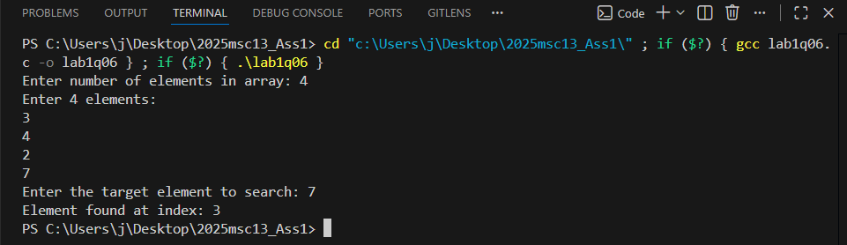
Binary
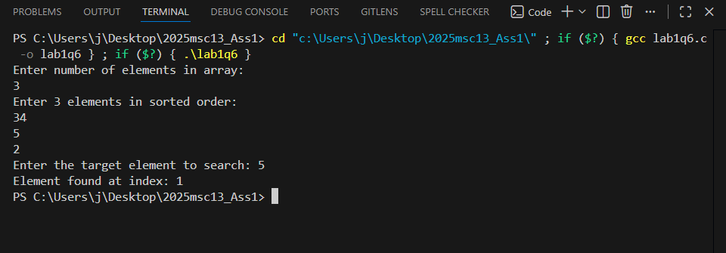

Question 7
// Insert an element at the user given location in arrays
#include <stdio.h>
int main()
{
int i, n, a[100], element, position;
// Input number of elements
printf("Enter the number of elements in array:");
scanf("%d", &n);
// Declare array of size n
printf("Enter the elements in array:\n");
for (i = 0; i < n; i++)
{
scanf("%d", &a[i]);
}
// Input the element to be inserted and the position
printf("Enter the element to be inserted:");
scanf("%d", &element);
printf("Enter the position to insert the element (0 to %d):", n);
scanf("%d", &position);
// Check for valid position
if (position < 0 || position > n)
{
printf("Invalid position!\n");
return 1;
}
// Shift elements to the right to make space for the new element
for (i = n; i > position; i--)
{
a[i] = a[i - 1];
}
// Insert the new element at the specified position
a[position] = element;
n++; // Increase the size of the array
// Print the updated array
printf("The updated array is:\n");
for (i = 0; i < n; i++)
{
printf(" %d", a[i]);
}

return 0;
}

Output 7

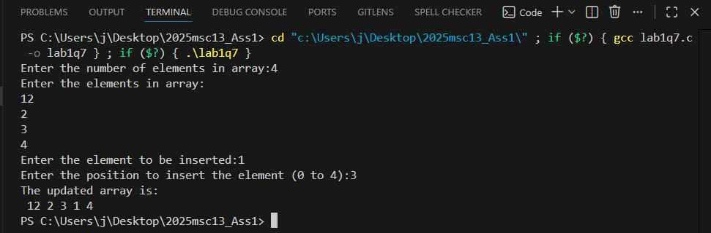

Question 8
// Delete an element at the user given location in arrays
#include <stdio.h>
int main()
{
int i, n, a[100], position;
// Input number of elements
printf("Enter the number of elements in array:");
scanf("%d", &n);
// Declare array of size n
printf("Enter the elements in array:\n");
for (i = 0; i < n; i++)
{
scanf("%d", &a[i]);
}
// Input the position to be deleted
printf("Enter the position to delete the element (0 to %d):", n - 1);
scanf("%d", &position);
// Check for valid position
if (position < 0 || position >= n)
{
printf("Invalid position!\n");
return 1;
}
// Shift elements to the left to delete the element at the specified position
for (i = position; i < n - 1; i++)
{
a[i] = a[i + 1];
}
n--; // Decrease the size of the array
// Print the updated array
printf("The updated array is:\n");
for (i = 0; i < n; i++)
{
printf(" %d", a[i]);
}

return 0;
}

Output 8
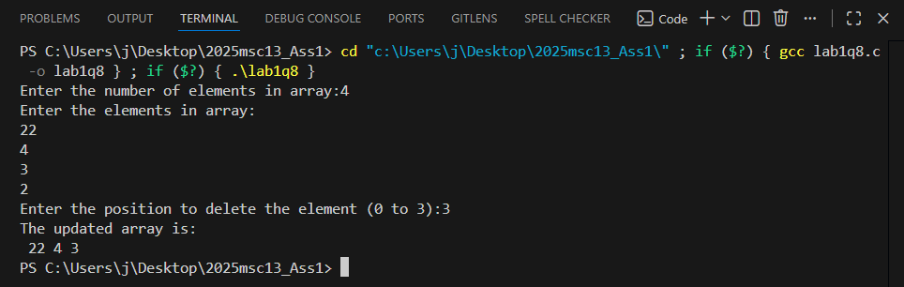
Question 9
// Merge two arrays of different length.
#include <stdio.h>
int main()
{
int i, j, n1, n2, a1[100], a2[100], merged[200];
// Input number of elements for first array
printf("Enter the number of elements in first array:");
scanf("%d", &n1);
// Input elements for first array
printf("Enter the elements in first array:\n");
for (i = 0; i < n1; i++)
{
scanf("%d", &a1[i]);
}
// Input number of elements for second array
printf("Enter the number of elements in second array:");
scanf("%d", &n2);
// Input elements for second array
printf("Enter the elements in second array:\n");
for (i = 0; i < n2; i++)
{
scanf("%d", &a2[i]);
}
// Merging the two arrays
for (i = 0; i < n1; i++)
{
merged[i] = a1[i];
}
for (j = 0; j < n2; j++)
{
merged[i + j] = a2[j];
}
// Print the merged array
printf("The merged array is:\n");
for (i = 0; i < n1 + n2; i++)
{
printf(" %d", merged[i]);
}
return 0;
}

Output 9
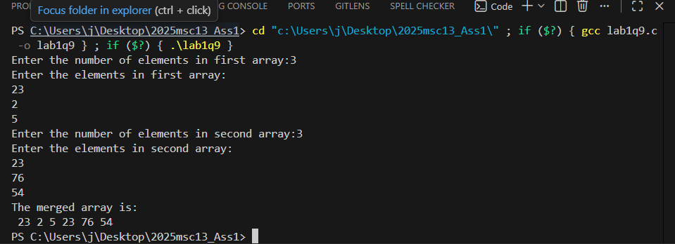
Question 10
// Write a program to store, read and print student details (Name, Rollno, Course, Branch, Dept, 5 subjects’marks, total and grade) demonstrate example.
#include <stdio.h>
struct Student
{
char name[50];
int rollno;
char course[50];
char branch[50];
char dept[50];
int marks[5];
int total;
char grade;
};
void calculateTotalAndGrade(struct Student *student)
{
student->total = 0;
for (int i = 0; i < 5; i++)
{
student->total += student->marks[i];
}
float average = student->total / 5.0;
if (average >= 90)
{
student->grade = 'A';
}
else if (average >= 80)
{
student->grade = 'B';
}
else if (average >= 70)
{
student->grade = 'C';
}
else if (average >= 60)
{
student->grade = 'D';
}
else
{
student->grade = 'F';
}
}
int main()
{
struct Student student;
// Input student details
printf("Enter student name: ");
scanf("%49s", student.name);
printf("Enter roll number: ");
scanf("%d", &student.rollno);
printf("Enter course: ");
scanf("%49s", student.course);
printf("Enter branch: ");
scanf("%49s", student.branch);
printf("Enter department: ");
scanf("%49s", student.dept);
printf("Enter marks for 5 subjects:\n");
for (int i = 0; i < 5; i++)
{
printf("Subject %d: ", i + 1);
scanf("%d", &student.marks[i]);
}
// Calculate total and grade
calculateTotalAndGrade(&student);
// Print student details
printf("\nStudent Details:\n");
printf("Name: %s\n", student.name);
printf("Roll Number: %d\n", student.rollno);
printf("Course: %s\n", student.course);
printf("Branch: %s\n", student.branch);
printf("Department: %s\n", student.dept);
printf("Marks: ");
for (int i = 0; i < 5; i++)
{
printf("%d ", student.marks[i]);
}
printf("\nTotal Marks: %d\n", student.total);
printf("Grade: %c\n", student.grade);
return 0;
}

Output 10
