Project Report
Reproducing S3-FIFO: Cache Eviction Using Only FIFO Queues
Group Member and Contribution
Lavneet Hora, [your eRaider]@ttu.edu, R11905178. This was a one-person project, so all work below was carried out by the single group member.
- Selected the paper and confirmed before starting that its evaluation could be reproduced on a laptop, by checking the authors' simulator against the machine and measuring the size of each public dataset.
- Built the simulation harness: the trace registry and loader, the one-hit-wonder analysis, the miss ratio experiment across 12 algorithms, and the small-queue parameter sweep.
- Implemented S3-FIFO independently from Algorithm 1 of the paper and validated it against the authors' reference C++ implementation, which is how the two ambiguities in the paper were found.
- Ran all simulations: 120 traces, 2.52 billion requests, 12 algorithms at two cache sizes.
- Produced every figure in this report, compared each against the original, and wrote the analysis of where the results differ and why.
- Wrote this report and the presentation slides.
Problem Statement
A cache is a small, fast store placed in front of a slower one. Web services put caches in front of databases, content delivery networks put them in front of origin servers, and operating systems put them in front of disks. Because a cache is always far smaller than the data people ask for, it runs full almost immediately, and from then on every object admitted means another object must be thrown out. The rule that picks the victim is the eviction algorithm. It is the single biggest lever on the miss ratio, which is the fraction of requests the cache fails to serve. A lower miss ratio means fewer slow trips to the backend, less load on that backend, and lower latency for the user, so a small improvement in the eviction algorithm is worth a lot at scale.
For most of the last thirty years that rule has been a variant of Least Recently Used. LRU keeps objects in a queue ordered by how recently they were accessed and evicts from the tail, on the assumption that recently used data will be used again. A long line of research has tried to beat it: ARC, 2Q, SLRU, LIRS, TinyLFU, LeCaR, CACHEUS and LHD among others. Nearly all of them are built out of one or more LRU queues with extra bookkeeping layered on top.
The paper argues that this whole family has been optimising the wrong thing. Chasing miss ratio alone has made these algorithms expensive in three ways that matter in production. The first is memory. An LRU queue is normally a doubly linked list, so every cached object carries two pointers. When the cached objects are themselves small, which is the common case in key-value caches, that overhead eats a real fraction of the cache. The second is throughput. LRU has to move an object to the head of the queue on every cache hit, which is a write to shared state and therefore needs a lock, on the hot path, on the operation that is supposed to be fast. This is why LRU does not scale well across cores. The third is complexity. These algorithms have parameters that are difficult to tune and they are difficult to implement correctly; the authors note that implementations of LIRS used in earlier published work contained two separate bugs. An algorithm that is hard to get right is one that production engineers avoid, which is why many real systems still run plain FIFO or LRU and simply accept the worse miss ratio.
The observation the paper builds on reframes what the eviction algorithm is actually for. A one-hit wonder is an object that is requested once and never again. Measured over a complete trace, roughly a quarter of objects are one-hit wonders, which does not sound like a crisis. But a cache never sees a complete trace. It sees a sliding window roughly the size of its own capacity. Measured over a window containing 10% of a trace's distinct objects, 72% of the objects in that window are one-hit wonders, and over a 1% window it is 78%. In other words most of what a cache admits is worthless, and the real job is not choosing which valuable object to keep but getting rid of the worthless ones fast, before they occupy space a useful object could have used. The authors call this quick demotion, and it is the idea the rest of the paper follows from.
Problem Solution
S3-FIFO is built from three FIFO queues and nothing else. There is no LRU queue anywhere in it, and no object is ever moved because it was read. The three queues are a small queue S holding 10% of the cache, a main queue M holding the other 90%, and a ghost queue G which stores keys only, with no data, and is sized to hold as many entries as M.
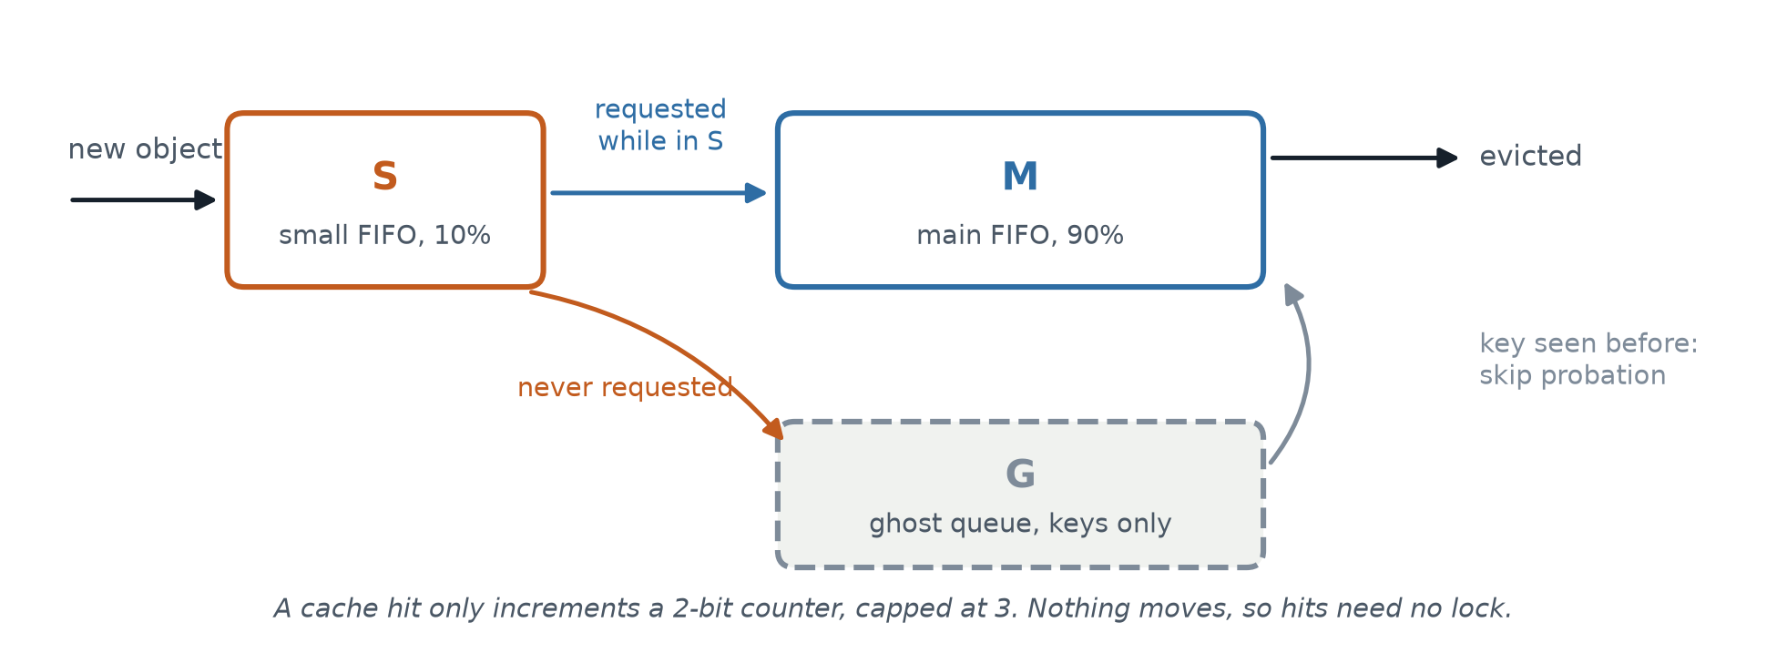
Figure 1. The three queues of S3-FIFO. Our own diagram, drawn to explain the algorithm.
A new object is inserted into S, the probationary queue, unless its key is already in G, in which case it is inserted straight into M instead. Each cached object carries a counter of two bits, capped at a value of 3. A cache hit does one thing only: it increments that counter. Nothing is moved and no list is re-linked, which is what allows a hit to proceed without taking a lock, and is the source of the algorithm's scalability.
Evictions are where the design shows its intent. When S is full, the object at its tail is examined. If it was requested while it sat in S, it has proved itself and is promoted into M. If it was never requested, which is the common case given the one-hit-wonder numbers above, the object is discarded and only its key is kept, pushed into the ghost queue G. The point of G is that it gives the cache a cheap memory of what it has already seen. If that same key is requested again later, the cache knows the object is not a one-hit wonder after all, and admits it directly into M, skipping probation. Evicting from M works like a clock sweep: the tail object is reinserted at the head with its counter decremented if the counter is above zero, and is evicted outright once the counter reaches zero.
The result is that unproven objects get a short, bounded stay in a small part of the cache, and only objects that have demonstrated reuse are allowed to occupy the bulk of it. That is quick demotion. The cost is two bits per object instead of two pointers, and the entire algorithm is about forty lines of pseudocode.
We implemented S3-FIFO ourselves from the paper's Algorithm 1, in Python, and validated it against the authors' reference C++ implementation on the same trace. Doing so uncovered two places where the paper's prose and its pseudocode contradict each other. Section 4.1 says an object moves from S to M if it was “accessed more than once”, which reads as a counter of at least one, while pseudocode line 23 requires the counter to be strictly greater than one. Separately, the prose states that the counter is cleared when an object is promoted, and the pseudocode never mentions clearing it. We implemented all four combinations and measured each against the reference.
Promotion rule | Counter reset | Worst gap | Described in
freq > 1 | Yes | 0.0014 | Neither alone
freq > 0 | Yes | 0.0017 | Prose
freq > 0 | No | 0.0055 | Neither
freq > 1 | No | 0.0058 | Pseudocode

The reading that matches the reference implementation, to within 0.0014 of absolute miss ratio, takes the threshold from the pseudocode and the counter reset from the prose. Neither half of the paper describes the algorithm correctly on its own, which is worth knowing for anyone implementing from it.
Simulation Result
The paper evaluates 6594 traces drawn from 14 datasets, several terabytes in total, which is not something a laptop can replay. We selected the two datasets small enough to run and reproduced both of them completely, every trace, rather than sampling. MSR Cambridge 2007 is 14 traces and 410 million requests; CloudPhysics 2015 is 106 traces and 2114 million requests. Together that is 120 traces and 2.52 billion requests. Every algorithm was run at the two cache sizes the paper presents, 10% and 0.1% of each trace's object count, with object size ignored, exactly as in the paper's section 5. Simulations used the authors' own libCacheSim, so the algorithm implementations are theirs and the experimental harness is ours. The complete run took about twenty hours on an eight-core laptop.
One consequence of that selection matters for everything below and is worth stating up front: MSR and CloudPhysics are both block storage workloads, whereas the paper's trace set is dominated by web and key-value workloads. Block traces are markedly less skewed, which is precisely the condition under which quick demotion pays off least. We are therefore testing S3-FIFO on the workloads least favourable to it.
Pair 1: one-hit-wonder ratio (paper Figure 3 and Table 1).
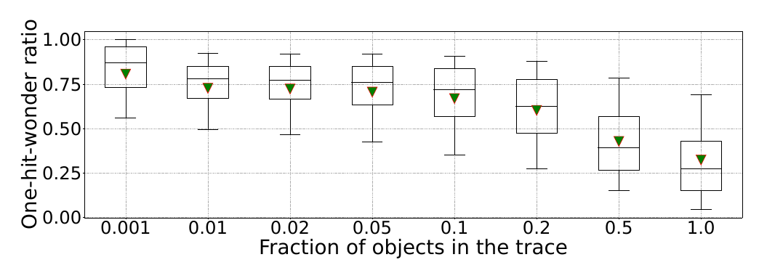
Figure 2a. Original: the paper's Figure 3, one-hit-wonder ratio across all 6594 traces.
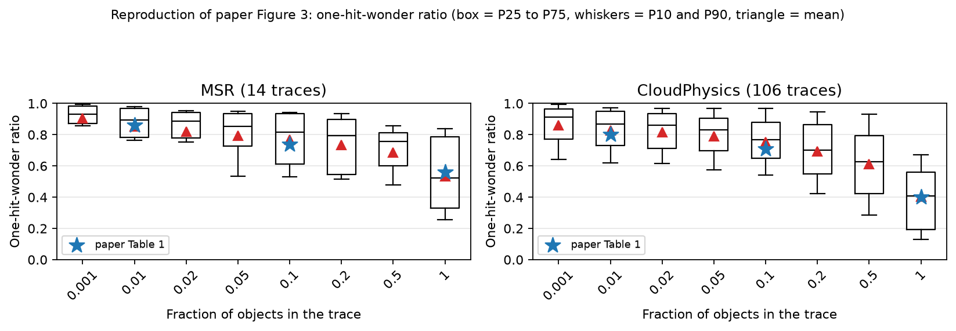
Figure 2b. Ours: the same measurement on MSR and CloudPhysics. Stars mark the paper's published values.
This measurement runs no cache simulation at all. It counts, for a window of a given length, what fraction of the objects in that window appear exactly once. We ran it first precisely because it is cheap and directly comparable, so it validates our trace decoding before any simulation result depends on it. Both figures show the same shape: the one-hit-wonder ratio is very high for short windows and falls as the window lengthens. The blue stars on our panels are the paper's own tabulated values, and they sit on our means in every case.
Dataset | Window | Paper | Ours | Difference
MSR | full trace | 0.56 | 0.54 | -0.02
MSR | 10% of objects | 0.74 | 0.77 | +0.03
MSR | 1% of objects | 0.86 | 0.85 | -0.01
CloudPhysics | full trace | 0.40 | 0.41 | +0.01
CloudPhysics | 10% of objects | 0.71 | 0.75 | +0.04
CloudPhysics | 1% of objects | 0.80 | 0.83 | +0.03

All six values agree to within 0.04. Our MSR traces also total 409.8 million requests against the 410 million the paper reports for that dataset, which is strong evidence we are working from the same underlying data. The small residual differences are expected: the paper samples windows at random and averages over 100 repetitions, so the statistic is itself a sampled estimate, and our random draws are not theirs.
Pair 2: miss ratio reduction from FIFO (paper Figure 6).
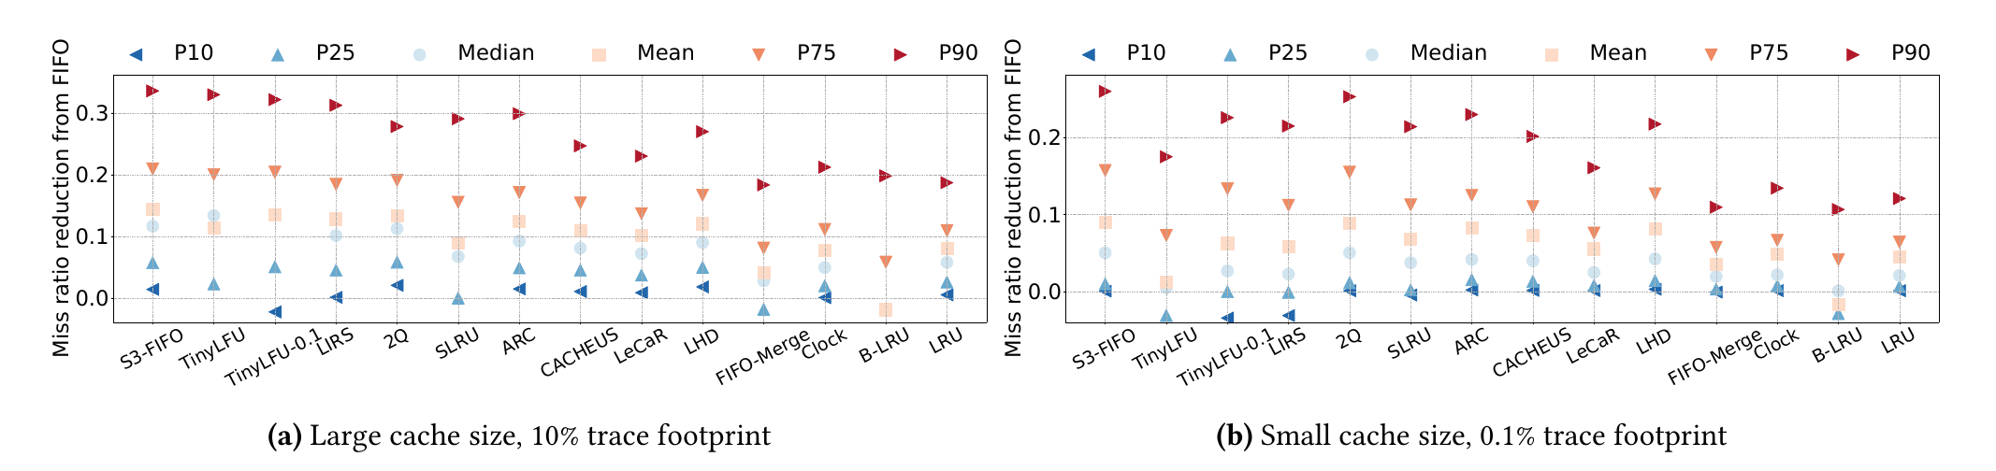
Figure 3a. Original: the paper's Figure 6, percentiles of miss ratio reduction from FIFO.
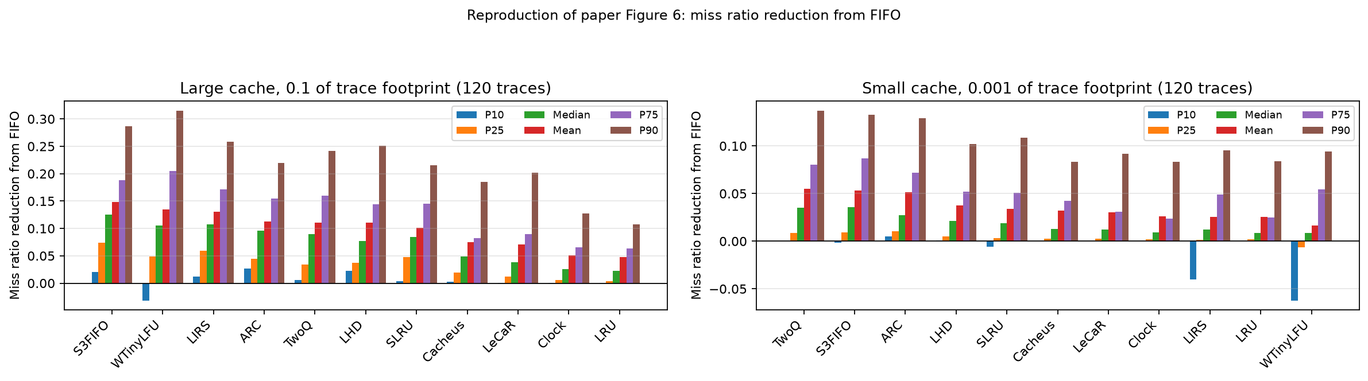
Figure 3b. Ours: the same percentiles over 120 traces.
This is the paper's central result. Because absolute miss ratios vary enormously between traces, both the paper and we report the reduction relative to FIFO, using the paper's asymmetric definition that bounds the value between -1 and 1 so that outliers cannot dominate the mean. On the large cache size, the left panel in each figure, our ranking reproduces the paper's headline claim: S3-FIFO is first of the eleven algorithms tested, with a mean reduction of 0.1479. The paper states a mean of 14% on the large cache size, so our 14.8% is a direct match.
Rank | Large cache (10%) | Rank | Small cache (0.1%)
1. S3-FIFO | 0.1479 | 1. 2Q | 0.0548
2. TinyLFU | 0.1348 | 2. S3-FIFO | 0.0533
3. LIRS | 0.1307 | 3. ARC | 0.0513
4. ARC | 0.1128 | 4. LHD | 0.0375
5. 2Q | 0.1109 | 5. SLRU | 0.0245

A second feature visible in both figures supports the paper's robustness argument. S3-FIFO keeps a positive P10 at both cache sizes, while TinyLFU and LIRS fall below zero there, meaning that on the worst tenth of traces those two algorithms are actually worse than plain FIFO. S3-FIFO is never much worse than the baseline, which is a property that matters more in production than a slightly better average.
The one place our result departs from the paper is the small cache size, where we find 2Q slightly ahead of S3-FIFO, 0.0548 against 0.0533, whereas the paper has S3-FIFO first. The margin is small, but the direction is a real difference and the explanation is the dataset selection described above. At a cache holding only 0.1% of a trace's objects, a newly admitted object is evicted again very quickly, so it often has no opportunity to demonstrate reuse before S discards it. 2Q does not suffer in the same way because it reserves a fixed fraction of the cache for new objects. This effect is strongest on workloads with little skew, which is exactly what block storage traces are. The paper's own discussion of small cache sizes describes the same mechanism.
Pair 3: mean reduction per dataset (paper Figure 7).
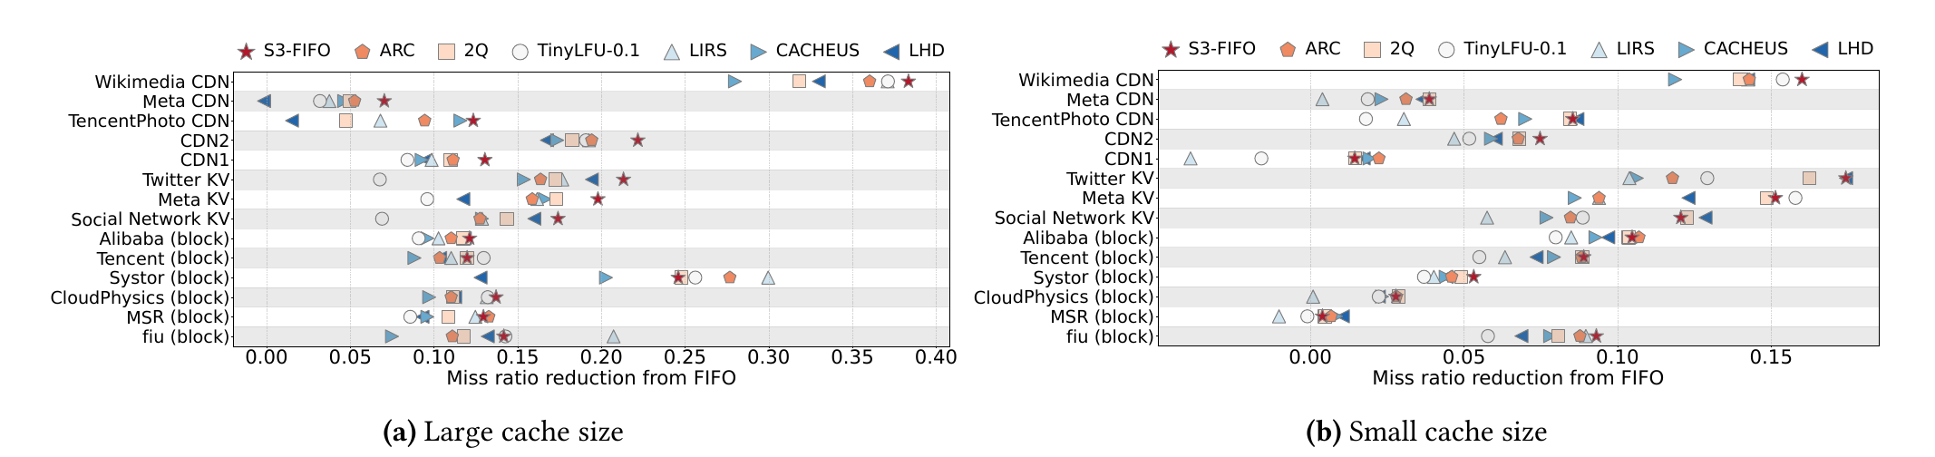
Figure 4a. Original: the paper's Figure 7, mean reduction per dataset, one row per dataset.
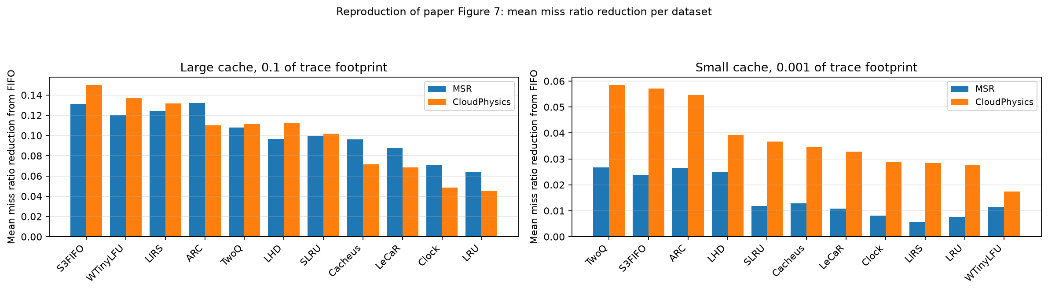
Figure 4b. Ours: mean reduction split by dataset at both cache sizes.
This pair is particularly useful because the paper publishes MSR and CloudPhysics as separate rows in its own figure, so our two datasets can be checked against the paper individually rather than against a pooled average over workloads we did not run. Our figure shows that the overall win is carried by CloudPhysics. On MSR alone at the large cache size, ARC very slightly beats S3-FIFO, 0.132 against 0.131, a gap too small to be meaningful. On CloudPhysics S3-FIFO is clearly ahead, 0.151 against 0.110. Reading the corresponding rows of the paper's figure shows the same pattern, with S3-FIFO's lead over the strongest LRU-based competitors narrowest on the block datasets. The agreement here is therefore better than the pooled comparison in the previous pair suggests, and it confirms that the difference we saw at the small cache size comes from which datasets we were able to run rather than from an error in the reproduction.
Pair 4: size of the small FIFO queue (paper Figure 11).
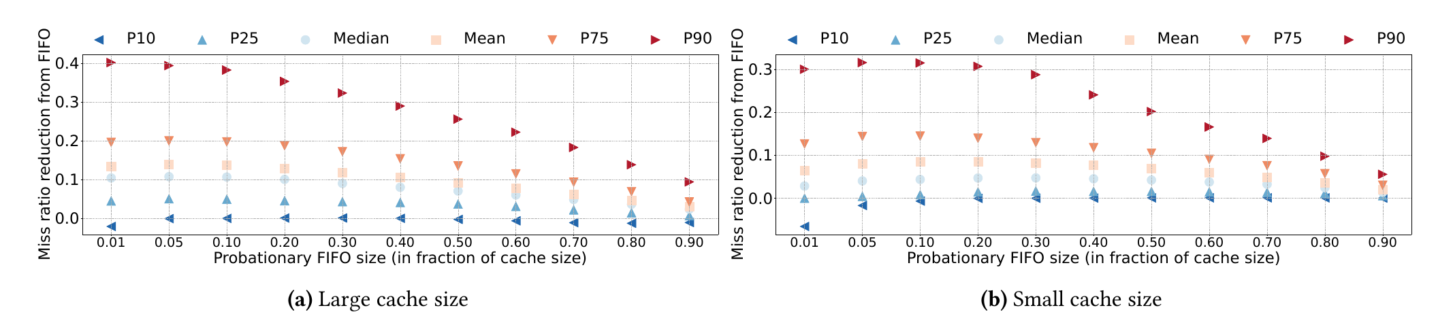
Figure 5a. Original: the paper's Figure 11, reduction against the size of the probationary queue.
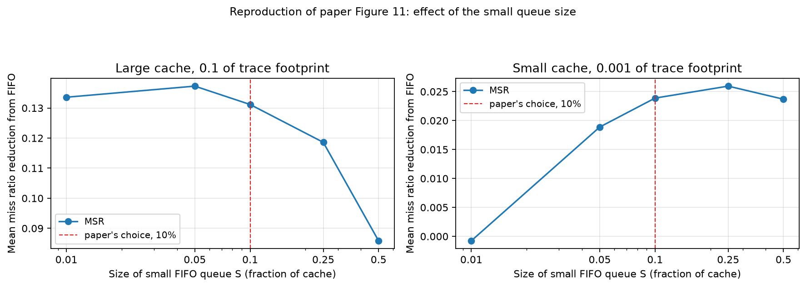
Figure 5b. Ours: mean reduction against the size of S, on the MSR dataset.
S3-FIFO has essentially one tunable parameter, the fraction of the cache given to S, which the paper fixes at 10%. We swept it from 1% to 50% to test how much that choice matters.
Size of S | Large cache | Small cache | Note
0.01 | 0.1336 | -0.0008
0.05 | 0.1373 | 0.0189 | best, large
0.10 | 0.1312 | 0.0239 | paper's choice
0.25 | 0.1186 | 0.0259 | best, small
0.50 | 0.0858 | 0.0237

Taken at face value this looks like a disagreement, since our best setting is 5% on the large cache and 25% on the small one rather than the 10% the paper uses. It is worth being careful about what the paper actually claims. Section 6.2 states that S3-FIFO is not sensitive to the size of S, and the paper's own figure shows a mean line that is close to flat across a wide range of settings before falling away. It does not claim that 10% is optimal on every workload. Our curve is flat in the same way, and 10% is within about 0.6 percentage points of the best setting at both cache sizes. The result therefore confirms the claim that was made, which is insensitivity, rather than contradicting it. What our data adds is that the location of the shallow optimum moves with cache size, so 10% reads as a sensible compromise rather than a tuned value.
Two further differences are worth recording. First, the public MSR dataset contains 14 traces that all clear the paper's stated cutoff of one million requests, whereas Table 1 of the paper reports 13; since our request total matches theirs almost exactly, this appears to be a bookkeeping difference rather than a different corpus. Second, while decoding the traces we found that the public dataset is not internally consistent about its next-access index: the MSR files number requests from zero and the CloudPhysics files number them from one. Assuming a single convention silently corrupts every next-access pointer in one of the two datasets, so our loader detects the convention per trace and cross-checks the result against an independent object count.
Conclusion
The paper's central claim reproduces. On the large cache size, across 120 traces and 2.52 billion requests, S3-FIFO achieves the lowest miss ratio of the eleven algorithms we tested, beating ARC, LIRS, TinyLFU, LHD and CACHEUS, and our mean reduction over FIFO of 14.8% matches the 14% the paper reports. It does this while being markedly simpler than any of them: three FIFO queues, two bits of metadata per object, no locking on cache hits, and about forty lines of pseudocode. The one-hit-wonder measurement that motivates the design reproduces to within 0.04 on all six published values.
The result is qualified in one place. At a very small cache size on block storage workloads, 2Q overtakes S3-FIFO by a narrow margin. We do not read this as a failure of the paper. Both datasets we were able to run are block workloads, which are far less skewed than the web and key-value traces that dominate the paper's evidence, and skew is what quick demotion exploits. The paper's own per-dataset figure shows the same narrowing on the same datasets. If anything, that S3-FIFO still wins at the large cache size on the workloads least suited to it strengthens rather than weakens the paper's case.
Reproducing the work also surfaced three things that are not visible from reading it. The paper's prose and pseudocode disagree in two places, and the correct implementation takes one detail from each. The public trace dataset uses two different indexing conventions without documenting the difference. And the evaluation, which at first looks like it needs a cluster, can be reproduced in full on two of its fourteen datasets using a laptop and about twenty hours, because the authors released both their simulator and their traces. That last point is the most encouraging one: a paper is far easier to trust when you can run it yourself.
References
[1] Our reproduction code and results: https://github.com/lavneethora/s3fifo-repro. The authors' original artifact is at https://github.com/Thesys-lab/sosp23-s3fifo.
[2] J. Yang, Y. Zhang, Z. Qiu, Y. Yue, and K. V. Rashmi, “FIFO queues are all you need for cache eviction,” in Proc. 29th ACM Symposium on Operating Systems Principles (SOSP ’23), Koblenz, Germany, Oct. 2023, pp. 130-149. doi: 10.1145/3600006.3613147.
[3] J. Yang, Y. Yue, and K. V. Rashmi, “libCacheSim: a high-performance library for building cache simulators,” 2023. [Online]. Available: https://github.com/1a1a11a/libCacheSim
[4] Cache trace datasets (MSR Cambridge 2007 and CloudPhysics 2015), distributed by the libCacheSim authors. [Online]. Available: https://github.com/cacheMon/cache_dataset

