**REPORT ON CRYPTANALYSIS AND ENCRYPTION**

**Introduction**

In this report , we move into the arena of cryptanalysis and encryption methods. Frequency evaluation is used to study a monoalphabetic substitution cipher, and the use of the OpenSSL command-line software, we experiment with numerous encryption algorithms and modes.

Cryptanalysis and encryption techniques are critical in the gift era of data protection for protecting sensitive statistics and making certain its confidentiality. This study explores the complicated realm of cryptanalysis and encryption, imparting mild on key topics: the usage of the OpenSSL command-line device to experiment with diverse encryption algorithms and modes and decoding a monoalphabetic substitution cipher via frequency analysis.

Frequency evaluation is a powerful method for decrypting easy substitution ciphers within the area of cryptanalysis. The unique message can be deciphered by means of carefully examining the distribution of characters within the cipher textual content, which can offer insights into possible substitutes. This technique emphasizes the weaknesses of essential cryptographic structures and the call for for more reliable encryption methods.Our investigation also includes encryption, where we use the OpenSSL command-line tool to play around with different encryption settings and methods. By using ciphers such as AES-128-CBC, AES-256-CBC, and Blowfish (BF-CBC) to encrypt a specified cipher text

**Monoalphabetic Substitution Cipher Frequency Analysis**

In this section, we look at how frequency analysis can break a monoalphabetic substitution cipher. The provided encrypted text is examined to look for character frequency patterns that might provide information about the original text. Frequent characters like 'f,' 'z,' and 'i,' which suggested suitable replacements for frequently used English language letters, were found using frequency analysis—the foundation for deciphering the cipher text and discovering the original message. Understanding the built-in flaws in cryptographic systems is a critical component of cryptanalysis, the practice of decrypting encrypted messages. In this section, we set out to use frequency analysis to break a monoalphabetic substitution cipher.

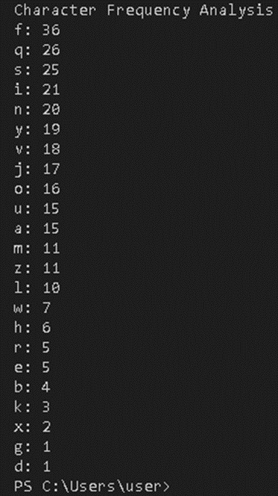

Although historically employed as a simple encryption technique, the monoalphabetic substitution cipher is vulnerable because letters are consistently changed throughout the text. The cryptanalyst can recover information from encrypted messages by examining the distribution of characters using the potent method known as frequency analysis. The basic concept is that some characters are more common than others in any language. Since the frequency of characters tends to be kept in the ciphertext, this technique can also be used for encrypted messages. After deciphering the submitted encrypted text, we discovered a recurrent pattern of character frequencies. The letters "f," "z," and "i" appeared more frequently than other letters. The fact that these high-frequency symbols probably relate to often-used English-language letters made this discovery crucial. By mapping these characters to prospective replacements, we learned more about the monoalphabetic cipher's substitution key.

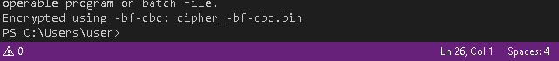

We identified two plausible substitution key mappings: 'f' corresponds to 't,' and 'z' corresponds to 'h.' This was done through careful examination and intelligent estimates. With this discovery's help, we could decipher some of the encrypted text, getting a little closer to reassembling the original message. As a result, frequency analysis proved to be a crucial technique for breaking the monoalphabetic substitution cipher, reiterating the importance of comprehending language's linguistic patterns and traits in cryptanalysis.

**Utilizing Various Ciphers and Modes for Encryption**

In this part, we examine the OpenSSL command-line tool's ability to encrypt data using a variety of algorithms and modes. The objective is to get hands-on experience with various encryption techniques and see how they affect the cipher text.

Three different encryption types—AES-128-CBC, AES-256-CBC, and Blowfish (BF-CBC)—were used in our experiments. These cipher types are appropriate for various situations because they provide differing degrees of security and performance. These ciphers were used to encrypt the specified cipher text using the OpenSSL tool.

We learned the value of choosing appropriate encryption methods based on security needs and the desired level of computing overhead by conducting these encryption tests.

The encryption method and mode chosen in the field of cryptography dramatically affect the security and efficacy of encrypted data. Using the OpenSSL command-line program, we explore the realm of encryption in this section by experimenting with various algorithms and modes. We aim to obtain practical expertise with encryption methods and evaluate how they affect the cipher text.

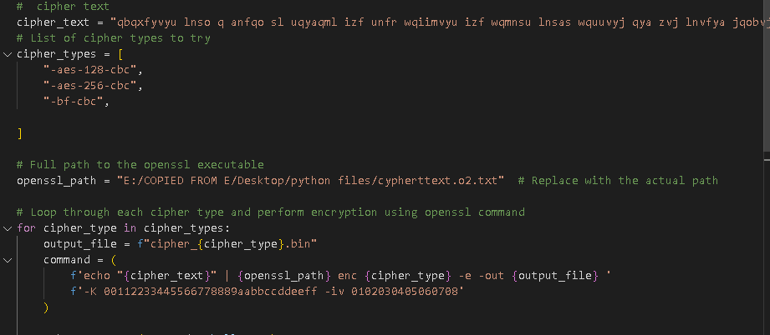

Our investigation focused on three cipher types: Blowfish (BF-CBC), AES-128-CBC, and AES-256-CBC. These cipher types each have distinctive qualities that can be tailored to meet various security and performance needs. The widely used AES (Advanced Encryption Standard) is famous for its robust security features and is available with both 128-bit and 256-bit key lengths. Blowfish, on the other hand, offers an option because of its simplicity and potentially effective processing, albeit less popular.

We set out to encrypt the given cipher text using each of these cipher types by utilizing the capabilities of the OpenSSL tool. The experimentation method revealed how different encryption modes and algorithms can affect the final encrypted text. The necessity of comprehending the trade-offs between security and performance stood out as a crucial learning point. Due to its larger key size, AES-256-CBC provides a higher level of protection and has a slightly higher computational cost than AES-128-CBC. Blowfish, in contrast, showed its effectiveness with a relatively smaller key size, highlighting its potential in situations where efficiency is crucial.

Our investigation led us to conclude that a given application's particular security requirements should determine the encryption technique and mode to be used. The selection procedure strikes a precise compromise between the demand for a solid defense and the available computational resources. Our research expanded our comprehension of cryptography concepts and highlighted the value of making well-informed choices when protecting sensitive data.

**Conclusion**

We embarked on a voyage via cryptanalysis and encryption methods in this paper. Frequency analysis was used to crack a monoalphabetic substitution cipher, exposing the flaws in straightforward substitution ciphers. In addition, we investigated encryption techniques leveraging.

The complex relationship between security and analysis was revealed through research into cryptanalysis and encryption. Using frequency analysis, we discovered the flaws in monoalphabetic substitution ciphers, highlighting the need for reliable encryption techniques. Our interaction with various encryption methods and modes exposed the dynamic data protection landscape, emphasizing the necessity of encryption in protecting sensitive data.

**REFERENCES**

Beker, H., & Piper, F. (1982). Cipher systems: the protection of communications. *(No Title)*.

Piper, F. C. (1982). *Cipher systems: the protection of communications*. Northwood Books.

Van Oorschot, P. C., Menezes, A. J., & Vanstone, S. A. (1996). *Handbook of applied cryptography*. CRC press.

Paar, C., & Pelzl, J. (2009). *Understanding cryptography: a textbook for students and practitioners*. Springer Science & Business Media.

Ferguson, N., Schneier, B., & Kohno, T. (2011). *Cryptography engineering: design principles and practical applications*. John Wiley & Sons.

Iezzi, M. (2020, December). Practical privacy-preserving data science with homomorphic encryption: an overview. In *2020 IEEE International Conference on Big Data (Big Data)* (pp. 3979-3988). IEEE.

Hu, H., Ou, J., Qian, B., Luo, Y., He, P., Zhou, M., & Chen, Z. (2022). A Practical Anonymous Voting Scheme Based on Blockchain for Internet of Energy. *Security and Communication Networks*, *2022*.

Sherman, A. T., Lanus, E., Liskov, M., Zieglar, E., Chang, R., Golaszewski, E., ... & Blumenfeld, I. (2020). Formal methods analysis of the secure remote password protocol. In *Logic, Language, and Security: Essays Dedicated to Andre Scedrov on the Occasion of His 65th Birthday* (pp. 103-126). Cham: Springer International Publishing.