Name : Lam Vinh Vong

Class : CS-146

Leetcode

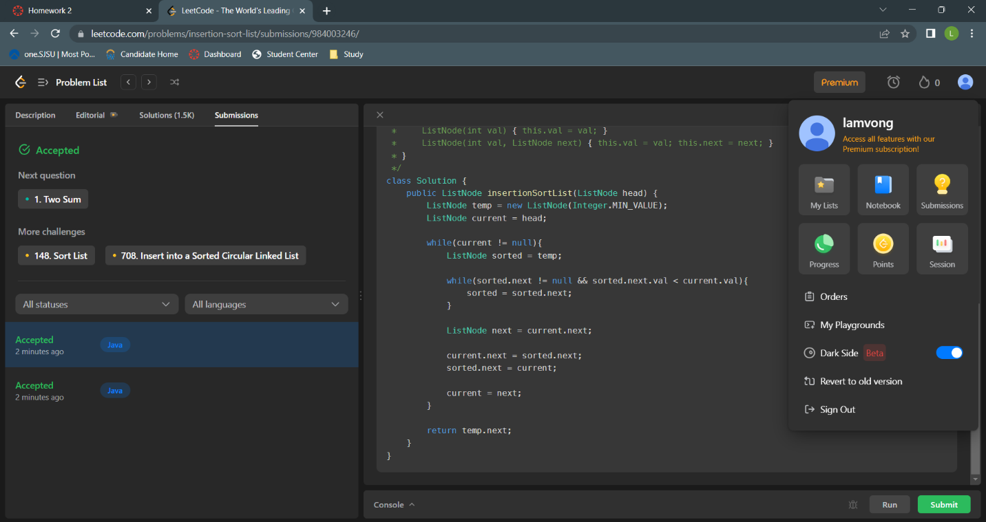

/**

 * Definition for singly-linked list.

 * public class ListNode {

 *     int val;

 *     ListNode next;

 *     ListNode() {}

 *     ListNode(int val) { this.val = val; }

 *     ListNode(int val, ListNode next) { this.val = val; this.next = next; }

 * }

 */

class Solution {

    public ListNode insertionSortList(ListNode head) {

        ListNode temp = new ListNode(Integer.MIN_VALUE);

        ListNode current = head;

        while(current != null){

            ListNode sorted = temp;

            while(sorted.next != null && sorted.next.val < current.val){

                sorted = sorted.next;

            }

            ListNode next = current.next;

            current.next = sorted.next;

            sorted.next = current;

            current = next;

        }

        return temp.next;

    }

}

Output :

