CA Tax & Legal – OneTech – Build & Run – Analysis
By: Keven Lavoie Date: 2026-10-30

1. Needs Analysis & Assumptions

Activities / Engagements
- Is the list of activity types fixed (meeting, document submission, login/logout, data change), or should it be extensible? What additional data should each type carry (meeting duration, document name, changed field with before/after values)?
- Since this is intended to be a simple application, the list of activity types will be fixed.
- Are the login/logout activities related to this application or to something else
- Login/logout activities will represent events originating from external systems rather than authentication events generated by this application. They can be registered through the REST API, without requiring the application itself to implement authentication.

Tax-Related Projects
- How should we identify a project?
- Each project will have a name, description, status, and active date.

Interface
- How will activities be registered?
- A user interface will allow activities to be logged manually, or they can be registered through an HTTP API call.
- Who will be viewing the activity logs?
- The application will be used by people with limited IT experience, so a user-friendly interface is required.
- How simple should application access and deployment be?
- A web application will allow portability and will be simple to deploy.

User Registration
- How will users be registered: through self-registration, administrator creation, or data import?
- Since the application is intended to be simple, users can be created through the application interface or through the HTTP API.
- How can a user be uniquely identified?
- Users will be uniquely identified by their email address.
- What user information should be stored?
- Name, email address, and role.

Security and Compliance
- Does the application require authentication?
- Since the application is intended to remain simple, authentication will not be implemented.
- If authentication is required, do we need a permission system to manage access to other users' activity logs based on user roles?
- No authentication means no user-level access control will be implemented.
- Does activity logging require a security mechanism, such as an API token?
- To keep things simple, the API is not protected with token.

2. Architecture & Design

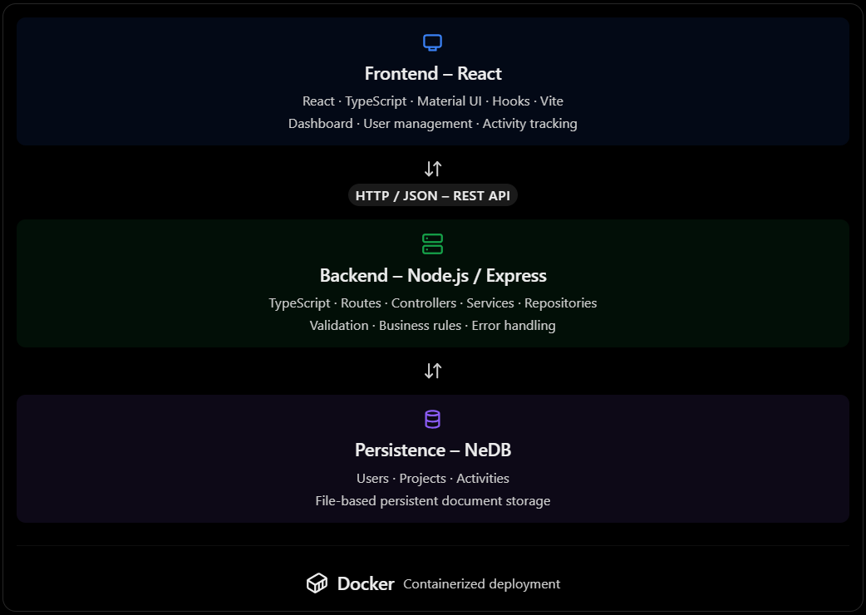
I propose a lightweight, modular, full-stack web application using React and TypeScript on the frontend, Node.js and Express on the backend, and NeDB for persistent data storage.
The application will be containerized using Docker to simplify deployment and ensure consistency between development and production environments.
The architecture follows a clear separation of concerns: the frontend handles user interactions, the backend manages business logic and REST API operations, and the database provides persistent storage.

Technologies
Frontend
- React
- TypeScript
- Material UI
- React Hooks
- Vite
Backend
- Node.js
- Express.js
- TypeScript
- REST API
- NeDB
Deployment
- Docker
I have extensive experience with these technologies and have used them successfully to build various types of web applications. They offer flexibility, good performance, and straightforward deployment, making them a suitable choice for this project.

3. Database / Storage Design

Design Overview
The data model is normalized, with each fact stored only once and records referencing each other through their respective _id fields.
Three NeDB datastores will be maintained in server/data/:
Collection | Purpose | Key Constraints and Indexes
users | Stores user information (name, email, role, active status) | _id; unique email address (stored in lowercase)
projects | Stores project details | _id
activities | Stores one immutable event per document | _id; indexes on userId, projectId, timestamp, and activityType

ER Diagram

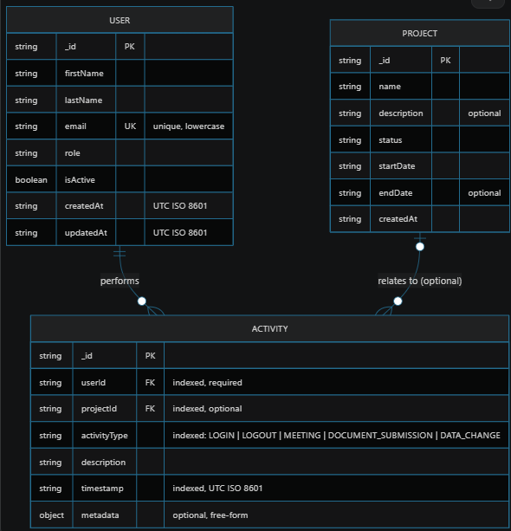4. Testing
Backend test cover:
- Users: creating a user, rejecting a duplicate email, updating a profile, and changing active status.
- Projects: validating and updating project records.
- Activities: creating validated activities, then filtering, sorting and paginating them.
- Dashboard: totals and activity statistics.
- Activity user lookup: identifying the user by userId, by email, or by both.

To run the tests, refer to the Available Scripts section in README.md.

5. Documentation
Refer to README.md for installation, configuration, usage, and other project documentation.

6. User Interface
I decided to use React with Material UI. I have extensive experience with both technologies, and they offer great flexibility and a wide range of components to build clean, modern, and user-friendly interfaces.

7. Use of AI Tools
- GitHub Copilot: Used to generate the initial project structure and assist with implementation through an iterative, AI-assisted development approach (vibe coding).
- ChatGPT: Used to help format and improve this document.

8. Questions & Suggestions
Features I could have added to improve this project:
- Authentication and private routes: Add login with JWT tokens and protect private HTTP routes with authentication middleware.
- Role-based access control: Admins can review all activity logs, while regular users can see only their own.
- Database choice by data volume: Depending on the expected data volume and concurrent writes, I could have used PostgreSQL or MongoDB instead of NeDB.
- Export and reporting: Export filtered activities to CSV or PDF, and add charts and scheduled summary reports.

