RoyalDB
Database Implementation and Administration Documentation

Royal Technology Solutions
CIS421 Database Management
LaVon Thomas
Post University
2026

Project Status: Implemented and validated in the Royal lab environment

1. Executive Summary
RoyalDB is a centralized relational database solution designed for Royal Technology Solutions, a fictional mid-size international managed IT services and cybersecurity company. The project was developed to replace fragmented operational information with a structured source of truth for customers, locations, devices, service contracts, support tickets, technicians, and technician assignments.
The project progressed from business requirements and conceptual modeling through physical implementation in PostgreSQL 18 on the DB01 Windows Server 2025 system. The completed lab implementation includes seven relational tables, sample operational data, relationship validation, CHECK and foreign-key integrity tests, role-based access control, least-privilege testing, and a verified backup-and-restore workflow.
This document records the architecture, database design, implementation, security model, validation evidence, backup and recovery process, troubleshooting history, maintenance recommendations, and production-readiness considerations.

2. Business Background and Need
Royal Technology Solutions supports customer technology environments through managed IT services and cybersecurity operations. As the organization grows, customer, asset, contract, ticket, and technician information can become fragmented across spreadsheets, email, and separate systems. Fragmentation creates risks such as duplicate records, inconsistent information, slower retrieval, limited reporting, and weaker control over sensitive operational data.
RoyalDB addresses this problem by centralizing structured operational information in a relational DBMS. The database is intended to improve consistency, enforce relationships and business rules, support authorized access, and provide a scalable foundation for reporting and future service-management capabilities.

3. Requirements and Stakeholders
Requirements were developed around the people and business processes that depend on RoyalDB. Key stakeholders include help-desk personnel, systems and network engineers, cybersecurity staff, account management, management, and authorized database administrators.
Stakeholder | Primary Information Need
Help desk | Customer, ticket, device, status, and assignment information
Systems / network engineers | Customer locations, devices, tickets, technical assignments
Cybersecurity staff | Authorized operational data, security-relevant tickets, controlled access
Account management | Customer, location, and contract information
Management | Accurate operational data and reporting
Database administrators | Schema, security, integrity, backup, recovery, and maintenance

4. Minimum Viable Product (MVP)
The MVP focuses on the core information required for daily service operations. It intentionally limits the first implementation to high-value structured data while leaving room for future expansion.
- Customer and customer-location management.
- IT asset and device tracking.
- Service-contract tracking.
- Support-ticket creation and status management.
- Technician records and technician-to-ticket assignments.
- Relationships among customers, locations, devices, contracts, tickets, and technicians.
- Authorized operational and management access.

5. Data Governance and Business Rules
RoyalDB governance addresses data ownership, quality, consistency, integrity, access, security, retention, backup, auditing, and appropriate use. Controlled values and relational constraints move important governance rules into the database itself.
Domain | Controlled Values / Rule
DeviceStatus | Active, Inactive, Maintenance, Retired
ContractStatus | Active, Pending, Expired, Terminated
ServiceLevel | Standard, Priority, Premium
Ticket Priority | Low, Medium, High, Critical
TicketStatus | New, Open, In Progress, Pending, Resolved, Closed
SkillLevel | Level 1, Level 2, Level 3, Specialist
TechnicianStatus | Active, Inactive, Leave
AssignmentStatus | Assigned, In Progress, Completed, Escalated
Date integrity | Contract end date cannot precede start date; ticket resolution/closure dates cannot precede creation.
Referential integrity | Required parent records must exist; parent deletion is restricted/handled rather than blindly cascaded.

6. Logical Data Model
RoyalDB contains seven core entities. Surrogate primary keys are used for the core entities, and foreign keys establish the required relationships. The Ticket Assignment entity resolves the many-to-many relationship between Ticket and Technician.
Entity | Primary Key | Purpose
CUSTOMER | CustomerID | Stores customer organizations.
LOCATION | LocationID | Stores customer sites/locations.
DEVICE | DeviceID | Stores supported IT assets/devices.
CONTRACT | ContractID | Stores customer service agreements.
TICKET | TicketID | Stores support/service requests.
TECHNICIAN | TechnicianID | Stores technical staff records.
TICKET_ASSIGNMENT | AssignmentID | Associates technicians with tickets and assignment status/work.

7. Relationship and Cardinality Rules
- A customer has one or many locations; each location belongs to exactly one customer.
- A customer can have zero or many contracts; each contract belongs to exactly one customer.
- A location can have zero or many devices; each device belongs to exactly one location.
- A customer can have zero or many tickets; each ticket belongs to exactly one customer.
- A device can be associated with zero or many tickets; a ticket can reference zero or one device.
- A ticket can have zero or many ticket assignments; each assignment belongs to exactly one ticket.
- A technician can have zero or many ticket assignments; each assignment belongs to exactly one technician.
- Ticket Assignment resolves the many-to-many Ticket-to-Technician relationship.
- DeviceID in Ticket is optional so non-device requests such as Microsoft 365 or VPN issues can be recorded.
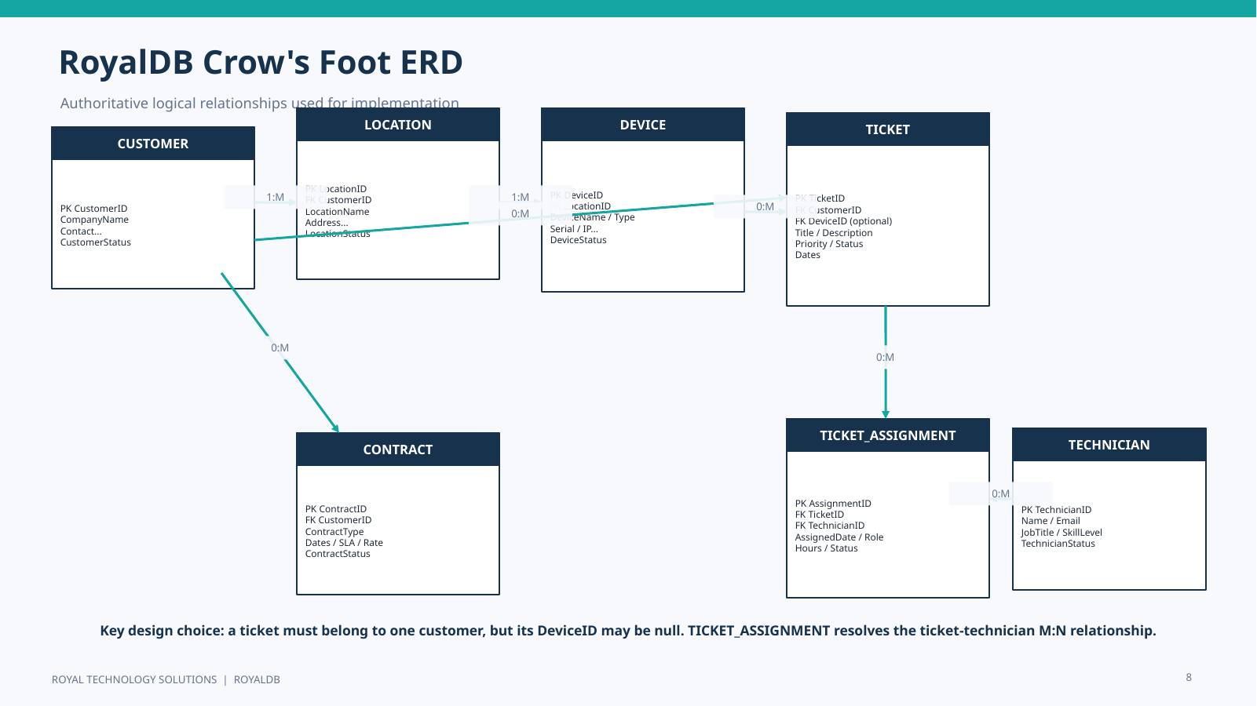
Figure 1. RoyalDB Crow's Foot entity relationship model.

8. Data Flow
The data-flow model complements the ER model by showing how information moves through Royal Technology Solutions. Customer and contract data, asset information, service requests, technician assignments, and management information interact through a centralized RoyalDB data store.
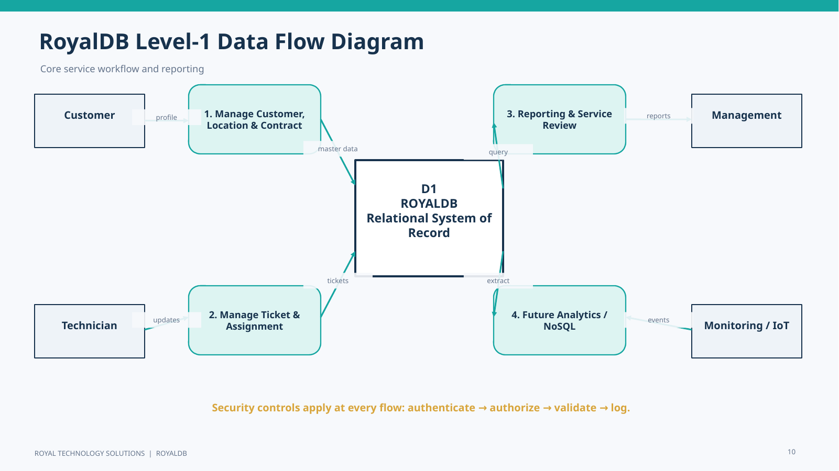
Figure 2. RoyalDB Level-1 data flow diagram.

9. Physical Environment and Implementation
Component | Implemented Configuration
Server | DB01 - Windows Server 2025
Domain | Royal1.Local
Intended DB01 address | 192.168.50.32
DBMS | PostgreSQL 18
Port | 5432
Database | royaldb
Schema | public
Physical naming | snake_case column/table identifiers

The SQL implementation created the planned relational schema and populated it with test data. A schema-verification query confirmed that the public schema contained exactly seven RoyalDB tables.
SELECT table_name
FROM information_schema.tables
WHERE table_schema = 'public'
ORDER BY table_name;
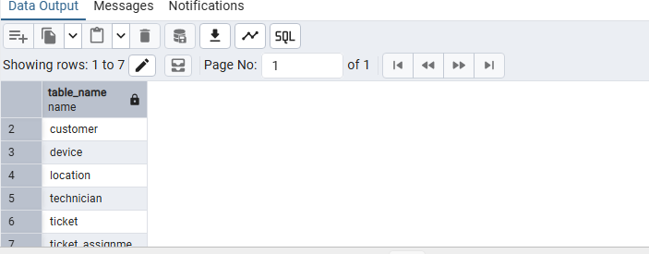
Figure 3. PostgreSQL schema verification showing the seven RoyalDB tables.

10. Verified Data Population
Table | Verified Row Count
customer | 3
location | 3
device | 4
contract | 3
technician | 3
ticket | 5
ticket_assignment | 4

These counts were verified in the live RoyalDB database and later verified again after restoring the backup into a separate test database.

11. Relational Query Validation
A JOIN query was used to validate the Customer-to-Ticket and optional Device-to-Ticket relationships. The physical PostgreSQL schema uses snake_case identifiers.
SELECT
t.ticket_id,
c.company_name,
t.ticket_title,
t.priority,
t.ticket_status,
d.device_name
FROM ticket AS t
JOIN customer AS c
ON t.customer_id = c.customer_id
LEFT JOIN device AS d
ON t.device_id = d.device_id
ORDER BY t.ticket_id;
The result returned five tickets. Device-backed tickets displayed a device name, while non-device service requests could return NULL for device_name. This validated the optional Device-to-Ticket relationship.
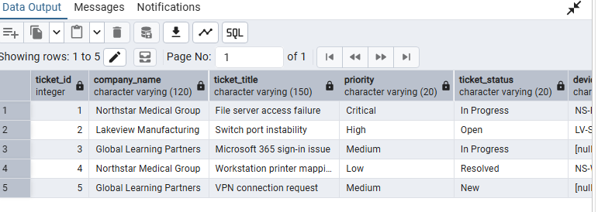
Figure 4. Successful Customer-Ticket-Device JOIN validation.

12. Ticket Assignment Bridge Validation
The Ticket Assignment bridge was tested with a multi-table JOIN. Ticket 1 returned two technician assignments, demonstrating that multiple technicians can participate in the same ticket while each technician can also work across multiple tickets.
SELECT
t.ticket_id,
t.ticket_title,
tech.first_name,
tech.last_name,
ta.assignment_role,
ta.assignment_status,
ta.hours_worked
FROM ticket AS t
JOIN ticket_assignment AS ta
ON t.ticket_id = ta.ticket_id
JOIN technician AS tech
ON ta.technician_id = tech.technician_id
ORDER BY t.ticket_id, tech.last_name;

13. Integrity Testing

13.1 CHECK Constraint Test
An attempt was made to insert a ticket with the unsupported priority value Urgent. PostgreSQL rejected the row through the ticket_priority_check constraint (SQLSTATE 23514). No invalid row was inserted.
INSERT INTO ticket (
customer_id, device_id, ticket_title, ticket_description,
priority, ticket_status, created_date
)
VALUES (
1, NULL, 'Invalid Priority Test',
'This record should be rejected by the database.',
'Urgent', 'New', CURRENT_TIMESTAMP
);
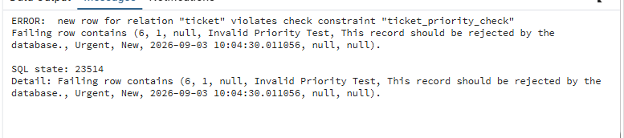
Figure 5. CHECK constraint correctly rejecting an invalid ticket priority.

13.2 Foreign-Key Test
A second test attempted to create a ticket for customer_id 9999. Because that customer does not exist, PostgreSQL rejected the row through the ticket_customer_id_fkey foreign-key constraint (SQLSTATE 23503).
INSERT INTO ticket (
customer_id, device_id, ticket_title, ticket_description,
priority, ticket_status, created_date
)
VALUES (
9999, NULL, 'Invalid Customer Test',
'This record should be rejected because the customer does not exist.',
'High', 'New', CURRENT_TIMESTAMP
);
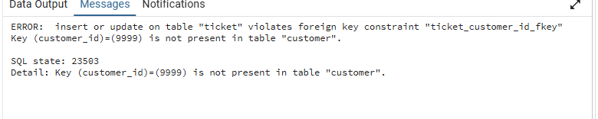
Figure 6. Foreign-key constraint correctly rejecting a nonexistent customer.

14. Role-Based Access Control (RBAC)
RoyalDB implements least privilege through PostgreSQL group roles and login users. The group roles are non-login roles; login users receive permissions through role membership.
Group Role | Intended Access
royaldb_dba | Full privileges on RoyalDB tables and sequences for database administration.
royaldb_tech | SELECT on tables; INSERT/UPDATE on ticket and ticket_assignment; sequence usage as needed.
royaldb_readonly | SELECT-only access to RoyalDB tables.

CREATE ROLE royaldb_dba NOLOGIN;
CREATE ROLE royaldb_tech NOLOGIN;
CREATE ROLE royaldb_readonly NOLOGIN;
GRANT CONNECT ON DATABASE royaldb
TO royaldb_dba, royaldb_tech, royaldb_readonly;
GRANT USAGE ON SCHEMA public
TO royaldb_dba, royaldb_tech, royaldb_readonly;
GRANT ALL PRIVILEGES ON ALL TABLES IN SCHEMA public TO royaldb_dba;
GRANT ALL PRIVILEGES ON ALL SEQUENCES IN SCHEMA public TO royaldb_dba;
GRANT SELECT ON ALL TABLES IN SCHEMA public TO royaldb_tech;
GRANT INSERT, UPDATE ON ticket, ticket_assignment TO royaldb_tech;
GRANT USAGE, SELECT ON ALL SEQUENCES IN SCHEMA public TO royaldb_tech;
GRANT SELECT ON ALL TABLES IN SCHEMA public TO royaldb_readonly;
Login users were created for DBA, technician, and read-only testing and assigned to the corresponding group roles. Passwords are intentionally excluded from this documentation.
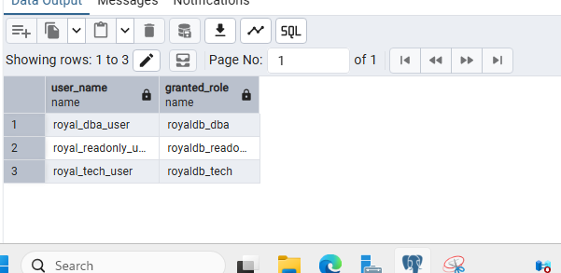
Figure 7. PostgreSQL role membership used for RoyalDB access control.

15. Least-Privilege Validation
Test Context | Operation | Result
Read-only user | SELECT from ticket | Allowed
Read-only user | UPDATE ticket | Denied
Technician user | UPDATE ticket | Allowed
Technician user | UPDATE customer | Denied

These tests demonstrate that users can perform required duties without receiving unnecessary modification or administrative rights. The technician test changed Ticket 5 to In Progress during validation; current data may therefore differ from earlier screenshots that showed that ticket as New.

16. Backup and Recovery Validation
A custom-format PostgreSQL backup was created with pg_dump and stored in C:\RoyalDB_Backups. The successful backup file was royaldb_full_2026-09-03_v2.backup.
& "C:\Program Files\PostgreSQL\18\bin\pg_dump.exe" `
-h localhost `
-p 5432 `
-U postgres `
-F c `
-f "C:\RoyalDB_Backups\royaldb_full_2026-09-03_v2.backup" `
royaldb
The backup was verified at 26,241 bytes. pg_restore -l successfully read the archive and reported a PostgreSQL custom-format archive with 63 table-of-contents entries. The backup was then restored into a separate database named royaldb_restore_test.
& "C:\Program Files\PostgreSQL\18\bin\pg_restore.exe" `
-h localhost `
-p 5432 `
-U postgres `
-d royaldb_restore_test `
-v `
"C:\RoyalDB_Backups\royaldb_full_2026-09-03_v2.backup"
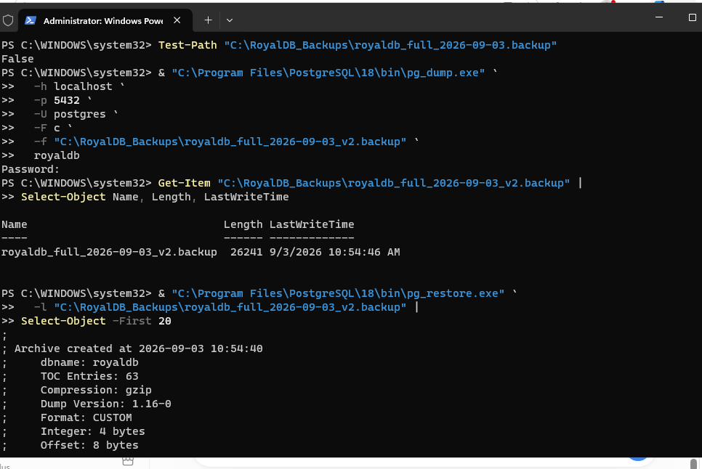
Figure 8. Successful RoyalDB backup and archive validation.
Post-restore verification returned the same row counts as the original database: 3 customers, 3 locations, 4 devices, 3 contracts, 3 technicians, 5 tickets, and 4 ticket assignments. This confirms that the archive could be restored and that the expected data survived the recovery process.
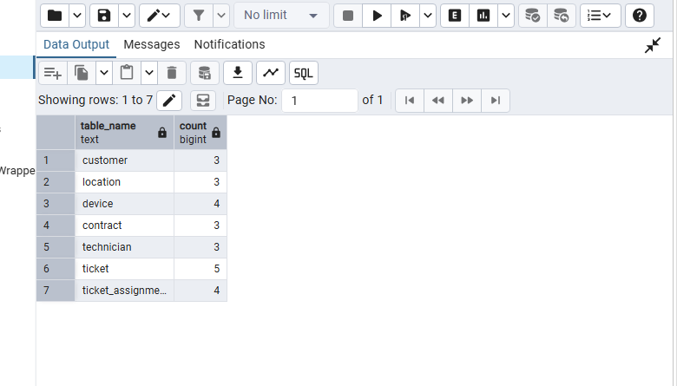
Figure 9. Restored royaldb_restore_test database row-count verification.

17. Security Architecture
RoyalDB uses a defense-in-depth security approach. The controls below are separated into those validated in the current lab and those recommended for a production deployment.
Control Area | Lab Status | Notes
Authentication / authorization | Implemented | PostgreSQL login users, group roles, and least-privilege tests.
Data integrity | Implemented | CHECK constraints, foreign keys, controlled values, required relationships.
Backup / restore | Implemented | Custom backup, archive validation, separate restore, data verification.
Network segmentation / firewall | Production recommendation | Restrict database connectivity to approved systems and administration paths.
TLS encryption | Production recommendation | Protect database connections in transit.
Centralized monitoring / auditing | Production recommendation | Collect logs and review privileged or suspicious activity.
Retention policy | Production recommendation | Define formal retention, archival, and deletion requirements.

18. Maintenance and Monitoring Plan
- Review PostgreSQL logs and database health regularly.
- Monitor storage growth, connection usage, and query performance.
- Maintain indexes and database statistics as workload grows.
- Review role membership and privileges on a recurring schedule.
- Apply tested PostgreSQL and operating-system security updates.
- Perform scheduled backups according to business recovery objectives.
- Run recurring restore tests rather than assuming backups remain usable.
- Document schema, role, configuration, and recovery-process changes.

19. Troubleshooting and Lessons Learned
Issue | Observed Problem | Resolution / Lesson
Domain join / DNS | DB01 initially could not locate Royal1.Local. | In this lab, the configuration that succeeded used an empty preferred DNS field and the domain controller as Alternate DNS. This is recorded as an environment-specific troubleshooting result, not a general Windows DNS standard.
SQL identifier mismatch | Initial JOIN used conceptual CamelCase identifiers such as CustomerID and failed. | The physical PostgreSQL implementation uses snake_case such as customer_id. Queries were corrected to match the physical schema.
Backup permission error | pgAdmin and the first pg_dump attempt returned Permission denied for the original backup path/name. | Folder writeability was tested, the old target was confirmed absent, and a new _v2 filename was used successfully with native pg_dump.
Security validation | Configuration alone does not prove least privilege. | SET ROLE tests confirmed allowed and denied operations for read-only and technician users.
Recovery validation | Creating a backup alone does not prove recoverability. | The archive was read, restored to a separate test database, and row counts were verified.

20. Implementation Status
Area | Status
Requirements and MVP | Complete
Logical data model / ERD | Complete
Data flow model | Complete
PostgreSQL 18 installation on DB01 | Complete
royaldb database and seven-table schema | Complete
Sample data and relational queries | Complete
CHECK / foreign-key integrity testing | Complete
RBAC and least-privilege testing | Complete
Backup, archive validation, restore, and data verification | Complete
Production network hardening and TLS | Recommended next step
Centralized monitoring / auditing | Recommended next step
Formal retention and recurring recovery schedule | Recommended next step
Production release / user acceptance | Future production phase

21. Future Expansion
The relational PostgreSQL implementation is appropriate for RoyalDB's structured transactional data. If Royal Technology Solutions later collects high-volume semi-structured or unstructured information such as security logs, monitoring events, or application telemetry, a NoSQL or hybrid architecture could complement rather than replace RoyalDB. This capability is a future recommendation and was not implemented in the current lab.

22. Conclusion
RoyalDB progressed from a business requirement into a functioning PostgreSQL database. The implementation validates the planned seven-entity relational model, optional device-to-ticket relationship, Ticket Assignment bridge, data-integrity constraints, role-based access controls, least privilege, and backup/recovery workflow. The remaining work is primarily production hardening, monitoring, formal retention, recurring recovery testing, and production release procedures.

Appendix A. Core SQL Validation Commands
-- Schema verification
SELECT table_name
FROM information_schema.tables
WHERE table_schema = 'public'
ORDER BY table_name;
-- Row counts
SELECT 'customer' AS table_name, COUNT(*) FROM customer
UNION ALL SELECT 'location', COUNT(*) FROM location
UNION ALL SELECT 'device', COUNT(*) FROM device
UNION ALL SELECT 'contract', COUNT(*) FROM contract
UNION ALL SELECT 'technician', COUNT(*) FROM technician
UNION ALL SELECT 'ticket', COUNT(*) FROM ticket
UNION ALL SELECT 'ticket_assignment', COUNT(*) FROM ticket_assignment;

Appendix B. Project Artifacts
Artifact | Purpose
Royal_Technology_Solutions_Unit_2_Data_Model.docx | Initial data-model documentation.
Royal_Technology_Solutions_Unit_3_Relational_Database_Model.docx | Relational model development.
Royal_Technology_Solutions_Unit_4_Entity_Relationship_Modeling_with_ERD.docx | ER modeling and ERD documentation.
Royal_Technology_Solutions_Unit_5_Advanced_Data_Modeling.docx | Advanced modeling documentation.
Royal_Technology_Solutions_Unit_6_SQL_Implementation.docx | SQL implementation documentation.
RoyalDB_Unit6_SQL_Implementation.sql | RoyalDB SQL build script.
Royal_Technology_Solutions_Unit_7_Big_Data_and_NoSQL.docx | Big Data / NoSQL extension analysis.
Royal_Technology_Solutions_Unit_8_Database_Administration_and_Security.docx | Administration and security documentation.
RoyalDB_CIS421_Final_Project_LaVon_Thomas_FINAL.pptx | Final board/CEO presentation with narration notes.

Appendix C. Academic and Project References
Bjeladinovic, S. (2018). A fresh approach for hybrid SQL/NoSQL database design based on data structuredness. Enterprise Information Systems, 12(8-9), 1202-1220.
Coronel, C., & Morris, S. (2023). Database systems: Design, implementation, & management (14th ed.). Cengage Learning.
Katz, A. (2020). Improved teaching of database schema modeling by visualizing changes in levels of abstraction. Journal of Information Systems Education, 31(4), 294-311.
Miartin, E. (2020). Revolutionary change. Business North Carolina, 40(12), 52-59.
Roller, D., Eck, O., & Dalakakis, S. (2002). Advanced database approach for cooperative product design. Journal of Engineering Design, 13(1), 49-61.
Wu, J., Wang, J., Nicholas, S., Maitland, E., & Fan, Q. (2020). Application of big data technology for COVID-19 prevention and control in China: Lessons and recommendations. Journal of Medical Internet Research, 22(10), e21980.

