Installed COV2CON version: 1.3.0
COVID-19 pandemic status indicators
The severity of a pandemic in a particular region of the world increases with its transmission rate, proportion of the population that is infected, and case fatality ratio; these characteristics can be estimated from publicly available pandemic indicators.
The European Centre for Disease Control (ECDC) compiles public COVID-19 related data from multiple countries. The Our World in Data (OWID) group repackages the data along with information parsed from additional official sources. The Johns Hopkins University (JHU) makes its own data sets publicly available. These data should be interpreted with caution when trying to compare the severity status, or condition, of the COVID-19 pandemic across countries.
COV2CON uses COVID-19 data sets published by OWID and JHU. The application is primarily designed to help visualize and explore the daily and historical values of three indicators that are considered to be most relevant for country comparison purposes: Positive rate, Total cases per million, and Active cases per million. Here are the reasons why.
For clarity, when a case is reportedly “confirmed” the patient has not necessarily presented with COVID-19 signs and symptoms that were confirmed by molecular tests (i.e., PCR). In many instances when cases are reported, only the molecular test was performed for diagnostic purposes.
The number of new cases reported increases in proportion to the number of new tests conducted; thus, the new case count in a country on a particular date, while important to health authorities for resource allocation purposes is not a good measurement of the transmission rate of COVID-19. Instead, a better measurement is the proportion of new positive tests out of total tests conducted; this is the Positive rate indicator presented in the COV2CON application. However, it is a characteristic of the select population that took a COVID-19 test (because they had signs & symptoms, or have come into contact with a confirmed patient, or just volunteered to take the test), rather than of the entire population.
Likewise, the total (or confirmed) number of cases increases with the number of tests conducted over a longer period of time. It is a cumulative count that does not factor in patients who recovered or died. However, a total case count that plateaus out is a good measure of how well a country controls the epidemic. To compare this effect across countries, the total case count is divided by the country population; this is the Total cases per million indicator presented in the COV2CON application and it is an estimate of the proportion of the population that has been infected.
The active case count, which is calculated by subtracting recovered cases and deaths from total cases, is a good measurement of the COVID-19 burden in a country. Here again, for country comparison purposes it is divided by the country population; this is the Active cases per million indicator presented in the COV2CON and it is an estimate of the proportion of the population that is known to be infected.
Another indicator, which is used in some regions for travel restriction purposes, is new cases, or new cases per million or hundred thousand population, or a daily average variation of these. Because new cases increase in proportion to new tests, this indicator does not correlate with Positive rate, as demonstrated in the plot below for a country where new cases per million increased dramatically as more patients got tested while the positive rate remained low. Obviously, the severity of a pandemic does not increase just because more people get tested and consequently more cases are reported. For these reasons, the New cases indicator and variants thereof are not presented in COV2CON.
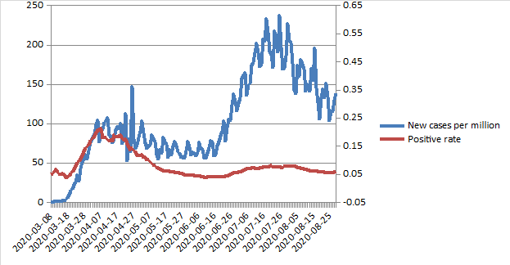
Finally, the number of new deaths is difficult to interpret as patients who pass away in a hospital setting are generally tested for the Cov-2 virus if they came into contact with another patient who tested positive. If they do test positive, they count as deaths by COVID-19 although causality is not necessarily demonstrated. The same limitation applies to patients with comorbidities: it is very difficult to determine if the cause of death is the Cov-2 virus or the comorbidity. For these reasons, the New deaths indicator and variants thereof are not presented in COV2CON.
Experts estimate the average case fatality ratio (CFR) by COVID-19 to be between 1% and 2%, although it can be greater than 50% when comorbidities are present.
Not all of these data are available for each country and for each date within the time frame since the COVID-19 pandemic broke out. For some countries, there are no Positive rate data available.
As a confirmed case essentially means a PCR-positive case, these cases may continue to accrue until potentially all the population gets tested, especially in countries that have the means to do the testing. Therefore, it is not surprising to see active cases increasing with time in the developed world. A PCR-positive individual is not necessarily sick so this molecular testing methodon its own is a poor choice for evaluating regional COVID-19 status, and unfortunately it drives important decisions such as when and where to initiate lockdowns, restrict travel, close businesses, etc. Clearly we could use a better COVID-19 stick.
Meet the consolidated indicator ACPO-14, which stands for “Active & Positive 14 days”. It is computed as the square root of the product of the average Positive rate and the slope of Active cases per million over the last 14 days (where both data are available; slope computation allows for 1-2 days’ worth of data to be missing at the ends of the 14-day sliding window but this is seldom the case, if at all) or zero, whichever is greater. It fits one possible intuition of pandemic risk. Feel free to ignore it or have fun with it.
The idea behind ACPO-14 is simple. Intuitively, the pandemic risk at a particular location increases with the positive rate and the density of active cases. If the positive rate drops to zero (i.e., there is no transmission) then it doesn’t really matter how many active cases there are as no more people will become infected. When the pandemic began, active cases were non-zero and the positive rate was high but the pandemic risk was still minimal as there were not many people who could transmit the infection. Last but not least, on any particular date Positive rate is a property of that point in time while Active cases per million is a reflection of the last six weeks of the pandemic, so together they describe a trend. Sounds ambiguous, ill-defined, and wishy-washy? Try experimenting with it and you may be surprised.

How to use COV2CON
Upon launch, COV2CON will attempt to download over the Internet the most up-to-date data sets. If it fails, it will attempt to use previous, local data sets and you will be given the option to try a manual update later.
Once the update is completed, the right-hand panel of the main application window shows a list of country names and values while the left-hand panel may show a graph of historical values for the selected country, if data is available.
By default, the country list shows Total cases per million with country names sorted in descending order of the indicator values. You can click one of the four radio buttons in the toolbar at the top of the main window to switch between Positive rate, Total cases per million, Active cases per million, and ACPO-14.
Note that countries for which no data is available on the date shown above the country list are included at the bottom of the country list, in no particular order, and instead of a value next to the country name the text “no data” is shown. However, if you click on one of these items, historical data will be shown in the graph, if available.
To quickly find a country and its associated value, sort the items on the country list alphabetically (see below).

Single country selection
You can change the selected country by using the Up/Down Arrow keys, or the mouse (click on the list and drag up or down).
You can filter country names by typing in the text box above the country list. Double-click this text box to sort country names alphabetically in ascending order.
While Total cases per million values are generally available for most country on any date, Positive rate, Active cases per million, and ACPO-14 (which depends on the last two) may not be available for the very last date or for some of the other dates. Simply change the date using the slider (see below) and the updated country name list will also include numerical values next to country names for the indicator currently selected.
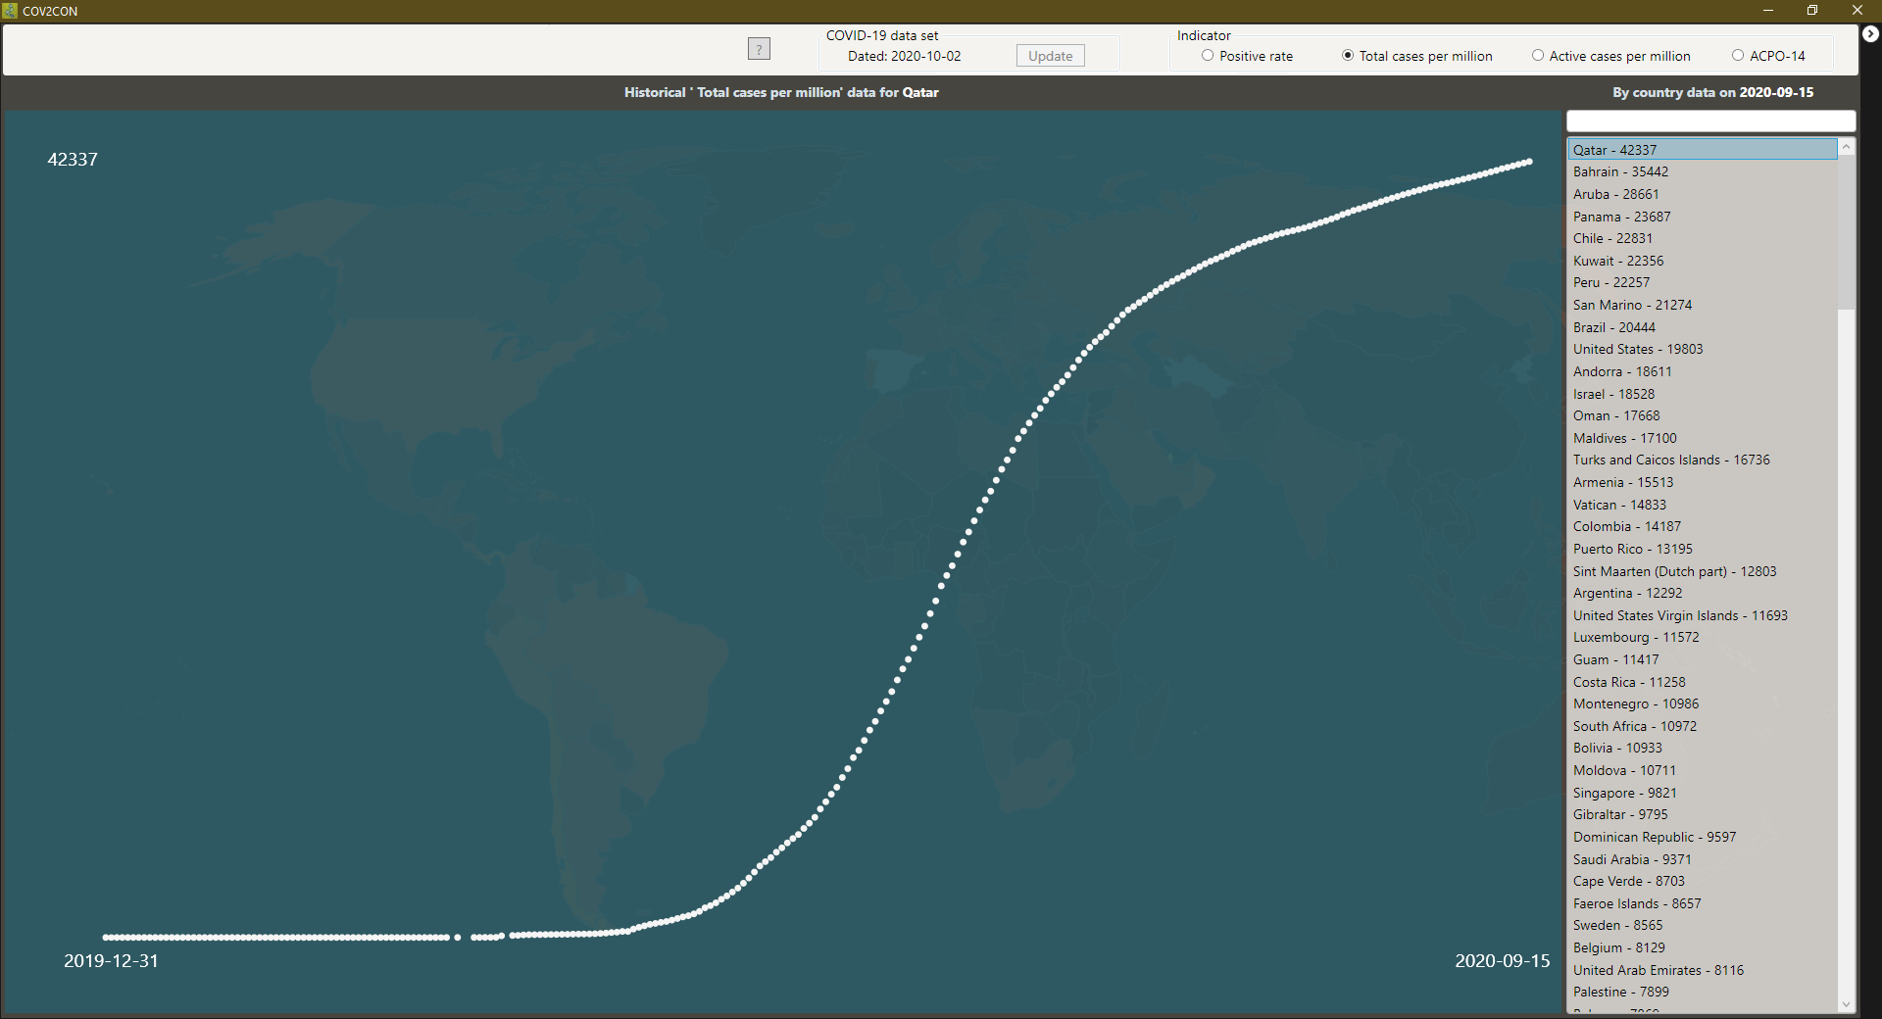
Date
By default, country values are shown for the last date in the data set.
You can change the date by hovering above the graph with the mouse pointer to show a pop-up slider and then dragging the slider handle to the left or to the right. The country list is updated as you change the date and release the mouse button. The country that was initially selected does not change and remains in view, if data is available for it on the new date; otherwise, the country at the top of the list on that date is selected instead.
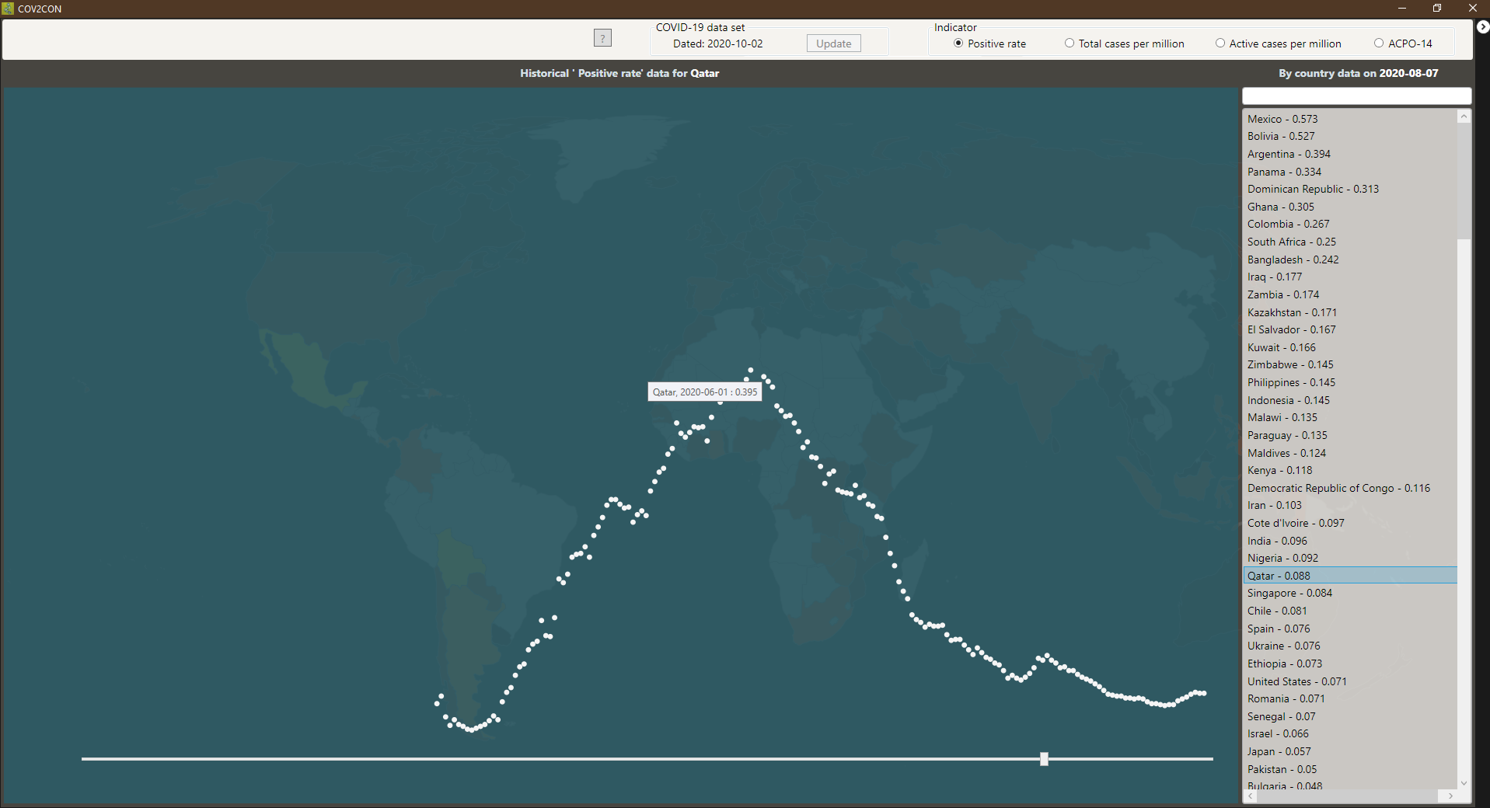
You can hover on any data point (the large coloured dots) in the graph to show indicator values on that date in a pop-up text.

Multiple country selection
COV2CON can overlay plots of historical data for up to 7 countries. To select multiple entries in the country list, press either the Ctrl key or the Shift key and then use the mouse buttons to make your selection.
A multiple selection does not change when switching between Positive rate, Total cases per million, and Active cases per million, although some items may require scrolling up or down to become visible on the list. However, if you try changing the date, only the first country in the selection stays selected; this is by design.
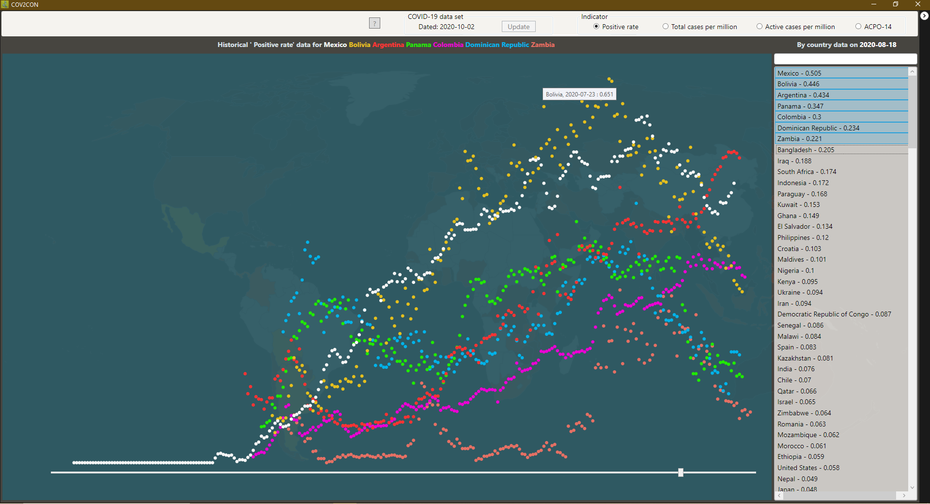

World maps
COV2CON can display a heat map of country data for the current indicator on the selected date. Click the top-right arrow button to switch between the map and the graph & country list panels. Hovering on any country on the map will show the value of the selected indicator for that country in a pop-up text. A gray background indicates the indicator value is not available for that country on the selected date.
Here is a map showing total cases per million:
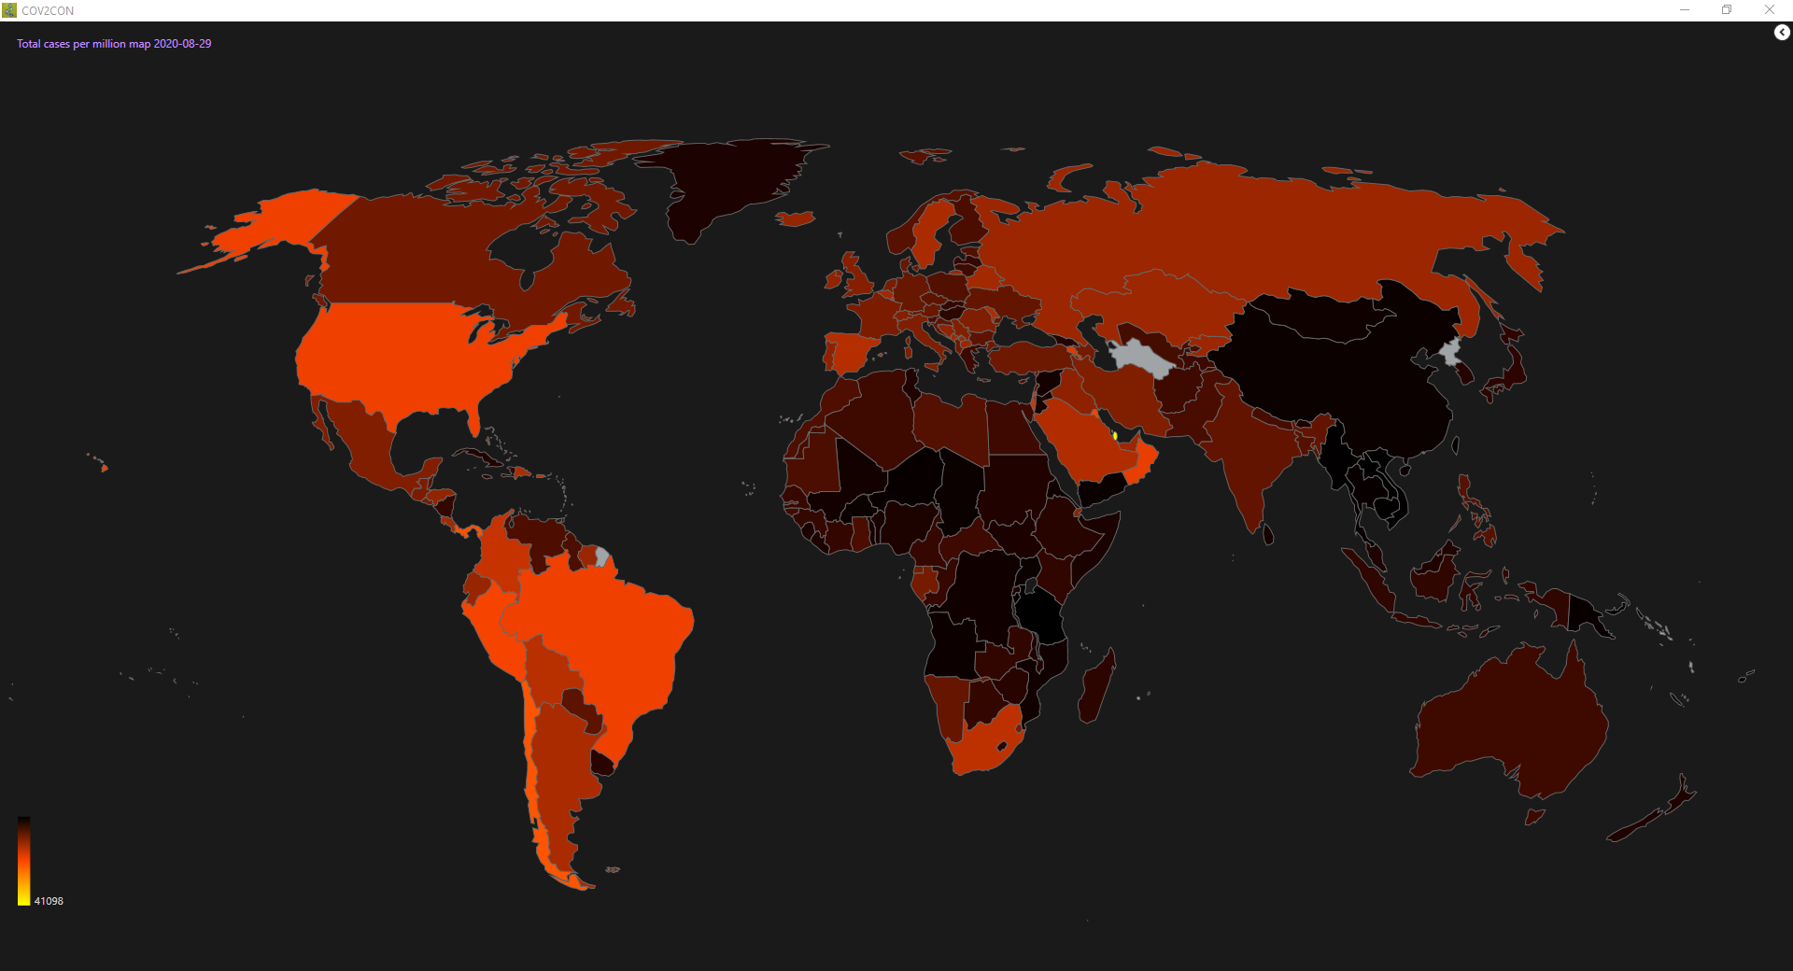
Most countries on the heat map above appear colourful (see palette at bottom-left) as Total cases per million is the most available reported indicator.
Positive rate figures are often missing on any particular date so the next map has a mottled aspect with gray areas; this is normal.
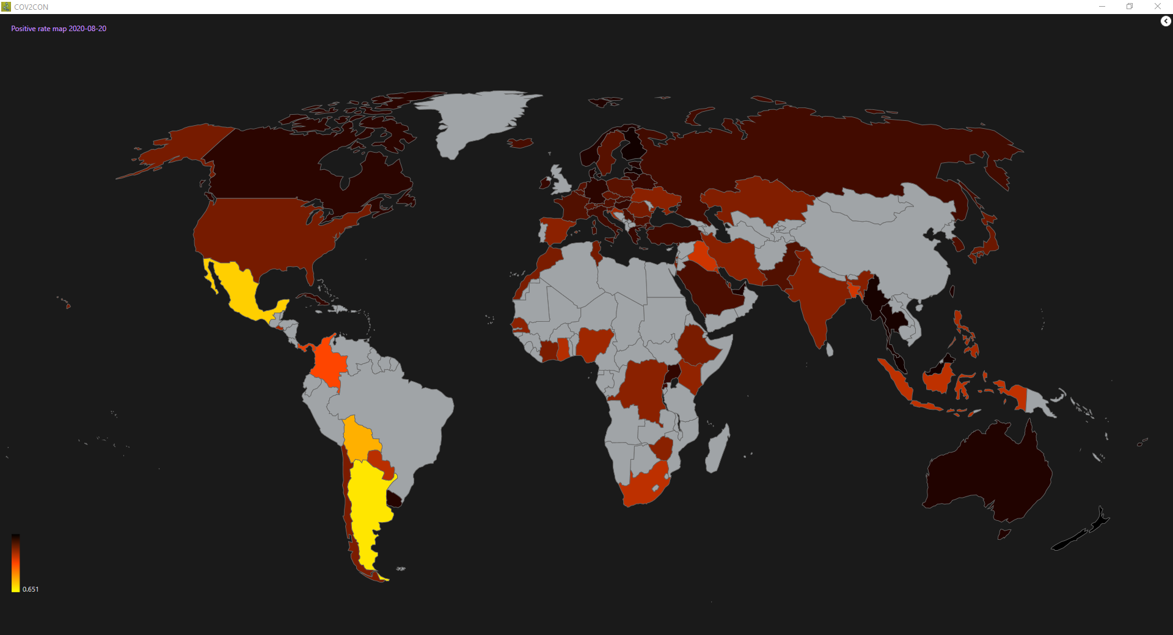
To change the app font size, press keys Ctrl and + or - at the same time.
To print the content of this help window, press keys Ctrl and P at the same time.

Copyright © 2020 Pegasone Inc.

