KIRKIRA

KECOBO Copyright Filing System
Concept & Technical Specification

Automated Filing Wizard · LLM Classification · Playwright Automation · Nightly Sync

Version 1.0 · 2025

Overview
The Kirkira KECOBO Copyright Filing System is a guided, automated platform that enables creators to register their intellectual property with Kenya's Copyright Board (KECOBO) and National Rights Registry (NRR) — without navigating the portal manually.

The system combines four core capabilities:
- LLM-assisted classification to identify the correct copyright category and subcategory
- A structured, step-by-step wizard that captures all required data and documents
- Playwright-based browser automation to file applications directly with KECOBO
- Asynchronous nightly sync to track application status and retrieve approved certificates

Goal | Reduce copyright filing friction for creators in Kenya by automating the full KECOBO submission lifecycle — from classification to certificate delivery.

User Flow
The filing process is broken into seven clearly defined steps. Each step is designed to collect the minimum required information before moving forward, with data saved as a draft at every stage.

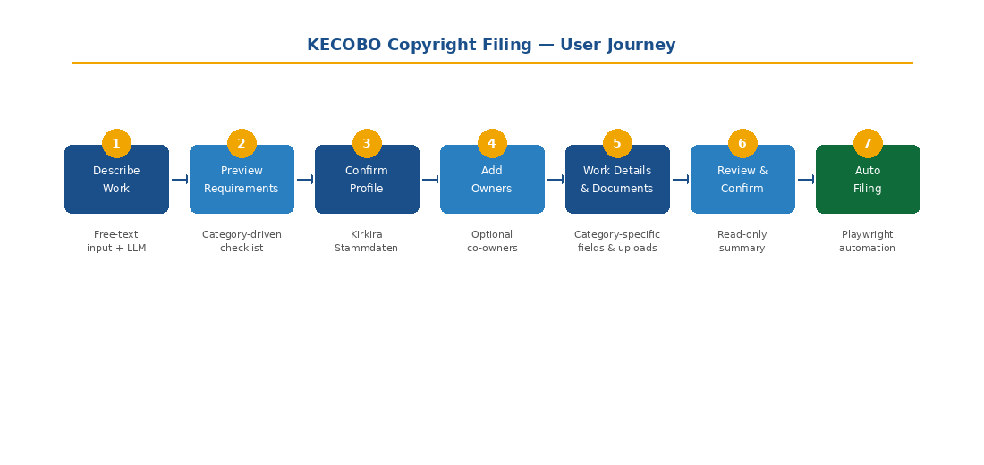
Figure 1: End-to-end user journey through the Kirkira copyright filing wizard

Step 1 — Describe the Work
The user provides a free-text description of their work, and optionally uploads a sample file. The system immediately calls the LLM to suggest the most appropriate category and subcategory.
- Input: free-text description + optional sample upload
- Output: suggested category/subcategory with confidence score
- User may accept the suggestion or override via dropdowns

LLM Note | If the confidence score falls below the defined threshold, the system displays: "We are not sure — please choose manually." The user always retains the ability to override any classification.

Step 2 — Preview Requirements
Based on the selected category and subcategory, the system displays a tailored checklist of required information and documents. This allows the user to prepare everything before proceeding.
- Required fields: title, year, authors, owners, etc.
- Required documents: work file, ID/passport, declaration, category-specific attachments

Step 3 — Confirm Profile (Stammdaten)
The system fetches the applicant's profile from Kirkira (Stammdaten), including name, address, contact details, and ID/passport number. The user confirms or completes any missing fields.
- A snapshot of the confirmed profile is saved to the application record
- This snapshot remains unchanged even if the user later updates their Kirkira profile

Step 4 — Additional Owners
The user is asked whether there are additional co-owners of the work. If yes, the wizard prompts for each owner's details.
- Name, address, contact information
- Ownership share or role (e.g. co-author, producer)
- Stored as an owners[] array on the application

Step 5 — Work Details & Documents
This step is driven entirely by the selected category and subcategory. Common fields (title, description, year, language, first publication date) are always shown. Category-specific fields are shown conditionally:
- Literary: work type (book/article), number of pages
- Musical: composer, lyricist, duration
- Audiovisual: director, producer, runtime

Document uploads required at this step:
- Work file (validated per category rules)
- Government-issued ID or passport
- Signed declaration form (or auto-generated PDF from template with e-signature)
- Any additional supporting documents

Step 6 — Review & Confirm
A read-only summary of the complete application is presented before filing is triggered. The user must explicitly confirm that all information is correct.
- Applicant profile snapshot
- Owners list
- Work details and category
- All uploaded documents

Step 7 — Background Filing
Upon confirmation, a KECOBO filing job is queued in the background. The user is immediately redirected to their dashboard. No further action is required from the user unless the application is rejected.
- Status begins as: Pending Submission
- Progresses through: Submitted → Under Review → Approved or Rejected

System Architecture
The platform is composed of four principal components that communicate asynchronously. Each layer has a clearly defined responsibility, enabling independent scaling and deployment.

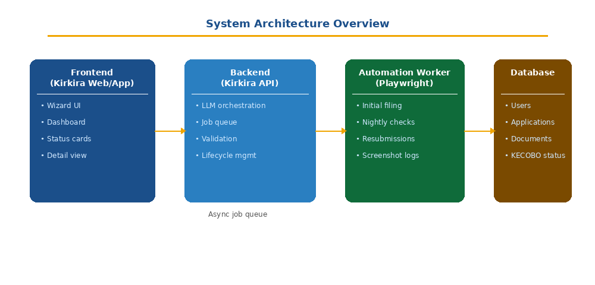
Figure 2: High-level system architecture — Frontend, Backend, Automation Worker, and Database

Frontend — Kirkira Web/App
- Multi-step wizard with draft persistence at each step
- Dashboard with application status cards
- Detail view (read-only) for submitted applications
- Certificate download for approved applications

Backend — Kirkira API
- Application lifecycle management and status transitions
- LLM orchestration: prompt construction, response parsing, confidence scoring
- Validation and normalisation of submitted data
- Job queue for Playwright filing tasks
- Nightly sync scheduler and cron management

Automation Worker — Playwright Runner
- Executes initial filing scripts against the KECOBO portal
- Runs nightly status checks for all active applications
- Handles resubmissions after rejection
- Stores screenshots and structured logs for each run

Database
- Stores users, applications, owners, documents, and KECOBO status
- Maintains an audit log of all status transitions
- Preserves applicant profile snapshots per application

Core Data Model
The application record is the central entity. It captures the full lifecycle of a copyright filing from draft through to certificate issuance.

Field | Type | Description
id | UUID | Unique application identifier
user_id | FK | Reference to applicant user
status | ENUM | draft → ready_for_filing → submitted → approved/rejected
category_id / subcategory_id | FK | LLM-suggested or user-selected category
title | String | Work title
applicant_profile_snapshot | JSON | Snapshot of Kirkira Stammdaten at time of filing
owners | JSON[] | Co-owners: name, address, share, role
work_metadata | JSON | Category-specific fields (pages, duration, etc.)
kecobo_reference | String | Reference number returned after submission
kecobo_status | String | Status as read from KECOBO portal
kecobo_last_checked_at | DateTime | Timestamp of last nightly sync

Documents are stored in a separate table linked to the application by a foreign key. Document types include: work_file, id_document, declaration, supporting, and certificate.

Application Status Lifecycle
Each application moves through a defined set of statuses. Status transitions are driven by either user action or the automated Playwright worker.

Status | Meaning | User Action Available | Color
Draft | Wizard not yet completed | Continue editing | Grey
Ready for Filing | All data validated, queued for automation | None (system processes) | Blue
Submitted | Filed with KECOBO via Playwright | View details | Blue
Under Review | KECOBO is reviewing the application | View details | Amber
Approved | Certificate issued by KECOBO | Download certificate | Green
Rejected | Application rejected with reason | Edit & Resubmit | Red

Playwright Automation
The Playwright runner handles two distinct workflows: the initial filing when the user confirms their application, and the nightly sync that checks for status updates across all active applications.

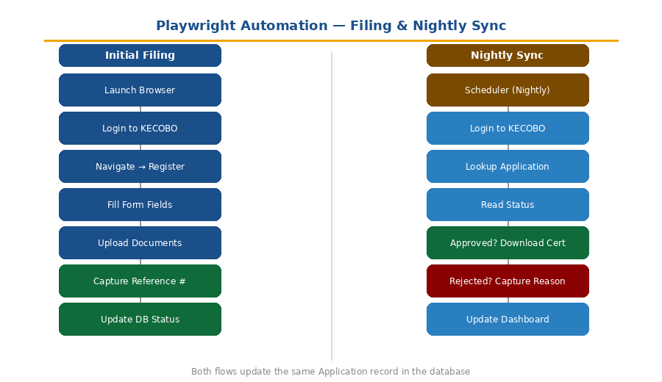
Figure 3: Playwright automation workflows — initial filing (left) and nightly status sync (right)

Initial Filing Job
Triggered immediately after the user confirms the overview. The job is queued and executed asynchronously.
- Launch browser (headless for production; visible for debugging)
- Authenticate with KECOBO using institutional credentials
- Navigate to the Register Work page
- Populate all form fields from structured application data
- Upload all required documents in correct sequence
- Capture confirmation page and extract reference number
- Update application status to Submitted and store the reference

Human Checkpoint | An optional pause before final submission can be enabled for high-stakes filings, allowing a human operator to review before the form is submitted to KECOBO.

Nightly Status Sync
The scheduler runs once per night and checks all applications with status Submitted or Under Review.
- Authenticate and navigate to the KECOBO application search page
- Locate each application by title, date, or KECOBO reference number
- Read the current status displayed on the portal
- If Approved: download the certificate PDF and store it as a Certificate document type
- If Rejected: capture the rejection reason and store it on the application record
- Update the Kirkira database and refresh the user's dashboard

Resubmission Flow
When an application is rejected, the user is shown the rejection reason on their dashboard card. They may choose to edit and resubmit without starting from scratch.
- User opens the rejected application card and clicks Edit & Resubmit
- The wizard re-opens with all previous data pre-filled
- Fields likely related to the rejection reason are highlighted
- User updates the relevant fields and/or uploads replacement documents
- User completes a new confirmation step
- A new Playwright job is queued — either using KECOBO's amend feature or creating a new application that references the previous one
- Status resets to Submitted / Under Review

LLM Classification
The category suggestion system uses the Anthropic API to classify works based on the user's free-text description. Few-shot prompting is used to improve accuracy across all supported category/subcategory combinations.

Input to the Model
- User's free-text work description
- Optional: a brief system-level description of each category/subcategory (few-shot examples)

Output from the Model
- category_id — matched category from the schema
- subcategory_id — matched subcategory
- confidence — normalised float between 0 and 1
- explanation — optional rationale shown to user if confidence is low

Guardrail | If confidence falls below the configured threshold, the system flags the suggestion as uncertain and instructs the user to select manually. The user always has full control and may override any suggestion at any time.

Implementation Priorities
Development is recommended in the following sequence to establish a solid foundation before building automation on top of it.

Priority | Component | Description
1 | Data & Schema | Finalize category/subcategory JSON and application + document models
2 | Wizard UX | Multi-step wizard with draft saving at each step
3 | LLM Classification | API call + category mapping + suggestion UI
4 | Validation Layer | File types, required fields per category/subcategory
5 | Playwright MVP | One full category end-to-end (Literary), then generalise
6 | Nightly Sync Job | Manual trigger first, then scheduled cron

Recommended Next Steps
To proceed from concept to implementation, the following artefacts should be produced:

- Sequence diagram covering the complete filing and sync flow
- User actions, backend API calls, Playwright steps, and KECOBO portal interactions

- Technical specification for the development team
- REST endpoint definitions and payloads
- Module boundaries and service interfaces
- LLM prompt templates and response schemas

- Category/subcategory schema in finalised JSON format
- Complete list of KECOBO work types with required fields and documents per type

- Playwright proof-of-concept for the Literary category
- Validates that the KECOBO portal can be fully automated end-to-end

