KIRKIRA

KECOBO Copyright Filing System
Technical Specification

For the Kirkira Development Team

Document | KECOBO Filing System — Technical Specification
Version | 1.0.0
Status | Draft — For Review
Date | 2025
Audience | Backend Engineers · Frontend Engineers · DevOps · QA
Reference | Concept Doc v1.0 · Category Schema v1.0.0

1. Document Purpose & Scope
This document is the primary technical reference for all engineers building the Kirkira KECOBO Copyright Filing System. It defines module boundaries, REST API contracts, database schema, job queue behaviour, Playwright automation contracts, and environment/deployment configuration.

It should be read alongside two companion artefacts:
- Kirkira KECOBO Concept & System Specification (v1.0) — the product and user-flow reference
- kecobo_categories_schema_v1.0.0.json — the authoritative category/subcategory/field/document schema

Scope | This spec covers the Kirkira backend API, the Playwright automation worker, the job queue, and the nightly sync scheduler. Frontend implementation details (component design, state management) are out of scope and covered separately in the Kirkira Frontend Spec.

2. Technology Stack
Layer | Technology | Notes
Backend API | Python 3.11+ · FastAPI | Async, OpenAPI auto-docs, Pydantic v2 validation
Database | PostgreSQL 15+ | Primary store; JSONB for metadata, owners, snapshots
ORM / Migrations | SQLAlchemy 2 · Alembic | Async SQLAlchemy sessions
Auth | JWT (RS256) + bcrypt | Short-lived access tokens, rotating refresh tokens
Job Queue | ARQ (Redis-backed) | Async Python job queue; retry logic built in
Message Broker | Redis 7+ | ARQ backend; also used for rate-limit counters
File Storage | S3-compatible (MinIO / AWS S3) | Presigned upload URLs; server-side encryption
Playwright Worker | Node.js 20 · Playwright 1.40+ | Runs in a separate container; Chromium headless
LLM Integration | Anthropic API (claude-sonnet-4-20250514) | Streaming disabled; structured JSON output
Frontend | React 18 · TypeScript · Vite | Separate repo; communicates via this API
Containerisation | Docker · Docker Compose | All services containerised
CI/CD | GitHub Actions | Lint → test → build → deploy pipeline
Monitoring | Prometheus · Grafana · Sentry | Metrics, dashboards, and error tracking

3. System Architecture
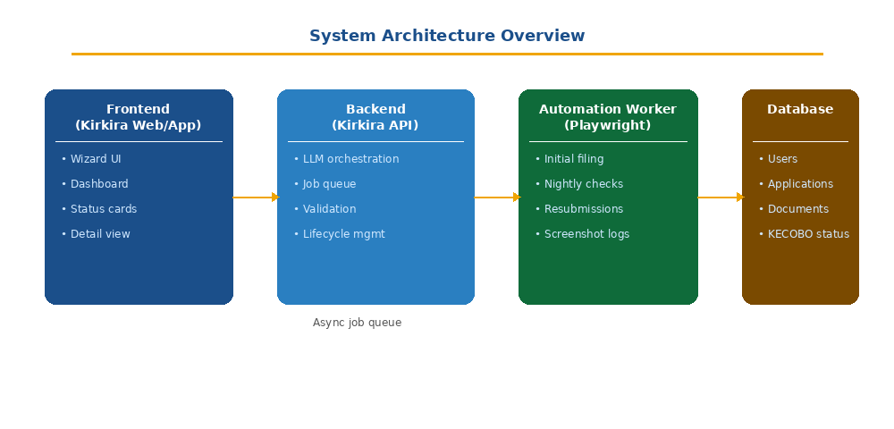
Figure 1: Component overview — Frontend, API, Worker, and Database

3.1 Component Boundaries
Component | Responsibility | Communicates With
Kirkira Frontend | Wizard UI, dashboard, document uploads | Kirkira API (REST + presigned S3 URLs)
Kirkira API | Application lifecycle, auth, LLM orchestration, job dispatch | DB, Redis, S3, Anthropic API
ARQ Worker (Python) | Long-running tasks: LLM calls, status updates | DB, Redis, S3
Playwright Worker | Browser automation: KECOBO filing + nightly sync | KECOBO/NRR portal (browser), DB via API or direct
PostgreSQL | Primary persistent store | API, ARQ Worker
Redis | ARQ job queue, rate-limit counters, session cache | API, ARQ Worker, Playwright Worker
S3 Storage | Document file storage | API (presigned URLs), Playwright Worker (download)

3.2 Inter-Service Communication
- Frontend → API: HTTPS REST. All endpoints under /api/v1/. Auth via Bearer JWT header.
- API → ARQ: Redis LPUSH via arq.create_pool(). Job payloads are JSON-serialisable Pydantic models.
- API → S3: Presigned PUT URLs issued to frontend for direct upload. API validates after upload via HEAD request.
- API → Anthropic: Synchronous HTTPS call from a background ARQ task (not the request thread).
- Playwright Worker → KECOBO: Chromium browser controlled via Playwright. No direct DB write — all status updates go through the internal API endpoint POST /internal/jobs/{id}/result.

4. Database Schema
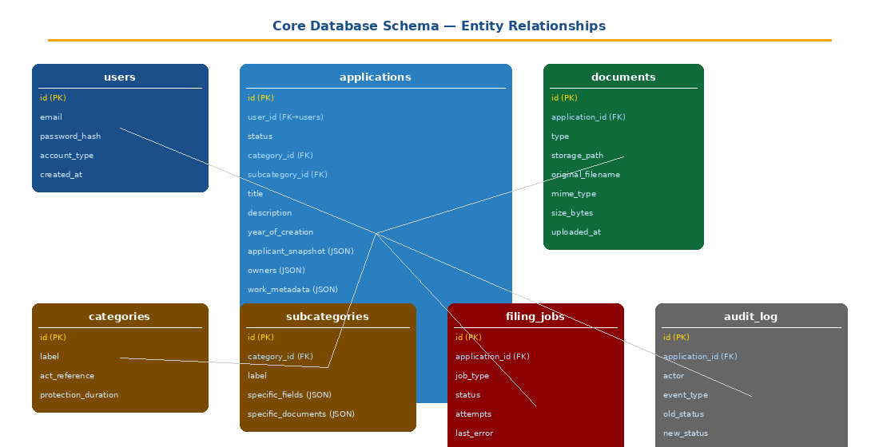
Figure 2: Core tables and foreign key relationships

4.1 users
Column | Type | Constraints | Notes
id | UUID | PK, DEFAULT gen_random_uuid()
email | VARCHAR(320) | UNIQUE, NOT NULL | Lowercased on insert
password_hash | VARCHAR(255) | NOT NULL | bcrypt; nullable for SSO-only accounts
account_type | VARCHAR(20) | NOT NULL | 'individual' | 'corporate'
full_name | VARCHAR(255) | NOT NULL
phone | VARCHAR(30) | NULLABLE
stammdaten | JSONB | DEFAULT '{}' | Cached Kirkira profile for pre-fill
created_at | TIMESTAMPTZ | DEFAULT now()
updated_at | TIMESTAMPTZ | DEFAULT now() | Updated by trigger

4.2 applications
Column | Type | Constraints | Notes
id | UUID | PK
user_id | UUID | FK → users.id, NOT NULL | Cascade delete
status | VARCHAR(30) | NOT NULL, DEFAULT 'draft' | See state machine §6
category_id | VARCHAR(10) | NOT NULL | e.g. 'LIT', 'MUS', 'AV'
subcategory_id | VARCHAR(20) | NOT NULL | e.g. 'LIT-BOOK'
llm_suggestion | JSONB | NULLABLE | {category_id, subcategory_id, confidence, explanation}
title | VARCHAR(500) | NOT NULL
description | TEXT | NOT NULL
year_of_creation | SMALLINT | NOT NULL
country_of_origin | CHAR(2) | NOT NULL, DEFAULT 'KE' | ISO 3166-1 alpha-2
language | VARCHAR(50) | NOT NULL
is_published | BOOLEAN | NOT NULL
first_publication_date | DATE | NULLABLE
first_publication_country | CHAR(2) | NULLABLE
is_commissioned | BOOLEAN | NOT NULL, DEFAULT false
commissioner_name | VARCHAR(255) | NULLABLE
applicant_snapshot | JSONB | NOT NULL | Stammdaten snapshot at submission time
owners | JSONB | DEFAULT '[]' | Array of {name, address, share, role}
work_metadata | JSONB | DEFAULT '{}' | Category-specific fields from schema
kecobo_reference | VARCHAR(100) | NULLABLE | NRR reference number after filing
kecobo_status | VARCHAR(50) | NULLABLE | Raw status string from KECOBO portal
kecobo_last_checked_at | TIMESTAMPTZ | NULLABLE | Set by nightly sync
rejection_reason | TEXT | NULLABLE
wizard_step | SMALLINT | DEFAULT 1 | Last completed step (1–7) for draft resume
created_at | TIMESTAMPTZ | DEFAULT now()
updated_at | TIMESTAMPTZ | DEFAULT now()

4.3 documents
Column | Type | Constraints | Notes
id | UUID | PK
application_id | UUID | FK → applications.id | Cascade delete
type | VARCHAR(30) | NOT NULL | 'work_file' | 'id_document' | 'declaration' | 'supporting' | 'certificate'
storage_key | VARCHAR(1000) | NOT NULL | S3 object key
original_filename | VARCHAR(500) | NOT NULL
mime_type | VARCHAR(100) | NOT NULL
size_bytes | BIGINT | NOT NULL
is_verified | BOOLEAN | DEFAULT false | Set true after HEAD check confirms upload
uploaded_at | TIMESTAMPTZ | DEFAULT now()

4.4 filing_jobs
Column | Type | Constraints | Notes
id | UUID | PK
application_id | UUID | FK → applications.id
job_type | VARCHAR(30) | NOT NULL | 'initial_filing' | 'status_check' | 'resubmission'
arq_job_id | VARCHAR(100) | NULLABLE | ARQ job identifier for tracking
status | VARCHAR(20) | DEFAULT 'queued' | 'queued' | 'running' | 'success' | 'failed' | 'retrying'
attempts | SMALLINT | DEFAULT 0
max_attempts | SMALLINT | DEFAULT 3
last_error | TEXT | NULLABLE
screenshot_keys | JSONB | DEFAULT '[]' | S3 keys for Playwright screenshots
queued_at | TIMESTAMPTZ | DEFAULT now()
started_at | TIMESTAMPTZ | NULLABLE
completed_at | TIMESTAMPTZ | NULLABLE

4.5 audit_log
Column | Type | Notes
id | UUID | PK
application_id | UUID | FK → applications.id (SET NULL on delete)
actor | VARCHAR(100) | 'user:{user_id}' | 'system' | 'playwright_worker'
event_type | VARCHAR(50) | 'status_changed' | 'document_uploaded' | 'job_queued' | 'kecobo_synced' | ...
old_status | VARCHAR(30) | NULLABLE
new_status | VARCHAR(30) | NULLABLE
metadata | JSONB | Free-form event context
created_at | TIMESTAMPTZ | DEFAULT now()

4.6 Key Indexes
Index | Table | Purpose
idx_applications_user_id | applications | List applications for a user
idx_applications_status | applications | Nightly sync: filter by status
idx_applications_kecobo_last_checked_at | applications | Identify stale records needing sync
idx_documents_application_id | documents | Fetch all documents for an application
idx_filing_jobs_application_id | filing_jobs | Find jobs for a given application
idx_filing_jobs_status | filing_jobs | Queue worker: find queued jobs
idx_audit_log_application_id | audit_log | Fetch history for an application

5. REST API Specification
Base URL: /api/v1. All endpoints return JSON. Authentication is Bearer JWT in the Authorization header unless marked PUBLIC.

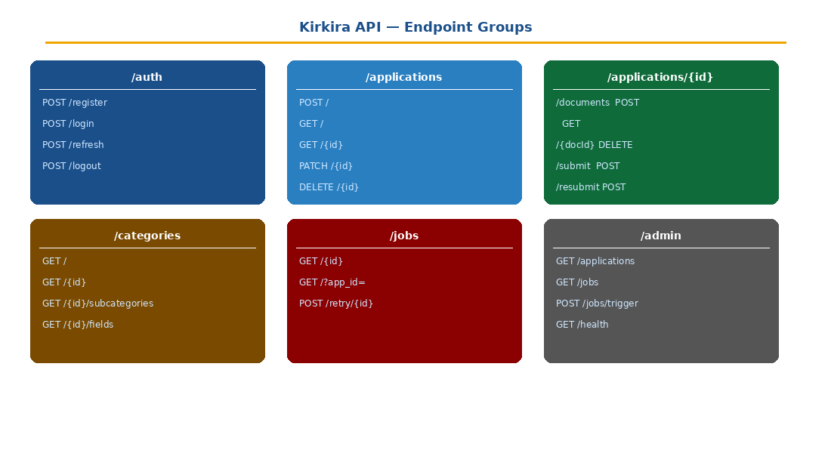
Figure 3: API endpoint groups and routes

5.1 Authentication — /auth

POST /auth/register
Register a new Kirkira user account.
Request body:
{ "email": "string", "password": "string (min 8)", "full_name": "string", "account_type": "individual | corporate" }
Response 201:
{ "user_id": "uuid", "email": "string", "account_type": "string" }
Errors: 409 email already registered · 422 validation failure

POST /auth/login
Authenticate and receive tokens.
Request body:
{ "email": "string", "password": "string" }
Response 200:
{ "access_token": "string (JWT, 15 min)", "refresh_token": "string (opaque, 30 days)", "token_type": "bearer" }
Errors: 401 invalid credentials · 429 rate limited (5 attempts / 15 min per IP)

POST /auth/refresh
Exchange a refresh token for a new access token.
Request: { "refresh_token": "string" }
Response 200: { "access_token": "string", "token_type": "bearer" }

POST /auth/logout
Revoke the current refresh token. Requires Bearer auth.
Response 204: No content

5.2 Applications — /applications

POST /applications
Create a new application (wizard step 1). Sets status = draft.
Request body:
{ "description": "string", "category_id": "string?", "subcategory_id": "string?" }
Behaviour: if category_id/subcategory_id are omitted, system triggers LLM classification job asynchronously. Returns immediately with a draft application; the LLM suggestion arrives via GET /applications/{id}.
Response 201:
{ "id": "uuid", "status": "draft", "wizard_step": 1, "llm_suggestion": null | { category_id, subcategory_id, confidence, explanation } }

GET /applications
List all applications for the authenticated user, paginated.
Query params: status (filter), page (default 1), page_size (default 20, max 100)
Response 200:
{ "items": [ApplicationSummary], "total": int, "page": int, "page_size": int }

GET /applications/{id}
Fetch a full application record including documents and latest job status.
Response 200: full Application object (see data model §4.2). Includes documents[] and latest_job{}.

PATCH /applications/{id}
Update application fields. Allowed in draft status only (or in rejected status when editing for resubmission). Uses JSON Merge Patch semantics.
Patchable fields: title, description, year_of_creation, country_of_origin, language, is_published, first_publication_date, first_publication_country, is_commissioned, commissioner_name, category_id, subcategory_id, owners, work_metadata, wizard_step, applicant_snapshot
Response 200: updated Application object
Errors: 409 if status not in (draft, rejected)

POST /applications/{id}/documents
Initiate a document upload. Returns a presigned S3 PUT URL. The frontend uploads directly to S3. The API verifies the upload via webhook or polling.
Request body:
{ "document_type": "work_file | id_document | declaration | supporting", "filename": "string", "mime_type": "string", "size_bytes": int }
Response 200:
{ "document_id": "uuid", "upload_url": "string (presigned PUT, 15 min TTL)", "fields": {} }

POST /applications/{id}/documents/{doc_id}/confirm
Called by the frontend after a successful S3 upload to mark the document as verified.
Response 200: { "document_id": "uuid", "is_verified": true }

DELETE /applications/{id}/documents/{doc_id}
Delete a document. Only allowed while application is in draft status.
Response 204: No content

POST /applications/{id}/submit
Transition application from draft → ready_for_filing and queue the initial filing job. Triggers full validation before accepting.
Validation checks before queuing:
- All required common fields present and non-empty
- All required common documents uploaded and verified
- All required category/subcategory-specific fields present
- All required category-specific documents uploaded and verified
- applicant_snapshot populated
Response 200:
{ "application_id": "uuid", "status": "ready_for_filing", "job_id": "uuid" }
Errors: 422 with field-level validation errors · 409 if status not draft

POST /applications/{id}/resubmit
Queue a resubmission job for a rejected application.
Response 200: { "application_id": "uuid", "status": "ready_for_filing", "job_id": "uuid" }
Errors: 409 if status not rejected

5.3 Categories — /categories
All endpoints are PUBLIC (no auth required).

Method + Path | Description | Response
GET /categories | List all top-level categories | [{id, label, description, subcategory_count}]
GET /categories/{id} | Full category detail | {id, label, act_reference, protection_duration, subcategories[]}
GET /categories/{id}/subcategories | List subcategories for a category | [{id, label, examples[]}]
GET /categories/{id}/subcategories/{sub_id}/fields | Fields + documents for a subcategory | {common_fields[], specific_fields[], common_docs[], specific_docs[]}

5.4 LLM Classification — /classify

POST /classify
Trigger an on-demand LLM classification. Returns immediately with a job_id; poll via GET /classify/{job_id}.
Request body:
{ "description": "string", "application_id": "uuid?" }
Response 202:
{ "job_id": "uuid" }

GET /classify/{job_id}
Poll classification result.
Response 200:
{ "status": "pending | complete | failed", "result": { "category_id": "string", "subcategory_id": "string", "confidence": 0.0–1.0, "explanation": "string" } | null }

5.5 Filing Jobs — /jobs
Method + Path | Description | Notes
GET /jobs/{id} | Get job status and logs | Returns status, attempts, last_error, screenshot_keys
GET /jobs | List jobs for an application (?app_id=uuid) | Paginated
POST /jobs/{id}/retry | Manually retry a failed job | Only for jobs with status=failed; admin or system

5.6 Internal Endpoints — /internal
Note | These endpoints are not exposed to the public internet. They are called only by the Playwright Worker container over the internal Docker network. Authenticated via a shared INTERNAL_API_SECRET header.

Method + Path | Called By | Purpose
POST /internal/jobs/{id}/result | Playwright Worker | Report job outcome: kecobo_reference, new status, screenshot keys, rejection reason
POST /internal/jobs/{id}/progress | Playwright Worker | Send intermediate progress updates (step name, screenshot)

6. Application State Machine
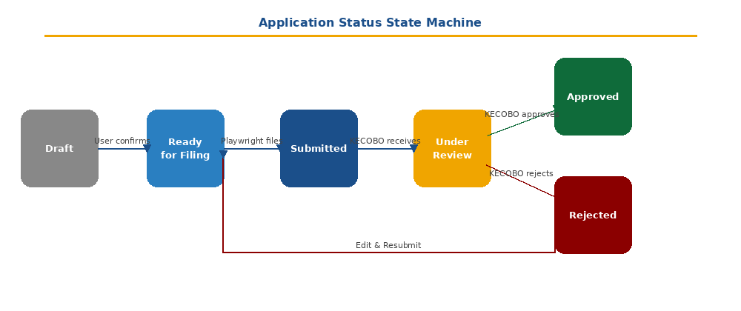
Figure 4: Status transitions and triggers

From Status | To Status | Trigger | Actor
(none) | draft | POST /applications | User
draft | ready_for_filing | POST /applications/{id}/submit (validation passes) | User
ready_for_filing | submitted | Playwright Worker: filing confirmed on KECOBO portal | System
submitted | under_review | Nightly sync: KECOBO status read as 'Under Review' | System
under_review | approved | Nightly sync: KECOBO status read as 'Approved' | System
under_review | rejected | Nightly sync: KECOBO status read as 'Rejected' | System
submitted | rejected | Nightly sync: rare — immediate rejection | System
rejected | ready_for_filing | POST /applications/{id}/resubmit | User
any | draft | Never — once past draft, status only moves forward or back to draft on explicit admin action | Admin only

Rule | Status can never be set directly by the frontend. All status transitions are made server-side by the API or Playwright Worker and are recorded in the audit_log.

7. LLM Classification Module

7.1 Model & Parameters
Parameter | Value
Model | claude-sonnet-4-20250514
Max tokens | 512
Temperature | 0 (deterministic)
Output format | JSON only — system prompt enforces structured JSON response

7.2 System Prompt Template
The system prompt is constructed server-side and never exposed to the client. It includes:
- Instruction to respond only in valid JSON with no preamble
- The complete list of category IDs and labels from the schema
- Three few-shot examples (one per common work type) to anchor classification
- A confidence rubric: 1.0 = obvious match, 0.7–0.9 = good match, below 0.6 = uncertain

System prompt skeleton:
You are a copyright classification assistant for the Kenya Copyright Board (KECOBO).
Your task: classify the work described by the user into exactly one of the following categories
and subcategories from the KECOBO schema. Respond ONLY with valid JSON. No preamble.

Categories: [{ id, label, subcategories: [{ id, label, examples[] }] }]

Respond with: { "category_id": "...", "subcategory_id": "...", "confidence": 0.0–1.0, "explanation": "..." }

7.3 Confidence Threshold & Fallback
Confidence | Behaviour
≥ 0.80 | Show suggestion as default selection. User can override.
0.60 – 0.79 | Show suggestion with warning: "We think this is the right category — please confirm."
< 0.60 | Do not pre-select. Show message: "We could not determine the category — please select manually." Log for review.

7.4 Error Handling
- If the LLM call fails (network error, 5xx, invalid JSON response), the job is retried up to 2 times with exponential backoff
- After 3 failures, the application is left in draft with llm_suggestion = null and the wizard prompts the user to select manually
- All LLM calls are logged with: prompt hash, token usage, latency, and confidence score

8. Document Storage

8.1 Upload Flow
Direct-to-S3 upload using presigned URLs. The API server never proxies file bytes.

Step | Actor | Action
1 | Frontend | POST /applications/{id}/documents with filename, mime_type, size_bytes
2 | API | Validate file type and size. Insert document record (is_verified=false). Generate presigned PUT URL (15 min TTL). Return document_id + upload_url.
3 | Frontend | PUT the file bytes directly to the presigned S3 URL.
4 | Frontend | POST /applications/{id}/documents/{doc_id}/confirm
5 | API | HEAD request to S3 to verify object exists and size matches. Set is_verified=true.

8.2 S3 Key Structure
documents/{user_id}/{application_id}/{document_type}/{uuid}_{original_filename}

8.3 Validation Rules
Document Type | Accepted MIME Types | Max Size
work_file | application/pdf, audio/*, video/*, image/*, application/zip | 50 MB (500 MB for video)
id_document | image/jpeg, image/png, application/pdf | 5 MB
declaration | application/pdf | 5 MB
supporting | application/pdf, image/*, application/zip | 10 MB
certificate | application/pdf | 5 MB (system-generated only)

8.4 Retention & Deletion
- Documents are retained indefinitely for approved applications
- On application deletion (draft only), all S3 objects are deleted via a background ARQ task
- Temporary presigned PUT URLs expire after 15 minutes; unconfirmed documents are purged by a nightly cleanup job

9. Job Queue (ARQ)

9.1 Defined Job Types
Job Function | Queue | Triggered By | Max Attempts | Timeout
classify_work | default | POST /classify or POST /applications | 3 | 30s
dispatch_filing_job | filing | POST /applications/{id}/submit | 1 | 10s (dispatches only; actual filing is Playwright)
verify_document | default | POST /documents/{id}/confirm | 3 | 15s
nightly_status_sync | scheduler | Cron (ARQ scheduler, nightly) | 1 | 2h
cleanup_unverified_docs | scheduler | Cron (daily, 03:00 UTC) | 1 | 30m

9.2 Filing Job Dispatch
dispatch_filing_job does not execute the filing directly. It:
- Validates the application is in ready_for_filing status
- Serialises the full application payload (all fields + document presigned GET URLs) into a JSON job envelope
- Pushes the envelope to a Redis list key: kecobo:filing:queue
- The Playwright Worker polls this queue and executes the browser automation

9.3 Retry Policy
Attempt | Delay Before Retry
1st retry | 30 seconds
2nd retry | 5 minutes
3rd retry | 30 minutes
After 3rd failure | Job status → failed; application status unchanged; alert sent to ops channel

10. Playwright Automation Worker

10.1 Worker Architecture
The Playwright Worker is a separate Node.js container. It does not share a codebase with the Python API. Communication is:
- Inbound: polls Redis list kecobo:filing:queue for filing jobs
- Outbound: calls POST /internal/jobs/{id}/result to report outcomes
- File access: receives presigned S3 GET URLs in the job envelope; downloads files at runtime

10.2 Filing Job Contract
Job envelope pushed to Redis by dispatch_filing_job:
{ "job_id": "uuid",
"application_id": "uuid",
"job_type": "initial_filing | resubmission",
"category_id": "LIT",
"subcategory_id": "LIT-BOOK",
"fields": { ...all common + specific fields },
"owners": [ { name, address, share, role } ],
"applicant": { ...snapshot fields },
"documents": [
{ "type": "work_file", "download_url": "presigned-s3-url", "filename": "...", "mime_type": "..." },
...
]
}

10.3 Filing Script Behaviour
The Playwright script follows these steps for an initial_filing job:

Step | Action | On Error
1 | Launch Chromium (headless: true in prod) | Abort job — report fatal
2 | Navigate to nrr.copyright.go.ke and authenticate | Retry up to 3x; report auth_failure
3 | Click 'Register New Copyright' | Screenshot + retry
4 | Select category and subcategory from dropdowns | Screenshot + abort if element not found
5 | Fill all form fields from job envelope | Screenshot + report field_error
6 | Download each document from presigned URL; upload via file input | Screenshot + abort
7 | Review summary page and take confirmation screenshot | Continue
8 | Click Submit (or pause for human review if HUMAN_REVIEW_REQUIRED=true)
9 | Capture confirmation page; extract KECOBO reference number via regex | Report reference_not_found
10 | POST /internal/jobs/{id}/result with outcome

10.4 Result Payload (POST /internal/jobs/{id}/result)
{ "outcome": "success | failure",
"kecobo_reference": "NRR-XXXX-XXXX | null",
"new_application_status": "submitted | failed",
"rejection_reason": "string | null",
"screenshot_keys": ["s3://..."],
"error_detail": "string | null"
}

10.5 Nightly Status Sync Script
Triggered by the ARQ scheduler (nightly_status_sync job) which pushes a sync envelope to Redis list kecobo:sync:queue. The Playwright Worker processes it sequentially for all active applications.

Step | Action
1 | Authenticate with KECOBO/NRR portal
2 | For each application in the sync batch: navigate to 'My Copyrights' or search by KECOBO reference
3 | Read displayed status (Approved / Rejected / Pending / Under Review)
4 | If Approved: download certificate PDF; upload to S3; create document record of type 'certificate'; set application status = approved
5 | If Rejected: capture rejection reason text; set application status = rejected; store rejection_reason
6 | POST /internal/jobs/{id}/result for each application processed
7 | Update kecobo_last_checked_at timestamp on each application

Rate Limiting | The nightly sync script introduces a 2-second delay between each application check to avoid triggering bot detection on the KECOBO portal. The batch is processed sequentially, not in parallel.

11. Validation Rules

11.1 Submission Validation
POST /applications/{id}/submit runs a full validation pass. The API returns 422 with a structured error array if any check fails. Each error includes: field, message, code.

Check | Error Code | Message
title empty | FIELD_REQUIRED | Title is required
year_of_creation in future | FIELD_INVALID | Year of creation cannot be in the future
year_of_creation < 1900 | FIELD_INVALID | Year of creation must be 1900 or later
category_id not in schema | INVALID_CATEGORY | Selected category is not valid
subcategory_id not in schema | INVALID_SUBCATEGORY | Selected subcategory is not valid for this category
required specific field missing | FIELD_REQUIRED | Field '{field_label}' is required for this work type
work_file not verified | DOCUMENT_REQUIRED | A copy of the work must be uploaded
id_document not verified | DOCUMENT_REQUIRED | An ID document or passport must be uploaded
declaration not verified | DOCUMENT_REQUIRED | A signed declaration must be uploaded
required specific doc missing | DOCUMENT_REQUIRED | Document '{doc_label}' is required for this work type
applicant_snapshot empty | PROFILE_INCOMPLETE | Applicant profile must be confirmed before submission

11.2 File Upload Validation
Validated at POST /applications/{id}/documents:
- MIME type must be in the allowed list for the document_type (see §8.3)
- size_bytes must not exceed the maximum for the document_type
- Maximum 10 documents per application (excluding certificates)
- Duplicate document_type: replacing an existing document is allowed (old S3 object scheduled for deletion)

12. Authentication & Security

12.1 JWT Configuration
Parameter | Value
Algorithm | RS256 (asymmetric — private key signs, public key verifies)
Access token TTL | 15 minutes
Refresh token TTL | 30 days (rolling)
Refresh token store | Redis (hashed token → user_id; revoked on logout)
Claims | sub (user_id), email, account_type, iat, exp

12.2 Rate Limiting
Endpoint | Limit | Window
POST /auth/login | 5 attempts per IP | 15 minutes
POST /auth/register | 10 registrations per IP | 1 hour
POST /classify | 20 calls per user | 1 hour
POST /applications | 50 per user | 24 hours
All other endpoints | 200 requests per user | 1 minute

12.3 Authorization Rules
- A user may only access applications where user_id = their own user_id
- The /internal/* namespace is only accessible from the internal Docker network (enforced at nginx/ingress level) and requires INTERNAL_API_SECRET header
- Admin endpoints (/admin/*) require account_type = 'admin' claim in the JWT
- All S3 presigned GET URLs for documents are short-lived (1 hour) and scoped to the specific object

12.4 KECOBO Credentials
- The KECOBO/NRR portal credentials used by the Playwright Worker are stored as Docker secrets / environment variables, never in the database or codebase
- Environment variables: KECOBO_USERNAME, KECOBO_PASSWORD, KECOBO_LOGIN_URL
- If KECOBO implements MFA in future, the Playwright Worker pauses and sends an alert to the ops channel

13. Error Handling & Observability

13.1 API Error Response Format
All errors return a consistent JSON envelope:
{ "error": { "code": "ERROR_CODE", "message": "Human-readable message",
"details": [ { "field": "...", "message": "...", "code": "..." } ] } }

13.2 HTTP Status Codes
Status | Meaning | When Used
200 | OK | Successful GET / PATCH
201 | Created | Successful POST creating a new resource
202 | Accepted | Job queued; result available later
204 | No Content | Successful DELETE or logout
400 | Bad Request | Malformed request body
401 | Unauthorised | Missing or invalid token
403 | Forbidden | Valid token but insufficient permission
404 | Not Found | Resource does not exist or user does not own it
409 | Conflict | State conflict (e.g. submitting a non-draft application)
422 | Unprocessable Entity | Validation failure with field-level errors
429 | Too Many Requests | Rate limit exceeded
500 | Internal Server Error | Unexpected server failure

13.3 Logging
- Structured JSON logs on stdout (compatible with Grafana Loki / CloudWatch)
- Every request logged with: request_id (UUID), user_id, method, path, status, latency_ms
- All state transitions logged with old_status and new_status
- Playwright Worker logs each step with: job_id, step_name, success (bool), screenshot_key, latency_ms

13.4 Alerting
Condition | Alert Target | Severity
Filing job fails after max retries | Ops Slack channel | P1
Nightly sync fails to complete | Ops Slack channel | P1
KECOBO authentication failure in Playwright | Ops Slack channel | P1
API error rate > 5% over 5 minutes | PagerDuty | P2
LLM classification confidence < 0.60 (frequent) | Ops Slack | P3
Unverified documents > 100 (cleanup backlog) | Ops Slack | P3

14. Environment Configuration

14.1 Environment Variables
Variable | Service | Description
DATABASE_URL | API | PostgreSQL connection string (asyncpg driver)
REDIS_URL | API + ARQ | Redis connection string
JWT_PRIVATE_KEY | API | RS256 private key (PEM) for signing tokens
JWT_PUBLIC_KEY | API | RS256 public key (PEM) for verifying tokens
S3_BUCKET | API | S3 bucket name for document storage
S3_ENDPOINT_URL | API | S3 endpoint (blank for AWS; set for MinIO)
AWS_ACCESS_KEY_ID | API | S3 credentials
AWS_SECRET_ACCESS_KEY | API | S3 credentials
ANTHROPIC_API_KEY | API / ARQ | API key for LLM classification calls
LLM_CONFIDENCE_THRESHOLD | API | Float 0–1; below this, show manual selection (default: 0.60)
KECOBO_USERNAME | Playwright | NRR portal login username
KECOBO_PASSWORD | Playwright | NRR portal login password
KECOBO_LOGIN_URL | Playwright | NRR portal URL (default: https://nrr.copyright.go.ke)
HUMAN_REVIEW_REQUIRED | Playwright | 'true' to pause before final KECOBO submit (default: false)
INTERNAL_API_SECRET | Playwright | Shared secret for /internal/* endpoints
INTERNAL_API_BASE_URL | Playwright | Base URL of the Kirkira API (internal Docker hostname)
SENTRY_DSN | API + ARQ | Sentry error tracking DSN
LOG_LEVEL | All | 'DEBUG' | 'INFO' | 'WARNING' | 'ERROR'

14.2 Environments
Environment | Purpose | HUMAN_REVIEW_REQUIRED | Playwright Headless
local | Developer workstation (Docker Compose) | true | false (visible browser)
staging | Integration testing | true | true
production | Live system | false | true

14.3 Docker Compose Services
Service | Image | Ports
api | kirkira/api:latest | 8000 (internal)
arq_worker | kirkira/api:latest | — (worker mode)
playwright_worker | kirkira/playwright:latest | — (polling only)
postgres | postgres:15-alpine | 5432 (internal)
redis | redis:7-alpine | 6379 (internal)
minio | minio/minio | 9000/9001 (local only)
nginx | nginx:alpine | 80, 443 (public)

15. Implementation Sequence
Recommended build order for the development team. Each phase should be completed and code-reviewed before the next begins.

Phase | Deliverable | Dependencies | Estimated Effort
1 | DB schema + migrations (Alembic) | None | 3 days
2 | Auth module: register, login, refresh, logout | Phase 1 | 3 days
3 | Category schema API (/categories/*) | Phase 1 | 2 days
4 | Application CRUD + validation layer | Phases 1–3 | 5 days
5 | Document upload flow (presigned S3 + confirm) | Phase 4 | 3 days
6 | LLM classification job (ARQ + Anthropic API) | Phases 2,4 | 3 days
7 | Application submit + state machine | Phases 4–6 | 3 days
8 | Playwright filing script (Literary MVP) | Phase 7 | 5 days
9 | Internal result endpoint + status sync | Phase 8 | 2 days
10 | Nightly sync scheduler + cron job | Phase 9 | 3 days
11 | Resubmission flow | Phases 8–10 | 2 days
12 | Playwright generalisation (all categories) | Phase 8 | 5 days
13 | Monitoring: Sentry, Prometheus, alerting | All phases | 2 days

16. Testing Strategy
Test Type | Tool | Scope | Coverage Target
Unit | pytest | Models, validators, LLM response parsing, state machine transitions | ≥ 85%
Integration | pytest + httpx + TestClient | API endpoints, DB interactions, ARQ job dispatch | ≥ 80% of endpoints
E2E — API | pytest + real DB + S3 | Full application lifecycle: create → submit → result | Critical paths 100%
E2E — Playwright | Playwright test runner | Filing script against KECOBO staging or mock portal | Literary category 100%
Contract | pydantic + JSON Schema | Validate all API responses against OpenAPI spec | 100% of endpoints
Load | Locust / k6 | API under concurrent load; job queue throughput | 50 concurrent users

Playwright Testing | The Playwright worker should be testable against a mock KECOBO portal (a lightweight HTML fixture served locally) for CI. A full integration test against the real NRR portal runs in staging only before each release.

17. Open Questions & Decisions Needed
# | Question | Owner | Status
1 | Does the KECOBO/NRR portal support multiple file uploads in one session, or must we upload and submit separately per document? | Engineering + QA | Open
2 | Will KECOBO introduce CAPTCHA or bot detection that would block Playwright? What is the fallback? | Engineering | Open
3 | Should the declaration form be auto-generated as a PDF from a Kirkira template, or must the user always upload a manually signed copy? | Product | Open
4 | Is the KECOBO reference number always visible on the post-submission confirmation page, or do we need to scrape the 'My Copyrights' list? | QA | Open
5 | What is the SLA for certificate issuance by KECOBO (currently quoted as 5–7 business days)? Should we alert the user if this window is exceeded? | Product | Open
6 | Are KECOBO registration fees paid directly on the NRR portal, or invoiced separately? Can Playwright handle payment flows? | Product + Engineering | Open
7 | Will Kirkira need to support multiple KECOBO account credentials (e.g. per-client institutional accounts), or always one shared Kirkira account? | Product | Open

