Project Report On

Design and Development of a Personal Finance Management System for Tracking Income, Expenses, Budget Planning, Savings Goals, and Investment Management

SUB: - Professional Skills (FSD)
Sem-V

Submitted in partial fulfilment of the requirements of the degree of
BACHELOR OF ENGINEERING
In
INFORMATION TECHNOLOGY
(A.Y. 2026-2027)

BY

31.Bhumika Gothankar
39.Utsavi Gurjar
52. Ananya Kanchan
55.Muskaan Kapri

Under the guidance of
Mrs. Apeksha Waghmare
Assistant Professor, I.T Department, TCET

Choice Based Credit Grading System with Holistic & Multidisciplinary Education
(CBSGS-HME 2023)

CERTIFICATE

This is to certify Utsavi Gurjar, Muskaan Kapri , Bhumika Gothankar and Ananya Kanchan are Bonafide students of INFORMATION TECHNOLOGY department, Thakur College of Engineering and Technology, Mumbai. They have satisfactorily completed the requirements of the Innovative Examination (IE) report Titled: " PERSONAL FINANCE MANAGEMENT SYSTEM " for the subject of NoSQL during the Academic Year 2025–26. This report represents their original work and has been prepared under the guidance and supervision of the undersigned.

Signature: |  | Signature:
Name: Mrs. Apeksha Waghmare |  | Name: Dr. Rajesh Bansode
Assistant Professor |  | HOD-IT
Date: |  | Date:
Place: |  | Place:

Declaration

We hereby declare that the project titled “Personal Finance Management System” has been developed as part of our academic project work. The project aims to develop a system for managing personal finances, including accounts, income, expenses, budgets, savings goals, and investments.
The project focuses on designing a structured database to store and manage financial information efficiently. The database includes entities such as User, Accounts, Transaction, Categories, Budget, Goals, Investment, Rewards, Reminder, and RiskProfile, connected through appropriate relationships.
We declare that the work presented in this project has been carried out by us as part of the given project requirements and has been completed under the guidance of our faculty.
Utsavi Gurjar
Bhumika Gothankar
Muskaan Kapri
Ananya Kanchan

Acknowledgement

I would like to express my sincere gratitude to our project guide and faculty members for their valuable guidance, support, and encouragement throughout the development of our project, “Personal Finance Management System.”
I am thankful to our college for providing the necessary resources and opportunity to work on this project. This project helped me gain knowledge about database design, entity-relationship diagrams, and the development of a finance management application.
Finally, I would like to thank everyone who directly or indirectly supported me in completing this project successfully.

Utsavi Gurjar
Bhumika Gothankar
Muskaan Kapri
Ananya Kanchan

INDEX

- Abstract
- Introduction
- Project Description
- Results and Discussions
- Conclusion and Future Scope
- References
- Annexure (Source Code)
- PowerPoint Presentation

Personal Finance Management System
1. Abstract
The Personal Finance Management System is a web-based application designed to help users manage their personal finances efficiently. It allows users to maintain their financial accounts, record income and expenses, create budgets, track savings goals, manage investments, and receive reminders for important financial activities.
The system stores financial information in a structured relational database. The database consists of entities such as User, Accounts, Transaction, Categories, Budget, Goals, Investment, Rewards, Reminder, and RiskProfile. These entities are connected through primary keys and foreign keys to maintain data consistency and relationships.
The main objective of this project is to provide users with a convenient way to monitor their financial activities, control spending, plan savings, and make better financial decisions. The system can be developed using a suitable frontend, backend, and relational database.
2. Introduction
Managing personal finances is an important part of everyday life. People need to keep track of their income, expenses, savings, budgets, and investments. Managing these activities manually using notebooks or spreadsheets can be time-consuming and may lead to errors.
The Personal Finance Management System aims to simplify this process by bringing important financial activities together in one application. Users can record transactions, organize expenses into categories, set budget limits, and monitor progress toward their financial goals.
The system also includes features for investment tracking, rewards management, reminders, and financial risk profiling. Its database design supports the organized storage and retrieval of user information.
Objectives
- To maintain user information securely.
- To record and manage income and expenses.
- To organize transactions using financial categories.
- To create budgets and monitor spending limits.
- To set savings goals and track progress.
- To maintain investment details and current values.
- To manage rewards and important financial reminders.
- To provide a structured database for financial information.
Problem statement
Traditional methods of managing personal finances can make it difficult to monitor spending, compare expenses against budgets, and track long-term savings goals. Therefore, a centralized system is needed to organize financial information and help users make informed financial decisions.
3. Project Description
3.1 Overview
The Personal Finance Management System is designed to help users store and manage their financial information through a centralized application. The system uses a relational database in which different tables are connected using primary keys (PK) and foreign keys (FK).
The ER diagram provided represents the database structure of the project.

3.2 Modules of the system
Module | Description
User | Stores user details, email, password hash, currency preference, and creation date.
Accounts | Maintains account names, account types, and account balances.
Transaction | Stores financial transactions, including amount, type, date, user, account, and category.
Categories | Organizes financial activities into categories such as food, travel, salary, and shopping.
Budget | Stores spending limits, budget periods, and start and end dates.
Goals | Stores savings targets, current savings, target dates, and goal status.
Investment | Maintains investment types, amounts, maturity dates, and current values.
Rewards | Records rewards earned through eligible financial activities and their redemption status.
Reminder | Stores reminders for financial activities, due dates, and related records.
RiskProfile | Stores the user's risk score and risk profile type.
3.3 Database design
The database contains ten main entities. Each entity has a primary key to identify its records uniquely. Foreign keys establish relationships between related tables and help maintain data integrity.
For example:
- A user can have multiple accounts.
- An account can have multiple transactions.
- A category can be associated with multiple transactions.
- A user can create multiple budgets and savings goals.
- An investment can be associated with a savings goal.
- A user can have multiple reminders and rewards.
These relationships help organize financial data and reduce unnecessary duplication. Separating information into related tables is a standard relational database design practice.

3.4 Working of the system
1. User Registration and Login
User enters account credentials
2. Financial Data Entry
Accounts, income, expenses, and categories
3. Financial Management
Budgets, goals, investments, and rewards
4. Database Storage
Records stored in related database tables
5. Financial Overview
Balances, budget progress, and savings status
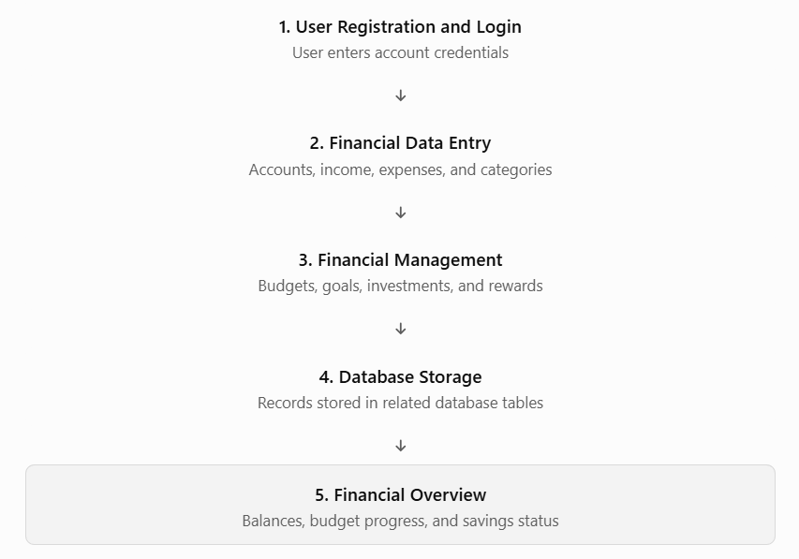

3.5 Technologies used
You can use the following table if these are the technologies used in your implementation. Change it if your actual stack differs.

Component | Suggested technology
Frontend | HTML, CSS, JavaScript or Angular
Backend | Java with Spring Boot
Database | PostgreSQL
Database management | pgAdmin
API testing | Postman
Development environment | Visual Studio Code or IntelliJ IDEA
3.6 Entity- Relationship Diagram
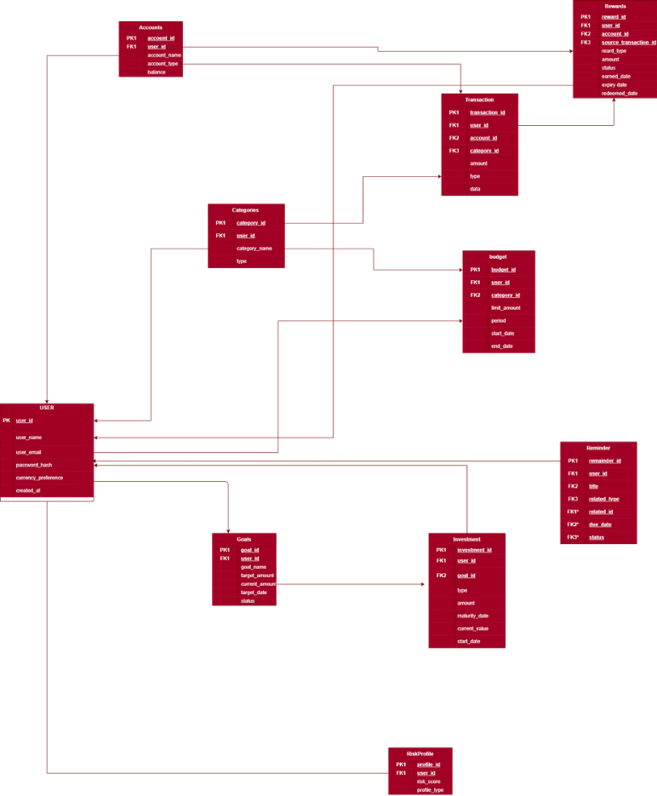

3.7 Advantages
- Centralized management of financial records.
- Easier tracking of income and expenses.
- Better budget planning and spending control.
- Organized monitoring of savings goals.
- Structured storage and retrieval of financial information.
- Scope for future reports, charts, and personalized financial insights.

Result and Discussion :
Database-
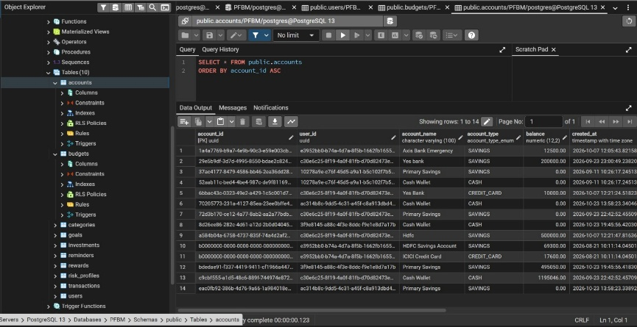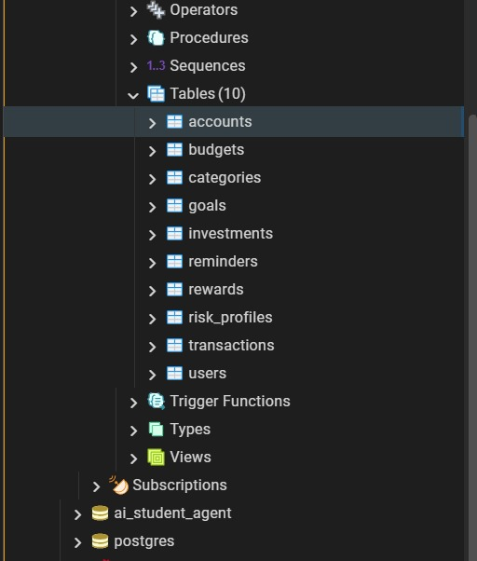

RestAPIs
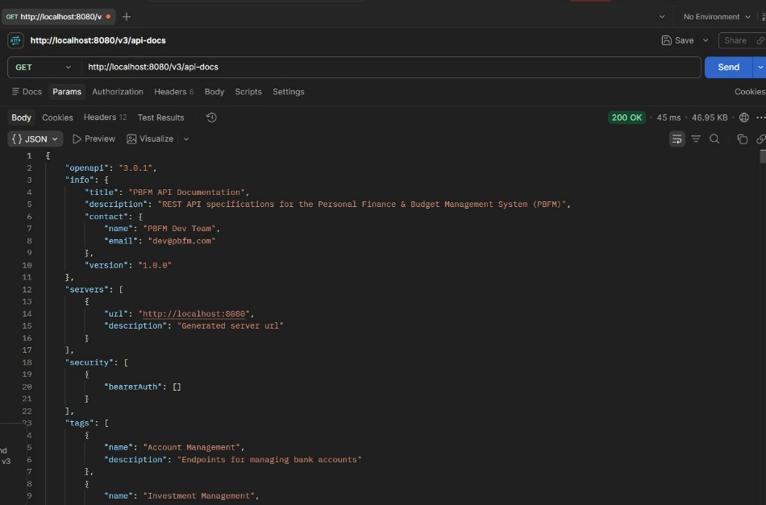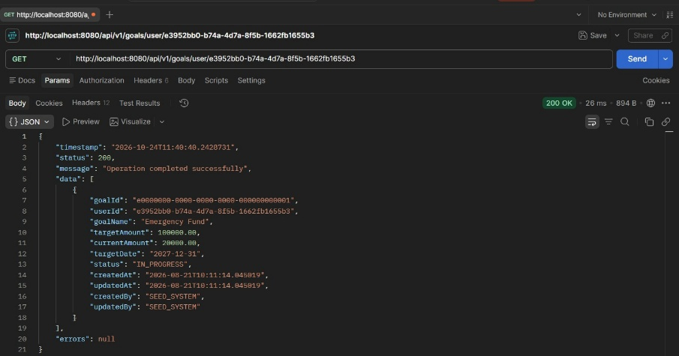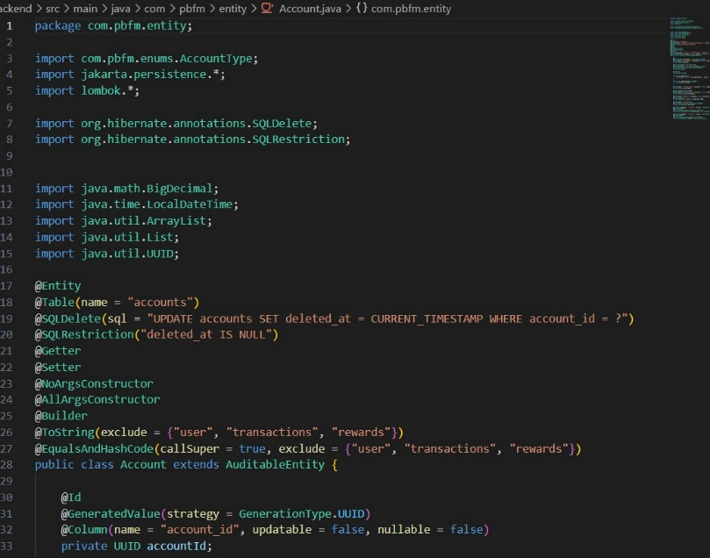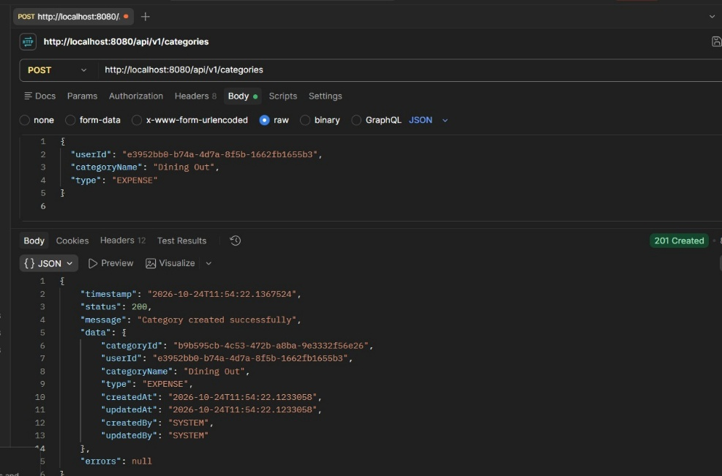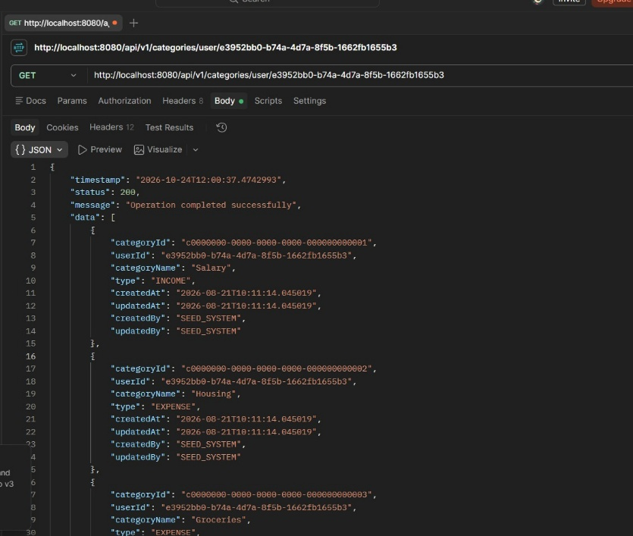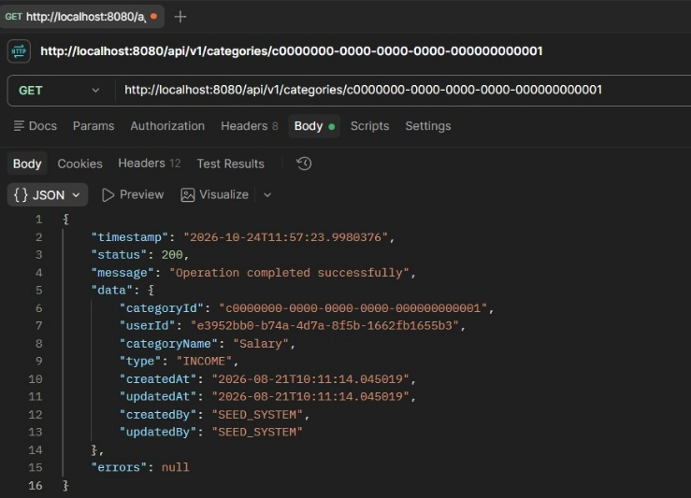
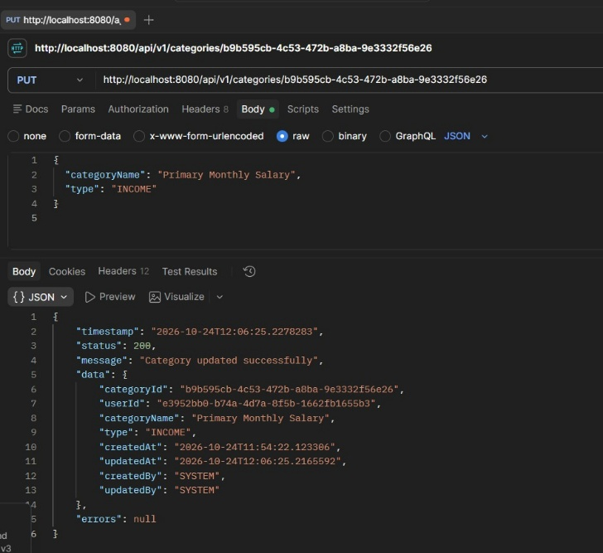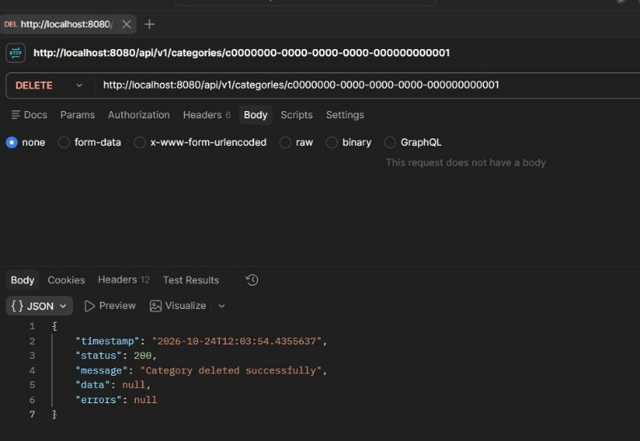

Logs and exceptional handling-
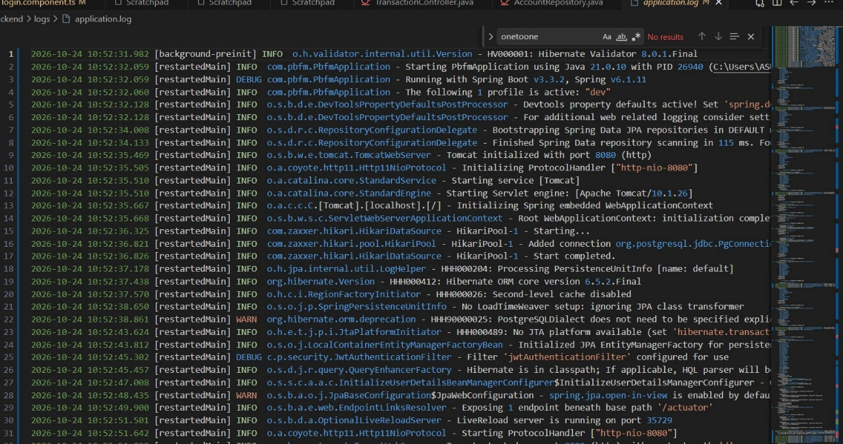
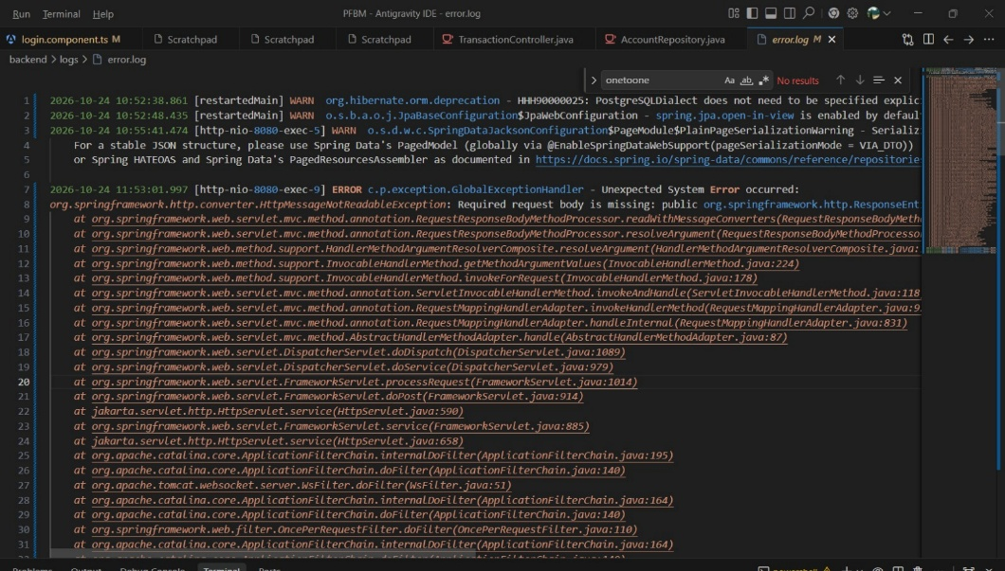
Swagger-
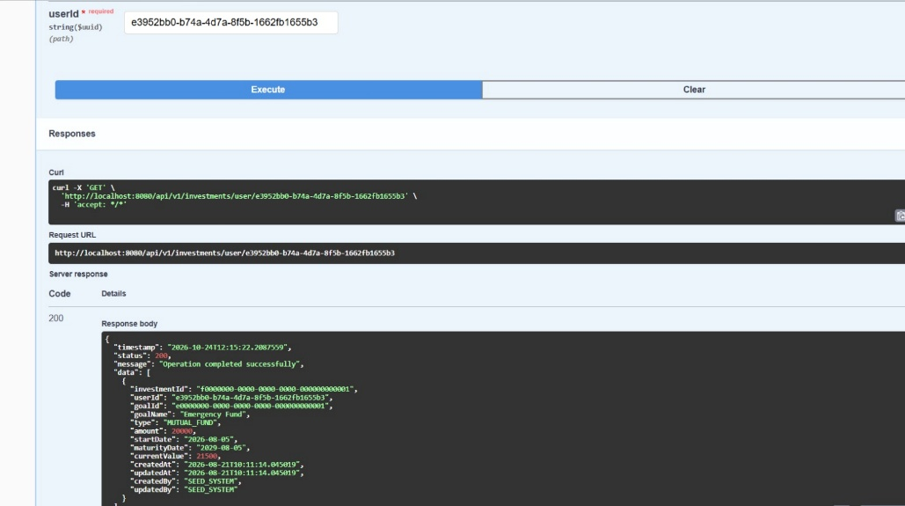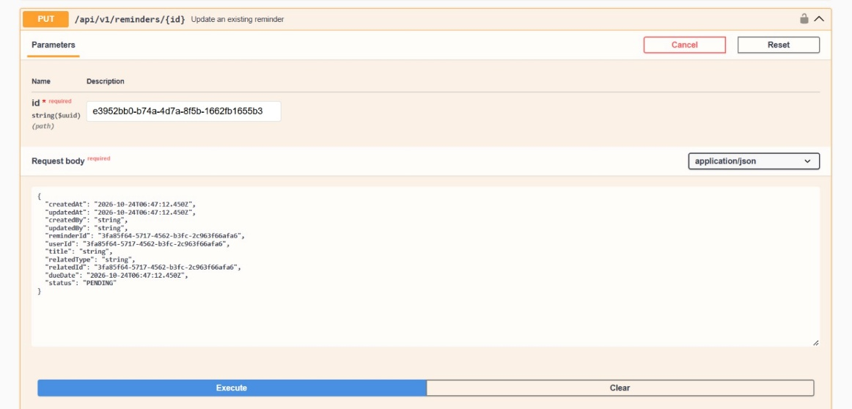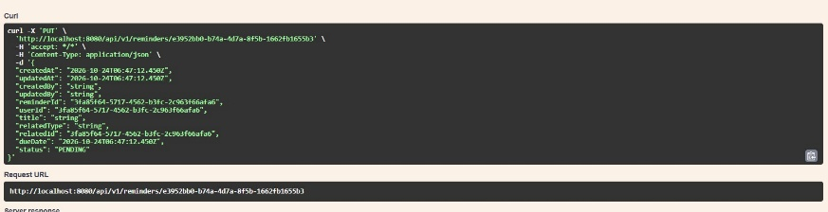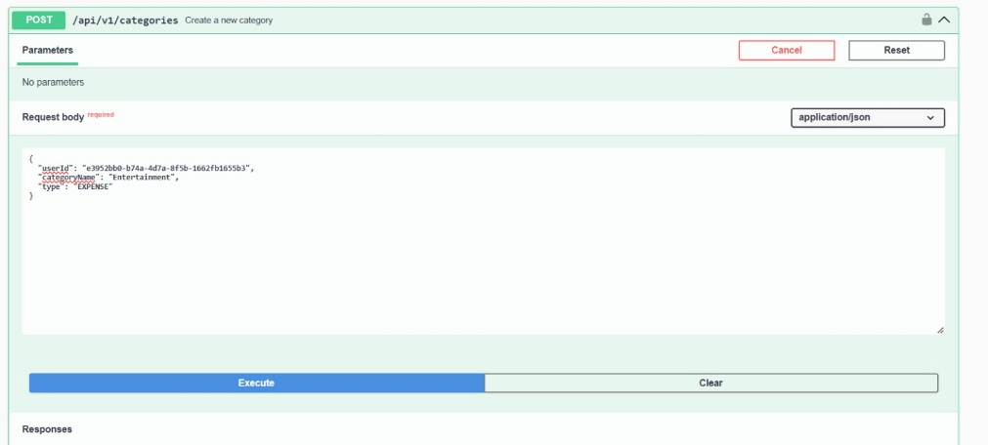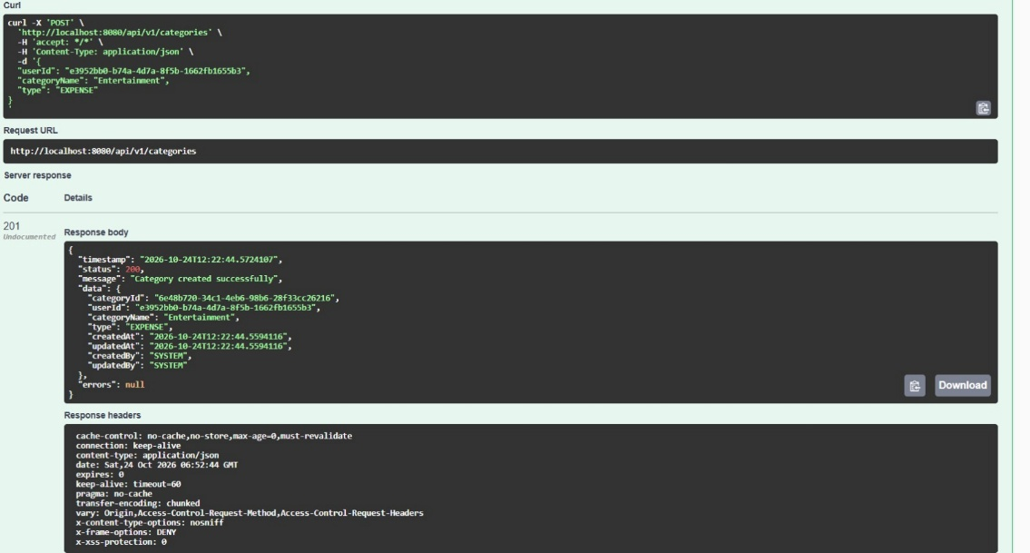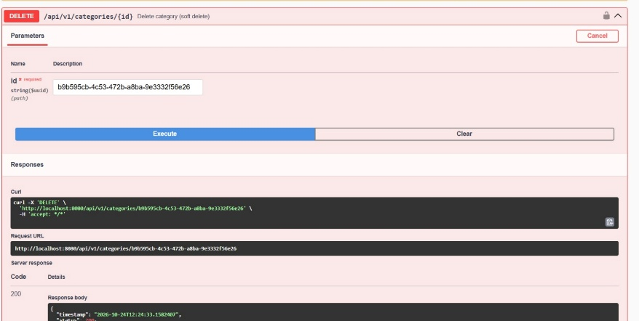
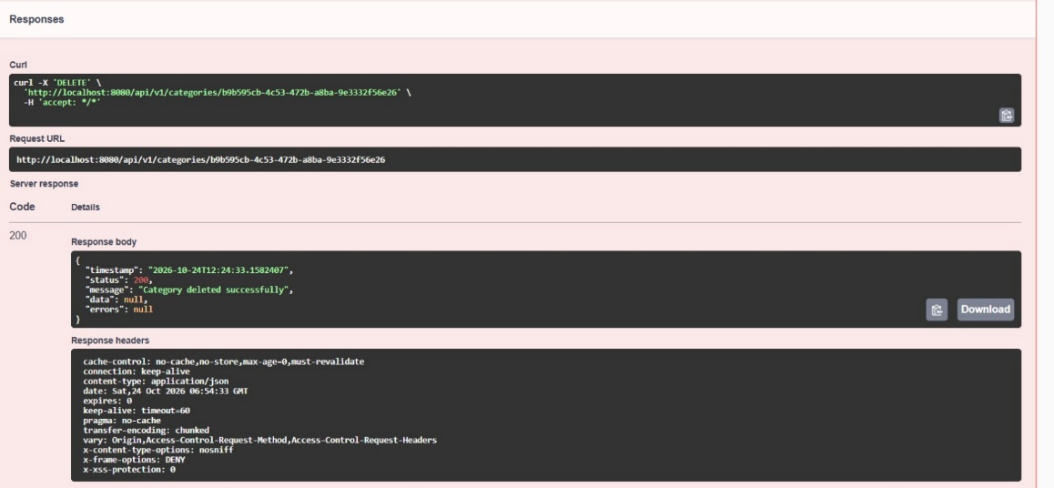
Pom.xml
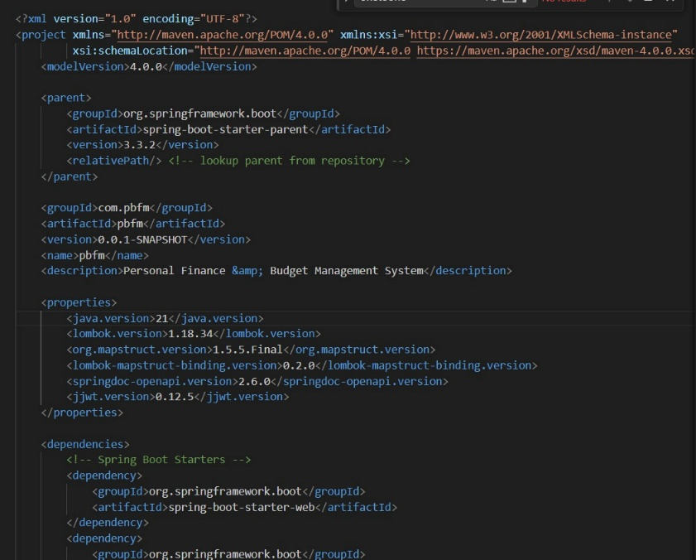

Localhost- Angular frontend-

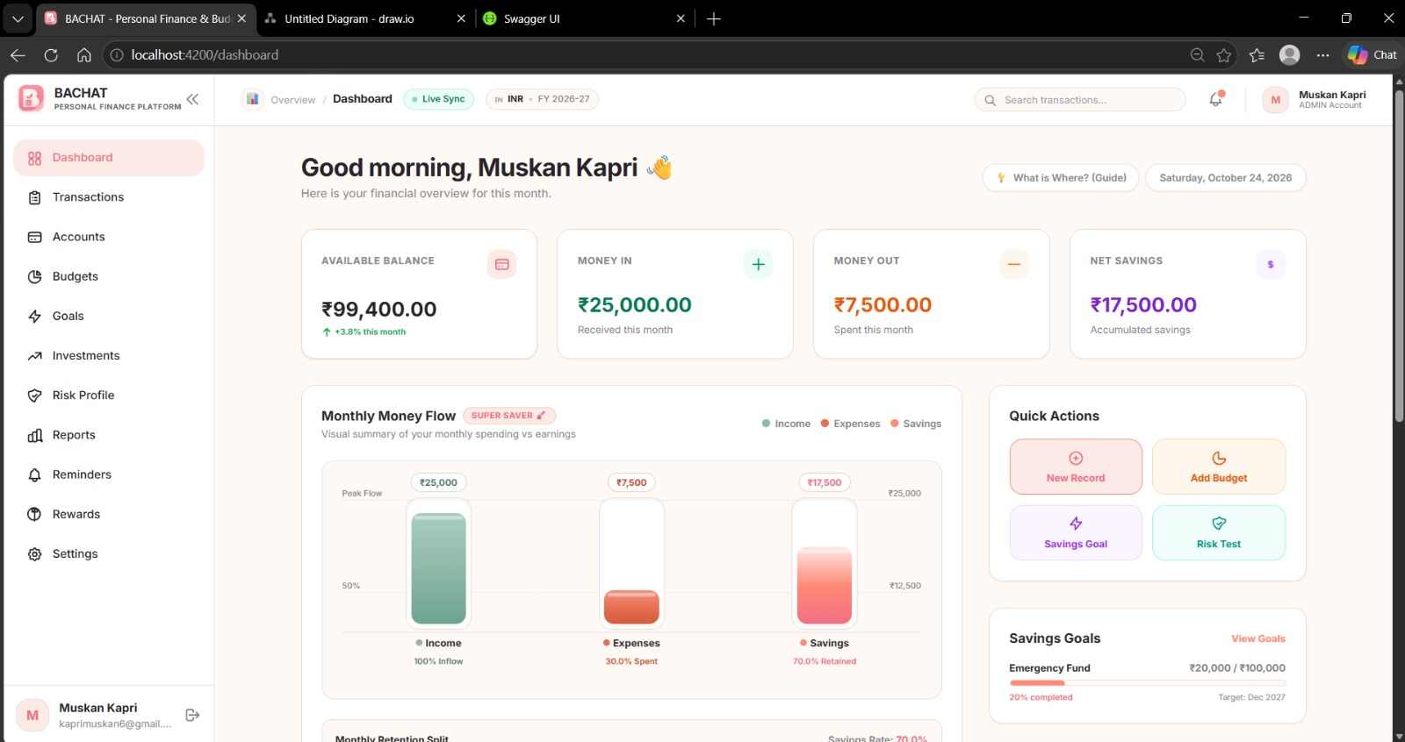

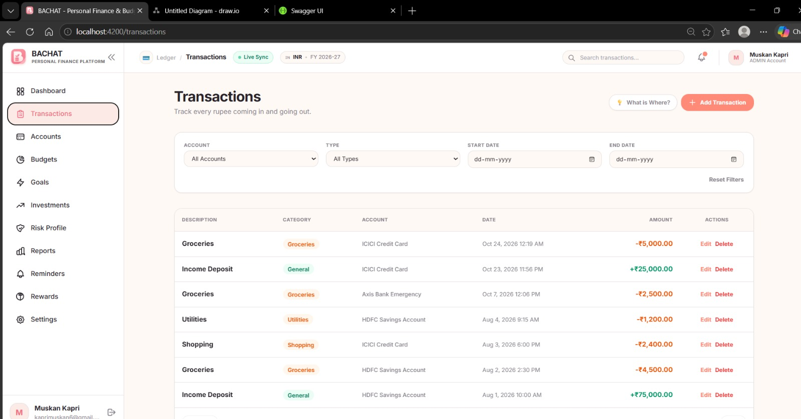
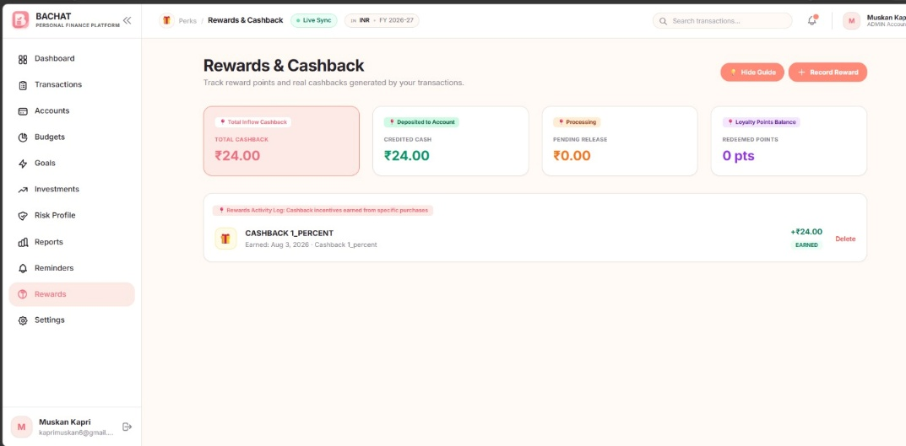

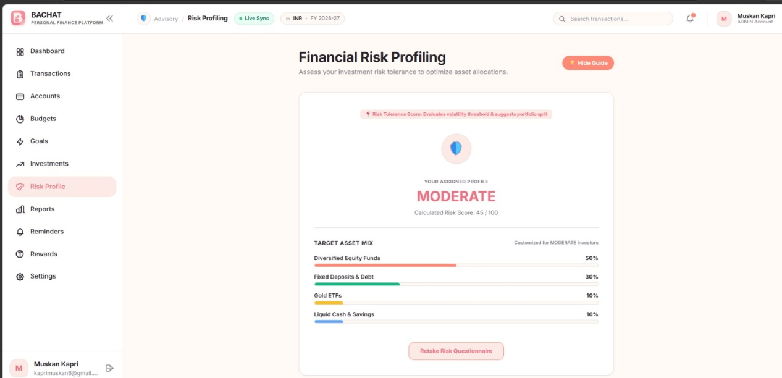

Conclusion and Future Scope
5.1 Conclusion
The Personal Finance Management System provides a structured approach to managing personal financial information. The project demonstrates the use of relational database concepts, including entities, attributes, primary keys, foreign keys, and relationships.
The database design covers major financial activities such as account management, transaction recording, budget planning, savings goals, investments, rewards, and reminders. By organizing these activities in one system, the application can help users understand their financial position and manage their money more effectively.
The project also provides practical experience in database design and application development. Its effectiveness in real-world use will depend on the successful implementation, testing, and security of the application.
5.2 Future scope
The system can be improved by adding the following features:
- Interactive dashboard: Visual charts for income, expenses, and monthly spending.
- Automated transaction import: Import financial records from supported files or services.
- Budget alerts: Notify users when spending approaches or exceeds a budget.
- Recurring reminders: Remind users about bills, payments, and savings contributions.
- Financial reports: Generate monthly, quarterly, and yearly summaries.
- Multi-currency support: Support multiple currencies and currency conversion.
- Enhanced security: Add secure authentication, access controls, and data encryption.
- Mobile application: Provide access through a mobile-friendly interface or dedicated app.
- Financial insights: Use historical spending patterns to offer budgeting suggestions.

6. References
1. Microsoft Support. Database Design Basics. Microsoft. Available at: https://support.microsoft.com/en-us/access/database-design-basics
2. PostgreSQL Global Development Group. PostgreSQL Documentation. PostgreSQL. Available at: https://www.postgresql.org/docs/
3. VMware, Inc. Spring Boot Reference Documentation. Spring. Available at: https://docs.spring.io/spring-boot/index.html
4. Google. Angular Documentation. Angular. Available at: https://angular.dev/
5. Postman, Inc. Postman Learning Center. Postman. Available at: https://learning.postman.com/
6. Spring. Spring Boot Reference Documentation. Available at: https://docs.spring.io/spring-boot/reference/
7. Angular. Angular Documentation: Developer Guide. Available at: https://angular.dev/
8. Postman. Postman Learning Center: API Testing and Development. Available at: https://learning.postman.com/

