IPL Data Analysis Report

# Problem Statement

The purpose of this project is to analyze Indian Premier League (IPL) data using Power BI. The analysis is focused on answering specific business questions related to team performance, player contributions, toss decisions, and match outcomes.

# Approach

The analysis was conducted entirely in Power BI. The workflow included:  
- Importing the IPL datasets (matches and deliveries).  
- Data cleaning and transformation using Power Query.  
- Building relationships between datasets for accurate calculations.  
- Creating DAX measures for KPIs such as runs, wickets, toss-win percentages, and match outcomes.  
- Designing interactive dashboards to answer the provided questions.

# Key Insights from Dashboard

1. Most Successful Team:  
 - Chennai Super Kings (CSK) consistently appear as the most successful team.  
  
2. Matches Won by Each Team:  
 - Delhi Daredevils, Deccan Chargers, Royal Challengers Bangalore, and CSK lead in victories based on the dataset.  
  
3. Toss Decision Impact:  
 - Winning the toss has a noticeable influence on winning the match, showing that toss strategy is critical.  
  
4. Top Bowlers:  
 - IK Pathan is highlighted as a top wicket-taker, along with consistent contributions from L Balaji and others.  
  
5. Batsman Performance:  
 - BB McCullum, G Gambhir, RS Bopara, and S Badrinath show strong batting consistency in the data slice analyzed.  
  
6. Extras Analysis:  
 - Several matches show reliance on extras (bye runs, leg byes) which significantly influenced results.  
  
7. Fielding Contributions:  
 - Fielding (catches and run-outs) had a direct impact on match outcomes, emphasizing that success is not only batting/bowling driven.  
  
8. Venue Insights:  
 - Matches in South African cities (e.g., Cape Town, Centurion) provided different winning patterns, showing the effect of neutral venues.

Dashboard

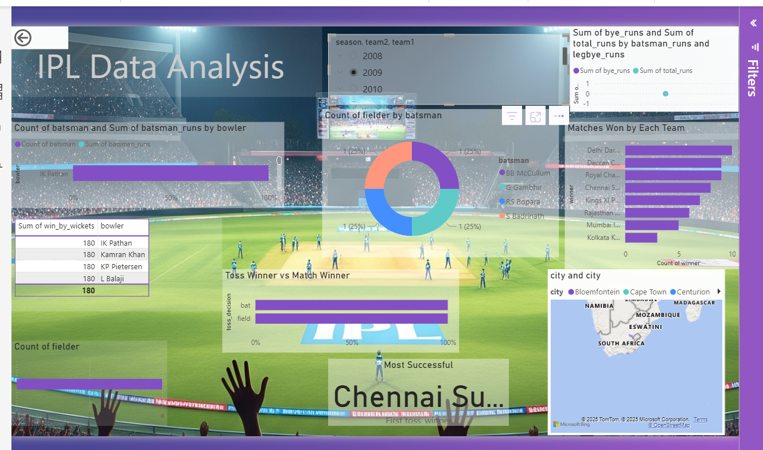

# Conclusion

The Power BI analysis provided actionable insights into IPL matches. It highlighted the dominance of teams like CSK, the critical role of toss decisions, and the impact of both batting and fielding performances. The dashboard created can be further extended with season-wise filters, player-level drill-downs, and predictive analysis for future IPL strategies.