**Tutorial -8**

Question:

1. Define the logic programming paradigm.
2. Download from https://www.swi-prolog.org/download/stable

Install to i.e., C:\bin\swipl

After installation:

Use your text editor to create a new knowledge base text file, copy the following content into it and save it as 'C:/bin/swipl/6/instructor.pl' .

|  |
| --- |
| % Fact  instructor(perkowski, ee271).  instructor(perkowski, ee171).  instructor(perkowski, ee478).  enrolled(alan-cheng, ee475).  enrolled(matthew, ee171).  enrolled(alan-cheng,ee171).  enrolled(alan-cheng,ee271).  enrolled(chris-clark,ee271).  enrolled(edison-tsai, ee171).  enrolled(chris-clark, ee171).  % Rule  teaches(Professor, Student) :- instructor(Professor,Class), enrolled(Student,Class). |

In the SWI-Prolog system, ?-

pwd.

It shows your current working directory. To change it to 'C:/bin/swipl/6',

working_directory(_,'C:/bin/swipl/6').

pwd. To confirm

To use instructor.pl as knowledge base,

consult("C:/bin/swipl/6/instructor.pl").

instructor.pl is a **knowledge base** file which consist of

Prolog **facts** – a database of predicates and associations.

Prolog **rules** – define new predicates by using Prolog facts.

Note: Prolog considers **capital** letters to denote **variables**, not predicates.

Prolog **Queries**

A query searches the database for the first fact that satisfies its goal.

If a fact is found then it either unifies the variable with a constant or Prolog returns true. / yes.

If a fact is not found that meets that condition then Prolog returns false. / no.

**Disjunction and Conjunction**

Use a semi-colon to request **subsequent** answers. In other words, a semi-colon signifies disjunction.

A comma signifies conjunction.

Once you have a knowledge base to consult, you can issue a query such as:

enrolled(X,ee271).

;

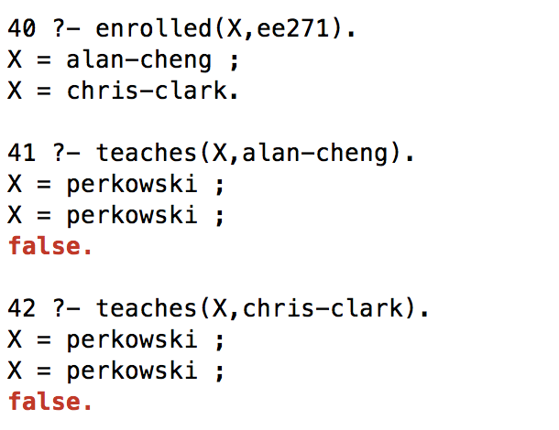

Prolog rules:

teaches(Professor, Student) :- instructor(Professor,Class), enrolled(Student,Class).

This is to say that an instructor only teaches if he teaches a class and students are enrolled in that class.

teaches (Professor, Student) :- instructor (Professor, Class), enrolled (Student,Class)

teaches (Professor, Student) <- instructor (Professor, Class), enrolled (Student,Class)

instructor (Professor, Class), enrolled (Student,Class) -> teaches (Professor, Student)

1. In PROLOG, consult instructorx.pl

In the Prolog system,

1. enrolled(X, cs365).
2. classmates(joseph, danielle,C).
3. classmates(joseph, jessica, C).

|  |
| --- |
| % Fact  instructor(perkowski, ee271).  instructor(perkowski, ee171).  instructor(perkowski, ee478).  instructor(bebis, cs365).  instructor(looney, cs311).  instructor(yuksel, cs446).  instructor(helfand, cs493).  instructor(quint, math486).  enrolled(jeske, ee171).  enrolled(greenwood, ee171).  enrolled(alan-cheng,ee171).  enrolled(alan-cheng,ee271).  enrolled(chris-clark,ee271).  enrolled(edison-tsai, ee171).  enrolled(chris-clark, ee171).  enrolled(ben, cs365).  enrolled(bill, cs365).  enrolled(bill, cs446).  enrolled(brian, cs311).  enrolled(brian, cs365).  enrolled(brittney, cs311).  enrolled(brittney, cs365).  enrolled(brittney, cs446).  enrolled(cody, cs311).  enrolled(cody, cs365).  enrolled(danielle, cs365).  enrolled(danielle, cs446).  enrolled(danielle, cs493).  enrolled(david, cs365).  enrolled(javier, cs365).  enrolled(jeffrey, cs365).  enrolled(jessica, cs311).  enrolled(jessica, cs446).  enrolled(jessica, math486).  enrolled(joel, cs365).  enrolled(joseph, cs311).  enrolled(joseph, cs365).  enrolled(joseph, cs446).  enrolled(joseph, cs493).  enrolled(joseph, math486).  enrolled(kellen, cs365).  enrolled(matts, cs311).  enrolled(matts, cs365).  enrolled(mattw, cs311).  enrolled(mattw, cs365).  enrolled(mattw, cs446).  enrolled(miran, cs365).  enrolled(ryan, cs365).  enrolled(samuel, cs365).  enrolled(shane, cs311).  enrolled(shane, cs365).  enrolled(shane, cs446).  enrolled(tiffany, cs311).  enrolled(tiffany, cs365).  enrolled(tiffany, cs446).  % Rule  teaches(Professor, Student) :- instructor(Professor,Class), enrolled(Student,Class).  classmates(S1, S2) :- enrolled(S1,C), enrolled(S2,C).  classmates(S1, S2, C) :- enrolled(S1,C), enrolled(S2,C). |