

**Track-Football-Player**

1. **Objective: What should we do?** 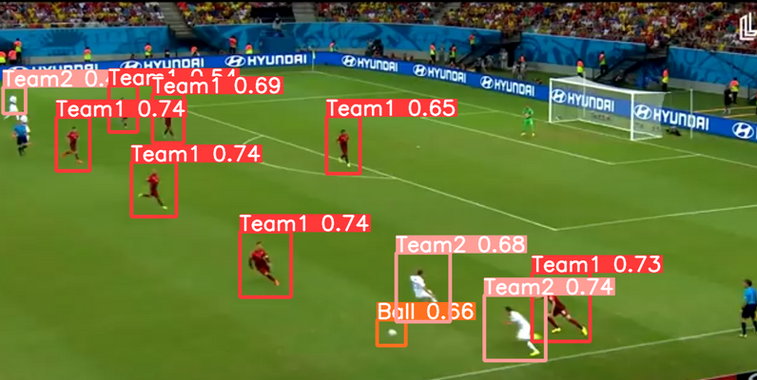

In this project, our ultimate goal is to develop a system that assists football-related video bloggers in automatically extracting player positions from a frame of a football match video. This system will segment players based on jersey colors into two teams and generate text boxes as required for subsequent manual identification of recognized players (including number, field position, name, age, etc.).

1. **Data: Where do we get the data?**

Ref: <http://suo.nz/2VNhKp>

(PS：<http://suo.nz/2GKRSL> /*To determine if an image is related to football.*/ )

Our preferred approach is to utilize pre-annotated datasets. Additionally, we can extract images from existing match videos by selecting key frames and then manually annotate them.

1. **Experience: Who should we learn from?**

Ref: https://github.com/IsaWdx/Track-Football-Player/blob/master

We've searched for relevant resources and previous experiences on GitHub and Kaggle, but currently, we haven't found very closely related projects. We may need to explore gradually and navigate this ourselves.

1. **Appearance：How does the GUI look like?**

* Website (Upload an image and receive the annotated image in return.
* Feature panels used for annotating tactics, such as arrows or circles.