Switch solutions

Taylah lucas, luke waldren, raymond fu, abe lawson

Team 119

MAY 25, 2016

User Guides

Version 1.0.0

**Contents**

Introduction and Purpose 2

Features 2

App Overview 2

Known Bugs or Limitation 2

# Introduction and Purpose

Switch Solutions is a mobile web application which provides detailed weather summaries for the current day and the previous 30 days for any location in the world. As a user you will be able to create a list of locations and view the weather summaries for each at any time. The application also provides a feature to always view the weather summaries of your current location.

In this guide you will be introduced to the features the application provides. You will be shown an overview of how to use the application. A description of the known bugs and limitations of the application will be provided at the end of the guide.

# Features

The application is designed to run on websites and on mobile devices.

Some of the features of this application include:  
  
- Weather summary:

The weather summary of the selected day for any selected location. The weather summary includes the forecast along with an image representing the forecast, the minimum and maximum temperatures, the wind speed in km/h, and the current humidity in %. This summary is calculated for the previous 30 days from the current day.

- Add locations and nicknames:

As a user you will be able to enter the address of any location in the world and view it on a google API map. You will also be able to add a nickname for the location, which is the name that will be used in the list of locations. If you choose not to enter a nickname, the formatted address of the location will be used. These locations will then have weather summaries provided for them.

- Remove locations:

­The app provides a simple button to remove the desired location from the list of locations you have produces. To do this, select a location from the list, and select the ‘REMOVE LOCATION’ button.

- Current location:

As a user the weather summary of your current location will automatically be generated and shown at the top of the list of locations.

- Maintains storage:

Even after closing the app, the added locations will be saved into a list to be viewed whenever the application is opened.

# App Overview

- Add Locations Page:

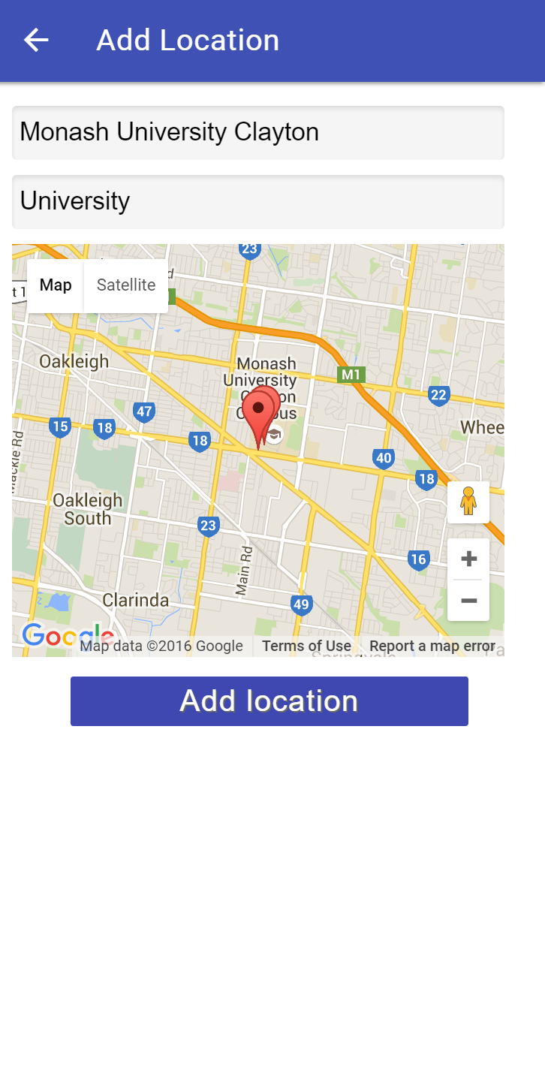This page is where you add a new location to your list of locations.

Click the arrow to return back to the list of locations.

Enter the formatted address here.

Enter a nickname for the location (optional).

View the location on a map.

Select this button to view the weather summary for this location.

Locations List Page:

This page displays a list of locations added by the user.

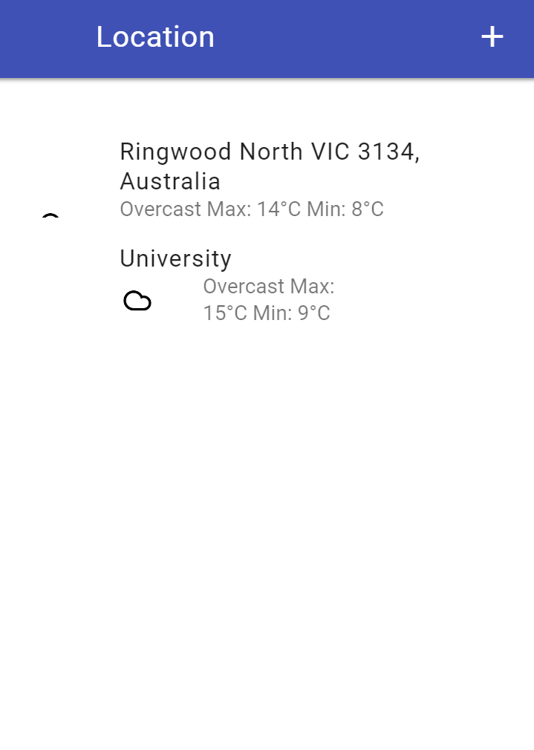

Select the ‘+’ to add a new location to the list.

This displays the weather summary for your current location.

Click on a location to view the weather summary and the location on a map.

View Location Page:

This page displays the weather summary and location on map of the selected location.

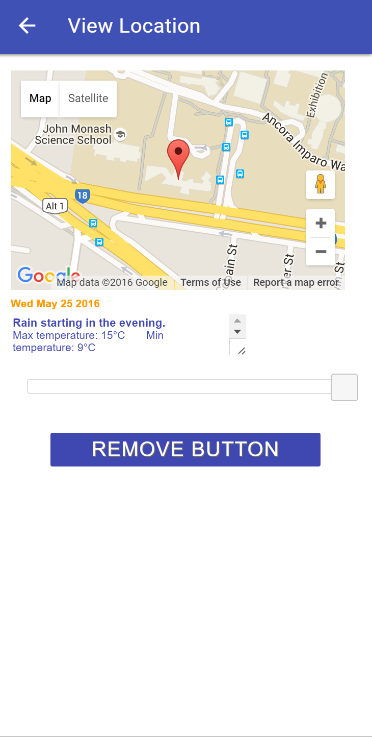

Select the arrow to return back to the list of locations.

View the location on the map.

Displays the selected date.

Adjust the slider to view the weather for any of the previous 30 days.

Select the arrows to view the weather summary.

Click ‘REMOVE BUTTON’ to remove the selected location from the locations list.

# Known Bugs or Limitation

***Delay in finding current location:***

It can take several seconds for the user’s current location to appear on the map once they have selected to view it. This could be due to limitations of the phones GPS or internet connection. Ensure mobile device is being used in an open area if possible when using this feature to ensure best results.

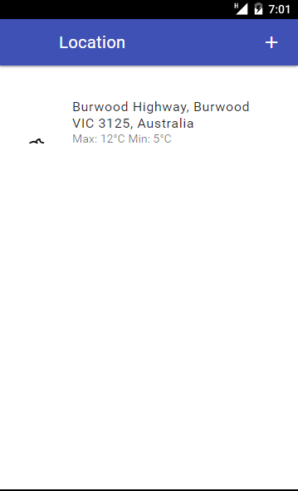

***Formatting issues on main page:***

When saving a location with a long address, or long nickname the weather information for that location may become unalligned or even unreadable. To prevent this issue from occuring ensure to give long addresses a brief nickname.

***Error message when entering a bad location:***

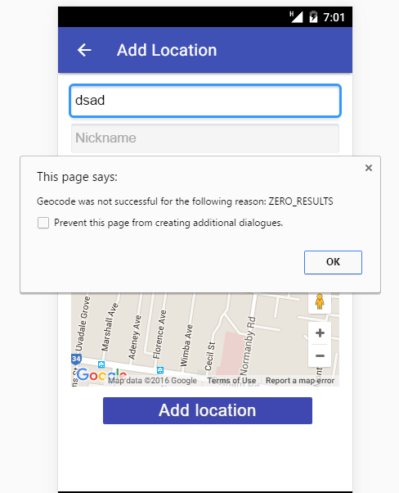When entering a location that does not exist the error message can come up quite quickly and not allow enough time to correct any spelling mistakes. If the error message appears too quickly or when a valid address is entered please contact SWITCH SOLUTIONS.

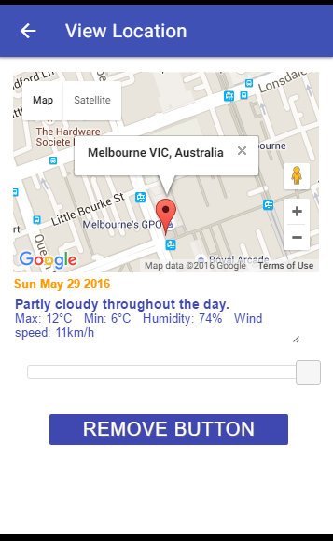***Map zoom level on view location page:***

The view location page does not connect to googles api. Therefore there is difficulty in determining what kind of address the user has saved. As a result the map zoom of the location may not be ideal. However this limitation can be easily fixed by simply tapping the map zoom controls. The zoom controls are located on the bottom right of the map.

***FAQ***

1. *The first item on the list doesn’t show my current location?*

There could be several issues causing this. First ensure that location services are enabled on your phone. This setting can be found in the quick access menu of both IOS and Android phones. Secondly ensure you are using Google Chrome and that you have granted it access to your location.

1. *I’ve saved too many locations? How do I clear up room?*

You can remove a saved location by clicking on it on the main page and then hitting the remove button.

1. *How do I look at a weather forecast for the future?*

Our app only handles past weather results.

1. *The main page only shows temperature? Where are my weather summaries!*

The weather summaries are the icons shown on the main page. For example, if the forecast predicted rain, a rain cloud would appear next to your location.

**Thanks for choosing SWITCH SOLUTIONS**