File Permissions in Linux
Managing authorization in the /home/researcher2/projects directory
Project description
As a security professional at a large organization, part of my role is to ensure that members of the research team hold the appropriate authorization to the files and directories they work with. In this project, I examined the existing permissions on the /home/researcher2/projects file system, compared them against the access each file and directory should have, and used Linux commands to modify the permissions that did not match. This removes unauthorized access and keeps the system secure.
Check file and directory details
To review the permissions of the files and the subdirectory in the projects directory, I used the following command:
ls -la
The -l option displays the output in long format, which shows the 10-character permission string for each item, and the -a option includes hidden files, such as .project_x.txt, whose names begin with a period. The command returned the following permissions:
drwx--x--- drafts
-rw--w---- .project_x.txt
-rw-rw-rw- project_k.txt
-rw-r----- project_m.txt
-rw-rw-r-- project_r.txt
-rw-rw-r-- project_t.txt
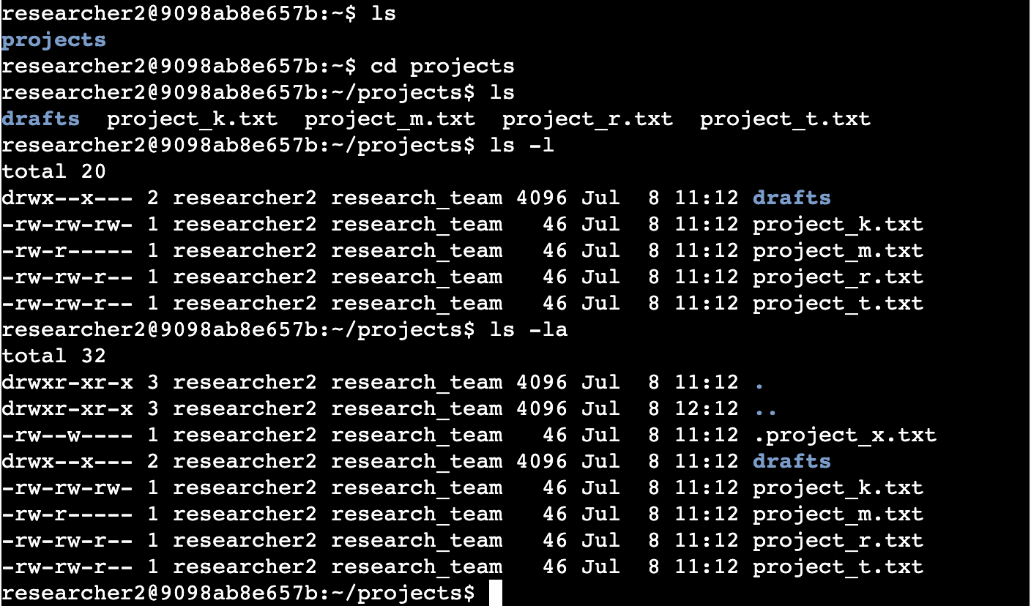
Screenshot: checking permissions with ls -la in the Bash shell. The -a option reveals the hidden file .project_x.txt, which ls -l alone does not show.
Describe the permissions string
Taking project_r.txt as an example, its permissions are represented by the 10-character string -rw-rw-r--. Each character describes a specific level of access:
The first character indicates the file type. A hyphen (-) represents a regular file, while a d would represent a directory, as seen with the drafts subdirectory (drwx--x---).
The next three characters (rw-) are the permissions for the user, or owner, of the file: read and write, but not execute. The following three characters (rw-) are the permissions for the group: read and write. The final three characters (r--) are the permissions for other, meaning all other users: read only. Throughout the string, r stands for read, w for write, x for execute, and a hyphen (-) means that permission is not granted.
Change file permissions
The organization does not allow other users to have write access to any files. Reviewing the permissions from the previous step, project_k.txt is the only file that grants write access to other (-rw-rw-rw-). I removed that access with the following command:
chmod o-w project_k.txt
The o-w argument removes (-) the write (w) permission from other (o). The file's permissions are now -rw-rw-r--, so other users can read the file but can no longer write to it.
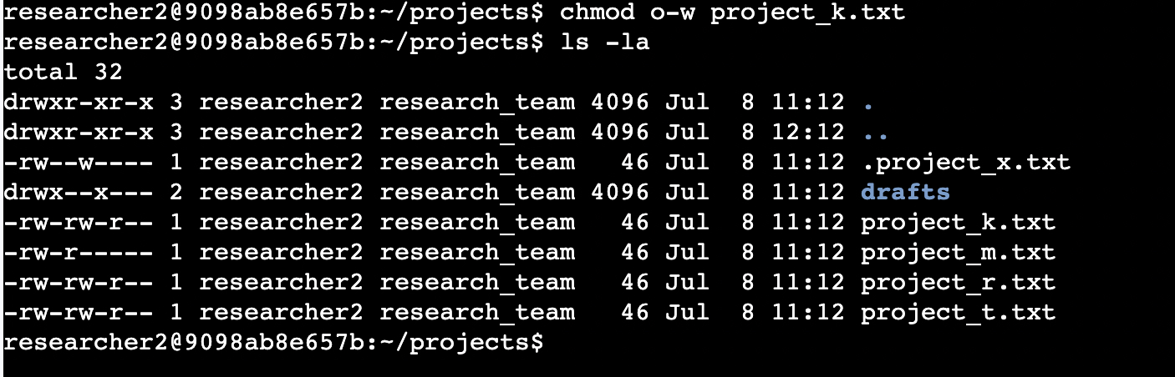
Screenshot: removing write access for other on project_k.txt, confirmed by the updated ls -la output.
Change file permissions on a hidden file
The research team has archived .project_x.txt, which is why its name begins with a period and it is treated as a hidden file. This file should not have write permissions for anyone, but the user and group should still be able to read it. Its permissions were -rw--w----, which gave the user read and write access and the group write access only. I updated it with the following command:
chmod u=r,g=r .project_x.txt
This command uses the equals sign (=) to set each permission group to exactly the access specified, replacing whatever was there before. u=r sets the user to read only, which removes the user's write access, and g=r sets the group to read only, which removes the group's write access and grants it read access, all in a single step. Other was already set to no access and is left unchanged. The resulting permissions are -r--r-----, so the user and group can read the file and no one can write to it.
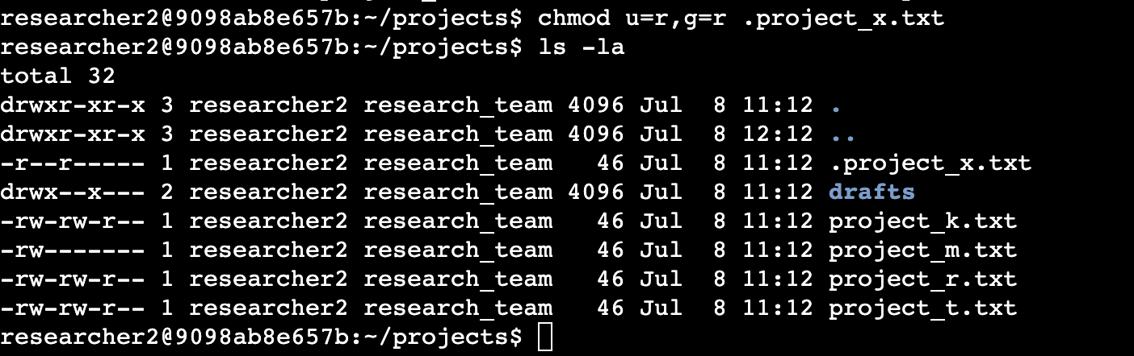
Screenshot: setting .project_x.txt to read-only for the user and group, confirmed by the -r--r----- output.
Change directory permissions
The files and directories in the projects directory belong to the researcher2 user, and only researcher2 should be able to access the drafts subdirectory and its contents. The directory's permissions were drwx--x---, which allowed the group to execute, or enter, the directory. I removed that access with the following command:
chmod g-x drafts
The g-x argument removes the execute permission from the group. The directory's permissions are now drwx------, so only the user (researcher2) retains access to it.
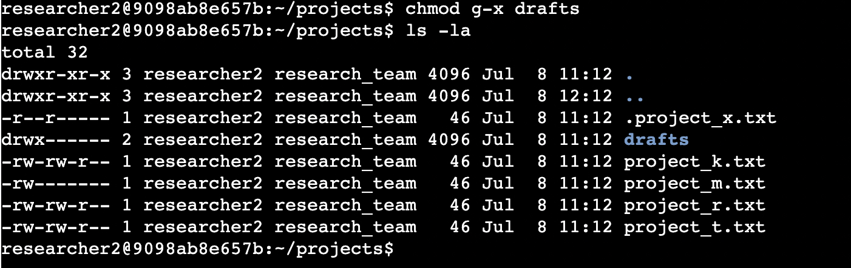
Screenshot: removing group access to the drafts directory, confirmed by the drwx------ output.
Summary
I examined the permissions of the files and the drafts subdirectory in the /home/researcher2/projects directory using ls -la, then compared them against the organization's authorization requirements. Three changes were needed: removing write access for other on project_k.txt, restricting the hidden file .project_x.txt to read-only for the user and group, and removing group access to the drafts directory. Using chmod, I applied each change so that the file system now grants only the intended level of access to each user.

