Algorithm for File Updates in Python
Automating allow list maintenance for a restricted patient records subnetwork

Project description
As a security professional at a health care company, one of my regular responsibilities is maintaining the file that controls which employees can access restricted patient records. Access to the restricted subnetwork is granted by IP address, and the file "allow_list.txt" holds the addresses that are permitted to sign in. When an employee should no longer have that access, their IP address is added to a separate remove list and has to be taken out of the allow list. In this project I developed a Python algorithm that opens "allow_list.txt", checks its contents against the remove list, deletes any IP address that appears on both, and writes the revised list back to the file. Automating the check makes a task that has to be repeated often faster and far less prone to human error.

Open the file that contains the allow list
The first step of the algorithm is to open the file so that its contents can be accessed. I assigned the file name to a variable and then opened it with a with statement:
import_file = "allow_list.txt"
with open(import_file, "r") as file:
Storing the file name in the import_file variable means the file only has to be identified once and can then be referred to by that variable throughout the algorithm. The with keyword manages the resources used while the file is open and automatically closes it once the indented block has finished running, so there is no need to call .close() separately. Inside the statement, the open() function takes two arguments: the file to be opened and the mode it should be opened in. The "r" argument opens the file in read mode. Finally, the as keyword assigns the file object returned by open() to the variable file, which the next step uses to access the contents.
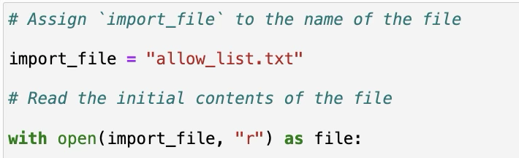
Screenshot: opening allow_list.txt in read mode with a with statement.

Read the file contents
With the file open, the next step is to convert its contents into something the algorithm can work with. :
ip_addresses = file.read()
The .read() method is called on the file object and converts the contents of the file into a string, which I stored in the variable ip_addresses. This line is indented because it belongs to the body of the with statement; the file has to be read while it is still open. At this point ip_addresses holds every IP address in the allow list as a single string, with the addresses separated by whitespace.
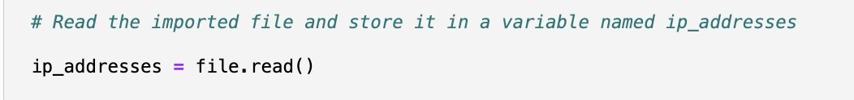
Screenshot: reading the file contents into the ip_addresses variable with .read().

Convert the string into a list
Individual IP addresses cannot be removed from a string, so the data has to be restructured before any of it can be deleted:
ip_addresses = ip_addresses.split()
The .split() method converts a string into a list. Because no argument is passed to it, it splits the string on whitespace by default, which includes the line breaks that separate the IP addresses in the file. The result is reassigned to ip_addresses, so the same variable now stores a list in which each IP address is its own element and can be accessed or removed individually. This line sits outside the with statement because the data is already in memory and the file itself is no longer needed.
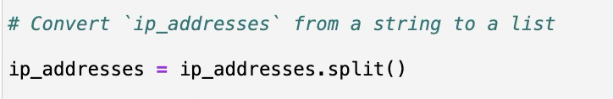
Screenshot: converting the ip_addresses string into a list with .split().

Iterate through the remove list
A second list called remove_list contains the IP addresses that should no longer have access to the restricted content. To compare it against the allow list, I set up an iterative statement:
remove_list = ["192.168.97.225", "192.168.158.170",
"192.168.201.40", "192.168.58.57"]

for element in remove_list:
The for keyword starts a loop that runs the indented code once for every item in the sequence that follows the in keyword. element is the loop variable, and on each pass through the loop it holds the current IP address from remove_list. Iterating through the remove list rather than the allow list means the loop only runs as many times as there are addresses to remove, which keeps the algorithm efficient as the allow list grows.
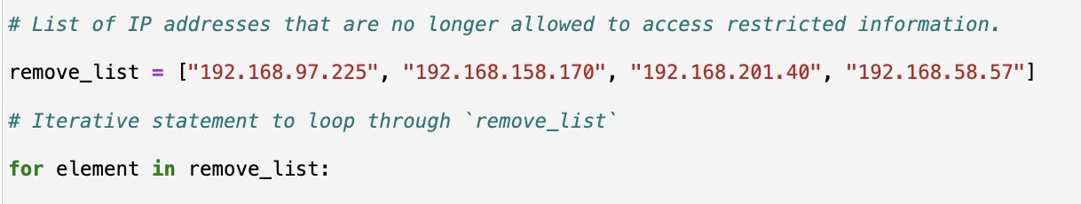
Screenshot: the for loop header that iterates through remove_list.

Remove IP addresses that are on the remove list
The body of the loop compares each address on the remove list against the allow list and deletes it where there is a match:
for element in remove_list:
if element in ip_addresses:
ip_addresses.remove(element)
The if statement evaluates whether the current value of element is present in the ip_addresses list. In this context in acts as a membership operator and returns True when the value is found. When the condition evaluates to True, the .remove() method is applied to ip_addresses and deletes the element passed to it. Evaluating the conditional first also prevents the algorithm from stopping with an error, because calling .remove() with a value that is not in the list raises a ValueError.
Applying the .remove() method in this way is possible because there are no duplicates in the ip_addresses list. The method only removes the first occurrence of the value it is given, so if the allow list contained the same IP address more than once, a single pass of the loop would leave the extra copies in place and those employees would keep their access.
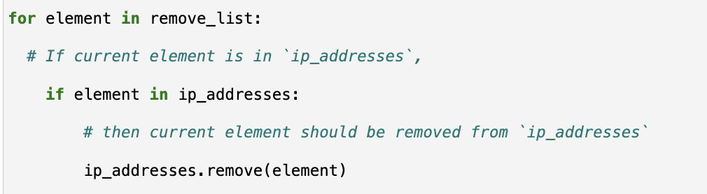
Screenshot: the conditional and the .remove() method inside the loop.

Update the file with the revised list of IP addresses
The revised data is held in a Python list, but the file has to store it as text, so the list is converted back into a string before it is written:
ip_addresses = "\n".join(ip_addresses)

with open(import_file, "w") as file:
file.write(ip_addresses)
The .join() method is called on the string "\n" and combines every element of ip_addresses into one string, inserting that string between each element. \n is the newline character, so each IP address is placed on its own line and the file keeps the same format it had originally.
A second with statement then reopens the file assigned to import_file, this time passing "w" to the open() function so that the file is opened in write mode, and the .write() method writes the string to it. Write mode overwrites the existing contents rather than adding to them, which is exactly what is needed here: the file should end up containing only the IP addresses that still have authorization.
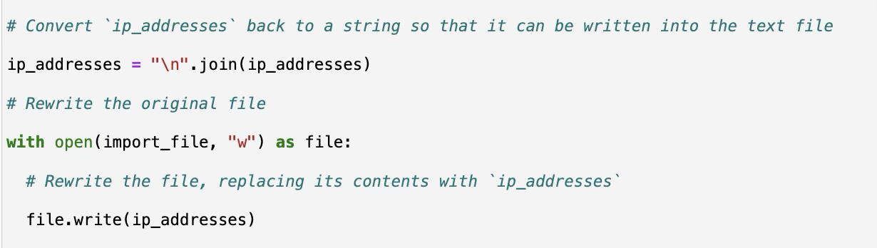
Screenshot: rebuilding the string with .join() and overwriting the file with .write().

Summary
I developed a Python algorithm that updates the allow list controlling access to a restricted subnetwork. The algorithm opens "allow_list.txt" with a with statement and the open() function, reads its contents into a string with .read(), and converts that string into a list with .split(). A for loop then iterates through the remove list, and a conditional inside the loop applies the .remove() method to delete any IP address that appears on both lists. Finally, .join() converts the revised list back into a single string separated by newline characters, and a second with statement uses .write() in write mode to overwrite the file with the updated allow list. The result is a repeatable process that withdraws an employee's access as soon as their IP address is added to the remove list. Because the algorithm can be run again whenever the remove list changes, it makes an authorization task that is performed regularly both faster and more consistent than editing the file by hand.

Complete algorithm
The full algorithm is shown below. Run end to end, it takes the allow list as it stands, strips out every IP address that appears on the remove list, and writes the shortened list back to "allow_list.txt".
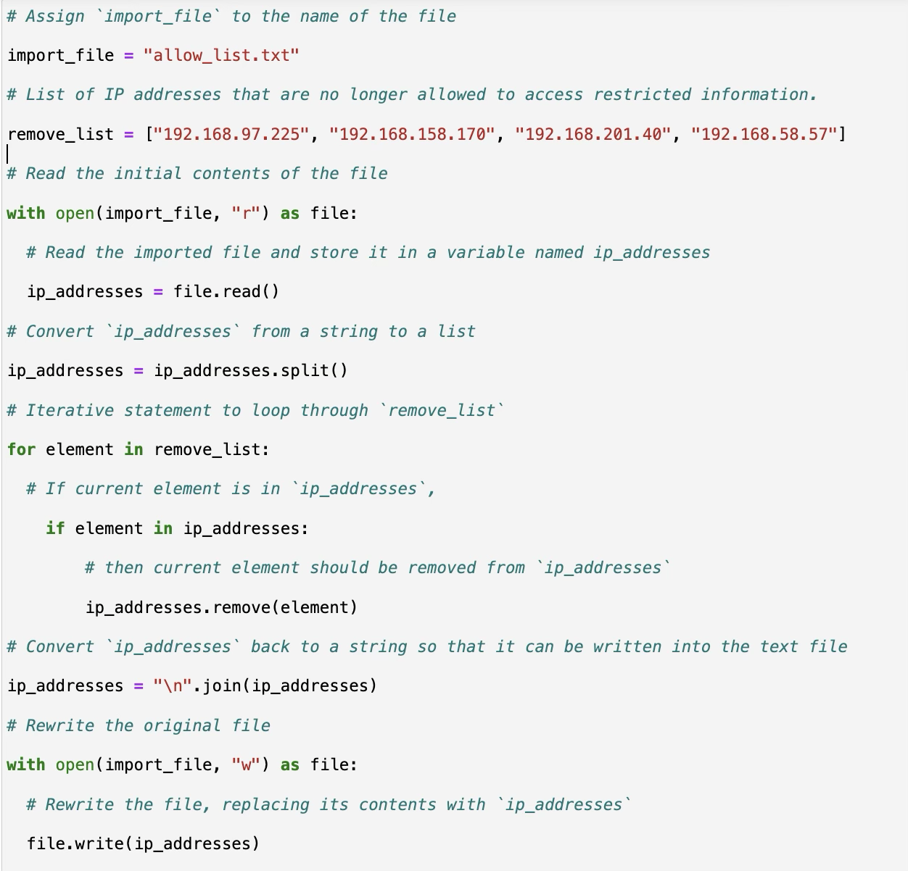
Screenshot: the complete algorithm in the Jupyter Notebook.

