1. If you encountered issue of Docker for Windows error: "Hardware assisted virtualization and data execution protection must be enabled in the BIOS"

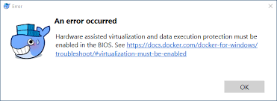

**Solution below**:

Go to task manager, under the performance tab, you will see that Virtualization is disabled. To enable it, browse how to enable Virtualization from BIOS of your system manufacturer, follow all the steps and restart your PC. Once it is enabled, you will see it as depicted below.

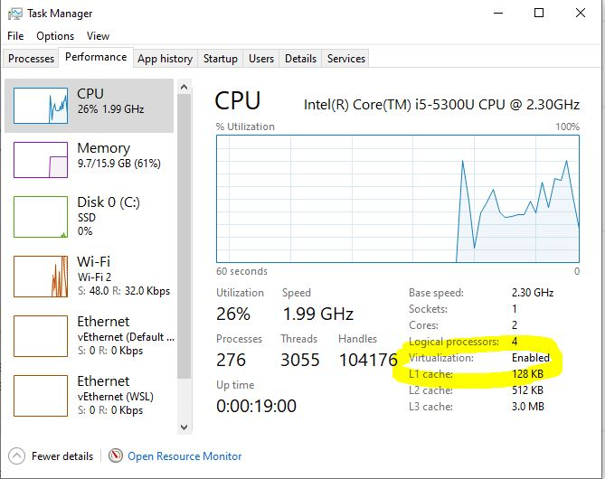

After the above, go to the control panel, and make sure you check Hyper-V and Windows Subsystem for Linux depicted below

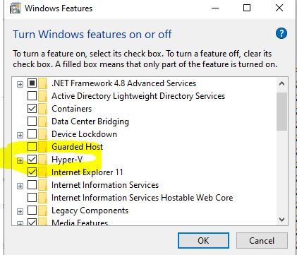

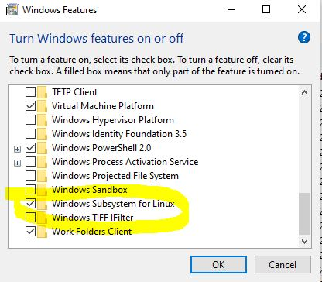

* After above, uninstall the Docker installed if you already installed it before, then install it again. After that, then download [WSL2 Linux kernel update package for x64 machines](https://wslstorestorage.blob.core.windows.net/wslblob/wsl_update_x64.msi)

from [Manual installation steps for older versions of WSL | Microsoft Docs](https://docs.microsoft.com/en-us/windows/wsl/install-manual#step-4---download-the-linux-kernel-update-package) and install it. Restart your system, then your docker desktop will be up and running. Cheers