AI-assisted decision journaling from public inquiry transcripts: a UK COVID-19 Inquiry case study
Akeeb Idowu Lawal

Master of Science in Artificial Intelligence
from the
University of Surrey



School of Computer Science and Electronic Engineering
Faculty of Engineering and Physical Sciences
University of Surrey
Guildford, Surrey, GU2 7XH, UK

May 2026
Supervised by: Dr Joaquin Prada

Akeeb Idowu Lawal 2026

Declaration of originality

I confirm that the project dissertation I am submitting is entirely my own work and that any material used from other sources has been clearly identified and properly acknowledged and referenced. In submitting this final version of my report to the JISC anti-plagiarism software resource, I confirm that my work does not contravene the university regulations on plagiarism as described in the Student Handbook. In so doing I also acknowledge that I may be held to account for any particular instances of uncited work detected by the JISC anti-plagiarism software, or as may be found by the project examiner or project organiser. I also understand that if an allegation of plagiarism is upheld via an Academic Misconduct Hearing, then I may forfeit any credit for this module or a more severe penalty may be agreed.

AI-assisted decision journaling from public inquiry transcripts: a UK COVID-19 Inquiry case study

Akeeb Idowu Lawal

Author Signature _______________________________ Date: _______________

Supervisor's name: Dr Joaquin Prada

Word Count

Number of Pages: 77
Number of Words: 14,558

Abstract
Important decisions made during public emergencies are often difficult to reconstruct because the supporting evidence is dispersed across complex public records. Public inquiry transcripts illustrate the problem: substantive decisions appear alongside questions, procedure, advocacy and retrospective narrative. This dissertation examines AI-assisted decision journaling as a method for creating and reviewing traceable candidate entries from such records, using UK COVID-19 Inquiry Module 2 hearing transcripts as a case study.
Eight hearing transcripts produced 414 candidate entries with mechanical source-quote traceability checks. The candidates were stored as a fixed reference dataset and reviewed through non-destructive flags. A stratified sample of 50 entries was assessed separately for journal validity and evidence strength, and automated confidence signals were compared with those judgements. Exploratory clustering organised all 414 candidates for navigation. A separate purposive sample of 60 entries tested Joint External Evaluation preparedness mapping, Decision Quality mapping and candidate-statement faithfulness through source-based human adjudication.
Of the 414 candidates, 351 passed mechanical traceability. In the stratified n = 50 sample, the most frequent validity-by-evidence cell was no × high (21/50): the quotation strongly supported the generated statement, but the item did not meet the journal definition. Automated confidence aligned more closely with evidence strength than journal validity. In the purposive n = 60 pilot, an observable Decision Quality element was identified more often than a defensible JEE mapping (37/60 versus 11/60), while generated wording was not consistently faithful enough to serve as authoritative evidence.
The findings support keeping candidate generation separate from evaluation and treating validated source passages as authoritative. The main contribution is a governed extraction-and-review process that may support source-linked retrospective review and organisational learning. The conclusions remain bounded by the eight-transcript case study and single-reviewer assessments; stronger independent human validation should precede wider scaling.

Table of Contents
Declaration of originality ii
Abstract iv
Table of Contents v
List of Figures ix
List of Tables x
Chapter 1 — Introduction 1
1.1 Background and context 1
1.2 Problem statement 2
1.3 Research aim and objectives 2
1.4 Scope and boundaries 3
1.5 Dissertation outline 4
1.6 Contributions 4
Chapter 2 — Literature review 5
2.1 Decision journals and crisis governance 5
2.2 NLP and information extraction from long documents 6
2.3 Grounding, traceability, and provenance 7
2.3.1 Traceability is not journal membership 8
2.4 Human evaluation of LLM outputs 8
2.4.1 Validity versus evidence strength 9
2.5 UK COVID-19 Inquiry as case study 10
2.6 Summary and research gap 11
Chapter 3 — Methodology 13
3.1 Research design and conceptual framework 13
3.2 Case study and corpus 15
3.2.1 Case study: UK COVID-19 Inquiry Module 2 15
3.2.2 Phase 1 corpus: eight hearing transcripts 15
3.2.3 Operational definition of a decision-journal entry 16
3.3 Extraction and source traceability 17
3.3.1 Data ingestion 17
3.3.2 Model, chunking and temperature 19
3.3.3 Decision object schema 19
3.3.4 Traceability as an auditable floor 20
3.4 Fixed reference dataset of candidate decision-journal entries 20
3.5 Phase 1 evaluation 21
3.5.1 Manual triangulation sample 21
3.5.2 GRACE-adapted quality assessment 21
3.5.3 Error taxonomy 21
3.5.4 Keyword baseline 22
3.6 Non-destructive review flags 22
3.7 Confidence and journal-validity evaluation (n = 50) 22
3.7.1 Stratified sample 23
3.7.2 Rubric A: journal validity 23
3.7.3 Rubric B: evidence strength 24
3.7.4 Interpretation framework 24
3.7.5 Automated confidence signals 25
3.8 Exploratory thematic clustering for journal navigation 25
3.9 Supplementary preparedness and Decision Quality mapping pilot 26
3.9.1 Frameworks 26
3.9.2 Evidence basis 27
3.9.3 Candidate ranking and adjudication 27
3.9.4 Review provenance 28
3.9.5 Source-passage traceability classifications 28
3.10 Scope, limitations and ethical considerations 28
3.10.1 What the research delivers 28
3.10.2 What was not built 28
3.10.3 Ethical and data considerations 29
3.11 Chapter summary 30
Chapter 4 — Results and evaluation 31
4.1 Overview of key results 31
4.2 Extraction and source traceability (n = 414) 31
4.3 Manual evaluation and extraction failure modes 32
4.4 Fixed reference dataset and non-destructive review flags 34
4.5 Journal validity, evidence strength and automated confidence (n = 50) 35
4.6 Exploratory thematic clustering for navigation (n = 414) 36
4.7 Supplementary preparedness and Decision Quality findings (n = 60) 37
4.8 Supplementary robustness and transfer checks 40
4.9 Summary of key findings 40
Chapter 5 — Discussion and conclusion 41
5.1 Interpretation of the main findings 41
5.1.1 Traceability, fidelity and journal validity 41
5.1.2 Confidence, discourse and human judgement 42
5.1.3 Clustering and framework mapping as complementary methods 42
5.2 Methodological and policy contribution 43
5.2.1 Governed candidate generation and review 43
5.2.2 Organisational learning and public-sector relevance 44
5.3 Limitations and threats to validity 45
5.3.1 Case-study and corpus scope 45
5.3.2 Human review and sample design 45
5.3.3 Technical and analytical limitations 46
5.3.4 Ethical and use boundaries 47
5.4 Conditions for responsible development and scaling 47
5.5 Conclusion 48
Appendix A — Manual excerpt evidence 49
excerpt_001 49
Bounded transcript text 49
Manual decisions 51
excerpt_002 51
Bounded transcript text 51
Manual decisions 52
excerpt_003 53
Bounded transcript text 53
Manual decisions 54
excerpt_004 54
Bounded transcript text 54
Manual decisions 55
excerpt_005 55
Bounded transcript text 56
Manual decisions 56
excerpt_006 57
Bounded transcript text 57
Manual decisions 58
Closing note 58
Appendix B — Supporting extraction and robustness results 59
B.1 Per-hearing extraction and traceability 59
B.2 Default versus inquiry prompt extraction counts 59
B.3 Error taxonomy definitions and counts (n = 42) 59
B.4 Keyword-baseline results by excerpt 60
B.5 GRACE-adapted quality scores 60
B.6 Report-genre pilot summary 61
B.7 Structural reliability stress-test 61
B.8 n = 60 review provenance note 62
Appendix C — Clustering supplement 63
C.1 Largest heuristic themes 63
C.2 Additional mid-sized themes 64
C.3 Inquiry-procedure and low-support groups 64
References 65

List of Figures
Figure 3.1. Two-phase workflow from public inquiry transcripts to a fixed reference dataset of candidate decision-journal entries. Phase 1 covers extraction and source traceability. Phase 2 applies review flags, n = 50 human validation, exploratory clustering for navigation, and a supplementary n = 60 Joint External Evaluation and Decision Quality mapping pilot. Human judgement remains the final authority for interpretation. 14
Figure 3.2. Technical implementation pipeline from eight inquiry transcripts to the fixed reference dataset and the separate evaluation, review, clustering and framework-mapping activities. 18
Figure 4.3. Assigned error categories in the stratified sample (n = 42). 34
Figure 4.9. Rubric A × Rubric B cross-tabulation (n = 50). 35
Figure 4.10. Theme distribution across 20 heuristic groups. 37

List of Tables
Table 3.1. Evaluation methods and the populations or samples they address. 15
Table 3.2. Phase 1 hearing transcript sample. 16
Table 3.3. Decision object schema. 19
Table 3.4. Non-destructive review-flag rules. 22
Table 3.5. Stratified confidence-validation sample (n = 50). 23
Table 3.6. Rubric A journal-validity criteria. 23
Table 3.7. Rubric B evidence-strength criteria. 24
Table 3.8. Rubric A × Rubric B interpretation framework. 24
Table 3.9. Decision Quality elements used in the n = 60 mapping pilot. 27
Table 3.10. Items deferred beyond MSc scope. 29
Table 4.1. Phase 1 corpus totals. 32
Table 4.2. Manual triangulation results. 32
Table 4.3. Automated confidence agreement with human Rubric B. 36
Table 4.4. Framework-mapping outcomes in the n = 60 pilot. 38
Table 4.5. Candidate-statement faithfulness classifications (n = 60). 39
Table 4.6. Supplementary robustness and transfer checks. 40

Chapter 1 — Introduction

1.1 Background and context
Modern governments responding to national emergencies must often decide quickly, under uncertainty, and across organisational boundaries. The records of those decisions are rarely held in one place. Instead they are scattered through reports, meeting notes, correspondence and public inquiries, which makes later reconstruction of what was decided, on what evidence, and with what follow-through a persistent institutional-memory problem [1], [2].
Structured records of decisions, supporting evidence and rationale offer one response to this problem. In this dissertation, a decision journal is defined as a structured record that pairs a decision claim with the evidence, provenance and contextual information needed for later review. This form of record-keeping can support accountability, audit and organisational learning [1], [2], [3]. In practice, however, many of the richest public sources are not journals at all. They are long, mixed texts in which agreements, adopted measures and authoritative directions sit beside questions, procedure, advocacy and narrative.
Large language models (LLMs) offer a plausible technical response to that documentation gap. Brown et al. [4] show that few-shot, in-context prompting can support task adaptation without task-specific fine-tuning, which motivates prompt-based structured extraction as an application of that capability. Reliable provenance and accountable acceptance into a decision journal are not established by that work alone. Foundation-model research documents risks such as hallucination, over-generation and sensitivity to prompt wording [5], [6]. In inquiry transcripts, these risks can blur the practical distinction between what was agreed and what was only urged or recalled. For high-stakes public records, extraction therefore needs mechanical source checks and human review, not face-value acceptance of model output.
The empirical case study used here is UK COVID-19 Inquiry Module 2. Established under its Terms of Reference in 2022, the Inquiry examines core decision-making and political governance during the pandemic [7]. Its hearing transcripts provide a reproducible public corpus in which ministers, officials and advisers recall decisions taken in COBR, COVID-O and related forums. The Inquiry is treated as a case study of a broader public-record decision-journaling problem, not as the sole purpose of the method.

1.2 Problem statement
The core problem is how to convert complex public records such as inquiry transcripts into structured, auditable candidate decision-journal entries without sacrificing provenance or human oversight. Transcripts use “decision” loosely: ministers urge action, witnesses offer retrospective lessons, and procedural business interrupts substantive testimony. A practical journal definition therefore has to distinguish agreements, adopted measures and authoritative directions from decision-like language that should not enter the record.
Automated extraction faces a further difficulty. An LLM may locate and quote a passage faithfully while still proposing the wrong kind of artefact for a decision journal, or it may generate a summary that alters the meaning of a usable source passage. Strong quote support is not the same as journal validity, and source-level availability is not the same as semantic faithfulness. Any useful system must therefore help humans review candidates rather than treat model output as accepted evidence.

1.3 Research aim and objectives
Aim
To design and evaluate an LLM-assisted method for creating traceable candidate decision-journal entries from complex public records, using UK COVID-19 Inquiry Module 2 transcripts as a case study.
Objectives
1. Develop a reproducible workflow that extracts structured candidate entries from public inquiry transcripts while retaining source quotations and provenance.
2. Evaluate extraction quality on eight Module 2 hearing transcripts using source-traceability checks, bounded manual review, error analysis and simple comparison methods.
3. Store the 414 candidates as a fixed reference dataset of candidate decision-journal entries so that later review and analysis do not alter the original extraction.
4. Assess journal validity and evidence strength on a stratified sample of 50 entries, and compare automated confidence signals with those human judgements.
5. Organise candidates for review using non-destructive flags and exploratory clustering, then use a separate sample of 60 entries to test whether validated passages support preparedness (JEE) and Decision Quality interpretation and whether generated summaries remain faithful to their sources.
6. Examine the method’s limitations, policy relevance, organisational-learning value and conditions for responsible scaling.

1.4 Scope and boundaries
The empirical work used eight Module 2 hearing transcripts and produced candidate decision-journal entries rather than an accepted catalogue of government decisions. Human evaluation used a stratified n = 50 sample for journal validity and evidence strength, and a purposive n = 60 pilot for Joint External Evaluation preparedness mapping, Decision Quality mapping and candidate-statement faithfulness. The study did not process or manually validate the full Inquiry archive, and the prototype was not evaluated as a production system. The conclusions concern feasibility and governed review at MSc scale.

1.5 Dissertation outline
Chapter 1 sets the problem, scope, aim and contribution. Chapter 2 reviews decision journaling, extraction, provenance, human evaluation and policy-framework literature, then identifies the research gap. Chapter 3 describes methods for extraction, traceability, fixed reference dataset construction, bounded validation, clustering and supplementary JEE/Decision Quality work. Chapter 4 reports results for n = 414, n = 50 and n = 60 separately. Chapter 5 interprets findings, states the contribution and limitations, sets scaling conditions and concludes. Appendices provide manual excerpts and supporting material.

1.6 Contributions
The methodological contribution is a governed review process rather than a new extraction or clustering algorithm. It links candidate entries to source evidence, preserves a fixed reference dataset, separates journal validity from evidence strength, and uses review flags, confidence checks, clustering and recognised frameworks without displacing human judgement.
The empirical contribution is bounded feasibility evidence from an eight-transcript case study and two separate evaluation samples: n = 50 for journal validity and evidence strength, and n = 60 for framework interpretation and candidate-statement faithfulness.
The policy and organisational-learning contribution is a practical model for source-linked retrospective review and institutional memory. It keeps AI-generated candidates visibly separate from human-validated records and does not claim deployment readiness or automated policy judgement.

Chapter 2 — Literature review
This chapter reviews literature on generating candidate decision records from public inquiry text at feasible scale, and on deciding which candidates should enter an auditable decision journal. Sections 2.1–2.2 cover decision journaling, crisis governance and LLM-based extraction. Sections 2.3–2.4 examine provenance, traceability and human evaluation, including the distinction between evidence strength and journal validity. Sections 2.5–2.6 situate the UK COVID-19 Inquiry case study and state the research gap.

2.1 Decision journals and crisis governance
Structured recording of decisions and supporting rationale has been advocated as useful practice in organisational learning and audit [2], [3]. Accountability literature emphasises that records should capture not only what was decided but the evidence and reasoning behind it, and that office-holders remain answerable for how decisions are documented [2]. In crisis governance, the same records support after-action review [1]. Public inquiries extend this logic to society-wide events: they provide an institutional mechanism for retrospective scrutiny of major incidents [8], as reflected in the UK COVID-19 Inquiry’s Terms of Reference, which require examination of how core decisions were made and what lessons should be learned [7].
As defined in Chapter 1 (Section 1.1), a decision journal is a structured record that pairs a decision claim with supporting evidence, provenance and contextual information needed for later review. Hearing transcripts, however, are not decision journals. They are performative, adversarial and temporally layered — witnesses recall past COBR meetings, counsel probes inconsistencies, and procedural business interrupts substantive testimony. Transforming transcripts into journal entries therefore requires an operational definition of what counts as a decision (agreements, adopted measures, authoritative directions) and a provenance discipline (every claim anchored to a verbatim quote). The transformation is treated here as an information-extraction and accountability problem rather than a deployment exercise for inquiry staff.
In inquiry dialogue, ministerial urging, retrospective recommendations and narrative descriptions can resemble decisions in surface form while failing the operational journal definition. The risks of over-generation documented in foundation-model research make this distinction important [5], [6]. Extraction therefore produces candidates; acceptance into a decision journal requires additional validation (Sections 2.3–2.4).
Decision journals can also be reviewed through recognised policy frameworks once the underlying evidence has been validated. In public-health emergency review, the Joint External Evaluation provides categories for preparedness capacities [9], while Decision Quality focuses on features of the decision process, including framing, information, values, alternatives, reasoning and follow-through [10], [11]. These frameworks support structured interpretation; they do not replace source traceability or the judgement of whether an extracted item belongs in the journal.

2.2 NLP and information extraction from long documents
Information extraction (IE) from long documents traditionally combined linguistic preprocessing, pattern rules and supervised models [12], [13]. Transformer-based pre-training (for example BERT) improved contextual representation for span extraction and classification [14], but many encoder pipelines still have bounded input lengths that make full long-document processing difficult [5], [15]. Modern LLMs may support longer context windows, yet longer context does not itself resolve provenance, discourse heterogeneity or artefact-validity problems. Inquiry transcripts also mix genres (question, answer, quotation, procedural). Task-specific supervised pipelines are costly to adapt when corpora, schemas or accountability requirements change.
Large language models shift the IE paradigm toward prompt-based extraction: a schema and instructions in natural language, few-shot or zero-shot, without task-specific fine-tuning [4]. Foundation-model surveys document both opportunity (flexible schemas, rapid prototyping) and risk (hallucination, inconsistent formatting, sensitivity to prompt wording) [5], [6]. Brown et al. support in-context task adaptation; they do not establish reliable decision-journal extraction, provenance preservation or public-sector auditability on their own.
Chunking long transcripts into overlapping sentence windows is adopted here as a reproducible and auditable processing unit: each window is processed independently with a structured schema (for example decision text, evidence, verbatim quote, source location). Chunking sacrifices global discourse coherence for auditability — each item’s quote must resolve within its window’s processed text — rather than because no contemporary model could admit longer inputs. Alternative architectures such as retrieval-augmented generation (RAG) [16] offer different provenance trade-offs. At this pilot’s bounded scale, complete fixed chunks were supplied directly to the model, which simplified item-level provenance inspection; a retrieval index was therefore not required for the chosen design.
Most IE literature evaluates whether models extract the right spans or labels, not whether extracted items should enter a target artefact. Prompt-based extraction addresses scalability, but accountability-oriented use requires treating the extractor as stage one of a multi-stage pipeline; traceability checks and post-extraction validation follow in Sections 2.3–2.4.

2.3 Grounding, traceability, and provenance
Accountable use of AI in government contexts emphasises transparency, traceability and human oversight [17], [18], [19]. For extraction pipelines, grounding means that every structured claim can be verified against source text [20], [21].
Mechanical traceability checks — verifying that each quoted span is locatable in the processed source after normalisation — implement grounding in auditable form. Traceability pass is necessary but not sufficient: human–machine agreement on content can co-occur with traceability failure (for example long quotes broken by PDF layout), and conversely a locatable quote may support the wrong kind of statement (procedural adjournment versus policy decision).

2.3.1 Traceability is not journal membership
Traceability establishes source provenance — that a quoted anchor exists in the source record. It does not establish journal membership — that the extracted statement belongs in a policy decision journal. A hearing adjournment can be quoted faithfully and pass traceability while failing journal validity; conversely, a valid policy decision may fail traceability because of PDF layout artefacts. Stratified human validation can show how often faithful extraction of non-journal discourse occurs within the evaluated sample.
Structural consistency and traceability therefore form the auditable floor; journal validity and evidence strength require separate human assessment (Section 2.4). LLM self-reported confidence is better treated as a hypothesis for empirical comparison against human rubrics than as ground truth in high-stakes settings [5], [6].

2.4 Human evaluation of LLM outputs
Qualitative technology evaluation requires human judgement at bounded sample depth plus corpus-scale automated metrics at breadth [22]. Towler et al. [23] propose MATA triangulation for comparing human and machine analysis of COVID-19 policy text: convergence categories of agreement, silence (present in one method only) and dissonance (genuine disagreement). MATA supports purposive comparison of human and machine extractions on the same text regions without requiring full-corpus manual coding.
Bondaronek et al. [24] introduce GRACE, a framework for evaluating AI-generated textual outputs on dimensions including interpretability, actionability, nuance and redundancy. As an unpublished preprint at the time of writing, GRACE has not undergone formal peer review. Its use here is treated only as a supplementary descriptive quality lens on a bounded sample, not as a validated benchmark for decision-journal correctness. Broader LLM evaluation research similarly treats human judgement and multi-criteria rubrics as central to assessing generated text [25].

2.4.1 Validity versus evidence strength
Neither MATA nor GRACE directly operationalises the question: should this extracted item be accepted into the decision journal? MATA compares human and machine presence of themes or decisions; GRACE rates quality dimensions of generated text. Both are valuable partial lenses. Neither separates (a) whether an entry belongs in the target artefact (journal validity) from (b) how strongly the quoted evidence supports the extracted decision text (evidence strength) — a distinction familiar from faithfulness evaluation in abstractive summarisation [26] and from broader debates on what human evaluation of NLP systems should measure [22]. Conflating those dimensions — for example, scoring a procedural adjournment as “low confidence” because it is not a policy decision — would misattribute extraction fidelity to artefact type.
This gap motivates dual-rubric human validation: one rubric for journal validity, one for quote-to-decision support. Towler’s human-in-the-loop framing [23] supports structured annotation on bounded samples. Extending that logic with non-destructive review flags, stratified confidence validation, automated signal comparison against evidence-strength ratings, and thematic clustering as a sense-making layer addresses accountability requirements that single-metric evaluation cannot capture. Automated semantic-similarity metrics were not adopted as primary endpoints here; traceability, MATA-style triangulation and rubric-based human assessment align better with high-stakes extraction tasks than semantic similarity alone.
Collectively, these studies suggest that no single evaluation framework adequately captures both extraction correctness and decision usefulness in high-stakes policy text. This motivates the multi-layer evaluation adopted in the present study, where structural consistency, traceability, evidence strength and journal validity are assessed separately, and where post-extraction enrichment (flags, confidence signals, thematic organisation) operates on a fixed reference dataset of candidate decision-journal entries without altering the underlying extraction results.

2.5 UK COVID-19 Inquiry as case study
The UK COVID-19 Inquiry public document archive provides reproducible primary data: hearing PDFs, metadata and supplementary reports [27]. Module 2 focuses on core UK decision-making and political governance — COBR, COVID-O, ministerial evidence and cross-government coordination. In this dissertation, Module 2 is treated as an empirical case study of a broader AI-assisted decision-journaling problem for complex public records, not as the sole intended application of the method.
The pilot corpus comprises eight hearing transcripts (28 November 2023 – 23 May 2024), selected for complete PDF availability, mix of witness types and coverage of early and late Module 2 sessions. Three hearing days received deeper manual review; five additional days support corpus-scale metrics. A report-genre pilot on one Module 2 “In Brief” PDF illustrates extraction on structured narrative prose as a supplementary genre contrast.
The case study combines realistic policy and institutional vocabulary, public reproducibility and inherent difficulty (recalled decisions, advocacy, procedural content). Public inquiry hearings are adversarial, performative records rather than neutral administrative documents [8], which limits generalisation beyond this genre.

2.6 Summary and research gap
Existing research suggests that large language models can adapt to extraction-like tasks through in-context prompting [4], although reliability for accountability-oriented extraction remains contingent on explicit provenance and validation. Parallel strands show that provenance and traceability improve trustworthiness in accountable AI use [17], [18], [19], and that human evaluation remains necessary in high-stakes domains [22], [23], [24]. These strands are commonly treated separately. Extraction studies focus on span or schema correctness; grounding work focuses on source linkage; evaluation frameworks focus on output quality or human–machine convergence. Few studies have examined how extracted outputs should be governed before being incorporated into an auditable decision record.
In particular, the literature provides limited guidance on combining source-linked candidate extraction, governed post-extraction review, separate assessment of evidence strength and journal validity, exploratory clustering for navigation, and bounded framework interpretation of validated source passages — especially when source text mixes policy decisions, inquiry procedure, counsel questions and narrative testimony. Retrieval-augmented generation addresses access to external knowledge [16], but it does not by itself determine whether an extracted item belongs in a target decision artefact. That artefact-validity judgement still needs to be combined with source provenance, bounded human review and non-destructive analysis on one fixed reference dataset.
The present work addresses that gap by combining traceable extraction with a layered post-extraction validation process at pilot scale (414 candidate entries, eight transcripts), including a purposive n = 60 pilot of Joint External Evaluation mapping, Decision Quality mapping and candidate-statement faithfulness. The methodological response, specified in the following chapter, treats the extractor as a candidate generator and the validation layers as the mechanism by which an auditable decision-journal prototype is assembled for human review.
The contribution is therefore not a new extraction algorithm, but a validation and review framework for assessing extracted candidates before they are accepted into an auditable decision journal.

Chapter 3 — Methodology

3.1 Research design and conceptual framework
This study designs and evaluates an LLM-assisted method for creating traceable candidate decision-journal entries from UK COVID-19 Inquiry Module 2 hearing transcripts. The work proceeds in two phases. Phase 1 generates candidate entries and checks whether each quoted source passage can be located in the processed transcript. Phase 2 then reviews and organises those candidates without changing the extracted text. Candidate generation and candidate evaluation therefore remain separate.
All later analyses use the same fixed reference dataset of candidate decision-journal entries. Different evaluation methods answer different questions: one checks source-quote location; another asks whether an entry belongs in a decision journal; another organises entries for navigation; a supplementary pilot asks whether source passages can support preparedness and Decision Quality interpretation. Human judgement remains necessary for deciding what the candidates mean and which of them belong in an auditable journal.
In this study, feasible MSc scale means a reproducible workflow bounded by eight processed hearing transcripts, 414 extracted candidate entries, the available manual evaluation samples, the research timeframe, and the available computing and API resources. It does not establish production scalability, economic efficiency, complete processing or full manual annotation of the wider Inquiry archive, or deployment readiness.
Figure 3.1 shows the workflow.
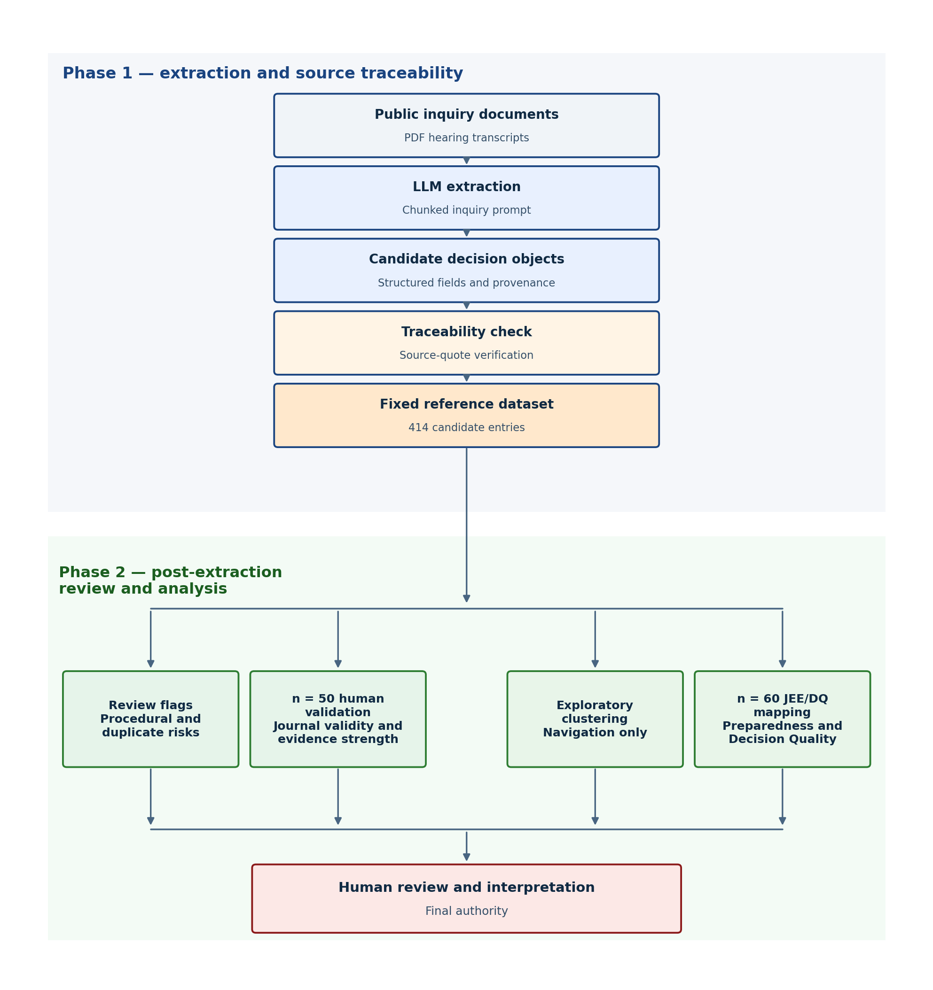
Figure 3.1. Two-phase workflow from public inquiry transcripts to a fixed reference dataset of candidate decision-journal entries. Phase 1 covers extraction and source traceability. Phase 2 applies review flags, n = 50 human validation, exploratory clustering for navigation, and a supplementary n = 60 Joint External Evaluation and Decision Quality mapping pilot. Human judgement remains the final authority for interpretation.

Table 3.1. Evaluation methods and the populations or samples they address.
Method | Question answered | Population or sample
Mechanical traceability | Can the source quote be located in the processed transcript? | All 414 candidates
Review flags | Which candidates need human caution? | All 414 candidates
n = 50 human validation | Is the entry a valid journal item, and how strongly does the quote support the extracted text? | Stratified sample of 50
Exploratory clustering | How can reviewers navigate the candidate pool? | All 414 candidates
n = 60 JEE/DQ mapping | Can source passages support preparedness or Decision Quality interpretation? | Purposive sample of 60

3.2 Case study and corpus

3.2.1 Case study: UK COVID-19 Inquiry Module 2
The empirical case is Module 2 of the UK COVID-19 Inquiry public archive, which focuses on core UK decision-making and political governance. Public hearing transcripts are suitable for decision extraction because they contain formal governance discussion, are publicly available for reproducibility, and require provenance for any claim attributed to the record. Module 2 concentrates on the core decision-making period the journal is designed to capture, while remaining small enough to evaluate carefully within an MSc project.

3.2.2 Phase 1 corpus: eight hearing transcripts
Phase 1 used eight Module 2 hearing transcripts spanning 28 November 2023 to 23 May 2024. Selection was purposive: complete PDF and text availability, a mix of witness types, and coverage of early and late Module 2 hearings. Eight transcripts provided enough variation to evaluate extraction behaviour while remaining feasible for manual validation. The wider Inquiry archive is much larger; that archive was not fully processed or manually annotated in this study.
Table 3.2. Phase 1 hearing transcript sample.
Hearing date | Approx. role in sample
28 Nov 2023 | Manual annotation (Gove / Cabinet Office)
30 Nov 2023 | Manual annotation (Gove narrative excerpts)
01 Dec 2023 | Manual annotation (Hancock)
07, 11, 13, 14 Dec 2023 | Broader automated extraction only
23 May 2024 | Broader automated extraction only

A report-genre pilot (one Inquiry “In Brief” PDF) illustrates a second document type but is not part of the fixed reference dataset; it is reported separately in Chapter 4.

3.2.3 Operational definition of a decision-journal entry
Manual annotation and Phase 2 validity assessment (Rubric A) use the following operational definition:
Decision journal entries record pandemic-response agreements, adopted measures, and authoritative directions (who decided or agreed what), as stated in the source text, including when recalled in inquiry evidence, each backed by a verbatim source quote. Witness opinion, speculation, and options that were not agreed are excluded.
This definition is stricter than colloquial use of “decision” in transcript dialogue. Advocacy, retrospective lessons, procedural hearing administration, and invitations to recommend are excluded even when the LLM extracts them with a supporting quote.
The inquiry-mode LLM prompt asks for “formal decisions announced during the hearing,” which partially aligns with this definition but can blur historical COBR or COVID-O decisions cited in testimony. That definitional tension is an evaluation finding reported in Chapter 4.

3.3 Extraction and source traceability

3.3.1 Data ingestion
Public inquiry documents were ingested through a staged, reproducible pipeline:
1. Harvest: Module 2 hearing metadata from the public inquiry API.
2. Download: hearing PDFs to local storage.
3. Text extraction: PDF-to-text with inquiry-aware cleanup of line breaks, page artefacts, and spacing.
The source list and processing settings were version-controlled so that the same corpus can be reproduced. Raw PDFs were not stored in the project repository because of file size; processed text and extraction outputs were retained for audit.
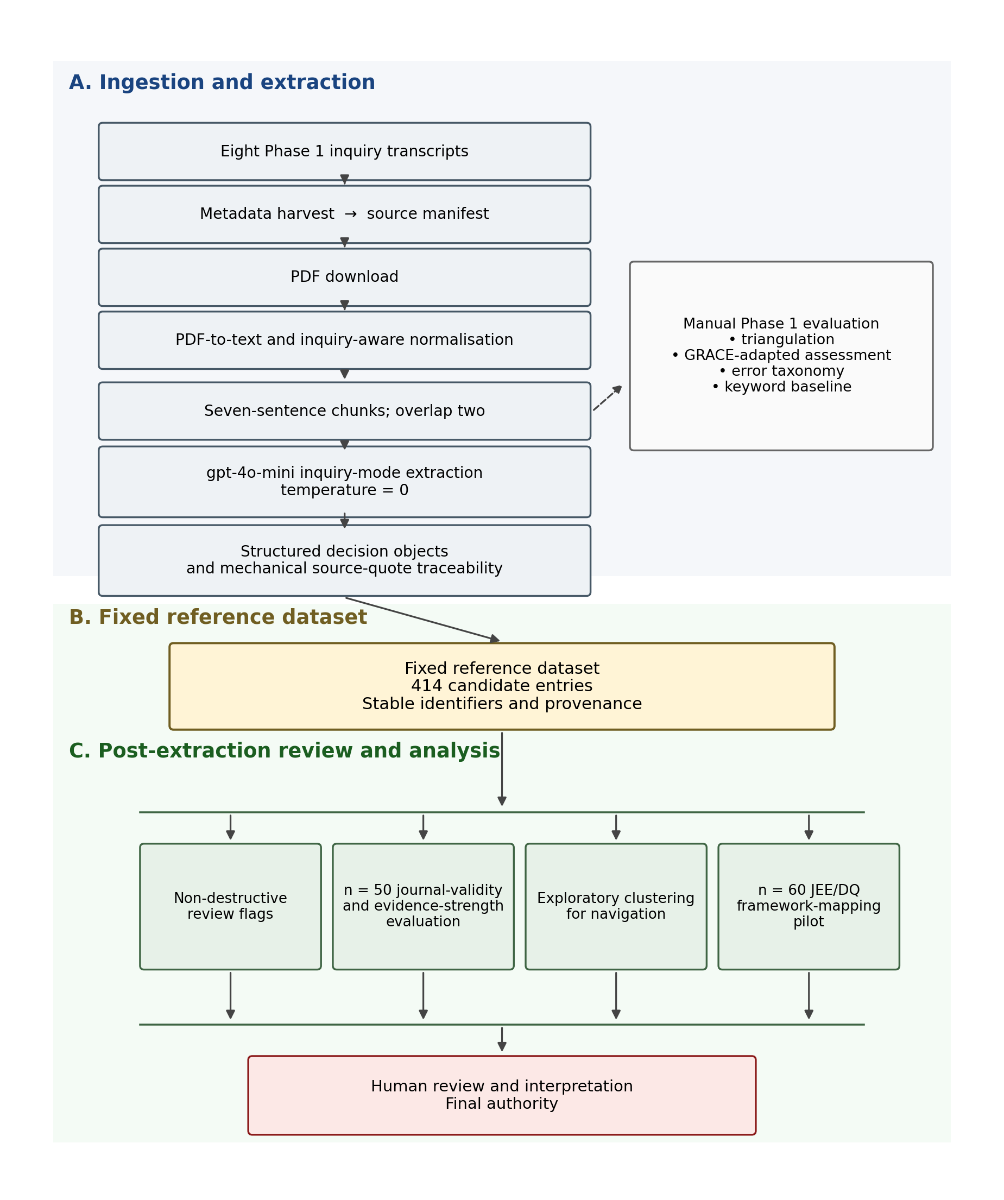
Figure 3.2. Technical implementation pipeline from eight inquiry transcripts to the fixed reference dataset and the separate evaluation, review, clustering and framework-mapping activities.

Retrieval-augmented generation was not adopted because extraction operated on sequential, fixed transcript chunks rather than retrieval across a heterogeneous collection. Each complete chunk is supplied directly to the model, which simplifies item-level provenance and mechanical traceability.

3.3.2 Model, chunking and temperature
Extraction used gpt-4o-mini through the OpenAI API. Transcripts were split into overlapping sentence windows of seven sentences per chunk with overlap of two. Sentence boundaries were preferred over fixed token windows so that source-location pointers remain interpretable and align with the mechanical traceability check.
Temperature controls how much variation the model is allowed to introduce when generating text. The main Phase 1 extraction used temperature 0 to reduce avoidable variation and support reproducibility of the fixed reference dataset. Temperature 0 does not guarantee identical semantic wording in every regeneration, but it removes one controllable source of randomness. Temperature 0.3 was used only in a separate structural reliability stress-test, reported in Section 4.8, to introduce limited output variation while checking schema consistency.
All eight Phase 1 transcript runs used the inquiry-mode prompt. Each chunk is processed independently; candidate entries from all chunks are merged and deduplicated within the run.

3.3.3 Decision object schema
Each extracted item is a structured object with four mandatory fields:
Table 3.3. Decision object schema.
Field | Purpose
decision | The extracted decision claim (normalised statement)
evidence | The model’s explanation of why the quote supports the decision
source_quote | Verbatim quote from the chunk text
source_location | Sentence-level pointer (for example, sentence_2, sentences_4-5)

Each run also records traceability_ok: a mechanical check that source_quote can be located in the processed source text after alphanumeric normalisation.

3.3.4 Traceability as an auditable floor
A pass confirms a quotable anchor in the source document. It does not confirm that the extraction is a valid decision-journal entry. Failures are classified by type and reported in Chapter 4. Traceability failure does not automatically imply low human confidence on evidence support; those dimensions are evaluated separately later.

3.4 Fixed reference dataset of candidate decision-journal entries
Phase 1 establishes a fixed reference dataset of candidate decision-journal entries before any interpretive processing begins. Extraction outputs from the eight inquiry runs were merged into one dataset with stable identifiers, hearing provenance, extraction fields, traceability outcomes, and space for later annotations.
The fixed reference dataset is the unchanged set of 414 candidate entries created in Phase 1. It is used as the common input for review flags, the n = 50 validation, exploratory clustering, and the n = 60 framework-mapping pilot. Keeping the dataset unchanged allows extraction quality to be evaluated separately from later review and interpretation.
This design supports three practical properties:
1. Auditability: every entry traces to a source transcript and extraction run.
2. Reviewability: humans can inspect or rate entries without re-running extraction.
3. Reproducibility: rebuilding from the same eight runs yields the same identifiers and counts.
The fixed reference dataset is not a verified catalogue of policy decisions. It is a candidate pool for review.

3.5 Phase 1 evaluation
Phase 1 evaluation combines detailed manual review of a small purposive sample with automated measures across the pilot corpus. The manual analysis compares human and LLM extraction, applies adapted GRACE dimensions, and identifies recurring error types. Automated checks assess traceability and compare the LLM with a simple keyword baseline. A separate structural reliability test examines schema consistency under limited output variation (Section 4.8). These methods answer different questions and are therefore reported separately rather than combined into a single quality score [23].

3.5.1 Manual triangulation sample
Six excerpts (approximately 200–450 words each) were drawn from three hearing days (28 November, 30 November and 1 December 2023) and two witness types. The author labelled decisions in each excerpt before inspecting model outputs in the same text regions, then compared manual and LLM extraction using MATA-style convergence categories [23].
Agreement means the manual and LLM labels refer to the same formal decision. Silence means a decision appears in one method only. Dissonance means genuine disagreement on whether a decision exists or what it was. Results are reported in Chapter 4.

3.5.2 GRACE-adapted quality assessment
A subset of LLM items from the triangulation workbook was scored on four dimensions adapted from the GRACE framework [24]: interpretability, actionability, nuance, and redundancy. GRACE characterises output-quality dimensions that traceability and the later confidence rubrics do not capture. It does not replace those methods.

3.5.3 Error taxonomy
To extend analysis beyond six excerpts, a stratified sample of 42 items was constructed: nine author-validated false positives from triangulation silence rows plus 33 heuristic-classified samples from the full inquiry corpus (random seed = 42). Items were labelled by error type. This provides sampled error-pattern evidence without claiming item-by-item manual verification of all 414 candidates.

3.5.4 Keyword baseline
A simple keyword baseline was applied to the same six excerpt regions to establish a lower bound for decision-detection recall against manual labels. Keyword matching isolates lexical trigger sensitivity from LLM semantic extraction. Results are compared in Chapter 4.

3.6 Non-destructive review flags
Review flags mark candidates that need human caution while leaving the full candidate pool intact. Flagged entries remain in the fixed reference dataset so that later analysis can still examine false positives and boundary cases. Flags identify entries for attention; they do not determine journal validity and they do not delete rows.
Table 3.4. Non-destructive review-flag rules.
Flag | Rule (summary)
procedural | Hearing adjournment, resume time, scheduling, or meta-inquiry text
possible_duplicate | Identical normalised decision text or shared source quote (at least 50 characters)

Flag rules were implemented as deterministic pattern checks over decision text and source quotes. Outcomes are reported in Chapter 4.

3.7 Confidence and journal-validity evaluation (n = 50)
The n = 50 evaluation tests whether automated confidence aligns with human judgement. It is separate from the later n = 60 preparedness and Decision Quality pilot.

3.7.1 Stratified sample
Human validation uses a stratified sample of fifty entries drawn from the fixed reference dataset after review flags (random seed = 42). The sample balances triangulation-linked cases, flagged entries, traceability failures, and unflagged traceable entries while remaining practical for detailed manual assessment.
Table 3.5. Stratified confidence-validation sample (n = 50).
Stratum | n | Selection
Triangulation workbook | 15 | Comparison rows mapped to journal IDs where possible
Flagged | 10 | Mix of procedural and possible_duplicate
Traceability fail | 10 | Random from traceability failures
Random unflagged traceable | 15 | traceability_ok = true, empty review_flags

The author rated items blind to automated confidence scores. Automated scores were generated only after the human labels were complete. Each item was presented as an audit package containing the decision text, evidence field, source quote, and source location.

3.7.2 Rubric A: journal validity
Rubric A asks whether the entry belongs in a policy or governance decision journal. It requires domain judgement.
Table 3.6. Rubric A journal-validity criteria.
Rating | Criterion
Yes | Agreed measure, authoritative direction, or adopted action (including recalled in testimony), with plausible quote support
No | Procedural, advocacy, witness opinion, narrative, or unadopted recommendation
Unclear | Borderline; ambiguous cases are retained as findings

3.7.3 Rubric B: evidence strength
Rubric B asks how strongly the audit package supports the stated decision text. It does not ask whether the entry belongs in the journal.
Table 3.7. Rubric B evidence-strength criteria.
Level | Criterion
High | Quote clearly supports the decision text with minimal inference
Medium | Partial or indirect support; some inference or bundling required
Low | Quote missing, unreadable, or does not support the decision

Rubric B used two yes/no checks: whether the quote is present and readable, and whether it supports the decision text, scored as 0 = low, 1 = medium, and 2 = high.

3.7.4 Interpretation framework
Cross-tabulating Rubric A and Rubric B yields interpretable patterns for Chapter 4:
Table 3.8. Rubric A × Rubric B interpretation framework.
Rubric A | Rubric B | Interpretation
Yes | High | Strong journal entries
Yes | Medium | Valid decision; partial or indirect quote support
Yes | Low | Decision-like but weakly evidenced
No | High | Correct extraction of the wrong artefact type
No | Medium | Not a journal entry; quote only partly supports text
No | Low | Noise
Unclear | High | Borderline inclusion; evidence supports extraction well
Unclear | Medium | Borderline inclusion; partial support
Unclear | Low | Borderline inclusion; weak support

3.7.5 Automated confidence signals
On the same stratified sample of 50 items, two automated confidence signals were generated after the human labels were complete:
1. Rule-based baseline: heuristics over decision verbs, hedging language, quote length, and traceability outcome.
2. LLM-assigned confidence: a second pass over decision and quote only, with an explicit reasoning field.
Both signals were compared with Rubric B using linear weighted kappa and were cross-tabulated separately with Rubric A. Linear weighting treats adjacent disagreements as less severe than disagreements across the full evidence-strength scale. Because the ratings were produced by a single author, the comparison is a structured feasibility assessment rather than an independently validated reliability study. Outcomes are reported in Chapter 4.

3.8 Exploratory thematic clustering for journal navigation
Exploratory thematic clustering organises the fixed reference dataset so that reviewers can navigate related candidates. It is an unsupervised organisational method rather than a validity test or formal policy classification.
All 414 candidate entries were included. Each entry was embedded from the concatenated decision text, evidence field, and source quote. OpenAI text-embedding-3-small vectors were clustered with agglomerative clustering using cosine distance. A cosine-distance threshold of 0.68 was used to cut the agglomerative hierarchy, producing 20 groups in this pilot. That value was the configured pilot threshold; it was not established as a universally optimal threshold, and a different cut could change cluster granularity.
Cluster membership was determined before labels were assigned. Heuristic thematic labels were added after the groups formed. The labels are navigation aids for reviewers. They are not a validated public-health taxonomy, and Joint External Evaluation or Decision Quality categories did not determine cluster membership.
The framework-mapping pilot in Section 3.9 uses source-based category assignment rather than clustering and leaves cluster membership unchanged. Results are reported in Chapter 4.

3.9 Supplementary preparedness and Decision Quality mapping pilot
The supplementary pilot applies established preparedness and Decision Quality categories to selected source passages. It is separate from the clustering analysis and does not change cluster membership. It uses a purposive sample of 60 entries. The sample is not statistically representative of all 414 candidates, and no inferential statistics were used. The pilot is supplementary to the main extraction and validation workflow.

3.9.1 Frameworks
The preparedness mapping used the Joint External Evaluation (JEE) tool for International Health Regulations (2005) core capacities [9]. The Decision Quality mapping used the six elements of Decision Quality as presented by Spetzler, Winter and Meyer [10] and operationalised from Decision Education Foundation definitions [11]:
Table 3.9. Decision Quality elements used in the n = 60 mapping pilot.
Element | Meaning in this study
helpful_frame | The passage helps define the decision problem or framing
clear_values | The passage makes trade-offs, priorities, or values explicit
creative_alternatives | The passage identifies or compares credible alternatives
useful_information | The passage supplies information relevant to the decision
sound_reasoning | The passage shows reasoned justification linking evidence and action
commitment_to_follow_through | The passage shows authorised action, implementation, or follow-through

Technical labels are retained for reproducibility; the table above gives their practical meaning.

3.9.2 Evidence basis
Generated decision statements were treated as candidate summaries. Validated source passages were the evidential basis for framework interpretation. Generated wording was not treated as authoritative. Two distinct boundary outcomes were allowed: no_mapping, where the passage did not support a framework category, and insufficient_evidence, where the available excerpt was too thin to decide.

3.9.3 Candidate ranking and adjudication
Cosine similarity ranked possible framework categories for each record. The ranking supported reviewer attention but did not determine the final assignment. Final assignments were based on source evidence and human adjudication. Category descriptions and evidence rules were fixed before the final analytical audit.

3.9.4 Review provenance
The n = 60 pilot was adjudicated by one reviewer and supported by AI-assisted source-integrity and coding-consistency audits. All 60 records had been reviewed previously. Six proposed corrections were then confirmed interactively by the reviewer. For 52 records, the consistency audit recommended no change and the earlier coding was retained without a new record-by-record review. Two records met the predefined automatic-clear rule. The resulting classifications should therefore be treated as a single-reviewer feasibility assessment, not as independently validated or gold-standard annotations.

3.9.5 Source-passage traceability classifications
One reviewer also classified how closely each generated decision statement related to its source passage using four categories: exact or near-verbatim; substantively faithful paraphrase; materially unsupported or altered; and non-traceable (Traceability=False). These classifications form a structured feasibility assessment rather than an independently validated estimate of model error.
Empirical mapping outcomes are reported in Chapter 4. This section describes only the method.

3.10 Scope, limitations and ethical considerations

3.10.1 What the research delivers
This project delivers a research pipeline: reproducible scripts, structured artefacts, annotation materials, and evaluation summaries suitable for independent audit within the eight-transcript pilot.

3.10.2 What was not built
Table 3.10. Items deferred beyond MSc scope.
Deferred item | Rationale
Full processing of the wider Inquiry archive | Eight transcripts were processed; the larger archive was not fully processed or manually annotated within MSc scope
Decision dependency network | Outside the contribution of this extraction and validation study; reserved for future work
Model retraining / feedback loop | The study evaluated prompt-based extraction and validation rather than supervised model development; a sufficiently large, independently validated labelled dataset was unavailable
Actionability scoring | Would require a validated entry set and stakeholder-agreed criteria beyond the present pilot
Full deployment or live decision support | Outside the research scope of this MSc project

Recognised preparedness and Decision Quality frameworks were examined through the supplementary n = 60 pilot in Section 3.9 rather than being deferred.

3.10.3 Ethical and data considerations
All source materials are from the public UK COVID-19 Inquiry archive. No private or participant-identifiable data beyond what is already published in hearing transcripts was collected. The author conducted the manual annotation and validation on the bounded samples; inter-rater reliability with a second human coder was not performed within project scope and is noted as a limitation in Chapter 5.
The extraction used the OpenAI API. Detailed token-usage and cost records were not retained for the Phase 1 runs, so computational cost was not evaluated as part of the study.

3.11 Chapter summary
Chapter 3 specified a two-phase methodology. Phase 1 extracts candidate entries from eight Module 2 transcripts, checks source-quote location, and stores the results as a fixed reference dataset of 414 candidates. Phase 2 then applies non-destructive review flags, an n = 50 dual-rubric human validation of journal validity and evidence strength, exploratory clustering for navigation, and a supplementary n = 60 Joint External Evaluation and Decision Quality mapping pilot. Human judgement remains necessary for interpretation. Chapter 4 reports the empirical outcomes.

Chapter 4 — Results and evaluation

4.1 Overview of key results
This chapter reports the evaluation outcomes for the Module 2 pilot. The findings are organised by sample: the fixed reference dataset of candidate decision-journal entries (n = 414), the stratified dual-rubric validation (n = 50), and the supplementary preparedness and Decision Quality pilot (n = 60). Figure 3.1 summarises the corresponding workflow.
The eight-transcript extraction produced 414 candidate entries, of which 351/414 (84.8%) passed mechanical source-quote traceability. In the stratified n = 50 validation sample, the most frequent Rubric A × Rubric B cell was no × high, 21/50 (42%): the quoted passage strongly supported the generated statement, but the item did not meet the operational journal definition. Automated confidence aligned more closely with evidence strength than with journal validity.
Exploratory clustering organised the 414 candidates into 20 groups for navigation, not verification. In the purposive n = 60 pilot, an observable Decision Quality element was found more often than a defensible Joint External Evaluation (JEE) mapping: 37/60 versus 11/60. The most frequent combined outcome in that pilot was observable Decision Quality without a defensible JEE mapping, 26/60 (43.3%). Candidate-decision wording was not always reliable enough to serve as evidence: 8/60 were exact or near-verbatim, 25/60 substantively faithful paraphrases, 20/60 materially unsupported or altered, and 7/60 non-traceable. All sample-specific findings apply only to the stated denominator.

4.2 Extraction and source traceability (n = 414)
Automated evaluation began with the inquiry-mode extractor on all eight Phase 1 Module 2 hearing transcripts. Table 4.1 summarises the corpus totals that define the fixed reference dataset.
Table 4.1. Phase 1 corpus totals.
Metric | Value
Transcripts processed | 8
Candidate entries | 414
Traceability pass | 351/414 (84.8%)
Traceability fail | 63/414 (15.2%)

Per-hearing traceability ranged from 78% (23 May 2024) to 91% (28 November 2023). Variation was mainly associated with processed-text and layout artefacts rather than absent quote fields. The full per-hearing table is reported in Appendix B.
On the two hearing days that received both default and inquiry-mode runs (30 November and 1 December 2023), inquiry mode extracted fewer candidates than the default prompt (50 versus 333; 32 versus 162). That comparison is limited to those two hearings and does not establish general model superiority. The full prompt-comparison table is in Appendix B.
Traceability failures were predominantly source_quote_not_found_in_text: the model returned a quote field that alphanumeric normalisation could not locate in the processed source text. These failures reflect PDF layout, line-break and normalisation effects. A smaller number involved bad source-location pointers. Mechanical pass/fail remains necessary but not sufficient for extraction quality.

4.3 Manual evaluation and extraction failure modes
Manual evaluation used the operational journal definition on six annotated excerpts from three hearing days. Triangulation followed the agreement / silence / dissonance categories in Table 4.2.
Table 4.2. Manual triangulation results.
Category | Meaning | Count
Agreement | Same formal decision; meaning aligns | 5
Silence | Present in one method only | 10
Dissonance | Genuine disagreement on decision existence or content | 0

The comparison comprised 15 rows and six manual decisions, with no dissonance. The ten silence rows were LLM-only extractions without a corresponding manual decision. Recurring false-positive types included narrative description, future recommendations and ministerial advocacy. Detailed excerpt text, identifiers, source spans and linked extraction IDs are in Appendix A.
Where LLM items were reviewed for quote support independent of journal validity, grounding was scored yes for 5 items, partial for 2 and no for 8. The eight unsupported scores align with silence-row false positives: a quote may be present without supporting a formal decision claim.
To extend beyond six excerpts, a stratified sample of 42 items was examined: 9 author-validated false positives from triangulation silence rows and 33 heuristic-classified items from the wider inquiry corpus. Figure 4.3 shows the assigned categories. The distribution should not be treated as full human validation of all 42 items, nor as representative of all 414 candidates. Among the author-validated false positives, advocacy, future recommendation and narrative were recurring types. The heterogeneous “other” category collected cases that did not recur frequently enough to justify separate named labels. Detailed definitions and counts are in Appendix B.
A simple keyword baseline on the same six excerpts recovered 1/6 of the manual decisions, compared with 5/6 agreement-row recall for inquiry-mode extraction. The baseline was intentionally simple and applies only to those excerpts. Per-excerpt keyword results are in Appendix B.
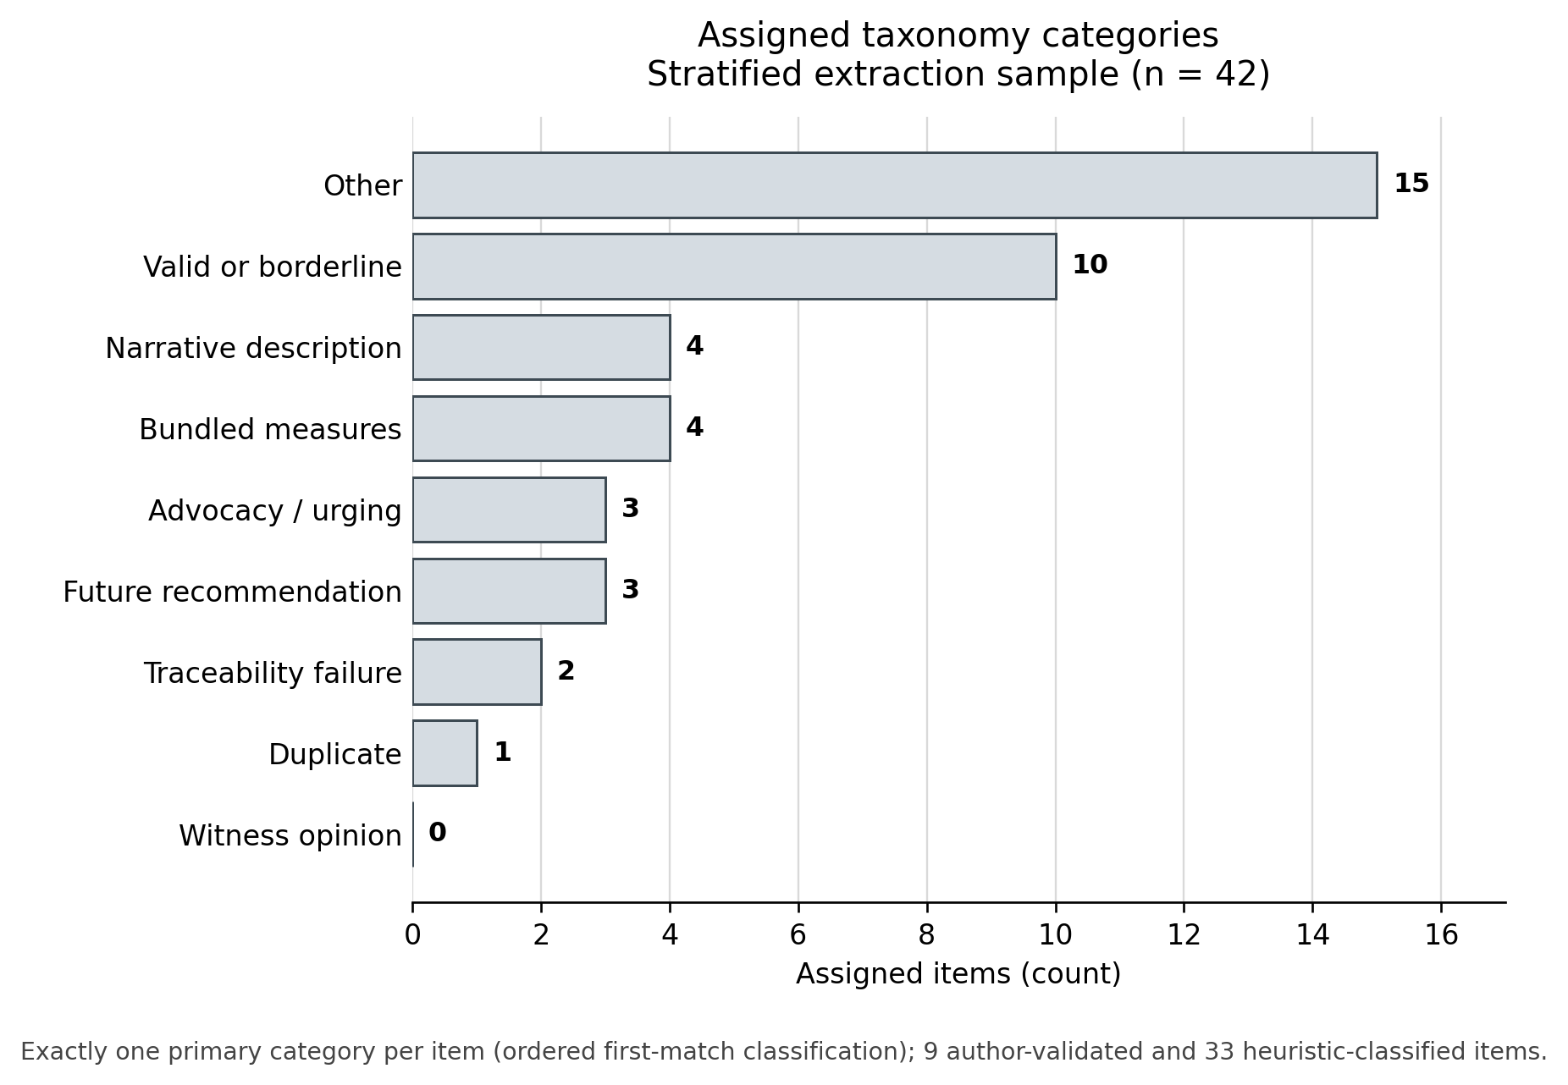
Figure 4.3. Assigned error categories in the stratified sample (n = 42).

4.4 Fixed reference dataset and non-destructive review flags
The eight Phase 1 extraction runs were merged into the fixed reference dataset used for all later review and analysis. Stable identifiers range from phase1-001 to phase1-414. Corpus totals are those already reported in Section 4.2; they are not repeated here.
Non-destructive review flags were applied using the rules defined in Chapter 3 Section 3.6. In the fixed reference dataset, 36/414 entries were flagged: 4 procedural and 32 possible duplicate. No rows were deleted. Flag counts mark review need and are not performance scores. Procedural flags also illustrate why journal validity and evidence strength must be rated separately: a hearing adjournment can be quote-supported while still failing the journal definition.

4.5 Journal validity, evidence strength and automated confidence (n = 50)
Human validation on a stratified sample of fifty entries (Chapter 3 Section 3.7) rated Rubric A (valid decision-journal entry?) and Rubric B (strength of quote-to-decision support?) blind to automated confidence scores.
Figure 4.9 shows the Rubric A × Rubric B cross-tabulation. In the stratified n = 50 sample, the most frequent cross-tabulation cell was no × high (21/50, 42%). Clean yes × high entries accounted for 11/50 (22%). The remaining cells were no × medium (11/50), no × low (1/50), unclear × high (5/50) and unclear × medium (1/50). Marginally, Rubric A comprised 11 yes, 33 no and 6 unclear; Rubric B comprised 37 high, 12 medium and 1 low. High evidence strength was therefore common, but journal suitability was not.
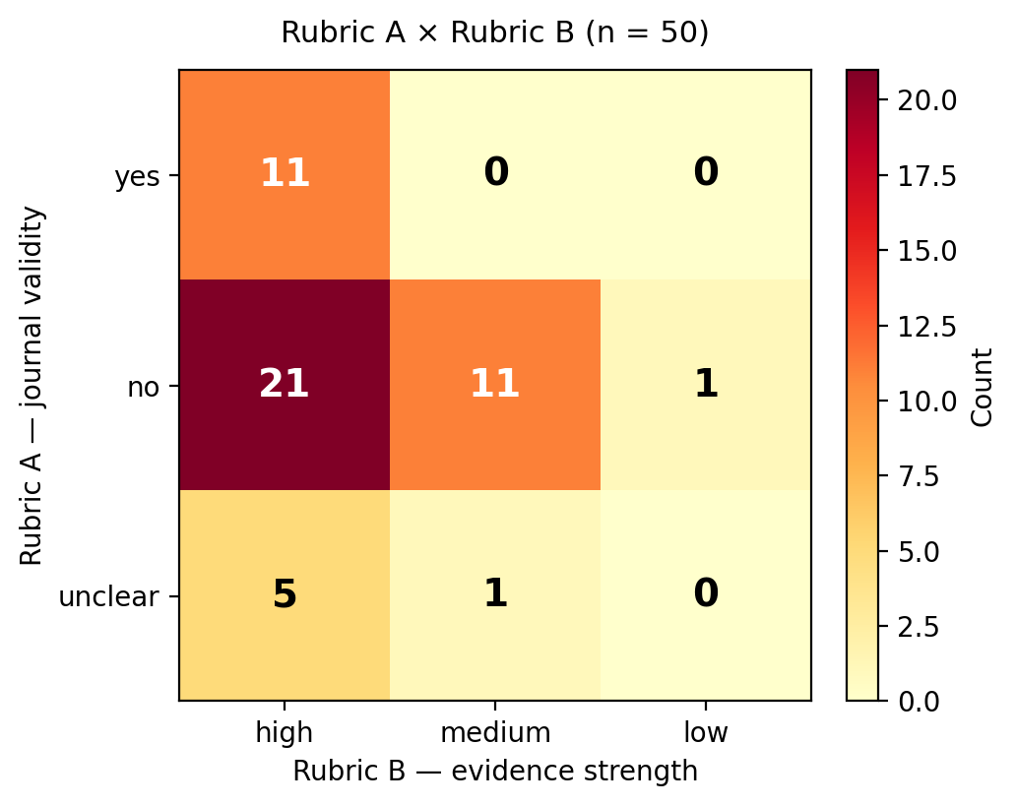
Figure 4.9. Rubric A × Rubric B cross-tabulation (n = 50).

After human rating, two automated confidence signals were compared with Rubric B (Table 4.3). Linear weighted kappa treats adjacent disagreements as less severe than disagreements across the full evidence-strength scale. Neither signal showed sufficient agreement to replace human judgement on journal inclusion. When automated confidence was high, only about one in four items were Rubric A = yes, which is consistent with confidence tracking evidence strength better than journal validity.
Table 4.3. Automated confidence agreement with human Rubric B.
Signal | Exact agreement | Linear weighted κ
Rule baseline | 80% | 0.48
LLM second pass | 76% | 0.39

An exploratory discourse-tag analysis on the same fifty items assigned all 21 no × high cases to non-policy inquiry-discourse tags. Fourteen of the fifty items remained unclassified where applicable. The genre-blindness reading is exploratory; the tags were not a validated classifier or a causal analysis.

4.6 Exploratory thematic clustering for navigation (n = 414)
Exploratory thematic clustering organised all 414 candidates into 20 groups using agglomerative clustering on OpenAI text-embedding-3-small embeddings with cosine distance. No entries were left unclustered under the configured cut. Labels were applied after the groups formed and remain heuristic navigation aids. Cluster membership is not JEE or Decision Quality mapping, and the framework-mapping pilot in Section 4.7 leaves cluster membership unchanged.
Figure 4.10 shows the distribution of group sizes. The largest groups provide starting points for navigation, although group size does not establish policy importance or journal validity. Smaller groups include inquiry-procedure content alongside policy themes, which is consistent with the n = 50 finding that quote support does not guarantee journal suitability. Detailed cluster composition and example entries are in Appendix C.
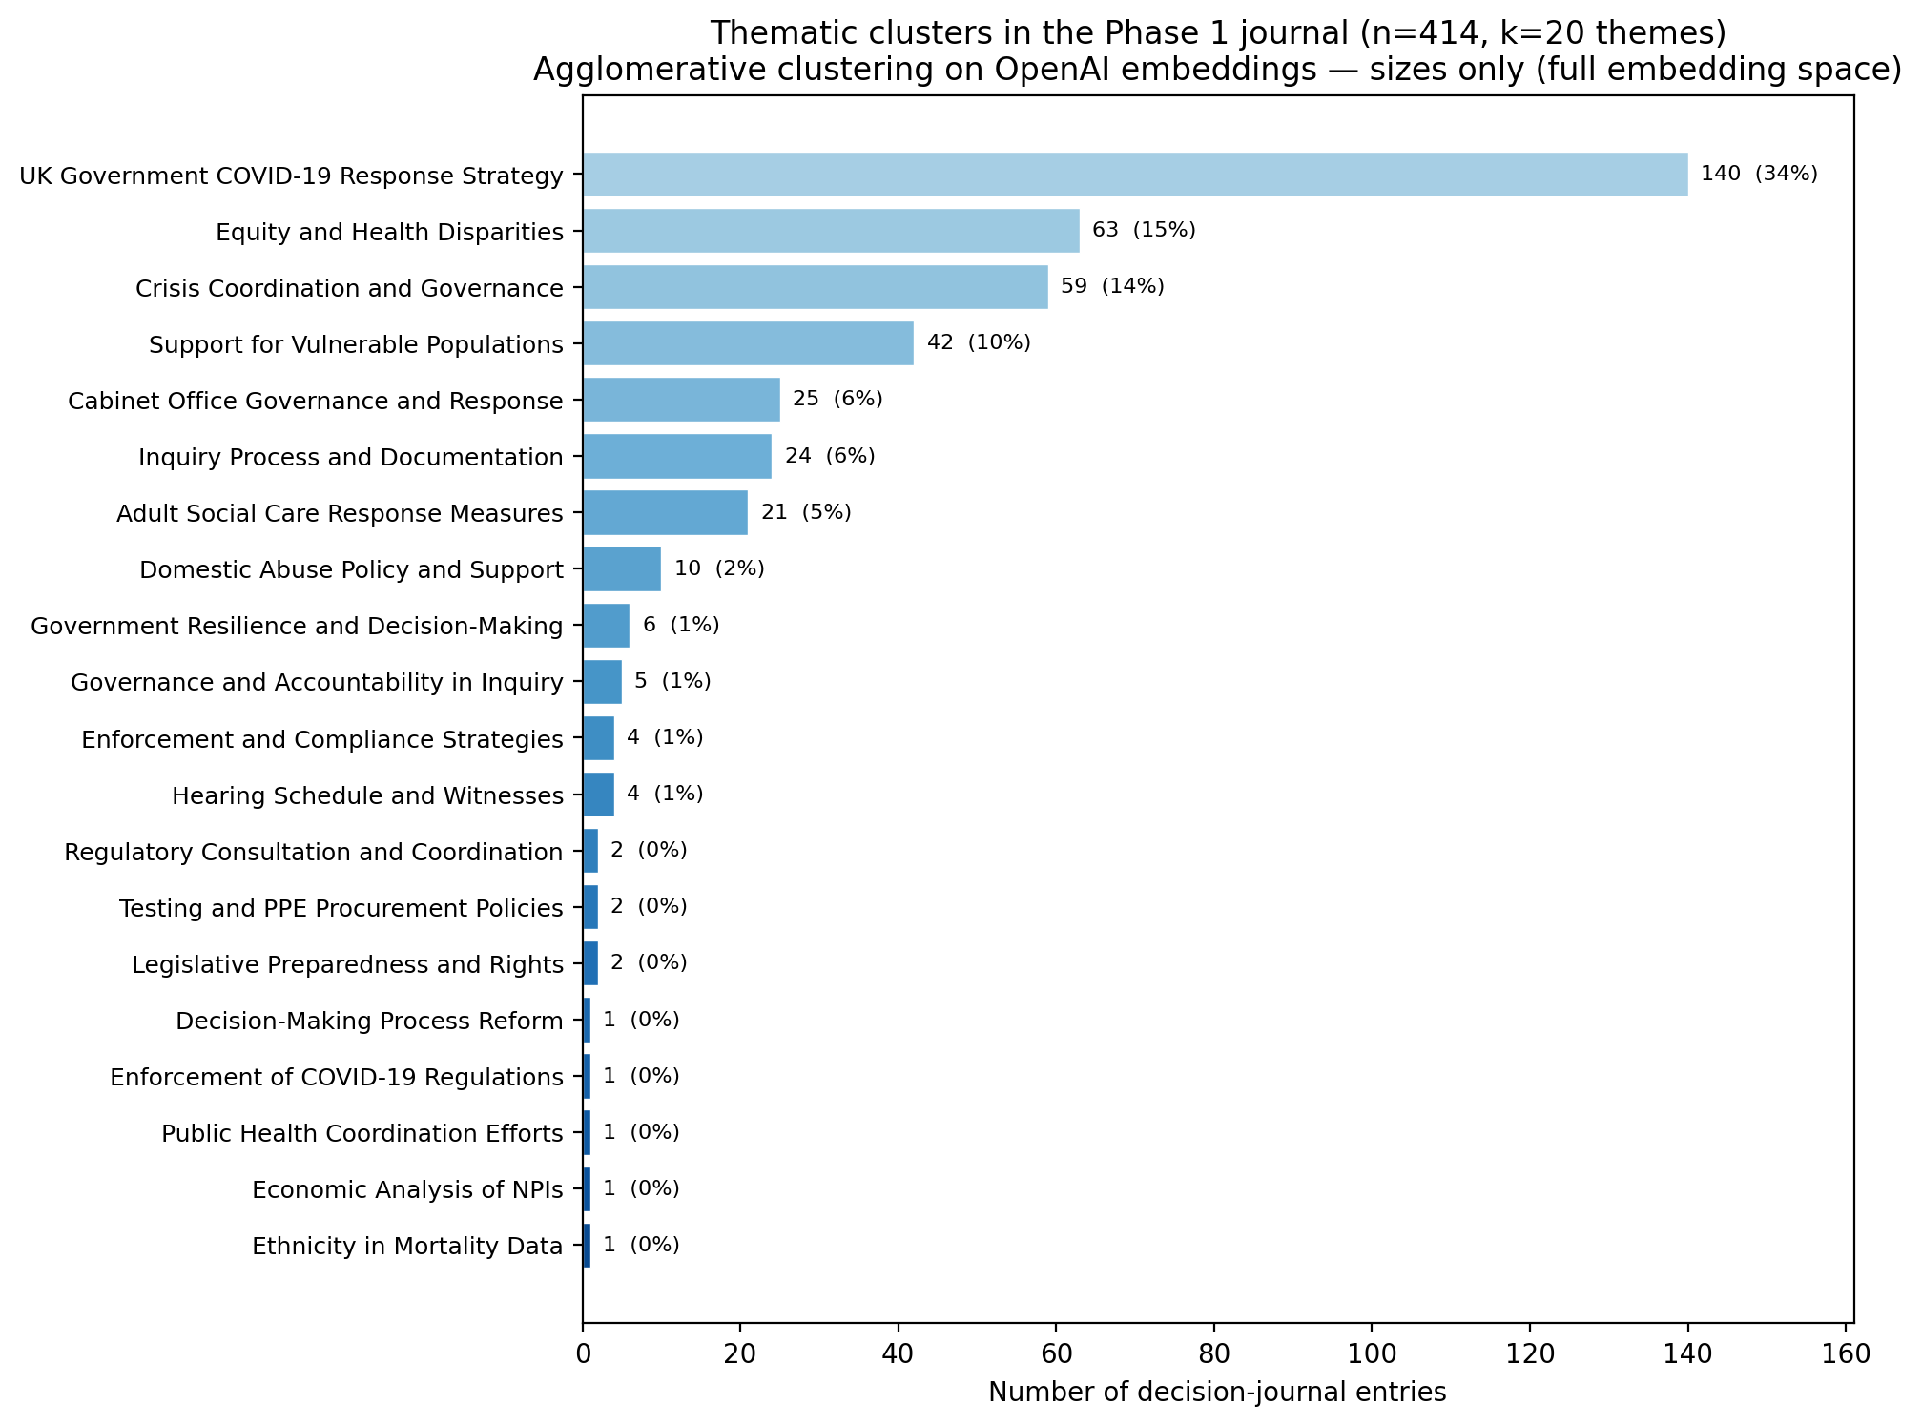
Figure 4.10. Theme distribution across 20 heuristic groups.

4.7 Supplementary preparedness and Decision Quality findings (n = 60)
The supplementary pilot applied JEE preparedness and Decision Quality categories to a purposive sample of 60 records (Chapter 3 Section 3.9). The sample is not statistically representative of the 414 candidates, and no inferential statistics were used. Validated source passages, rather than generated decision wording, were the evidential basis for framework interpretation.
Table 4.4 reports the framework-mapping outcomes. JEE mapping was assigned for 11/60 records (18.3%). The remaining outcomes were no_mapping (16/60, 26.7%), insufficient_evidence (22/60, 36.7%) and procedural or inquiry content (11/60, 18.3%). These last two outcomes are different: no_mapping means the passage was understood but did not support a preparedness capacity, whereas insufficient_evidence means the available excerpt was too thin to decide. An observable Decision Quality element was recorded for 37/60 records (61.7%). The most frequent combined outcome in this purposive 60-record pilot was an observable Decision Quality element without a defensible JEE mapping, 26/60 (43.3%).
Table 4.4. Framework-mapping outcomes in the n = 60 pilot.
Result family | Outcome | Count | Percentage
JEE | Mapped | 11/60 | 18.3%
JEE | no_mapping | 16/60 | 26.7%
JEE | insufficient_evidence | 22/60 | 36.7%
JEE | Procedural/inquiry | 11/60 | 18.3%
Decision Quality | Observable Decision Quality element | 37/60 | 61.7%
Combined JEE/DQ | Observable Decision Quality without defensible JEE mapping | 26/60 | 43.3%

Note. The four JEE rows partition the n = 60 sample. The Decision Quality and combined rows overlap with those JEE outcomes and should not be added to the JEE total.
Decision Quality elements describe features visible in a decision passage, such as framing, values or commitment to follow through. JEE mapping requires evidence of a specific preparedness capacity. An observable Decision Quality element does not mean that the underlying decision was good, and a JEE mapping does not demonstrate adequate preparedness performance.
Among the 11 JEE-mapped records, Infection prevention and control (R4) occurred in 3/11 (27.3%), while IHR coordination, National IHR Focal Point functions and advocacy (P3), Surveillance (D2), and Risk communication and community engagement (R5) each occurred in 2/11 (18.2%). Those shares should not be overinterpreted given the small mapped denominator. Among the 37 Decision Quality-mapped records, the primary elements were commitment to follow through (22/37, 59.5%), helpful frame (8/37, 21.6%), clear values (6/37, 16.2%) and useful information (1/37, 2.7%).
Source-level traceability was available for 53/60 records (88.3%). That figure records the availability of a traceable source passage. It does not establish that the generated decision statement faithfully represented that passage.
Table 4.5 reports the candidate-statement faithfulness classifications. Generated decision statements were not treated as authoritative evidence. Of the 60 candidate decisions, 8 were exact or near-verbatim representations of their source passages and 25 were judged to be substantively faithful paraphrases. Twenty introduced materially unsupported or altered meaning despite retaining a traceable source passage, while 7 were classified as non-traceable (Traceability=False). Framework interpretation therefore relied on the validated source passage rather than the generated decision statement. These categories were assigned by a single reviewer and should be interpreted as a structured feasibility assessment rather than an independently validated estimate of model error.
Table 4.5. Candidate-statement faithfulness classifications (n = 60).
Classification | Count | Percentage
Exact or near-verbatim | 8/60 | 13.3%
Substantively faithful paraphrase | 25/60 | 41.7%
Materially unsupported or altered | 20/60 | 33.3%
Non-traceable (Traceability=False) | 7/60 | 11.7%

The pilot used single-reviewer adjudication supported by AI-assisted source-integrity and consistency audits. Six proposed corrections received interactive confirmation; 52 records retained earlier coding without a new record-by-record review; and 2 records met the predefined automatic-clear rule. Further review-provenance detail is provided in Appendix B and retained in the project repository.

4.8 Supplementary robustness and transfer checks
Supplementary checks tested quality lenses and transfer beyond the main hearing corpus. Table 4.6 summarises the bounded outcomes. Detailed tables are in Appendix B.
Table 4.6. Supplementary robustness and transfer checks.
Check | Scope | Main result
GRACE-adapted assessment | n = 16 triangulation-linked items | Descriptive quality lens only; not a journal-validity filter
Keyword lower-bound comparison | Six annotated excerpts | Keyword recall 1/6; LLM agreement-row recall 5/6
Report-genre pilot | One Module 2 “In Brief” report | 53 candidates; 50/53 mechanically traceable; no manual validation
Structural reliability stress-test | 50 regenerations at temperature 0.3 | 49/50 structural pass; schema robustness only

The GRACE-adapted scores are a descriptive quality lens only. The report-genre pilot shows transfer to a second document type, but those 53 items were not merged into the fixed reference dataset and were not manually validated. The structural reliability stress-test used temperature 0.3 and measured structural consistency only; the 49/50 pass rate does not establish decision accuracy or journal validity.

4.9 Summary of key findings
The Module 2 pilot produced 414 candidate entries with 84.8% mechanical traceability. In the stratified n = 50 sample, the most frequent dual-rubric cell was no × high (21/50), so evidence strength and journal validity must be assessed separately. Automated confidence tracked Rubric B more closely than journal inclusion. Clustering organised the 414 candidates into 20 navigation groups without validating them. In the purposive n = 60 pilot, Decision Quality features were observable more often than defensible JEE mappings, and framework interpretation depended on validated source passages rather than generated decision wording.

Chapter 5 — Discussion and conclusion
This chapter considers what the findings mean for AI-assisted decision journaling and for the use of extracted public records in policy review. The results show that producing traceable candidate records is technically feasible at the scale examined, but traceability alone does not establish that an entry belongs in a decision journal or that its generated summary faithfully represents the source. The discussion therefore focuses on the distinction between candidate generation and human validation, the complementary roles of clustering and recognised policy frameworks, and the conditions under which the approach could support organisational learning.

5.1 Interpretation of the main findings

5.1.1 Traceability, fidelity and journal validity
Mechanical source-quote traceability on the fixed reference dataset of candidate decision-journal entries showed that most extracted quotes could be located in the processed hearing text (Chapter 4 Section 4.2). That check matters: without a locatable anchor, a candidate cannot be audited against the public record. It is not, however, a test of journal membership. The stratified n = 50 validation separated evidence strength from journal validity and showed that strong quote support can accompany items that still fail the operational journal definition (Chapter 4 Section 4.5). In short, the extractor can reproduce decision-like language accurately while proposing the wrong kind of artefact for a decision journal.
The purposive n = 60 pilot sharpens the same point from another direction. Source-level traceability records whether a usable source passage is available; candidate-statement faithfulness asks whether the generated decision wording accurately represents that passage (Chapter 4 Section 4.7). Those questions are related but not identical. A passage can be available while the generated summary introduces unsupported or altered meaning. For policy interpretation, therefore, the validated source passage remains authoritative. Generated candidate statements are working products for review, not substitutes for the underlying transcript evidence [6], [26].

5.1.2 Confidence, discourse and human judgement
In the stratified n = 50 sample, the most frequent Rubric A × Rubric B cell was no × high: the quoted passage strongly supported the generated text, yet the item did not meet the journal definition (Chapter 4 Section 4.5). That cell pattern should not be read as a corpus-wide prevalence estimate. It is a sample-specific signal that discourse or artefact type can be misclassified even where quote support is strong. The exploratory discourse tags applied to the same fifty items are consistent with a genre-blindness working hypothesis, but they left some records unclassified and do not establish a causal mechanism. The safer claim is narrower: human judgement is still required to decide whether an extraction belongs in a decision journal, and that judgement is not reducible to quote matching alone [22], [23].
Automated confidence behaved in line with that separation. Both the rule baseline and the LLM second pass aligned more closely with evidence strength than with journal inclusion (Chapter 4 Section 4.5). High automated confidence may help reviewers decide where to look first. It cannot replace a domain decision about artefact type, and it should not be treated as a self-reported guarantee of quality [5], [6]. The practical implication is a review posture rather than a new failure-mode claim: treat confidence as an inspection aid, keep journal validity as a human call, and avoid collapsing fidelity and suitability into a single score.

5.1.3 Clustering and framework mapping as complementary methods
Exploratory clustering organised all 414 candidates into thematic groups for navigation (Chapter 4 Section 4.6). Heuristic labels were applied after the groups formed. Those labels help a reviewer find related candidates; they are not a validated policy ontology and they do not verify journal membership. Separately, the purposive n = 60 pilot applied recognised Joint External Evaluation (JEE) preparedness and Decision Quality categories to source passages (Chapter 4 Section 4.7; Chapter 3 Section 3.9). Framework mapping did not rerun, replace or validate clustering. The two analyses answer different questions.
Clustering can make a large candidate pool easier to navigate. Decision Quality mapping asks which features of the decision process are visible in a passage, such as framing, information use, values or commitment to follow through [10]. JEE mapping asks whether the available evidence supports assignment to a recognised preparedness capacity [9]. In the purposive 60-record pilot, an observable Decision Quality element was recorded for 37/60 records and a defensible JEE mapping for 11/60. Within that pilot, the most frequent combined outcome was an observable Decision Quality element without a defensible JEE mapping, 26/60 (Chapter 4 Section 4.7). A defensible reading is that a transcript passage may show how an issue was framed, what information was used or whether implementation followed, while still lacking enough capacity-specific evidence for a preparedness assignment. That pattern does not mean Decision Quality mapping proves a decision was good, that JEE non-mapping indicates poor preparedness, or that the n = 60 distribution estimates the full 414-entry set.

5.2 Methodological and policy contribution

5.2.1 Governed candidate generation and review
The main methodological contribution is a governed process for creating and reviewing candidate decision-journal entries from public inquiry text. The pipeline generates candidates with mandatory provenance fields, checks mechanical traceability, and stores a fixed reference dataset so later enrichment does not silently rewrite the extraction object. Non-destructive review flags mark caution without deleting rows. Dual-rubric human validation separates journal validity from evidence strength. Automated confidence is compared with those judgements rather than accepted at face value. Clustering supports navigation across the candidate pool, while recognised frameworks support structured interpretation on a bounded supplementary sample. Human judgement determines journal inclusion.
That contribution is deliberately bounded. It is not a new clustering algorithm, a new JEE instrument, a new Decision Quality theory, an automatically verified policy catalogue, or a deployment-ready application for inquiry staff. Its claim is procedural: candidate generation and candidate evaluation can be kept separate, auditable and inspectable at MSc pilot scale, in a form that makes failure modes visible before any institutional use [17], [18], [19].

5.2.2 Organisational learning and public-sector relevance
UK COVID-19 Inquiry Module 2 is the empirical case study through which the dissertation examines a broader problem: how public-health and crisis institutions can reconstruct decision records from complex public transcripts under auditable governance. Structured decision recording has long been linked to accountability and organisational learning [1], [2], [3]. Public inquiries extend that logic to society-wide events, but hearing transcripts are not themselves decision journals. A governed extraction-and-review workflow sits between those two artefacts.
Used carefully, such a workflow could support retrospective reconstruction of what was said to have been decided; source-linked review of the evidence attached to candidate records; inspection of framing, information use and follow-through where those features are visible; and navigation across large candidate sets. It can also keep AI-generated candidates visibly distinct from human-validated entries, which is a minimum requirement if institutions are to use language models without mistaking generated summaries for settled findings [17], [18], [19]. Decision Quality and JEE categories can help public-health readers ask recognisable review questions about process features and preparedness capacities, provided the mappings remain interpretive aids rather than performance scores [9], [10].
The claim stops there. The prototype does not determine whether a government decision was correct, evaluate political performance, measure preparedness adequacy, guarantee improved outcomes, provide live decision support, or stand ready for deployment. Its policy value is methodological and organisational: it shows how candidate records from public text can be generated, challenged and reviewed in a form that supports institutional memory without pretending that machine output has already settled the record.

5.3 Limitations and threats to validity

5.3.1 Case-study and corpus scope
The evaluation used eight Module 2 hearing transcripts rather than the wider Inquiry archive of approximately 300 documents. The corpus was purposive, chosen for pilot feasibility and for hearings concerned with core decision-making and political governance. Public inquiry hearings are an adversarial and retrospective genre; transfer to other document types remains limited. A single report-genre pilot showed that the pipeline can run beyond hearing transcripts, but those outputs were not manually validated and were not merged into the fixed reference dataset (Chapter 4 Section 4.8). Feasibility at MSc scale does not establish production scalability or economic efficiency.

5.3.2 Human review and sample design
Both principal human evaluations were single-reviewer designs. In the stratified n = 50 validation, all ratings were made by the author. The reported kappa values measure alignment between automated confidence signals and the author’s Rubric B ratings; they are not inter-rater reliability coefficients [28]. Sparse cells in the Rubric A × Rubric B cross-tabulation also limit how firmly cell proportions, including the no × high pattern, can be interpreted. That pattern remains a sample-specific finding, not a corpus-wide error rate (Chapter 4 Section 4.5).
In the purposive n = 60 framework-mapping pilot, original adjudication was likewise by one reviewer. Six proposed corrections received interactive confirmation, 52 records retained earlier coding without a new record-by-record review, and two met the predefined automatic-clear rule (Chapter 4 Section 4.7; Appendix B.8). Candidate-statement faithfulness classifications were also assigned by a single reviewer. These outputs support a structured feasibility assessment; they are not independently validated gold-standard annotations, and the n = 60 sample is not representative of all 414 candidates.

5.3.3 Technical and analytical limitations
Mechanical traceability tests presence in processed plain text, not page-level linkage to published Inquiry PDFs, and source locations remain chunk-relative. Extraction used a single model with fixed inquiry-mode prompting and chunking; no model or prompt ablation was run at corpus scale. Detailed token-usage and cost records were not retained for the Phase 1 runs, so computational cost was not evaluated as part of the study. The keyword baseline was intentionally simple, and GRACE scoring provided only a supplementary quality lens. The structural reliability stress-test measured schema robustness under limited output variation; it did not establish decision accuracy or journal validity (Chapter 4 Section 4.8).
Clustering structure depends on embedding choice, linkage and cut; heuristic labels are navigation aids rather than a verified ontology, and exploratory projections were illustrative only (Chapter 4 Section 4.6). Framework mapping used cosine similarity only to rank candidate categories for human review; final assignments rested on source-passage adjudication in a purposive sample and should not be read as performance judgements about decision quality or preparedness (Chapter 3 Section 3.9; Chapter 4 Section 4.7).

5.3.4 Ethical and use boundaries
All source material came from the public Inquiry archive. The study did not use private submissions or unpublished evidence bundles. Generated candidate records must not be cited as official Inquiry findings, and source passages should be checked before any interpretive use. AI-generated and human-validated states need to remain visibly distinct. Any organisational deployment would require roles, review capacity and accountability mechanisms beyond the scope of this dissertation [17], [18], [19].

5.4 Conditions for responsible development and scaling
Future development should follow the order of the risks already visible in the results. Inter-rater validation comes first, because both the n = 50 rubrics and the n = 60 framework and faithfulness codes need evidence of stability beyond a single reviewer. Discourse- and speaker-aware checks on journal validity should follow, because the no × high pattern points to artefact-type confusion rather than missing quotes alone. Stronger page-level provenance would then improve audit against published PDFs. Controls for candidate-summary faithfulness are needed before generated wording is treated as an evidence layer. Confidence signals should be recalibrated toward journal validity rather than evidence strength alone. Periodic coding-consistency review is advisable if mapping work expands. Only after those layers are strengthened does wider corpus expansion make methodological sense. Interface, product and deployment work come last: web tools, dependency networks, actionability scoring, live inquiry support and staff deployment all presuppose a validated candidate set and institutional governance that this dissertation does not design.
That order also states the responsible-use conclusion of the supplementary n = 60 analysis. The pilot is suitable as feasibility evidence when its purposive sampling, single-reviewer limits and non-representativeness of the 414-entry set are kept explicit. Broader scaling should wait for stronger independent human validation and planned review capacity. Generated decision statements should not become the evidential basis.

5.5 Conclusion
This dissertation designed and evaluated an LLM-assisted method for producing traceable candidate decision-journal entries from complex public records, using UK COVID-19 Inquiry Module 2 hearings as a case study of a broader public-record decision-journaling problem. At the eight-transcript scale examined, the pipeline produced a fixed reference dataset with mechanical provenance checks, indicating that the workflow was feasible within the study’s bounded scope. Extraction alone was not enough. Journal validity, semantic faithfulness and framework interpretation still required human judgement.
The main contribution is therefore the governed separation of candidate generation from later evaluation: flags, dual rubrics, tested confidence, navigational clustering and bounded framework interpretation operate on one inspectable object without treating machine output as a verified policy catalogue. Used under those constraints, the workflow can support source-linked retrospective review and organisational learning from public emergency records. The next justified step is stronger independent human validation before any expansion of the corpus.

Appendix A — Manual excerpt evidence
This appendix provides the six bounded Module 2 hearing excerpts used for manual triangulation in Chapter 4 Section 4.3. Each excerpt is the exact character-span text from the processed transcript. The project repository retains the machine-readable annotation files and complete extraction-run provenance.
Table A.1. Manual excerpt index for triangulation.
ID | Hearing | Span | Manual | LLM IDs
excerpt_001 | 28 Nov 2023 | 83955–86750 | 1 | 15, 16
excerpt_002 | 28 Nov 2023 | 229233–232162 | 2 | 31, 32
excerpt_003 | 30 Nov 2023 | 0–1382 | 0 | —
excerpt_004 | 30 Nov 2023 | 21739–24495 | 0 | 32–37
excerpt_005 | 01 Dec 2023 | 0–1508 | 0 | 1, 2
excerpt_006 | 01 Dec 2023 | 26169–28883 | 3 | 39, 40

Table A.1 uses short column labels for readability: ID = excerpt identifier; Hearing = hearing date; Span = character span in the processed transcript; Manual = number of manual decisions; LLM IDs = linked extraction item identifiers.

excerpt_001
Hearing date: 28 November 2023
Transcript: transcript-of-module-2-public-hearing-on-28-november-2023
Source span: characters 83955–86750
Linked LLM item IDs: 15, 16

Bounded transcript text
conclusion?A.I believe it was the case that the Secretary of Stateand others within DHSC would have been pressing uponNumber 10 and the Prime Minister the need to act at thattime as well.Q.Well, I'm afraid I need to press you. You say youbelieve. Have you seen emails or communications from 1 2 3 4 5 6 7 8 910111213141516171819202122232425 UK Covid-19 Inquiry 28 November 2023 (17) Pages 65 - 68 69 the DHSC, institutionally, to the Prime Minister saying,"We're behind the curve, we've missed a trick here. Weare delayed and there is an urgent need for morestringent measures and we need a change in strategy"?A.No, but my recollection of the conversations that I hadaround that time was that the Secretary of State was ofthat view and I should say that I'm pretty certain thathe would have communicated that in conversation with thePrime Minister.But, again, I would not have been in all of thoseconversations and one of the reasons why I texted andemailed as I did was to alert people to my concerns andto hope that if they were, as I believed bothDominic Cummings and Matt Hancock were, if they were ofsimilar mind, to feel strengthened in their desire topush forward with these restrictions because they wouldknow that they had my support.Q.On 12 March, as we know, there was self-isolation forindividuals who were symptomatic for seven days?A.Yes.Q.After the weekend, on 16 March, COBR decided that thereneeded to be further, more stringent measures, and youwill recall the household isolation for 14 days, reducedcontact advice, over 70s particularly must ensure thatthey reduce contact? 1 2 3 4 5 6 7 8 910111213141516171819202122232425 70 A.Yes.Q.And there was a warning about the need to move toshielding imminently.On the 18th, COBR decided to close schools fromthe 20th, just in very general terms, Mr Gove.Did you have any direct dealings with the PrimeMinister during the course of that week as to whether ornot those more stringent measures needed to be applied?I ask you this because the evidence from Mr Cummings hasbeen that there was a widespread view -- he said prettymuch everyone -- considered the Prime Minister to beoscillating -- I'm not using his word but that's thesense of it -- in relation to his response. What was your assessment of the Prime Minister'sintent, state of mind, as to whether these measuresshould be countenanced?A.I think the Prime Minister found the decisionsdifficult. It's not that he found decision-makingdifficult, it is that a decision to restrict freedoms inan unprecedented way went against his instincts and theprinciples that governed his political outlook. The Prime Minister at the time, Mr Johnson, wassomeone who was a liberal in so many senses, andcertainly someone who found the idea of restricting freeassociation deeply difficult,

Manual decisions
m1: On 18 March 2020, COBR decided to close schools from 20 March.
Comparison status: 2 triangulation-workbook row(s).

excerpt_002
Hearing date: 28 November 2023
Transcript: transcript-of-module-2-public-hearing-on-28-november-2023
Source span: characters 229233–232162
Linked LLM item IDs: 31, 32

Bounded transcript text
wasemployed frequently to mean England or Great Britain orthe UK. There wasn't clarity in the UK Government'shandling of this matter. My Lady, I've got no further questions. 1 2 3 4 5 6 7 8 910111213141516171819202122232425 UK Covid-19 Inquiry 28 November 2023 (47) Pages 185 - 188 189 A.Can I just say that --LADY HALLETT: I think you have answered that question,thank you very much, Mr Gove. Thank you, Ms Mitchell. Right, Mr Friedman. Don't worry about turning your back, Mr Gove,because we need your voice into the microphone.Questions from MR FRIEDMAN KC MR FRIEDMAN: Thank you, my Lady. Secretary of State, I act for four national disabledpeople's organisations. Can I ask you to look at INQ000083917, please. It is an email from the Covid-19 Taskforce to,amongst others, Emran Mian and Helen Dickinson, but it'scopied to, and I'm going to summarise, departments likethe Minister for Disabled People, people from theEquality Hub and Disability Unit and, about a quarter ofthe way down, Michael Gove Mailbox, private secretary.Do you see your address?A.I do.Q.It's 5 November 2020. And just on the second page,under the heading "Context" it reads: "At the 29 October meeting of COVID-O, the committeeagreed to an ambitious package of measures to preventtransmission to and within groups that have been 1 2 3 4 5 6 7 8 910111213141516171819202122232425 190 disproportionately impacted by COVID-19, focusing inparticular on ethnic minority communities. The PrimeMinister and CDL also asked departments, in slower time,for a more ambitious package that can preventdisproportionate impacts from COVID-19 for people withdisabilities."The question is, why did the Covid Taskforceindicate to the key decision-makes as of 5 November thatthe PM and CDL had acknowledged that the ambitiouspackage for disabled people could be developed ina slower time to that which had been developed andalready agreed for other disproportionately affectedpeople?A.I think Counsel to the Inquiry earlier drew attention tothe fact that I'd written a letter chastising, if that'sthe right word, other government departments for nothaving risen to the challenge of doing everythingpossible for those groups. I think it would have beenthe case that we could have implemented, or wereimplementing, some of the measures that would mitigatethe impact on ethnic minority communities because theywere simply more ready to deliver. My recollectionwould be that more work was required in order to makesure that the additional policies necessary for thoseliving with disabilities were also ready for delivery. 1 2 3 4 5 6 7 8 910111213141516171819202122232425 191 So I don't think it's about a hierarchy of need, I thinkit's about the preparedness of policy.Q.Just on that letter, I don't need to bring it up, butit's the October 2020 letter, the terrible missedopportunity chastisement where you told the chair thisafternoon you wanted everybody to raise their

Manual decisions
m1: At the 29 October 2020 COVID-O meeting, the committee agreed to an ambitious package of measures to prevent transmission among disproportionately impacted groups, focusing on ethnic minority communities.
m2: The Prime Minister and CDL asked departments to develop a more ambitious package (on a slower timeline) to prevent disproportionate COVID-19 impacts on people with disabilities.
Comparison status: 2 triangulation-workbook row(s).

excerpt_003
Hearing date: 30 November 2023
Transcript: transcript-of-module-2-public-hearing-on-30-november-2023
Source span: characters 0–1382
Linked LLM item IDs: —

Bounded transcript text
1 Thursday, 30 November 2023 (10.00 am) LADY HALLETT: Mr Keith.MR KEITH: Good morning, my Lady. Today's witness isMatt Hancock.MR MATT HANCOCK (affirmed) Questions from LEAD COUNSEL TO THE INQUIRY LADY HALLETT: Mr Hancock, may I give you the same apologyI've given other witnesses we have had to call back.I'm sorry the modular structure means we have to keepimposing on you, but thank you for coming.THE WITNESS: Not at all.MR KEITH: Could you give your full name.A.Yes, I am Matthew John David Hancock.Q.Mr Hancock, you are the MP for West Suffolk, and ofcourse we have received evidence in Module 1 from youthat you were Paymaster General and Minister for theCabinet Office from May 2015 to July 2016, and then youserved as Secretary of State for Health and Social Carefrom 9 July 2018, when you took over fromJeremy Hunt MP, and you served in that post to26 June 2021 when you resigned?A.That's right.Q.Thank you for the provision of a further statement. Youobviously provided a great deal of information for the 1 2 3 4 5 6 7 8 910111213141516171819202122232425 2 purposes of Module 1, and you gave evidence, and youhave further assisted by providing a lengthy statement,176 pages, which we can see there on the screen, andalso a supplementary statement -- you were good enoughto respond to a number of additional areas thatthe Inquiry put to you.I just want to put into place,

Manual decisions
No manual decision
Comparison status: No comparison rows.

excerpt_004
Hearing date: 30 November 2023
Transcript: transcript-of-module-2-public-hearing-on-30-november-2023
Source span: characters 21739–24495
Linked LLM item IDs: 32, 33, 34, 35, 36, 37

Bounded transcript text
--A.Yeah.Q.-- as the cross-government machine ramps up --A.Yeah.Q.-- as the scale of the crisis is finally understood andsteps had to be taken, to what extent had the DHSC goton top of co-ordinating or promoting or suggesting thesorts of countermeasures and infection control measuresthat ultimately were at the heart of the government'sresponse?A.Well, so by -- from the end of February, when thePrime Minister took the chair at COBR, which was 1 2 3 4 5 6 7 8 910111213141516171819202122232425 19 symbolically very important, when the Chancellor of theDuchy of Lancaster got stuck in -- and you heard fromhim how he came to a COBR, was alarmed, asked some verygood questions, followed that up with me, and from --and you might think that I was unhappy to receive thatemail and those questions. On the contrary, I wasdelighted, and he -- and after a discussion about wherewe were up to, he became a very, very strong ally indriving action all the way through the crisis. So fromearly March it shifted and it became a whole-governmenteffort.Of course in March/April the department continued tohave to do much, much, much more, and increasingamounts, and so we were -- we were under enormouspressure and enormous stress. We brought in moreresources, basically from wherever we could find them,and did everything that we could. But it was --you know, that ramp-up was extremely difficult.LADY HALLETT: Mr Hancock, I'm sorry to interrupt, couldI just ask you to rewind, I didn't realise Mr Keith wasmoving on.Going back to the time before the end of February,and I appreciate that you say central government shouldhave got involved earlier, apart from the fact thatother government departments would have done some of the 1 2 3 4 5 6 7 8 910111213141516171819202122232425 20 work that you felt your department had to, was anythingnot done? I appreciate you shouldn't have been doingit, you say, but was anything not done because centralgovernment wasn't involved earlier?A.Well, I think that for the future the plans for whatNPIs to put in place, for instance, that isn't a HealthDepartment thing. And once we got the structuresproperly set up, it wasn't a Health Department thing, itwas a Cabinet Office thing, quite rightly.So it was -- it was in mid to late February that theSAGE system got going on designing NPIs, and we also didsome work on that in the department, especially in thearea of the legals that were needed.That sort of work, you know, hopefully for next timewill already be on the books. You know, we shouldalready have published legal draft legislation --published draft legislation that is ready in case itneeds to be enacted.Back then we had, thankfully, thanks to thepreparation work, one of the areas of preparation workthat went well,

Manual decisions
No manual decision
Comparison status: 6 triangulation-workbook row(s).

excerpt_005
Hearing date: 01 December 2023
Transcript: transcript-of-module-2-public-hearing-on-01-december-2023
Source span: characters 0–1508
Linked LLM item IDs: 1, 2

Bounded transcript text
1 Friday, 1 December 2023 (10.00 am) MR MATT HANCOCK (continued) Questions from LEAD COUNSEL TO THE INQUIRY (continued) LADY HALLETT: Mr Keith.MR KEITH: Thank you, my Lady.Mr Hancock, you told the Inquiry yesterday how inSeptember of 2020 you were urging for more measures,more stringent measures, trying to move the process on,for greater intervention.I would just like to show you some, and they're onlya very small sample of the messages that you sent,demonstrating that indeed throughout September andOctober you were urging the process forward.INQ000048399 is a WhatsApp group. On page 35, on17 September -- thank you -- at 5.25:"To avoid national lockdown we need to act fast inparts of the country where it's going in the wrongdirection."Then further down the page, at 2.00.46, 46 secondspast 2:"We have just held a very alarming JBC Gold."Sharp rises in the North East & Merseyside ..."We need to get tiering sorted and tougher localaction in place pronto." 1 2 3 4 5 6 7 8 910111213141516171819202122232425 2 The reference to tiering there, Mr Hancock, may wepresume that's a reference to what you said yesterdayabout how the tiering proposal was first debated inSeptember; you're endeavouring there or you're makingquite plain that the system needs to be sorted fortiering?A.Yes.Q.Page 38, and this is 8 October, 8.47, at the top of thepage, Matt Hancock:"We need to be making the argument in every forum: "- there is a problem"- we want to avoid full lockdown"- our call to action."On 9 October in

Manual decisions
No manual decision
Comparison status: 2 triangulation-workbook row(s).

excerpt_006
Hearing date: 01 December 2023
Transcript: transcript-of-module-2-public-hearing-on-01-december-2023
Source span: characters 26169–28883
Linked LLM item IDs: 39, 40

Bounded transcript text
by which SAGE and other bodies from Aprilonwards looked at this issue.Did you also commission work through Public HealthEngland? There was a rapid review, I think, on 12 May,then a full review on 31 May. And then did you alsocontribute to the decision that further work and thereports be ultimately commissioned throughKemi Badenoch?A.Yes. I was particularly struck by the death of thefirst four NHS doctors, three of whom were froman ethnic minority background. I was acutely aware ofthe disproportionate impact on those from ethnicminority backgrounds, especially amongst the wider NHSworkforce as well, not just the doctors and nurses butalso more broadly, including porters and other staff whodo vital work and often are very closely in contact withpatients.So this is something that I was worried about fromearly in the pandemic. I'd in fact worked on thisbefore the pandemic, including raising the issues ofdiscrimination within the NHS, and there was -- therewas work under way on a particularly difficult issuethat came up in NHSBT. So there was a wide range of 1 2 3 4 5 6 7 8 910111213141516171819202122232425 24 work on this, I was aware of it from the start and I wasvery glad when Kemi was tasked by the Prime Minister tolead and really get to the bottom of this.MR KEITH: Forgive me one moment.My Lady, those are all the questions for Mr Hancock.LADY HALLETT: Thank you very much.Ms Morris, are you going first?Questions from MS MORRIS KC MS MORRIS: Thank you, my Lady.Mr Hancock, I ask questions on behalf of CovidBereaved Families for Justice UK and Covid BereavedFamilies for Justice Northern Ireland, who sit behindme, and together we represent over 7,000 bereavedfamilies, bereaved by Covid, many who sit behind me, andmany of whom have lost families in care homes.So my questions are centred at high level on thedecision on 19 March to discharge untested hospitalpatients into those care homes.Yesterday you accepted in evidence that on15 May 2020 in a press conference, you said that, "Rightfrom the start, we've tried to throw a protective ringaround ... care homes". So the context of my questionsis to probe with you your claim that you had taken thosesteps right from the start or at all?A.Yes. Yes. 1 2 3 4 5 6 7 8 910111213141516171819202122232425 UK Covid-19 Inquiry 1 December 2023 (6) Pages 21 - 24 25 Q.So I'm going to take you through some of the key datesat the start of the pandemic and examine what was knownor ought to have been known by you and your departmentand how that informed the decisions that were made on19 March. Okay?Can we first have on screen, please, INQ000049363,page 2.This is the minutes of an adult social carecoronavirus meeting.Thank you. It's "Action #3",

Manual decisions
m1: A rapid review (12 May) and a full review (31 May) on ethnic minority disparities were commissioned through Public Health England.
m2: Further work and reports on ethnic minority disparities were commissioned through Kemi Badenoch; the Prime Minister tasked her to lead this work.
m3: On 19 March 2020, a decision was made to discharge untested hospital patients into care homes.
Comparison status: 3 triangulation-workbook row(s).

Closing note
The six excerpts above are the complete bounded source texts used for Chapter 4 triangulation. Machine-readable annotations and extraction-run identifiers remain in the project repository.

Appendix B — Supporting extraction and robustness results
This appendix holds detailed tables moved out of Chapter 4 so that the main results chapter can focus on key findings. Corpus totals and interpretation remain in Chapter 4 Sections 4.2–4.8.

B.1 Per-hearing extraction and traceability
Table B.1. Per-hearing extraction and traceability results.
Hearing date | Chunks | Decisions | Traceability pass | Pass rate
28 Nov 2023 | 212 | 32 | 29/32 | 91%
30 Nov 2023 | 181 | 50 | 43/50 | 86%
01 Dec 2023 | 94 | 32 | 28/32 | 88%
07 Dec 2023 | 144 | 36 | 32/36 | 89%
11 Dec 2023 | 185 | 56 | 45/56 | 80%
13 Dec 2023 | 168 | 106 | 93/106 | 88%
14 Dec 2023 | 78 | 57 | 46/57 | 81%
23 May 2024 | 168 | 45 | 35/45 | 78%

B.2 Default versus inquiry prompt extraction counts
Table B.2. Default and inquiry prompt extraction counts.
Transcript | Default prompt decisions | Inquiry prompt decisions
30 Nov 2023 | 333 | 50
01 Dec 2023 | 162 | 32

B.3 Error taxonomy definitions and counts (n = 42)
Table B.3. Error taxonomy definitions and counts (n = 42).
Error type | Definition | Count | %
Advocacy or urging | Ministerial or colloquial urging; not a recorded agreement | 3 | 7%
Future recommendation | Retrospective lesson or future “should”; not adopted | 3 | 7%
Narrative description | Descriptive account; not a decision event | 4 | 10%
Duplicate | Near-duplicate extraction of the same passage | 1 | 2%
Traceability failure | Quote not locatable in the source text | 2 | 5%
Bundled measures | Multiple distinct measures in one LLM item | 4 | 10%
Witness opinion | Belief or state of mind; not a formal decision | 0 | 0%
Valid or borderline | Plausible decision recall; may be a true positive | 10 | 24%
Other | Unclassified by heuristics | 15 | 36%

Nine items were author-validated; 33 were heuristic-classified. The distribution is not a full human validation of all 42 items and is not representative of all 414 candidates.

B.4 Keyword-baseline results by excerpt
Table B.4. Keyword-baseline results by excerpt.
Excerpt | Manual decisions | LLM agreement rows | Keyword candidates | KW recall (manual)
excerpt_001 | 1 | 1 | 2 | 1/1
excerpt_002 | 2 | 2 | 0 | 0/2
excerpt_003 | 0 | 0 | 0 | n/a
excerpt_004 | 0 | 0 | 0 | n/a
excerpt_005 | 0 | 0 | 0 | n/a
excerpt_006 | 3 | 2 | 1 | 0/3

Aggregate recall versus the six manual decisions: keyword baseline 1/6; inquiry-mode LLM agreement rows 5/6.

B.5 GRACE-adapted quality scores
Table B.5. GRACE-adapted quality scores.
Dimension | Mean (1–5) | n
Interpretability | 3.06 | 16
Actionability | 2.69 | 16
Nuance | 2.38 | 16
Redundancy | 4.31 | 16

Scores are descriptive only and are not interpreted as normative journal-validity benchmarks.

B.6 Report-genre pilot summary
Table B.6. Report-genre pilot summary.
Metric | Value
Document | Module 2, 2A, 2B, 2C Report In Brief
Processed text length | 12,659 characters
Extraction mode | Default prompt (not inquiry mode)
Decisions extracted | 53
Traceability pass | 50/53 (94%)
Traceability fail | 3

No manual annotation was performed on the report pilot. These items were not merged into the fixed reference dataset.

B.7 Structural reliability stress-test
Table B.7. Structural reliability stress-test results.
Metric | Value
Total outputs | 50
Structural pass (all checks) | 49
Structural consistency rate | 98%
JSON parse failures | 0
Schema / missing-field failures | 0
Sole failure mode | Source quote not found in text (1 output)

Design: ten fixed transcript chunks × five regenerations at temperature 0.3. The rate characterises schema robustness under limited variation; it does not establish decision accuracy or journal validity (Chapter 3 Section 3.1; Chapter 4 Section 4.8).

B.8 n = 60 review provenance note
Detailed machine-readable provenance for the n = 60 review is retained in the final analytical-audit repository output.
Table B.8. n = 60 review provenance routes.
Route | n | Meaning
Interactive confirmation of proposed corrections | 6 | Earlier coding updated after interactive review
Retained without new record-by-record review | 52 | Earlier coding retained after consistency screening
Automatic-clear | 2 | No consistency flags; earlier coding unchanged

The pilot remains a single-reviewer feasibility assessment, not independently validated gold-standard annotation.

Appendix C — Clustering supplement
This appendix supplements Chapter 4 Section 4.6. Exploratory clustering organised all 414 candidates in the fixed reference dataset into 20 groups for navigation. Labels are heuristic and do not validate journal membership or assign JEE/Decision Quality categories.
An earlier dense cluster-composition graphic was too small to read at dissertation page size and is replaced here by readable cluster tables. Cluster membership, sizes and heuristic labels are unchanged.

C.1 Largest heuristic themes
Table C.1. Largest heuristic themes in the candidate corpus.
Cluster ID | Heuristic label | n | % of corpus | Example candidate (shortened)
4 | UK Government COVID-19 Response Strategy | 140 | 34% | The Coronavirus action plan was published, outlining the strategic approach of the UK Government.
8 | Equity and Health Disparities | 63 | 15% | An ambitious package of measures to prevent transmission among disproportionately impacted groups was agreed.
3 | Crisis Coordination and Governance | 59 | 14% | Responsibility for delivery during the crisis should have been broadened to other parts of government earlier.
2 | Support for Vulnerable Populations | 42 | 10% | Free school meals will be made available to children during holiday and other periods.
0 | Cabinet Office Governance and Response | 25 | 6% | Ministerial implementation groups and the Covid-19 Taskforce were established to address the crisis.

Group size provides a starting point for navigation. It does not establish policy importance or journal validity.

C.2 Additional mid-sized themes
Table C.2. Additional mid-sized heuristic themes.
Cluster ID | Heuristic label | n | Example candidate (shortened)
6 | Inquiry Process and Documentation | 24 | The Inquiry should propose a report after Modules 1 and 2.
9 | Adult Social Care Response Measures | 21 | An action plan for adult social care was announced on 15 April.
5 | Domestic Abuse Policy and Support | 10 | The Ask for ANI scheme was established to assist victims of domestic abuse.

C.3 Inquiry-procedure and low-support groups
Examples of smaller groups that capture inquiry procedure rather than pandemic-policy substance include Hearing Schedule and Witnesses (n = 4) and Inquiry Process and Documentation (n = 24). Twelve low-support groups (n ≤ 5), including singleton outliers, are retained in the clustering report and are not discussed individually in Chapter 4. Clustering does not delete procedural entries; it surfaces them for human review. Full cluster membership fields remain in the fixed reference dataset and clustering report for audit.

References
[1] A. Boin, P. 't Hart, E. Stern, and B. Sundelius, The Politics of Crisis Management: Public Leadership Under Pressure, 2nd ed. Cambridge, UK: Cambridge University Press, 2017.
[2] M. Bovens, "Analysing and assessing accountability: a conceptual framework," European Law Journal, vol. 13, no. 4, pp. 447–468, 2007, doi: 10.1111/j.1468-0386.2007.00378.x.
[3] D. J. Power, Decision Support Systems: Concepts and Resources for Managers. Westport, CT, USA: Quorum Books, 2002.
[4] T. Brown et al., "Language models are few-shot learners," in Advances in Neural Information Processing Systems, vol. 33, 2020, pp. 1877–1901.
[5] R. Bommasani et al., "On the opportunities and risks of foundation models," arXiv:2108.07258, 2021. [Online]. Available: https://arxiv.org/abs/2108.07258
[6] Z. Ji et al., "Survey of hallucination in natural language generation," ACM Computing Surveys, vol. 55, no. 12, Art. no. 248, 2023, doi: 10.1145/3571730.
[7] UK COVID-19 Inquiry, Terms of Reference, 2022. [Online]. Available: https://covid19.public-inquiry.uk/terms-of-reference/ (Accessed: 22 May 2026).
[8] House of Lords, Select Committee on the Inquiries Act 2005, The Inquiries Act 2005: post-legislative scrutiny (HL 2013–14, 143). London, UK: The Stationery Office, 2014. [Online]. Available: https://publications.parliament.uk/pa/ld201314/ldselect/ldinqact/143/143.pdf (Accessed: 22 May 2026).
[9] World Health Organization, Joint external evaluation tool: International Health Regulations (2005), 3rd ed. Geneva, Switzerland: World Health Organization, 2022. [Online]. Available: https://www.who.int/publications/i/item/9789240051980 (Accessed: 25 July 2026).
[10] C. Spetzler, H. Winter, and J. Meyer, Decision Quality: Value Creation from Better Business Decisions. Hoboken, NJ, USA: Wiley, 2016, doi: 10.1002/9781119176657.
[11] Decision Education Foundation, "Defining Decision Quality," (n.d.). [Online]. Available: https://www.decisioneducation.org/principles-of-decision-quality/defining-decision-quality (Accessed: 25 July 2026).
[12] D. Jurafsky and J. H. Martin, Speech and Language Processing: An Introduction to Natural Language Processing, Computational Linguistics, and Speech Recognition, 2nd ed. Upper Saddle River, NJ, USA: Prentice Hall, 2009.
[13] S. Sarawagi, "Information extraction," Foundations and Trends in Databases, vol. 1, no. 3, pp. 261–377, 2008, doi: 10.1561/1500000003.
[14] J. Devlin, M.-W. Chang, K. Lee, and K. Toutanova, "BERT: pre-training of deep bidirectional transformers for language understanding," in Proc. NAACL-HLT, 2019, pp. 4171–4186, doi: 10.18653/v1/N19-1423.
[15] I. Beltagy, M. E. Peters, and A. Cohan, "Longformer: the long-document transformer," arXiv:2004.05150, 2020. [Online]. Available: https://arxiv.org/abs/2004.05150
[16] P. Lewis et al., "Retrieval-augmented generation for knowledge-intensive NLP tasks," in Advances in Neural Information Processing Systems, vol. 33, 2020, pp. 9459–9474.
[17] L. Floridi et al., "AI4People—an ethical framework for a good AI society: opportunities, risks, principles, and recommendations," Minds and Machines, vol. 28, no. 4, pp. 689–707, 2018, doi: 10.1007/s11023-018-9482-5.
[18] OECD, Recommendation of the Council on Artificial Intelligence, OECD/LEGAL/0449. Paris, France: OECD Publishing, 2019, doi: 10.1787/c5186142-en.
[19] UK Government, Central Digital and Data Office, "Guidance to civil servants on use of generative AI," 2023. [Online]. Available: https://www.gov.uk/government/publications/guidance-to-civil-servants-on-use-of-generative-ai/guidance-to-civil-servants-on-use-of-generative-ai (Accessed: 22 May 2026).
[20] H. Rashkin et al., "Measuring attribution in natural language generation models," Computational Linguistics, vol. 49, no. 4, pp. 777–840, 2023, doi: 10.1162/coli_a_00486.
[21] J. Thorne, A. Vlachos, C. Christodoulopoulos, and A. Mittal, "FEVER: a large-scale dataset for fact extraction and verification," in Proc. NAACL-HLT, 2018, pp. 809–819, doi: 10.18653/v1/N18-1074.
[22] S. Gehrmann, E. Clark, and T. Sellam, "Repairing the cracked foundation: A survey of obstacles in evaluation practices for generated text," Journal of Artificial Intelligence Research, vol. 77, pp. 103–166, 2023, doi: 10.1613/jair.1.13715.
[23] L. Towler et al., "Applying machine-learning to rapidly analyze large qualitative text datasets to inform the COVID-19 pandemic response: comparing human and machine-assisted topic analysis techniques," Frontiers in Public Health, vol. 11, Art. no. 1268223, 2023, doi: 10.3389/fpubh.2023.1268223.
[24] P. Bondaronek et al., "Evaluating the quality of AI-generated outputs for textual analysis with GRACE (Grounded Review and Assessment of Computational Evidence): a comparative evaluation of ten methods including topic modelling, deep learning, and large language models," JMIR Preprints, unpublished preprint, 2026. [Online]. Available: https://preprints.jmir.org/preprint/91433 (Accessed: 22 May 2026).
[25] L. Zheng et al., "Judging LLM-as-a-judge with MT-Bench and Chatbot Arena," in Advances in Neural Information Processing Systems, vol. 36, 2023, pp. 46595–46623.
[26] J. Maynez, S. Narayan, B. Bohnet, and R. McDonald, "On faithfulness and factuality in abstractive summarization," in Proc. ACL, 2020, pp. 1907–1915, doi: 10.18653/v1/2020.acl-main.173.
[27] UK COVID-19 Inquiry, Public document archive, (n.d.). [Online]. Available: https://covid19.public-inquiry.uk/documents/ (Accessed: 22 May 2026).
[28] R. Artstein and M. Poesio, "Survey article: Inter-coder agreement for computational linguistics," Computational Linguistics, vol. 34, no. 4, pp. 555–596, 2008, doi: 10.1162/coli.07-034-R2.

