CM IPC Module
Composite Level Design
Contents
1. Introduction
1.1 Abbreviations
1.2 References
1.3 Definitions
2. Specification
2.1 Subject Description
2.1.1 Communication sockets
2.2 External Relations and Interactions
2.2.1 Installation Notes
3. Design Aspects
3.1 Design Structure
3.2 Internal Relations and Interactions
3.2.1 Internal IPC Scenarios
3.2.2 IPC Objects
3.2.3 IPC Messages
3.2.4 Startup and shutdown
3.3 Design Considerations
3.3.1 MFC Socket Classes
3.3.2 CommChat
4. Constraints
5. Changes
Appendix A Using IPC Classes

Introduction

This document describes the interprocess communication (IPC) classes that are used throughout the CM system. This document is intended to aid the implementation and maintenance of the CM software.
The IPC classes described in this document are a C++ class framework built around the Windows Sockets version 1.1 API. As the astute reader knows, there are already several Windows Sockets class hierarchies available. Section 3.3 of this document discusses a few of the most popular of these solutions and the reasons that they were not deemed fit for use within CM.

Abbreviations
CM | Connection Manager
IPC | Interprocess Communication
PS | Protocol Server

References
[WS] | Windows Sockets Specification 1.1  MSDN development library CD

Definitions

Specification

Subject Description

Communication sockets
The CM system uses various Windows sockets for interprocess communication. Since Windows sockets are used, it does not matter if the 2 communicating processes reside on different machines as long as a LAN connection is available.
The 4 types of communication sockets used by CM are:
- Control socket. Used for communication between the TSP and the CM Broker.
- Data stream socket. Used for the data stream between the user application and the protocol server.
- Server socket. Used for communication between the CM Broker and the protocol server.
- Monitor socket. Used by the monitor application for communication to and from the protocol server and CM Broker.
An overview of how the various components of CM relate to each other is given in Figure 1 below:
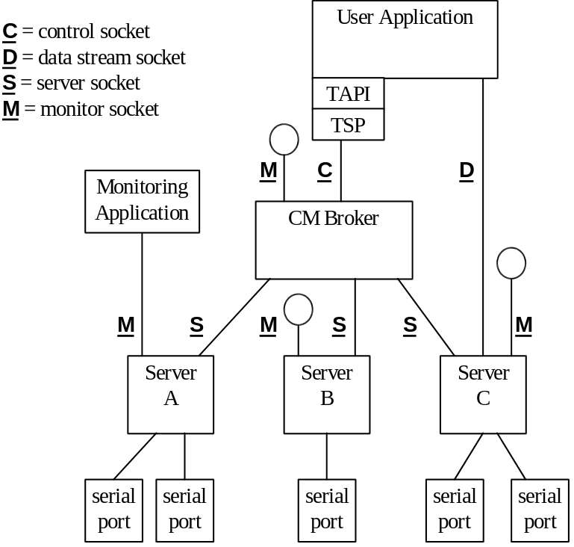
Figure 1 CM Communication Sockets

The Windows sockets used by CM are always point-to-point connection mode, as provided by the TCP/IP protocol (in contrast to the connectionless datagrams of the UDP protocol). In order to make the point-to-point Windows socket connection, one application (or thread) needs to create a socket and call “listen”, while another application must create a socket and call “connect” (in that order).
There are 2 types of Windows sockets function calls: synchronous and asynchronous. The classes described in this document provide for both of these types of function calls. The default is synchronous mode, but this can be overridden at any time during the lifetime of the socket connection.

External Relations and Interactions
The IPC module does not call other parts of the CM system; it is instead used by other modules. Therefore, this document does not describe any external relations and interactions.
This module does, however, invoke the Windows Sockets library which is external to the IPC module. Refer to [WS] for details of Windows Sockets.

Installation Notes
Windows sockets configured with TCP/IP protocol must already be installed and running on the system before CM is installed. A part of installing TCP/IP is enabling a particular address resolution scheme. There are many options in implementing an address resolution scheme, such as DHCP, DNS, WINS, HOST file, etc. Also, almost any combination of options for address resolution is possible; each customer’s site will have its own requirements. Installation of the CM software is not dependent on which address resolution scheme was chosen, but is reliant on the fact that there is a working address resolution scheme in place.
For a server or client installation, the CM installation procedure will ask for the TCP/IP name where the broker is running. For a broker installation this is of course not necessary.
There can only be one broker per network address space. A broker installation will attempt to enforce this restriction.
The CM installation procedure will need to add 1 unique service and port number to the TCP/IP services database for the control socket. The services database is often located in the %SystemRoot%\SYSTEM32\DRIVERS\ETC\SERVICES on the local system.

Design Aspects

Design Structure
The IPC Module is a class library that is used by other modules of the CM system. Therefore, no internal structure is given here. Refer to Figure 2 for a class diagram.

Internal Relations and Interactions
This subsection describes the interfaces between different parts of the subject and the nature of those interfaces.

Internal IPC Scenarios
This section describes how the IPC class library interacts with Windows Sockets internally. A user of the IPC library will not normally be concerned with these internal details.

Sockets startup and shutdown
Note that before any Windows sockets routines can be used, an application must call WSAStartup. Before an application exits, it should close all sockets it is using and call WSACleanup.
The CCM2Socket class and its subclasses automatically take care of the calls to WSAStartup and WSACleanup.

Server socket
A server socket binds to a particular TCP/IP port and listens for a client socket to connect to this port number. Once the connect request is received, the server socket must call accept to complete the connection.
CM uses the synchronous (blocking) form of the Windows Sockets listen() function.

Client socket
A client socket will call connect() specifying a TCP/IP port number and a host machine’s address.
CM uses the synchronous (blocking) form of the Windows Sockets connect function.

Connect a socket via the control socket
An application that needs to setup a server socket, monitor socket, or data stream socket will do so via the broker’s control socket. To make such a connection involves the following steps:

step | Broker | Application (peer) | Description
1 | X |  | The broker always listens on the control socket for incoming connections. The control socket is always connected to the well-known TCP/IP port for CM2.
2 |  | X | Connect to the broker’s control socket.
3 | X |  | The broker will clone the control socket. The cloned socket will be connected on a system-assigned port. The broker then accepts the application’s connection request on this cloned socket. At the same time, the broker goes back to listening on the control socket.
4 |  | X | An identification message is sent so that the broker knows if the peer is a protocol server, monitor, or TSP companion.
5 | X |  | Receive the message from step 4. The broker then sends the peer an identification message.
Table 1. Server socket connection sequence

IPC Objects
This subsection describes the various classes that comprise the IPC subsystem. The IPC subsystem also includes several classes that are not directly related to communication but are needed to support various parts of the CM system (for example, CCM2State). For lack of a better place, these classes are described in this document.
Figure 2 below shows the relationships of the IPC classes.

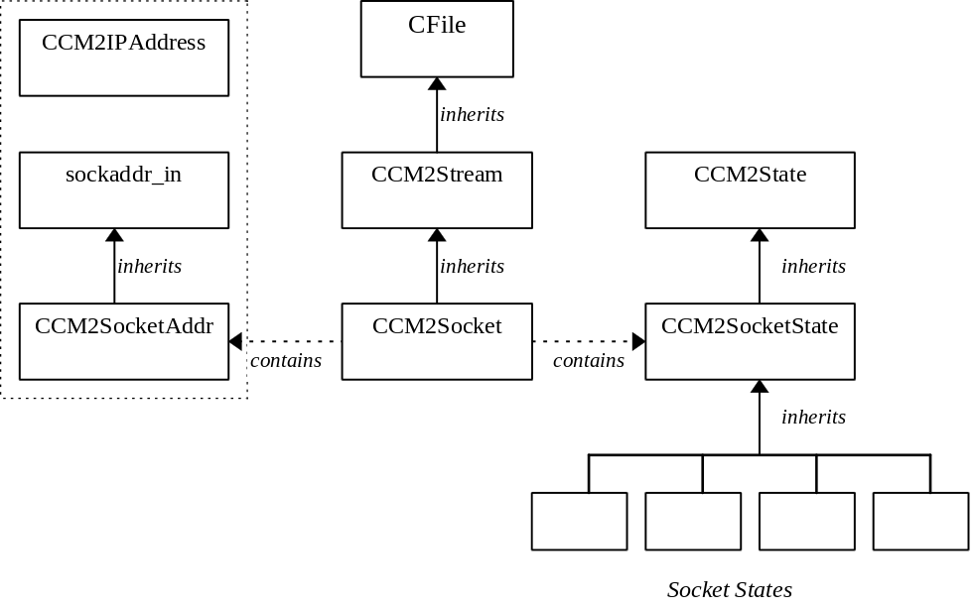
Figure 2 Internal Classes

These internal classes are described in the subsections that follow here below. The specification for each of these classes is divided into the following subsections:
- Description This subsection contains general comments about the class, describing what it is and how it is to be used. Any exceptions and dependencies are also listed here (for example, if a class is a singleton). Also the base class is named in this subsection.
- Interface Contains a list of the external functions, that is, how this object is called by other objects.
- Member variables Only the member variables specific to this class are mentioned here. For member variables inherited from the base class, see the documentation for that base class.
- States Many of the broker objects must maintain an internal state. All of this module’s internal classes accomplish this using a state class tree that is derived the CCM2State abstract base class. See paragraph 3.2.2.5 below for more detail.

CCM2IPAddress

Description
The CCM2IPAddress class provides mapping between IP addresses and names. The constructors for this class enable a variety of IP address types to be created. This class does not inherit from any other class.
This class is primarily used internally by the IPC classes.
The constructor calls the WSAStartup routine when the first instance of this class is created. The destructor calls the WSACleanup routine when the last instance of this class is destroyed.

Interface
CCM2IPAddress(void)
The constructor with no parameters creates a wildcard IP address (INADDR_ANY). This is useful for a server-side socket that will listen for connections from any client machine.
CCM2IPAddress(LPCSTR name)
This constructor creates an IP address via the name resolution mechanism. The name parameter can be either an Internet host name such as “hosta.philips.nl” or a numeric address such as “129.133.133.3”. If the name does not resolve, then the IP address is set to the constant INADDR_NONE.
CCM2IPAddress(const CCM2IPAddress& rInAddr)
This is the copy constructor.
DWORD NetAddress(void) const
Return the internal, network byte-order address. This function is for use by the internal implementation of the CCM2Socket class. It can be used to fill in the in_addr structure that some Windows sockets functions require (for example connect).
operator LPCSTR (void)
Returns a static (textual) representation of the IP address. This will be either the Internet host name or the numeric address. This routine is used to return a “human readable” representation of the connection, which is useful for logging or debugging. Note that the gethostbyaddr Windows socket routine is used to convert the address into a textual format.

Member variables
- m_dwAddress 4 byte network address in internal, network byte-order format
- m_szHostName
Peer host name cache
- m_uInstances Instance count of this object used to control startup and shutdown of sockets library

States
None.

CCM2Socket

Description
Class CCM2Socket encapsulates the functionality for one end of a socket connection. The socket can be either a client-side or a server-side socket connection, depending on how the Open routine is invoked. Recall that a server-side socket listens on a TCP/IP port and a client-side socket actively connects to the TCP/IP port.
This class can be directly instantiated or can be used as a base class for specific types of sockets.
This class has a member variable of type CCM2IPAddress which is instantiated when CCM2Socket is constructed. This member variable takes care of initalizing the Windows Sockets library.
CCM2Socket inherits from the CCM2Stream class.

Interface
Note: Besides the routines explicitly documented below, the pure virtual member functions from the CCM2Stream base class are also implemented (see section 3.2.2.4.2 below for details).
CCM2Socket (void)
The default constructor initializes an instance of this class, but does not attempt to open a socket connection.
CCM2Socket (LPCSTR pszFileName, UINT uOpenFlags)
The same conditions for the Open routine below also apply to this constructor.
CCM2Socket (const CCM2SocketAddr & rSockAddr, UINT uOpenFlags)
This is an alternate constructor that directly accepts a CCM2SocketAddr address instead of a file name (which has to be parsed). The following is a sample usage of this constructor:
CCM2Socket s1(CCM2SocketAddr(“host1.philips.com”, 1250),
CFile::modeReadWrite);
BOOL Open(const char* pszFileName, UINT uOpenFlags, CFileException* pError = NULL)
This function overrides the Open function from the CFile base class. It provides the same functionality as CFile::Open, with the following exceptions:
- The pszFileName parameter can be in one of the following forms:
Type | Example | Description
Full Internet URL | “//hosta.bcs.philips.com:1234”  “http://hosta.xyz.nl:2345”  “//abc.my.net:bcs_broker” | Creates a client-side socket that connects to the URL given. The number after the last colon is the TCP/IP port number, which could also be given as a service name. Note that any protocol prefix such as “http:” are ignored.
Port number | “:1234” | Creates a server-side socket that listens on the given port number.
Blank | “” or NULL | Creates a server-side socket that listens on a system-generated port number.
TCP address | “129.133.133.4:1234” | Creates a client-side socket that connects to the address and port number given.
- The following open flags are supported: modeRead, modeWrite, modeReadWrite, modeCreate, and modeAsyncSocket. If modeCreate is specified, then a server-side socket will be created, regardless of the type of file name specified. Note that these mode flags are all defined by the CFile class except for modeAsyncSocket, which is defined by the CCM2Socket class.
BOOL Open (const CCM2SocketAddr& rSockAddr, UINT uOpenFlags, CFileException* pError = NULL)
This is an alternate form of the Open routine that directly accepts a CCM2SocketAddr address instead of a file name (which has to be parsed). The following is a sample usage of this routine:
CCM2Socket s1;
s1.Open(CCM2SocketAddr(“host1.philips.com”, 1250), modeReadWrite);

void Abort(void)
This function causes any pending I/O operations on the socket to be cancelled.
void Close(void)
This function closes the socket. Any outstanding reads and writes are cancelled.
CCM2Socket& CreateServer(const WORD wPort, const CCM2IPAddress * pHost = 0)
This function is used to connect a new socket via the current socket. For example, the protocol server establishes a control socket connection with the broker. It then calls CreateServer to obtain a CCM2ServerSocket connection with the broker. This process is described in section 3.2.1.4 of this document. The first 5 steps of Table 1 are implemented by the CreateServer routine. To implement the remaining 2 steps is simply a matter of destroying the CCM2ClientSocket object.
This function can be called with a well-known port number. If it is called with a port number equal to zero, then the system will generate a unique port number to be used.
WARNING: This routine is not yet implemented, since it is not sure that it will ever be used.
BOOL Listen(const INT nBackLog = 4)
Performs a blocking listen for connections on a server socket. The nBackLog parameter specifies how many clients are allowed to be queued up waiting for a connection to this server socket.
void SetAsyncMode(const BOOL bMode)
Switches between synchronous and asynchronous I/O mode. When bMode is TRUE, then asynchronous mode is selected.
UINT Read(LPVOID pBuf, UINT uCount)
Performs a read from the socket, filling pBuf. The parameter nCount specifies the maximum bytes that will be read. The actual bytes read is returned by this function. This routine works in three different modes, depending on the I/O mode and whether a callback routine has been registered. The following table shows how these 3 modes relate to the I/O mode and callback:
SetAsyncMode | RegisterCallBack | Description
FALSE | -- | Blocking mode: the Read function does not return until some data is available.
TRUE | 0 | Polling mode: the Read function reads the data that is already in the Winsock buffers and returns the number of bytes read. If no data is available then Read returns 0
TRUE | (address of callback) | Asynchronous mode: If data is already in the Winsock buffers, then it is read and the Read function returns immediately. Otherwise, a worker thread is created to do a blocking read on the socket. As soon as data is available, the worker thread will call the user’s registered callback with the buffer and number of bytes actually read.
Table 2 Socket I/O Modes
void Write(const LPVOID pBuf, UINT nCount)
Writes the specified number of bytes from pBuf to the socket. This call is subject to the same conditions as the Read call described in Table 2.
CALLBACK* RegisterCallback(CM2CallBack pCallback = 0)
Register a default routine that will be called when an asynchronous RPC completes. This function returns the address of the previous callback, or 0 if there was no previous callback.
INT SetSockOpt(INT nOptionName, const void * pOptionValue, INT nOptionLen, INT nLevel = SOL_SOCKET)
Used to set certain socket options, such as keepalive or input/output buffer size. Socket options are simply passed on to the Windows Socket library for processing. Therefore, all Windows Sockets options are supported by this member function.
This function returns 0 if successful; otherwise it returns SOCKET_ERROR.
BOOL GetSockOpt(INT nOptionName, void * pOptionValue, INT * pnOptionLen, INT nLevel = SOL_SOCKET)
Used to retrieve the current socket option settings. The request is passed directly to the Windows Socket library for processing.
INT RemoteProcedure (CM2IpcStruct* pData, FARPROC pCallback = 0)
This member function performs a remote procedure call. Note that the contents of the pData parameter is application dependent. Each IPC message will be defined as a subclass of CM2IpcStruct, adding its own member variables to the standard header fields (such as m_wFunction; m_wPacketSize; and m_dwSequence).
This function returns a 0 if the call was successfully completed. The return code is negative if an error occurred. If the return code is a positive value, then the RPC will be performed asynchronously. In this case the return value will be used by the callback routine to identify which of the outstanding asynchronous calls has returned a value.
When an asynchronous remote procedure completes, then it calls the user’s routine given as the pCallback parameter to this routine. If pCallback parameter is given as 0 then the routine that was given as parameter to the RegisterCallback() routine is called instead.
INT RemoteReadData(CM2IpcStruct* pData, UINT uMaxLength = 0)
This member function is used to read a remote procedure call. The contents of the pData parameter depends on which message is being sent.
This routine returns the actual number of byte read.
Users of this routine should pass the maximum length that can be read in the uMaxLength parameter. If this parameter is given as 0, then RemoteReadData will use the value of pData->m_wPacketSize.
INT RemoteWriteReply(CM2IpcReplyStruct* pData, DWORD dwSequence = 0)
This member function is used to reply to a remote procedure call. The dwSequence parameter contains the unique identifier (cookie) for the asynchronous call for which this reply is referring. If dwSequence is not specified, then RemoteWriteReply will use the value in pData->m_dwSequence. Each remote reply message will be defined as a subclass of CM2IpcReplyStruct, adding its own member variables as needed.
operator SOCKET (void) const
This member cast function is used to retrieve the socket handle. This is usually not necessary, but is useful if the user needs to directly call low-level Windows Sockets routines.
operator LPCSTR (void) const
This member cast function is used to retrieve a textual representation of the socket connection (for example, “host1.philipcs.com:80”).

Member variables
- CCM2SocketAddr m_PeerName
Socket address of the other end of the connection.
- UINT m_uOpenFlags
The current I/O mode flags that were given when opening this socket.
- BOOL m_bAsyncMode
Indicate if non-blocking I/O will be performed.

States
The CCM2Socket class has the following states: Closed, OpenedServer, OpenedClient, Listening, Ready, Reading, and Writing. The state transition diagram for this class is given in Figure 3 below.

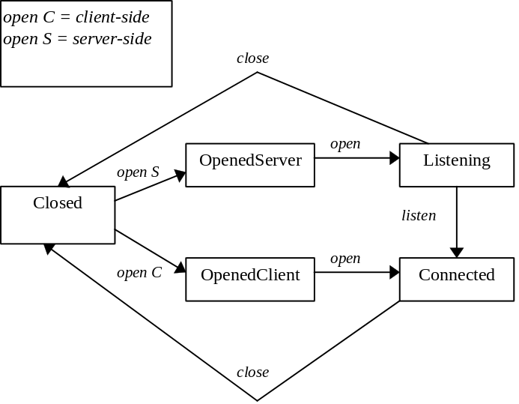
Figure 3 CCM2Socket States
Note that the state following Closed is either OpenedServer or OpenedClient, depending on how the socket is opened. See the description for the Open function above for more details.

CCM2SocketAddr

Description
The CCM2Socket class requires CCM2SocketAddr in its implementation of the Open member function.
The CCM2SocketAddr class inherits from sockaddr_in (see the winsock.h header file). Note that since sockaddr_in is a structure, no functionality is inherited.
This class is primarily used internally by the IPC classes.

Interface
CCM2SocketAddr(const CCM2IPAddress Host, WORD wPort)
This constructor combines the IP address class with a port number to form a unique socket address. If the port number is 0, then the system will generate a unique port number.
CCM2SocketAddr(LPCSTR pszHost, WORD wPort)
This is an alternate constructor that combines the host name and port number to form a unique socket address. If the port number is 0, then the system will generate a unique port number. If the host is blank, then the socket can connect to any host (INADDR_ANY is used for host address). INADDR_ANY is useful for a server-side socket that listens for requests from any client.
CCM2SocketAddr(LPCSTR pszHost, LPCSTR pszService)
This constructor is similar to the preceding one, except that the service name of the port is given instead of the actual port number. The Windows sockets routine getservbyname is used to resolve this service name.
DWORD NetAddress(void) const
Returns the network address in internal format.
WORD PortNumber(void) const
Returns the port number for this socket address. This is especially useful when the constructor was called with port = 0 in which case the system assigns the next port available. This routine then can be used to find out which port the system has assigned.
operator sockaddr * (void) const
Returns the sockaddr structure representing the object.
operator LPCSTR (void) const
Returns a static (textual) representation of the socket address. This will be either the Internet host name or the numeric address followed by a colon and the port number. For example “hosta.philips.nl:1230”.

Member variables
Inherits the following variables from sockaddr_in:
- short sin_family
- u_short sin_port
- struct in_addr sin_addr
- char sin_zero[8]

States
None.

CCM2Stream

Description
The CCM2Stream class provides an abstract base class for the various transport-specific classes (CCM2Socket for example). This class is not specific to any particular transport mechanism and and therefore can be used as a base class for Windows sockets, named pipes, RPC, etc.
This class inherits from the MFC CFile class.
Since the Open, Read, Write, and Close semantics differ for the various transport mechanisms, CCM2Stream does not implement these functions; nor does it have a public constructor.

Interface
virtual BOOL Open(LPCSTR pszFileName, UINT uOpenFlags, CFileException* pError = NULL) = 0
This pure virtual function overrides the Open function of the CFile base class. It is provided here in order to force subclasses to implement their own functionality.
virtual UINT Read(LPVOID pBuf, UINT uCount) = 0
This pure virtual function overrides the Read function of the CFile base class. It is provided here in order to force subclasses to implement their own functionality.
virtual void Write(const LPVOID pBuf, UINT uCount) = 0
This pure virtual function overrides the Write function of the CFile base class. It is provided here in order to force subclasses to implement their own functionality.
virtual void Abort(void) = 0
This pure virtual function overrides the Abort function of the CFile base class. It is provided here in order to force subclasses to implement their own functionality.
virtual void Close(void) = 0
This pure virtual function overrides the Close function of the CFile base class. It is provided here in order to force subclasses to implement their own functionality.
virtual BOOL Reconnect(void)
This member function may be implemented by a subclass (i.e., CCM2Socket) that is able to reuse its instances for subsequent connections.
Class CCM2Stream implements this function by always returning FALSE.
virtual void SetAsyncMode(const BOOL bMode) = 0
This pure virtual function defines the SetAsyncMode interface for sub-classes of CCM2Stream. Note that this operation is an extension of the CFile interface. It is provided here in order to force subclasses to implement their own functionality.
virtual INT RemoteProcedure(CM2IpcStruct* pData, CALLBACK* pCallback = 0) = 0
This member function may be implemented by a subclass (i.e., CCM2Socket) in order to perform remote procedure calls. Note that the contents of the pData parameter is defined by the application using this class.
This function returns a 0 if the call was successfully completed. The return code is negative if an error occurred. If the return code is a positive value, then the RPC will be performed asynchronously. In this case the return value will be used by the callback routine to identify which of the outstanding asynchronous calls has returned a value.
virtual INT RemoteReadData(CM2IpcStruct* pData, UINT uMaxLength = 0) = 0
This member function may be implemented by a subclass (i.e., CCM2Socket) that is able to to read a remote procedure call. The contents of the pData parameter depends on which message is being sent.
When implemented (by a subclass) this routine should return the actual number of bytes read.
virtual INT RemoteWriteReply(CM2IpcReplyStruct* pData, DWORD dwSequence = 0) = 0
This member function may be implemented by a subclass (i.e., CCM2Socket) that is able to reply to a remote procedure call. The dwSequence parameter must contain the unique identifier for the asynchronous call for which this reply is referring. The contents of the pData parameter depends on which message is being sent.
CALLBACK* RegisterCallback(CM2CallBack pCallback = 0)
Register a default routine that will be called when an asynchronous RPC completes. This function returns the address of the previous callback, or 0 if there was no previous callback.
CCM2STATUSCODE QueryStatus(void)
Returns the current status of the stream. The possible statuses are: SC_OK, SC_NODATA, SC_EOF, and SC_FAILED.

Member variables
- CCM2State * m_pState
Current state.
- CM2CallBack m_pDefCallback
Address of the registered callback routine.

States
(see states for CCM2Socket class).

CCM2State

Description
The class CCM2State is to be considered a family of classes: there is no strict inheritence hierarchy defined. An object that uses CCM2State will define its own base class and a set of subclasses -- one subclass per state. Because of this layout the set of the subclasses are referred to as a “state tree.”
This section describes the class mechanisms for representing states and also describes the members that all “state trees” have in common. The general structure of an example state tree is given in Figure 4 below.

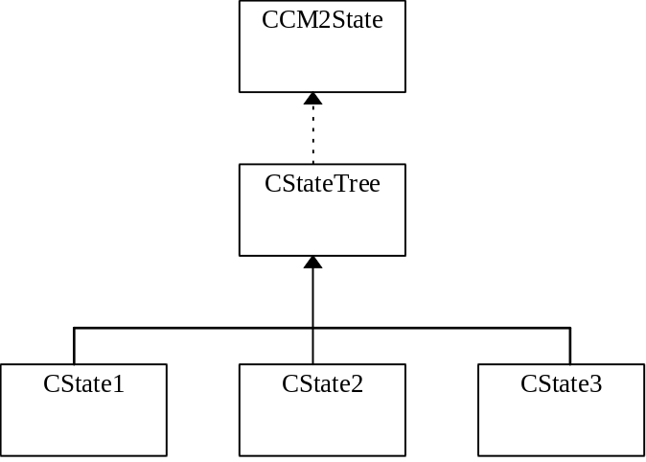
Figure 4 Example State Tree

Notes:
Note that the use of CCM2State is a design decision. It is used to distribute state-dependent behavior across several subclasses. Therefore, for classes with many states, the class functionality is distributed over many subclasses. A possible drawback is that changes to a “state tree” could result in several classes needing to be changed. On the other hand, such distribution is actually good if there are many states. The code for each state is isolated from the other states and is thus easier to understand. If the state tree method is not used, then some other approach is needed, which often results in a large switch statement, or some other monolithic programming construction.
The state transitions are performed by the subclasses themself. In other words, a state subclass has knowlege of which state follows. However, this is usually not a problem.
Instances of a state subclass can be shared unless they define member variables. The static member function “Instance()” is used when sharing is enabled.

Interface
Each particular state tree will define its own interface.

Member variables
- static <subclass> * m_pInstance
Each subclass that allows the state object to be shared will have an instance variable.

States
None.

CCM2SocketState

Description
The class CCM2SocketState is used as the base class for all the socket state subclasses. The state subclasses are as follows: CCM2SSClosed, CCM2SSOpenedServer, CCM2SSOpenedClient, CCM2SSListening, and CCM2SSReady.

Interface
Note that the following virtual interface functions cause an error if called. State subclasses will therefore need to override the functions that can sensibly be handled at that state.
virtual void Abort(void)
virtual void Close(void)
virtual CCM2Socket& CreateServer(const WORD wPort, const CCM2IPAddress* pHost)
virtual BOOL GetSockOpt(INT nOptionName, void * pOptionValue, INT * pnOptionLen, INT nLevel = SOL_SOCKET)
virtual BOOL Listen(const INT nBackLog)
virtual BOOL Open (const CCM2SocketAddr& rSockAddr, UINT uOpenFlags, CFileException* pError = NULL)
virtual UINT Read(LPVOID pBuf, UINT uCount)
virtual DWORD ReaderThread(IOPARAMS* pIOP)
virtual INT SetSockOpt(INT nOptionName, const void * pOptionValue, INT nOptionLen, INT nLevel = SOL_SOCKET)
virtual void Write(const LPVOID pBuf, UINT uCount)
virtual DWORD WriterThread(IOPARAMS* pIOP)
static CCM2SocketState* Instance(void)
Each state subclass will implement the Instance function that returns the single instance of the state object.

Member variables

States
Uninitialized, Closed, OpenedServer, OpenedClient, Listening, Connected, Reading, Writing

IPC Messages
The various modules (or application programs) of CM communicate by sending messages across Windows Sockets. Messages that are specific to a particular CM module are described in the Composite Level Design document for that particular module.
By design, the IPC messages used by CM have a consistent format throughout all of the CM modules. Therefore, this section describes the common format of IPC messages and the mechanism used for sending these messages. This section also lists a few messages that are not specific to any particular CM module.

An IPC class that is derived from the CCM2Stream abstract base class can implement a high-level, remote procedure call mechanism. This is accomplished by implementing the three member functions: RemoteProcedure, RemoteReply, and (optionally) RegisterCallback.
The RemoteProcedure routine is called by applications that need to invoke a remote procedure. The RemoteReply routine is used by the application that answers (or fulfills) the request.

The standard layout of an IPC message is as follows:
- function call ordinal
- packet size. This is the number of bytes in the whole message, including the header.
- sequence. This is a counter that uniquely identifies each remote procedure call.
- input parameters to the remote procedure in the form of a structure. The layout will depend on the function call.
The standard layout of an IPC reply is as follows:
- The function call ordinal, packet size, and sequence (see above structure).
- return code -- the return value from the remote procedure, if applicable
- output parameters from the remote procedure in the form of a structure. The layout will depend on what the remote procedure returns.
As mentioned above, each CM module’s CLD will document its own messages. The following section documents messages that are not specific to any one CM module.

General Messages
EndOfFile
Indicate to the other end of the socket that there is no more data to be expected from this socket.
EndOfData (FunctionCallOrdinal)
Some of the IPC messages used by CM are of an iterative nature. For example, the monitor application asks the broker for a list of applications, resulting in multiple replies (one reply for each application). The EndOfData message indicates the end of such a list.
This message has one parameter that contains the function call ordinal of the iterative message that has reached the end of its dataset.
GenericReply
When an application calls RemoteReadData to receive an IPC message, it is never certain as to which IPC message will be received. Therefore GenericReply is defined to be large enough to receive any of the other IPC messages.

Startup and shutdown
Several CM modules have special requirements during startup and shutdown. Some of these requirements are not specific to any one module. Therefore, these startup and shutdown scenarios are described here instead of in each of these modules.
Upon receiving a WM_CLOSE or WM_QUIT message, the CM module should send EndOfFile messages to all of its active socket connections. Then each of these sockets should be closed.

Design Considerations
This subsection describes the arguments used in the various design decisions that are made.

The interface between IPC objects and other parts of the CM system must be generic enough to work under multiple network communication strategies and protocols. Users of the IPC classes should not have to worry about any network dependencies. This allows the transport layer to be replaced with a minimum of effort.
Note that several other sockets class hierarchies are available. The following subsections gives an overview of other class libraries that were rejected for use in CM.

MFC Socket Classes
The Microsoft Foundation Class (MFC) implements socket functionality as three classes: CSocket, CAsyncSocket, and CSocketFile. The class hierarchy is shown in Figure 5.

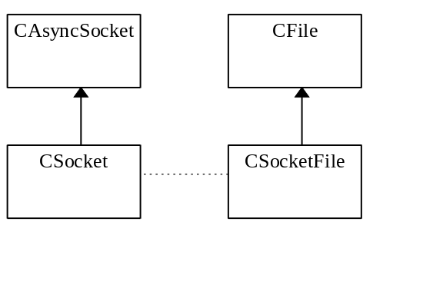
Figure 5 MFC Socket Class Hierarchy
The CAsyncSocket class is a thin C++ layer on top of the Windows Sockets library. CSocket uses the blocking calls of Windows sockets and further adds the following calls: a call to detect if there is an outstanding blocking call, a call to cancel the current blocking operation and a message pump mechanism. Note that MFC implements CSocket by issuing asynchronous operations and polling in order to maintain a fine level of control. The CSocketFile is based on a subset of CFile which also contains a pointer to an already opened CSocket object.
There are several problems with the MFC approach to sockets:
- The CAsyncSocket class is almost a one-to-one mapping of the Windows sockets C library. Although this allows virtually full access to all sockets features, it does not provide enough abstraction. In other words, the code using this class is specific to sockets.
- The CSocket class is not efficient in implemented blocking calls since it constantly polls the socket. This is unacceptable for modules such as the Broker and the Protocol Server which have multiple sockets open.
- The CSocketFile class is a poor attempt to use the familiar CFile abstraction. It does not implement the Open interface of CFile (when open is in fact the most difficult part of sockets). Instead, CSocketFile has a pointer to an already open CSocket object. To compensate for lack of socket support in CSocketFile, the CSocket member variable is declared public.
- Functions such as select that operate on sets of socket handles are not supported.

CommChat
The CommChat example and article on the Developer Network CD also points out several of the weaknesses of the MFC socket classes, before introducing its own solution.
The CommChat class hierarchy is given in Figure 6.

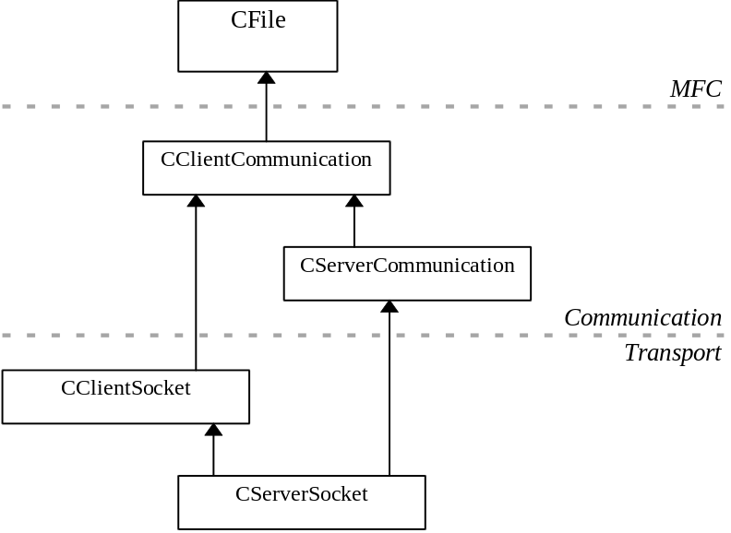
Figure 6 CommChat Socket Class Hierarchy

Note that this class hierarchy consists of three layers: MFC, communication, and transport layers. The MFC layer provides the CFile abstraction. The communication layer provides classes that are not dependent on the transport medium/protocol. The classes derived from CClientCommunication and CServerCommunication contain the specifics of the transport being used (Windows sockets in the figure above). Other derived class could be based on RPC, named pipes, etc.
Advantages of the CommChat class hierarchy:
- Provides a complete, high level abstraction of the CFile class.
- Subclasses of CClientCommunication and CServerCommunication can be used in a transport independent fashion.
Disadvantages of the CommChat class hierarchy:
- Multiple inheritence from a common base class is not advisable.
- Asynchronous socket functions are not supported. This is because CFile does not have asynchronous (or overlapped) capabilities.
- Functions such as select that operate on sets of socket handles are not supported.

Constraints
This section describes deviations between this SDS and the requirements for the subject (e.g. described in the SPS).

Changes
Revision 00, Accepted after peer review on 14-6-96 by M. Woudboer.

- Appendix A Using IPC Classes
The following steps tell how to use the IPC classes in a module.
First, be sure to add the J:\CMII\include directory to Visual C++ settings. Also, make sure that J:\CMII\bin is in your PATH. (that’s where the DLL resides). Applications will also need to link with the J:\CMII\lib\CM2IPC.LIB stub library.
In the following paragraphs a quick guide to using the IPC classes is given. Since the CCM2Socket class inherits from CFile its syntax should be familar. Only the open (and constructor) syntax is extented as shown below.
The first code sample shows how to connect a client-side socket to TCP/IP port number 1704 on a system called “tcphost”. Note that 1704 is the port number of the CM2 broker.

#include <CM2IPC.hpp>

CCM2Stream* pSocket;

OnConnect()
{
pSocket = new CCM2Socket(CCM2SocketAddr(“tcphost”, 1704),
CFile::modeReadWrite);
if (pSocket->QueryStatus() == SC_FAILED)
{
delete m_pSocket;
}
}
To open a server-side socket, simply leave the system name blank:
. . .
CCM2Stream * pClient;
CCM2Stream * pServer;
pServer = new CCM2Socket(CCM2SocketAddr(“”, 1704), . . .
// Alternative: CCM2Socket(“:1704”, . . .
while (TRUE)
{
// Must do a listen on server port
pClient = pServer->Listen();
}

The read and write syntax is the same as that of CFile:
pSocket->Write(buffer, length);
int actualRead = pSocket->Read(buffer, maxSize);

There are 2 ways to turn on non-blocking mode:
- Include the CFile::modeAsyncSocket flag in the call to the constructor (or Open routine).
- Call SetAsyncMode(TRUE) for the stream. All subsequent calls will then be non-blocking, until SetAsyncMode(FALSE)is called.
By default the non-blocking mode will do polling, i.e., a Read call will always return immediately, reading only the data that has already been transported. If no data is available, then Read will return a 0. See also Table 2 for an overview of the socket class I/O modes.
The third mode uses a worker-thread to wait for data. When data has been transported, the worker thread will call the user’s registered callback routine, as shown in the following example:

void
MyCallback(DWORD Size, LPVOID Buffer)
{
char* pBuf = static_cast<char *> (Buffer);
if (Size)
{
pBuf[Size] = '\0';
TRACE(pBuf);
}
}

OnConnect()
{
. . . (etc., from above) . . .
pSocket->RegisterCallback(MyCallback);
}

AsyncRead()
{
pSocket->SetAsyncMode(TRUE);
int in_len = m_pSocket->Read(inbuff, BUF_LEN);
if (in_len)
{
// Data was immediately available and has been read
// into inbuff. No worker thread was created
}
else
{
// No data was available. MyCallback will be called with
// the data (and length) when data becomes available.
}
}

The following code shows how to send an IPC package, in this case the EndOfData message:

EndOfData EndDataMsg;
EndDataMsg.m_wEndFunction = IPC_EnumerateResponse;
pStream->RemoteProcedure(&EndDataMsg);

The follow code shows how to receive an IPC message and determine which message was sent:

// GenericReply is a message large enough to hold any IPC
CM2IpcStruct* pMsgANY = new GenericReply;

if (pStream->RemoteReadData(pMsgANY) == 0)
{
TRACE("No data on stream -- exiting\n");
delete pMsgANY;
return 1;
}

switch (pMsgANY->m_wFunction)
{
case IPC_Identification: // TSP companion
case IPC_ConnectServer: // Protocol Server
. . . etc. . . .
}
delete pMsgANY;

