ENTERPRISE CYBER THREAT INTELLIGENCE
ASSESSMENT REPORT
Subject Organization: NIIT Port Harcourt
Prepared by: Bob-Manuel Emmanuel
Contact: emmanuelbobmanuel129@gmail.com
Classification: TLP:AMBER — Restricted Distribution
Assessment date: Not provided in source material

Executive Summary
This report presents the results of a cyber threat intelligence (CTI) assessment conducted for NIIT Port Harcourt in response to reported concerns regarding increasing digital exposure, targeted communication directed at employees, and suspicious login attempts. The observed indicators collectively suggest a credible possibility of attempted compromise by an external threat actor, although the source material does not confirm that a compromise has occurred.
The assessment applied a structured methodology combining the intelligence cycle and the MITRE ATT&CK framework, supported by open-source intelligence (OSINT) techniques, to evaluate the organization's external exposure and identify plausible attack vectors.
Findings indicate that publicly accessible email addresses associated with the organization are limited, suggesting relatively low direct OSINT exposure in this specific area. This does not eliminate risk: indicators reviewed suggest that a threat actor could plausibly leverage inferred email-address patterns, previously compromised credential datasets, or alternative communication channels to conduct social engineering (phishing) and credential-based attacks.
Recommended priority actions include strengthening authentication (including multi-factor authentication), improving email and endpoint protection, enforcing HTTPS/TLS on all web-facing login interfaces, and introducing physical identification controls (e.g., student ID cards) to reduce the risk of in-person social engineering.

1. Introduction
This report provides a cyber threat intelligence evaluation of NIIT Port Harcourt's external exposure and potential security concerns. The primary objectives are to identify publicly available data relating to the organization and to examine its digital footprint.
The assessment is organized into methodology, findings, intelligence correlation, risk analysis, and recommendations, with the overall goal of highlighting externally visible security weaknesses.

1.1 Objectives
- Identify publicly available information relating to the organization
- Assess employee and organizational exposure
- Discover digital assets and online footprints
- Investigate publicly available infrastructure
- Correlate intelligence findings into meaningful conclusions
- Assess security risk based on the intelligence collected
- Produce a professional intelligence report

1.2 Overview
An overview section is listed in the source document's table of contents; however, no descriptive content for this section was provided in the source material. It is presented here as a placeholder only.

1.3 Scope
The assessment was limited to passive open-source intelligence (OSINT) activity using publicly available information. No unauthorized or intrusive activity was performed.

2. Tools Used
The following tools were identified in the source material as having been used to support the assessment:
Tool | Purpose
Google Dorking | Advanced search-operator based reconnaissance
Whois | Domain registration lookup
theHarvester | Email address and subdomain discovery
Wayback Machine | Historical website analysis
Maltego | Relationship mapping / infrastructure reconnaissance
HTTrack | Offline website analysis
Shodan | Internet-facing asset discovery
OSINT Framework | Domain registration reconnaissance

3. Methodology
The assessment followed the intelligence cycle methodology to ensure a structured and repeatable process, comprising the following phases:
- Planning
- Collection
- Processing
- Analysis
- Dissemination
The investigation combined network reconnaissance with adversary-behavior classification. OSINT techniques were used to gather background information such as domain names, subdomains, and contact details, providing context on the organization's infrastructure and its real-world use.
Findings were analyzed against the MITRE ATT&CK framework to classify potential adversary behavior. The observed suspicious communication was assessed by the analyst as consistent with Phishing (T1566) under the Initial Access tactic.

4. Findings — Threat Analysis
Using an OSINT reconnaissance tool (Maltego), the target IP address associated with the organization's infrastructure was identified (referenced in the source document as Figure 1).
An active scan was subsequently conducted against the target IP address 176.123.0.55, with service and version detection enabled (referenced in the source document as Figure 2).
The scan identified multiple exposed services, summarized below:
Exposed Service | Observed Detail | Associated Risk
FTP (port 21) | Open, service and version detection returned a banner | Unauthorized access if weak credentials or misconfiguration exist
POP3 mail (port 110) | Open | Credential exposure; phishing/credential-based attack surface
SMTPS (port 465) | Open | Abuse for phishing distribution / mail spoofing risk
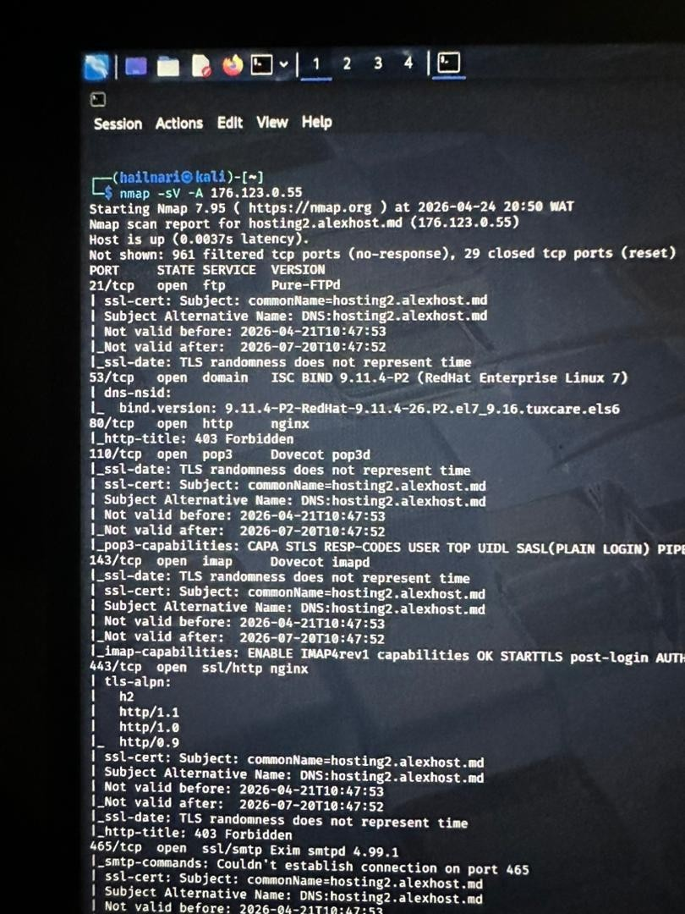

The source material states that the presence of multiple services across different ports indicates a multi-service architecture, which increases the overall attack surface and introduces risk through:
- Service misconfiguration
- Outdated software versions
- Credential-based attacks
- Web and email exploitation vectors

5. Intelligence Correlation
The combination of exposed web and email services, together with publicly available domain and contact information, creates a plausible attack path. As assessed in the source material, an attacker could use OSINT data to craft targeted phishing emails, distribute them via the exposed SMTP service, and potentially host malicious content on the exposed web servers.

6. Intelligence Assessment
An "Intelligence Assessment" section heading appears in the source document's table of contents and body structure; however, no analytical content was provided under this heading in the source material. No assessment content is fabricated here — this section is noted as not provided.

7. Risk Analysis
A "Risk Analysis" section heading appears in the source document; however, no risk-rating content (e.g., likelihood/impact scoring or a risk matrix) was provided in the source material. Based only on the narrative findings and conclusion supplied elsewhere in the document, the analyst characterized the overall risk to the organization as moderate, driven primarily by insecure communication channels, outdated software components, and weak monitoring mechanisms. No separate quantitative or matrix-based risk analysis was supplied, and none is invented here.

8. Vulnerability Reference
The source document references one specific vulnerability identifier: CVE-2026-4490, stated as capable of allowing an attacker to gain unauthorized administrative access without valid login credentials. No further technical detail (affected software/version, CVSS score, or exploitation specifics) was provided in the source material regarding this CVE, and none is assumed here.

9. Recommendations

9.1 Secure Authentication Mechanisms
Observation: Sensitive user credentials are exposed due to insecure transmission methods. Password input fields are reported as being transmitted over unencrypted HTTP pages, exposing login credentials to interception attacks such as packet sniffing.
- Enforce HTTPS (Hypertext Transfer Protocol Secure) across all web pages, especially login interfaces
- Implement TLS (Transport Layer Security) encryption to protect data in transit
- Apply secure HTTP headers (e.g., HSTS, Content Security Policy) to strengthen protection

9.2 Protection Against Credential Leakage
Observation: The assessment identified weaknesses that may lead to password exposure.
- Ensure password fields are properly masked and never logged in plaintext
- Implement secure session-management practices to prevent session hijacking
- Use strong hashing algorithms (e.g., bcrypt or Argon2) for password storage

9.3 Patch Management and Vulnerability Remediation
Observation: The system is running outdated software components, which introduces known vulnerabilities, including CVE-2026-4490 as referenced in the source assessment.
- Regularly update and patch all software, including cPanel and server components
- Establish a formal patch-management policy to ensure timely updates
- Conduct periodic vulnerability scans to identify and remediate new issues

9.4 Monitoring and Incident Detection
Observation: There is insufficient visibility into suspicious activity on the platform.
- Implement logging and monitoring to track login attempts and unusual behavior
- Deploy intrusion detection/prevention systems (IDS/IPS)
- Configure alerts for repeated failed login attempts or abnormal access patterns

9.5 User Awareness and Access Control
Observation: User-related risks, particularly among students, were identified.
- Issue secure user identifiers (e.g., ID cards) and enforce strong password policies
- Educate users, including students, on avoiding unsafe practices such as credential sharing
- Implement multi-factor authentication (MFA) as an additional layer of security

10. Conclusion
The assessment concludes that the current system presents a moderate security risk, primarily attributable to insecure communication channels, outdated software, and weak monitoring mechanisms.
If left unaddressed, the source material states these vulnerabilities could lead to:
- Unauthorized access to administrative accounts
- Exposure of sensitive user data
- Increased susceptibility to cyberattacks
The source material notes that although suspicious login attempts were observed, it remains unclear whether this activity is benign or indicative of malicious intent. Regardless, it highlights the need for improved monitoring and response capability.

Final Position
The source document states that immediate action is required to:
- Secure communication channels (HTTPS implementation)
- Update and patch vulnerable systems
- Strengthen authentication and monitoring controls
By implementing the recommendations outlined above, the organization can reduce its attack surface and improve resilience against potential cyber threats, per the source assessment's own conclusion.

11. References
A "References" section heading appears in the source document; no citation list or bibliography content was provided in the source material. None is fabricated here.

Appendix A — OSINT Assignment
The source document contains a separate section titled "OSINT ASSIGNMENT" with the heading "TARGET: DR MARTHA OZOHU MUSA." No further content, findings, or data appear beneath this heading in the source material — the section is empty.
Analyst note: Because no content was supplied under this heading, no OSINT findings, biographical detail, or analysis regarding this named individual are presented in this report. Reporting on identifiable individuals requires the underlying findings actually be supplied by the requester; none were provided here, so none have been generated or inferred.

Appendix B — Source Material Limitations
This report was compiled strictly from the content of the uploaded document. The following items were referenced by heading in the source document but had no supporting content provided, and are therefore explicitly flagged rather than completed with assumed information:
- Overview (Section 1.2)
- Intelligence Assessment (Section 6)
- Risk Analysis (Section 7) — no quantitative/matrix-based scoring provided
- References (Section 11)
- OSINT Assignment target profile (Appendix A)
Additionally, embedded screenshots referenced in the source document as "Fig 1" and "Figure 2" were retained conceptually (Maltego infrastructure mapping and an active service scan) but their full technical output (e.g., complete banner strings, timestamps, scan tool identity) was not transcribed as text in the source material beyond what is summarized in Section 4.

