**Breakpoints**

We used continuous segmented regression models to calculate the location of a change in the slope of ice dates for Tornio and Suwa. In general, a continuous segmented regression (CSR) takes the form



where yi are observations of ice date,  is a latent variable representing potentially unobserved ice dates ( and yi only differ in Tobit model, described below), x­i are the years of the time series, β0 is the intercept of the regression (ice date on year 0), β1 is the temporal trend in ice date (change in ice date per change in year), the ak are the breakpoints (k was either 1 or 2), the βk+1 are the changes in the temporal trend at each of the k breakpoints, and the εi are the errors. Note that the βk+1 parameters indicate the effect of years elapsed since the breakpoint once the breakpoint has passed on ice date.

The Tornio time series began in 1693 and ended in 2013, thus x = 1, 2, … 321. Ice breakup dates for the River Torn ranged from day 117 to day 160, and the ice melted each year of the time series. For Tornio, we fit CSR parameters using ordinary least squares using the lm() function in the statistical programming language R.

The Suwa time series began in 1443 and ended in 2004 (x = 1, 2, … 562), and ice observations were made for 427 of the 562 years (See Fig X in Main Text). The day that Lake Suwa froze ranged from day -54 to day 41 (negative values indicate freezing before January 1st of the designated “year”); however, there were 37 years when the lake did not freeze. If the lake is considered as an instrument that measures a value, which we call ice date, that indicates the favorability of conditions for ice formation, and if we understand the lake instrument to censor these measurements at 41, then the no-freeze years can be encoded as ice dates of 41. We consider Lake Suwa as an instrument with output of ice date that is censored at an upper limit, L = 41. As such, the observed yi are related L and the latent variable in the following manner:



To address this censoring of Lake Suwa ice dates while fitting the parameters in Eq. 1, we used a Tobit regression model. For a Tobit regression model for which observations have an upper limit, the log likelihood of observing data given the parameters β (as in Eq 1) and σ2 (the variance of ε in Eq 1), can be calculated as:



where φ(.) and Φ(.) are the probability and cumulative density functions of the normal distribution, respectively. The first term is the standard normal likelihood, and applies to observations for which an ice date was observed. The second term reflects the probability of the observation being censored, and applies to no-freeze years. Given parameter values, the equation reflects the probabilities of observing the ice dates (yi) during freeze years, as well as the probabilities that ice date was censored (unobserved) during no-freeze years. Thus, the β in the Tobit regression model indicate the effect of unit change in X on the latent variable, . We used Tobit regression models as implemented by the vglm() function in the R package VGAM to fit parameters in Eq. 1 to Lake Suwa data.

We compared AIC values from CSR models containing one or two breakpoints to multiple regression models containing only year or only year and year2 as predictor variables. We fit models either by OLS (River Tornio) or by maximum likelihood of the corresponding Tobit regression (Lake Suwa) (Table 1).

**Table 1.** AIC values of regression models relating ice date () to years elapsed (xi)

|  |  |  |
| --- | --- | --- |
| Model | Tornio AIC | Suwa AIC |
|  | 2155.825 | 3536.38 |
|  | 2154.881 | 3515.407 |
|  | 1240.113 | 3513.241 |
|  | 1239.815* | 3511.682** |

*Breakpoints restricted to being at least 50 years apart; See Figure S1.

**Breakpoints restricted to being at least 50 years apart; if restricted to 25 years, AIC = 3510.898.

For both systems, a regression model with a single breakpoint was more parsimonious than either of the models not containing breakpoints. The slight difference in AIC between the breakpoint models did not warrant further consideration of the more complicated model.

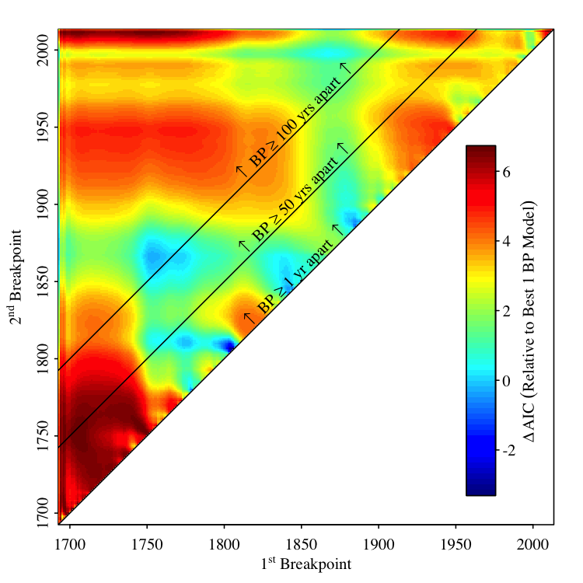

**Figure S1.** Changes in AIC of two breakpoint model relative to the one breakpoint model (Table S1) corresponding to year of first and second breakpoint.

**Changing drivers**

Models

p-values and bootstrapping