Project 1 Paper and String Installation

|  |  |
| --- | --- |
| Jack Lawless  Fourth Year  jl126247@umconnect.umt.edu | Chris  Third Year  Buddyiscool34@gmail.com |

ABSTRACT

Project One was an attempt to make an interactive installation that was made entirely out of paper, string, tape and nothing more. In our project we decided to make a hanging piece where the audience could pull on strings to make the piece move in unique ways.

1. Introduction

In this project we were to transform or create a space into an interactive art piece using only paper, tape and string. Chris and I tried to create a piece that consisted of a series of hanging strings that had paper balls attached to the and ‘control strings’ that were used as levers to engage the piece in movement. The audience would pull on these levers displacing the strings creating movement, and when the movements paired it creates an illusion of patterned movements that engages the audience into interacting more.

1. Content
2. Our project was an attempt to make a visual field that could be manipulated through physical actions of the viewer.
3. We decided to do this idea for the project because it seemed visually interesting and a challenge to complete. We wanted to create something interactive that also had aesthetic beauty and would capture the viewer. The idea was based off an installation I saw, it was modified to fit the requirements for the project and to engage the viewer in an interactive way. If resources and time were not such a factor I would have wished to cover an entire room in hanging strings so that the experience would be encapsulating, as well as making the interaction more intriguing by creating different rigging systems that would move the strings in unexpected ways.
4. This idea stemmed from an installation I saw that consisted of ping pong balls with LED lights inside attached to strings which were attached to servo motors. The artist was able to control the movement of the ping pong balls by controlling the servo motors with his computer. Also, he was able to change the color within the ping pong balls from his computer. This really captivated me and made me want to create something similar that was more interactive. Obviously, we did not have the time or resources to do an installation as intense as this one, but we did have the necessary materials to recreate something similar. This was a huge inspiration and motivation for the project and I even had other students come up to me and say that it reminded them of the ping pong ball installation.
5. I started with sketches thinking about how to create a field of strings that could be manipulated physically. We figured out a rig that could do just that. It took trial and error to get there but we were able to make a simple rig out of paper and string. From the rig hung strings that could be lifted up by a participant pulling on a separate designated string.
6. The rigging took awhile to create and set up to start working. Unfortunately, that’s all we got done. We got the initial set up for the project installed but ran out of time. We only had one string controlling one part of the install. There were no aesthetics and it was small, it was easy for the viewer to dismiss due to its incompletion.
7. I found time is your enemy and you have to fight against it. We did not have the project complete and as our peers said it was more of an object rather than an interactive installation. I would have loved to make the installation big enough to where someone could just walk in the middle of it and be surrounded by the hanging strings. Also, I would have loved to add technology to this idea. Such as the ping pong ball installation, only instead it being just an installation it would be interactive too. For example, what if you took the ping ball installation, made it accessible to the audience, and underneath would be pressure plates. You could track the participant and change colors based on where they step, illuminating only the lights near the participant. Or the strings could raise and lower dependent upon the participants positions and movements.
8. If I were to continue on the project I would approach it more like the example of the ping pong ball installation. I would base the install on a bigger scale with easier controls for the audience. Also, as an aesthetic I would introduce colors and a changing venue to give the audience a sense of exploration.
9. This project was challenging, due to limitations within resources and time. But, we learned a lot from it. You have to think about every detail when doing an installation, where it is, what is the message, how does the audience interact, how do they react, etc. Now we have a better idea of what an interactive installation actually is. It takes in the viewer and requires them to participate in order to receive anything back from it. That being said, it is better to change the total environment for the viewer, to make them feel encapsulated and in control. I will keep this in mind on the upcoming projects.
   1. Supporting Material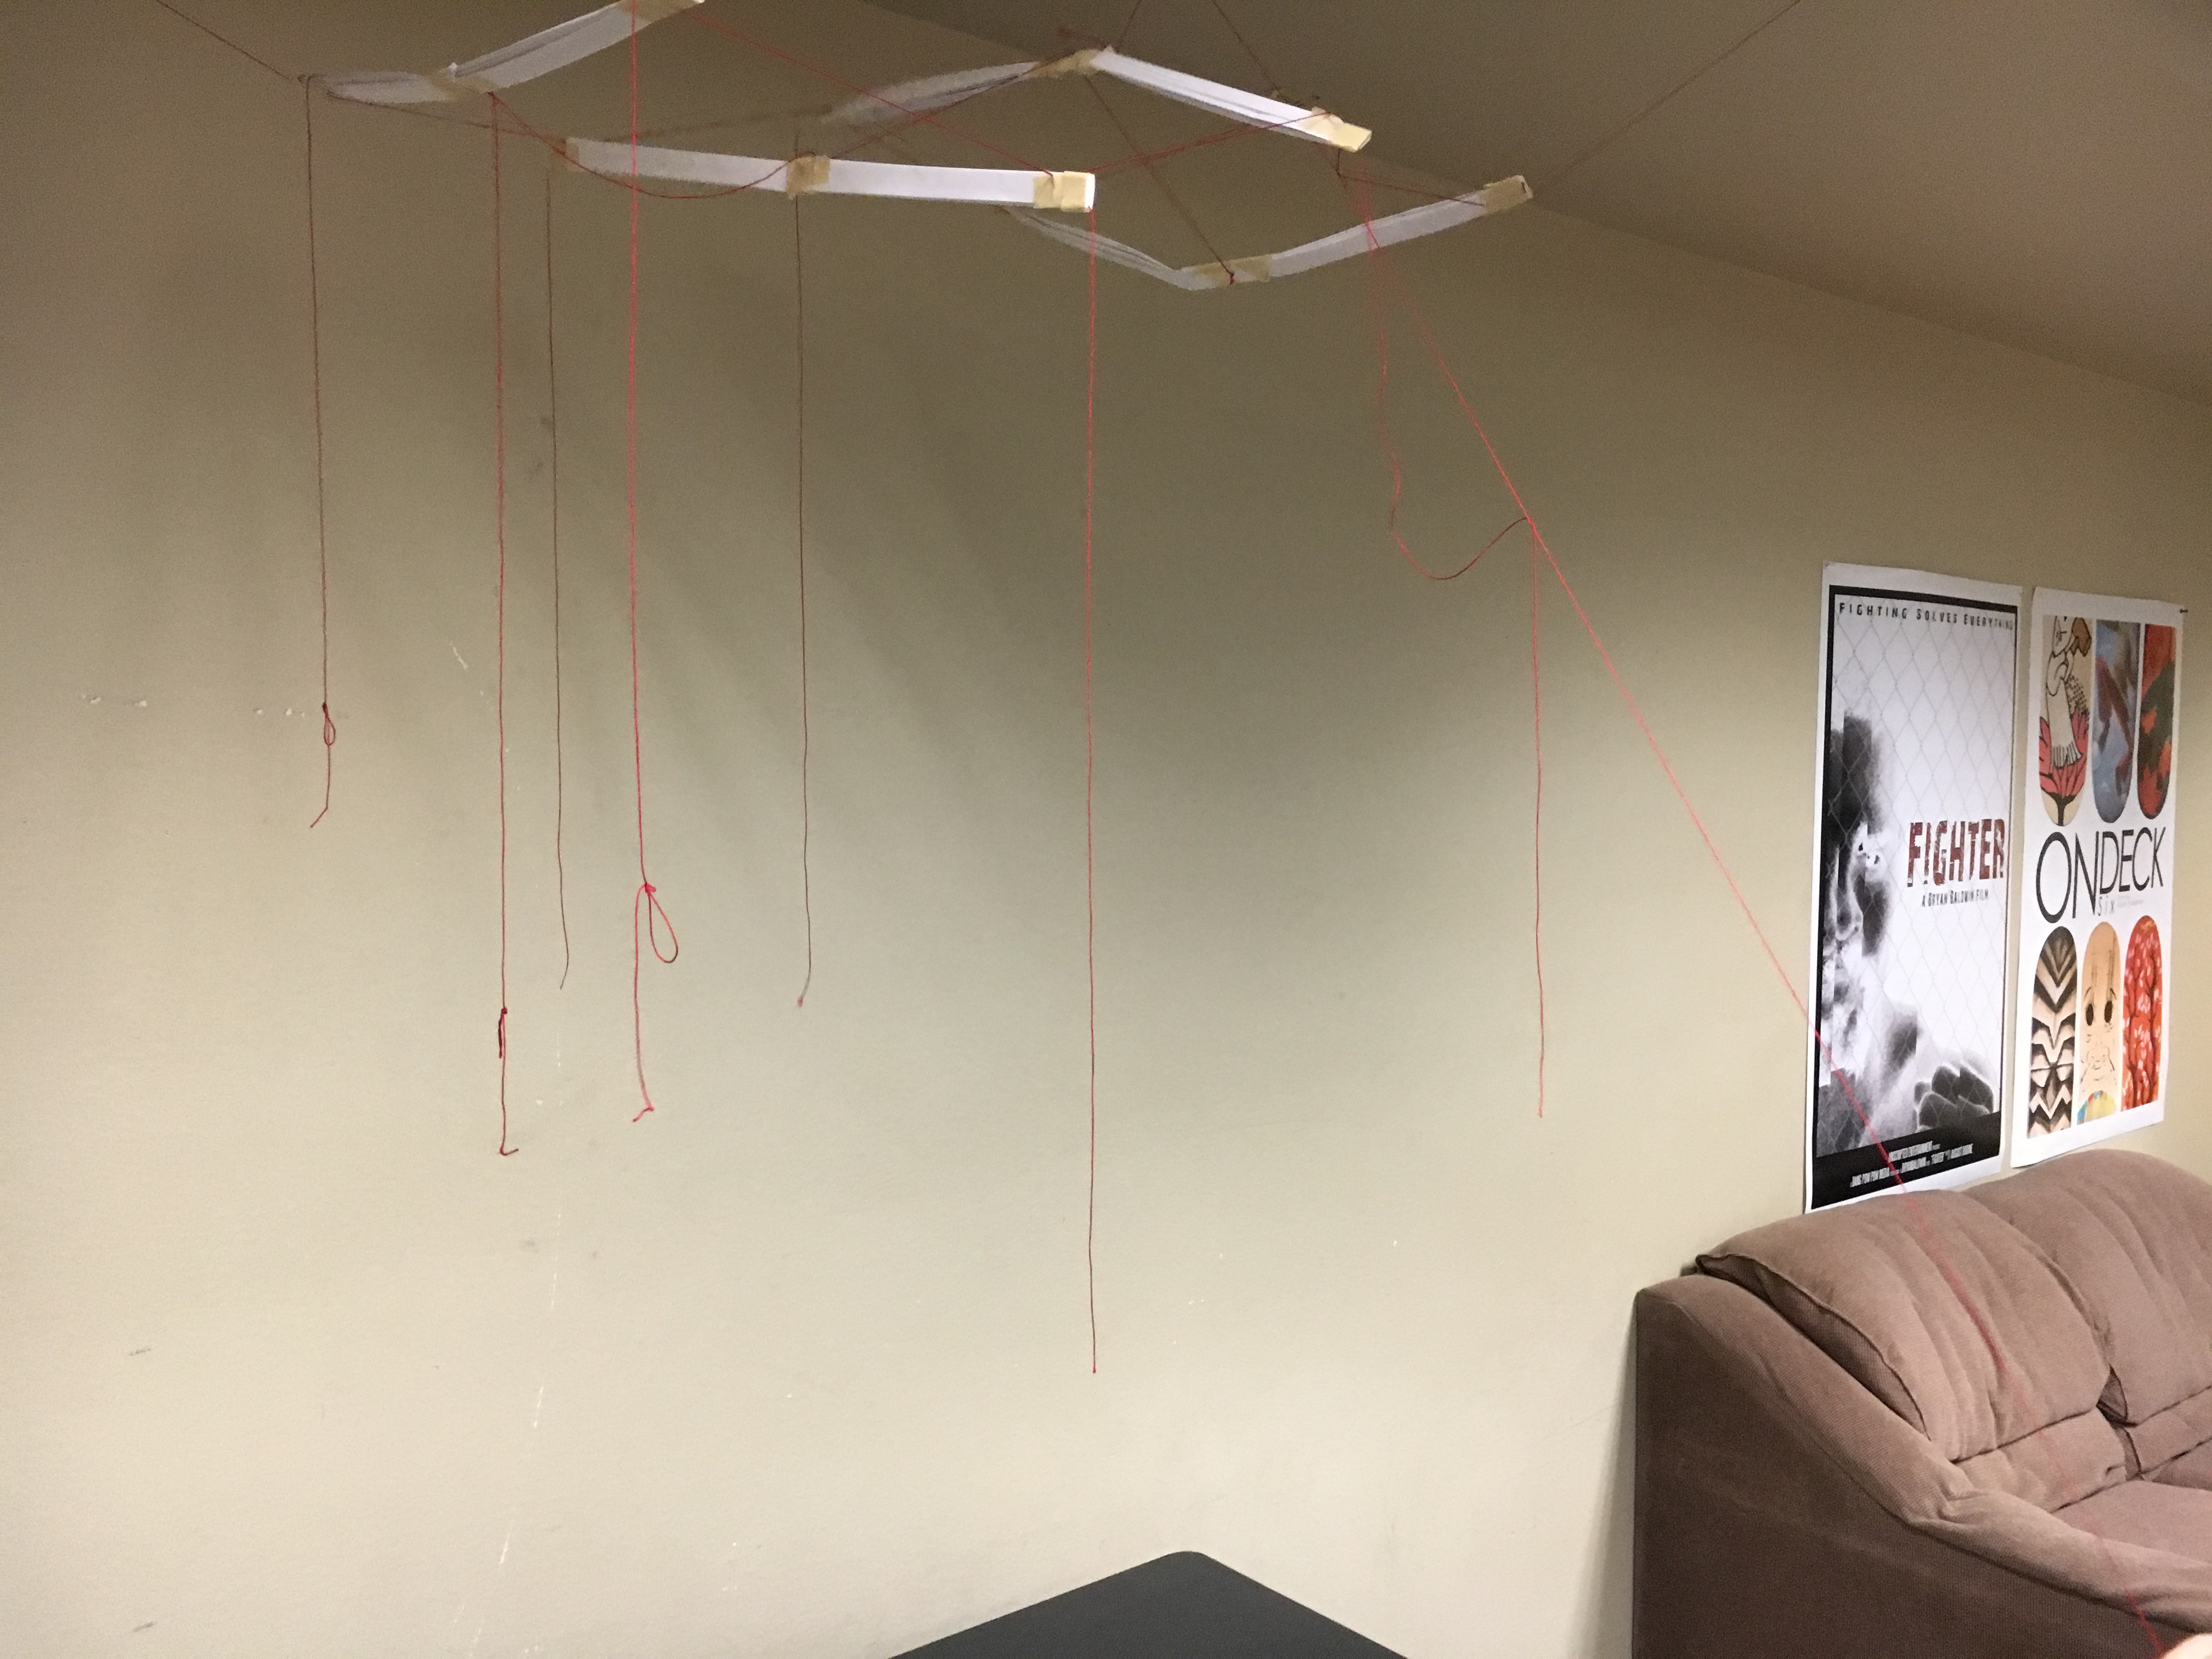

**Figure 1.** Project 1 installation: Participant pulls on string to raise the paper bar.

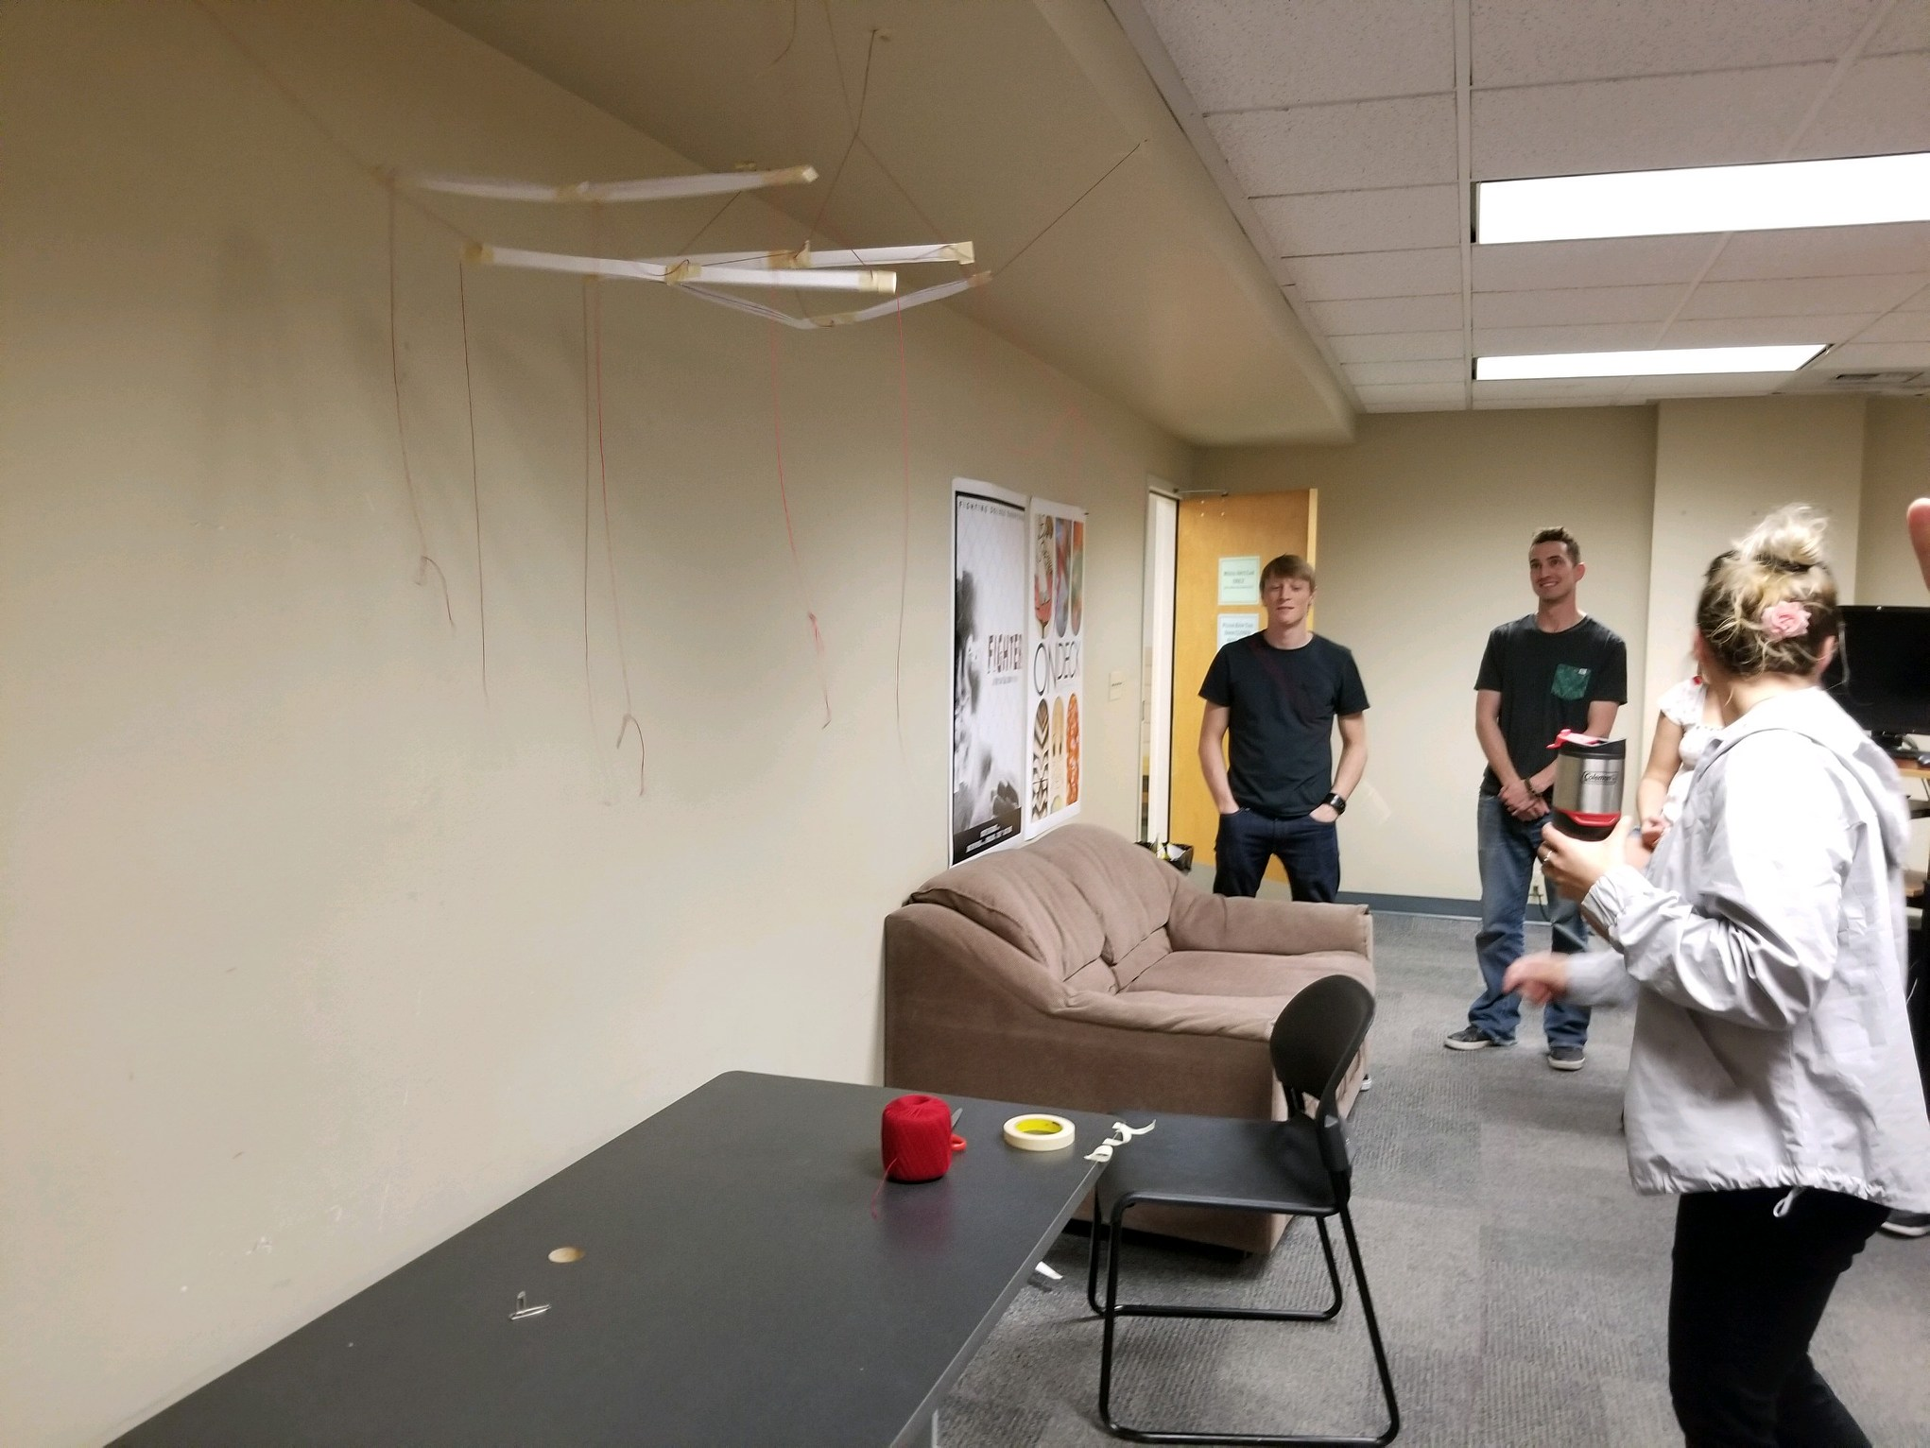

**Figure 2**. Picture of Project 1 with another angle for size reference and rig setup.

1. Conclusions

This project was challenging. It made you think and develop under limited circumstances. The hardest part about creating an interactive installation is how to connect the audience. How do we get them enveloped in this interactive install and make them want to enjoy it further? Well first off, its hard to do something as complicated as that with just paper, tape and string. I learned that we have to change the participants environment, encapsulate them within the installation that begs them to participate.

I would have loved to create something like this on a larger scale with more resources then just paper tape and string. I would like to take the idea of the ping pong led install and our own and combine them into an interactive light piece.

This project gave me further insight on how to approach an interactive installation. You have to figure out every detail and step before constructing. It’s better to have everything laid out before hand and have every detail accounted for to receive good results. This project was fun and challenging, it definitely gave me new insight and ideas for future projects in this class and on my own.