CS 261 Midterm 2 Spring 2008 Name:

There are six questions on this exam, the first five are each worth 15 points and the last is 25 points.

- Arrange the values 1 to 10 into a Binary Search Tree that is also complete.

7
9
4
2
6
8
10
1
3
5

- Write the values from your tree above as they would be visited in a pre-order traversal, a post-order traversal, an in-order traversal and a level-order traversal. Label each of your traversals.

Pre-order: 7, 4, 2, 1, 3, 6, 5, 9, 8, 10
Post-order: 1, 3, 2, 5, 6, 4, 8, 10, 9, 7
In-order: 1, 2, 3, 4, 5, 6, 7, 8, 9, 10
Level-order: 7, 4, 9, 2, 6, 8, 10, 1, 3, 5

- Add the value 9 into the following AVL tree and show the resulting tree after balance has been restored. (We’ll just ignore this)
10
3
12
2
5
11
13
1
4
7
14
6
8

- Give a short explanation (in English, not code) of how a new value is inserted into a skip list. You can draw pictures if you want.
  - Find correct location of the newValue
Starting at the top, slide right before the next link is greater than newValue. Then, progressively work your way down. For example, if we wanted to find the correct location of 4, we wouldn’t slide right, we’d slide down twice and then slide right on the bottom row when we arrived at link 3 and stop before link 7.
  - 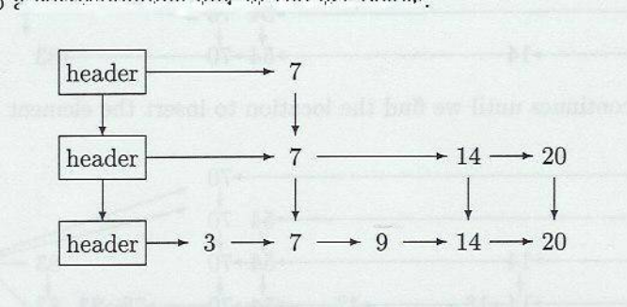Add the value
Insert a new link at this location, then, move upwards, flipping a coin. As long as heads, add to next higher row. At top, again flip, if heads make new row.

- Write a algorithm to perform binary search on an ordered array, returning either the position of the test element, or if not in the collection the position where it could be inserted without violating ordering. size is the size of the data array.

int binarySearch (double [ ] data, int size, double test) {
int low = 0;
int high = size;
while (low < high) {
int mid = (low + high) / 2;
if (data[mid] < test))
low = mid + 1;
else high = mid;
}
return low;
}
- (25 points) Assuming you have the binary search algorithm you wrote in the previous question, as well as the functions to insert a value into a given position in dynamic array, and remove a value from a given position, write the three functions to implement the bag interface. Give the big-O execution time for each.

struct dyArray {
double * data;
int size;
int capacity;
};

void insertAt (struct dyArray * da, int position, double value); // assume these
void removeAt (struct dyArray *da, int position); // are written for you

void sortedBagAdd (struct dyArray * da, double value) { // O( N )

insertAt(da, binarySearch(da->data, value), value);

}

void sortedBagRemove (struct dyArray * da, double value) { // O( N )

int pos1 = sortedBagContains(da, value);
if (pos1)
removeAt(da, pos1);

}

int sortedBagContains (struct dyArray * da, double value) { // O( log N )

int pos = binarySearch(da->data, value);
if (pos >= 0 && pos < da->size && da->data[pos] == value)
return pos + 1;
return 0;

}

