DEMETRIA, Olivia Jan Louville

FULCHER, Lawrean Angeley

LAGUNDA, Ann Renzel

The installation guide includes:

1. List of all the software (including all possible version) the user needs to install and where to download it:
   1. Google Chrome - <https://www.google.com/chrome/browser/desktop/>
   2. XAMPP - <https://www.apachefriends.org/index.html>
2. Settings that the user must set/configure in order to run the project (including the DB).
   1. After installing Xampp, find the location of htdocs in the Xampp folder (e.g. C:\xampp\htdocs) then paste the folder AMS that contains the source code of the project.
   2. Open Xampp Control Panel then start Apache and MySQL
   3. Open a browser (if you already disabled the web security, if not, proceed to instruction 3) and search for localhost/AMS which directs you to the homepage of the system.
   4. If you already have an existing xampp account and it has a username and password, you can set it in C:\xampp\htdocs\AMS\application\config. Find database.php, open it, then edit the username and password. Example below:

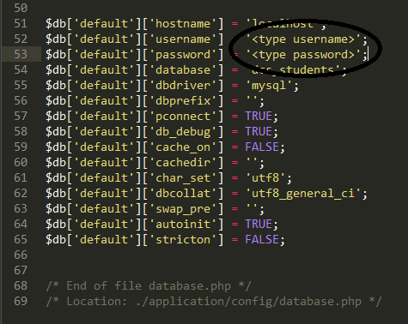

1. Disabling security (Google Chrome)
   1. Make sure that there are no chrome processes running by deleting all the chrome processes in the Task Manager
   2. Open Command Prompt.
   3. Go to the location of your chrome.exe (eg. cd C:\ProgramFiles(x86)\Google\Chrome\Application)
   4. Type Chrome.exe --disable-web-security and hit enter
   5. This should automatically open the browser and then proceed to instruction 2.c