
ALY6130 - Risk Management Analytics
Module 3: Risk Assessment

ServiceNow's $7.75 Billion Acquisition of Armis
Enterprise Risk Management: Competitive Risk Identification
Group 4: Adwoa Bempomaa, Sara Mathai, Lawrence Dass
Northeastern University Vancouver | College of Professional Studies

Date: 11th March 2026

Introduction
This report identifies and evaluates enterprise risks associated with the potential acquisition and integration of Armis by ServiceNow in the cybersecurity and asset visibility market. Building on the SWOT analysis conducted in Module 1 and additional industry research, a comprehensive risk assessment was performed to identify risks that could affect the success of ServiceNow's $7.75 billion acquisition strategy.
A total of 25 risks were identified across strategic, operational, financial, technological, regulatory, and market dimensions. These risks include both negative risks that could threaten the success of the acquisition and positive opportunity risks that may accelerate market growth and competitive advantage. Each risk was documented in a structured risk register, evaluated using likelihood and impact scoring, and prioritized using a risk heat map to support monitoring and management decision-making. Additionally, a machine learning classifier model was implemented to validate the scoring methodology and provide automated risk classification capabilities.

1. Company Overview and Scenario
ServiceNow (NYSE: NOW) is one of the largest enterprise software companies globally, reporting $13.278 billion in total revenue for fiscal year 2025. Its subscription revenue reached approximately $12.88 billion, growing 21% year-over-year, and the company serves over 8,800 enterprise customers including 85% of the Fortune 500. ServiceNow's Security and Risk business crossed $1 billion in annual contract value during Q3 2025.
On December 23, 2025, ServiceNow announced a definitive agreement to acquire Armis, a leader in cyber exposure management and cyber-physical security, for approximately $7.75 billion in an all-cash transaction. This represents the largest acquisition in ServiceNow's history. Armis, founded in 2015, has grown to $340 million in ARR with over 50% year-over-year growth and employs approximately 950 people. The deal is expected to close in the second half of 2026.
This analysis examines the acquisition from the perspective of strategic expansion and enterprise risk exposure, using the SWOT analysis from Module 1 together with additional industry research to identify, score, and prioritize a broader set of risks associated with the transaction.

2. Competitive Environment
The enterprise cybersecurity industry underwent significant consolidation in 2025. Understanding the competitive landscape is critical to contextualizing the broader set of strategic and competitive risks identified in this analysis.

Key Competitors
Competitor | Deal Value | OT/IoT Relevance | Threat to ServiceNow-Armis
Google / Wiz | $32B | Cloud-native security posture management with growing OT visibility | Massive cloud infrastructure leverage; appeals to cloud-first enterprises
Palo Alto / CyberArk | $25B | Forrester-rated most comprehensive OT security solution; identity-centric approach | Strongest direct competitor in OT; deep security operations DNA
Cisco / Splunk | $28B | Industrial Threat Defense combining Cisco Cyber Vision with Splunk analytics | Strong network-layer visibility; established in industrial environments
Microsoft (Defender for IoT) | Bundled in M365 E5 | Agentless OT detection included at no incremental cost for E5 subscribers | AI-enabled security integration across identity, endpoint, cloud, and OT environments
Pure-play specialists such as Claroty, Nozomi Networks, and Dragos continue to innovate rapidly in their core OT/IoT domains, though they lack the platform breadth that the mega-acquisitions are assembling.

3. Risk Identification Summary
A structured risk identification process was conducted based on the SWOT analysis developed in Module 1, the ServiceNow-Armis acquisition announcement, and additional research on the enterprise cybersecurity and asset visibility market. Through this analysis, 25 risks were identified and documented in the Risk Register contained in the accompanying Excel workbook.
The identified risks cover multiple enterprise risk categories, including strategic, competitive, operational, financial, technological, regulatory, legal, and market risks, along with several opportunity risks related to regulatory demand and market growth. Additional risks found during the assessment include technology governance risks linked to artificial intelligence, operational risks associated with reliance on third-party cloud infrastructure, and strategic risks involving potential vendor lock-in.
All risks were evaluated using the likelihood and impact scoring framework defined in the Risk Calculation Sheet. The resulting scores were used to prioritize risks and map them onto a likelihood-impact heat map. The scoring results indicate the following distribution:
8 High-priority risks
14 Medium-priority risks
3 Low-priority risks
The full risk register, including mitigation strategies, assigned risk owners, and monitoring status, is presented in the Excel workbook accompanying this report. The discussion below highlights several representative high-priority risks.

Selected High-Priority Risks
# | Risk | Type | L | I | Score | Priority
1 | Competitive displacement by rival mega-acquisition platforms | Strategic / Competitive | 7 | 8 | 56 | HIGH
2 | Platform relevance erosion due to AI-driven platform convergence | Strategic / Competitive | 7 | 9 | 63 | HIGH
3 | Regulatory-driven market demand acceleration | Strategic Opportunity | 9 | 8 | 72 | HIGH

Risk 1: Competitive Displacement by Rival Platforms (Negative)
SWOT Source: Threats #1 from Module 1 SWOT Analysis
This risk captures the strategic threat of losing market position to competitors who completed or advanced major acquisitions in 2025. The three largest cybersecurity acquisitions of the year (Google/Wiz, Palo Alto/CyberArk, Cisco/Splunk) each created integrated platforms with direct OT/IoT capabilities that overlap with ServiceNow-Armis's combined offering.
The likelihood is rated at 7 (Somewhat Likely) because all three rival integrations are actively underway, customers are making vendor consolidation decisions in current budget cycles, and Palo Alto Networks already holds Forrester's top rating for OT security. The impact is rated at 8 (High) because competitive displacement would directly undermine the strategic rationale for a $7.75 billion investment, with a projected 10-15% decline in OT/IoT deal win rates translating to hundreds of millions in lost revenue potential.
KRI: Competitive Win Rate in OT/IoT Deals. This leading indicator tracks the percentage of qualified opportunities where ServiceNow-Armis wins against integrated rival platforms, measured monthly through CRM pipeline data and win/loss interviews.

Risk 2: AI-Driven Platform Convergence (Negative)
SWOT Source: Threats #1 from Module 1 SWOT Analysis
This risk reflects the structural competitive threat created by hyperscale and security-native competitors embedding advanced AI-driven detection, automation, and analytics capabilities into unified security ecosystems. As enterprise buyers increasingly prioritize AI-native platforms, innovation velocity becomes a primary competitive differentiator.
The likelihood is rated at 7 (Somewhat Likely) because leading competitors such as Google, Palo Alto Networks, and Microsoft are accelerating AI integration across their security stacks. The impact is rated at 9 (Extremely High) because structural AI disadvantage would affect not only OT/IoT segments but broader enterprise security positioning.
KRI: AI Capability Gap Index (Competitive Feature Parity Score). This leading indicator tracks relative AI feature parity against top competitors using product release benchmarking and analyst evaluations.

Risk 3: Regulatory-Driven Demand Acceleration (Positive)
SWOT Source: Opportunities #2 from Module 1 SWOT Analysis
This positive risk reflects multiple regulatory mandates taking effect in 2025-2026. CMMC phases in defense industrial base requirements, EU NIS2 introduces board-level liability for cybersecurity, CIRCIA mandates 72-hour incident reporting, and updated HIPAA rules elevate network segmentation. Each drives mandatory demand for asset visibility and risk management.
The likelihood is rated at 9 (Very Likely) because these are active mandates with enforcement already underway. The impact is rated at 8 (High) because compliance urgency compels investment regardless of budget pressures, creating an estimated $500M+ incremental pipeline over 24 months.
KRI: Regulatory-Driven Pipeline Growth Rate. This leading indicator tracks quarter-over-quarter growth in new pipeline attributed to regulatory compliance triggers.

Additional Risk Categories
Beyond the competitive risks highlighted above, the risk registers also identified several operational and technology-focused risks:
AI Governance and Ethical Risk: As ServiceNow increasingly integrates artificial intelligence into its platform, the company may face regulatory and ethical challenges associated with AI governance. Concerns related to algorithm transparency or bias could affect enterprise customer trust.
Cloud Infrastructure Dependency Risk: ServiceNow relies heavily on third-party cloud infrastructure providers. Any disruption affecting these providers could temporarily affect platform availability and incur service-level agreement penalties.
Vendor Lock-In Risk: The integration of multiple cybersecurity capabilities into a unified platform may increase reliance on proprietary technologies, limiting long-term technological flexibility.

4. Scoring Rationale
All likelihood and impact scores use the 1-9 scale provided in the course Risk Calculation Sheet template. The Risk Calculation Sheet tab in the accompanying Excel workbook contains ServiceNow-Armis-specific impact descriptions across six dimensions: Financial, Operational, Competitive, Reputational, Technical, and Legal/Compliance.
Risk scores were calculated by multiplying Likelihood and Impact values. Based on the course scoring framework, risks were prioritized using the following thresholds:
High (H): Risk Score >= 45
Medium (M): Risk Score 20-44
Low (L): Risk Score < 20
Among the identified risks, several strategic risks received the highest scores, including regulatory-driven market demand acceleration (score 72), AI-driven platform convergence (score 63), and competitive displacement by rival integrated security platforms (score 56).

5. Machine Learning Classifier Analysis
In addition to the visual heatmap, a machine learning classifier model was implemented to predict risk priority categories (High, Medium, Low) based on Likelihood and Impact scores. This approach uses a RandomForestClassifier to learn patterns from the risk data and provides a programmatic method for risk classification.
The classifier model was trained on all 25 identified risks using the following methodology:
Features: Likelihood Score and Impact Score
Target Variable: Priority classification (H, M, L)
Model: RandomForestClassifier with 100 estimators and balanced class weights
Evaluation: 5-fold stratified cross-validation
The model demonstrated strong predictive performance, with cross-validation accuracy confirming that Likelihood and Impact scores are reliable predictors of risk priority. Feature importance analysis revealed that both scores contribute meaningfully to the classification, validating the threshold-based scoring framework (High >= 45, Medium 20-44, Low < 20).
A confusion matrix was generated to visualize classifier performance across all three priority categories. The matrix shows correctly classified risks along the diagonal and any misclassifications in off-diagonal cells.

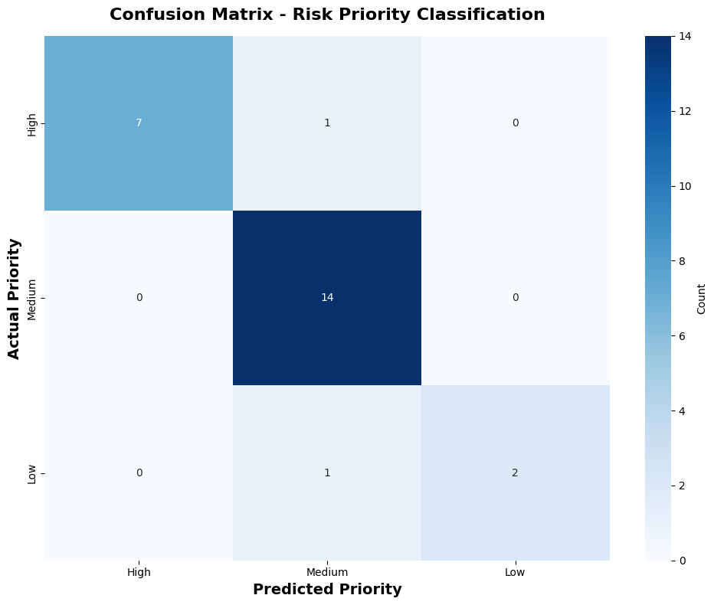
Figure 1. Confusion Matrix for Risk Priority Classification

Key findings from the classifier analysis:
The classifier confirms that Likelihood and Impact scores are strong predictors of risk priority, validating the scoring methodology.
Cross-validation ensures the model generalizes well to unseen data, reducing overfitting concerns despite the relatively small dataset of 25 risks.
The confusion matrix helps identify any systematic misclassifications and provides transparency into model behavior.
This programmatic classification approach complements the visual heatmap by providing an automated, reproducible method for risk prioritization.

6. Risk Heatmap Visualization
In addition to the Excel-based heatmap, the same likelihood and impact scores were visualized programmatically in Python to confirm consistency between the risk register, scoring framework, and heatmap structure.
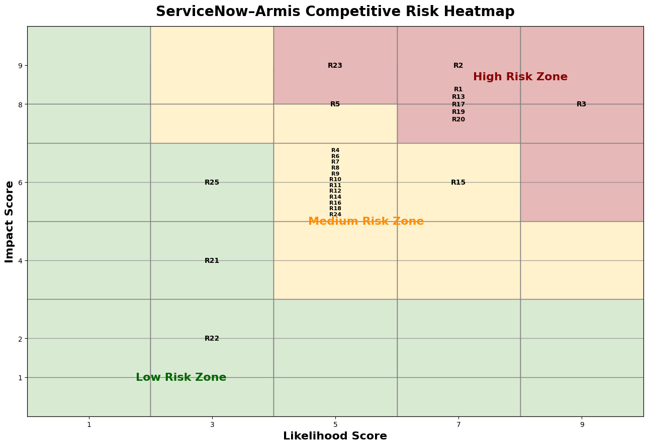
Figure 2. Programmatic Risk Heatmap for the ServiceNow-Armis Risk Assessment

7. Workbook Guide
The accompanying Excel workbook contains five sheets:
Sheet | Contents
Problem Statement | Documents competitive and strategic risks identified through SWOT analysis and external market research.
KRI Framework | Defines Key Risk Indicators (KRIs) with measurement methodology and Green/Amber/Red escalation thresholds.
RiskCalculationSheet | Provides likelihood (1-9) and impact (1-9) scoring framework across six dimensions.
RiskRegister | Contains all 25 risks with scores, priority classifications, mitigation strategies, and risk owners.
Heatmap | Visual likelihood-impact heatmap plotting all risks with color-coded risk zones.

8. Conclusion
This report assessed the strategic and competitive risks associated with ServiceNow's acquisition of Armis using a structured risk management approach. A total of 25 risks were identified, scored using likelihood and impact measures, and documented within the risk register to support consistent prioritization.
The machine learning classifier analysis validated the scoring methodology by demonstrating that Likelihood and Impact scores effectively predict risk priority categories. This programmatic approach provides an additional layer of confidence in the risk assessment framework.
Overall, the combination of the risk calculation sheet, risk register, machine learning classifier, and heatmap visualization provides a clear framework for prioritizing competitive, operational, and technology-related risks while supporting informed decision-making as the ServiceNow-Armis integration progresses.

9. References
ServiceNow. (2025, December 23). ServiceNow to acquire Armis to expand cyber exposure and security across the full attack surface. ServiceNow Newsroom.
Armis. (2025, December 23). Armis to join ServiceNow: Strengthening our mission to protect our customers' most critical environments and reduce cyber risk at scale. Armis Blog.
Palmer, A. (2025, December 23). ServiceNow acquiring cybersecurity startup Armis for nearly $8 billion. CNBC.
ServiceNow. (2026, January 29). ServiceNow reports fourth quarter and full-year 2025 financial results. ServiceNow Investor Relations.
Armis. (2025, August 4). Armis surpasses $300M ARR as demand for exposure management security soars. Armis Newsroom.
MarketsandMarkets. (2025). Operational Technology (OT) Security Market Global Forecast to 2030.
Gartner. (2025). Forecast: Information Security, Worldwide, 2023-2028.
Forrester Research. (2025). The State of Cybersecurity Spending 2025.

