

ALY6130 - Risk Management Analytics
Module 3: Risk Assessment

ServiceNow's $7.75 Billion Acquisition of Armis
Enterprise Risk Management: Competitive Risk Identification

Group 4: Adwoa Bempomaa, Sara Mathai, Lawrence Dass
Northeastern University Vancouver | College of Professional Studies

Date: 9th March 2026

Introduction

This report identifies and evaluates enterprise risks associated with the potential acquisition and integration of Armis by ServiceNow in the cybersecurity and asset visibility market. Building on the SWOT analysis conducted in Module 1 and additional industry research, a comprehensive risk assessment was performed to identify risks that could affect the success of ServiceNow’s $7.75 billion acquisition strategy.

A total of 22 risks were identified across strategic, operational, financial, technological, regulatory, and market dimensions. These risks include both negative risks that could threaten the success of the acquisition and positive opportunity risks that may accelerate market growth and competitive advantage. Each risk was documented in a structured risk register, evaluated using likelihood and impact scoring, and prioritized using a risk heat map to support monitoring and management decision-making.

1. Company Overview and Scenario
ServiceNow (NYSE: NOW) is one of the largest enterprise software companies globally, reporting $13.278 billion in total revenue for fiscal year 2025. Its subscription revenue reached approximately $12.88 billion, growing 21% year-over-year, and the company serves over 8,800 enterprise customers including 85% of the Fortune 500. ServiceNow's Security and Risk business crossed $1 billion in annual contract value during Q3 2025.
On December 23, 2025, ServiceNow announced a definitive agreement to acquire Armis, a leader in cyber exposure management and cyber-physical security, for approximately $7.75 billion in an all-cash transaction. This represents the largest acquisition in ServiceNow's history. Armis, founded in 2015, has grown to $340 million in ARR with over 50% year-over-year growth and employs approximately 950 people. The deal is expected to close in the second half of 2026.
This analysis examines the acquisition from the perspective of strategic expansion and enterprise risk exposure, using the SWOT analysis from Module 1 together with additional industry research to identify, score, and prioritize a broader set of risks associated with the transaction.

2. Competitive Environment
The enterprise cybersecurity industry underwent significant consolidation in 2025. Understanding the competitive landscape is critical to contextualizing the broader set of strategic and competitive risks identified in this analysis.

Key Competitors
Competitor | Deal Value | OT/IoT Relevance | Threat to ServiceNow-Armis
Google / Wiz | $32B | Cloud-native security posture management with growing OT visibility | Massive cloud infrastructure leverage; appeals to cloud-first enterprises
Palo Alto / CyberArk | $25B | Forrester-rated most comprehensive OT security solution; identity-centric approach | Strongest direct competitor in OT; deep security operations DNA
Cisco / Splunk | $28B | Industrial Threat Defense combining Cisco Cyber Vision with Splunk analytics | Strong network-layer visibility; established in industrial environments
Microsoft (Defender for IoT) | Bundled in M365 E5 | Agentless OT detection included at no incremental cost for E5 subscribers | AI-enabled security integration across identity, endpoint, cloud, and OT environments reinforces Microsoft’s unified security ecosystem and enterprise platform leverage

Pure-play specialists such as Claroty, Nozomi Networks, and Dragos continue to innovate rapidly in their core OT/IoT domains, though they lack the platform breadth that the mega-acquisitions are assembling.

3. Risk Identification Summary
A structured risk identification process was conducted based on the SWOT analysis developed in Module 1, the ServiceNow–Armis acquisition announcement, and additional research on the enterprise cybersecurity and asset visibility market. Through this analysis, 22 risks were identified and documented in the Risk Register contained in the accompanying Excel workbook.
The identified risks span multiple enterprise risk categories, including strategic, competitive, operational, financial, technological, regulatory, legal, and market risks, as well as several opportunity risks related to regulatory demand and market growth. Together, these risks reflect the key uncertainties that could influence the strategic success of ServiceNow’s $7.75 billion acquisition of Armis and its ability to compete in the rapidly evolving cybersecurity platform market.
All risks were evaluated using the likelihood and impact scoring framework defined in the Risk Calculation Sheet. The resulting scores were used to prioritize risks and map them onto a likelihood–impact heat map, providing a visual representation of risk severity and relative priority. The scoring results indicate the following distribution across the risk register:
- 7 High-priority risks
- 13 Medium-priority risks
- 2 Low-priority risks
The full risk register, including mitigation strategies, assigned risk owners, and monitoring status, is presented in the Excel workbook accompanying this report. The discussion below highlights several representative high-priority risks that illustrate the most significant competitive exposures associated with ServiceNow’s acquisition of Armis.

Selected High-Priority Risks
# | Risk | Type | Likelihood | Impact | Score | Priority
1 | Competitive displacement by rival mega-acquisition platforms | Strategic / Competitive | 7 | 8 | 56 | HIGH
2 | Platform relevance erosion due to AI-driven platform convergence | Strategic / Competitive | 7 | 9 | 63 | HIGH
3 | Regulatory-driven market demand acceleration | Strategic Opportunity | 9 | 8 | 72 | HIGH

Risk 1: Competitive Displacement by Rival Platforms (Negative)
SWOT Source: Threats #1 from Module 1 SWOT Analysis
This risk captures the strategic threat of losing market position to competitors who completed or advanced major acquisitions in 2025. The three largest cybersecurity acquisitions of the year (Google/Wiz, Palo Alto/CyberArk, Cisco/Splunk) each created integrated platforms with direct OT/IoT capabilities that overlap with ServiceNow-Armis's combined offering.
The likelihood is rated at 7 (Somewhat Likely) because all three rival integrations are actively underway, customers are making vendor consolidation decisions in current budget cycles, and Palo Alto Networks already holds Forrester's top rating for OT security. The impact is rated at 8 (High) because competitive displacement would directly undermine the strategic rationale for a $7.75 billion investment, with a projected 10-15% decline in OT/IoT deal win rates translating to hundreds of millions in lost revenue potential.
KRI: Competitive Win Rate in OT/IoT Deals. This leading indicator tracks the percentage of qualified opportunities where ServiceNow-Armis wins against integrated rival platforms, measured monthly through CRM pipeline data and win/loss interviews. A declining win rate signals that competitors are gaining ground before the full integration is complete.

Risk 2: AI-Driven Platform Convergence and Structural Relevance Risk (Negative)

SWOT Source: Threats #1 from Module 1 SWOT Analysis
This risk reflects the structural competitive threat created by hyperscale and security-native competitors embedding advanced AI-driven detection, automation, and analytics capabilities into unified security ecosystems. As enterprise buyers increasingly prioritize AI-native platforms, innovation velocity becomes a primary competitive differentiator.
The likelihood is rated at 7 (Somewhat Likely) because leading competitors such as Google, Palo Alto Networks, and Microsoft are accelerating AI integration across their security stacks, and analyst evaluations increasingly emphasize AI capability depth. The impact is rated at 9 (Extremely High) because structural AI disadvantage would affect not only OT/IoT segments but broader enterprise security positioning, potentially shifting long-term competitive perception and market valuation.
KRI: AI Capability Gap Index (Competitive Feature Parity Score). This leading indicator tracks relative AI feature parity against top competitors using product release benchmarking and analyst evaluations. Sustained parity below defined thresholds signals emerging structural disadvantage.

Risk 3: Regulatory-Driven Demand Acceleration (Positive)
SWOT Source: Opportunities #2 from Module 1 SWOT Analysis

This positive risk reflects multiple regulatory mandates taking effect in 2025-2026. CMMC phases in defense industrial base requirements, EU NIS2 introduces board-level liability for cybersecurity, CIRCIA mandates 72-hour incident reporting, and updated HIPAA rules elevate network segmentation. Each drives mandatory demand for asset visibility and risk management, precisely what ServiceNow-Armis delivers.

The likelihood is rated at 9 (Very Likely) because these are active mandates with enforcement already underway, not speculative proposals. The impact is rated at 8 (High) because compliance urgency compels investment regardless of budget pressures, creating an estimated $500M+ incremental pipeline over 24 months. ServiceNow-Armis's FedRAMP Moderate, DISA IL5, and KLAS Healthcare IoT authorizations provide pre-qualified access to the highest-value segments, with Armis's federal business growing 120%+ year-over-year.

KRI: Regulatory-Driven Pipeline Growth Rate. This leading indicator tracks quarter-over-quarter growth in new pipeline attributed to regulatory compliance triggers, sourced from CRM opportunity tagging. Growth above 25% QoQ confirms regulatory demand is converting to commercial opportunity; a slowdown signals competitors may be capturing compliance-driven deals.
4. Scoring Rationale
All likelihood and impact scores use the 1–9 scale provided in the course Risk Calculation Sheet template. The Risk Calculation Sheet tab in the accompanying Excel workbook contains ServiceNow–Armis–specific impact descriptions across six dimensions: Financial, Operational, Competitive, Reputational, Technical, and Legal/Compliance. These impact definitions were calibrated to reflect the scale and strategic significance of ServiceNow’s $7.75 billion acquisition of Armis and its implications for the enterprise cybersecurity market.
Each identified risk was evaluated using this scoring framework. Risk scores were calculated by multiplying Likelihood and Impact values, producing a composite score that reflects both the probability of occurrence and the severity of potential consequences.
Based on the course scoring framework, risks were prioritized using the following thresholds:
• 7 High-priority risks
• 13 Medium-priority risks
• 2 Low-priority risks
The likelihood–impact heatmap generated in the Excel workbook plots all 22 risks on a two-dimensional matrix using likelihood on the horizontal axis and impact on the vertical axis. This visualization highlights the concentration of higher-severity risks in the upper-right quadrant of the matrix, indicating areas where management attention and mitigation planning should be prioritized.
Among the identified risks, several strategic risks received the highest scores, including regulatory-driven market demand acceleration (score 72), AI-driven platform convergence (score 63), and competitive displacement by rival integrated security platforms (score 56). These risks represent the most significant strategic factors influencing the success of the ServiceNow–Armis acquisition. In addition to the Excel-based heatmap, the same likelihood and impact scores were also visualized programmatically in Python to confirm consistency between the risk register, scoring framework, and heatmap structure.
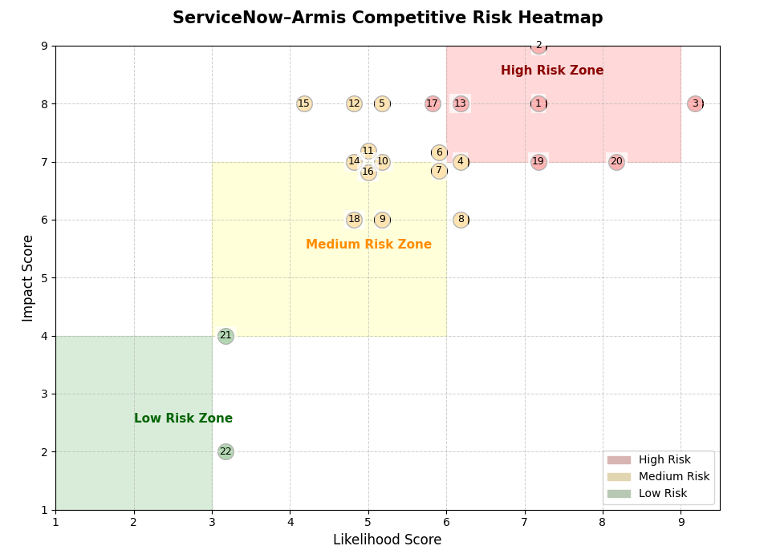
Figure 1. Programmatic Risk Heatmap for the ServiceNow–Armis Risk Assessment

5. Workbook Guide
The accompanying Excel workbook contains five sheets, each serving a distinct purpose in the risk identification process:
Sheet | Contents
Problem Statement | Documents the competitive and strategic risks identified through the SWOT analysis and external market research. Each entry explains the underlying risk driver and why monitoring the risk is important in the current competitive environment.
KRI Framework | Defines Key Risk Indicators (KRIs) used to monitor emerging risk trends. Each risk is associated with a leading indicator and measurement methodology, including Green/Amber/Red escalation thresholds.
RiskCalculationSheet | Provides the likelihood (1–9) and impact (1–9) scoring framework used to evaluate risks. Impact descriptions are tailored to the ServiceNow–Armis acquisition across Financial, Operational, Competitive, Reputational, Technical, and Legal/Compliance dimensions.
RiskRegister | Contains the complete register of 22 identified risks, including likelihood scores, impact scores, calculated risk scores, priority classification (High, Medium, Low), mitigation strategies, assigned risk owners, and monitoring status.
Heatmap | Visual likelihood–impact heatmap plotting all identified risks on the risk matrix. The heatmap highlights the concentration of high-severity risks and supports prioritization of mitigation and monitoring efforts.

6. Conclusion

This report assessed the strategic and competitive risks associated with ServiceNow’s acquisition of Armis using a structured risk management approach. A total of 22 risks were identified, scored using likelihood and impact measures, and documented within the risk register to support consistent prioritization. The analysis shows that a majority of identified risks fall within the medium and high priority ranges, highlighting the importance of monitoring competitive pressures, platform innovation, and integration challenges following the acquisition. Overall, the combination of the risk calculation sheet, risk register, and heatmap visualization provides a clear framework for prioritizing key risks and supporting informed decision-making as the acquisition evolves.

7. References
ServiceNow. (2025, December 23). ServiceNow to acquire Armis to expand cyber exposure and security across the full attack surface. ServiceNow Newsroom.
Armis. (2025, December 23). Armis to join ServiceNow: Strengthening our mission to protect our customers' most critical environments and reduce cyber risk at scale. Armis Blog.
Palmer, A. (2025, December 23). ServiceNow acquiring cybersecurity startup Armis for nearly $8 billion. CNBC.
ServiceNow. (2026, January 29). ServiceNow reports fourth quarter and full-year 2025 financial results. ServiceNow Investor Relations.
Armis. (2025, August 4). Armis surpasses $300M ARR as demand for exposure management security soars. Armis Newsroom.
MarketsandMarkets. (2025). Operational Technology (OT) Security Market Global Forecast to 2030.
Gartner. (2025). Forecast: Information Security, Worldwide, 2023-2028.
Forrester Research. (2025). The State of Cybersecurity Spending 2025.

